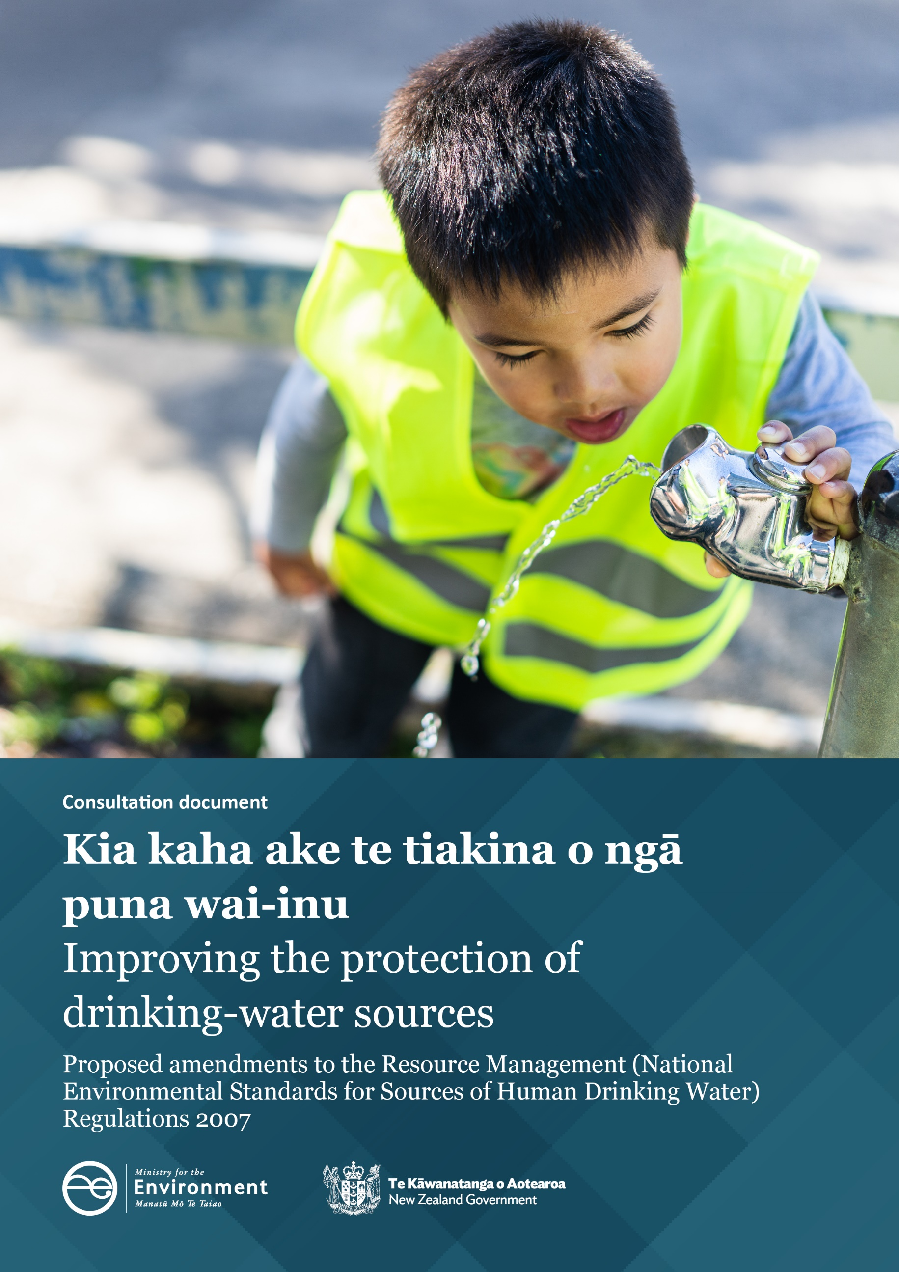

Disclaimer
The information in this publication is, according to the Ministry for the Environment’s best efforts, accurate at the time of publication. The Ministry will make every reasonable effort to keep it current and accurate. However, users of this publication are advised that:
- The information does not alter the laws of New Zealand, other official guidelines, or requirements.
- It does not constitute legal advice, and users should take specific advice from qualified professionals before taking any action based on information in this publication.
- The Ministry does not accept any responsibility or liability whatsoever whether in contract, tort, equity, or otherwise for any action taken as a result of reading, or reliance placed on this publication because of having read any part, or all, of the information in this publication or for any error, or inadequacy, deficiency, flaw in, or omission from the information in this publication.
- All references to websites, organisations or people not within the Ministry are for convenience only and should not be taken as endorsement of those websites or information contained in those websites nor of organisations or people referred to.

This document may be cited as: Ministry for the Environment. 2022. Kia kaha ake te tiakina o ngā puna wai-inu / Improving the protection of drinking-water sources: Proposed amendments to the Resource Management (National Environmental Standards for Sources of Human Drinking Water) Regulations 2007: Consultation document. Wellington: Ministry for the Environment.

Published in January 2022 by the
Ministry for the Environment
Manatū Mō Te Taiao
PO Box 10362, Wellington 6143, New Zealand
ISBN: 978-1-99-102503-6
Publication number: ME 1617
© Crown copyright New Zealand 2022
This document is available on the Ministry for the Environment website: environment.govt.nz.

Contents
Message from the Minister 6
Executive summary 7
The current NES-DW 8
Other protections for source water 9
Proposed amendments to the NES-DW 10
We are seeking your feedback 10
Section 1: Context 11
New Zealand’s drinking water problems 11
The National Environmental Standard for Sources of Human Drinking Water (NES-DW) 2007 11
Havelock North: a wake-up call 12
The Three Waters Review 14
The wider regulatory framework for drinking water and freshwater 14
The importance of the NES-DW for iwi/Māori 17
Scope of the proposed amendments 17
Section 2: Proposed changes to the NES-DW 19
Overview of the proposal 19
Proposal 1: How at-risk source water areas are delineated 19
Proposal 2: How activities that pose risks to source water are regulated or managed 26
Proposal 3: Protecting all registered water supplies 36
Section 3: Impacts of amending the NES-DW 39
An amended NES-DW would clarify source water requirements 39
How will an amended NES-DW affect stakeholders and iwi/Māori? 39
How will the NES-DW work with source-water provisions in the WSA and other freshwater national direction? 40
What are the anticipated outcomes? 42
What are the anticipated benefits? 45
What are the anticipated costs? 46
Potential resources and alignments 47
Section 4: What does this mean for you? 48
Scenario 1: Application of synthetic nitrogen fertiliser 48
Scenario 2: Agrichemicals 50
Scenario 3: Drilling and bore construction 51
Scenario 4: Wastewater discharges 53
Case studies 54
Section 5: How to have your say 56
Timeframes 56
How to make a submission 56
Consultation questions 58
Appendices 62
Appendix A: Indicative areas included in SWRMA 1 and 2 for currently registered water supplies 62
Appendix B: How the new source water provisions work together 65
References 66

Tables
Table 1: What is in and out of scope of the NES-DW? 18
Table 2: Comparison between current and proposed NES-DW requirements and application 37
Table 3: How the amended NES-DW will affect stakeholders and iwi/Māori 39
Table 4: Source-water roles and responsibilities 40
Table 5: Benefits of amending the NES-DW 45
Table 6: Summary of current case study participants 54

Figures
Figure 1: Regulatory framework to protect drinking water 15
Figure 2: Indicative SWRMA for rivers 23
Figure 3: Indicative SWRMA for lakes 23
Figure 4: Indicative SWRMA for an aquifer 24
Figure A.1: SWRMA 2 for surface water supplies 63
Figure A.2: SWRMA 2 for groundwater supplies 64
Figure B.1: Relationships and requirements for source water management 65

Message from the Minister
Everyone should have access to safe drinking water. That’s why we are considering changes to the NES-DW (National Environmental Standard for Sources of Human Drinking Water) to make our drinking water safer, and we want to hear what
you think.
The current NES-DW is simply not fit for purpose. It is imprecise and difficult to put into practice. The proposed changes to the NES-DW address these concerns. This document outlines three proposed areas of improvement: standardising the way we define source water areas, strengthening regulation of activities around water sources, and including more water suppliers under the NES-DW.
It’s crucial we have protections in place along each step of the water supply process, from source to tap. The NES-DW is designed to be the first step, focusing on the source of the water, and we want to strengthen it to make it work more effectively.
Together, these changes will help protect both the health of the water source and the health of the community. They also recognise Te Mana o te Wai, acknowledging the fundamental importance of water to the health and wellbeing of our people and our environment.
The Ministry for the Environment is running public consultation to hear what you think of these proposals. Feedback is welcome until 6 March 2022 and will be used to refine our proposed changes to the NES-DW before they are redrafted and gazetted later in 2022.
Thank you for taking the time to consider the proposals, and we look forward to hearing your views.

Hon Kiritapu Allan
Associate Minister for the Environment

Executive summary
The first barrier for preventing waterborne illness is to protect the water bodies from which drinking water is taken – rivers, lakes and aquifers – from contamination. The Resource Management (National Environmental Standards for Sources of Human Drinking Water) Regulations 2007 (NES-DW) were intended to support source water protection by providing national direction on how to manage activities that could impact the quality of treated drinking water.
A Government review of the ‘Three Waters’ regulatory system was initiated following an incident in Havelock North in 2016, where four people died and an estimated 5,500 fell ill with gastroenteritis. It was found the outbreak was at least partly caused by Campylobacter contamination in the town’s drinking water source. Along with the direct health implications, the total economic costs to society are estimated to be just above $21 million. The subsequent Havelock North Inquiry identified various issues with the regulatory regime, including ‘significant problems’ with the NES-DW.
The Three Waters Review has resulted in the establishment of a new dedicated regulator, Taumata Arowai, and the new Water Services Act 2021 (WSA). The WSA sets requirements that water suppliers must meet to ensure they provide safe drinking water. Freshwater protections continue to be provided for under the Resource Management Act 1991 (RMA).
This consultation document seeks feedback on proposed changes to the NES-DW intended to improve source water protection.

Box 1: What has come from the Havelock North Inquiry?
The Havelock North Inquiry (HNI) found that urgent improvements to regulations and service delivery arrangements were needed to support safe and resilient water supplies. In response to those findings:
- the Government set up the Three Waters Review
- a new water services regulator – Taumata Arowai – has been established
- the Water Services Act (WSA) has passed
- service delivery through four new water service entities is proposed.
Fundamental principles of drinking water safety
The HNI recommended the following principles of drinking water safety be used, and these underpin the WSA:
- Principle 1 – a high standard of care must be embraced
- Principle 2 – protection of source water is of paramount importance
- Principle 3 – maintain multiple barriers against contamination
- Principle 4 – change precedes contamination
- Principle 5 – suppliers must own the safety of drinking water
- Principle 6 – apply a preventative risk management approach.
The multiple-barrier approach
The multiple-barrier approach requires drinking-water suppliers put safety measures in place at every stage of the supply process to address the risk from all possible sources of contamination. This includes:
- protecting water at its source
- effective treatment (when required)
- secure distribution
- effective monitoring
- effective responses to incidents and events.

The current NES-DW
The current NES-DW specifies technical details for regional plan rules and consenting decisions, where activities are likely to result in certain drinking water supplies breaching national standards (DWSNZ) after treatment.
The HNI identified various issues with the current regulatory regime, including ‘significant problems’ with the NES-DW and the protection of source water. In particular, the NES-DW is complex and difficult to interpret and apply, it doesn’t cover the full range of activities that can pose a risk to source water, nor provide adequate protection for water supplies serving less than 500 people.
The HNI recommended a full review of the NES-DW to enable risks to source water to be addressed in a straightforward and comprehensive manner.
Box 2: What activities could pose risks to source water?
Activities that may affect source water include discharges of contaminants into the environment, such as from wastewater management, other water takes, damming and diverting water flows, works in riverbeds, earthworks, and drilling into aquifers.
These activities can increase the likelihood of contaminants, such as bacteria (including pathogens), chemicals, sediment, and other substances, entering the water body. These risks often go unrecognised, especially contamination of groundwater in aquifers that cannot be seen.
Water treatment is intended to remove or treat contaminants to acceptable levels for drinking, but not all contaminants can be addressed, and treatment can be costly. Activities that may introduce contaminants to source water pose a risk that needs to be appropriately managed.
Managing rivers, lakes and aquifers, and land uses that may affect water quality or quantity, is the responsibility of regional councils under the Resource Management Act 1991 (RMA).

Other protections for source water
The NES-DW was introduced in 2007 and was the sole national direction for freshwater at that time. Since the enactment of the NES-DW, additional national direction instruments have been made, including:
- the National Policy Statement for Freshwater Management 2020 (NPS-FM), which requires regional councils to recognise drinking water as a value within a catchment, where appropriate
- the National Environmental Standard for Freshwater 2020 (NES-F), which sets standards for farming activities, and activities that pose risks to wetland and river loss, and impact fish passage
- the Stock Exclusion Regulations 2020, which aim to reduce nutrient and sediment inputs from farming activities to water and improves bacterial loadings in water due to stock.
The new WSA requires all drinking-water suppliers other than domestic self-suppliers to register with Taumata Arowai and prepare Source Water Risk Management Plans (SWRMP) to identify, manage and monitor risks to source water. Under the WSA regional councils are required to contribute information to SWRMP, annually publish information about source water quality and quantity, and report to Taumata Arowai. Regional councils must also assess the effectiveness of their interventions every three years.
The WSA has also amended the RMA requiring consenting authorities to consider risks and effects on source water for registered water supplies (new section 104G). New national standards for drinking water and operational compliance rules are also proposed, which will replace the current Drinking-water Standards for New Zealand 2005 (Revised 2018) (DWSNZ).
While freshwater and drinking water management through the WSA and NPS-FM strengthen the recognition of the hazards and risks to source water, there remains a need to explicitly ensure plans and resource consents address those risks in a nationally consistent way.

Proposed amendments to the NES-DW
National environmental standards focus on the technical details for plan rules, and how local authorities make consenting decisions.
In September 2019, submissions on high-level proposals for amending the NES-DW were invited through the Action for Healthy Waterways consultation. Since then, the proposals have been refined through technical advice, analysis and engagement with regional councils, water suppliers, iwi/Māori, and other organisations.
The objectives of proposed amendments to the NES-DW are to strengthen and align national direction for protection and management of source water, by improvements in the following areas:
- Proposal 1: how at-risk source water areas are delineated
- Proposal 2: how activities that pose risks to source water are regulated or managed
- Proposal 3: protecting all registered water supplies.
These amendments are also intended to align with source water requirements of the WSA.

We are seeking your feedback
This consultation document sets out the options for proposed amendments to the NES-DW and we welcome your views.
For the full list of questions in the document, and some general ones, see the section on ‘How to have your say’. The consultation questions are given as a guide only. You do not have to answer them all, and any comments are welcome.
Submissions are due by 6 March 2022. We expect the new regulations to be published in the New Zealand Gazette in the second half of 2022.

Section 1: Context

New Zealand’s drinking water problems
New Zealanders are at risk of getting sick from their drinking water. Drinking water which does not meet water quality standards (the maximum acceptable values of a range of microbiological, chemical and radiological properties of drinking water) can create significant public health risk, particularly as a single contamination event can lead to acute illness.
Most New Zealanders have access to safe water, but a significant proportion of the population do not. According to the Ministry of Health’s most recently available data on drinking-water quality (Annual Report on Drinking-Water Quality 2019–2020), in 2019–20, an estimated 79 per cent of New Zealanders received drinking water from sources that met all safety requirements for bacteria, microorganisms and chemicals. This indicates that an estimated 21 per cent of New Zealanders did not have access to water that complies with the full set of standards.
The 2019–20 Annual Report further highlighted how small water supplies are less likely than large water supplies to meet these standards. While large supplies (supplying more than 10,000 people) had 85 per cent of drinking water sources meeting all safety requirements for bacteria, microorganisms and chemicals for small supplies (supplying 101 to 500 people), only about 31 per cent met these standards. This suggests that smaller communities are particularly vulnerable to poorer quality drinking water. In New Zealand, smaller water supplies (to populations of fewer than 500 people) serve an estimated one in five people.
Everyone deserves safe drinking water, whether from a large or small supply. There are several steps to achieve this, and different pieces of legislation governing each step. From source to tap, multiple barriers are required to ensure that our drinking water is safe.
The first and most important step is protecting the source water – our rivers, lakes, and aquifers – from contamination. The NES-DW was intended to fulfil this role.

The National Environmental Standard for Sources of Human Drinking Water (NES-DW) 2007
National environmental standards are regulations under the RMA that set out technical standards, methods, or requirements for certain specified activities.
The NES-DW sets the requirements for protecting sources of drinking water from contamination. At the time it was made, the NES-DW was the sole instrument of national direction for freshwater.
The NES-DW was intended to provide the first barrier protection to certain types of registered drinking water supplies, alongside drinking-water regulations in the Health Act (Part 2A, now repealed in favour of the WSA). The NES-DW has three key components applicable to different types of activities, dependent on the size of the community served by that supply.
Box 3: Key components of the NES-DW 2007
- Regulations 7 and 8: A regional council cannot grant water or discharge permits upstream of a source water abstraction point if the activity is likely to impact a water supplier’s ability to meet the DWSNZ after that water has been treated.
- Regulation 10: A regional council cannot permit certain activities upstream of a source water abstraction point if the activity is likely to impact a water supplier’s ability to meet the DWSNZ after that water has been treated. Those activities include use of land, and river and lake beds, as well as those relating to water and discharges.
Regulations 7, 8 and 10 apply only to registered drinking water supplies that service communities of over 500 people, more than 60 days a year.
- Regulation 12: Any consent authority must, where any activity could significantly impact source water quality through an emergency event, impose a condition on the consent requiring the water supplier is notified.
Regulation 12 applies to registered drinking water supplies that service communities of over 25 people, over 60 days a year.

Havelock North: a wake-up call
Problems with the drinking water regulatory framework became evident in August 2016, when four people died and an estimated 5,500 fell ill with gastroenteritis in Havelock North. This was caused by Campylobacter contaminating the town’s drinking water supply.
Along with the direct health implications, it is estimated this outbreak had a significant economic impact across sectors. The great majority of these costs were jointly incurred by individual households (estimated at $12.4 million) and local government ($4.1 million). Added to this, illness-related costs were estimated at $2.5 million.
The Havelock North inquiry considered the causes of the outbreak and the response to it, and recommended measures to prevent similar incidents. It found ‘a number of significant problems with the [NES-DW] in their current form’.

Box 4: Findings of the Havelock North Inquiry
Determining at-risk source water areas
- Regulations 7, 8 and 10 apply ‘upstream’ of an ‘abstraction point’. There are challenges applying this terminology to groundwater takes, and some activities downstream (or in aquifers, downgradient) of an abstraction point can impact source water. In catchments where ‘upstream’ is a substantial area, there is no guidance to narrow down the area of interest.
- There is also no accurate database of drinking water sources and abstraction points.
- The protections of Regulations 7, 8 and 10 only apply where an activity is likely to impact drinking water quality after treatment (DWSNZ), requiring regional council staff to have knowledge of existing water quality issues, treatment processes and the capability for treatment of individual supplies.
Plan rules and consenting challenges
- Regulations 7 and 8 are limited to water and discharge permits, which do not allow other activities that could impact source water to be considered. In particular, land-use activities pose significant risks to groundwater and both unconsented earthworks and insecure bores were identified as factors in the Havelock North incident, where the most likely cause of the contamination was a nearby pond that was hydraulically connected to the aquifer. However, the inquiry noted that nearby insecure bores may have presented a pathway for contamination to reach the aquifer.
- Regulations 7 and 8 only apply to prospective applications and do not retrospectively apply to existing consents and activities that may be adversely affecting source water.
- Regulation 10 applies restrictions to rules in regional plans, but activities controlled by rules in city and district plans can also pose a high risk to source water.
- Source water impacts cannot be considered in rules where discretion is controlled or restricted unless source water is listed as a matter of discretion.
- There is no express requirement under the NES-DW for water supplier involvement consent applications, or in developing plan rules.
- Regulation 12 emergency notification provisions after an accident or event has occurred does not advocate a proactive and preventative approach to risk.
- There has been variable implementation, and a potential lack of awareness, and a potential belief that applying the NES-DW is a regional council function.
Extending protections to all registered drinking water supplies
- The size of a water supply should not determine the level of first barrier protection, and there are challenges in basing application of the regulations on the population serviced by a supply.
The HNI emphasised ‘a comprehensive review is required. This should start with a ‘clean sheet’. The Inquiry considers that mere ‘tinkering’ will not suffice to address the issues and concerns raised.’
In response to this, we reviewed the NES-DW in 2017 and concurred with the HNI’s findings and found that implementation had been variable across New Zealand. While regional councils had been considering source water risks to some degree, there was no discernible impact on source water quality. The implementation by territorial authorities was found to be potentially very low.
Overall, current application of the NES-DW requires subjective, individual, and potentially costly case-by-case determination, leaving room for interpretation, error, and inconsistency across regions. The HNI recommended addressing ‘the various risks in a straightforward and comprehensive manner’ so the NES-DW is simple and easy to interpret and apply.

Findings and recommendations
To read the reports on the findings and recommendations of the reviews, see:
- Stage 1 Report of the Havelock North Inquiry
- Stage 2 Report of the Havelock North Inquiry
- Ministry for the Environment Review of the NES-DW.

The Three Waters Review
In response to the findings of the HNI, the Government set up the Three Waters Review. In 2019, Cabinet agreed to improvements in drinking-water regulation. Initiatives included:
- establishing a new water regulator, Taumata Arowai
- introducing the Water Services Act (WSA)
- a proposal to deliver three waters services through four new water service entities
- developing new national standards and operational compliance rules for drinking water to replace the DWSNZ (with consultation anticipated to occur early 2022).
Box 5: The definition of ‘source water’ in the Water Services Act
The WSA defines source water as:
- the water body from which water is abstracted for use in a drinking water supply (for example a river, stream, lake, or aquifer); and
- rainwater
The RMA applies to freshwater in water bodies. Therefore, in this document, ‘source water’ discussion is limited to water from the water body identified in part (a) of the definition above.

The wider regulatory framework for drinking water and freshwater
Activities in source water catchments that could impact water quality or quantity are regulated under the RMA. Drinking water supplies and suppliers are regulated under the WSA (and where those supplies are owned by councils, the Local Government Act 2002), and connections into private property and buildings are regulated by the Building Act 1991, as shown in figure 1.
Figure 1: Regulatory framework to protect drinking water
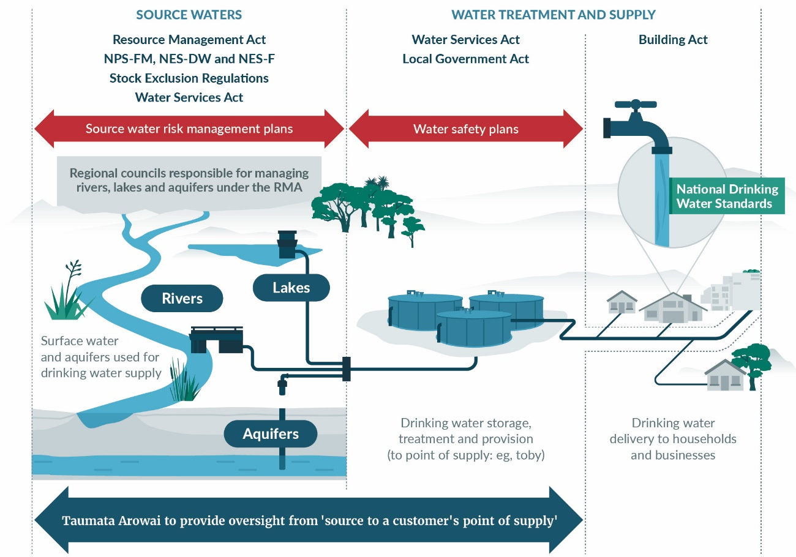

National direction for freshwater under the RMA
At the time it was made, the NES-DW was the sole national direction instrument for freshwater. However, it is now one of four national direction instruments aimed at improving freshwater management.
The National Policy Statement for Freshwater Management (NPS-FM) was first made in 2011 and further updated in 2020 as part of the Essential Freshwater programme, which aimed to stop further degradation of freshwater resources, reverse past damage, and address water allocation issues. Essential Freshwater also resulted in the making of the Resource Management (National Environmental Standards for Freshwater) Regulations 2020 (NES-F), and the Resource Management (Stock Exclusion) Regulations 2020, and sought public feedback on high-level proposals to amend the NES-DW. Of relevance to source water, Essential Freshwater:
- establishes Te Mana o te Wai as the cornerstone of New Zealand’s freshwater management system
- prescribes how regional councils must manage the cumulative effects of all activities that can affect freshwater through the NPS-FM. Drinking water supply is a compulsory value in source water catchments and the regional council must identify attributes to assess this value, set target states and identify limits on resource use, prepare an action plan, or impose resource consent conditions to achieve those target states. Amended regional plans must be notified before 2025
- aims to reduce nutrient and sediment inputs from farming activities to water and improves bacterial loadings in water due to stock through the making of the National Environmental Standard for Freshwater 2020 and Stock Exclusion Regulations 2020.
The NPS-FM, NES-F, and NES-DW work in parallel to direct regional councils on how to manage discharges, water takes, and land use. For example, the NPS-FM requires regional councils to determine what level of nitrogen in water bodies will meet their goals for freshwater, and to prevent further degradation through their plans. In parallel, the NES-F regulates a number of activities that pose risks to the health of freshwater and freshwater ecosystems.
Box 6: Te Mana o te Wai: the cornerstone of freshwater management
Te Mana o te Wai refers to the fundamental importance of water. It recognises that by protecting the health and wellbeing of our freshwater, the health and wellbeing of our people and environment is protected.
Te Mana o te Wai is based on six principles that inform how freshwater must be managed:
- Mana whakahaere: the power, authority and obligations of tangata whenua to make decisions that maintain, protect and sustain the health and wellbeing of, and their relationship with, freshwater.
- Kaitiakitanga: the obligation of tangata whenua to preserve, restore, enhance and sustainably use freshwater for the benefit of present and future generations.
- Manaakitanga: the process by which tangata whenua show respect, generosity and care for freshwater and for others.
- Governance: the responsibility of those who make decisions about freshwater to prioritise the health and wellbeing of freshwater now and into the future.
- Stewardship: the obligation of all New Zealanders to manage freshwater so that it sustains present and future generations.
- Care and respect: the responsibility of all New Zealanders to care for freshwater in providing for the health of the nation.
Te Mana o te Wai also introduces a hierarchy of obligations:
- the health and wellbeing of water bodies and freshwater ecosystems
- the health needs of people (such as drinking water)
- the ability of people and communities to provide for their social, economic and cultural wellbeing.

Source water provisions of the Water Services Act
The WSA has replaced Part 2A of the Health Act and it requires everyone who has functions, powers, and duties under that Act to give effect to Te Mana o Te Wai. All drinking-water suppliers other than domestic self-suppliers must register with Taumata Arowai and prepare Source Water Risk Management Plans (SWRMP) to identify, manage and monitor risks to source water. Regional councils are required to contribute information to SWRMP, annually publish information about source water quality and quantity, and report to Taumata Arowai. They must assess the effectiveness of their interventions every three years.
The WSA provides 12 months for currently registered drinking-water suppliers to re-register and submit SWRMP (by November 2022). It allows four years for unregistered drinking-water suppliers to register (by November 2025) and seven years to submit SWRMP, unless an acceptable solution is adopted, or a general exemption granted. Taumata Arowai may issue an acceptable solution to provide an alternative approach for certain types of smaller water supplies, who do not have the capability or capacity to undertake comprehensive risk management planning (including SWRMP).
The WSA has also amended the RMA requiring resource consent decision-makers to consider risks and effects on source water for registered water supplies (new section 104G). New national standards for drinking water and operational compliance rules are also proposed, which will replace the DWSNZ.

The importance of the NES-DW for iwi/Māori
The Treaty of Waitangi (Te Tiriti) is the foundation of the Crown–iwi/hapū relationship with regard to freshwater resources. Addressing tangata whenua values and interests, including the involvement of iwi and hapū in managing freshwater, is key to giving effect to Te Tiriti.
National environmental standards cannot prescribe direct involvement of iwi/Māori in their implementation, as this would require broader amendments to the RMA. However, measures like the NPS-FM direct regional councils to actively involve tangata whenua in freshwater management and decision-making, through transfer or delegations of power, or joint management agreements. Through the NPS-FM, iwi and hapū are expected to have greater involvement in freshwater issues. As the NES-DW will be designed to fit within the wider NPS-FM framework, the requirements of the NPS-FM are expected to follow through to the NES-DW.
In parallel, the Crown and regional councils will need to engage with iwi and hapū with interests and settlements covering certain areas. This will ensure that policy implementation is consistent with the Crown’s commitments. It also reflects the Crown’s obligations under relationship redress, relationship agreement, and deed of settlement regarding engagement and policy development.
The proposed amendments to the NES-DW are not intended to affect Treaty settlements and arrangements. Officials have not identified any proposed changes that are inconsistent with resource management arrangements or rights established by specific Treaty settlement legislation.

Scope of the proposed amendments
Preferred solutions to amend the NES-DW are limited to the scope provided to national direction instruments under sections 43 and 43A of the RMA, and to the protection of source water. Any overriding policy direction or merging of freshwater national direction instruments will be considered as part of Resource Management System Reform.
Table 1: What is in and out of scope of the NES-DW?
In scope | - Review and amendment of the current NES-DW to ensure activities that pose risks to drinking water safety (including direct sources and activities that create pathways for contamination) are appropriately managed  - Consideration of the size/type of drinking water supply to which the NES-DW applies  - Support or guidance for implementation of an amended NES-DW
Out of scope | - Use of alternative new national direction instruments, such as national policy statements or regulations  - Amendments to other existing national direction instruments  - Water allocation for drinking water supply (including water bottling)  - Protection of water supplies used entirely for non-drinking water purposes eg, stock water or irrigation  - Access to water for drinking or related infrastructure  - Changes to how iwi/Māori are involved in RMA planning  - How water supplies/suppliers are regulated through the Water Services Act  - Any requirements of, or amendments to, the DWSNZ

Box 7: Resource management system reform
Following recommendations by the Resource Management Review Panel, the Government has initiated work to repeal the RMA and replace it with three new pieces of legislation:
- Natural and Built Environments Act
- Strategic Planning Act
- Climate Change Adaptation Act.
As part of this work programme, national direction instruments (including the NES-DW, NPS-FM, and NES-F) will be integrated into a single instrument provisionally known as the National Planning Framework (NPF).
The policy intent of existing instruments will likely be retained, to the extent that it aligns with the new purpose and principles of the proposed NPF. Any requirements of the NES-DW would likely be carried over into the new framework.

Section 2: Proposed changes to the NES-DW

Overview of the proposal
Changes to the NES-DW are proposed that will improve how risks to source water management are considered by making improvements in the following three areas:
- Proposal 1: How at-risk source water areas are delineated. This involves establishing scientifically derived methodology for mapping source water risk management areas (SWRMAs) for different types of water bodies (rivers, lakes and aquifers), based on the time it takes for contaminants to travel to a source water intake and the level of filtration or mixing before reaching the intake. A mechanism would also be included that would allow regional councils to propose ‘bespoke’ delineation, where appropriate.
- Proposal 2: How activities that pose risks to source water are regulated or managed. The overall aim is to ensure higher-risk activities are managed either through more stringent controls or direction where necessary, or through consistent consideration of source water effects.
- Proposal 3: Protecting all registered water supplies. It is proposed to expand the NES-DW to cover the same supplies as the Water Services Act (WSA), being all water suppliers other than domestic self-suppliers.
Box 8: springs and wetlands
‘Rivers and lakes’ are the primary types of surface water bodies, and ‘aquifers’ are the groundwater bodies, from which drinking water is sourced, and for which methodology to delineate SWRMA are based. However, both springs and wetlands may also be used as drinking water sources.
- Springs are formed when groundwater flows to the surface from an aquifer. There are several types of spring that can form, and these can occur in a variety of locations and surface settings eg, the side of a hill or in a low-lying valley.
- Wetlands are “permanently or intermittently wet areas, shallow water, and land water margins that support a natural ecosystem of plants and animals that are adapted to wet conditions” (RMA section 2).
Which approach will be taken by a regional council when mapping SWRMAs will depend on the characteristics of a given spring or wetland, eg, surface or groundwater default SWRMAs or a combination of both. A bespoke SWRMA is most suitable for these more complex sources.

Proposal 1: How at-risk source water areas are delineated

Issues
The existing NES-DW requires regional councils to identify certain activities ‘upstream’ of an ‘abstraction point’ and then determine whether those activities are likely to introduce or increase the concentration of contaminants in treated drinking water, beyond what is allowable in the DWSNZ. The Havelock North Inquiry (HNI) found the approach to be subjective, individual-based, and potentially costly on a case-by-case basis. It also found that it left too much room for interpretation, error, and inconsistency across regions.

Terminology
Regulations 7, 8 and 10 apply ‘upstream’ of an ‘abstraction point’.
Upstream, in relation to an abstraction point, means:
a. in the case of surface water (other than a lake), upstream of the abstraction point
b. in the case of groundwater, up-gradient of the abstraction point
c. in the case of a lake
i. anywhere within the lake that could affect the water quality at the abstraction point
ii. upstream of any river that could affect the water quality at the abstraction point
iii. upgradient of any groundwater that could affect the water quality at the abstraction point.
Abstraction point means a place at which water in the environment is abstracted for use in a registered drinking-water supply (for example, the place at which water is abstracted from a river, stream, or lake or from a groundwater source).
The HNI concluded that ‘upstream’ does not adequately capture contaminant transport in groundwater. Some activities downstream (or for groundwater, downgradient) of an abstraction point can impact source water. In catchments where ‘upstream’ is a substantial area, there is no guidance to narrow down the area of interest.
The HNI also found issues with the definition and interpretation of ’abstraction point’ because it is often unclear precisely where abstraction occurs. For example, opinions differ on whether an abstraction point is the screens in the casing of a bore, or whether it is in fact a wider area, such as the ‘zone of influence’.
To address these issues, the HNI recommended use of spatial zones to delineate risk. In our review of the NES-DW, we considered current regional council use of source protection zones. However, significant variation was found in the methods used to define those zones, and in applying restrictions in those zones. Many regional councils also noted challenges in reaching agreement on how best to define source protection zones for different types of water supply. Feedback from regional councils to date has also indicated that a national approach for defining at-risk areas would help to avoid protracted debate and litigation.

Locating registered water supplies
Under the (now repealed Part 2A Drinking Water) Health Act, drinking-water suppliers were required to register, but they were not required to provide details of the location from where water was sourced. Consequently, there has been no national database of this information available for regional councils to consistently identify the location of registered water supplies.
Regulations 7, 8 and 10 of the NES-DW only apply to water supplies registered under the Health Act, that service communities of over 500 people for more than 60 days per year. While some water takes are permitted by regional plans, most takes for communities of this size are likely be provided for by consent, so regional councils should generally be able to identify where those registered suppliers abstract source water.
Regulation 12 applies to registered water supplies to communities of over 25 people, in operation more than 60 days per year. Some of these smaller supplies are likely to take and use water within regional permitted activity rules, so there may be no record of their location of take available to consent authorities to inform their application of regulation 12.
It is noted the WSA has addressed the lack of abstraction point location data: all drinking-water suppliers, other than domestic self-suppliers, must register and provide details of the location of each abstraction point to Taumata Arowai. Suppliers currently registered under the Health Act must register under the WSA by November 2022, while unregistered suppliers have until November 2025 to register. Taumata Arowai will provide this information to regional councils to enable their mapping of at-risk areas.

Protection based on treated drinking water quality
The protections provided by Regulations 7, 8 and 10 are only applied should an activity be likely to impact the quality of treated drinking water. This is problematic because:
- it requires regional councils and resource users to have knowledge of existing water quality issues and treatment processes for individual supplies, and the skills to assess whether an activity might feasibly impact the quality of that water after it has been treated.
- the DWSNZ do not provide acceptable limits for all contaminants
- the approach potentially allows degradation of water which is inconsistent with the NPS-FM approach of at least maintaining (if not improving) water quality
- it inappropriately emphasises reliance on treatment processes as a solution to contamination.

Proposed changes

Establishing a default methodology for delineating source water risk management areas (SWRMAs)
It is proposed to amend the NES-DW by replacing the ‘upstream’ and ‘abstraction point’ definitions and reliance on understanding the likely quality of water after it has been treated, with a default methodology for delineating ‘source water risk management areas’ (SWRMAs) as a way to identify areas where activities have a higher likelihood of affecting source water.
The delineation of the SWRMAs would reflect risk of source water contamination based on the time for contaminants to travel to the abstraction point. These times also consider the time needed for some contaminants (eg, bacteria) to become inactive and volumes required for mixing in the source to reduce the contaminant concentration to a lower level, considering local and international best practice aimed at:
- providing immediate protection to source water at the abstraction point
- providing protection against medium and long-term risks
- protection against microbial and other types of contamination.
These risk-based areas will be used to establish if additional controls on activities are necessary. Three levels of SWRMA around each source water abstraction point would be established, as described in Box 9 and shown in figures 2 through 4 below.
Box 9: Default SWRMA zones
SWRMA 1 is the immediate area around the source water take where there is an immediate risk of contamination because there is very little time to respond to any contamination before it enters the water supply. Most activities will be restricted in this area.
- For rivers, it encompasses the river and its bed 1,000 metres upstream and 100 metres downstream of the intake, extending 5 metres into land from the river edge.
- For lakes, it encompasses the lake and its bed within a 500-metre radius of the intake, extending 5 metres into land from the lake edge.
- For aquifers, it encompasses land within a 5-metre radius around the intake (bore head).
SWRMA 2 is a larger area where activities need to be managed, to mitigate more medium-term risks of contamination. The size will vary because it is based on the time it takes for water to flow to the source.
- For rivers, it is the river and bed from where water travels to the intake within an 8-hour period.
- For lakes, it is the entire lake area, extending landward 100 metres, and includes tributaries (being the area from where water travels to the lake within an 8-hour period).
- For aquifers, it is the land area above where groundwater travels to the intake (bore) within a 1-year period, to a maximum of 2.5 kilometres.
SWRMA 3 is the entire catchment area for the source water. Persistent contaminants and cumulative effects of all activities within the catchment are the management focus in this area, and they are considered to be appropriately managed under the RMA. The proposed amendments to the NES-DW aim to clarify that consenting decisions must address source water risks.
Figure 2: Indicative SWRMA for rivers
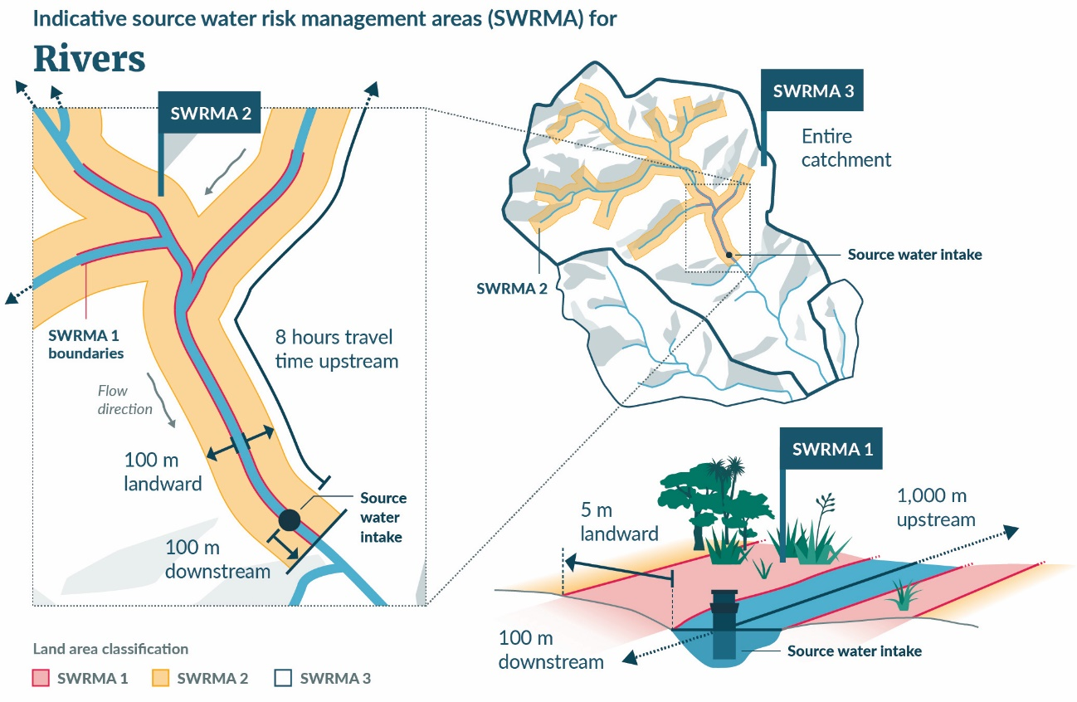
Figure 3: Indicative SWRMA for lakes
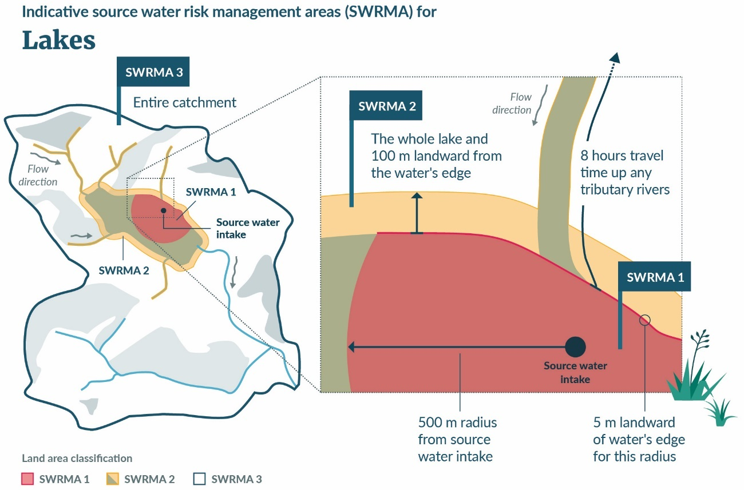
Figure 4: Indicative SWRMA for an aquifer
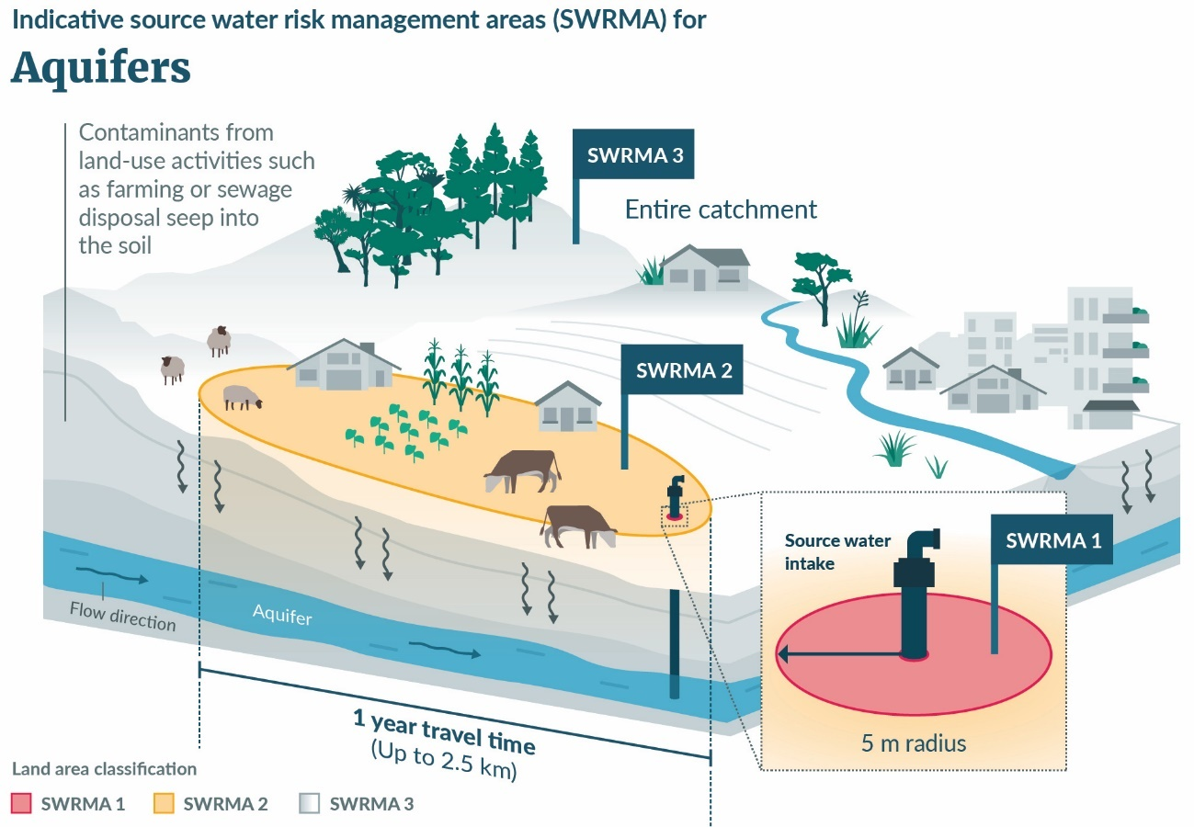
Appendix A includes indicative maps of where SWRMA 2 (encompassing SWRMA 1) would apply across New Zealand for both surface water and groundwater sources, based on currently registered water supplies.
Additional guidance materials for delineation of drinking water source protection zones are available in the Ministry for the Environment’s website:
- Technical guidelines for drinking water source protection zones
- Drinking water source protection zones: Delineation methodology and potential impacts of national implementation
- Guidelines for modelling Source Water Risk Management Areas.
Questions: the default method for delineating SWRMA
- Domestic and international evidence suggests that delineating three at-risk areas is a good approach for protecting sources of drinking water. Do you think this is a good approach for protecting our source waters? What other approach can you think of that could contribute to protecting our drinking water sources? Do you think that three areas (and therefore levels of control) are sufficient to protect our drinking water sources?
- In your view, is the method to determine each SWRMA, for each type of water body, the best option?
- Should other factors be considered in determining size?
- What challenges can you foresee in delineating SWRMAs?
- Do you have any comments or feedback on the detail contained in the technical guidance materials?
- Should SWRMA for all aquifers be bespoke so their unique features, depth and overall vulnerability can be considered?
- For lakes, do you agree that SWRMA 2 should include the entire lake area?
- What might be an alternative approach?
- SWRMA 1 for lakes and rivers is proposed to extend 5 metres into land from the river/lake edge. This contrasts with 3 metre setback requirement of the Resource Management (Stock Exclusion) Regulations 2020. SWRMA 1 is proposed to be used as a basis for controlling activities close to source water intakes, and applies to a wide range of activities. Do you think these differing setbacks will cause confusion or result in other challenges?
- There is evidence suggesting that a 10–30-metre radius around source water bores is a preferable way to delineate the area where activities would be heavily restricted (SWRMA 1). However, a 5-metre radius is the most workable option for the location of intakes in New Zealand.
- Do you agree that a 5-metre radius around a source water bore gives enough protection? Why or why not?
- If not, what alternative would you suggest?
- While water takes from complex spring systems or wetlands may require a bespoke SWRMA to ensure consideration of any contamination pathways present, a default method is necessary to ensure interim protection. Do you think a default method is practicable in most situations?
- Do you think a regional council should determine (on a case-by-case basis) the most applicable default method for a river, lake or aquifer, or is a different default approach necessary?
- If so, what alternative would you suggest?
Questions: regional council mapping of SWRMAs
- How long do you think is necessary for regional councils to delineate SWRMAs for currently registered water supplies in each region using the default method?
- What challenges do you foresee in delineating SWRMAs, when previously unregistered supplies are registered with Taumata Arowai (see Proposal 3 for more details)?
- What support could enable regional councils to delineate SWRMAs within shorter timeframes?
- Do you think consideration should be given to mapping currently unregistered supplies as they register (but before the four-year deadline provided under the Water Services Act), or do you think that waiting and mapping them all at the same time is a better approach?

Establishing a bespoke methodology for delineating SWRMAs
It is also proposed to include a mechanism in the NES-DW that allows regional councils to establish ‘bespoke’ SWRMAs, where appropriate. This would cover scenarios where the default SWRMA would not give enough protection (eg, conjunctive sources, such as a gallery intake in shallow gravels adjacent to a river) or where it would unnecessarily restrict land use (eg, where data and evidence show there is adequate protection).
As part of this proposal, the NES-DW may specify minimum requirements, and is supported by guidance on the methodologies for defining these bespoke SWRMAs. A bespoke approach may be proposed at any time; however, the default approach would apply until any bespoke approach is formally established.
Question: the bespoke method for delineating SWRMAs
- If a regional council has already established local/regional source water protection zones through a consultative process, should there be provision to retain that existing protection zone as a bespoke method without further consultation or consideration against new national direction?

What does this mean in practice?
This proposal would require regional councils to map the default SWRMA for all registered drinking water supplies in their region. It is anticipated this would occur in two main phases:
- following completion of re-registration of drinking-water suppliers under the WSA (who must do so by November 2022)
- following initial registration of all unregistered drinking-water suppliers (who must do so by November 2025).
Once the two phases of mapping are completed, newly created drinking water supplies would require mapping immediately following their registration with Taumata Arowai.
Where the default method is used, there would be no requirement for regional councils to consult on the SWRMAs through the RMA Schedule 1 process. SWRMAs would be formalised through the gazette process and published on the regional council’s website.
Regional councils wishing to adopt bespoke SWMRAs may need to use the full RMA Schedule 1 process and seek approval from the Minister for the Environment, so these areas can be gazetted.

Proposal 2: How activities that pose risks to source water are regulated or managed

Issues
The scope of the NES-DW controls on activities that may adversely affect source water is limited, effects on source water are not consistently or appropriately addressed, and water suppliers may not be involved when activities pose a risk to source water.

Scope of activities covered
In consent processes under the current NES-DW, regional councils are only able to decline consents for discharges, and taking, damming, or diverting water, where those activities contribute to large supplies breaching national drinking water standards after treatment. Those restrictions can only be applied during consent applications, and not to existing activities. Regional councils also cannot permit activities where those activities contribute to large supplies breaching national drinking-water standards.
This is a problem because:
- contaminants may also come from other activities such as earthworks, borehole drilling, and riverbed disturbance, potentially including some that are controlled in district or city plans. Those activities may be new or existing
- the current settings rely on the expertise of regional council staff to put adequate protections in place. However, this is a specialist skill, and the expertise and data are often not readily available. As a result, source water does not get enough attention, and safe supply relies on treatment processes to address contamination
- the DWSNZ does not identify or provide acceptable limits for all contaminants
- the approach potentially allows degradation of water which is inconsistent with the NPS-FM approach of at least maintaining (if not improving) water quality, and it inappropriately emphasises reliance on treatment processes as a solution to contamination.

Groundwater bore management
The HNI, and our ongoing engagement with communities and water suppliers, have highlighted issues around how groundwater bores are constructed and managed.
Groundwater is often accessed through bores (also known as ‘wells’), which are generally constructed by drilling into the aquifer and installing the following components:
- casing: the tube-shaped structure that maintains the ground opening and keeps dirt and unwanted water out
- screen: the tube-shaped structure attached to the bottom of a casing that allows groundwater from the aquifer to enter the bore, while keeping sediment out
- bore head: the structure at the ground surface, that secures bore access
- pumping equipment: used to draw water from the aquifer to the surface (where natural artesian pressure is inadequate to do so).
New Zealand Standard (NZS) 4411:2001 Environmental Standard for Drilling of Soil and Rock contains specifications for drilling, bore design and construction, production testing, and record keeping. NZS are generally considered ‘best practice’, but they are not a legal requirement unless specified by relevant regional rules or resource consent conditions.
However, the HNI noted issues with NZS 4411:2001:
- they do not contain useful details for drinking water bores
- they do not effectively require proof of sealing
- the process for judging bores satisfactory is unclear, as are the required qualifications of the person carrying out the assessment

- below-ground bore heads pose an unacceptable risk, but are not prohibited or even mentioned
- the monitoring requirements for deep bores are deficient.
In addition to allowing access to groundwater within an aquifer, a poorly drilled, constructed or maintained bore (or other earthworks over a vulnerable aquifer) can provide a preferential pathway for contaminants to enter the aquifer, either from the surface or from other overlying shallow groundwater.
In New Zealand, there are many historically constructed bores. While some may still be in regular use, many are now disused or forgotten. Those bores are of unknown construction quality and security and pose a risk to groundwater quality.
In Havelock North, contaminated surface water entered the aquifer, either via a nearby pond that was linked to the aquifer, nearby disused bores or via the insecure headworks of the drinking water bore itself. The aquifer was also found to be penetrated by a significant number of disused or uncapped bores, and the confining (or semi-confining) layer above the aquifer (the aquitard) had been affected by earthworks at a neighbouring property, leaving it vulnerable to entry by contaminated water. The HNI recommended a prohibition on new below-ground bore heads, and that a comprehensive review of NZS 4411:2001, regional plans, and current consent conditions be undertaken (as well as a review of the DWSNZ, building consent conditions and water suppliers’ polices and standards).

How effects on source water are considered and addressed
For activities that are controlled or restricted discretionary, if effects on source water or water quality are not identified in the matters of control or discretion, then those effects cannot be considered. However, the WSA has recently amended the RMA to require consenting authorities to consider risks and effects on source water for registered water supplies (new s104G). Whether those considerations extend to controlled or restricted discretionary activities is not explicit.
Because of the scope and complexity of the NES-DW, there is inconsistency in how effects on source water are considered, and whether appropriate consent conditions are imposed. A proactive and preventative approach to source water risk may not be taken. There is evidence that some consent authorities consider application of the NES-DW a regional council function.

Water supplier involvement in RMA processes
There is no express requirement under the NES-DW for water supplier (or drinking water regulator) involvement consent applications, or in developing plan rules, meaning they may not be aware of the risk to their supply, or able to provide input on how others propose to manage that risk. This is inconsistent with drinking water safety Principles 5 and 6: that suppliers must own the safety of drinking water, and a preventative risk management approach should be taken.

Proposed changes
To improve how activities that pose risks to source water are regulated or managed, the following matters are being considered:
- restricting activities in the immediate vicinity of source water intakes (SWMRA 1), while enabling water suppliers to undertake intake management
- removing any permitted activity status for high-risk activities within SWRMA 2
- improving bore management, and land disturbance over vulnerable aquifers, to ensure potential adverse effects on groundwater are managed
- ensuring risks to source water are considered for all activities within SWRMA, with appropriate conditions imposed
- incentivising engagement with water suppliers.
Feedback is being sought on the appropriate degree of national direction necessary for activity management within SWMRAs.

Controlling activities in SWRMA 1
Box 10: SWRMA 1
SWRMA 1 is a localised area immediately around the source-water intake, of highest short-term risk:
- for rivers it encompasses the river and its bed 1,000 metres upstream and 100 metres downstream of the intake, extending 5 metres into land from the river edge
- for lakes it encompasses the lake and its bed within a 500-metre radius of the intake, extending a 5-metre buffer from the lake edge
- for aquifers it encompasses land within a 5-metre radius around the abstraction point (bore head).
For any person other than the drinking-water supplier, consideration is being given to placing stringent controls on activities in SWRMA 1, to avoid, or where necessary, mitigate, adverse effects on source water. The proposed activities to which controls would apply are:
- land uses including drilling of bores and earthworks over vulnerable aquifers
(RMA section 9)
- uses of the beds of lakes and rivers (RMA section 13)
- all restrictions on water (RMA section 14)
- discharges, excluding to air (RMA section 15).
When undertaken close to a source water intake, these activities present a contamination risk to source water. Controls would apply to all new activities, and new applications for consent subject to a short transition period. Retrospective application of these requirements to existing activities within SWRMA 1 is discussed further in relation to risk management, below.
In SWRMA 1, resource users should consider if any activity is essential, and if alternatives are available (including moving the location of the activity beyond SWRMA 1). Consideration is being given to prohibiting certain activities and using non-complying or discretionary activity status where a consent option may be required in SWRMA 1.
For water suppliers, abstraction point maintenance is necessary, and in applying greater restrictions for other resource users around the intake, allowances must also be made for water suppliers to undertake any necessary work on their abstraction point and associated infrastructure to support the provision of safe drinking water.
Questions: SWRMA 1 controls
- Do you think national direction on activities within SWRMA 1 is necessary?
- If so, what activities should it address?
- How restrictive should controls be in SWRMA 1, for resource users other than water suppliers?
- Are there any activities you believe should be fully prohibited in this area?
- Are there any activities you believe should be permitted or specifically provided for or acknowledged in this area?
- For water suppliers, are there any other activities beyond intake maintenance/management that should be provided for?
- In and around freshwater, control of pest species (including aquatic pest species) may be necessary, including through physical control (removal, that may include bed disturbance) or chemical control (discharge).
- How much of an issue is this in and around abstraction points?
- How critical is that work?
- How often is this work mandated by other regulation or requirements?
- How frequently is this work undertaken by parties other than the drinking-water supplier (or their contractors)?

Restricting high-risk activities in SWRMA 2
Box 11: SWRMA 2
SWRMA 2 is a larger area around the abstraction point based on the time it takes for water to flow to the source, where activities need to be managed to mitigate more medium-term risks:
- for rivers it is the area from where water travels to the intake within an 8-hour period
- for lakes it is the entire lake area, extending landward 100 metres, and includes tributaries (being the area from where water travels to the lake within an 8-hour period)
- for aquifers it is the land area above where groundwater travels to the intake (bore) within a
1-year period, to a maximum of 2.5 kilometres.
The highest-risk activities to source water in SWRMA 2 are direct discharges to water, and land disturbance over vulnerable aquifers including the drilling of bores and earthworks (discussed further below).
Regional councils already control activities under their regional plans, and any activity whose environmental effects have been determined to be likely more than minor will require consent.
Within SWRMA 2, the intent is to ensure:
- no regional council permits activities that pose a high-risk to source water. Activities that have been identified as potentially high-risk within SWRMA 2 are direct discharges of contaminants to water, and land disturbance over vulnerable aquifers (being the drilling, construction and maintenance of bores, or earthworks that damage aquitards). Vulnerable aquifers are discussed further below
- that all consenting in this area actively consider the effects of the activity on source water.
Should national direction on controls within SWRMA 2 be given, the requirements would apply to all new activities, and new applications for consent, subject to a short transition period. Retrospective application of any new requirements to existing activities within SWRMA 2 is discussed further in relation to risk management, below.
Questions: SWRMA 2 controls
- Do you think national direction on activities within SWRMA 2 is necessary?
- If so, what activities should it address?
- In your view, how much will this proposal impact the current situation in your region?
- What discharges to water are currently permitted?
- Should provision be made to continue to permit those activities? What controls are typically used to ensure potential adverse effects are managed?
- Are there any other activities that should not be permitted within SWRMA 2?
- The original intent of SWRMA 2 was to manage microbial contamination. However, there are indications that protections against other contaminants may be required. What contaminants do you think should be controlled in SWRMA 2?
- What other challenges do you see when making a consent application within SWRMA 2?

SWRMA 3 considerations
No additional restrictions are proposed in SWRMA 3, as current requirements under the RMA are considered adequate. The proposed amendments to the NES-DW will simply clarify that the effects of any activity on source water must be considered in a catchment used for source water.
Question: SWRMA 3 controls
- Do you think any additional controls, other than broad consideration of the effects of the activity on source water, are required in SWRMA 3?

Improve land-use controls over aquifers – groundwater bores and earthworks
To improve land-use controls over aquifers, and in particular SWRMA 2, consideration is being given to:
- ensuring an appropriate quality standard applies to the drilling, construction, and maintenance of bores
- addressing existing bores whose quality of construction is unknown, or known to be of a poor standard, or that are disused
- prohibiting below-ground bore heads.
A national environmental standard can prescribe technical standards directly, or through incorporation by reference of a quality standard. If NZS 4411:2001 is to be used, it requires updating to ensure the concerns identified through the HNI are addressed. This would be through a process separate to, but aligned with, the NES-DW (and WSA).
Questions: groundwater bore management
- What is your view on how to address issues with bores – should it be enough to amend the NZS 4411:2001 (with reference to that standard in the NES-DW), or should greater direction be given in the NES-DW itself?
- For existing bores:
- What is your view on requiring unused bores to be decommissioned?
- Should bores of poor quality be required to be upgraded or decommissioned? What timeframe might be reasonable to do this?
- For many older bores there are no records. What sort of evidence could be used to support the ongoing use of these bores, or demonstrate they pose a low risk to the security of the aquifer?
- What is your view on prohibiting below-ground bore heads?
- Regional councils are responsible for control of the use of land for the purpose of maintenance and enhancement of the quality of water in water bodies (RMA section 30(1)(c)(ii)). Do you think territorial authorities have a role in land management over aquifers, and if so, what is that role?
Some shallow aquifers are more susceptible to earthworks, which like bores, can disturb an aquitard and provide a preferential pathway for contaminants into groundwater. Feedback is being sought on the most appropriate ways to ensure vulnerable aquifers are identified, and earthworks are controlled.
Questions: identifying and managing activities over vulnerable aquifers
- It is not clear which approach might be best for ensuring risk to vulnerable aquifers is appropriately managed. Do you think that an NES-DW is the right tool for addressing this? If not, what approach might be better?
- Would it be helpful if guidance on vulnerable aquifers was provided to support freshwater planning as the NPS-FM is given effect?

Ensure risks to source water are considered for all activities within a SWRMA, with appropriate conditions imposed

Existing activities
Should controls be imposed in SWRMA 1 and SWRMA 2, there will be some existing activities lawfully occurring that:
- may no longer be permitted eg, discharges of contaminants
- have ‘existing use rights’ eg, bores drilled and constructed many years ago
- have a consent, but the consent may not adequately address current effects on source water (and those consents do not expire for many years) eg, diversion or damming of water.
Consideration is being given to retrospectively applying the requirements of the NES-DW to those activities where effects on source water are ongoing and require addressing. Section 128 of the RMA allows water and discharge permits, and land-use consents granted by a regional council to be reviewed when an NES has been made.
There can be considerable challenges in retrospectively applying an NES, particularly where an activity is long established, and the activity may have been there before any registered water supply. However, there can also be benefits. For aquifers, existing bores have been identified as a potentially significant risk to groundwater quality.
Questions: retrospective application of the NES-DW to existing activities
- What activities do you believe the NES-DW should retrospectively apply to / not apply to, and why?
- In your view, what are the key challenges and benefits to retrospective application?

Matters of discretion when considering effects on source water
The WSA has amended the RMA to include new section 104G, which requires consenting authorities consider risks and effects on source water for registered water supplies. It is not explicit whether those considerations extend to controlled or restricted discretionary activities and amending the NES-DW provides the opportunity to clarify that matter.
To support full and consistent consideration of effects on source water, new criteria are proposed as matters of discretion to apply to all consent decisions within SWRMA. The matters of discretion are:
- type and scale of activity, and the potential for releasing contaminants into the environment that may affect source water
- the need for, and the adequacy of, operational and contingency measures to prevent the release of contaminants, and the response in the event this occurs
- the potential pathways for contamination to move from the activity site to an abstraction point, including the likely pathway and expected travel time
- the effect of the activity on contamination pathways that may reach the abstraction point, including whether the activity could create new pathways or shorten existing ones
- the degree to which the water supplier’s source water risk management plan under the WSA addresses the activity
- the potential risk to source water
- whether the consent is for renewal of an existing consent, and the proposed activities present the same or less risk to water sources than the activities for which consent is expiring
- the need for the activity to be within the SWRMA, and alternative options available
Question: criteria when considering effects on source water?
- Do you agree with the proposed list of criteria?
- Are any additional criteria needed, or clarifications?

Proactive response planning
Consideration is being given to the need to require proactive emergency response planning for certain activities within SWRMA that have the potential to significantly affect source water in the event of an accident or emergency, or natural event.
In those circumstances, consent holders would be required to prepare a risk management / emergency response plan documenting how they would manage the risks of accidental contamination. Consent holders would be required to have this plan reviewed by a suitably qualified professional, and to give a copy of the plan to the relevant council. Consent holders would be exempted from developing a separate plan if they are already required to prepare one for the same activity under another piece of legislation, such as the Health and Safety at Work Act, or the Hazardous Substances and New Organisms Act.
All council consenting authorities, including territorial authorities, should be applying this requirement where necessary. It is proposed to better identify the types of activities this requirement should be considered for and applied to, thus providing better clarity for any role of territorial authorities in implementing the NES-DW. Implementation guidance and support for territorial authorities will also be provided as necessary.
Questions: proactive response planning
- What types of activity might pose a significant risk to a water supply in an accident, emergency, or other natural event?
- Do you think it is reasonable to require all activities with some potential to affect source water to undertake response planning, or just those with a higher risk (likelihood and consequence)?

Water supplier involvement
To support water supplier ownership of the safety of drinking water, it is proposed to incentivise their involvement in consent processes. This change would not preclude any other requirements on applicants to engage with potential affected parties or iwi/Māori with statutory acknowledgement.
It is proposed to allow consent applicants to avoid notification of their application (and its associated costs). This would apply if they get written approval from the water supplier for the proposed activity. This process would be set through sub-section 43A(7) of the RMA. The aim is to encourage applicants to engage directly with the water supplier before applying for a consent.
The WSA imposes duties on water suppliers to provide safe water to the community they serve, and therefore there is no need to consider the community they serve to be potentially affected in consent applications.
Consent applications for SWRMA 1 and 2 may still be subject to public or limited notification for another reason, as determined by regional councils when following the process in section 95 of the RMA. For example, if the activity is on land that is subject to statutory acknowledgment, this may require limited notification of the iwi authority, regardless of the proposed NES-DW provisions.
Questions: water supplier involvement
- Do you agree that resource users should engage with water suppliers in consenting matters, within SWRMA 1 and 2?
- What hurdles do you see in promoting this engagement with water suppliers?
- What support might small water suppliers need to effectively engage in the consent process?

What does this mean in practice?
Should national direction be given for controls on activities within a SWRMA, regional councils will need to update their regional plans and procedures to ensure their planning frameworks are consistent with the NES-DW and risks to source water are considered in consent decisions.
For any new activities restricted in SWRMA 1, resource users would need to consider alternatives to undertaking that activity, in that location. Where there is no practicable alternative and the activity is necessary, a consent application may be made.
For new high-risk activities in SWRMA 2, eg, the discharge of contaminants to water, or drilling and construction of bores, resource users may now require a resource consent if their regional council previously permitted this activity.
All consent applications and decisions on consents must assess effects on source water, and resource users will be incentivised to engage with water suppliers about their activities and risk management approaches.
For any activities where retrospective application of the NES-DW is applied, regional councils may review those activities under section 128 RMA. Bores are a particular focus, and owners of any poor-quality bores may be required to rectify issues or decommission the bore.
For certain activities with the potential to significantly affect source water in the event of an accident or emergency, or other natural event, resource users will be required to document their intended response, including contacting the water supplier, in a written plan.
Questions: general matters relating to managing source-water risks
- A National Environmental Standard is a regulation under the Resource Management Act 1991 (RMA) that requires, among other things, that regional councils make changes to their regional plan rules. Making these changes can add costs (eg, financial, administrative) for regional councils.
- In your view, how might regional councils be affected by the NES-DW’s new requirements to change regional plan rules?
- Do these effects outweigh the expected benefits of better source water protection?
- In your view, how could the amendments to the NES-DW better align with farm plans?
- Is reliance on the NPS-FM, NES-F and Stock Exclusion Regulations enough to manage the long-term effects of farming activities on underlying aquifers and water bodies?
- Can you identify potential duplication between the NES-DW and other regulations that control land use?
- If you are a water supplier, do you think these amendments will affect your ability to supply water (positively or negatively)? Would they influence whether you continue to provide water?
- If you are a resource user, do you think these amendments will affect how you currently use your land or undertake activities? Will you have to change how you do things as a result?

Proposal 3: Protecting all registered water supplies

Issues
The main protections of the NES-DW currently only apply to activities that could affect a registered drinking water supply that serves no fewer than 501 people for not less than 60 days in a calendar year.
The WSA has expanded the drinking water regulatory system to include all supplies other than domestic-self suppliers. The new drinking water regulatory system under the WSA is intended to work and align with RMA provisions for freshwater management.

Proposed changes
To achieve an improved drinking water regulatory system, it is proposed to apply the source water protections of the NES-DW to all registered drinking-water supplies to align with the WSA. This will be achieved through a staggered approach that aligns with the transition timeframes in the WSA, being:
- 12 months for currently registered supplies to re-register (by November 2022)
- four years for unregistered supplies to register (by November 2025).
After currently unregistered water supplies become registered with Taumata Arowai, the protections of the NES-DW will extend to them. Inclusion of currently unregistered water supplies poses logistical challenges because:
- the number of these small supplies is estimated to be over 75,000
- there is a lack of data about the specific traits and location of unregistered supplies
- regional councils will have to map SWRMAs for every small supply, creating an extra administrative burden.
To address these challenges, a staged approach over several years is proposed. In practice, this approach would work like this:
- Step 1: water supplies will need to register (if they are currently unregistered) or re-register (if they are already registered) with Taumata Arowai. Currently registered supplies will have 12 months to do this, whereas unregistered ones will need to apply to register within four years.
- Step 2: once source water location data is made available by Taumata Arowai, regional councils will be required to map source water protection areas (as per Proposal 1). Options for formalising delineated areas are still being considered, but may include changes to regional plans through Schedule 1 of the RMA, and alternative gazettal processes prescribed by the NES-DW.
- Step 3: regional councils will need to update regional plans to remove any rules that duplicate or conflict with the provisions of the NES-DW.
- Step 4: regional councils and territorial authorities apply the amended NES-DW requirements in the consent process.
This approach would allow time for regional councils and the Government to work together on methods for defining SWRMAs that can be applied at scale.
Table 2 summarises the requirements and application of the current NES-DW against the proposed amended NES-DW.
Table 2: Comparison between current and proposed NES-DW requirements and application
Water-supply category | Current NES-DW | Amended NES-DW
Large-medium-minor  more than 500 people | Regional councils cannot grant certain water or discharge permits or permit activities that would cause or exacerbate a drinking water supply breaching the DWSNZ  Any consent authority must include an ‘emergency notification provision’ on certain consents  Regulations 7, 8, 10, 12 | Regional councils would be required to map SWRMA for all currently registered water supplies, following their re-registration with Taumata Arowai, by November 2022. Taumata Arowai will supply abstraction point data to regional councils to allow mapping to occur.  Anticipating a new NES-DW to come into effect by late 2022 supports regional council’s inclusion of SWRMA maps in new freshwater plans by December 2024.  New controls within SWRMA would apply once SWRMA mapping has been formalised, and a short transition period would likely be provided.
Small-neighbourhood  25–500 people | Any consent authority must include an ‘emergency notification provision’ on certain consents  Regulation 12 | If the drinking water supply is currently registered, the amended NES-DW would apply as per large supplies.
Neighbourhood – specified self-supplier | The NES-DW does not currently apply | If the drinking water supply is currently unregistered, those water supplies have until November 2025 to register with Taumata Arowai under the WSA, where they will provide abstraction point data. Taumata Arowai will supply this data to regional councils to allow mapping to occur.  Regional councils would then commence mapping of these supplies. Given the large estimate of unregistered water supplies, it is uncertain how long mapping might take. The earliest SWRMA mapping might be completed is late 2027.  The associated controls within SWRMA could not apply until after mapping has been formalised.

Questions: which water supplies should be protected by the NES-DW
- Do you think the protections of the NES-DW should apply to all registered water supplies?
- If not, what types of supplies should be excluded, and why?
- The WSA has a registration timeframe of four years for currently unregistered supplies.
- Do you agree with aligning application of the NES-DW with the WSA? If not, why?
- In your view, what are the challenges resulting from including these newly registered supplies within the NES-DW framework?

What does this mean in practice?
As the smaller, currently unregistered water supplies register with Taumata Arowai, and SWRMAs are mapped by regional councils, controls will be imposed in those SWRMA, affecting local resource users.
There is uncertainty about currently unregistered water supplies: their type (surface or groundwater, or rainfall), number and location. The land area affected is currently unknown.

Section 3: Impacts of amending
the NES-DW

An amended NES-DW would clarify source water requirements
The amendments aim to clarify the areas and activities where risks to source waters must be considered and managed. Some councils will likely have to consent or refuse activities in certain areas where they were previously permitted. The current approach of allowing these activities to occur, or without consideration of source water effects, is putting the drinking-water supply at risk.

How will an amended NES-DW affect stakeholders and iwi/Māori?
The roles and responsibilities of various stakeholders and iwi/Māori under an amended NES-DW are summarised in Table 3.
Table 3: How the amended NES-DW will affect stakeholders and iwi/Māori
Group | Roles and responsibilities
Iwi/Māori | - Iwi/Māori have various roles under an amended NES-DW, including as water supplier, and resource user (see below).  - Iwi/Māori also have an obligation as kaitiaki to preserve, restore, and enhance freshwater for the benefit of present and future generations.  - Consultation is intended to improve understanding of how an amended NES-DW could impact iwi/Māori.
Regional councils | - Mapping SWRMAs for all registered water supplies in their region, including engagement with water suppliers and other parties to help validate the delineation of SWRMAs and updating regional plans.  - Updating operational procedures to ensure the NES-DW is being applied to applicable consenting decisions and considered as part of compliance, monitoring and enforcement activities.  - Informing and educating resource users of the requirements of the NES-DW and any previously permitted activities now requiring a consent (noting a transition period will be provided for).
Territorial authorities (as consent authorities) | - For any relevant land use restrictions, or other activities where proactive emergency response planning should be applied, updating operational procedures to ensure the NES-DW is being applied to applicable consenting decisions, and associated information and education of resource users.
Water suppliers | - Permitted to undertake certain activities around their source water abstraction point, that support the provision of safe drinking water.  - Asked by resource users or regional councils, for greater involvement in consent applications where a risk to source water is identified.
Resource users | - Activities continue to be controlled under the RMA, regional/district plans, and through any national direction including the NES-DW.  - Restricted from certain activities very close to source water abstraction points (SWRMA 1).  - New consents may be required for high-risk activities in a broader area around the abstraction point (SWRMA 2) depending on how well their regional council previously regulated those risks.  - Must consider the effects of their activity on local registered drinking water supplies, and are encouraged to engage with water suppliers when considering how to avoid, remedy, or mitigate effects.
Central government | - Taumata Arowai to facilitate access to information on water supplies as contained in the national drinking water supply register, including location of abstraction points and information on risks to source waters (as identified in SWRMPs).  - Ministry for the Environment to provide support and guidance for councils to undertake mapping of SWRMAs.  - Ministry for the Environment to provide guidance on assessing risks to source water in consenting decisions in accordance with the requirements of the NES-DW.

How will the NES-DW work with source-water provisions in the WSA and other freshwater national direction?
Under the new drinking-water regulatory regime, the NES-DW works alongside source water provisions in the WSA, and other freshwater direction under the RMA. The actions required of water suppliers, resource users, and regional councils are summarised in
Table 4. The flow diagram in Appendix B illustrates the relationships between each party, and how information is used to refine planning requirements. As noted above, iwi/Māori also have an obligation to preserve, restore, and enhance freshwater for the benefit of present and future generations (not otherwise shown in Table 4 or Appendix B).
Table 4: Source-water roles and responsibilities
 | Water supplier | Regional council | Resource user
Water Services Act – source water | Prepare a SWRMP based on supply scale, complexity, and risk and monitor source-water quality, unless an acceptable solution has been adopted or supplier has been granted a general exemption. | Provide information to water suppliers on activities, risks or hazards, and water quality data.  Undertake appropriate actions to address source-water risks or hazards.  Report on source-water quality and quantity, and the effectiveness of interventions. | Not applicable.
RMA – national direction | Have regard to any values set under the NPS-FM in the SWRMP. | Update regional plans to reflect requirements of NPS-FM and NES-DW. | Have regard to any values set under the NPS-FM in the SWRMP.
RMA – resource consent | Permitted to undertake certain low-risk activities around intakes to support provision of safe drinking water.  Invited to be involved in the consent process where a risk to source water is identified. | Consider risks to source water in decisions.  Provide information and advice to resource users on the consent process.  Notify drinking water suppliers in the event of an accidental contamination event/spill. | Consider the effects of their activity on local registered drinking water supplies.  Restricted from activities very close to drinking water intakes (SWRMA 1).  Consent required for high-risk activities in a slightly broader area around the intake (SWRMA 2).  Consider how to avoid, remedy, or mitigate effects.  Encouraged to engage with water suppliers.  Prepare an emergency response plan to address risk of accidental contamination (where applicable) and notify regional council of any spill.
Mitigations to the impacts of new requirements | Taumata Arowai to provide guidance on developing SWRMP and accessing information from regional councils.  Funds available to help marae and non-council suppliers to meet regulatory requirements.  Phased approach to registration and when compliance is required. | Proposed approach to compliance rules for information sharing with water suppliers focused on enablers building on current channels (eg, existing web alert systems).  Phasing SWRMA mapping to align with WSA, will consider practicalities of mapping and formal establishment.  Consent considerations limited to registered water supplies. | SWRMA information available, and SWRMP provided, to aid assessment of environmental effects for consent applications.  Water supply location identified, and supplier contact details available.  Ministry for the Environment and regional councils to provide guidance on consenting expectations and addressing effects on source water.
Benefits | Enabled to undertake activities to support a safe drinking water supply without consent (eg, intake maintenance or reinstatement).  Information about RMA activities more readily available.  Avoided costs in investigating source contamination and finding new water supplies. | Clarity and national consistency in how source water risk is addressed through the consent process.  Any deficiencies in regional plans addressed.  Increased knowledge of water supplies in region as registration progresses.  Improved public health outcomes at regional level.  Avoided costs in investigating source contamination. | Improvements in public health, wellbeing and environmental outcomes.  Clarity and national consistency in how source-water risk is addressed through the consent process.

What are the anticipated outcomes?

Better water management benefits the environment
Better source water protection means that the health of our water bodies will gain precedence over other elements in the drinking water system. The proposed amendments will help councils maintain freshwater and groundwater quality, particularly in catchments that also serve as drinking water sources.
Some contaminants, such as nitrates, persist for a long time in the environment. Once an aquifer has been contaminated beyond a certain level, the treatment options are both expensive and complex. Minimising contaminants in our aquifers in the first place will reduce future costs of investigating and dealing with cumulative contamination and emerging contaminants.
Protecting waterways also brings certain ecosystem health and climate-related benefits that are not relevant to these proposals, but could be a by-product of the amendments. These positive effects are not included below, but it is worth considering the broader advantages of managing risks to our source water.

Protecting water upholds our Treaty partnership
There are difficulties in quantifying benefits that fully reflect the aspirations and expectations of iwi/Māori. The proposed amendments are designed to contribute to Te Mana o te Wai, and to the spiritual and theological aspects of iwi/Māori water use and access. The amendments are expected to enhance Māori customary activities such as mahinga kai (gathering food), and the centrality of freshwater’s mauri (vital essence).

Reducing risk improves health and lowers costs
Improved source water management is anticipated to lead to reductions in preventable waterborne diseases, such as diarrhoeal diseases, cholera, typhoid and others. Diarrhoeal diseases include those caused by Campylobacter, E. coli and Cryptosporidium, and account for an annual 1.5 million deaths globally. About 58 per cent of that burden is in low and middle-income countries. These diseases are therefore seen as preventable in countries such as New Zealand.
Inadequate water, sanitation and hygiene (WASH) is the main factor in these infections. It is estimated that in New Zealand, cases of campylobacteriosis can be found in 150 per 100,000 people. While cases have improved following strengthened food safety regulation passed in 2007–08, infection cases remain issues of concern.
A key remaining risk factor is unsafe drinking water. Better risk management for water sources could prevent a future Havelock North incident, and reduce our annual average infection rates, with an aim to preventing these infections altogether.
Rates and factors related to waterborne disease include:
- In 2019, 537 cases of campylobacteriosis, 140 cases of cryptosporidiosis and 211 cases of giardiasis where drinking water was a risk factor were notified. These are likely underestimated due to poor reporting of risk factors (ie, reporting the potential causes of the infection) by district health boards (DHBs).
- Waterborne outbreak incidents are not rare events in New Zealand. A study published by the Ministry of Health documents 25 waterborne outbreaks between 1984–2006.
- Notification rates for waterborne diseases are higher for children aged 0–4. Children can be more susceptible to disease and health effects from elemental pollution of water sources (eg, lead). Minimising these risks to children will not only have immediate benefits (fewer children catching preventable waterborne diseases) but could also improve health long term, by reducing exposure during these critical developmental stages.
- Better management of source water risk through the NES-DW, combined with enhanced monitoring requirements in the WSA, will lower the risk of pollution of water sources.
Although some people will recover quickly from waterborne disease, some have long-term health consequences, such as when campylobacter infection leads to reactive arthritis, Guillain-Barré syndrome or irritable bowel syndrome. Reducing the risks of waterborne disease reduces the chance of these long-term impacts, which can put personal and financial burdens on people.
Notification rates of waterborne diseases vary by DHB. Some of this may be due to DHBs not completing a full assessment of risk factors, but case studies show that the management of risks to source water under the existing NES-DW varies by region.
Clarifying and strengthening the NES-DW will bring a national approach to mitigating the risks and may reduce waterborne disease in regions with higher notification rates.
Rural communities have higher notification rates for waterborne diseases such as campylobacteriosis and cryptosporidiosis.
- Rural supplies are more variable and there may be fewer resources for managing risks than for large municipal supplies.
- This increases the importance of source protection, to keep small supplies safe.
- The proposed NES-DW amendments, together with the WSA, will take a systematic and catchment-wide approach to water source protection, including small rural supplies.

Health and economic impacts of contaminated water
As well as individual cases, large outbreaks can have significant health and economic impacts.
Box 12: Havelock North outbreak
- The main impacts lasted for about four weeks, with a relatively long ‘tail’ of secondary and residual effects.
- Four deaths were notified as being associated with the outbreak.
- Long-term health complications were also associated with the outbreak, three cases of Guillain-Barré Syndrome (an autoimmune disorder) were notified and about 20 per cent of confirmed cases were associated with reactive arthritis.
- The total economic cost was estimated at $21 million. Most of this (about $12.4 million) was borne by the communities (eg, alternative water supplies, taking time off during the outbreak) at an average of $2,440 per household (5,088 households affected).
- About 50 per cent of households had to take an average of 8–9 days away from normal activities during the outbreak.
- The second largest economic impact was on local government (about $4.1 million), mainly for investigation/diagnosis and consequential stages.
Small outbreaks like that in Darfield in 2012 (138 confirmed or probable cases) can have similar impacts. By some accounts, cost estimates range from $714,500 to $1.26 million (depending on estimates of unreported cases).
There are also risks associated with chemical contamination, ranging from low-level exposure over a lifetime and short-term exposure to higher concentrations or more toxic elements. While bacterial contamination is, on some occasions, immediately noticeable due to gastrointestinal upset, health impacts from chemical contamination may be less noticeable.
Although it can be difficult to quantify the benefit from reducing risks of microbiological and chemical contamination, the above numbers show the potential monetised costs to communities and the Government, and highlights those at greater risk (children and rural communities).
Better management can reduce these risks and would remove the potential costs of a major outbreak altogether.

What are the anticipated benefits?
The benefits of amending the NES-DW are summarised in Table 5.
Table 5: Benefits of amending the NES-DW
Recipient of benefit | Description
Environment | Freshwater will be given additional protections where it is used as a source for drinking water.  By protecting source water, the health of the environment will gain precedence over its multitude of uses, in line with Te Mana o te Wai.
Iwi/Māori | Supports an obligation to preserve, restore, and enhance freshwater for the benefit of present and future generations.
Resource users | Resource users will have certainty over where source water may be at-risk from their activities, and improved clarity over requirements for protecting source water in their local area. Relationships with water suppliers will be established and grow.
Regulators | Regional councils will have improved and clearer direction to exercise their role as environmental regulators. The NES-DW will be easier to understand and apply.  Taumata Arowai will be supported by a strong regulatory framework under the RMA through which it can exercise its functions under the WSA.
Water suppliers | Will have improved influence over, understanding of, and involvement with the activities of resource users that may affect source water.  Improved information and RMA processes will be available to inform their SWRMP and support their own management of risk to source water.  Potential reduction in, or avoidance of additional, water treatment costs. Potential avoidance of the need to seek new water sources should existing ones become unsuitable as source water.  Avoidance of costs related to investigating future outbreaks, which could range between $400,000 (for small outbreaks) to $4 million (for major outbreaks), based on previous outbreaks.  Marae water suppliers will be supported in their role as kaitiaki.  Water suppliers may have reduced RMA costs associated with maintaining their abstraction point, as the NES-DW makes this more permissive.
Water supply consumers | Water consumers will benefit from reduced risk to source water and associated improved public health and avoided cost outcomes (eg, the need for water suppliers to find a new water source or increase treatment due to poor water quality, or where public health is impacted).  Avoidance of costs to the public from the impacts of an outbreak, which could be as high as $2,440 per household.
The amendments to the NES-DW are part of wider Three Waters Reform. The benefits, particularly economic, are complex to assess in isolation from these wider reforms. A report commissioned by Department of Internal Affairs as part of this wider reform noted the following benefits:
- significant positive impact on all industries, particularly those that are more capital and water intensive. The water sector cuts across a range of industries, including construction, engineering and manufacturing. This increase in activity associated with reform is initially driven by activity in the water delivery sector, and there are positive flow-on effects to sectors across New Zealand
- an 80 per cent increase in the water delivery workforce over 30 years, to meet the increased demand from water reform
- a likely economic benefit of $14 billion – $23 billion over the next 30 years, as well as higher tax revenue
- GDP and employment growth across the country, with the highest economic impact expected for provincial and rural regions
- more efficient asset management and investment.

What are the anticipated costs?
The proposed changes to the NES-DW are expected to create additional costs. For instance, delineation of, and control of activities in, SWRMA 1 and SWRMA 2 will have impacts on how land and water are used in some circumstances, such as when an activity poses a high-risk to source water. Section 4 provides more details for what this could mean for communities.
The main one-off costs estimated by officials are:
- $400,000: a one-off cost to the Government for guidance, consultation with stakeholders, and technical assistance for consent authorities, to aid the implementation of the NES-DW and set up the mechanism for Ministerial approval of bespoke SWRMAs.
- $1000–$5000: delineating a single water supply. Regional councils can make cost efficiencies by doing this for several water supplies at the same time, eg, $5,000 – $10,000 per region using a default SWRMA.
- $70,000 – $300,000: delineating a water supply using a bespoke SWRMA. However, a number of regional councils have already defined source protection areas for their regions, and it is expected those councils would apply for bespoke SWRMAs using existing data. The cost in this scenario would be about $5,000 for a region. The cost to the Government for approving these bespoke SWRMAs is estimated at $10,000 per water supply.
- $100,000 and $200,000 per consent authority: to review activity status in the amended NES-DW against existing plans. This cost may vary depending on the extent to which existing source water protection provisions align with the amended NES-DW.
The following estimated costs would potentially apply to resource users related to consenting activities in SWRMA 1 and 2.
- For activities permitted under the current NES-DW that may require consent under the proposed amendments, the costs will vary depending on the complexity of the application. Consent costs may lie between $5,000-$40,000 per application.
This data was extrapolated from case studies. Due to this and regional variation in activity management, it is not possible to estimate the total number of consents needed in this process from the available data.
Calculating the costs of the amendments on a national level is complex, due to regional variation in activity management.
Recent media coverage notes that ongoing water reforms may motivate some small water suppliers to stop their provision of drinking-water services. While discussions with some small water suppliers have not indicated the proposed amendments to the NES-DW would motivate them to stop providing drinking water services, feedback is being sought to better understand the impacts of these proposals on all water suppliers. Where there are significant or potentially significant problems with a private water supplier (eg, ceasing to operate a supply), territorial authorities are required to work collaboratively with that supplier, its affected consumers, and Taumata Arowai.

Potential resources and alignments
As part of Three Waters Reform, $30 million was set aside to support non-council, small rural drinking water suppliers. Of this, $9.5 million, is allocated for currently registered supplies and $18.5 million is allocated to marae suppliers. This funding is intended to directly support treatment options, and work is being undertaken to establish appropriate approaches for small scale water treatment, and to build capability in the sector to develop, operate and maintain those systems.
As the Three Waters Reform programme progresses, Ministry for the Environment officials are working with Taumata Arowai and the Department of Internal Affairs to identify opportunities for joined up implementation avenues. This work is aimed at ensuring that appropriate levels of support and guidance are provided to councils and water suppliers to help mitigate identified risks and costs. It is anticipated this work could include support and guidance for mapping at-risk areas, regional plan reviews and evaluating the efficacy of measures to address adverse effects on source water.

Section 4: What does this mean for you?
To illustrate the potential effects of the proposed amendments to the NES-DW on resource users – those who undertake activities controlled by the RMA – some example scenarios are provided below. These scenarios were included to help understand how the amendments to the NES-DW could work in practice, and to illustrate what the changes motivated by these amendments could look like.
These scenarios are only indicative, and do not fully reflect all situations. They also may not fully account for all relevant legislative and operational complexities.

Scenario 1: Application of synthetic nitrogen fertiliser
Excess nutrients (eg, nitrates, phosphates) from fertilisers can pollute our waterways if found in high concentrations. If their release into the environment is not managed appropriately, it could lead to high concentrations of nutrients in water bodies, leading to adverse environmental and human impacts:
- plants and algae are stimulated which can affect oxygen levels in freshwater and cause the death of fish
- groundwater systems can also be impacted by fertilisers, where concentrations take some time to reach aquifers and they are not as easy to see the health of the water as rivers
- there are some negative health effects from certain nutrients contaminating drinking water, as well as emerging evidence of more health concerns.
Standards for the application of synthetic nitrogen fertiliser are established by rules in the
NES-F, overriding any less stringent rules in regional plans.

Example
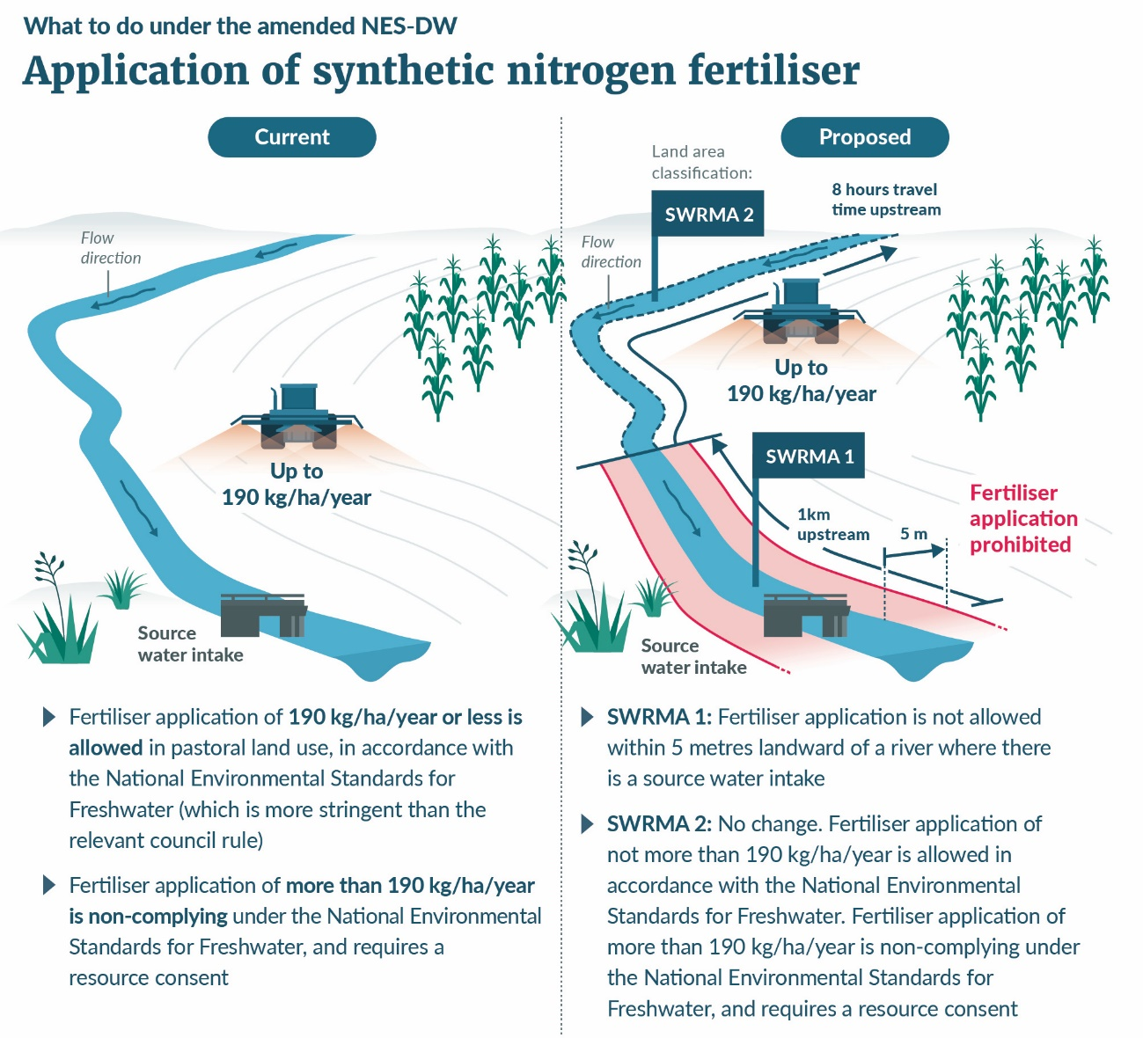
Sarah is a pastoral farmer who applies synthetic nitrogen fertiliser on her fields at a rate less than 190 kg/ha/year, and always uses fertiliser in accordance with the Code of Practice for Nutrient Management, as required by the NES-F.
After the amended NES-DW comes into effect, Sarah’s regional council has mapped SWRMAs for a local registered water supply that sources water from a river that passes through her property. SWRMA 1 extends 5 metres landward from the river, 1 kilometre upstream of the source water abstraction point, and 100 metres downstream. The river is encompassed by SWRMA 2 for a further distance upstream.
Under the amended NES-DW, Sarah will no longer be able to apply fertiliser to the 5 metre strip of land beside the river. However, there will be no change in how Sarah applies fertiliser elsewhere on her land, as long as she continues to apply no more than 190 kg/ha/year. If she chooses to apply more, she will need to make an application for resource consent, where potential adverse effects on the environment, including risks to source water, will be considered.

Scenario 2: Agrichemicals
Pesticides, insecticides, fungicides, and herbicides are used to control pest species. The Hazardous Substances and New Organisms Act 1996 covers the import and manufacture of hazardous substances, including controls which may be imposed for its use, while the RMA applies where the use of that substance (contaminant) requires a discharge into the environment.
When used on land, if not applied appropriately, these chemicals can enter waterways and pose significant risks to ecosystems and human health. Some of these chemicals can persist in the environment for a very long time, affecting the quality of drinking water sources. For this reason, it is important to limit the risk of agrichemicals getting into water sources.
Some herbicides are designed to control aquatic pest species and are intended to be applied directly to water.

Example
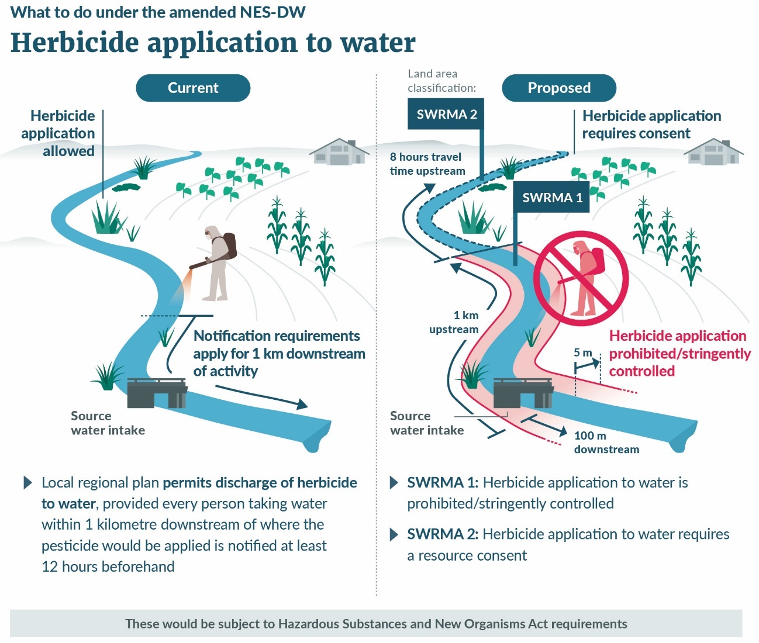
Matiu has aquatic weeds growing in the river that passes through his farm. Matiu usually controls those weeds through spraying herbicide directly into the creek during low flows.
Under the current Regional Plan rules for his region, the application of a herbicide for aquatic pest control is a permitted activity, providing Matiu adheres to the manufacturer’s specifications and he holds a GROWSAFE certification, and notifies every person taking water within 1 kilometre downstream of where the pesticide would be applied, a week in advance.
However, Matiu may not be aware of all drinking water takes from the river, as their takes may be permitted by regional council rules and there is currently no public register available of drinking water supplies.
After the amended NES-DW comes into effect, Matiu’s regional council has established there is a registered drinking water supply to three lifestyle blocks downstream. The river that passes through Matiu’s property is now covered by both SWRMA 1 and SWRMA 2.
Matiu will no longer be able to apply herbicide in SWRMA 1, and will need a resource consent to apply herbicide in SWRMA 2, because there is a risk that within 8 hours of its application, the herbicide-impacted water could be drawn in through the supply’s source water abstraction point.
Depending on the approach adopted for controls within SWRMA 1, and the degree of stringency applied, the following options could be considered [note that feedback is being sought on the necessity of activities such as aquatic pest control in freshwater, and whether it may be an activity that needs providing for]:
- Matiu will need to consider how critical his aquatic weed control is in this area, and any alternative means of weed control, eg, through mechanical removal – noting that bed disturbance in SWRMA 1 is also strictly controlled, or habitat modification.
- Where the work is essential and there is no alternative, Matiu could work with the water supplier to establish a solution (such as turning off the pumps and relying on stored water reserves for a period) and seek consent for the discharge. He would need to clearly establish the measures to be implemented to address source water effects.

Scenario 3: Drilling and bore construction
Groundwater is found in aquifers: an underground body of rock and/or sediment that holds freshwater. Typically, aquifers are surrounded by less-permeable layers called aquitards, which contribute to protecting groundwater from surface contamination.
Groundwater is a reliable source of drinking water, but it requires appropriate risk management to keep the aquifer safe from contamination.
If not handled properly, activities such as drilling or earthworks can reduce an aquitard’s protection, increasing the risk of contaminants reaching groundwater. Bore drilling and construction, and earthworks above vulnerable aquifers need to pay special consideration to how provision of a preferential pathway for contamination will be addressed.
The risks posed by earthworks can be mitigated through good design, and resource consent conditions that ensure these risks are managed.
For bores, drilling equipment should be clean and drilling processes should not introduce contaminants into the aquifer (such as drilling fluids), attention should be paid to the layers above the aquifer and with seals at the appropriate depths, and the bore should be secured at the surface, including fitting of a backflow prevention device.

Example
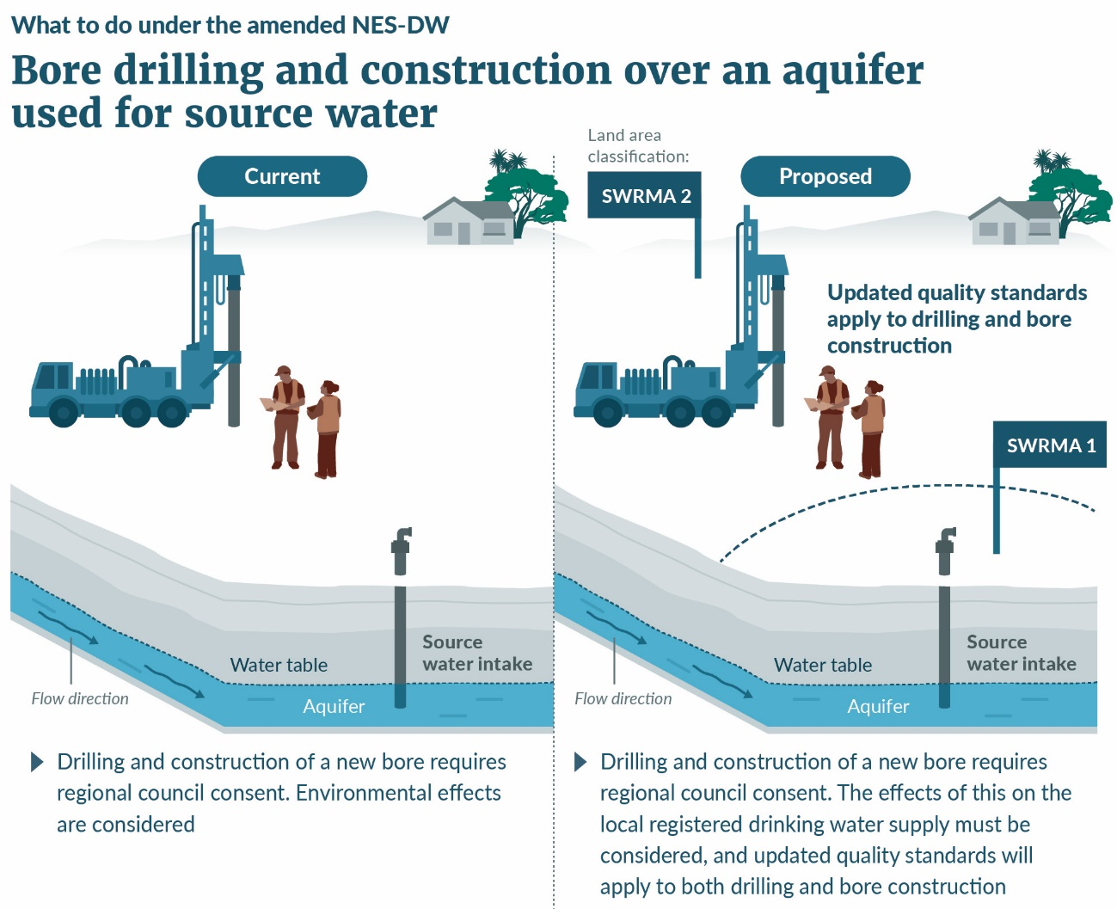
Aziz has a dairy shed and wants to install a bore to access groundwater in the aquifer underlying his land. Under his regional council rules, the drilling and construction of a bore is a controlled activity and requires consent (while the taking of groundwater is within permitted volumes of the regional plan). The regional council grants a consent for the bore, subject to various requirements, including adherence to drilling standard NZS 4411:2001, and installation of a concrete apron around the bore head. Aziz chooses to install a below-ground bore head as he is not prevented from doing so.
Under the amended NES-DW, Aziz’s regional council has found that this area is located in SWRMA 2 from a groundwater source. A consent is still needed but both Aziz, in making the application, and the regional council when making its decision, must ensure the effects of drilling and constructing the bore on source water are considered.
New bore quality standards are applied – this bore has an above-ground bore head, has a bentonite seal below ground as well as a concrete apron above ground, and it is fitted with a backflow prevention device.

Scenario 4: Wastewater discharges
Wastewater discharges contain bacteria and pathogens that can make people sick if they source water. Wastewater discharges can also affect the mauri of a water body if they enter the water body.
Discharge of effluent to land is generally preferrable to discharge to water, as effluent can be further treated through some types of soils, where it is applied at suitable loading rates.

Example
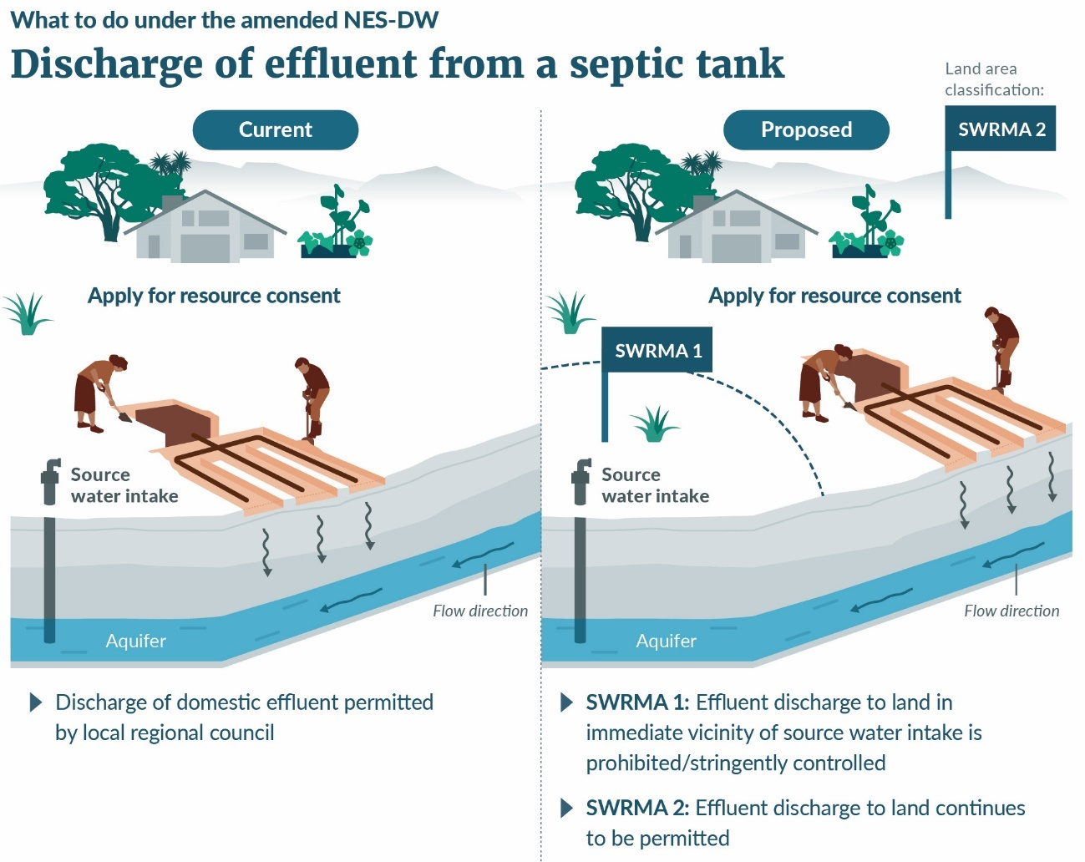
Sione owns a lifestyle block and wants to install a new on-site septic tank. Under current rules in his region, the discharge of effluent to land from a domestic wastewater system is permitted subject to certain conditions. When establishing its regional rules, the council considered small domestic volumes at low loading rates, over a relatively deep aquifer, were unlikely to cause effects that were more than minor.
Under the amended NES-DW, Siones’s regional council has determined his property is located within SWRMA 2.
The regional plan rules are not impacted by the NES-DW. Sione’s effluent discharge is still permitted, subject to certain conditions being met.
As the regional council gives effect to the NPS-FM, and notifies amended freshwater plans, it must consider drinking water as a value, and consider how it manages surrounding activities.
Under the WSA, the local water supplier monitors source water quality. If source water shows no indication of being impacted by effluent, then the regional council might continue to permit effluent discharge, or they may constrain where effluent can be applied to mitigate risk. However, if monitoring showed source water quality was impacted by effluent, the regional council would have to consider all activities in the catchment that could be contributing to the issue, and how best to manage those activities in future.

Case studies
To better understand the implications of the proposed changes to the NES-DW on small rural suppliers (including marae) and their surrounding communities, the Ministry commissioned an evaluation using real life situations (case studies). In the case studies, activities within SWRMA under the proposed amended NES-DW are compared against the same activities occurring under the current relevant regional plan rules.
Participants were selected based on availability and willingness to participate as well as variables in supply characteristics and surrounding land use. A mix of land uses has been identified in the areas surrounding the water supplies, primarily pastoral farming, with smaller amounts of horticulture and forestry, and in some cases residential areas. The suppliers vary in primary activity on their land, source water, number of extraction points, and number of dwellings supplied with drinking water for human consumption (see Table 6).
Table 6: Summary of current case study participants
Primary focus of water supplier | Source water | Number of abstraction points | Customers supplied
Council-owned rural supply | River | 1 | Multiple farms, domestic dwellings, school, and campsite
Dairy, beef, sheep farm | Groundwater | 1 | Multiple domestic dwellings
Beef and sheep farm | Groundwater | 1 | Multiple domestic dwellings, woolshed, cattle yard
Dairy farm | Groundwater | 3 | Multiple domestic dwellings, cow shed
Marae | Spring | 1 | Marae, marae office, multiple domestic dwellings
The case study report will be finalised and made available on the Ministry for the Environment’s website in late January 2022.
Initial indications based on the case studies, are that resource users in SWRMA undertaking typical pastoral farming, horticultural and household activities are unlikely to be significantly impacted by the proposed amendments to the NES-DW. In the case studies, the proposed amendments to the NES-DW, had:
- a greater effect for resource users in the areas surrounding surface water supplies because the area covered by SWRMA 1 is larger
- no anticipated additional costs resulting from the proposed amendments in SWRMA 2, for onsite effluent discharges, pastoral farming activities and application of fertiliser and agrichemicals
- an impact on direct discharges to surface water, and water takes. Stormwater was identified as one such discharge that could be impacted, however in the rural areas of these case studies, stormwater discharges are few, and more likely to go to land. For water takes, although SWRMA 1 is relatively limited in extent, there could be additional consenting costs for other resource users seeking to take water.
For water suppliers, it is likely that some activities related to maintaining a water supply
(eg, maintaining intake structures) will be more permissive, reducing costs associated with resource consent applications.

Section 5: How to have your say
We welcome your feedback on the proposals in this consultation document. The questions throughout the document are a guide only – see the list below. You do not have to answer them all, and any comments are welcome.
To ensure others clearly understand your point of view, you should explain the reasons for your views and give any supporting evidence.

Timeframes
This consultation starts on 10 January 2022 and ends on 6 March 2022.
When the consultation period has ended, we will analyse and summarise submissions. We will then provide final policy advice to the Government on the preferred options.

How to make a submission
You can make a submission in two ways.
- Use our online submission tool, available at https://consult.environment.govt.nz/freshwater/nes-drinking-water
This is our preferred way to receive submissions.
- Write your own submission.
In your submission, please make sure you include:
- the title of the consultation
- your name or organisation
- your postal address
- your telephone number
- your email address.
If you are posting your submission, send it to:
Improving the protection of drinking-water sources
Urban Water team
Ministry for the Environment
PO Box 10362
Wellington 6143
If you are emailing your submission, you can send it to nesdw.consultation@mfe.govt.nz as a:
- PDF
- Microsoft Word document (2003 or later version).
When emailing your submission, please use add ‘Improving the protection of drinking-water sources’ in the subject line.
Submissions close on 6 March 2022.

For more information
Please send any queries to:
Email: nesdw.consultation@mfe.govt.nz
Post: Improving the protection of drinking-water sources, Urban Water team, Ministry for the Environment, PO Box 10362, Wellington 6143

Publishing and releasing submissions
All or part of any written submission the Ministry for the Environment receives electronically or in printed form, including your name, may be published on our website, environment.govt.nz. Unless you clearly specify otherwise in your submission, the Ministry will consider that you have consented to website posting of both your submission and your name.
Submissions may also be released to the public under the Official Information Act 1982 following requests to the Ministry for the Environment (including by email). Please advise if you object to the release of any information contained in your submission and, in particular, which parts you consider should be withheld, and the reasons for withholding the information.
Any personal information you supply to the Ministry when making a submission will only be used by the Ministry in relation to the consultation covered in this document. You have the right to request access to or to correct any personal information you supply to the Ministry.
If you have any questions about the publishing and releasing of submissions, or if you would like to access or correct any personal information you have supplied, please email info@mfe.govt.nz.

Consultation questions
The default method for delineating SWRMA
- Domestic and international evidence suggests that delineating three at-risk areas is a good approach for protecting sources of drinking water. Do you think this is a good approach for protecting our source waters? What other approach can you think of that could contribute to protecting our drinking water sources? Do you think that three areas (and therefore levels of control) are sufficient to protect our drinking water sources?
- In your view, is the method to determine each SWRMA, for each type of water body, the best option?
- Should other factors be considered in determining size?
- What challenges can you foresee in delineating SWRMAs?
- Do you have any comments or feedback on the detail contained in the technical guidance materials?
- Should SWRMA for all aquifers be bespoke so their unique features, depth and overall vulnerability can be considered?
- For lakes, do you agree that SWRMA 2 should include the entire lake area?
- What might be an alternative approach?
- SWRMA 1 for lakes and rivers is proposed to extend 5 metres into land from the river/lake edge. This contrasts with 3 metres setback requirement of the Resource Management (Stock Exclusion) Regulations 2020. SWRMA 1 is proposed to be used as a basis for controlling activities close to source water intakes, and applies to a wide range of activities. Do you think these differing setbacks will cause confusion or result in other challenges?
- There is evidence suggesting that a 10–30-metre radius around source water bores is a preferable way to delineate the area where activities would be heavily restricted (SWRMA 1). However, expert advice suggests a 5-metre radius is the most workable option.
- Do you agree that a 5-metre radius around a source water bore gives enough protection? Why or why not?
- If not, what alternative would you suggest?
- While water takes from complex spring systems or wetlands may require a bespoke SWRMA to ensure consideration of any contamination pathways present, a default method is necessary to ensure interim protection. Do you think a default method is practicable in most situations?
- Do you think a regional council should determine (on a case-by-case basis) the most applicable default method: for a river, lake or aquifer, or is a different default approach necessary?
- If so, what alternative would you suggest?
Regional council mapping of SWRMA
- How long do you think is necessary for regional councils to delineate SWRMAs for currently registered water supplies in each region, using the default method?
- What challenges do you foresee in delineating SWRMAs, when previously unregistered supplies are registered with Taumata Arowai (see Proposal 3 for more details)?
- What support could enable regional councils to delineate SWRMAs within shorter timeframes?
- Do you think consideration should be given to mapping currently unregistered supplies as they register (but before the four-year deadline provided under the Water Services Act), or do you think that waiting and mapping them all at the same time is a better approach?
Bespoke method for delineating SWRMA
- If a regional council has already established local/regional source water protection zones through a consultative process, should there be provision to retain that existing protection zone as a bespoke method without further consultation or consideration against new national direction?
SWRMA 1 controls
- Do you think national direction on activities within SWRMA 1 is necessary?
- If so, what activities should it address?
- How restrictive should controls be in SWRMA 1, for resource users other than water suppliers?
- Are there any activities you believe should be fully prohibited in this area?
- Are there any activities you believe should be permitted or specifically provided for or acknowledged in this area?
- For water suppliers, are there any other activities beyond intake maintenance/management that should be provided for?
- In and around freshwater, control of pest species (including aquatic pest species) may be necessary, including through physical control (removal, that may include bed disturbance) or chemical control (discharge).
- How much of an issue is this in and around abstraction points?
- How critical is that work?
- How often is this work mandated by other regulation or requirements?
- How frequently is this work undertaken by parties other than the drinking-water supplier (or their contractors)?
SWRMA 2 controls
- Do you think national direction on activities within SWRMA 2 is necessary?
- If so, what activities should it address?
- In your view, how much will this proposal impact the current situation in your region?
- What discharges to water are currently permitted?
- Should provision be made to continue to permit those activities? What controls are typically used to ensure potential adverse effects are managed?
- Are there any other activities that should not be permitted within SWRMA 2?
- The original intent of SWRMA 2 was to manage microbial contamination. However, there are indications that protections against other contaminants may be required. What contaminants do you think should be controlled in SWRMA 2?
- What other challenges do you see when making a consent application within SWRMA 2?
SWRMA 3 controls
- Do you think any additional controls, other than broad consideration of the effects of the activity on source water, are required in SWRMA 3?
Groundwater bore management
- What is your view on how to address issues with bores – should it be enough to amend the NZS 4411:2001 (with reference to that standard in the NES-DW), or should greater direction be given in the NES-DW itself?
- For existing bores:
- What is your view on requiring unused bores to be decommissioned?
- Should bores of poor quality be required to be upgraded or decommissioned? What timeframe might be reasonable to do this?
- For many older bores there are no records. What sort of evidence could be used to support the ongoing use of these bores, or demonstrate they pose a low risk to the security of the aquifer?
- What is your view on prohibiting below-ground bore heads?
- Regional councils are responsible for control of the use of land for the purpose of maintenance and enhancement of the quality of water in water bodies (RMA section 30(1)(c)(ii)). Do you think territorial authorities have a role in land management over aquifers, and if so, what is that role?
Identifying and managing activities over vulnerable aquifers
- It is not clear which approach might be best for ensuring risk to vulnerable aquifers is appropriately managed. Do you think that an NES-DW is the right channel for addressing this? If not, what approach might be better?
- Would it be helpful if guidance on vulnerable aquifers was provided to support freshwater planning as the NPS-FM is given effect?
Retrospective application of the NES-DW to existing activities
- What activities do you believe the NES-DW should retrospectively apply to / not apply to, and why?
- In your view, what are the key challenges and benefits to retrospective application?
Criteria when considering effects on source water
- Do you agree with the proposed list of criteria?
- Are any additional criteria needed, or clarification?
Proactive response planning
- What types of activity might pose a significant risk to a water supply in an accident, emergency, or other natural event?
- Do you think it is reasonable to require all activities with some potential to affect source water to undertake response planning, or just those with a higher risk (likelihood and consequence)?
Water supplier involvement
- Do you agree that resource users should engage with water suppliers in consenting matters, within SWRMA 1 and 2?
- What hurdles do you see in promoting this engagement with water suppliers?
- What support might small water suppliers need to effectively engage in the consent process?
General matters relating to managing source-water risks
- A National Environmental Standard is a regulation under the Resource Management Act 1991 (RMA) that requires, among other things, that regional councils make changes to their regional plan rules. Making these changes can add costs (eg, financial, administrative) for regional councils.
- In your view, how might regional councils be affected by the NES-DW’s new requirements to change regional plan rules?
- Do these effects outweigh the expected benefits of better source water protection?
- In your view, how could the amendments to the NES-DW better align with farm plans?
- Is reliance on the NPS-FM, NES-F and Stock Exclusion Regulations enough to manage the long-term effects of farming activities on underlying aquifers and waterbodies?
- Can you identify potential duplication between the NES-DW and other regulations that control land use?
- If you are a water supplier, do you think these amendments will affect your ability to supply water (positively or negatively)? Would they influence whether you continue to provide water?
- If you are a resource user, do you think these amendments will affect how you currently use your land or undertake activities? Will you have to change how you do things as a result?
Which water supplies should be protected by the NES-DW
- Do you think the protections of the NES-DW should apply to all registered water supplies?
- If not, what types of supplies should be included, and why?
- The WSA has a registration timeframe of four years for currently unregistered supplies.
- Do you agree with aligning application of the NES-DW with the WSA? If not, why?
- In your view, what are the challenges resulting from including these newly registered supplies within the NES-DW framework?
Other comments
- Do you have any other comments you wish to make?

Appendices

Appendix A: Indicative areas included in SWRMA 1 and 2 for currently registered water supplies
The maps shown in Figures A-1 to A-2 show SWRMA 2 (encompassing SWRMA 1) for all currently registered water supplies under the Health Act. Currently registered water supplies are those used for populations over 501 people, and those supplies for between 101 – 500 people that are used for at least 60 days per year. The maps do not include currently unregistered water supplies serving less than 100 people, are proposed to be protected by the NES-DW under Proposal 3.
The SWRMA were established using the approach outlined in the report commissioned by the Ministry. This report also identifies the land area and land types that will be included in SWRMA 1 and 2 restrictions resulting from an amended NES-DW. The mapping is considered as conservative (ie, it provides a possible over-estimate of the registered water supply areas included, rather than an under-estimate).

Figure A.1: SWRMA 2 for surface water supplies
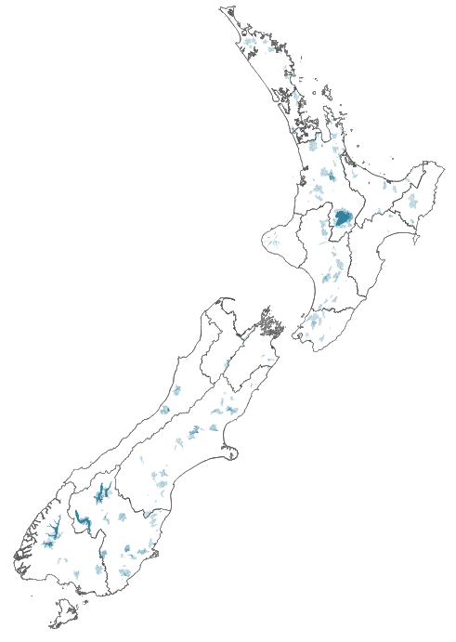
Note: The Chatham Islands, with one registered surface water supply, is not included on this map
Figure A.2: SWRMA 2 for groundwater supplies
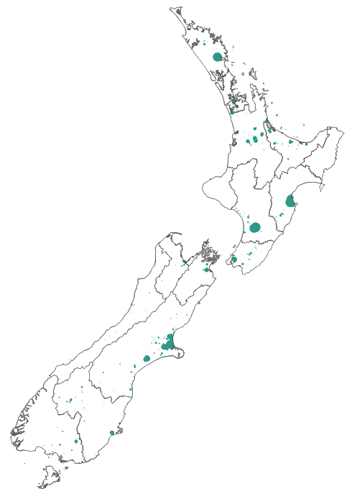
Note: The Chatham Islands, with one registered groundwater supply, is not included on this map

Appendix B: How the new source water provisions work together
Source water and freshwater provisions under the RMA work with source water provisions of the WSA, and these requirements apply differently to key stakeholders. Figure B.1 illustrates the relationships between each party, and how information is used to refine planning requirements.
Figure B.1: Relationships and requirements for source water management
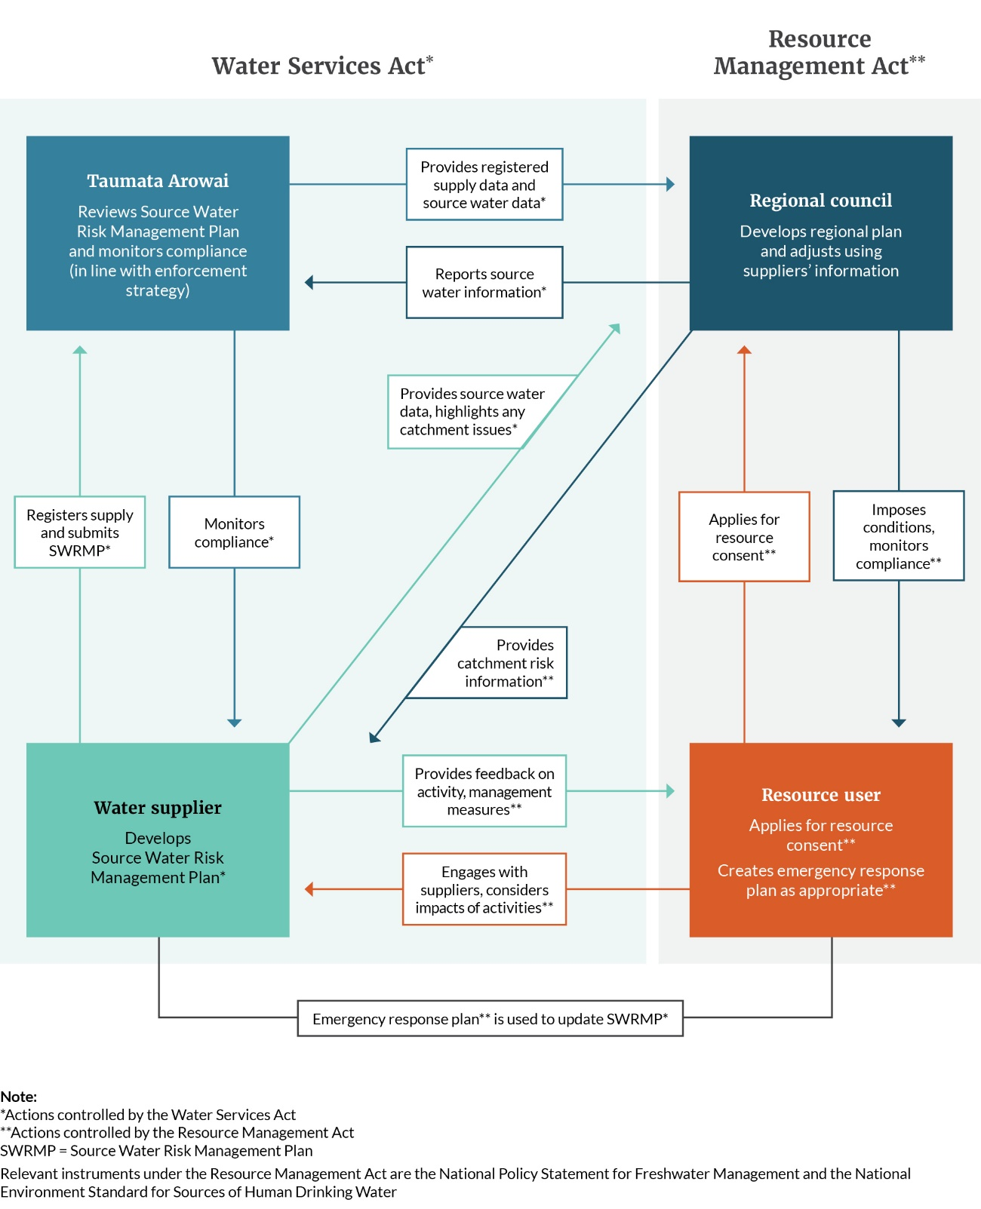

References
Department of Internal Affairs. 2021. Industry Development Study & Economic Impact Assessment. Wellington: Department of Internal Affairs.
Department of Internal Affairs. 2017a. Government Inquiry into Havelock North Drinking Water (2017) Report of the Havelock North Drinking Water Inquiry: Stage 1. Wellington: Department of Internal Affairs.
Department of Internal Affairs. 2017b. Government Inquiry into Havelock North Drinking Water (2017) Report of the Havelock North Drinking Water Inquiry: Stage 2. Wellington: Department of Internal Affairs.
Department of Internal Affairs. 2021. Industry Development Study & Economic Impact Assessment. Wellington: Department of Internal Affairs.
Environmental Health Intelligence New Zealand. 2020a. Access to safe drinking-water. Massey University.
Environmental Health Intelligence New Zealand. 2020b. Notifications for potentially waterborne diseases. Massey University.
Environmental Health Intelligence New Zealand. 2020c. Notifications for potentially waterborne disease with untreated drinking water as a risk factor. Massey University.
Ministry for the Environment. 2018. Review of National Environmental Standard for Sources of Human Drinking Water. Wellington: Ministry for the Environment.
Ministry of Health. 2020. Annual Report on Drinking-water Quality 2018-2019. Wellington: Ministry of Health.
Ministry of Health. 2017. The economic costs of the Havelock North August 2016 waterborne disease outbreak. Wellington: Sapere Research Group.
New Zealand Herald. 2020. Source protection zones for drinking water catchments.
Sheerin, I., Bartholomew, N., & Brunton, C. 2014. Estimated community costs of an outbreak of campylobacteriosis resulting from contamination of a public water supply in Darfield, New Zealand. The New Zealand Medical Journal, 127(1391), 13–21.
World Health Organization. 2015. Waterborne diseases. Geneva: World Health Organization.

Drinking water, wastewater, and stormwater.
Water is considered safe to drink, where it meets the DWSNZ: a set of criteria prescribing limits for various contaminants that may be present in drinking water.
Annual Report on Drinking-Water Quality 2019–2020
Water is considered safe to drink, where it meets the DWSNZ: a set of criteria prescribing limits for various contaminants that may be present in drinking water.
Government Inquiry into Havelock North Drinking Water (2017) Report of the Havelock North Drinking Water Inquiry: Stage 1.
The economic costs of the Havelock North August 2016 waterborne disease outbreak.
Hydraulically-connected water bodies are called conjunctive sources, eg, where a pond and an aquifer are linked, there is a pathway for the water to flow from the aquifer to the pond and pond to the aquifer.
Review of National Environmental Standard for Sources of Human Drinking Water.
The area around the bore where groundwater depth/flow is affected by the removal of water from the bore.
For an example see https://www.epa.gov/sourcewaterprotection/delineate-source-water-protection-area and https://www.gov.uk/guidance/groundwater-source-protection-zones-spzs.
Waterborne diseases.
Notifications for potentially waterborne diseases.
Notifications for potentially waterborne disease with untreated drinking water as a risk factor.
Estimated community costs of an outbreak of campylobacteriosis resulting from contamination of a public water supply in Darfield, New Zealand.
The economic costs of the Havelock North August 2016 waterborne disease outbreak.
Notifications for potentially waterborne diseases.
Government Inquiry into Havelock North Drinking Water (2017) Report of the Havelock North Drinking Water Inquiry: Stage 2.
Estimated community costs of an outbreak of campylobacteriosis resulting from contamination of a public water supply in Darfield, New Zealand.
Industry Development Study & Economic Impact Assessment.
As required through recent amendments to section 127 of the Local Government Act (2002)

