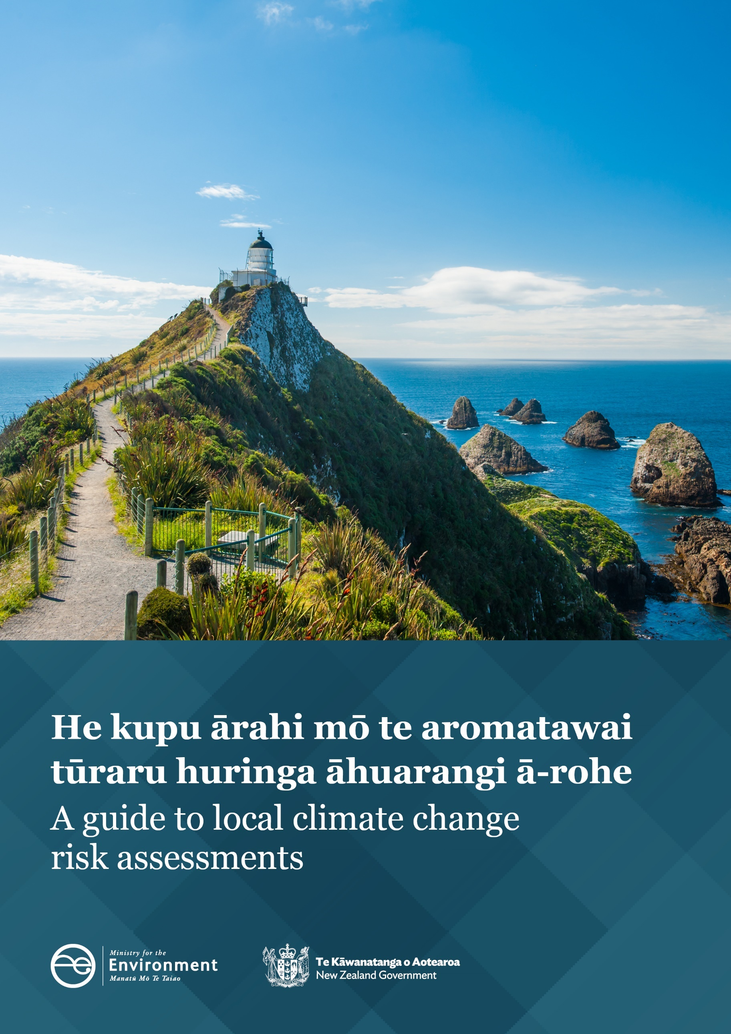

Disclaimer
The information in this publication is, according to the Ministry for the Environment’s best efforts, accurate at the time of publication. The Ministry will make every reasonable effort to keep it current and accurate. However, we advise users of this publication that:
- the information provided has no official status and so does not alter the laws of New Zealand, other official guidelines or requirements
- it does not constitute legal advice, and users should take specific advice from qualified professionals before taking any action based on information in this publication.

Lead authors
James Hughes, Katherine Cowper-Heays, Michelle Meaclem (Tonkin + Taylor).
Ministry for the Environment Project Team
Lisa Marquardt, Sarah Anderson, Marie McCarthy, Tamara Polglase.
Acknowledgements
We would like to thank the following advisors and contributing authors:
Local Government Working Group: Jane Palmer (Bay of Plenty Regional Council), Tom Bowen (Horizons Regional Council), Marion Schoenfeld (Christchurch City Council), Morag Butler (Environment Canterbury), Jeff Farrell (Whakatāne District Council), Hadyn Butler (Porirua City Council), John Stewart (Local Government New Zealand).
Iwi/Māori Caucus: Roana Bennett, Shaun Awatere, Donna Gardiner, Danny Broughton, Mariana Te Rangi, Sylvia Tapuke.

This document may be cited as: Ministry for the Environment. 2021. He kupu ārahi mō te aromatawai tūraru huringa āhuarangi ā-rohe / A guide to local climate change risk assessments. Wellington: Ministry for the Environment.

Published in September 2021 by the
Ministry for the Environment
Manatū Mō Te Taiao
PO Box 10362, Wellington 6143, New Zealand
ISBN: 978-1-99-003381-0
Publication number: ME 1595
© Crown copyright New Zealand 2021
This document is available on the Ministry for the Environment website: environment.govt.nz.

Contents
Introduction 7
Objectives of this guide 7
Honouring Te Tiriti o Waitangi (the Treaty of Waitangi) 7
Context 8
Using this guide 9
1 Phase 1: Getting started 15
1.1 Step 1A: Establish project team, governance, and communication plan 16
1.2 Step 1B: Establish project principles, purpose, and level of assessment 19
1.3 Step 1C: Identify stakeholders and plan for iwi/Māori and stakeholder engagement 21
2 Phase 2: Setting up the risk assessment 24
2.1 Step 2A: Inputs and scale of assessment 25
2.2 Step 2B: Climate change scenarios and timeframes 26
2.3 Step 2C: Develop and agree organising themes 28
3 Phase 3: Carrying out the risk assessment 34
3.1 Step 3A: Identify hazards; screen elements at risk 34
3.2 Step 3B: Detailed physical risk assessment 40
3.3 Step 3C: Additional analyses 49
3.4 Step 3D: Review risk-rating workbook 51
3.5 Step 3E: Risk assessment report 51
4 Phase 4: Next steps 54
4.1 Step 4A: Risk prioritisation 54
4.2 Step 4B: Adaptation planning 55
5 Resources 57
Glossary 58
Bibliography 64
Appendix A: Climate hazards list 68
Appendix B: Preparing a climate risk survey 71
Appendix C: Risk-screening template 73
Appendix D: Risk assessment template 75
Appendix E: Sample consequence rating table 76
Appendix F: Engagement 77
Appendix G: Sample risk assessment report 81
Appendix H: Assessing governance maturity 82
Appendix I: Transition risks (low carbon) 84
Appendix J: Examples of indirect/cascading risks 86

Tables
Table 1: Examples of risk assessment project team, roles, and responsibilities 16
Table 2: Suggested guiding principles 19
Table 3: Level of risk assessment at different scales 21
Table 4: Value domain descriptions from the NCCRA framework 29
Table 5: Example: mid- and long-term climate projections for RCP8.5 37
Table 6: Examples of risk statements and descriptions 38
Table 7: Example of a risk matrix 39
Table 8: Exposure rating scale 43
Table 9: Vulnerability matrix (combining sensitivity and adaptive capacity) 44
Table 10: Vulnerability rating and definition 44
Table 11: Risk matrix (combining vulnerability and exposure) 45
Table 12: Example of risk rating table (infrastructure) 45
Table 13: Factors that can influence consequences 49
Table 14: Examples of opportunities in various sectors 50
Table 15: Sample climate hazard list from NCCRA framework 68
Table 16: Example of a consequence rating table 76
Table 17: Sample questions for councils in managing climate risks 82
Table 18: Examples of transition risks relevant to councils 84
Table 19: Indirect/cascading risk examples 86

Figures
Figure 1: The climate change adaptation process 9
Figure 2: Process for local risk assessments 10
Figure 3: Physical risks, transition risks and opportunities 11
Figure 4: Climate-related risk as the interaction of climate hazards with the vulnerability and exposure of human and natural systems 12
Figure 5: Direct and indirect climate risk examples 13
Figure 6: Interdependencies and cascades between sectors which can influence climate risk 14
Figure 7: Example of project structure for a local risk assessment 17
Figure 8: RCP scenarios showing annual emissions per year 26
Figure 9: Process for step 3A 34
Figure 10: Climate projections for New Zealand 36
Figure 11: Steps of the risk assessment approach 41
Figure 12: Elements at risk: exposure and vulnerability 42
Figure 13: Sample vulnerability chart: health risks (impacts) in Australia 47
Figure 14: Evidence and agreement statements and their relationship to confidence. Confidence increases towards the top right corner 48
Figure 15: Climate adaptation and mitigation synergies 50
Figure 16: The climate change adaptation process 55
Figure 17: International Association of Public Participation (IAP2) spectrum of participation 78
Figure 18: Modelling towards mātauranga Māori aspirations and outcomes 80

Introduction
Aotearoa New Zealand is experiencing the impact of a changing climate and will continue to do so as greenhouse gases increase in our atmosphere. Our average annual temperature rose by 1.13 degrees Celsius from 1909 to 2019, sea levels are rising, and we are seeing changes in drought and extreme rainfall. The effectiveness of efforts by New Zealand and our global partners to reduce greenhouse gas emissions will influence how the climate changes in the future.
In 2020, the Government released the National Climate Change Risk Assessment (NCCRA), as part of their role in guiding the nation’s response and adaptation to climate change. Councils and communities need to understand and proactively manage climate risk at local scales as the effects of climate change intensify and communities are becoming more aware that climate hazards could affect things they value.
This guide sets out a risk assessment framework for local use, which is broadly consistent with the NCCRA framework. Local assessments will likely inform the next national assessment due in 2026 and will be necessary to support national adaptation planning and legislation.
This guide was developed by Tonkin and Taylor with direction from, and workshops with, a Local Government Working Group and Māori caucus and panel in early 2021. The aim is to review and update it as required, and as the context for risk assessments evolves.

Objectives of this guide
This guide aims to:
- promote consistency in local climate change risk assessments, supporting local government decisions on adaptation, and ensuring links with the NCCRA
- set a foundation for consistency across all local assessments, while also allowing for local values.
This guide applies to local risk assessments – for regions, districts or communities. It is written mainly for local government representatives to lead and implement, in partnership with local iwi/Māori on behalf of communities. However, anyone carrying out a local assessment may use it.

Honouring Te Tiriti o Waitangi (the Treaty of Waitangi)
When planning an assessment, we must consider the needs of iwi/Māori through early dialogue. The assessment should acknowledge the rangatiratanga of Māori, the status of Māori as Tiriti partners, and the potential for contribution from mātauranga Māori. The partnership is reflected throughout this guide. See specifically step 1C (engagement) and step 3A (identifying hazards).

Context
New Zealand is a signatory to the Paris Climate Agreement of 2015 and the Sendai Framework for Disaster Risk Reduction. Both agreements stipulate that parties must recognise the importance of averting, minimising and addressing loss and damage associated with the adverse effects of climate change.
New Zealand has set a legislative and policy framework to build national resilience to climate change, underpinned mainly by the Climate Change Response (Zero Carbon) Amendment Act 2019 (ZCA). The ZCA commits us to identifying future risks and opportunities through the NCCRA, and requires a National Adaptation Plan (NAP) within two years of the release of the NCCRA. Section 5ZW of the ZCA requires reporting organisations (which include local authorities) to provide information on adaptation to the Minister of Climate Change or the Climate Change Commission. The NCCRA was based on Arotakenga Huringa Āhuarangi: A Framework for the National Climate Change Risk Assessment for Aotearoa New Zealand.
The Government is also undertaking significant reforms to the resource management system, including increasing resilience to climate change, through three new acts: a Natural and Built Environments Act, a Strategic Planning Act, and a Climate Change Adaptation Act.

Adaptation planning: five steps
A risk assessment forms part of the broader adaptation planning process, as set out in the Coastal Hazards and Climate Change Guidance (Ministry for the Environment [MfE], 2017).
Figure 1 shows the five steps and key questions for adaptation planning. These can apply to a range of climate hazards. This guide focuses on Steps 1 and 2:
- Understanding the context, hazards, and exposure.
- Assessing vulnerability and risk.

Why undertake a local assessment?
The primary purpose of a local assessment is to inform adaptation planning. It can also link to other processes/activities, including resource management, iwi management plans, land-use planning and regulation, strategic planning, infrastructure management, and emergency management. It can be used to work alongside iwi/Māori as Treaty partners on a range of priorities (social, cultural, economic, and environmental).
Figure 1: The climate change adaptation process
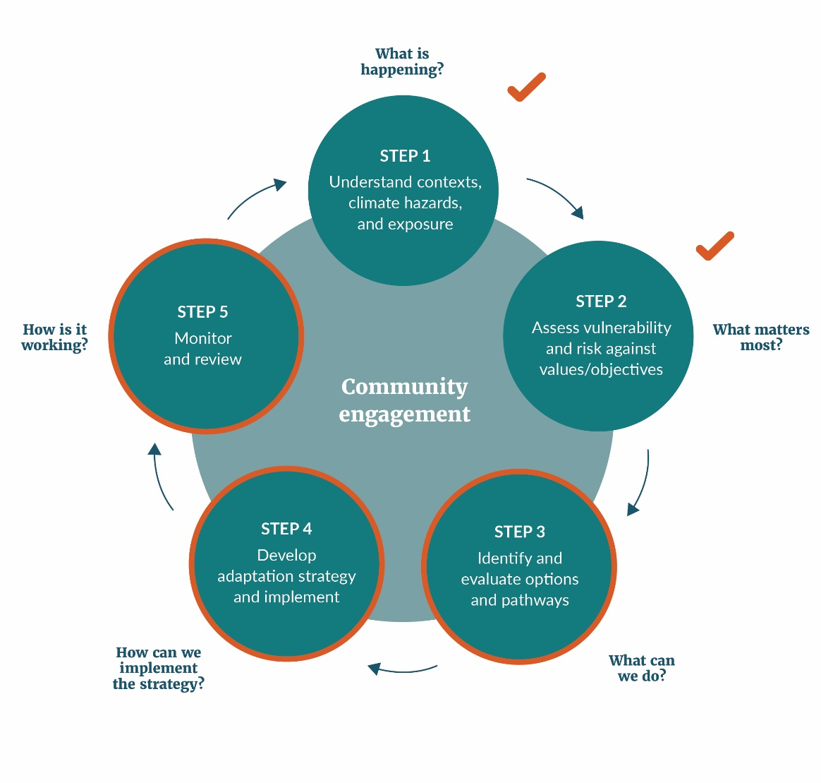
Adapted from MfE (2017) and Local Government New Zealand (2019)

Reviews
It is important to periodically review and update assessments as our knowledge about risk evolves and as we close information gaps. The proposed period for updating the NCCRA is every six years, and councils should consider a similar timeline for their assessments.

Using this guide
This guide sets out a step-by-step process to carry out local risk assessments. Figure 2 summarises the four phases, the groups to involve in each step, key outputs, and links to resources in this guide.
Phase 1: Getting started, including establishing the project team, setting principles, and planning for engagement.
Phase 2: Setting up the assessment, including agreed themes.
Phase 3: The methodology, including assessing physical risks, and optional elements (consequences, opportunities, and geospatial analysis).
Phase 4: The next steps after the assessment.
Figure 2: Process for local risk assessments
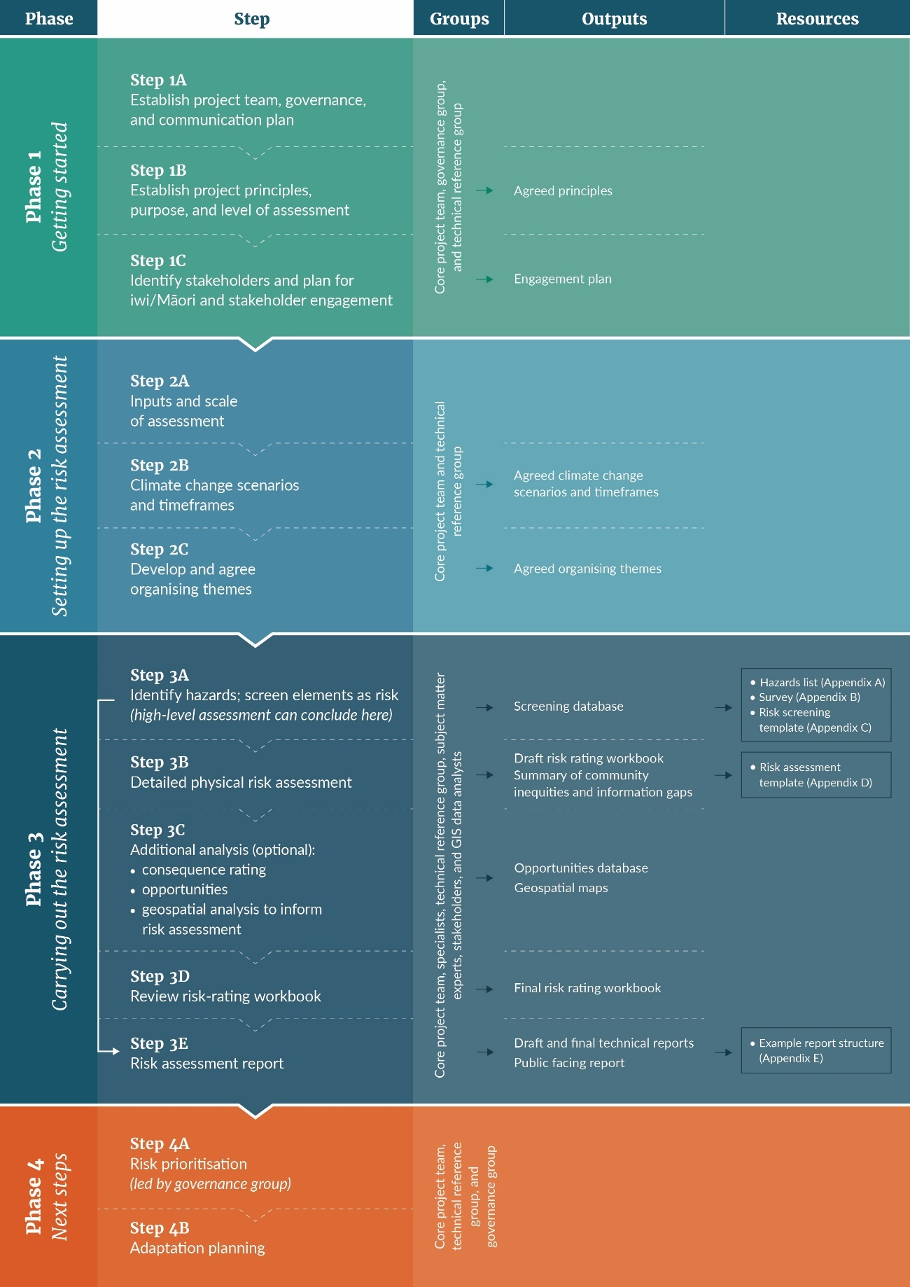

Box 1: Concepts and terms
Risk: The ‘core’ definition is “the potential for adverse consequences” (Reisinger et al, 2020).
Climate change risk assessments identify risks to things of value in communities, due to potential changes in the climate. The assessments can help to prioritise risks, which can then drive targeted action and investment in adaptation.
Physical risks are those resulting from climate change hazards and are the focus of this guidance. These can be acute, such as increasingly extreme weather (eg, cyclones, droughts, floods). They can also arise from longer-term (chronic) shifts in precipitation, temperature, sea-level rise, and more variable weather patterns. Physical risk is generally the potential for losing something of value, for example, when a person’s home is damaged by flooding or fire.
Elements at risk refers to the people or systems affected by a physical risk – eg, assets, ecosystems, cultural taonga, infrastructure.
Transition risks are typically associated with the shift to a lower-carbon economy (TCFD, 2017) – for example the financial and legal implications of climate-related policies, shifting away from fossil fuels or to low-carbon technologies. In this guide, transition risks are also those arising in communities as they move towards climate resilience and begin adaptation. In this context, adaptation must address fairness and equity, and ensure that decisions do not worsen pre-existing inequities.
Hazards are defined as climate-related events (such as floods or heatwaves), or evolving trends or their gradual physical impacts (IPCC, 2014b).
Opportunities are the positive outcomes that may arise from a changing climate.
Figure 3 shows the relationship between physical and transition risks, the opportunities, and how both require strategic planning and management.
Figure 3: Physical risks, transition risks and opportunities
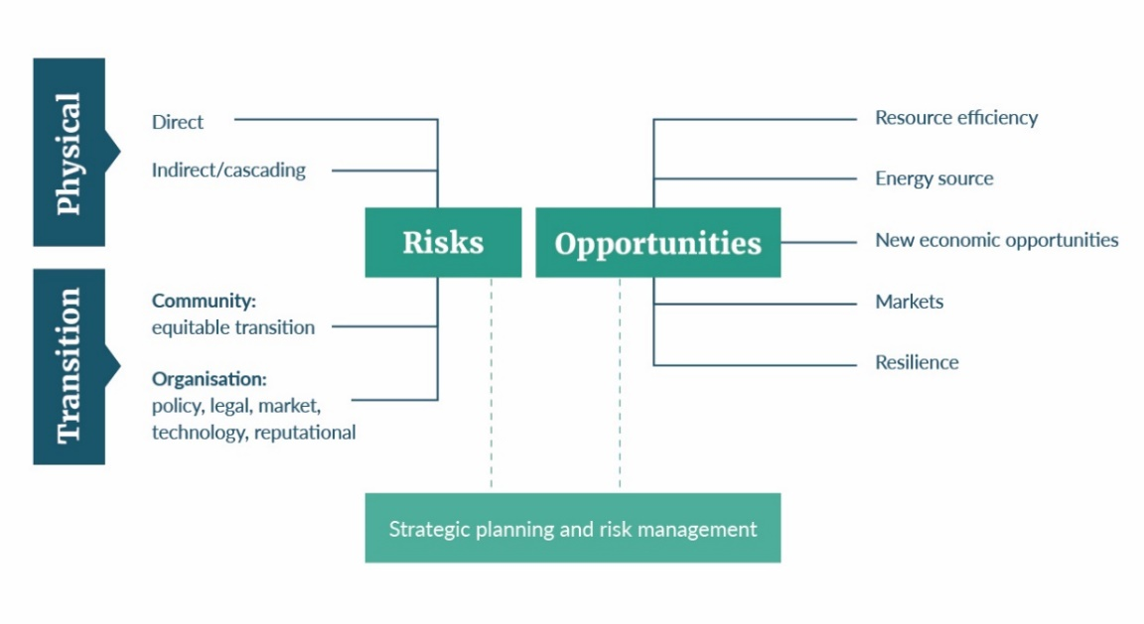
Source: adapted from Task Force on Climate-Related Financial Disclosures (TCFD, 2017)
Direct risks are those where there is a direct link between a hazard and an element at risk that is exposed and vulnerable. For example, storms and flooding damaging buildings and infrastructure, droughts leading to crop failure, or extreme temperatures causing heat stress.
Indirect risks – see Box 2.
Figure 4 shows how risk arises from three elements:
- climate hazards (which can be physical events or trends, such as sea-level rise or seasonal climate changes)
- the degree to which things we value (eg, people, assets, taonga) are exposed to the hazard
- their vulnerability to its effects.
The NCCRA (MfE, 2019) uses this framing.
Uncertainty applies to each of the three elements, ie, uncertainty not only about the magnitude and frequency of hazards, but also about the exposure and vulnerability to a hazard.
Figure 4: Climate-related risk as the interaction of climate hazards with the vulnerability and exposure of human and natural systems
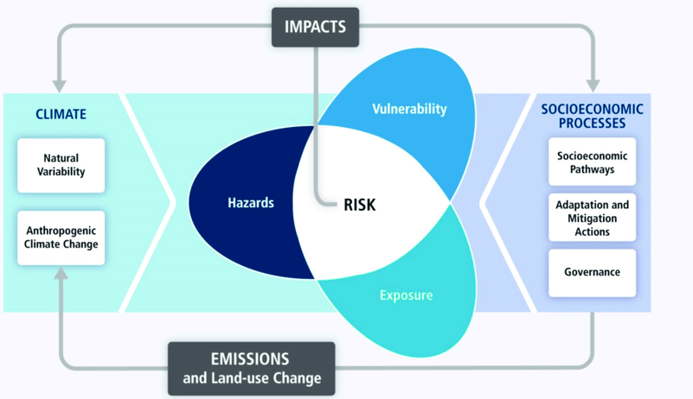
Source: Oppenheimer, et al., 2014

Box 2: Indirect and cascading risks
Risks can be direct or indirect, and cascade or create ‘knock-on’ effects. The terminology used for these types of risk are still emerging. Below are some definitions.
Indirect risks
Indirect risks are further removed from a hazard – for example, impacts on mental health, disruptions to supply chains, migration, social wellbeing, and cohesion. They are the result of direct risks elsewhere, which can be local or distant. Figure 5 shows examples of direct and indirect risks.
Figure 5: Direct and indirect climate risk examples
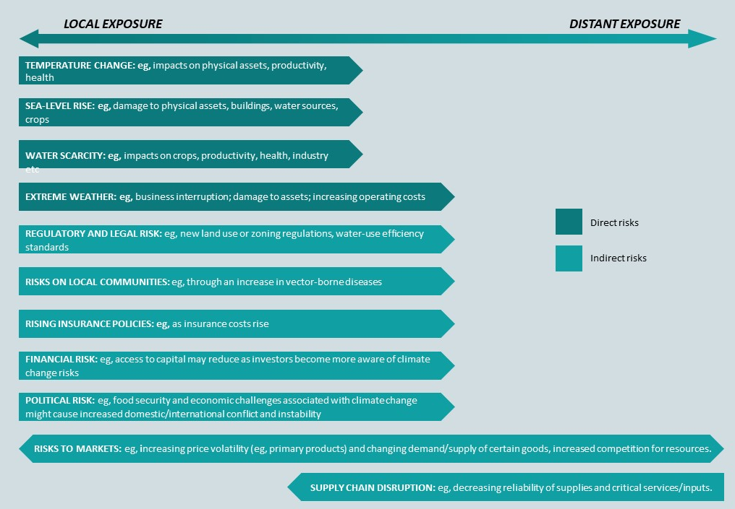
Source: Adapted from Pauw (2014)
Cascading risks
Climate change risks can propagate as ‘cascades’ across physical and human systems, potentially compounding to form many risks across various sectors. Such effects arise because of the links between natural and socio-economic systems as they change, and from feedback loops between them.
Cascading risks can have significant implications for community wellbeing, and the management and governance of climate risks (Lawrence et al, 2018).
Interdependencies
The chain of causality is often described as a ‘toppling domino effect’, where a sudden shock generates uncontrolled losses down the line of connected systems. Another word for this is ‘interdependencies’.
Understanding cascades
Figure 6 shows a range of interdependencies that can influence climate risk. Understanding cascades can help identify:
- potential impacts downstream
- points where a crisis may escalate
- the role of human-induced elements.
A holistic or systems approach is consistent with a te ao Māori perspective. This promotes understanding of both dependencies between elements, and cascading impacts.
Risk assessment teams may wish to look at examples of cascades. This may help in understanding and prioritising the risks, as well as in communicating these risks to stakeholders and communities. Teams can also consider cascading risks when assessing consequences (see section 3.2.4, step 3B).
Figure 6: Interdependencies and cascades between sectors which can influence climate risk
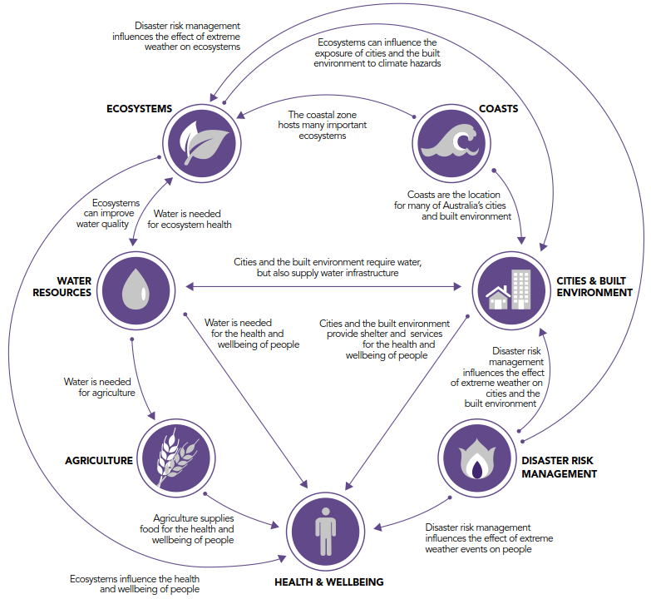
Source: Australian National Climate Resilience and Adaptation Strategy, 2015

PHASE 1:
Getting started

STEP 1A: Establish project team, governance, and communication plan
STEP 1B: Establish project principles, purpose, and level of the assessment
STEP 1C: Identify stakeholders and plan for iwi/Māori and stakeholder engagement

1 Phase 1: Getting started

1.1 Step 1A: Establish project team, governance, and communication plan
Who: Core project team, governance group, technical reference group | Outputs: Project team
Summary: Set up a project team and a technical reference group. Establish oversight, communication, and governance to ensure buy-in and success.
Those carrying out the assessment may be council staff, iwi/Māori, consultants, or partnerships with other councils or agencies. Carefully consider the project structure and allocate appropriate resources. This will go a long way to making it a success.

1.1.1 Project team and governance
As well as a core project team, you will need a technical reference group, and appropriate oversight and governance.
Also recommended: strong project leadership and engagement of subject matter experts.
One person may fill more than one role, particularly for smaller assessments, or where resources are limited. Table 1 sets out common roles and responsibilities.
Figure 7 shows an example structure of these groups.
Table 1: Examples of risk assessment project team, roles, and responsibilities
Group | Purpose | Who is involved
Governance group | - Organisational support  - Makes ultimate decision on prioritising risks and where to focus adaptation planning and response | This will vary among councils. It could be:  - council leadership team  - council elected members  - mayoral forum  - wider group including some combination of the above with iwi/Māori
Project leadership | - Senior ’champion’ giving authority to the project manager and core team  - Promotes benefits and helps manage issues as they arise | - A senior staff member as sponsor or champion  - A staff member to drive the process and document outcomes (project manager)
Core project team | - Drives the project  - Key contact with technical reference group and governance  - Manages budget, meetings, and workshops | - A staff member to drive the process and document outcomes (project manager)  - Treaty partners, hapū or iwi, acknowledging that councils have different ways of working together  - Subject matter experts  - Engagement specialists
Technical reference group | - Independent expertise, sector knowledge, and advice  - Technical advice throughout the project | Likely to include:  - council staff (across councils if appropriate)  - iwi/Māori (at least some level of representation even if not reflective of all iwi/hapū within the area)  - risk assessment expert (internal or external)  - subject matter experts (from within council or from different sectors)
Subject matter experts | - Detailed expertise on specific matters through surveys, workshops, and conversations | Diverse expertise including:  - council staff or external experts covering a range of disciplines (eg, council activities, infrastructure, biodiversity, economics, climate science)  - iwi/Māori and knowledge of mātauranga Māori  - industry specialists  - emergency management  - the local economy  - risk management, adaptation, business continuity, future thinking
Figure 7: Example of project structure for a local risk assessment
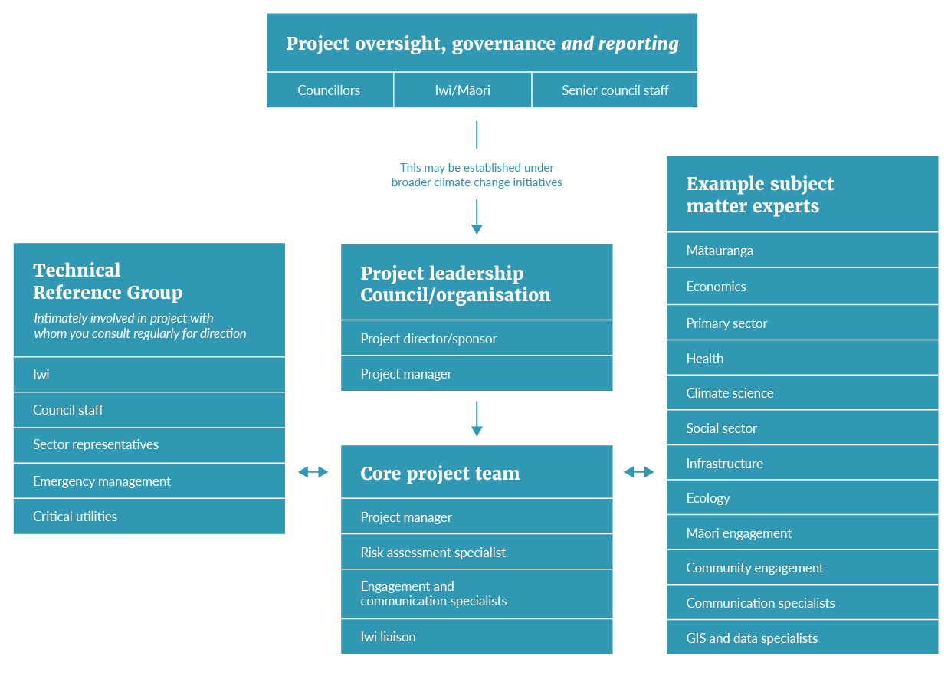

Governance
Governance and oversight of the process and the resulting actions are critical. This is because of the potential strategic influence of the assessment, combined with the inherent uncertainty. Strong governance ensures the assessment is targeted, outputs align with decisions, and buy-in is as broad as possible.
Governance and management staff must be aware of information that is communicated internally and externally. Appendix H outlines ways to assess the maturity of governance for risk assessments and adaptation.

1.1.2 Communication
Communication is vital for success and should be led by a senior-level champion. Approval from senior management is likely to be necessary to support any significant time the team has contributed. Senior representation may also help to develop or manage relationships with other organisations. Regular updates can encourage awareness of planned actions and progress, promoting participation and a better-informed contribution to the strategy.
Communication is essential for engaging with iwi/Māori partners and stakeholders such as the public and communities (section 1.3, step 1C). Treaty partners and stakeholders will be spread across the project groups and will perform different roles. This will require different approaches, depending on the phase of the project and who is involved.

1.1.3 Timeframes
The indicative timeframe for high-level risk identification and screening (step 3A only) is two to four months. For a detailed risk assessment, allow 12 to 18 months.

1.1.4 Working with iwi/Māori
Consider a co-design approach to the risk assessment with iwi/Māori.
Co-design is an iterative process of collaboration to gain new insights and develop solutions (NSW Council of Social Services, 2017). It provides an opportunity to reconcile Māori and Western knowledge systems, align with kaupapa Māori research and core values, and enable iwi/Māori to play an active role (Wakefield, 2019).
Co-design principles can include (Wakefield, 2019):
- whakawhanaungatanga (building relationships and trust)
- manaakitanga (affirming and upholding the mana of the people present)
- kotahitanga (unity)
- rangatiratanga (self-determination).
Embedding these principles into the process can:
- enable scheduling to consider specific needs of iwi/Māori
- give iwi/Māori the right to decide the level of their participation
- enable explicit decision-making by iwi/Māori
- build capacity (Wakefield, 2019).
Step 1C (section 1.3.3) has more detail on engaging with iwi/Māori.

1.2 Step 1B: Establish project principles, purpose, and level of assessment
Who: Core project team, governance group, technical reference group | Outputs: Agreed principles and scope of the assessment
Summary: Identify principles at the outset, to guide the assessment. Clearly identify the purpose and level of the assessment.

1.2.1 Ngā mātāpono (guiding principles)

Developing principles
Principles to guide the assessment should relate to the local context and can be developed inpartnership with iwi/Māori. For reference, see strategic documents such as the NCCRA, local/regional strategic statements, and iwi management and environmental plans.

Principles from the NCCRA
The NCCRA framework established a set of mātāpono that highlight the concepts of taiao (the natural world) and tangata (people) when carrying out a local risk assessment.
Each principle is in te reo Māori, with a translation. Table 2 shows examples of how to apply them.
Table 2: Suggested guiding principles
Principle (from NCCRA) | Use in a risk assessment
Manaakitanga (care and reciprocity)  - Respect and care for others and the environment  - Responsibility to promote wellbeing and health for both  - Recognition that people and the environment are inextricably linked | Consider:  - Cascading risks and how risks interrelate  - Social vulnerability
Kaitiakitanga (intergenerational sustainability)  - Protect and guard our taonga (environmental assets)  - Recognise the mauri (life force and essence) of the environment (ie, personification of landmarks and waterways)  - Guardianship of the environment for future generations | - Link to greenhouse gas emissions reduction  - Take a cautious approach (for instance, when choosing a representative concentration pathway (RCP) and timeline)
Whanaungatanga (connectedness and relationships)  - Recognition of Crown–Māori partnership through Te Tiriti o Waitangi  - Engagement, communication, and shared experiences  - Collaboration and collective action with marae, iwi, hapū, and communities | - Align with the NCCRA and reporting requirements (linking to domains and following prescriptive guidance)  - Incorporate te ao Māori principles appropriate to locality
Ōhanga (prosperity)  - Recognition of intergenerational equity  - Promotion of secure, stable, and diverse livelihoods  - Minimising harm to our taonga from economic activities | - Include transition risks  - Consider opportunities
Rangatiratanga (leadership and autonomy)  - Recognise, interweave, and live Te Tiriti o Waitangi and its principles  - Respect the notions of mana whenua, mana moana, mana taiao  - Be guided by scientific, historic, local, and mātauranga Māori | - Act with honesty and transparency; not over- or underplaying risks  - Identify own responsibility for managing risks and staying flexible
Kia mahi ngātahi (engagement and participation)  - Engage national, regional, and local agencies (eg, pan-Māori, Māori, iwi, and hapū representatives affected by the assessment) in the process  - Give contributors the opportunity to contribute to the development of the National Adaptation Plan  - Seek input from participants in designing their role | Consider:  - inclusivity  - strengthening relationships  - allowing enough time and resources
Kia āwhina (support)  - Recognise the needs and interests of all participants, including decision-makers  - Give participants the information they need to participate in a meaningful way; respect and consider their views  - Communicate with participants about the outcomes, and how their input affected decisions | - Appropriate communication to the audience (avoid being too technical)  - Assigning enough resources

1.2.2 Purpose of the assessment
Clarifying why you need a local assessment helps set the objectives and the level of assessment required. You can then give relevant information to all partners and stakeholders.
The main reasons are to prioritise high risks and to inform adaptation planning. Other reasons may include responding to reporting requirements (eg, ZCA, financial disclosures); managing biodiversity and habitats; informing spatial and land-use planning; infrastructure management; asset management; long-term plans; working with iwi/Māori and local communities.

1.2.3 Level of assessment
The different levels of assessment range from a high-level screening, to detailed qualitative, quantitative, or geospatial assessments (phase 3). To decide on the appropriate level, the lead organisation must consider the:
- purpose of the assessment
- quality and amount of data or information available
- scale and nature of the risk.
Iterative climate assessments can make best use of the available data, to inform more detailed assessments. For example, a high-level, qualitative assessment could be a first step if limited data are available (or as a method to cope with rapidly changing climate science, impacts, and understanding of climate risk). This may identify a potential high or extreme risk, which could then be the focus of a data-gathering phase to inform a later, detailed, quantitative, or geospatial risk assessment.
Table 3 shows the level of assessment that is likely to be suitable at various scales.
Table 3: Level of risk assessment at different scales
Level of assessment | Typical scale | Description
First-pass/high-level screening (qualitative) | Regional/district/community/sector | Identifying and describing risks in regions, districts, cities, local communities within agreed themes, value domains, and aggregating to sector-level risks (transport, water, terrestrial biodiversity)
Detailed assessment (qualitative) | Regional/district/community/sector | Identified risks are rated based on an agreed method  Descriptions of risks can discuss sub-regional and sub-sectoral differences
Detailed assessment (quantitative or geospatial) | District or sector | Uses downscaled climate projections, district and city hazard and exposure modelling, and vulnerability analysis to assess risks  Risks are rated according to agreed method, supported by quantitative data  Descriptions of risks can discuss a range of spatial scales; may include detailed geospatial maps or asset registers
Organisational assessment | Organisation (eg, council) | Assesses risk or identifies issues/gaps in organisational maturity relating to climate change risk and adaptation  Can relate to key organisational functions, including strategy, planning, infrastructure/asset management, civil defence emergency management, business continuity, risk management, governance, legal and reputational, and finance

1.3 Step 1C: Identify stakeholders and plan for iwi/Māori and stakeholder engagement
Who: Core project team, governance group, technical reference group | Outputs: Engagement plan
Summary: Engagement is a critical element. Develop engagement plans at the start of the project. Follow good practice (see International Association of Public Participation, IAP2).

1.3.1 Identify stakeholders
Local communities can hold practical information about hazards and risks, which can complement technical assessments. Seeking input from stakeholders, including community members and technical experts, is a key step during the risk identification and assessment phases. Stakeholders may include wider community representatives who can inform understanding of the local risks to individuals, iwi/Māori, communities, and sectors. In your planning it is important to note that iwi/Māori are Treaty partners not stakeholders.

They may be supported by subject matter experts in the project team – for example:
- Māori/iwi/hapū contacts
- researchers (eg, Crown research institutes, universities, private companies)
- policy analysts (eg, hazard, risk, and climate policy) in central and local government
- practitioners (eg, planners, engineers, economists, social, cultural, environmental, legal) with experience in climate matters)
- central government, local government, and infrastructure/asset owners
- professional bodies with representatives well versed in climate change (eg, New Zealand Planning Institute, Resource Management Law Association)
- sector and industry organisations or representatives (eg, district health board, primary sector, tourism, telecommunications services)
- public services or groups (eg, civil defence, fire service)
- non-governmental organisations
- youth representatives (eg, youth councils, schools)
- the local community, including affected landowners and local community groups
(eg, ratepayers associations).
The type of engagement will vary during the different stages of the assessment. For example, you should engage a broader range of stakeholders at the early risk identification and screening phase, and a narrower number of stakeholders/subject matter experts during the detailed risk assessment phase.

1.3.2 Plan for engagement
The activities for both the development and implementation of an engagement strategy to undertake a risk assessment, are outlined in Chapter C1 of the National Arotakenga Huringa Āhuarangi Framework. The guidelines presented here are based on the general and iwi-specific considerations for engagement within the NCCRA framework, as well as the consideration of mātauranga Māori in the risk assessment process.
Develop your engagement plans in line with good practice principles, as set out by the International Association of Public Participation (IAP2). Activities may include workshops, hui, structured interviews, surveys, digital engagement, and media. Appendix F has more details.
Effective engagement may benefit the risk assessment process and outcomes through sharing and gathering information and building positive long-term relationships.

1.3.3 Considerations for engaging with Māori
When planning for engagement with iwi/Māori, consider the capability and capacity of those you seek out. They will have varying skills, resources, and knowledge, and competing priorities. Also consider the time needed to address issues and give input, and the time that individuals can invest.
Follow best practice (eg, Te Arawhiti Guidelines for engagement with Māori). A person with knowledge and experience of Māori engagement principles and tikanga should be on the team. For more detail, see appendix F.
Early dialogue is important to determine iwi/Māori involvement. Contact local mana whenua to discuss and agree on the level of participation. Within the local region there will be iwi and other significant Māori groups that will be important to contact. In some regions, there are significant pan-Māori groups that will also expect to be included in conversations. This, for example, is represented in pan-Māori urban authorities.
Consider equipping iwi/Māori with resources to draw up their own frameworks and make their own local assessments. These could then feed into/sit alongside regional or local assessments.

Te ao Māori
Te ao Māori, is a combination of values, beliefs, histories, knowledge systems, and ways of perceiving the world that are unique to Māori. Mātauranga Māori (Māori knowledge systems) is integral to a te ao Māori perspective. While there are a range of levels at which a te ao Māori view can be incorporated, working with iwi/Māori from the outset to determine the extent of input is suggested.
This could include:
- considering te ao Māori values in the risk assessment and assessing risks with relevance to Māori throughout the process
- acknowledging and stating the limitations of a technical risk assessment from a te ao Māori perspective.
- recognising that appropriately skilled people in councils must manage relationships with iwi/Māori
- recognising the status of iwi/Māori as Te Tiriti o Waitangi partners
- acknowledging that some issues affect iwi/Māori disproportionately and iwi/Māori may be better placed to find solutions.

1.3.4 Considering mātauranga Māori
Mātauranga Māori or Māori knowledge has many definitions that cover belief systems, values, and knowledge. Mātauranga Māori incorporates knowledge and understanding of everything visible and invisible existing in the universe (MfE, 2019). Mātauranga Māori, like other indigenous knowledge, is well recognised for the potential contribution and inroads that this body of knowledge can make towards advancing climate adaptation and emissions reduction.
Throughout the assessment, you can use various processes and methods to identify risks relevant to iwi/Māori, and to taonga, assets, and cultural constructs. These can include kaupapa Māori methodologies, collaborative processes, and a combination of modelling quantitative and qualitative assessments.
For more detail see section 3.1.3 (step 3A). Appendix F has general information on engagement with iwi/Māori, and mātauranga concepts.

PHASE 2:
Setting up the risk assessment

STEP 2A: Inputs and scale of assessment
STEP 2B: Climate change scenarios and timeframes
STEP 2C: Develop and agree organising themes

2 Phase 2: Setting up the risk assessment

2.1 Step 2A: Inputs and scale of assessment
Who: Core project team, governance group, technical reference group | Outputs: List of inputs, scale of assessment, data gaps.
Summary: The scale of assessment (and data availability) will influence the inputs you need for climate hazards and elements at risk.
Section 1.2.3 (step 1B) outlined the range of inputs, and the varied levels of assessment.
A combination of qualitative and quantitative information will be useful, particularly when assessing community risks.
All assessments should use regional or local (downscaled) climate projections and other hazard data (eg, for coastal inundation, flood hazards). If these are unavailable, use the national projections.
You can generally source information on elements at risk from surveys of subject matter experts, literature review and engagement. If you undertake a detailed geospatial assessment, you will need specific data (eg, infrastructure networks).
For a list of resources, see section 5.

2.1.1 Scale of assessment
If you’re assessing risk at a large scale, it can be challenging to account for differing geographical responses and levels of exposure to climate stressors. This can dilute the risk measures when they are aggregated to a regional level and may mean you overlook significant impacts occurring within only some sub-regional areas (eg, from farming).
It may be useful to subdivide the region of assessment, so you can group risks that are unique to certain areas and assess them independently. You could consider the risks according to:
- sub-region, district, or community, or
- type of environment – eg, rural vs urban, coastal vs inland, mountainous vs low-lying.
Use your judgement when determining the scale and level of detail, along with the degree of aggregation of information. This can affect the costs and resources you will need. In many cases, you can make an assessment with limited data, identifying gaps and improvements for future iterations (section 3.2.3).

2.2 Step 2B: Climate change scenarios and timeframes
Who: Core project team, technical reference group | Outputs: Agreed climate change scenarios and timeframes
Summary: Align scenarios and timeframes with those in the NCCRA. Timeframes: present day, mid-century, end of century, and 2150 (optional). Climate projections: RCP4.5 and RCP8.5. You can include other timeframes and scenarios to suit local needs.
Climate change scenarios are a way of describing possible future changes to climate variables and hazards. Use the scenarios that align with the NCCRA and with climate projections at a national and regional level.
Councils (or others using this guide) may consider other scenarios and timeframes as they see fit. You can also include alternatives as information emerges (eg, new IPCC Climate Change Assessment Reports) or regulation changes (eg, new resource management system).

2.2.1 Representative concentration pathways
The climate change projections recommended in this guide (see figure 8) align with those in the NCCRA framework. They are derived from four representative concentration pathways (RCPs) and were used by the Intergovernmental Panel on Climate Change (IPCC) in its fifth Assessment Report (2013–2014) (IPCC, 2014a).
Figure 8: RCP scenarios showing annual emissions per year
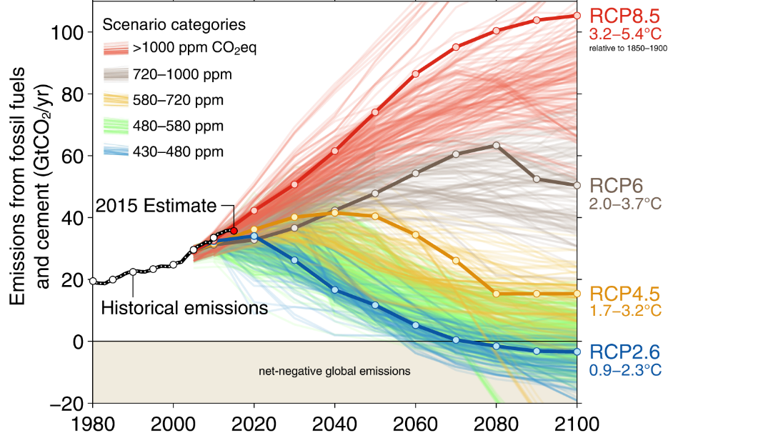
Source: Fuss et al (2014)
The RCP scenarios are:
- RCP 2.6 – this represents a future where emissions are reduced. It leads to a range of mean annual temperature projected across New Zealand of 0.5–0.8°C by 2031–2050, and 0.5–0.7°C by 2081–2100.
- RCP 4.5 – this is a lower mid-range scenario, where greenhouse gas emissions are stabilised. It leads to a range of mean annual temperature projected across New Zealand of 0.6–0.9°C by 2031–2050 and 1.3–1.4°C by 2081–2100.
- RCP 6.0 – this is a higher mid-range scenario where emissions are stabilised. It leads to a range of mean annual temperature projected across New Zealand of 0.7–1.1°C by 2031–2050 and 1.6–1.8°C by 2081–2100.
- RCP 8.5 – this is a ‘high-end’ emissions scenario with high global emissions. It leads to a range of mean annual temperature projected across New Zealand of 0.9–1.1°C by 2031–2050 and 2.8–3.1°C by 2081–2100.
The two recommended RCPs for a risk assessment are RCP 4.5 and RCP 8.5: the lower mid-range and high-end scenarios.
The RCP 8.5 scenario is useful to identify the most significant risks if warming continues unabated. The RCP8.5 ‘high-end’ scenario is a precautionary, underpinning assumption for a risk assessment (Hausfather, 2019). Predicting emissions trajectories, and their likelihood, is complex and depends on factors including climatic and atmospheric science, socio-economic and technological change over time, and international/national climate policies. Most, if not all, are extremely hard to predict with certainty.
The RCP4.5 scenario is useful to identify risks under a more ambitious reduction pathway, where emissions peak around 2040 and then decline.

Transition risks
The first NCCRA did not consider transition risks, but future iterations may. In this guide, transition risks include those associated with the shift to a lower-carbon economy, and with the move towards climate resilience in communities. The Taskforce on Climate-related Financial Disclosure (TCFD) advises evaluating the risks from the transition to a lower-carbon economy in terms of a scenario with a global temperature increase of 2ºC or lower (TCFD,2017).
For more detail, see appendix I.

2.2.2 Recommended timeframes
Three main timeframes are recommended for assessing risks (and opportunities) from climate change. There is a fourth for coastal hazard risks resulting from rising sea levels (MfE, 2020).
Present day (past 10–20 years). The impacts already occurring from climate change are a starting point for considering the urgency of the risks you identify. This is also a useful starting point when seeking feedback, before considering future impacts.
30 years: around 2050 (or the decade 2040–2050). This covers the next few cycles of council long-term plans, and 30 years is the planning timeframe for local government infrastructure strategies (Local Government Act 2002, section 101B) and asset management plans. It also aligns with the longer terms granted for resource consents (up to 35 years).
By 2100 (around 60–80 years). Typically used as the juncture for detailed climate change projections. A limitation of this timescale is that some decisions (eg, land-use planning) require at least 100-year timeframes. However, this timeframe enables projections for a wide range of climate variables without the need for extrapolation.
By 2150 (optional). For coastal hazard risks related to sea-level rise, given that (MfE, 2019):
- the New Zealand Coastal Policy Statement 2010 has a mandate to assess coastal hazard risks (including climate change) to “at least 100 years” (Department of Conservation, 2010)
- a set of New Zealand-specific sea-level rise projections to 2150 is available in the Coastal Hazards and Climate Change Guidance for Local Government (Ministry for the Environment, 2017, p 105, Figure 27)
- national coastal flooding risk exposure mapping has been completed for coastal areas up three-metre rises (Parliamentary Commissioner for the Environment, 2015; Paulik et al, 2019b; LGNZ, 2019b).

2.3 Step 2C: Develop and agree organising themes
Who: Core project team, governance group, technical reference group | Outputs: Agree on organising themes
Summary: Using themes to consider risks helps to structure your assessment. They could reflect the local context, recognising te ao Māori, and linking to the NCCRA.
The term ‘risk’ generally relates to the potential for the loss of something of value, so there will likely be a lot of information to consider. Themes will help you manage this. They can also help you identify who to involve in surveys and workshops.
You can draw on a range of frameworks, including the NCCRA framework, Treasury’s Living Standards Framework, He Ara Waiora, National Disaster Resilience Strategy and Te Whare Tapa Whā (see Box 3). Or, councils may decide to work with iwi/Māori and stakeholders to develop organising themes that reflect specific needs.
Some things to consider when identifying themes:
- taonga or values relevant to the local assessment, which reflect a range of world views including te ao Māori
- alignment with the NCCRA. For reporting, you may need to map your themes back to the NCCRA ‘value domains’
- linking to potential ownership and responsibility for the identified risks.

Addressing connections
A limitation of the NCCRA and many other similar frameworks is that they cite discrete themes without clearly illustrating the connections between them. It is challenging to balance a risk assessment methodology with diverse views and values. One way is by exploring the interdependencies of the themes, to gain a more complete understanding of how climate change will affect all aspects of wellbeing (Box 3).
Box 3: Examples of frameworks with organising themes
NCCRA framework
The NCCRA framework draws on the Treasury’s He Ara Waiora framework and the National Disaster Resilience Strategy. It was developed to gain an understanding of risk across five valuedomains (natural, human, built, economy, and governance). See table 4 for the domain descriptions.
Table 4: Value domain descriptions from the NCCRA framework
Value domain | Description
Human | People’s skills, knowledge, and physical and mental health (human); the norms, rules, and institutions of society (social); and the knowledge, heritage, beliefs, arts, morals, laws, and customs that infuse society, including culturally significant buildings and structures (cultural).
Natural environment | All aspects of the natural environment that support the full range of our indigenous species, he kura taiao (living treasures), and the ecosystems in terrestrial, freshwater, and marine environments.
Economy | The set and arrangement of inter-related production, distribution, trade, and consumption that allocate scarce resources.
Built environment | The set and configuration of physical infrastructure, transport, and buildings.
Governance | The governance architecture and processes in and between governments, and economic and social institutions. Institutions hold the rules and norms that shape interactions and decisions, and the agents that act within their frameworks.

Treasury’s Living Standards Framework (LSF) and He Ara Waiora
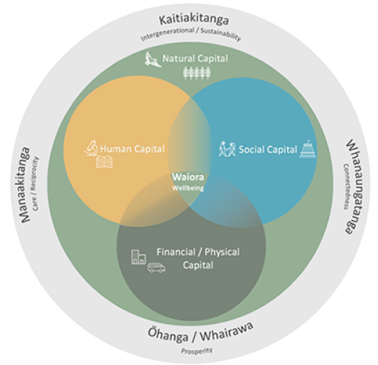
The LSF is a New Zealand-specific framework developed by the Treasury. It draws on a range of national and international approaches to wellbeing. It applies to several aspects of life experience, such as housing, income, employment, education, community engagement, enjoyment of environmental amenity, and health and safety. These are presented as four interdependent forms of ‘capital’ – natural, human, social, and financial and physical (the Treasury, 2019).
He Ara Waiora is a development of the LSF to incorporate te ao Māori. The framework presents waiora/wellbeing as the foundation of all types of capital, with natural capital underpinning human, social, financial, and physical. These apply in the context of shared societal values or principles of manaakitanga, kaitiakitanga, whanaungatanga, and ōhanga (O’Connell et al, 2018).
National Disaster Resilience Strategy
The National Disaster Resilience Strategy (Rautaki ā-Motu Manawaroa Aituā) outlines the vision and long-term goals for civil defence emergency management in Aotearoa New Zealand. The model is of a resilient nation, identifying six types of resilience that are fundamental to protecting Aotearoa’s capital and future wellbeing. These concepts are underpinned by knowledge, and operate at several scales, from individuals and family/whānau to businesses and organisations, communities and hapū, cities and districts, and governance at a national level (Ministry of Civil Defence & Emergency Management, 2019).
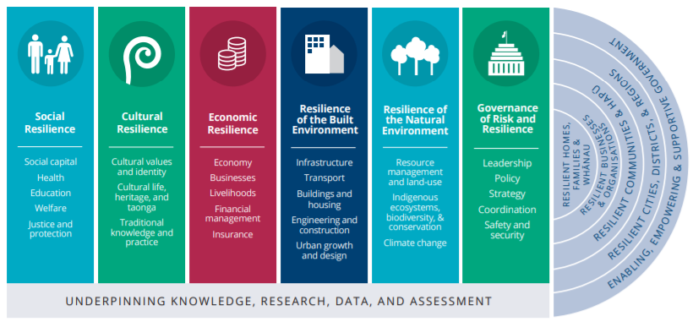
Te Whare Tapa Whā
Te Whare Tapa Whā model was designed for the health sector, but could apply to climate change where it integrates the nature of climate change risks within mātauranga Māori. The model has four elements representing hauora (wellbeing): taha tinana (physical health), taha wairua (spiritual health), taha whānau (family health), and taha hinengaro (mental health). These are likened to the walls and roof of a whare (house), supported by whenua (land). The model applies across a range of scales, from whānau (family), to maunga (mountains) to te moana (the sea) (Durie, 1994).
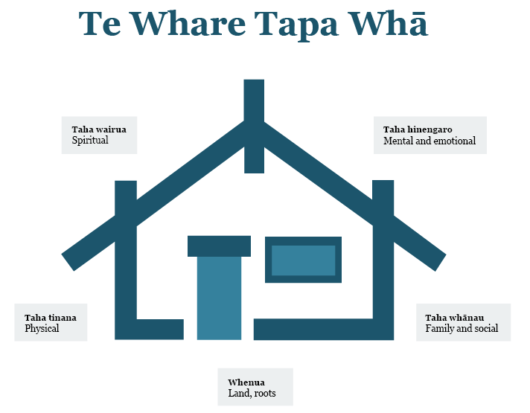

PHASE 3:
Carrying out the risk assessment

STEP 3A: Identify hazards; screen elements at risk
STEP 3B: Detailed physical risk assessment
STEP 3C: Additional analysis (optional):
• Consequence rating
• Opportunities
• Geospatial analysis
STEP 3D: Review risk-rating workbook
STEP 3E: Risk assessment report

Box 4: Assessing climate change risk
Defining risk
Reisinger et al (2020) define risk as “the potential for adverse consequences for human or ecological systems, recognising the diversity of values and objectives associated with such systems. In the context of climate change, risks can arise from potential impacts of climate change as well as human responses to climate change. Relevant adverse consequences include those on lives, livelihoods, health and wellbeing, economic, social and cultural assets and investments, infrastructure, services (including ecosystem services), ecosystems and species”.
Risk assessments aim to understand the nature and level of climate change risk. They inform our actions to reduce such risks.

3 Phase 3: Carrying out the risk assessment
This section relates to assessing physical risks from either acute climate events or longer-term climatic changes.

Two-step process
Your assessment can follow the two steps set out here:
- Step 3A: Identify hazards; screen elements at risk.
- Step 3B: Qualitative (and in some cases quantitative) detailed assessment (and rating).
If you are short on time and resources, you could just do the risk screening. You could make the detailed assessment at a later time.

3.1 Step 3A: Identify hazards; screen elements at risk
Who: Core project team, technical reference group, subject matter experts, stakeholders, GIS specialists, data analysts | Outputs: Risk screening database
Summary: Identify the local climate hazards. List the ‘elements at risk’ (eg, people, systems, assets) that could be exposed or vulnerable. Screen these against the hazards, to find where there is potential for impact on each element.
Figure 9 shows the process for step 3A.
Figure 9: Process for step 3A
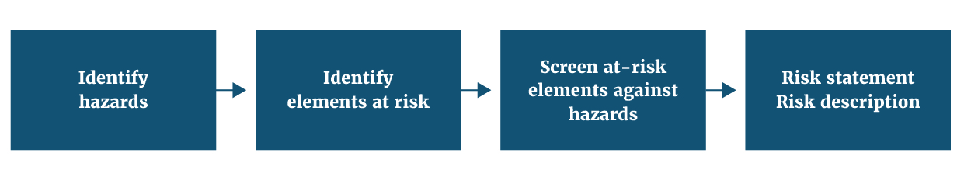

3.1.1 Identify climate hazards

Timeframes and RCP scenarios
For details, go back to section 2.2, step 2B.
As discussed in section 2.2, you will need to evaluate the risks at three points: present, 2050, 2100.
Ideally, you should also use two RCP scenarios (RCP8.5 and RCP4.5). RCP8.5 is generally considered a ‘high end’ or in some cases, a ‘business as usual’ emissions scenario (MfE, 2017). RCP4.5 is an intermediate scenario where emissions peak around 2040, then decline.
The first step is to identify the relevant climate projections and hazards. The project team will need to source hazard information from:
- national climate projections (MfE, 2018).
- regional or local downscaled climate projects (if available).
- regional or local data such as geospatial coastal inundation, coastal erosion, and flood hazards.
The broad range of hazards will be similar for most parts of New Zealand. Appendix A lists examples. Use this as an initial checklist for this risk identification stage.
Figure 10shows high-level climate projections for New Zealand. Table 5 is an example you can develop at a regional level, summarising hazards of interest. Use this key information during the engagement (survey, workshops) to better understand the potential impacts of different hazards at different timeframes.
Figure 10: Climate projections for New Zealand
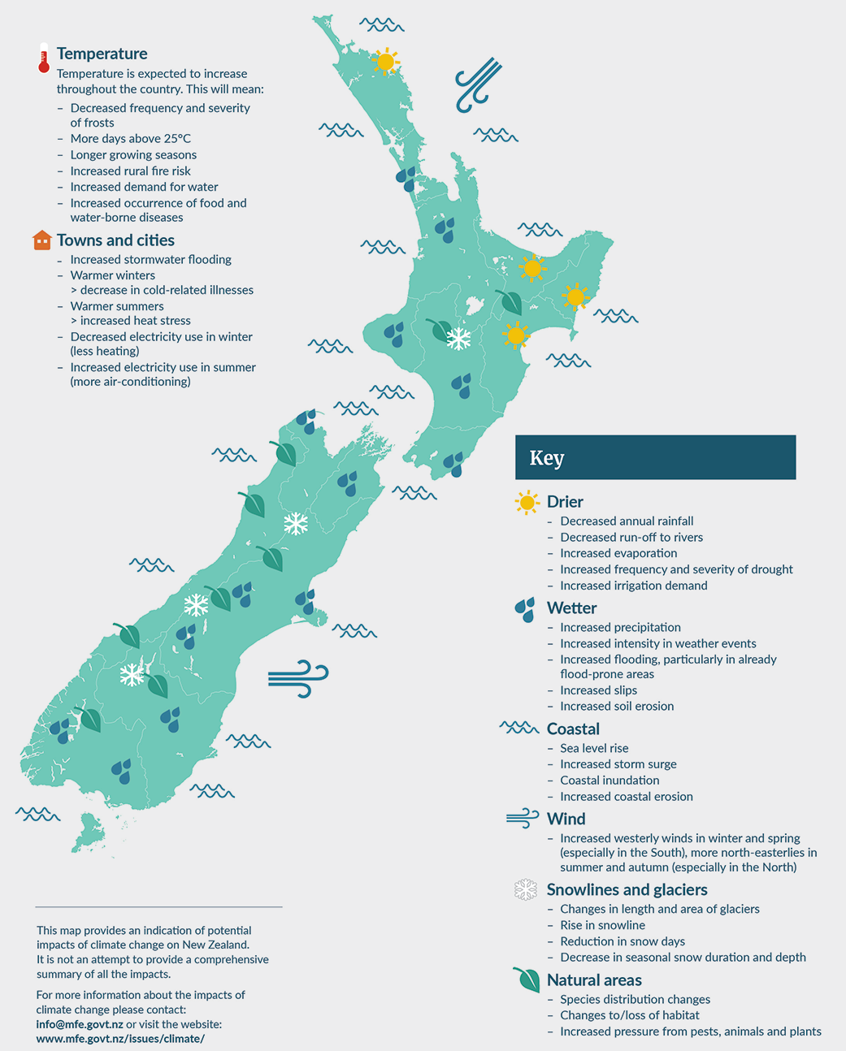

Table 5: Example: mid- and long-term climate projections for RCP8.5
Climate driver/variable | Mid-term (2040) RCP8.5 | Long-term (2090) RCP8.5
Higher temperature | + 0.5–1.0°C  + 1.0–1.5°C (Autumn) | + 2.5–3.0°C  + 3.0–3.5°C (Autumn)
Average change in ‘hot days’ from present day (20) | + 20–25 days  + 15–20 days (coastal areas) | + 70–80 days  + 40–50 days (coastal areas)
Annual rainfall | - 8–15% in summer rainfall  + 10–15% winter rainfall | - 10–15% in summer rainfall  + 4–8% in winter rainfall
Average change in ‘cold nights’ from present day | - 6–10 cold nights | - 15–25 cold nights
Sea-level rise | + 0.3 m | + 0.8 m
Wind (mean speed) | - 3–6% in summer  + 1–3% in spring | 6–10% in summer  + 4–6% in winter
Inland flooding | + 6% rainfall depth  (24 hr, 100 yr) | + 18% rainfall depth  (24 hr, 100 yr)

3.1.2 Identify elements at risk and screen against hazards
When you have listed the hazards, you can consider the elements at risk (eg, people, assets, values, taonga, species) that are affected by these hazards.
The aim is to quickly make a long list of potential risks, drawing on knowledge from partners and stakeholders. This can be through desktop research, online surveys or workshops.

Stakeholder surveys
Surveys are more efficient and gather information from a wider source. You can use this for focused discussion in a workshop, at the detailed assessment stage. For information and suggestions, see appendix B.
Points for partners and stakeholders to consider include:
- the element at risk from a specific hazard
- justification of risk, and the context
- whether the risk is direct (from hazard events) or indirect (from cascading impacts)
- specific locations where risk is/will likely be present
- for direct risks, examples of possible cascading (downstream) impacts (eg, affecting wellbeing).

Analyse and list your findings
The project team or subject matter experts will need to review and consolidate the input as follows:
- Review feedback to remove duplicates and irrelevant information.
- Decide whether an identified risk is direct or indirect/cascading. See box 2.
- Write a statement for each risk. This should follow a simple format, for example, “Risk to element at risk X due to climate hazard Y” (eg,“Risk to transport networks due to coastal inundation”). See table 6.
- Write a short description of the risk, based on the input received. This adds context and detail to the risk statement, for example, “Coastal inundation is already an issue to roads in our district and is projected to worsen over time”. You may include the spatial distribution or variability of the risk (which parts of the region/district where it will likely occur). See table 6.

Indirect or cascading risks (see box 2)
For indirect risks, a risk statement can be more descriptive. For example, “the risk of worsening water quality due to the combination of more intense, brief rainfall (causing runoff), drought and land use”.
Table 6: Examples of risk statements and descriptions
Risk ID | Climate hazard | Element at risk | Risk statement | Risk description/known locations
1 | Sea-level rise, coastal flooding | State highway network | Risk to the state highway network due to sea-level rise and coastal flooding | State highway network follows the coast and is at risk from sea-level rise which, combined with severe weather and high tides, causes damage and outages
2 | Changes in rainfall | Agriculture/horticulture | Risk to agriculture/ horticulture due to changes in rainfall/ drought | To grow commercial and other crops requires year-round water supplies
3 | Inland flooding | Water quality | Risk to water quality from inland flooding | Flood water over agricultural land carries contaminants into receiving environments (eg, from farm drains/effluent ponds/dairy infrastructure)
4 | Higher temperature (including more hot days) | Natural ecosystems | Risk to natural ecosystems from higher temperatures | Warmer conditions will enable/assist both new pest incursions and naturalisations of sub-tropical/tropical organisms
5 | Extreme weather (wind and storms) | Stormwater network | Risk of urban stormwater networks being overwhelmed by extreme weather/flooding | More frequent storms increase likelihood that stormwater systems will be overwhelmed, increasing flood risk

Screening the elements at risk
You can list the risks under themes and climate hazards (table 7) for an overview of the risk landscape. This can also identify any obvious gaps where you might need further stakeholder input.
Do the screening while considering a high-end climate scenario (RCP8.5), so you capture a wide range of potential risks.
Table 7: Example of a risk matrix
Theme* | Element at risk | Climate hazard
 |  | Drought | Increased temp | Flooding | Extreme events | Sea-level rise | Etc …
Built | Buildings | ✓ |  | ✓ | ✓ | ✓
 | Roads |  | ✓ | ✓ | ✓ | ✓
 | Water supply | ✓ | ✓ | ✓ | ✓
 | Wastewater | ✓ | ✓ | ✓ |  | ✓
Natural | Taonga species | ✓ | ✓ | ✓ |  | ✓
 | Freshwater ecosystems | ✓ | ✓ | ✓ |  | ✓
Economy | Tourism | ✓ |  | ✓ | ✓
 | Horticulture | ✓ |  | ✓ | ✓
For a more detailed matrix, see appendix C.*See step 2C.

3.1.3 Mātauranga Māori and identifying risks to iwi/Māori
Mātauranga Māori is informed by understanding that people are only one part of a broader network of relationships. This is defined by whakapapa, where Ranginui (Sky Father) and Papatūānuku (Earth Mother) are the primordial parents. The connections are not only in physical form, but also in wairua (spiritual) form. Supporting the ecosystem is viewed in these terms and is often defined in terms of kaitaikitanga (stewardship/guardianship).
The wealth of accumulated community and individual knowledge (mātauranga Māori) is uniquely place-focused and based on empirical observation. It should be a specific consideration when identifying climate-related risks. The holders of this knowledge are tangata whenua, and access to this knowledge may only be obtained through consultation with local iwi.
For risk assessments, both physical and spiritual wellbeing (environment and people) are viewed as interconnected and critical. The iwi/Māori protocols associated with physical and spiritual wellbeing will differ between iwi/hapū groups and will require specific local conversations with the right individuals/groups. Risks to iwi/Māori are best identified and assessed by working together with local iwi representatives. There is no specific methodology, but it is understood there are several pilot assessments underway, ranging from local iwi developing their own risk assessment with support from local council through to iwi/Māori having governance oversight of climate change projects (eg, Independent Māori Statutory Board in Auckland).
The Treaty of Waitangi is the platform for a partnership approach between iwi/Māori and the Crown/Pākeha. This is essential for decisions on climate change interventions and adaptation and to ensure equity of outcomes in the social, cultural, environmental, and economic domains. Incorporating an understanding of mātauranga Māori, as well as considering cultural and social differences helps us grasp the wider climate implications for New Zealand. This could make a significant contribution to the risk assessment process.

3.2 Step 3B: Detailed physical risk assessment
Who: Core project team, technical reference group, subject matter experts, stakeholders, GIS specialists, data analysts | Outputs: Draft risk-rating workbook
Summary: Assess direct climate risks, based on exposure and vulnerability, to generate a rating for each risk. Consider indirect/cascading risks separately.
- Set up targeted engagement (eg, workshops) with subject matter experts and key stakeholders, to gain insight into the screened elements at risk.
- You could review the literature on each risk.
- The spreadsheet developed from the stakeholder input (step 3A) forms the basis for the workshops. For a detailed template, see appendix D.

3.2.1 General methodology
Many climate risks are complex, so a detailed assessment is generally qualitative, drawing on specialist and local knowledge (which acknowledges the uncertainty).
The recommended method uses a qualitative rating of exposure and vulnerability (figure 11). It draws from the IPCC conceptual risk framework (box 1, figure 4). This shows that risks from climate change arise from the interaction between a hazard (triggered by an event or trend related to climate change), vulnerability (susceptibility to harm), and exposure (of the people, assets, or ecosystems to the hazard).
You should use this method for direct risks only (ie, where there is a direct relationship between an element at risk and a hazard). These are the most common risks.

Rating indirect/cascading risks
Assessing indirect or cascading risks is difficult, as they are complex and often still emerging. Methods for evaluating these risks are not well developed internationally. However, for a suggested approach see section 3.2.2. These types of risks can help you prioritise direct risks (step 4A).

Assessment steps
Figure summarises the steps for both direct and indirect/cascading risks.
The optional step 3C is an assessment of consequence, for a more refined prioritisation of risk. Here, consequence relates to importance, significance, or value. You may prioritise a particular risk, due to its significance for communities, iwi/Māori, or other stakeholders. This is discussed in section 3.3.1, step 3C.
Figure 11: Steps of the risk assessment approach
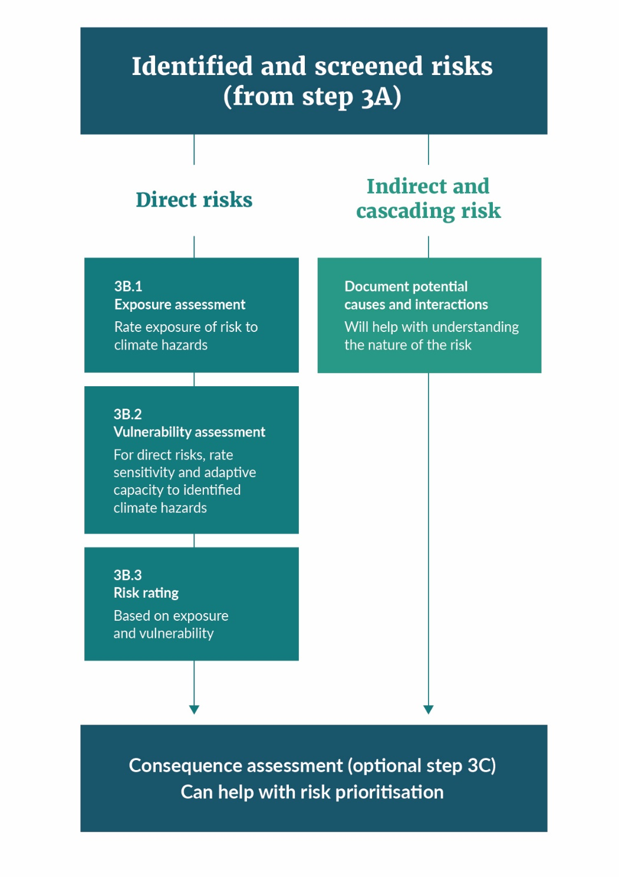

3.2.2 Holding a workshop
The project team will need to hold workshops to assess the risks identified in step 3A (identification of hazards and screening elements at risk) and capture the feedback. Here are some tips.
- Set a clear agenda and consider sending out a briefing note to ensure participants understand the context and purpose. Appoint a skilled facilitator. For a large group, consider individual table facilitators as well.
- Gather a range of materials to use in breakout sessions – eg, regional climate projections, prepared templates for capturing risk information, post-it notes.
- Explain the context before you start any activities. This should include local climate, project information context and an outline of the methodology.
- Summarise the results of any surveys and outputs of the identification and screening stage.
- Ask participants to work through the risk assessments, in order to rate each risk (sections 3.2.3 and 3.2.4). Record the justifications for all ratings, and other details (eg, references, contacts for further information, areas of uncertainty). You could create an automated spreadsheet to capture and rate each risk during the session. This will depend on the size of the group. It is not recommended for big groups where there is a potential for a large number of risks.
- Remember to also capture indirect/cascading risks and consequences.

3.2.3 Evaluating direct risks

Elements at risk, exposure, and vulnerability
We assess direct climate risks by looking at:
- the elements at risk: people, livelihoods, species or ecosystems, environmental processes and resources, infrastructure, or economic, social, or cultural assets
- their exposure to the climate hazard
- their vulnerability which comprises sensitivity and adaptive capacity.
Figure 12: Elements at risk: exposure and vulnerability
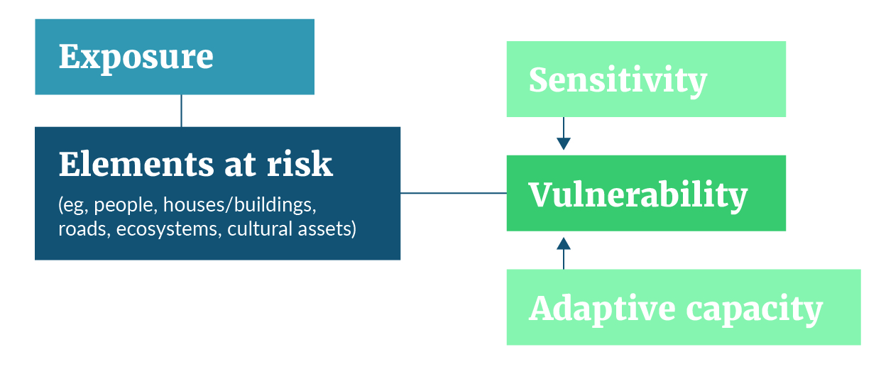

Step 3B.1: Assessing exposure
What is exposure?
Exposure refers to the presence of people, livelihoods, species or ecosystems, environmental functions, services, and resources, infrastructure, or economic, social, or cultural assets in places and settings that could be adversely affected by a climate hazard (IPCC, 2014a).
Points to consider are the spatial location and extent of exposure (quantity) of an element at risk to the hazard.
Evaluation of exposure is usually uncertain, due to changes in the hazard and the wider context.
The scale for rating exposure ranges from low to extreme (table 8), across three timeframes (present, 2050, 2100). Ideally it applies to two RCP scenarios (RCP8.5 and RCP4.5), to represent the changing severity of the hazards.
In most cases it is unlikely there will be enough data for a detailed quantitative rating.
Table 8: Exposure rating scale
Exposure rating | Qualitative definition | Quantitative definition
Extreme | Significant and widespread exposure of elements to the hazard | >75% of sector or element is exposed to the hazard
High | High exposure of elements to the hazard | 50–75% of sector or element is exposed to the hazard
Moderate | Moderate exposure of elements to the hazard | 25–50% of sector or element is exposed to the hazard
Low | Isolated elements are exposed to the hazard | 5–25% of sector or element is exposed to the hazard
Source: MfE, 2019

Step 3B.2: Assessing vulnerability
What is vulnerability?
Vulnerability refers to the propensity or predisposition to be adversely affected by a climate hazard. Vulnerability encompasses a variety of concepts, including sensitivity to harm, and lack of capacity to adapt (or adaptive capacity) (IPCC, 2014a).
We evaluate vulnerability by separately considering an element at risk’s sensitivity and adaptive capacity. It is independent of exposure or location. These terms are defined as follows:
- Element at risk (eg, system or species).
- Sensitivity refers to the degree to which an element at risk is affected, either adversely or beneficially, by climate variability or change (IPCC, 2014a). Sensitivity relates to how the element will fare when exposed to a hazard, which is a function of its properties or characteristics.
- Adaptive capacity refers to the ability of systems, institutions, humans, and other organisms to adjust to potential damage, to take advantage of opportunities, or to respond to consequences (IPCC, 2014a). It relates to how easily/efficiently an element at-risk can adapt (autonomously) or be adapted (planned) when exposed to a climate hazard. Again, this is a function of an at risk element’s properties or characteristics.

Rating scale
Generally, we make a qualitative assessment of sensitivity and adaptive capacity. Both assessments will be uncertain. For both, we can use a four-point scale:
Sensitivity: from low to extreme.
Adaptive capacity: from very low to high.
It is simpler to rate sensitivity and adaptive capacity independently of the RCP scenario and timeframe, which would give a single vulnerability rating for each risk. In some cases, you could include quantitative data – for example, using fragility functions for infrastructure to justify the rating.
Adaptive capacity requires a conservative approach, particularly where planned adaptation needs investment (which may not be guaranteed).
A high adaptive capacity will reduce the overall vulnerability rating. Any assumptions that influence the adaptive capacity of an element at risk should be recorded to avoid a situation where a high adaptive capacity rating (and consequent lower vulnerability rating) reduces the likelihood of the planned adaptation being implemented and funded.
Table 9 combines the ratings for sensitivity and adaptive capacity, to produce a vulnerability rating on a four-point scale. A spreadsheet can generate this automatically. Table 10 lists the definitions of each vulnerability rating.
Table 9: Vulnerability matrix (combining sensitivity and adaptive capacity)
 |  | Sensitivity
 |  | Low (L) | Moderate (M) | High (H) | Extreme (E)
Adaptive capacity | Very low (4) | Moderate | High | Extreme | Extreme
 | Low (3) | Low | Moderate | High | Extreme
 | Medium (2) | Low | Moderate | Moderate | High
 | High (1) | Low | Low | Low | Moderate
Table 10: Vulnerability rating and definition
Vulnerability rating | Definition
Extreme | Extremely likely to be adversely affected, because the element or asset is highly sensitive to a given hazard and has a low capacity to adapt.
High | Highly likely to be adversely affected, because the element or asset is highly sensitive to a given hazard and has a low capacity to adapt.
Moderate | Moderately likely to be adversely affected, because the element is moderately sensitive to a given hazard and has a low or moderate capacity to adapt.
Low | Low likelihood of being adversely affected, because the element has low sensitivity to a given hazard and a high capacity to adapt.

Social vulnerability/inequities
A range of factors may predispose some communities or individuals to harm from climate hazards. They include age, ethnicity, socio-economic inequities, or pre-existing health conditions. You can assess these to determine a level of social vulnerability (representing inequities).
- For quantitative approaches, see section 3.2.5.
- Coastal Hazards and Climate Change: Guidance for Local Government (MfE, 2017) has a practical example of vulnerability assessment.

Step 3B.3: Risk rating
Table 11 combines the vulnerability and exposure ratings, to produce a risk rating based on the four-point scale. A spreadsheet can generate this.
Table 11: Risk matrix (combining vulnerability and exposure)
 |  | Exposure
 |  | Low (L) | Moderate (M) | High (H) | Extreme (E)
Vulnerability | Extreme (4) | Moderate | High | Extreme | Extreme
 | High (3) | Low | Moderate | High | Extreme
 | Moderate (2) | Low | Moderate | Moderate | High
 | Low (1) | Low | Low | Moderate | High
Table 12 shows a sample output, with risk ratings over five periods. The ratings are a technical assessment and do not necessarily indicate the priority of the risk; you can consider other factors to help determine prioritisation. This is discussed in section 4.1, step 4A.
Table 12: Example of risk rating table (infrastructure)
Risks |  | Risk rating
# | Risk statement | Present | 2050  RCP4.5 | 2050  RCP8.5 | 2100  RCP4.5 | 2100  RCP8.5
A | Risk to road infrastructure due to increasing landslides | High | High | High | Extreme | Extreme
B | Risk to rail infrastructure due to coastal hazards | High | High | High | Extreme | Extreme
C | Risk to buried three waters infrastructure due to sea-level and groundwater rise | Moderate | High | High | Extreme | Extreme
D | Risk to wastewater treatment plants due to coastal inundation | Moderate | High | High | Extreme | Extreme
E | Risk to drainage infrastructure due to increased rainfall | Moderate | High | High | High | Extreme
RCP scenarios: see figure 8.

3.2.4 Assessing indirect and cascading risks
Assessing indirect or cascading risks is difficult (see box 2). However, there may be good reason to act on some of these risks, because of the significant consequences – for example, the risk of mental health problems in communities due to ongoing and frequent climate-related events. Section 3.2.5 addresses community inequities.

Record your information
Capture the descriptions of indirect and cascading risks, noting their connections and potential chains of causality.
Action points:
- List the links between these downstream risks and each of the direct risks. Use a common framework such as the four ‘wellbeings’ (economic, social, cultural and environmental). You can also use the template in appendix G.
- Carry forward the indirect risks that are common to several direct risks, or have significant consequences, to consider later in the assessment (refer assessment of consequences in section 3.3.1, step 3C).
- Cross-check cascading risks from any surveys, against the hazards you have identified.
You may have to address the actual indirect risk itself, or address a risk further upstream. This may influence how you present it in your risk reporting. Some examples of indirect risks are in appendix J.

3.2.5 Assessing community inequity and vulnerability
Climate change will have ramifications for community wellbeing, identity, autonomy, and sense of belonging. These will be felt most strongly by those already marginalised in society, or those facing hardship, who are less able to access/pay for resources. We expect new inequities to emerge as climate change is experienced more widely. It is predicted to have particular adverse consequences for iwi/Māori.
Direct impacts on communities and iwi/Māori may include increased exposure to hazards such as heat waves and weather events, flooding, and fires.
Indirect impacts include disruption to health services, migration, housing and livelihood stresses, food security, hardship, and health inequality including mental health and community health problems (Royal Society, 2017).
Different levels of inequity (or social vulnerability) will influence the level of risk that communities face. Although imperfect, measures of inequity or social vulnerability can give some insight and help identify where the consequences may be more severe, and where local responses may be necessary.
Contributing factors include: rapid population growth, aging population, poverty, hunger, poor health, low levels of education, and lack of resources and services (Fischer et al, 2002; Jenson, 2010).

Resources
- 2018 New Zealand Deprivation Index (Salmond, King, & Waldegrave, 2005)
- Social Vulnerability Indicators for Flooding (Mason, et al, 2019).
Some councils have studied specific vulnerabilities. One example is the report Development of Auckland Heat Vulnerability Index (Joynt & Golubiewski, 2019), which presents spatial maps of heat vulnerability across Auckland.
Community input
When assessing community vulnerability, include local knowledge from stakeholders, iwi/Māori, local communities, and agencies. The NCCRA cited a range of climate-related risks to iwi/Māori and their social, cultural, spiritual, and economic wellbeing. Pre-existing inequities in iwi/Māori communities will exacerbate these risks.
Figure 13 is a sample chart for vulnerable groups, listing health-related risks and their impact. This was developed for an Australian context, but it could be applied here. It can help us understand the implications of risk for communities at a more local level.
Figure 13: Sample vulnerability chart: health risks (impacts) in Australia
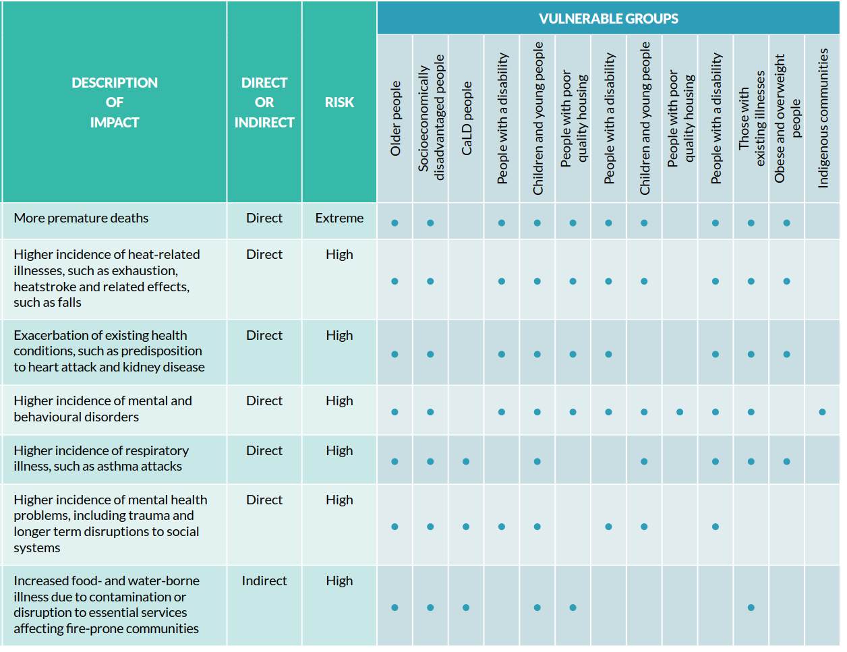
Source: Northern Alliance for Greenhouse Action, 2017

Equity in transition
Disadvantaged and vulnerable communities will need support in the transition to a low-carbon economy, and when facing the adverse impacts of climate change. This aligns with the central promise of the 2030 Agenda for Sustainable Development, and one of the United Nations Sustainable Development Cooperation Framework Principles: Leave No One Behind (LNOB).
LNOB is a commitment made by all UN member states. It represents the focus to end all discrimination and exclusion, as well as reduce the inequalities and vulnerabilities that can marginalise people and communities (UN Sustainable Development Group, 2021). If LNOB is not adopted, the transition could worsen social inequities.
The New Zealand Government has committed to ‘a just transition’. The Just Transitions Unit will ‘focus on the impacts of major climate change policy decisions on households, communities, industries and regions’ (Ministry of Business, Innovation & Employment, n.d.).

Equity in adaptation
We must consider these social inequities when deciding on priorities, action plans, and funding for adaptation responses.

3.2.6 Information gaps and further work
For each risk, summarise any gaps in the information. This will help reveal any further work needed to improve understanding.
Clearly describe both uncertainty and confidence about a risk. The level of confidence in the risk will depend on how accurately you state the risk.
For more information, see Reisinger et al (2020).
The IPCC (AR5) recommends using certain terms to denote the degree of certainty in findings:
- the type, amount, quality and consistency of evidence (terms: limited, medium, or robust
- the degree of agreement (terms: low medium or high).
Generally, evidence is most robust when there are several consistent, independent lines of high-quality evidence.
Figure 14: Evidence and agreement statements and their relationship to confidence. Confidence increases towards the top right corner
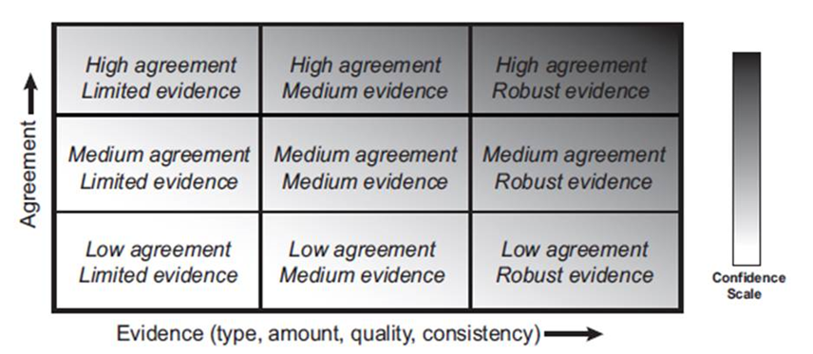
Source: IPCC AR5
You can apply this to each variable in steps 3B.1–3 (exposure, sensitivity, and adaptive capacity). You can also use it to identify where you need additional research, study, or data.

3.3 Step 3C: Additional analyses
Who: Core project team, technical reference group, subject matter experts, iwi/Māori, stakeholders | Outputs: Consequence ratings, opportunities assessment, geospatial analysis
Summary: Optional analyses that can enhance your risk assessment relate to consequences, opportunities, and geospatial assessments, to aid in analysing and reporting risks.
This section outlines three optional assessments that can improve the risk ratings and help prioritise risks.

3.3.1 Consequence rating (optional)
For direct and indirect risks, you can also assess their consequences. Consequence relates to the importance, significance, or value to communities, iwi/Māori or other stakeholders.
Often the risks identified through screening are, by virtue of being on the list, more consequential. A comparative assessment of consequence for all risks may be difficult, due to competing value judgements. It may be enough to base the assessment on the exposure and vulnerability rating alone (for direct risks).

Examples of consequence rating
- Table 13 lists some factors that may be useful to distinguish levels of consequence.
- For a sample consequence rating table, see appendix E.
- You can add a column for these ratings in the spreadsheet. See template, appendix D.
Local government decision-makers could then use this information when prioritising risks (section 4.1, step 4A).
Table 13: Factors that can influence consequences
Theme/element at risk | Higher consequence examples | Lower consequence examples
Infrastructure and built environment | Elements of infrastructure systems or networks which are critical, as they serve large populations, or for other reasons (eg, serve vulnerable communities) | Minor elements of infrastructure networks
Ecosystems and nature | Endangered, endemic, or taonga species | Introduced species
Economic sectors | Sectors which generate high levels of employment to a local economy | Sectors which generate low levels of employment in a local economy

3.3.2 Opportunities (optional)
Climate change may present opportunities that lead to positive or beneficial outcomes. There will be direct and indirect opportunities from mitigation and adaptation.
Direct opportunities relate to the change in climate – such as growing new crops, and cheaper home heating.
Indirect opportunities relate to adaptation or to emission-lowering efforts (table 14).
Your assessment should collate the credible, positive opportunities from a warmer climate, for a theme or sector.
Document your analysis clearly in reporting.
Table 14: Examples of opportunities in various sectors
Sector | Opportunities
Agriculture | - Climate-resilience (eg, drought-resistant seeds)  - Water-saving irrigation systems  - Weather risk insurance, crop insurance, and other insurance products
Water management | - Advanced water management technologies (eg, desalination)  - Drainage systems that cope with extreme weather
Solid waste | - Advanced waste-to-energy technology  - More recycling of building material
Construction | - Resilient buildings  - Resilient construction methods and materials
Transport | - Resilient transport infrastructure (eg, coastal railway lines)  - Reduced transport carbon emissions with increased mode shift/reduced fossil fuel use
Communication and information | - Climate change information and research  - Advanced weather forecasting systems
Adapted from Pauw, 2014.
Figure 15 shows opportunities for synergies in adaptation and mitigation.
Figure 15: Climate adaptation and mitigation synergies
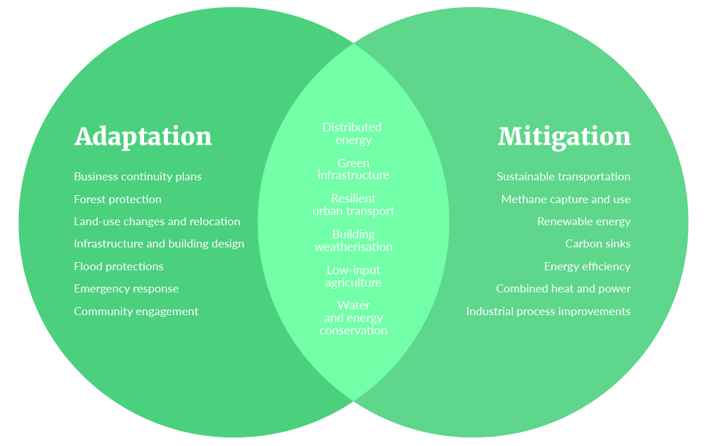
Adapted from Connecting the Dots: Adaptation + Mitigation Synergies (Udvardy & Winkelman, 2014)

3.3.3 Geospatial analysis (optional)
Geospatial analytics can inform your assessment at a more granular level. This can involve using digital geospatial tools (software such as ARC-GIS) to overlay digital hazard data with data on elements at risk (identified through step 3A).
This is most beneficial where hazard information is clearly defined, such as data on modelled coastal inundation, erosion, or inland flood plains.
This can enable:
- a detailed assessment of exposure in various hazard scenarios (eg, for flooding this can be for various events with different average recurrence intervals)
- a detailed assessment of element at risk sensitivity based on data attributes (eg, for infrastructure this may be related to the age, condition, or material of a network)
- an assessment of criticality for infrastructure networks, which can be integrated with exposure and sensitivity data, for a more granular view of risk.

Examples of geospatial tools
- Waikato Regional Council Coastal Inundation Tool
- Greater Wellington Regional Council Future Impacts of Climate Change Tool.

3.4 Step 3D: Review risk-rating workbook
Who: Core project team, technical reference group, subject matter experts | Outputs: Final risk-rating workbook
Summary: Review the draft workbook to validate, challenge, or adjust risk ratings.
All team members should review the draft risk-rating workbook. Different parties can do risk ratings in isolation, so it’s important to review and compare them together as a draft.
The team can review the workbook by circulating it online, through a workshop or through conversations with iwi/Māori and stakeholders.
The final workbook should capture and reflect feedback from the review and will inform the risk assessment report.

3.5 Step 3E: Risk assessment report
Who: Core project team, technical reference group, governance group | Outputs: Draft and final technical reports; public-facing report
Summary: The risk assessment report should reflect purpose and audience, and include technical, qualitative and quantitative information, hazard register, spatial maps, and information to aid prioritisation.
The risk assessment report documents the results of the climate change risk assessment. It will be communicated to a wide audience, including councillors, senior managers, and staff in the organisation, iwi/Māori, partner agencies, local businesses, and the wider community.
The report might include:
- technical reports to inform technical and planning staff
- informative reports, infographics, summary sheets for stakeholders and the wider public
- hazard register
- spatial maps
- online and print media.
The report should:
- clearly present the risk assessment results and ratings
- document the methods used to identify, analyse, and evaluate these risks
- highlight any limitations and assumptions
- provide evidence to inform an adaptation plan with actions, resources, and timeframes.
For a sample report structure, see appendix G.
A draft report should be prepared for review by the broader project team, technical reference group, and governance group.
The final report should reflect feedback on the draft.
A public-facing report can also be prepared, simplifying and summarising the information so that everyone can easily understand.

3.5.1 Grouping the risks
Some assessments may have a large number of risks. This can make it difficult to manage risk databases, and to report on the risks.
The organising themes can be helpful as a way to distinguish between broad types of risk (section 2.3, step 2C).
Consider grouping similar risks together, for practical communication and reporting.
Ways to group and present risks for reporting include:
- by theme and element at risk
- by hazard (eg, risks from coastal inundation, inland flooding, fire weather)
- group/aggregate by broad element at risk type (eg, ‘water supplies’ could cover groundwater sources, surface water sources, storage dams, municipal supplies, irrigation supplies); or group by climate hazard (eg, risks to water supplies could be discussed collectively in relation to drought, salination, rainfall, and fire weather)
- by location or ‘environment’ (eg, district, community, or rural vs urban, coastal vs inland).
Aim to present the risks in a variety of ways, to form a comprehensive ‘story’ of the risk landscape.

PHASE 4:
Next steps

STEP 4A: Risk prioritisation
Step 4B: Adaptation planning

4 Phase 4: Next steps

4.1 Step 4A: Risk prioritisation
The risk assessment report presents a set of direct and indirect risks that you have assessed and rated.
The next step is to decide which risks to take forward into adaptation planning, and which may need further work.

Who prioritises the risks?
The governance group will identify the priority risks for adaptation planning and response, supported by the project team and technical reference group.

What does it involve?
Prioritising the risks requires:
- balancing many factors in combination with the technical risk assessment ratings. This is challenging, as different types of risk require different management
- drawing on the risk assessment results and other information on values and potential consequences, all of which contain significant uncertainty
- presenting this information to the governance group in a transparent and robust way
- developing and agreeing on the priorities. This is best done through a workshop.

Points to consider
- Primary risk rating (exposure, vulnerability) in relation to timeframe (section 3.2, step 3B).
- Consequence of the risk, reflecting local values (section 3.3.1, step 3C).
- Specific location/community inequities or vulnerabilities that may drive a response (section 3.2.5).
- Cost of response and funding options.
- Level of uncertainty remaining, and whether to do more research before agreeing on any action.
- Whether early action is needed before the risk manifests, to avoid ‘locking in’ a poor outcome.

Approach
There is no specific methodology for prioritisation, as different regions and communities have different objectives and context. One approach is to follow a multicriteria assessment process. This balances a range of values, reflecting different stakeholder interests.

4.2 Step 4B: Adaptation planning
The risk assessment provides an evidence base to inform adaptation planning across all of a council’s functions.
An adaptation plan or strategy, with identified actions, resources and timeframes is a way to respond to the prioritised risks.

Approach
This guide does not cover the details of adaptation planning.
The Coastal Hazards and Climate Change Guidance (MfE, 2017) offers a five-step approach (figure 16). The first two steps involve the risk assessment; the next three relate to adaptation.
Figure 16: The climate change adaptation process
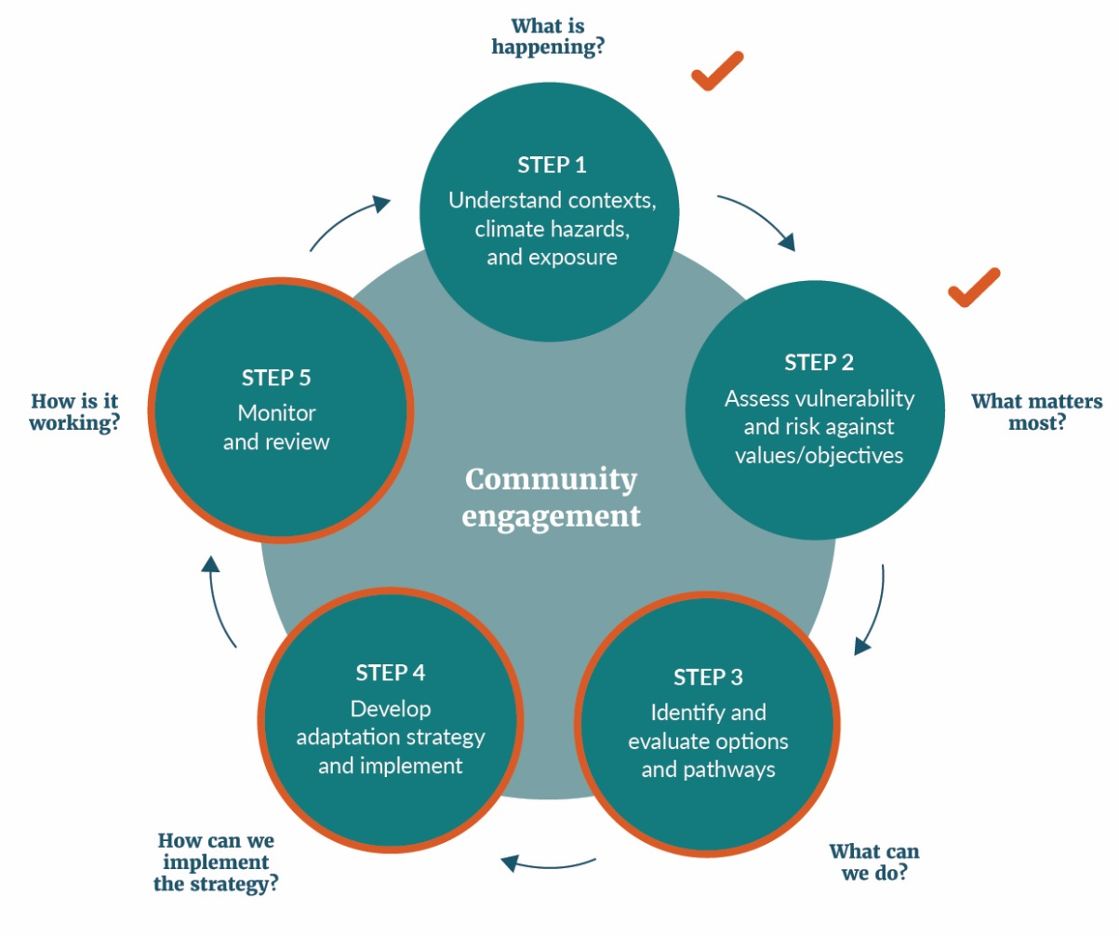
Adapted from MfE (2017) and LGNZ (2019)

Adaptation steps
The three adaptation steps are:
Step 3: What can we do about it? ie, identifying and evaluating options.
Step 4: How can we implement the strategy?
Step 5: How is it working? ie, monitoring, revisiting risk assessments, regular reviews of adaptation responses, and possible adjustments.

Points to consider
- Whatever the approach to completing these steps, stakeholder engagement is the key to successful planning and implementation. It must be central to all climate change adaptation work.
- Finally, council decisions must reflect the outcomes of the risk assessment. If necessary, the governance group should ensure that these outcomes are mainstreamed into adaptation planning.

5 Resources
Coastal Hazards and Climate Change: Guidance for Local Government (MfE, 2017)
ISO 14090: Adaptation to Climate Change Principles, Requirements and Guidelines (2019)
ISO 31000: Risk Management Guidelines (2018)
Recommendations of the Task Force on Climate-related Financial Disclosures (2017)
National Climate Change Risk Assessment (MfE, 2020)
Arotakenga Huringa Āhuarangi A Framework for The National Climate Change Risk Assessment for Aotearoa New Zealand (MfE, 2019)
Climate projections for New Zealand (MfE, 2018 second edition)
LGNZ Sea Level Rise Exposure Survey (LGNZ, 2019)
New Zealand Fluvial and Pluvial Flood Exposure (Paulik et al, 2019a)
Coastal Flooding Exposure Under Future Sea-level Rise for New Zealand Prepared for the Deep South Challenge (Paulik et al, 2019b)
IPWEA Practice Note 12.1: Climate change impacts on the useful life of infrastructure (2019)
Stormwater, wastewater and climate change: Impacts on our economy, environment, culture and society (Hughes, Cowper-Hayes, Bell & Stroombergen, 2019)
Māori knowledge systems, networks, and actions for climate change (Harmsworth and Awatere, 2013)
Australian National Climate Resilience and Adaptation Strategy, 2015
Projected changes to New Zealand’s climate (NIWA website)

Glossary
Term | Definition
Adaptation | Adjustment to actual or expected climate and its effects. In human systems, adaptation seeks to moderate or avoid harm, or exploit beneficial opportunities. In some natural systems, human intervention may aid adjustment to expected climate change and its effects (IPCC, 2014c).
Adaptive capacity | The ability of systems, institutions, humans, and other organisms to adjust to potential damage, to take advantage of opportunities, or to respond to consequences (IPCC, 2014c).
Assets | ‘Things of value’, which may be exposed or vulnerable to a hazard or risk. Physical, environmental, cultural, or financial/economic element that has tangible, intrinsic or spiritual value (see Taonga) (Ministry for the Environment, 2019).
Baseline | The baseline (or reference) is any datum against which change is measured.
Biodiversity | The variability among living organisms from terrestrial, marine, and other ecosystems. Biodiversity includes variability at the genetic, species, and ecosystem levels (IPCC, 2014c).
Capital | Capital can be defined as tangible and intangible items that are highly valued. Four capitals are defined by the treasury’s Living Standards Framework. These are natural, human, social, and financial/physical.
Cascading effects (of climate change) | Effects that flow on from a primary hazard, to compound and affect other systems in a dynamic sequence.
Climate | Usually defined as the average weather, or more rigorously, as the statistical description in terms of the mean and variability of relevant quantities over a period of time ranging from months to thousands or millions of years. The classical period for averaging these variables is 30 years, as defined by the World Meteorological Organization. The relevant quantities are most often surface variables such as temperature, precipitation and wind. Climate in a wider sense is the state, including a statistical description, of the climate system (IPCC, 2014c).
Climate change | A change in the state of the climate that can be identified (eg, through statistical tests) by changes or trends in the mean or the variability of its properties, and that persists for an extended period, typically decades to centuries. Climate change includes natural internal climate processes or external climate forces such as variations in solar cycles, volcanic eruptions, and persistent anthropogenic changes in the composition of the atmosphere or in land use (IPCC, 2014c).
Climate projection | A simulated response of the climate system to a scenario of future emission or concentration of greenhouse gases and aerosols, generally derived from climate models. Climate projections are distinguished from climate predictions by their dependence on the emission/concentration/ radiative forcing scenario, which is in turn based on assumptions concerning, for example, future socioeconomic and technological developments that may or may not be realised (IPCC, 2014c).
Climate variables | Physical, chemical, biological variables characterise Earth’s climate (World Meteorological Organization, 2021). This can include temperature, precipitation, humidity, and wind.
Community | A geographic location (community of place), a community of similar interest (community of practice), or a community of affiliation or identity (such as industry) (MfE, 2019).
Confidence | A qualitative measure of the validity of a finding, based on the type, amount, quality, and consistency of evidence (eg, data, mechanistic understanding, theory, models, expert judgement) and the degree of agreement (MfE, 2019).
Consequence | The outcome of an event that may result from a hazard. It can be expressed quantitatively (eg, units of damage or loss, disruption period, monetary value of impacts or environmental effect), semi-quantitatively by category (eg, high, medium, low level of impact) or qualitatively (a description of the impacts) (adapted from MCDEM, 2019). Also, the outcome of an event affecting objectives (ISO/IEC 27000:2014 and ISO 31000: 2009) (MfE, 2019).
Disaster | Severe alterations in the normal functioning of a community or a society due to hazardous physical events interacting with vulnerable social conditions, leading to widespread adverse human, material, economic, or environmental effects that require immediate emergency response to satisfy critical human needs and that may require external support for recovery (IPCC, 2014c).
Driver | An aspect that changes a system. Drivers can be short term but are mainly long term in their effects. Changes in both the climate system and socio-economic processes including adaptation and mitigation are drivers of hazards, exposure, and vulnerability. Drivers can be climatic or non-climatic (MfE, 2019).
Elements at risk | People, values, taonga, species, sectors, assets etc that are potentially vulnerable to climate change impacts.
Emissions | The production and discharge of substances that are potentially radiatively active (ie, absorb and emit radiant energy) in the atmosphere (eg, greenhouse gases, aerosols) (MfE, 2019).
Exposure | The presence of people, livelihoods, species or ecosystems, environmental functions, services, and resources, infrastructure, or economic, social, or cultural assets in places and settings that could be adversely affected by a change in external stresses that a system is exposed to. In the context of climate change these are normally specific climate and other biophysical variables (IPCC, 2007).  The number, density or value of people, property, services, or other things that are valued (taonga) that are present within an area subject to one or more hazards (i.e. within a hazard zone), and that may experience potential loss or harm (MCDEM, 2019).
Extreme weather event | An event that is rare at a particular place and time of year. Definitions of rare vary, but an extreme weather event would normally be as rare as or rarer than the 10th or 90th percentile of a probability density function estimated from observations. By definition, the characteristics of what is called extreme weather may vary from place to place in an absolute sense. When a pattern of extreme weather persists for some time, such as a season, it may be classed as an extreme climate event, especially if it yields an average or total that is itself extreme (eg, drought or heavy rainfall over a season) (IPCC, 2014c).
Financial risk | A risk that involves financial loss to firms. It generally relates to markets, credit, liquidity, and operations.
Frequency | The number or rate of occurrences of hazards, usually over a particular period (MfE, 2019).
Greenhouse gas (GHG) | Gaseous constituents of the atmosphere, both natural and anthropogenic, that absorb and emit radiation at specific wavelengths within the spectrum of thermal infrared radiation emitted by Earth’s surface, the atmosphere itself, and by clouds. This property causes the greenhouse effect. Water vapour (H₂O), carbon dioxide (CO₂), nitrous oxide (N₂O), methane (CH₄), and ozone (O₃) are the primary greenhouse gases in Earth's atmosphere.
Hazard | The potential occurrence of a natural or human-induced physical event or trend or physical impact that may cause loss of life, injury, or other health impacts, as well as damage and loss to property, infrastructure, livelihoods, service provision, ecosystems, and environmental resources (IPCC, 2014c).  In this guide, hazard usually refers not only to climate-related physical hazards (such as floods or heatwaves) but also to evolving trends or their gradual physical impacts (IPCC, 2014c).
Heatwave | A period of abnormally and uncomfortably hot weather (IPCC, 2014c).
Impacts (consequences, outcomes) | The effects on natural and human systems of extreme weather and climate events and of climate change. Impacts generally refer to effects on lives, livelihoods, health, ecosystems, economies, societies, cultures, services, and infrastructure due to the interaction of climate changes or hazardous climate events occurring within a specific time period and the vulnerability of an exposed society or system. Impacts are also referred to as consequences and outcomes (IPCC, 2014c).
IPCC | Intergovernmental Panel on Climate Change – a scientific and intergovernmental body under the auspices of the United Nations.
Kaupapa Māori | Literally translates to ‘a Māori way’. Smith (2005) describes it as: related to ‘being Māori, connected to Māori philosophy and principles, taking for granted the validity and legitimacy of Māori, taking for granted the importance of Māori language and culture, and is concerned with the ‘struggle for Māori autonomy over Māori cultural well-being’ (Cram, 2017). As an analytical approach Kaupapa Māori is about thinking critically, including developing a critique of non-Māori constructions and definitions of Māori and affirming the importance of Māori self-definitions and self-valuations.
Land use | The arrangements, activities, and inputs made in a certain land-cover type (a set of human actions). Also relates to the social and economic purposes for which land is managed (eg, grazing, timber extraction, and conservation). In urban settlements it is related to land uses in cities and their hinterland. Urban land use has implications for city management, structure and form and thus on energy demand, greenhouse gas emissions, and mobility, among other aspects (IPCC, 2014c).
Likelihood | The chance of a specific outcome occurring, where this might be estimated probabilistically (IPCC, 2014c).
Māori values and principles | Māori values and principles derive from Māori views of the world. Values and principles can be defined as instruments through which Māori make sense of, experience, and interpret the world. They form the basis for Māori ethics and principles (MfE, 2019).
Mātauranga Māori | Māori knowledge. This has many definitions that cover belief systems, epistemologies, values, and knowledge in a traditional and contemporary sense. It incorporates knowledge, comprehension and understanding of everything visible and invisible existing in the universe (MfE, 2019).
Mitigation | A human intervention to reduce the sources or enhance the sinks of greenhouse gases (IPCC, 2014c).
NCCRA | National Climate Change Risk Assessment
Percentile | A value on a scale of 100 that indicates the percentage of the data set values that is equal to, or below it. The percentile is often used to estimate the extremes of a distribution. For example, the 90th (or 10th) percentile may be used to refer to the threshold for the upper (or lower) extremes.
RCP | Representative concentration pathway. A suite of future scenarios of additional radiative heat forcing at Earth’s surface by 2100 (in Watts per square metre), which is the net change in the balance between incoming solar radiation and outgoing energy radiated back up in the atmosphere. Each RCP can be expressed as a greenhouse gas concentration (not emissions) trajectory adopted by the IPCC for its Fifth Assessment Report (AR5) in 2014 (IPCC, 2014c).
Resilience | The capacity of social, economic, and environmental systems to cope with a hazardous event, trend, or disturbance by responding or reorganising in ways that maintain their essential function, identity, and structure, while also maintaining the capacity for adaptation, learning, and transformation (IPCC, 2014c).
Risk | The potential for consequences where something of value is at stake and where the outcome is uncertain, recognising the diversity of values. Risk is often represented as probability or likelihood of occurrence of hazardous events or trends multiplied by the impacts if these events or trends occur. The term risk is used to refer to the potential, when the outcome is uncertain, for adverse consequences on lives, livelihoods, health, ecosystems and species, economic, social and cultural assets, services (including environmental services), and infrastructure. Risk results from the interaction of vulnerability, exposure, and hazard. To address the evolving impacts of climate change, risk can also be defined as the interplay between hazards, exposure, and vulnerability (IPCC, 2014c).
Risk assessment | The qualitative or quantitative process of identifying, analysing and evaluation risk, with several entry points for communication, engagement, monitoring, and review (AS/NZS ISO 31000:2009, Risk Management Standard).
Shock | A sudden, disruptive event with an important and often negative impact
Stress | A long-term, chronic issue with an important and often negative impact
Stressor (climate) | Persistent climatic occurrence (eg, change in pattern of seasonal rainfall) or rate of change or trend in climate variables, such as the mean, extremes, or the range (eg, ongoing rise in mean ocean temperature or acidification), which occurs over a period of time (eg, years, decades, centuries), with important effects on the system exposed, increasing vulnerability to climate change (MfE, 2019).
System | A set of things working together as parts of an interconnected network or a complex whole.
Taonga Māori | Tangible and intangible items that are highly valued in Māori culture. Taonga Māori include:  - natural environment (whenua/land, ngahere/forests, awa/rivers, maunga/mountains, and moana/ocean)  - human and non-human capital (whānau/families, hapū/sub-tribes, iwi/tribes), spiritual (mauri/the intrinsic life force within living entities)  - social capital (mātauranga Māori/Māori knowledge, intergenerational transfer of knowledge)  - economic capital (financial value of assets including land holdings)  - material capital (buildings including marae, commercial investments, and private homes) (MfE 2019).
Three waters | Drinking water, wastewater, and stormwater.
Transition | The move to a lower-carbon economy. In this guide, it also refers to transitions relating to equitable and resilient outcomes in the face of physical climate risks.
Uncertainty | A state of incomplete knowledge that can result from a lack of information or from disagreement about what is known or even knowable. It may have many types of sources, from imprecision in the data to ambiguously defined concepts or terminology, or uncertain projections of human behaviour (IPCC, 2014c).
Vulnerability | The propensity or predisposition to be adversely affected. Vulnerability encompasses a variety of concepts and elements including sensitivity or susceptibility to harm and lack of capacity to cope and adapt (IPCC, 2014c).  Assessing vulnerability is broader than conventional risk assessments. It includes indirect and intangible consequences on the four wellbeings, and adaptiveness and adaptive capacity (eg, communities, whānau, hapū, and iwi may be resourceful and adaptive, but may lack the resources, insurance access and mandate or capacity to adapt) (MfE, 2019).
ZCA | Climate Change Response (Zero Carbon) Amendment Act 2019

Bibliography
Australian Greenhouse Office. (2006). Climate change impacts and risk management – a guide to business and government. https://www.environment.gov.au/system/files/resources/21c04298-db93-47a6-a6b0-eaaaae9ef8e4/files/risk-management.pdf
Australian Government. (2015). Commonwealth of Australia National climate resilience and adaptation strategy. https://www.environment.gov.au/system/files/resources/3b44e21e-2a78-4809-87c7-a1386e350c29/files/national-climate-resilience-and-adaptation-strategy.pdf
Bater, R., Hamaker-Taylor, R., Mulholland, E., Barker, S. (2020). Questions to assist non-executive director oversight of physical climate risk management. Acclimatise, Minter Ellison and Chapter Zero. https://www.chapterzero.org.uk/wp-content/uploads/2020/07/QUESTIONS-TO-ASSIST-NON-EXECUTIVE-DIRECTOR-OVERSIGHT-OF-PHYSICAL-CLIMATE-RISK-MANAGEMENT-vF.pdf
Bell, R., Paulik, R., Wadwha, S. (2015). National and regional risk exposure in low-lying coastal areas. Areal extent, population, buildings and infrastructure. Parliamentary Commissioner for the Environment.
Chartered Professional Accountants Canada. (2019). Enhancing Climate-related Disclosure by Cities: A Guide to Adopting the Recommendations of the Task Force on Climate. Chartered Professional Accountants Canada.
Cram, F. (2017). Kaupapa Māori health research. In P. Liamputtong (Ed.), Handbook of research methods in health and social sciences. Springer.
Department of Conservation. (2010). New Zealand Coastal Policy Statement 2010.
Durie, M. (1994). Whaiora: Māori health development (2nd ed.). Oxford University Press.
Dymond, J., Basher, l. (2019). SedNetNZ: A new model to predict land management effects on erosion and sediment yield. Soil Horizons Newsletter 21(September). www.landcareresearch.co.nz/publications/newsletters/soil/issue-21/sednetnz
Federation of Canadian Municipalities. (2019). Municipalities for Climate Innovation Programme. Climate Adaptation Maturity Scale. Federation of Canadian Municipalities.
Fischer, G., Velthuizen, H., Shah, M., Nachtergaele, F. (2002). Global agro-ecological assessment for agriculture in the 2st^{t} century: methodology and results.International Institute for Applied Systems Analysis.
Fuss, J., Canadell, J.G., Peters, G.P., Tavoni, M., Andrew, R.M., Ciais, P., Jackson, R.B., Jones, C.D., Kraxner, F., Nakicenovic, N., Le Querre, C., Raupach, M.R., Sharifi, A., Smith, P., Yamagata, Y. (2014, October). Betting on negative emissions. Nature Climate Change, 4. https://www.globalcarbonproject.org/global/pdf/Fuss_2014_Betting%20on%20negative%20emissions.NatureCC.pdf
Gardner, J., Dowd, A-M., Mason, C., Ashworth, P. (2009). A Framework for Stakeholder Engagement on Climate Adaptation. Climate Adaptation Flagship working paper no 3. Commonwealth Scientific and Industrial Research Organisation. https://research.csiro.au/climate/wp-content/uploads/sites/54/2016/03/3_CAF_WorkingPaper03_pdf-Standard.pdf www.csiro.au/resources/CAF-workingpapers.html
Harmsworth, G.R., Awatere, S., Procter, J. (2014, November 3-6). Meeting water quality and quantity standards to sustain cultural values [Paper presentation]. 21st Century Watershed Technology Conference and Workshop Improving Water Quality and the Environment Conference Proceedings. University of Waikato, Hamilton, New Zealand. DOI:10.13140/2.1.3507.8086.
Hausfather, Z. (2019). Explainer: The high- emissions ‘RCP8.5’ global warming scenario. https://www.carbonbrief.org/explainer-the-high-emissions-rcp8-5-global-warming-scenario
Hughes, J., Cowper-Heays, K., Olesson, E., Bell, R., & Stroombergen, A. (2019). Stormwater, wastewater and climate change: Impacts on our economy, culture and society. Deep South Science Challenge.
Institute of Public Works Engineering Australasia National Asset Management Strategy Council. (2017). Asset management and financial management guidelines: Climate Change Impacts on the Useful Life of Infrastructure (Practice Note 12.1). Institute of Public Works Engineering Australasia.
Intergovernmental Panel on Climate Change. (2013). Climate Change 2013: The Physical Science Basis. Contribution of Working Group I to the Fifth Assessment Report of the Intergovernmental Panel on Climate Change. Stocker, T.F., Qin, D., Plattner, G-K., Tignor, M., Allen, S.K., Boschung, J., Nauels, A., Xia, Y., Bex, V., Midgley, P.M. (Eds.). Cambridge, UK: Cambridge University Press. www.ipcc.ch/report/ar5/wg1/
Intergovernmental Panel on Climate Change. (2014a). Annex II: Glossary. In: Climate Change 2014: Impacts, Adaptation, and Vulnerability. Part B. Regional Aspects. Contribution of Working Group II to the Fifth Assessment Report of the IPCC.
Intergovernmental Panel on Climate Change. (2014b). Climate Change 2014: Synthesis Report. Contribution of Working Groups I, II and III to the Fifth Assessment Report of the Intergovernmental Panel on Climate Change. Pachauri, R.K., Meyer, L.A. (Eds).
Intergovernmental Panel on Climate Change. (2014c) Summary for policymakers. In: Climate change 2014: Impacts, adaptation and vulnerability. Part A: Global and sectoral aspects. Contribution of Working Group II to the Fifth Assessment Report of the Intergovernmental Panel on Climate Change [C B Field, V R Barros, D J Dokken, K J Mach, M D Mastrandrea, T E Bilir, M Chatterjee, K L Ebi, Y O Estrada, R C Genova, B Girma, E S Kissel, A N Levy, S MacCracken, P R Mastrandrea and L L White (Eds)]. Cambridge University Press, pp 1–32.
Jenson, J. (2010). Defining and measuring social cohesion. Commonwealth Secretariat and United Nations Research Institute for Social Development.
Joynt, J. L., & Golubiewski, N. E. (2019). Development of the Auckland Heat Vulnerability Index. Auckland Council.
Lawrence, J., Blackett, P., Cradock-Henry, N. & Nistor, B.J. (2018). Climate Change: The Cascade Effect. Cascading impacts and implications for Aotearoa New Zealand. Deep South Challenge.
Local Government New Zealand. (2019a). Exposed: Climate change and infrastructure Guidance for councils. https://www.lgnz.co.nz/assets/Uploads/6ed34721bd/LGNZ-2019-CC-guidance-document-FULL.pdf
Local Government New Zealand. (2019b). Vulnerable: The Quantum of Local Government Infrastructure Exposed to Sea Level Rise. https://www.lgnz.co.nz/assets/Uploads/d566cc5291/47716-LGNZ-Sea-Level-Rise-Report-3-Proof-FINAL-compressed.pdf
Mason, K., Lindberg, K., Haenfling, C., Schori, A., Thomas, K., Popovich, B., & Borman, B. (2019). Social vulnerability indicators for flooding in Aotearoa New Zealand. Wellington: Environmental Health Indicators Programme, Massey University. https://www.ehinz.ac.nz/assets/Social-Vulnerability-Indicators/Research-report-social-vulnerability-indicators-for-flooding.pdf
McKercher, K.A. (2010). Beyond Sticky Notes. Doing Co-Design for real: mindsets, methods and movements.
Ministry for the Environment. (2017). Coastal Hazards and Climate Change: Guidance for Local Government. https://environment.govt.nz/publications/coastal-hazards-and-climate-change-guidance-for-local-government/
Ministry for the Environment. (2018). Climate Change Projections for New Zealand: Atmospheric projections based on simulations undertaken for the IPCC 5th Assessment 2nd edition. https://environment.govt.nz/assets/Publications/Files/Climate-change-projections-2nd-edition-final.pdf
Ministry for the Environment. (2019). Arotakenga Huringa Āhuarangi: A Framework for the National Climate Change Risk Assessment for Aotearoa New Zealand. https://environment.govt.nz/assets/Publications/Files/arotakenga-huringa-ahuarangi-framework-for-national-climate-change-risk-assessment-for-aotearoa-FINAL.pdf
Ministry for the Environment. (2020). National Climate Change Risk Assessment for Aotearoa New Zealand: Main report – Arotakenga Tūraru mō te Huringa Āhuarangi o Aotearoa: Pūrongo whakatōpū. https://environment.govt.nz/assets/Publications/Files/national-climate-change-risk-assessment-main-report.pdf
Ministry of Business, Innovation & Employment. (n.d.). Just Transition. https://www.mbie.govt.nz/business-and-employment/economic-development/just-transition/
Ministry of Civil Defence & Emergency Management. (2019). National Disaster Resilience Strategy Rautaki ā-Motu Manawaroa Aituā.
National Institute of Water and Atmospheric Research. (2019). CLUES: Catchment Land Use for Environmental Sustainability Model. www.niwa.co.nz/freshwater-and-estuaries/our-services/catchment-modelling/clues-catchment-land-use-for-environmental-sustainability-model
Network for Greening the Financial System. (2019). A call for action. Climate change as a source of financial risk. https://www.ngfs.net/sites/default/files/medias/documents/synthese_ngfs-2019_-_17042019_0.pdf
New South Wales Council of Social Services. (2017). Principles of Co-Design. https://www.ncoss.org.au/wp-content/uploads/2017/06/Codesign-principles.pdf
Northern Alliance for Greenhouse Action. (2017). Adaptation in the North. An integrated regional vulnerability assessment. http://www.naga.org.au/uploads/9/0/5/3/9053945/adaptation_in_the_north_volume_6.pdf
O’Connell, E., Greenaway, T., Moeke, T., Sacha, M. (2018). He Ara Waiora/A Pathway Towards Wellbeing (DP 18/11). The New Zealand Treasury.
Te Arawhiti /Office for Māori Crown Relations. (2018). Guidelines for Engagement with Māori. https://www.tearawhiti.govt.nz/assets/Maori-Crown-Relations-Roopu/6b46d994f8/Engagement-Guidelines-1-Oct-18.pdf
Oppenheimer, M., Campos, M., Warren, R., Birkmann, J., Luber, G., O’Neill, B., & Takahashi, K. (2014). Emergent Risks and Key Vulnerabilities. In M. Brklacich, & S. Semenov (Eds.), Climate Change 2014: Impacts, Adaptation, and Vulnerability. Part A: Global and Sectoral Aspects. Contribution of Working Group II to the Fifth Assessment Report of the Intergovernmental Panel on Climate Change (pp. 1039-1099). Cambridge University Press.
Parliamentary Commissioner for the Environment. (2015). Preparing New Zealand for Rising Seas: Certainty and Uncertainty. www.pce.parliament.nz/publications/preparing-new-zealand-for-rising-seas-certainty-anduncertainty
Paulik, R., Craig, H., Collins, D. (2019a). New Zealand Fluvial and Pluvial Flood Exposure. NIWA Client Report 2019118WN prepared for the Deep South Science Challenge. https://deepsouthchallenge.co.nz/wp-content/uploads/2021/01/Exposure-to-River-Flooding-Final-Report.pdf
Paulik, R., Stephens, S.A., Wadhwa, S., Bell, R.G., Popovich, B., Robinson, B. (2019b). Coastal Flooding Exposure under Future Sea-Level Rise for New Zealand. NIWA Client Report 2019119WN prepared for the Deep South Science Challenge.
Pauw, W. (2014). Not a panacea: Private-sector engagement in adaptation and adaptation finance in developing countries. Climate Policy, 15(5), 583-603. https://doi.org/10.1080/14693062.2014.953906
Reisinger, A., Howden, M., Vera, C., Garschagen, M., Hurlbert, M., Kreibiehl, S., Mach, K.J., Mintenbeck, K., O’Neill, B., Pathak, M., Pedace, R., Pörtner, H-O., Poloczanska, E., Corradi, M.R., Sillmann, J., van Aalst, M., Viner, D., Jones, R., Ruane, A.C., Ranasinghe, R. (2020). The Concept of Risk in the IPCC Sixth Assessment Report: A Summary of Cross-Working Group Discussions. Intergovernmental Panel on Climate Change, 15.
Royal Society. (2017). Human Health Impacts of Climate Change for New Zealand. https://www.royalsociety.org.nz/assets/documents/Report-Human-Health-Impacts-of-Climate-Change-for-New-Zealand-Oct-2017.pdf
Salmond, C., King, P., & Waldegrave, C. (2005). A New Zealand Index of Socioeconomic Deprivation for Individuals. Health Research Council of New Zealand.
Smith, L. T. (2005). On tricky ground - Researching the native in the age of uncertainty. In N. K. Denzin, & Y. S. Lincoln (Eds.), The Sage handbook of qualitative research, 1-12. Thousand Oaks, California.
Standards New Zealand / Standards Australia. (2010). Communicating and Consulting about Risk (HB327:2010). Standards Australia.
Task Force on Climate-Related Financial Disclosures. (2017). Recommendations of the Task Force on Climate-related Financial Disclosures.
The Treasury, (2019) Our living standards framework. https://www.treasury.govt.nz/information-and-services/nz-economy/higher-living-standards/our-living-standards-framework
Udvardy, S., & Winkelman, S. (2014). Connecting the Dots: Adaptation + Mitigation Synergies. Center for Clean Air Policy.
United Nations Sustainable Development Group. (2021). Leave No One Behind. https://unsdg.un.org/2030-agenda/universal-values/leave-no-one-behind
Wakefield, R.E. (2019). What is co-design in a Māori space?: Kotahitanga in action. Te Kura nui o Waipareira, (3), 14-19. https://wairesearch.waipareira.com/wp-content/uploads/2019/11/Waipareira-Journal_Kotahitanga-Issue-3-2019-WEB.pdf
World Meteorological Organization. (2021). Essential Climate Variables. https://public.wmo.int/en/programmes/global-climate-observing-system/essential-climate-variables

Appendix A: Climate hazards list
This is an example of a climate hazard list from the NCCRA framework. See NCCRA Section B1.3 for more details.
Table 15: Sample climate hazard list from NCCRA framework
Hazard (arising from climate change) | Primary climate-related variables | Secondary climate-related variables
Higher mean temperatures: air and water | - Higher day and night temperatures  - Higher mean water (freshwater and marine temperatures) | - More heatwaves and warm spells  - Fewer frosts or cold days
Heatwaves: increasing persistence, frequency and magnitude | - Higher day and night temperatures  - Increase in persistence of maximum daily temperatures above 25 degrees Celsius | - Changes in seasonal winds  - Humidity changes from changes in cloudiness
More and longer dry spells and drought | - Low seasonal rainfall  - Change in seasonal wind patterns  - Interannual variability (eg, 2-4 year El Niño-Southern Oscillation (ENSO)) | - Higher day and night temperatures
Changes in climate seasonality with longer summers and shorter winters | - Fewer frosts or cold days  - Higher day and night temperatures  - Changes in seasonal rainfall | - Changes in seasonal wind
Increasing fire weather conditions: harsher, prolonged season | - Low seasonal rainfall  - Change in seasonal wind patterns  - Increase in persistence of maximum daily temperatures above 25 degrees Celsius  - Humidity changes from changes in cloudiness | - Higher day and night temperatures  - Interannual variability (eg, ENSO)
Increased storminess and extreme winds | - Increase in storminess (frequency, intensity) including tropical cyclones  - Changes in extreme wind speed | - Changes in wind seasonality  - Interannual variability (eg, ENSO)  - Increase in convective weather events (tornadoes, lightning)
Change in mean annual rainfall | - Higher or lower mean annual rainfall in sub-national climate zones  - Changes in seasonal winds | - Humidity changes from changes in cloudiness
Reducing snow and ice cover | - Higher day and night temperatures  - Changes in rainfall seasonality  - Change in seasonal wind patterns  - Receding snowline  - Reduced snow and glacier cover  - Earlier snow melt | - Increase in avalanches  - Interannual variability (eg, ENSO)
Increasing hail severity or frequency | - Increase in hail severity or frequency  - Increase in convective weather events (tornadoes, lightning) | - Humidity changes from changes in cloudiness
River and pluvial flooding: changes in frequency and magnitude in rural and urban areas | - Changes in extremes: high intensity and persistence of rainfall  - Increase in hail severity or frequency  - Interannual variability (eg, ENSO)  - Increased storminess and wind  - Relative sea-level rise (including land movement)  - Rising groundwater from sea-level rise | - Humidity changes from changes in cloudiness  - Changes in rainfall seasonality  - Changes in seasonal wind patterns  - More and longer dry spells and droughts (antecedent conditions)
Coastal and estuarine flooding: increasing persistence, frequency and magnitude | - Relative sea-level rise (including land movement)  - Change in tidal range or increased water depth  - Permanent increase in spring high-tide inundation  - Rising groundwater from sea-level rise  - Changes in extremes: high intensity and persistence of rainfall  - Increase in storminess (frequency, intensity) including tropical cyclones | - Changes in waves and swell  - Changes in extreme wind speed  - Changes in sedimentation (estuaries and harbours)
Sea-level rise and salinity stresses on brackish and aquifer systems and coastal lowland rivers | - Relative sea-level rise (including land movement)  - Permanent and episodic (low river flow) saline intrusion  - Low seasonal rainfall  - Rising groundwater from sea-level rise  - Permanent increase in spring high-tide inundation | - Changes in sedimentation (estuaries and harbours)  - Interannual variability (eg, ENSO)
Increasing coastal erosion: cliffs and beaches | - Relative sea-level rise (including land movement)  - Changes in waves and swell  - Changes in extreme rainfall: high intensity and persistence  - Changes in sedimentation from catchment run off  - Increased storminess and extreme winds  - Interannual variability (eg, ENSO) | - Rising groundwater from sea-level rise  - Changes in rainfall seasonality  - Change in seasonal wind patterns
Increasing landslides and soil erosion | - Changes in extreme rainfall: high intensity and persistence  - Changes in rainfall seasonality  - More and longer dry spells and droughts (antecedent conditions) | - Interannual variability (eg, ENSO)
Marine heatwaves: more persistent high summer sea temperatures | - Higher mean ocean temperatures  - Increase in persistence of maximum daily temperatures eg, above 25 degrees Celsius  - Change in seasonal wind patterns  - Ocean circulation changes | - Interannual variability (eg, ENSO)  - Changes in waves and swell
Ocean chemistry changes: nutrient cycling and pH changes | - Changes in ocean nutrient cycling – upwelling and carbon  - Ocean acidification (pH decreasing)  - Higher mean surface-water temperatures  - Change in seasonal wind patterns | - Ocean circulation changes  - Interannual variability (eg, ENSO)
International influences from climate change and greenhouse gas mitigation preferences | - Immigration  - Markets (pricing, preferences)  - Pacific Island countries (disaster responses, development)
Other?
Source: Arotakenga Huringa Āhuarangi: A Framework for the National Climate Change Risk Assessment for Aotearoa New Zealand

Appendix B: Preparing a climate risk survey

Why have a survey?
The purpose of a survey is to gather and track knowledge, thoughts, ideas, and concerns from a wider source.

Who is it for?
The engagement plan will help the project team decide who to send the survey to. Survey recipients would normally include subject matter experts.
Be aware of the groups you are surveying and tailor the survey to them.
How to create a survey
You can create a climate risk survey using online software (eg, Survey Monkey).

What do you want to find out?
Surveys can be used to gather more information on elements at risk. It can also provide information to help decide priority risks and to identify knowledge gaps.

What should go in the survey?
It is recommended to keep the survey concise. When drafting questions, the following points should be considered.
Provide context: At the start, outline the local situation for climate change projections, as a background to the risks for the region.
Allow for several responses: This will allow for multiple risks to be identified.
Write effective questions: To get the most useful responses, here are some simple tips.
- Before you write the question, be clear about the exact information you are seeking.
- Keep the questions clear and short. They must be easy to answer.
- Stick to one point for each question. Do not combine different questions.
- Try them out on a friend or neighbour. The wording may be unclear or may include terms they do not understand.

How to use the survey results
Read through all responses, discard irrelevant information, and summarise responses. Incorporate concepts into the risk-screening and risk assessment templates (Appendix C and D) and the risk assessment report. As the survey responses can be quite broad, they can be used as discussion points for subsequent workshops as part of the engagement process. The responses can also direct subsequent research and literature review.

Example survey questions
Example survey questions on different elements at risk:
Q1: Please choose one of the hazards from the climate change projections for the area.
- Q1a: ELEMENT AT RISK: Can you name an element at risk of the climate hazard selected? (eg, water availability, native species (taonga), water quality, tourism)
- Q1b: RISK JUSTIFICATION: Please describe why this is a risk for the region
- Q1c: RISK LOCATIONS: Can you name where the risk is a particular problem?
- Q1d: DIRECT/INDIRECT RISK: Is the risk generally a result of direct impacts from climate hazards?
If it is a direct risk, can you also give examples of possible cascading (downstream) impacts of the risk (eg, relating to wellbeing)?
Q2: Please choose another hazard from the climate change projections for the area.
- Q2a: ELEMENT AT RISK: Can you name an element at risk of the climate hazard selected? (eg, water availability, native species (taonga), water quality, tourism)
- Q2b: RISK JUSTIFICATION: Please describe why this is a risk for the region
- Q2c: RISK LOCATIONS: Can you name where the risk is a particular problem?
- Q2d: DIRECT/INDIRECT RISK: Is the risk is generally a result of direct impacts from climate hazards?
If it is a direct risk, can you also give examples of possible cascading (downstream) impacts of the risk (eg, relating to wellbeing)?

Appendix C: Risk-screening template
You can use this template to document the relationship between elements at risk and climate hazards.

Template for direct risk-screening
Theme (from NCCRA) | Element at risk (examples) | Climate hazard
 |  | Increased temperature | Increased hot days (heatwaves) | Decreased cold (frosty) nights | Increase in wildfire | Changes in precipitation | Increase in heavy rainfall | Decrease in snow | Increase in drought | Increase in extreme wind | Change in solar radiation | Decrease in humidity | Sea-level rise | Increase in ocean temperature | Increase in ocean acidification | General
Built | Water supply
 | Buildings
 | Landfills
 | Wastewater
 | Stormwater
 | Ports
 | Roads
 | Airports
 | Electricity infrastructure
Natural | Taonga species
 | Coastal ecosystems
 | Riverine ecosystems and species
 | Lake ecosystems
 | Terrestrial ecosystems
 | Marine ecosystems
 | Sub-alpine ecosystems
 | Carbonate-based, hard shelled species
 | Wetland ecosystems and species
 | Indigenous forest ecosystems
 | Freshwater ecosystems
 | Endangered species
Economy | Tourism
 | Fisheries
 | Agriculture
 | Horticulture
Human | People
 | Cultural heritage sites

Appendix D: Risk assessment template
This template is for evaluating direct risks. It assumes vulnerability (as defined by sensitivity and adaptive capacity) is constant across timeframes. If vulnerability was deemed to change over time, then the template can be amended to suit. A spreadsheet can be set up with drop-down boxes for the rating inputs and the overall risk rating can be generated automatically based on the exposure, sensitivity, and adaptive capacity inputs. Stakeholders must capture the justification and assumptions underlying the ratings, when completing the template.
Risk ID | Climate hazard | Element at risk | Risk statement | Risk description | Potential downstream (cascading) impacts | Exposure |  |  |  |  | Exposure rating justification / comments | Sensitivity | Sensitivity rating justification / comments | Adaptive capacity | Adaptive capacity rating justification / comments | Vulnerability | Risk |  |  |  |  | Consequence rating | Consequence rating justification / comments
 |  |  |  |  |  | Present | Mid-2050 RCP4.5 | Mid-2050 RCP8.5 | Long 2100 RCP4.5 | Long 2100 RCP8.5 |  |  |  |  |  |  | Present | Mid-2050 RCP4.5 | Mid-2050 RCP8.5 | Long 2100 RCP4.5 | Long 2100 RCP8.5
1 | Sea-level rise, coastal flooding | State Highway network | Risk to the state highway network due to sea-level rise and coastal flooding | State Highway network follows the coast and is at risk from sea-level rise which, combined with severe weather and high tides, causing damage and outages | Include text as relevant relating to downstream impacts across, for example, the four wellbeings (economic, cultural, environmental, and social) | Low | Moderate | High | High | Extreme | Include text as relevant | Moderate | Include text as relevant | Low | Include text as relevant | High | Low | Moderate | High | High | Extreme | Major | Include text as relevant
2 | Changes in rainfall | Agriculture/horticulture | Risk to agriculture/horticulture due to changes in rainfall/drought | To grow commercial and other crops requires year-round water supplies
3 | Inland flooding | Water quality | Risk to water quality due to inland flooding | Flood water over agri land mobilises contaminants into receiving environments (including from eg, drains/effluent ponds/dairy infrastructure)
4 | Higher temperature (including increased hot days) | Natural ecosystems | Risk to natural ecosystems due to higher temperatures | Warmer conditions will enable/assist new pest incursions and naturalisations of sub-tropical/tropical organisms
5 | Extreme weather (wind and storms) | Stormwater network | Risk to urban stormwater being overwhelmed due to extreme weather events leading to flooding | Increased storms create possibility stormwater systems are more likely to be overwhelmed, increasing flood risk

Appendix E: Sample consequence rating table
Table 16: Example of a consequence rating table
Rating | Consequence/criteria
 | Public safety | Local economy and growth | Community and lifestyle | Environment and sustainability | Public administration
Catastrophic | Large numbers of serious injuries or loss of lives | Regional decline leading to widespread business failure, loss of employment, and hardship | The region would be seen as very unattractive, moribund, and unable to support its community | Major widespread loss of environmental amenity and progressive irrecoverable environmental damage | Public administration would fall into decay and cease to be effective
Major | Isolated instances of serious injuries or loss of lives | Regional stagnation such that businesses are unable to thrive and employment does not keep pace with population growth | Severe and widespread decline in services and quality of life within the community | Severe loss of environmental amenity and a danger of continuing environmental damage | Public administration would struggle to remain effective and would be seen in danger of failing completely
Moderate | Small numbers of injuries | Significant general reduction in economic performance relative to current forecasts | General appreciable decline in services | Isolated but significant instances of environmental damage that might be reversed with intensive efforts | Public administration would be under severe pressure on several fronts
Minor | Serious near misses or minor injuries | Individually significant but isolated areas of reduction in economic performance relative to current forecasts | Isolated but noticeable examples of decline in services | Minor instances of environmental damage that could be reversed | Isolated instances of public administration being under severe pressure
Insignificant | Appearance of a threat but no actual harm | Minor shortfall relative to current forecasts | There would be minor areas in which the region was unable to maintain its current services | No environmental damage | There would be minor instances of public administration being under more than usual stress but it could be managed
Source: Climate change impacts and risk management – a guide to business and government

Appendix F: Engagement
Effective engagement can benefit the risk assessment process and outcomes, as well as wider community relationships through:
- Sharing information – building awareness and understanding of the project among partners and stakeholders, so they can better understand the final report and the process used to achieve it.
- Gathering information – providing a strong, broad, and representative evidence base to inform the risk assessment, including verification and informed input into the risks, opportunities, adaptation action information, and gaps for further consideration.
- Building lasting relationships – forging positive and mutually advantageous links with and between key stakeholders, iwi/Māori, and local government agencies. This includes laying the groundwork for continued engagement – ensuring that at the end of the risk assessment process, there is a foundation for further engagement with partners and stakeholders, for future adaptation work that follows a transparent and repeatable process. This will form a sound basis for future risk assessments.
These guidelines are based on the general and iwi-specific considerations for engagement in the NCCRA framework.

General considerations
Engagement is an important part of a climate change risk assessment. It should take place at each stage of the process with iwi organisations, and internal and external stakeholders.
Engagement is a planned process with the purpose of working across organisations, partners, stakeholders, and communities to shape decisions or actions in relation to a problem, opportunity, or outcome. Not all those with a vested interest may want to be actively involved in a risk assessment; some may prefer regular updates, while others may need to be fully involved.

Terminology
The word ‘stakeholder’ refers to the individuals, groups, organisations, or a political entity with a vested interest in decisions on the impact of a policy, project, or proposition. We can also use the word ‘community’, meaning individuals and groups of people, stakeholders, interest groups, and citizen groups. A community may be a geographical location (community of place), a community of similar interest (community of practice), or a community of affiliation or identity (such as industry). ‘Partner’ refers to engagement with iwi/Māori, reflecting the partnership principles of Te Tiriti o Waitangi.

Types of engagement
Many methods and forms of engagement may be needed at different stages in the process, and you can use a range of activities (eg, informing, consultation, involving, collaborating), as in figure 17. However, risk assessments will generally not require or enable ‘empowerment’, because no adaptation decisions are made that actively enable empowerment.
Figure 17: International Association of Public Participation (IAP2) spectrum of participation
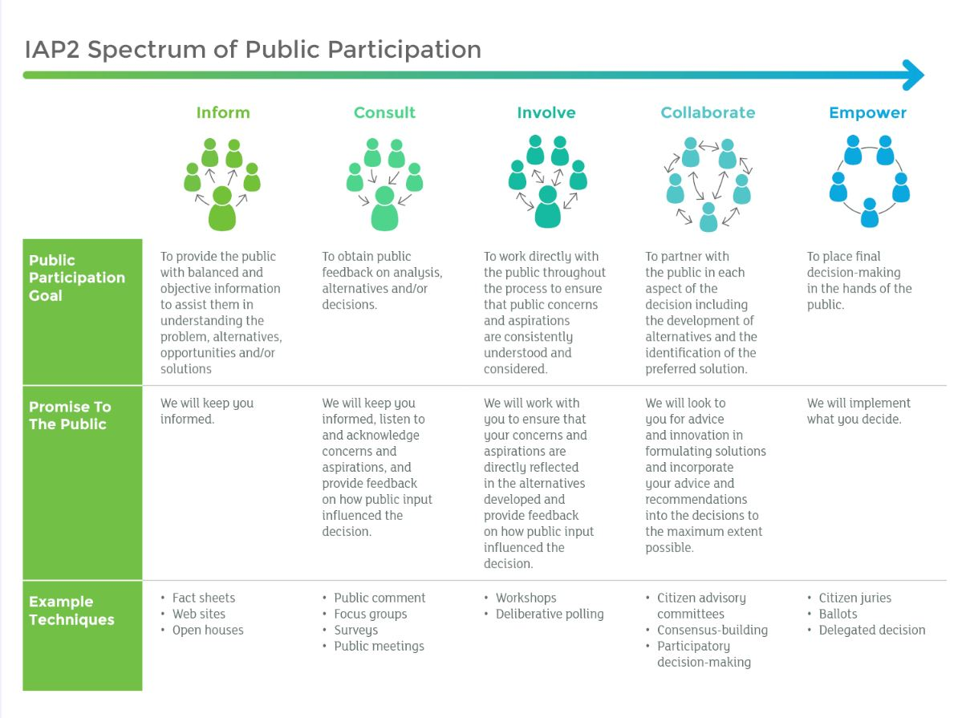

Resources
Guidance on engagement principles, process, and design include:
- Guidelines for Engagement with Māori (Te Arawhiti, 2018)
- Coastal Hazards and Climate Change Guidance (Ministry for the Environment, 2017)
- International Association of Public Participation (IAP2)
- Standards Australia/New Zealand (2010).

Considerations for engaging with Māori
When planning for engagement with iwi/Māori, you need to consider the capacity and capability of those you are engaging with. This includes their skills, knowledge, competing priorities, resources, and the time they need to effectively respond to a request.
When making a local risk assessment, use established best practice on engagement with Māori (eg, Te Arawhiti ,Guidelines for engagement with Māori). A person with knowledge and experience of Māori engagement principles and tikanga should be involved in the process.
Authentic partnerships with Māori are essential for better quality outcomes. It enables the collection of on-the-ground information, views, and reactions, and it strengthens the legitimacy of outcomes. Engaging effectively with Māori contributes to effective policy, and helps agencies give robust advice to Ministers and deliver better outcomes. Genuine engagement with Māori by the Government is (Te Arawhiti, 2018) an acknowledgement:
- of their rangatiratanga and status as Te Tiriti o Waitangi partners
- that mātauranga Māori makes an important contribution to solving policy and practical problems
- that Māori have the resources and capability to contribute, and resources are allocated to empower iwi/Māori to make decisions and develop solutions for themselves
- that some issues affect Māori disproportionately and Māori are therefore better placed to develop solutions.
Engagement is about building effective relationships; this is particularly important with Māori. Wherever possible, pick up the phone or make kanohi ki te kanohi (face-to-face) contact, rather than sending emails.
Iwi/Māori organisations often have limited capacity for engagement, and other competing priorities. Māori groups are under pressure to respond and react to requests from multiple agencies. Iwi/Māori representatives may not be paid for their time, often have limited resources, and much of their workforce is voluntary or part-time. Māori organisations and representatives must be involved in planning engagement, to design a realistic process that suits both parties.
Considerations include:
- checking if iwi/Māori organisations have organisational environmental or climate change management plans. If so, check their requirements before any engagement, because they may contain a preferred method for engagement, associated costs, and identified issues and priorities around climate change. These plans can inform the engagement strategy
- checking on the location of engagement activities and what Māori would prefer (eg, at a marae, and who will book this, for example, the consultant or the iwi/Māori representative). Make sure everyone is aware of any protocols for that marae
- budgeting for the hui, Māori, iwi or hapū time, and any cultural support
- ensuring the timeframes are suitable to both parties
- before gathering any mātauranga Māori, the level of sensitivity, protection, dissemination, use, and ‘ownership’ will be discussed and agreed on by those offering the mātauranga. ‘Knowledge-brokers’ from local iwi will be very useful here.

First steps
To begin the process, make contact with Māori who represent interests in the identified themes of the risk assessment. National and pan-Māori collectives could include: the Iwi Chairs Forum (Pou Taiao Committee); New Zealand Māori Council; New Zealand Māori Women’s Welfare League; Office of the Māori Climate Commission; and National Māori Climate Network. Māori engagement expertise, and well-established and connected networks are preferred for successfully connecting with these institutions.
For larger, regional assessments, some climate change risks may be specific to certain areas. This would require engagement with tangata whenua (Māori, iwi, hapū mandated organisations and institutions) in the area at risk. Once again, relevant expertise and robust networks are preferred.
Ensure resourcing is adequate – for example, paid time and travel for iwi and hapū representatives, koha, and cultural advisors.

Consideration of mātauranga Māori
Throughout the process, you can collaborate on identifying risks with iwi/Māori to specific taonga and assets across the themes of the assessment.
Figure 18 shows how modelling, quantitative assessment and mātauranga Māori can generate land-management scenarios and mitigations, to meet outcomes and aspirational targets of iwi and hapū for their cultural assets and taonga.
Cultural and science monitoring can be used to observe trends towards or away from aspirational targets. Figure 18 shows a model used by Harmsworth et al (2014) in the Manawatū and Kaipara catchments. This involved continuous refinement through ‘proof of concept’ and catchment-modelling tools. This approach can improve risk management strategies, sustain or protect cultural values, and increase iwi/Māori participation in climate change adaptation.
Figure 18: Modelling towards mātauranga Māori aspirations and outcomes
Source: Harmsworth et al (2014)

Appendix G: Sample risk assessment report

Report structure
Recommended section titles for a technical risk assessment report include:
- Introduction including context, project team, assessment process
- Climate change projections and timeframes
- Methodology
- Risk assessment results by theme (including direct and indirect/cascading risks), for example:
- Human
- Natural
- Economy
- Built
- Governance
- Summary of community inequities/vulnerabilities
- Reporting on other considerations including consequence assessment and opportunities
- Knowledge gaps and future research
- Summary and next steps
- References
- Appendices and acknowledgement of contributions, including previous assessments, data sources and other inputs (eg, workshop results, survey results).

Appendix H: Assessing governance maturity
Assessing governance includes identifying potential gaps and weaknesses in governance and policy/strategy for managing climate change risks. There are a number of ‘maturity’ assessment frameworks, which can be useful in this process. Examples include:
- Exposed: Climate change and infrastructure – Guidance for councils (LGNZ, 2019)
- Municipalities for Climate Innovation Program – Climate Adaptation Maturity Scale (Federation of Canadian Municipalities, 2019)
- A guide for adopting the TCFD recommendations for cities (Chartered Professional Accountants Canada [CPA], 2019).
Below are some topics and questions a council could explore.
Table 17: Sample questions for councils in managing climate risks
Topic area | Questions
Governance and oversight | - Is the council compliant with regulatory expectations on governance of climate risks for councils?  - Who is responsible for overseeing management and reporting on climate-related risks throughout the council?  - How well is the council bringing together teams – strategy, risk, operational, finance, audit, procurement, legal, environmental, health and safety, human resources etc – to promote cross-council ownership of climate strategy and embedding a consistent approach across the organisation?  - How well is the council engaging with governmental, non-governmental, and business stakeholders to influence policy aimed at improving climate resilience?
Capability and capacity | - Does the council have the right capability and capacity across departments to implement its physical climate risk strategy in a context of climate uncertainty?  - Are we being supported by appropriate experts and advisors?
Strategy | - What actions is the council taking to manage physical risks effectively, for the organisation and the community?  - Have actions been identified to contribute to effective systems for optimising adaptation measures?  - How are changes in extreme weather events and incremental climatic changes considered in the design phases for new developments and infrastructure?  - How does the council prioritise and allocate funding for climate resilience actions?  - Are emergency management and business continuity plans regularly reviewed to assess their adequacy in delivering services following extreme events?
Risk management | - Have physical climate risks been evaluated for the council, community, stakeholders, supply chains etc?  - Have material transition risks been identified?
Policy | - Has local/regional policy and legislation been reviewed in terms of how it contributes to climate goals?  - Have misalignments been identified and are remedies being planned and addressed?  - Have the implications of emerging government policy and legislation been understood?
Source: Adapted from Bater et al, 2020

Appendix I: Transition risks (low carbon)
Transition risks are typically defined as climate-related risks associated with the move to a lower-carbon economy (TCFD, 2017).
The most common risks relate to:
- Policy and legal actions  - Technology changes | - Market responses  - Reputational considerations (TCFD, 2017).
In this guide, transition risks also include risks associated with the shift towards climate resilience in communities. These can relate to social inequities that should be considered when developing adaptation responses.
Transition risk assessments in local government are still emerging, and best practice guidance is not yet available.
For some useful starting points, see this recent publication from Canada (CPA, 2019).
Table 18: Examples of transition risks relevant to councils
Transition risk area | Example risks
Policy | Carbon prices (via ETS), policies, and government incentives/investments to achieve zero-carbon goals. Related to low carbon technologies, transport policies, green building policies, policies relating to urban form.  There are also a range of inter-relationships with other government policies relating to water, natural hazards, resource management etc.
Legal | Litigation that arises for insufficient disclosure around material financial risks or failure of organisations to adequately address climate change. Examples of climate-related litigation include lawsuits filed against Mill Rd in Auckland.
Technology | Advances to current and/or new innovations, such as renewables, and massive deployment of renewable fuels for transit (eg, electrification, hydrogen).
Market | Shifts in supply and demand of products and services due to government policies, technology, and consumer behaviour.
Reputation | Risk to brand, customer support, and community social licence.
Source: Adapted from CPA (2019)

Transition scenarios
It is useful to look at potential scenarios for transition, and the drivers that may influence them.
The Network for Greening the Financial System (2019) provides two example scenarios for an orderly and disorderly transition.

An orderly transition
This assumes immediate action is taken to reduce emissions, in line with the Paris Agreement. Emissions prices stay in place nationally (and are introduced soon internationally), and increase annually, to keep global warming well below 2°C. This corresponds to reaching net zero CO₂ emissions between 2050 and 2070.
Since policy measures are introduced early and increase progressively, transition risks are assumed to remain low over the period.

A disorderly transition
This shows a much more challenging pathway to the Paris Agreement targets. In this scenario, climate policy follows nationally determined contributions until 2030. Acknowledging that these efforts will not be enough to meet commitments, emissions prices are revised substantially upward after 2030. The delay means that net zero CO₂ emissions must be reached more quickly, by around 2050. Correspondingly the increase in emissions prices is much more severe.
- A comprehensive assessment of transition risks should involve governance, legal, policy, financial and technical expertise to address the full breadth of implications.
- There is currently little clarity or guidance on how councils can assess transition risk. Later versions of this guide may explore this in more detail.

Appendix J: Examples of indirect/ cascading risks
Table 19: Indirect/cascading risk examples
Theme | Risk example
Human | Risk of exacerbating existing inequities and creating new inequities
 | Risks to Māori social, cultural, spiritual, and economic wellbeing
 | Risks to mental health, identity autonomy, and sense of belonging
 | Risk of worsening social cohesion and community wellbeing
 | Risk of conflict, disruption, and loss of trust in local and central government
Governance | Risks of exacerbated climate change impacts due to unfit institutional arrangements
 | Risks due to potential for climate change related litigation
 | Failing to meet Treaty obligations to engage adequately with and protect current and future generations of Māori from the impacts of climate change
 | Risks to emergency management functions
 | Risks to democratic decision-making process
Economy | Risk of lost productivity
 | Risks to access to capital and the broader financial system
 | Risks to asset insurability
 | Risks to supply chains and distribution networks

Relating to the additional radiative forcing or heating (Watts) per square metre area of Earth since pre-industrial conditions in 1750.
The IPCC’s 6th assessment report, due for release in 2022, will likely present some new/modified scenarios.
Chapter 19 of the IPCC’s 5th Assessment Report discusses emergent risks in detail.
Note that further or amended requirements, direction or guidance for adaptation planning may be included in the current legislative reforms (including resource management reform, three waters review, local government review).
https://www.stuff.co.nz/auckland/124658237/climate-group-sues-government-over-controversial-mill-rd-highway

