Online Waste Levy System (OWLS 2.0)
User guide for waste disposal facility operators
Version 9, 2023

Disclaimer
The information in this publication is, according to the Ministry for the Environment’s best efforts, accurate at the time of publication. The Ministry will make every reasonable effort to keep it current and accurate. However, users of this publication are advised that:
- The information does not alter the laws of New Zealand, other official guidelines, or requirements.
- It does not constitute legal advice, and users should take specific advice from qualified professionals before taking any action based on information in this publication.
- The Ministry does not accept any responsibility or liability whatsoever whether in contract, tort, equity, or otherwise for any action taken as a result of reading, or reliance placed on this publication because of having read any part, or all, of the information in this publication or for any error, or inadequacy, deficiency, flaw in, or omission from the information in this publication.
- All references to websites, organisations or people not within the Ministry are for convenience only and should not be taken as endorsement of those websites or information contained in those websites nor of organisations or people referred to.

This guide may be cited as: Ministry for the Environment. 2023. Online Waste Levy System (OWLS 2.0): User guide for waste disposal facility operators. Wellington: Ministry for the Environment.

First published in September 2020, updated version published in December 2023.
Published by the Ministry for the Environment
Manatū mō te Taiao
PO Box 10362, Wellington 6143, New Zealand
environment.govt.nz
ISBN: 978-1-99-003332-2 (online)
Publication number: ME 1544
Other publications in this series include:
- Calculation and Payment of the Waste Disposal Levy: Guide for waste disposal facility operators
- Waste Disposal Levy–Training for Waste Disposal Facility Operators: Training workbook

© Crown copyright New Zealand 2023

Contents
About this guide 5
How to use this guide 5
Where to go for help 5
Further information 5
Chapter 1: Introduction to OWLS 2.0 6
Overview 6
Applying to register for OWLS 2.0 8
Adding a new user to OWLS 2.0 11
Logging in as a new user 15
Logging in to OWLS 2.0 25
Moving around OWLS 2.0 27
Creating a new facility within OWLS 2.0 30
Chapter 2: Monthly and quarterly returns 35
Overview 35
Return Summary screen 36
Submitting a return 38
Verifying a return 47
Amending a return 50
View Tax invoice / Statement (monthly reporting facilities only) 50
Chapter 3: Annual and six-monthly returns 55
Overview 55
Return Summary screen 56
Submitting a final annual/six-monthly return 58
Verifying a final annual/six-monthly return 64
Amending a final annual/six-monthly return 67
Chapter 4: Applications 68
Overview 68
Applying to submit an annual return 69
Applying to submit a six-monthly return 71
Applying to use the average tonnage method for motor vehicles 73
Applying for an extension of time to submit your monthly return 76
Applying for an extension of time to pay 78
Applying for an extension of storage time for material on your facility 80
Applying for a waiver 83
Applying for a refund 85
Applying for a site class change 87
Application summary screen 89
Methodologies 90
Chapter 5: Viewing and updating details 91
Overview 91
Updating client details 92
Updating disposal facility details 93
Viewing or updating details for personnel 95
De-activating personnel 97
Emails and activities 99
Chapter 6: Reports 102
Overview 102
Generating or exporting a report 103
Glossary 107

About this guide
This guide is designed to help waste disposal facility operators use the Online Waste Levy System (OWLS 2.0) to register, send returns and apply for extensions of time, waivers, methodologies and refunds.

How to use this guide
This guide has been designed to help with using OWLS 2.0. It explains the purpose of the screens, how to use the screens and other important information about using the system.
You will need to use this guide together with the Calculation and Payment of the Waste Disposal Levy guide, which covers information about the:
- Waste Minimisation Act 2008
- Waste Minimisation (Calculation and Payment of Waste Disposal Levy) Regulations 2009
- Waste Minimisation (Information Requirements) Regulations 2021
- disposal facility operator’s responsibilities regarding the levy.

Where to go for help
An online function is available from every screen within OWLS 2.0.
If you need more advice, or help with using OWLS 2.0, please call our helpdesk on 0800 WDLEVY (0800 935 389).

Further information
Further information about the waste disposal levy is available from the Ministry for the Environment
Phone: 0800 WDLEVY (0800 935 389)
Email: info@wastelevy.govt.nz
Ministry web facility: https://environment.govt.nz/what-government-is-doing/areas-of-work/waste/waste-disposal-levy/
OWLS 2.0 web facility: www.wastelevy.govt.nz
When you contact us via 0800 WDLEVY, depending on your query, we may need to verify your identity. We will do this using information you provided when you registered.

Chapter 1: Introduction to OWLS 2.0
This chapter provides a brief overview of the Online Waste Levy System (OWLS 2.0) and tells you how to set up new users, log in to and move around OWLS 2.0. It contains the following topics:
Topic
Overview
Applying to register for OWLS 2.0
Adding a new user to OWLS 2.0
Logging in as a new user
Logging in to OWLS 2.0
Moving around OWLS 2.0
Creating a new facility within OWLS 2.0

Overview

Introduction
OWLS 2.0 is the Ministry for the Environment’s internet application that enables disposal facility operators to carry out waste disposal levy requirements online. It has been designed to minimise compliance costs disposal facility operators incur to meet their obligations under the Waste Minimisation Act 2008 and the Waste Minimisation (Calculation and Payment of Waste Disposal Levy) Regulations 2009.
OWLS 2.0 allows operators to register, send returns and apply for extensions of time, waivers, methodologies and refunds.

Registering on OWLS 2.0
Once you have registered with us, you will be given access to OWLS 2.0. This is a secure website. The only people who can access your information are people you authorise, and our staff or contractors authorised to administer the levy.

User access types
Disposal facilities have the following types of user access:
- Site data entry – Can update returns that will be placed in a status of ‘Pending Verification’.
- Site verifier – Can create/update personnel update/verify returns, update Client/Site details and create/modify applications.
- Mandatory to be the first user created when registering a Client and/or Facility.
- Site verifier delegator – Can create/update personnel update/verify returns, update Client/Site details, create/modify applications, and delegation access.
- Site facility administrator – has delegation and view access, cannot perform other functions in OWLS. Can be assigned to multiple Sites.
The table below shows the functions for each user type.

 | Functions that users can perform | Disposal facility users
 |  | Data entry | Facility Administrator | Verifier | Verifier Delegator
Contacts and users | View or change operator address details | View | Change | View | Change
 | View or change disposal facility contact and finance details | View | Change | View | Change
 | View, add or change contact people details | View | Add / Change | View | Add / Change
 | Add Personnel | No access | Add | No access | Add
Returns | View returns summary | View | View | View | View
 | Submit or verify new return | Submit | No access | Submit | Submit / Verify
 | View or change a verified return | View | View | View | Change
 | Submit an amendment | No access | No access | No access | No access
 | View and download statements | View / Download | View / Download | View / Download | View / Download
Applications and methodologies | View applications summary | View | View | View | View
 | Add new applications | No access | No access | No access | Add
 | Change a pending application | No access | No access | No access | Change
 | View methodologies | View | View | View | View
Reports | View reports online or download | View / Download | View / Download | View / Download | View / Download

Applying to register for OWLS 2.0

When to use
Use these steps if you want to register your organisation, facility and personnel within OWLS 2.0
Notes:
- If you have already signed up for OWLS, but need to create a new facility, please see Creating a new facility within OWLS 2.0.
- New users must have a RealMe login for authentication to access OWLS 2.0, please see What is RealMe

Role
- New users

Overview
Organisations can submit an online application form to register for the Online Waste Levy System. Organisations can register multiple facilities at once, making it easy to get started with OWLS and begin meeting your reporting requirements.

Steps
Step | Action
1 | Open the Application to Register for the Online Waste Levy System page.
2 | The application form contains three parts – Organisation Details, Facility Details, Verifier Details:  Section Description  Organisation Details The details of the organisation being registered.  Facility Details The details of the facilities you wish to register within OWLS  Verifier Details The person that will be created as a verifier for all registered facilities. Note: It is mandatory to add a Verifier user when completing the Online registration. For more information on personnel roles please see User access types
3 | Organisation Details  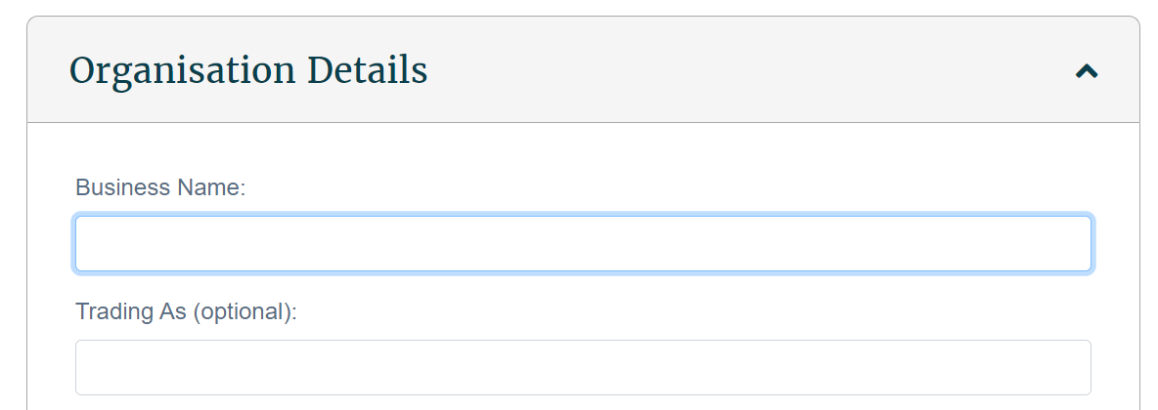  Field Description  Legal Name Enter the legal name of the organisation.  Trading As (Optional) Enter the trading name of the organisation (the name you use publicly).  NZBN (Optional) Enter the NZBN number of the organisation. Your NZBN can be found on the New Zealand Companies Register website. (Not applicable for Territorial Authorities)  Certificate of Incorporation Upload a copy of your Certificate of Incorporation. This can be found on the New Zealand Companies Register website. This file will be deleted once your application has been assessed. (Not applicable for Territorial Authorities)  Ownership Type Select the ownership type of the organisation.  Date of Incorporation Enter the Date of Incorporation for the facility. Note: This can be found on the Certificate of Incorporation issued by the Companies Office.  Organisation Postal Address Enter the Postal Address of the organisation (the address for all correspondence).  Organisation Physical Address Enter the physical address of the organisation.  Contact Number Enter a contact phone number for the organisation.  Contact Email Enter a contact email address for the organisation.
4 | Facility Details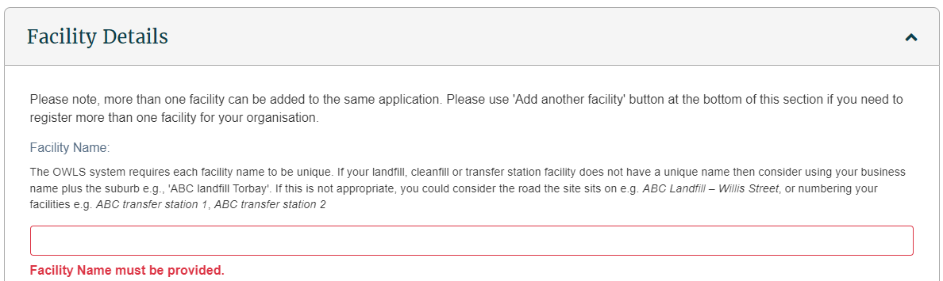  Field Description  Name Enter the name of the facility.  Territorial Authority Select the Territorial Authority for the region e.g. Auckland Council.  Demographic Type Select the primary demographic composition of the waste catchment area for your facility.  Facility Start Date The date the facility became operational.  Site Latitude Enter the site latitude coordinates of disposal facility location. Selecting your address on Google Maps will provide this.  Site Longitude Enter the site longitude coordinates of disposal facility location. Selecting your address on Google Maps will provide this.  Facility Physical Address Enter the physical address of the facility.  Contact Number Enter the contact number of the facility. If this is the same as the organisation contact number, use the “Same as Organisation Contact Number” checkbox.  Contact Email Enter the contact email address of the facility. If this is the same as the organisation email address number, use the “Same as Organisation Contact Email” checkbox.  Estimated Annual Tonnage Enter the estimated annual tonnage of waste. If your annual tonnage is less than 1000 tonnes, you may wish to apply for permission to submit annual returns.  Cover Material Sourced Select the source of the cover material used at the facility.  Site Class Select the class of your facility. Your class type should be determined using the information on this fact sheet, please note that your class type may differ from your council consent.  Methodology Select the method(s) your disposal facility uses or proposes to use to calculate waste and diverted material tonnage. For more information on this please see Waste levy – Measuring waste tonnages.  Methodology – Start Date Enter the Start date of each methodology for returns.  Add Another Facility If you wish to add additional facilities, click this button.
5 | Verifier Details  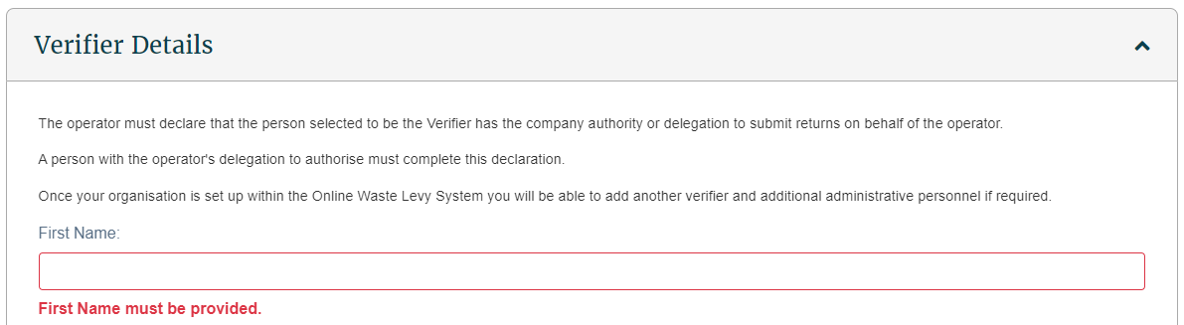  Field Description  First Name Enter first name.  Preferred Name (Optional) Enter a preferred name.  Surname Enter surname.  Position (Optional) Enter position.  Contact Area(s) (Optional) Select contact areas.  Contact Number Enter a contact number. Note: If this is the same as the organisation contact number, use the “Same as Organisation Contact Number” checkbox.  Contact Email Type the contact email address. Note: If this is the same as the organisation email address number, use the “Same as Organisation Contact Email” checkbox.  Proof of ID Upload proof of ID for verification purposes (driver's licence, passport, or birth certificate). This file will be deleted once your application has been assessed.
5 | Click the checkbox next to the “I’m not a robot” text, and if needed complete the CAPTCHA test.  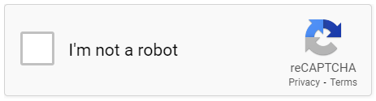
6 | Click Submit Application
7 | Once the Waste Levy team has assessed your application an email will be sent either approving or rejecting your application.
If your application is rejected you will need to submit a new application form, taking note to correct any issues outlined in the rejection email.

If your application is approved, you will receive an email outlining the approved facilities and containing a link to log in to OWLS for the first time. For more information on logging into OWLS for the first time, please see Logging in as a new user.

What happens next?
If your application has been approved, you can complete your sign up for OWLS by following the link in the approval email.

Adding a new user to OWLS 2.0

When to use
Use these steps when you want to create a login for someone else.

Roles that can perform the action
- Verifier Delegator – can create/update personnel, update/verify returns, update Client/Site details and create/modify applications.
- Facility Administrator – can create/update personnel, has delegation and view access, cannot perform other functions in OWLS. Can be assigned to multiple Sites.

Steps
Before you begin, ensure you have the First Name, Surname, Contact Number, and email address of the person you wish to add. If they already use OWLS 2.0, please check this matches the information they already use.
Step | Action
1 | Log in to OWLS 2.0
2 | Navigate to the site you wish to add someone to, click the Personnel button on the left.  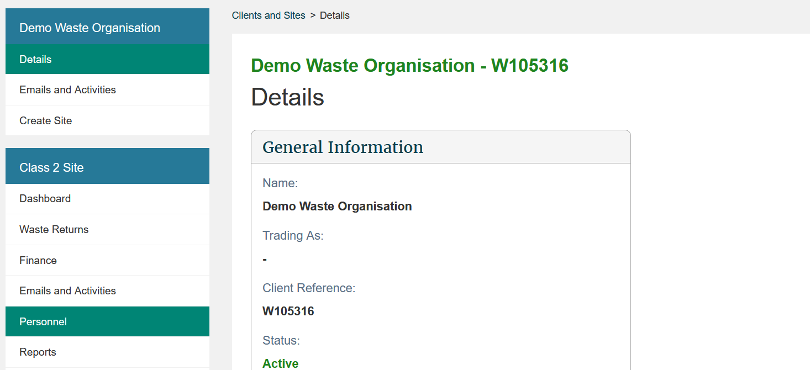
3 | This is the list of Personnel who have already been added to this site. Click the “Add Person” button at the bottom of the list.  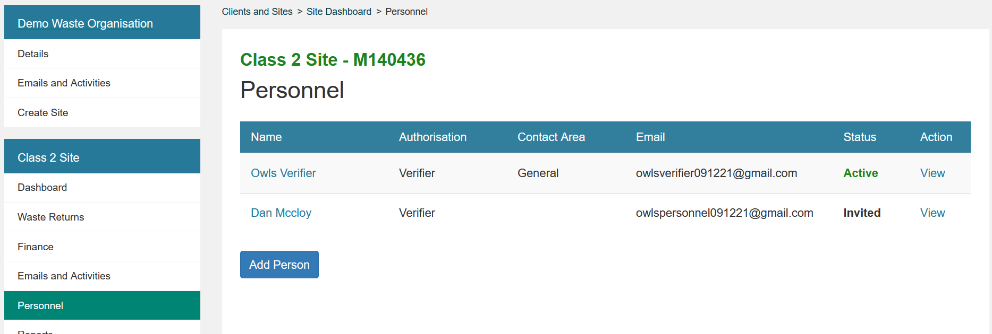
4 | Start typing the name of the person you wish to add in the “Name” box. As you type, OWLS 2.0 will search for users attached to this client whose names match what you’ve typed.  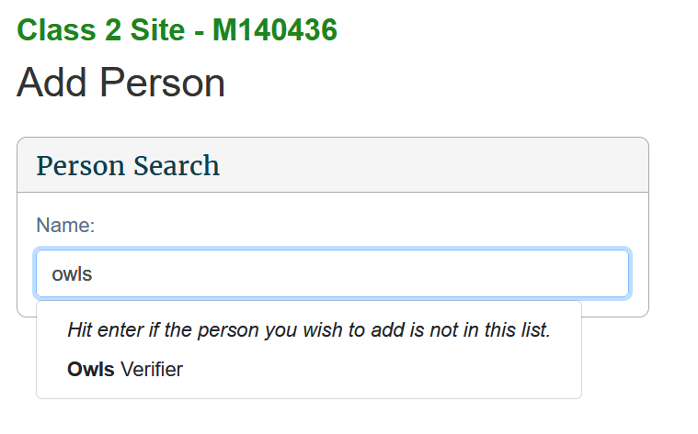  If you see the person you’re looking for, click their name, and skip to step 5b; if not, hit enter and proceed to step 5a.  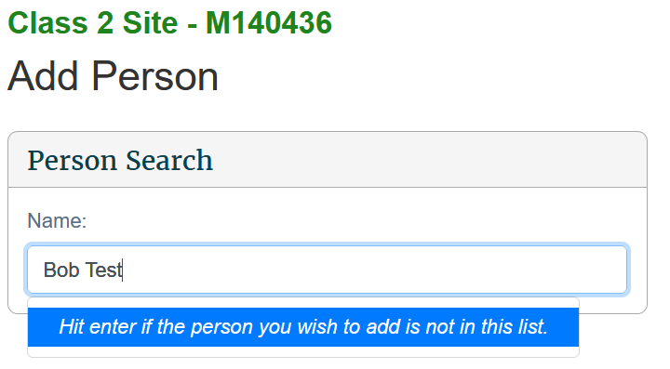
5a | The form will put the text you’ve written into the First Name text field, remove the surname from that box if needed and fill out the rest of the form with their details.  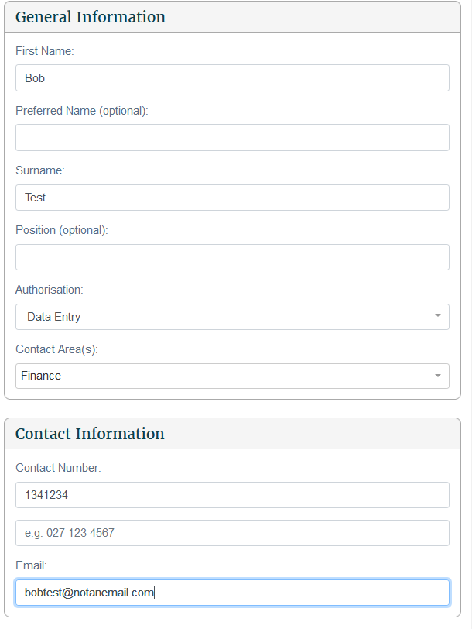
5b | The form will prepopulate with the user’s existing first name, surname, and contact details.  Select the Authorisation and/or Contact Area(s) you’d like them to have for this site by clicking the drop down and selecting from the available choices.  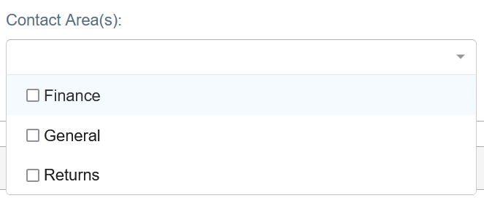
6 | Click Save.  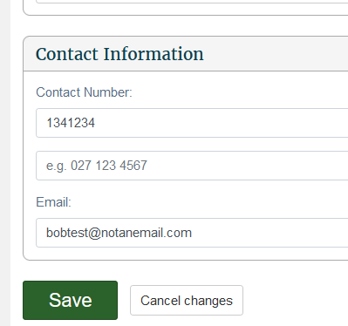  You will be returned to the Personnel page, and OWLS 2.0 will send an invitation to join the site to the email address you entered.  Note: if the user you added wasn’t given any Authorisation, they will not receive an email.
7 | On the personnel page you will see that their user Status is “Invited”. Once the user has clicked the link and logged in for the first time, this status will change to “Active”.  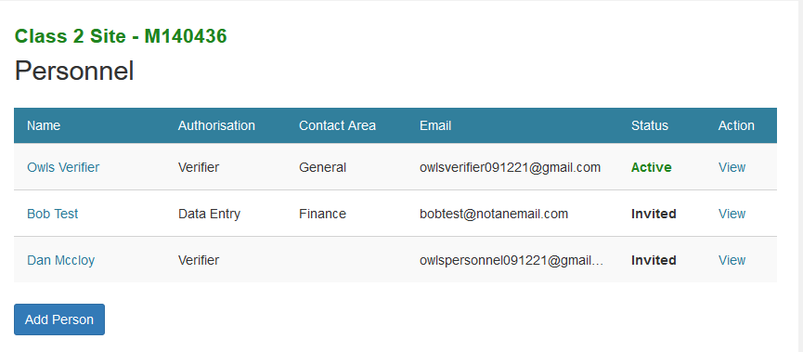Note: there is a delay for Authorisation and Contact Area to appear on this screen – if at first the new user appears on this screen without them, please wait a few seconds and refresh the page.

What happens next?
We will set up the new user and email the login details. Once the user receives this email, they can register a RealMe account and log into OWLS 2.0.
Note: The email is valid for 24 hours. If you miss activating your login within that time, you will need to contact the help desk at 0800 WDLEVY (0800 935 389).

Logging in as a new user

When to use
Use these steps if you need to log in for the first time
Note: If you are not logging in for the first time, please see the Logging in to OWLS 2.0 steps.

Roles
- Site data entry – Can update returns that will placed in a status of ‘Pending Verification’
- Site verifier – Can create/update personnel update/verify returns, update Client/Site details and create/modify applications.
- Site verifier delegator – Can create/update personnel update/verify returns, update Client/Site details, create/modify applications, and delegation access.
- Facility Administrator – can create/update personnel, has delegation and view access, cannot perform other functions in OWLS. Can be assigned to multiple Sites

Overview
OWLS 2.0 uses RealMe for login and authentication management. You will need to either use an existing RealMe account or set up a RealMe account to log in to OWLS 2.0, as outlined in the steps below.

What is RealMe® and how do you access it?
Your RealMe login is a single username and password you can use to securely access services online.
More on RealMe:
- Privacy and security – https://www.realme.govt.nz/privacy-and-security/
- Two Factor Authentication – https://www.realme.govt.nz/help/#second-factor-authentication
- Where is it currently used? – https://www.realme.govt.nz/where-to-use-realme/

Steps
Step | Action
1 | Find the email you received from OWLS 2.0 when you registered. Go to step 2.  Note: The email is valid for 24 hours. If you miss activating your login within that time, you will need to contact the help desk at 0800 WDLEVY (0800 935 389).  Please check your spam folder if there is a delay in receiving.
2 | Open the email and click the Please complete the sign-up process here link.  Result: You will be redirected to the OWLS 2.0 login page.
3 | Click Login with RealMe.  Result: You will be redirected to the RealMe login page where you can:  - log in using an existing RealMe login  - set up a new RealMe login.  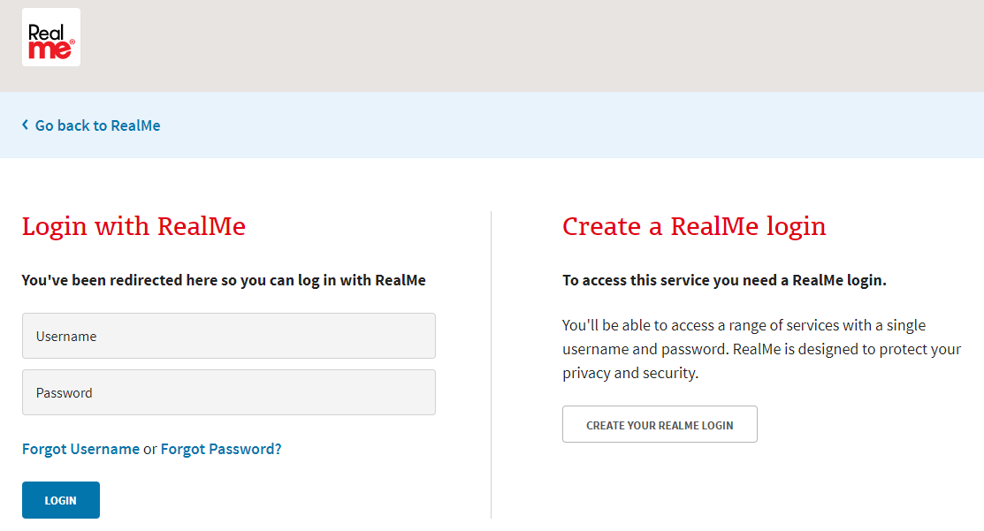
4 | If you are logging in with an existing RealMe login, complete the required fields under “Login with RealMe” and click Login.  Result: You will be logged in and redirected to the OWLS 2.0 dashboard.  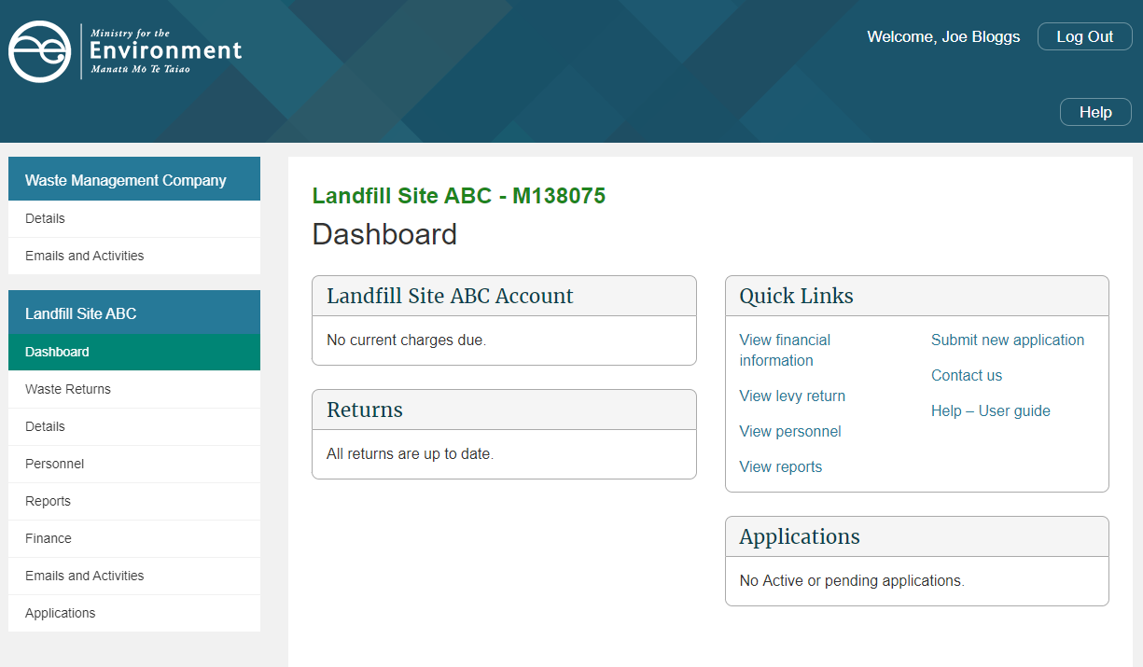
5 | If you need to set up a new RealMe login, click Create your RealMe login instead.  Result: The RealMe set up your account page displays.  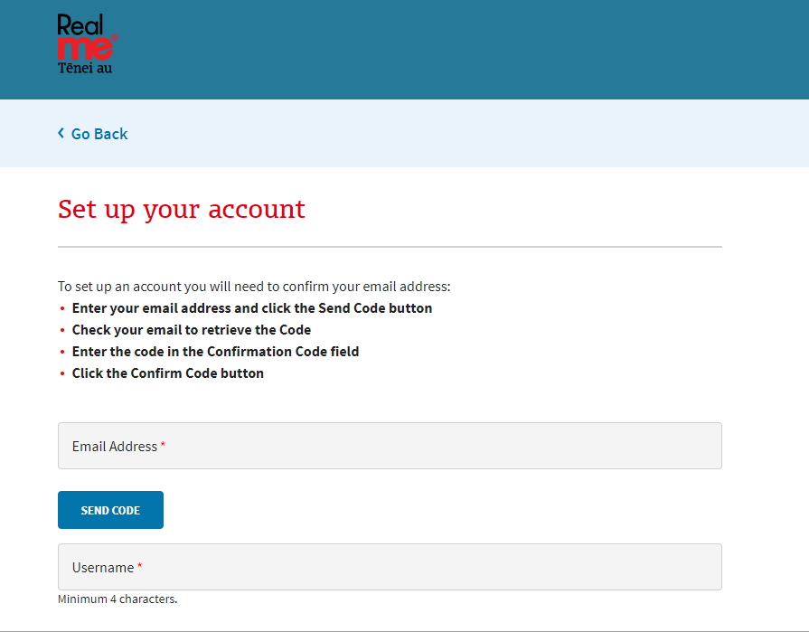
6 | Enter the following information:  Field Description  Email address Type the email address you wish to use with RealMe.  Username Type the username you wish to use with RealMe.
7 | You will need to confirm your email using a code.  To do this, click SEND CODE.
8 | Check your email inbox for the confirmation code.  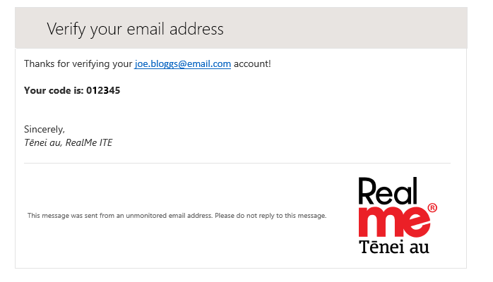
9 | On the RealMe “Set up your account” page, enter the confirmation code as per the email.  Click CONFIRM CODE.  Result: your email will be verified for use with RealMe.  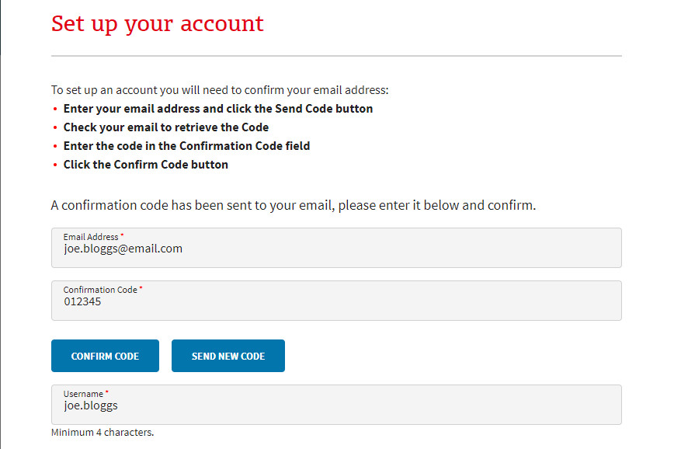  Note: if you require a new code, click SEND NEW CODE. A new confirmation code will be sent to your email.
10 | Field Description  Password Type the password you wish to use with RealMe. Note: A RealMe password must be at least 7 characters long. If it is less than 12 characters, it must contain at least 3 of the following: - UPPERCASE (A–Z) - lowercase (a–z) - numbers (0–9) - symbols (eg, #, $, !, @, ^, &, *, etc) Type the password again in the next field.
11 | When you have finished entering a password, click Continue to proceed.  Result: The next RealMe Set up your account page displays.
12 | If you wish to provide a mobile number, type it in the relevant field.  You can also provide an alternative number. If you wish to do so, type it in the relevant field.
13 | Next, you will need to select three security questions.  Use the drop-down menus on each row to select the questions.  Type your answer(s) in the relevant field(s).
14 | The secret PIN is optional. If you wish to add a secret PIN to your RealMe login, type it in the relevant field.  Note: If you enter a secret PIN, it must:  - be a five-digit number  - have no more than three consecutive numbers, and  - not repeat the same digit more than twice.  Confirm the PIN by typing it again in the next field.  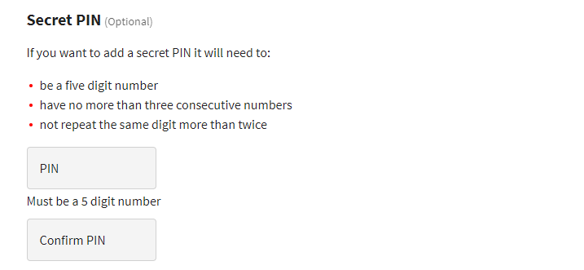
15 | Tick the box to accept the RealMe Terms of Use.  Then, click Continue.  Result: The RealMe” Second-factor authentication” page displays.  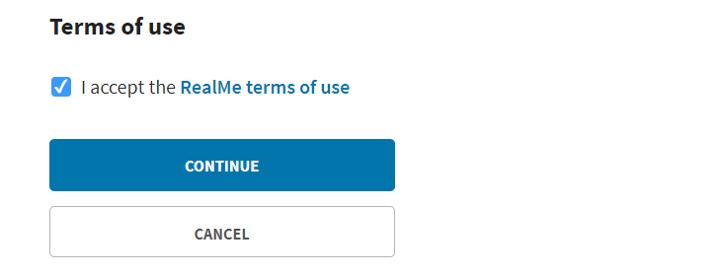
16 | You will need your mobile phone to set up second-factor authentication.  Select the method by which you’d like to receive your unique code:  - Use an authenticator app – a unique code will be generated via an authenticator app. Refer to step 17 for download instructions. (Preferred method)  - Use your mobile number – a unique code will be sent to your mobile number.
17 | To generate your code via an authenticator app, you will need to have installed the Google Authenticator app on a compatible mobile phone.  Note: You can download the app from either the Apple App Store or Google Play Store by clicking on the logos.
18 | Open the Google Authenticator app on your phone.  Result: The Authenticator app will display.
19 | Tap the icon.  Next, tap Scan Barcode.  Use your phone’s camera to scan the QR code generated by RealMe.  Result: Google Authenticator will generate a unique code on your phone.
20 | Enter the code generated by Google Authenticator on the RealMe Set Up Google Authenticator page. The unique code will only remain valid for 60 seconds.  Result: You will be logged in and redirected to the OWLS 2.0 dashboard.  Note: If you opt to use Google Authenticator to generate a unique code, you will need to access the app each time you log into OWLS 2.0. The app will generate a unique code for each login.

What happens next?
You can now access OWLS 2.0 using a RealMe login.

Logging in to OWLS 2.0

When to use
Use these steps to log in to OWLS 2.0 using your existing RealMe login details.
Note: If you are logging in for the first time, see the Logging in as a new user steps.

Roles
- Site data entry – Can update returns that will placed in a status of ‘Pending Verification’
- Site verifier – Can create/update personnel update/verify returns, update Client/Site details and create/modify applications.
- Site verifier delegator – Can create/update personnel update/verify returns, update Client/Site details, create/modify applications, and delegation access.
- Facility Administrator – can create/update personnel, has delegation and view access, cannot perform other functions in OWLS. Can be assigned to multiple Sites

Steps
Step | Action
1 | Open your browser, and go to the website www.wastelevy.govt.nz  Result: The Home page displays. You can click:  - Home – Return to Ministry for the Environment home page  - Log in – Access the log in page.  - Help – Access to the help section.  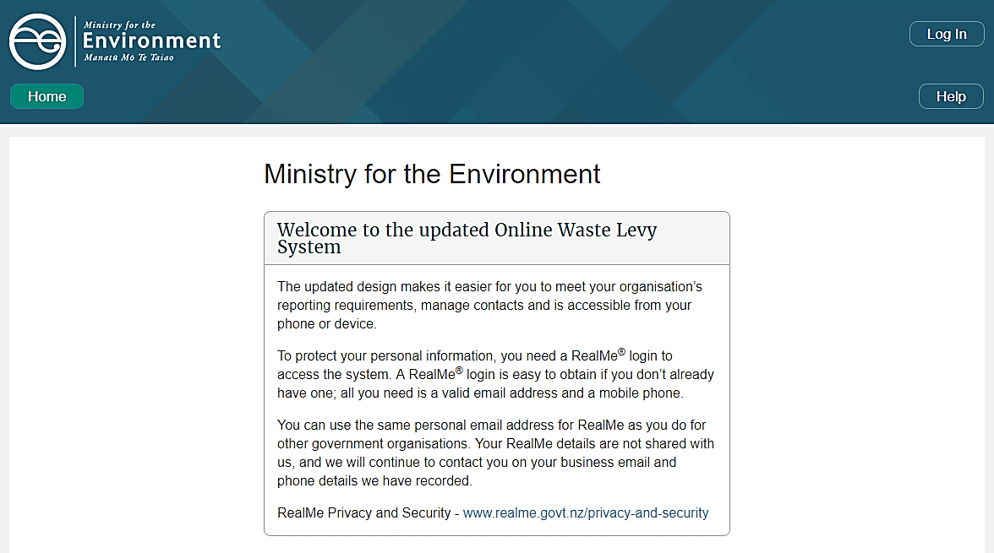
2 | Click Login.  Result: The OWLS 2.0 login page displays.
3 | Click Login with RealMe to access OWLS 2.0 using your RealMe login credentials  Result: You will be redirected to the RealMe Login page where you can enter your username and password.  Notes:  - The password is case sensitive.  - You must use the RealMe account you used to register with OWLS 2.0  - If you have forgotten your username or password, please refer to the RealMe login page and click Forgot Username or Forgot Password or contact the RealMe 24/7 helpdesk at 0800 664 774.

What happens next?
You can use the OWLS 2.0 functions for your disposal facility as required.

Moving around OWLS 2.0

Disposal Facility Dashboard
When you first log on to OWLS 2.0 you are presented with your disposal facility dashboard. From here you can access all the functions available to you.
Your dashboard tells you:
- any balance due for payment
- when your next invoice is due
- which returns have not been submitted
- a summary of your applications
- a Quick Links field, from which you can access:
- financial information
- levy returns
- personnel
- reports
- new application submissions
- contact details for support
- a help section, including the user guide.
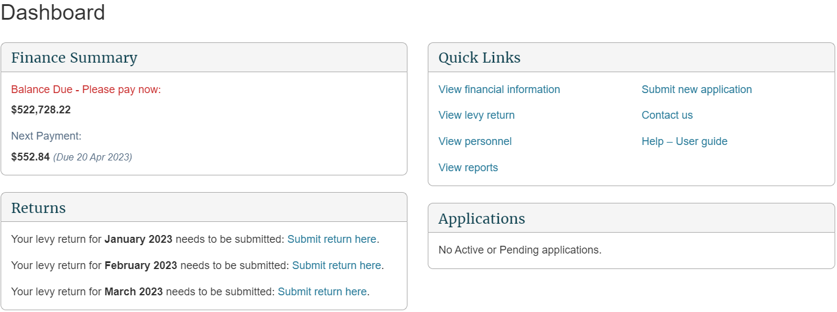

Content menu
Use the content menu to access different areas of OWLS 2.0. Depending on your level of authorisation, you may not have access to all areas.
The topmost section refers to the “client” or company.
Use the content menu to access:
- Client details
- Emails and activities
The following section relates to the disposal facilities under the client’s management.
Use the content menu to access:
- Disposal Facility Dashboard
- Waste Returns
- Disposal Facility Details
- Disposal Facility Personnel
- Reports
- Finance
- Emails and activities
- Disposal Facility Applications
- Disposal Facility Compliance
Note: The content menu will tell you which area you are currently in with a green-coloured field.
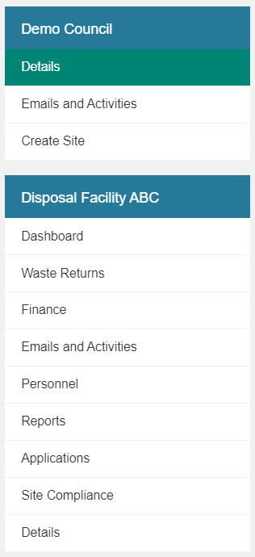

Directory display
The directory display will also tell you which area you are in.
You can click on the name of an area to go there.
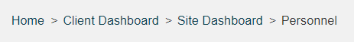

Home button
Use the home button to return to the top of the screen.

Notifications banner
The banner at the top of the screen contains important information and notifications from the Waste Levy team.
If a link with additional information is available, this is displayed as a button under the main banner text.

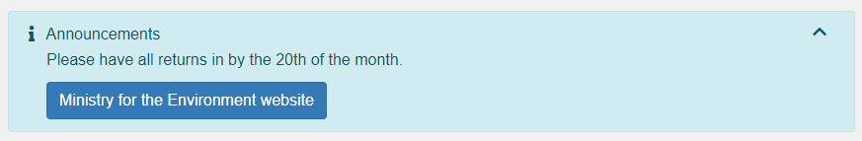

Field types and validation
There are four field types used in OWLS 2.0. To move from one field to the next, you can either use your mouse, or press the Tab key on your keyboard.
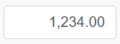 | Free text field – users can edit and update these fields
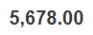 | System-populated field – users cannot edit these fields
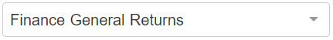 | Drop-down list – users can select options from the list
 | Check box – users can either select or de-select the box
Some fields have built in validation. If your entry is incorrect or is not valid for the field (eg, no @ in an email address, or a required field has been left blank), a message prompting you to update the field displays next to the field name.
Some fields require you to enter information. If you leave a blank entry (eg, if you try to submit a return with no information), the following banner will appear.
The colour of the disposal facility name will indicate whether a facility is open or closed.
If the disposal facility name is in green, this indicates an open, active facility.
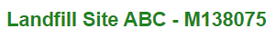
If the disposal facility name is in red, this indicates a closed facility.
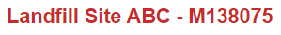

Help
An online help function is available from every screen within OWLS 2.0.
Click the icon on the top-right corner to open the specific help page for the screen.

Creating a new facility within OWLS 2.0

When to use
Use these steps to create a new facility within OWLS 2.0 under your current organisation.

Role
- Site Verifier – Can create/update personnel update/verify returns, update Client/Site details and create/modify applications.

Steps
Step | Action
1 | Once logged into OWLS, select the ‘Create Site’ link from the left-hand menu:  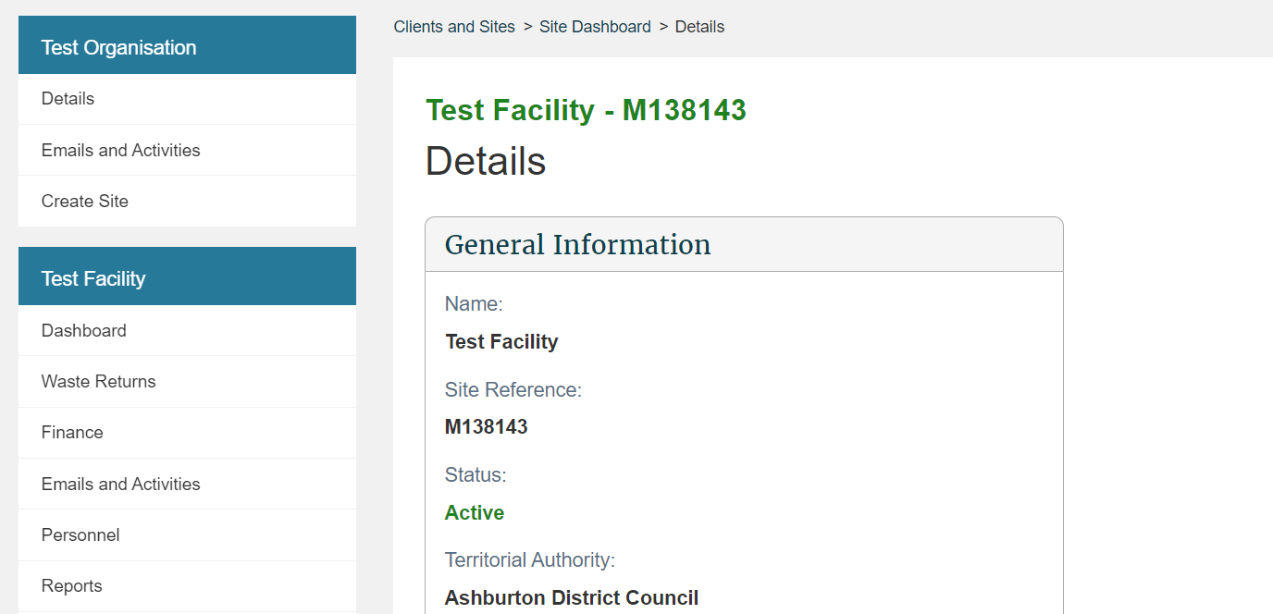  Result: You are taken to the Site creation screen  Note: The terms ‘site’ and ‘facility’ are used interchangeably throughout OWLS.
2 | General Information  Enter the Name, Territorial Authority, Demographic Type, Facility Start Date and Site Latitude and Longitude.  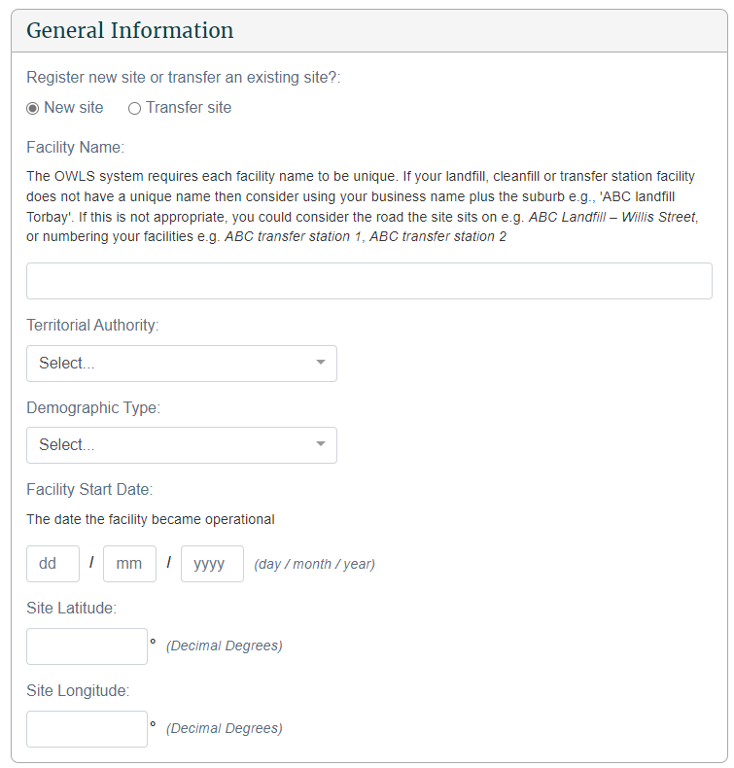
3 | Contact Information  Start entering the Physical Address of the facility and select from the dropdown list.  If the address does not appear in the list, enter the full address of the facility.  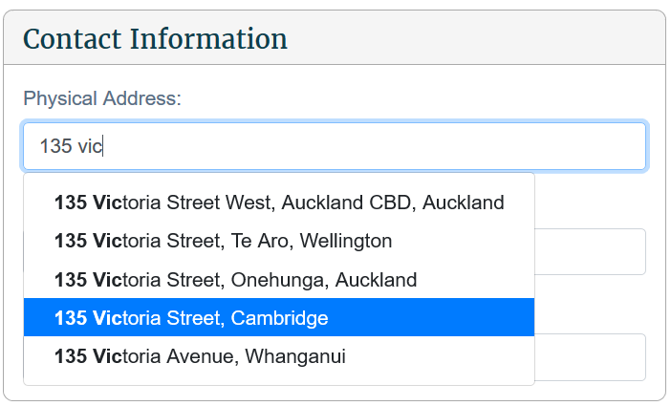  Enter the Site Email and Site Phone Number.  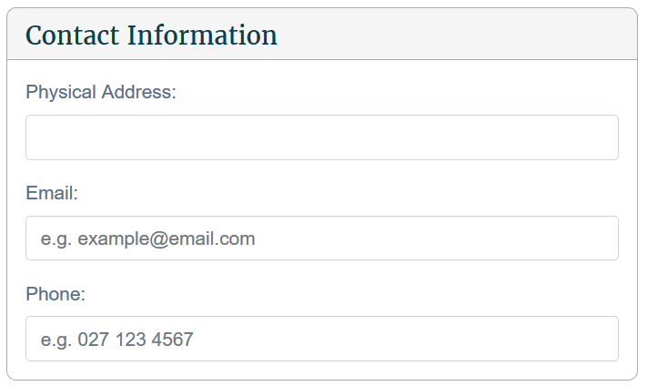
Finance Information

Optionally enter a Statement Email Address and Purchase Order Number.
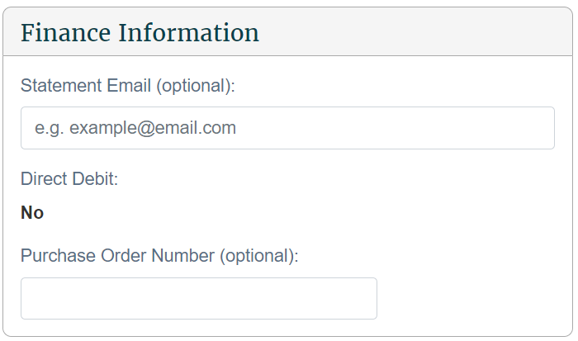
5 | Operational Information  Insert the Estimated Annual Tonnage and the Cover Material Sourced.  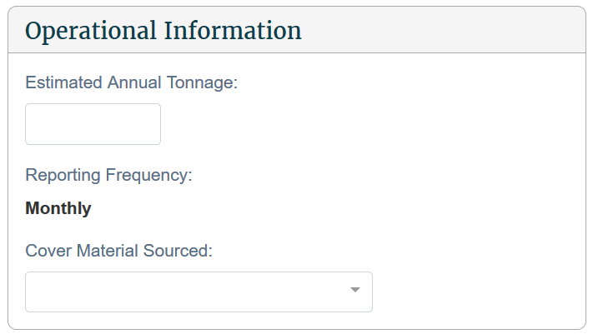
6 | Site Classes  Select your class from the dropdown list. Your class type should be determined using the information on this fact sheet; please note that your class type may differ from your council consent.  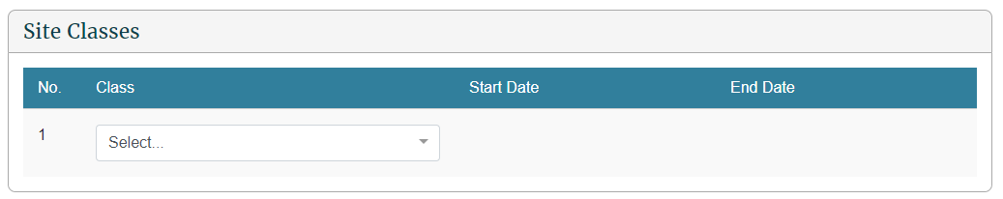
7 | Methodologies  Select each methodology for measuring materials used by the facility, along with the start date of that measuring methodology.
8 | Confirmation  Confirm that all the details for the site are correct and click Save.

What happens next?
We will consider your application and advise you of the outcome via email. Once approved, your new site will be available for you to use immediately in OWLS.

Chapter 2: Monthly and quarterly returns
This chapter provides information on submitting and updating monthly and quarterly returns. It contains the following topics:
Topic
Overview
Return summary screen (monthly returns)
Submit a return
Verify a return
Update a return
View invoices and statements

Overview

Introduction
Where appropriate, facility operators must submit returns to us on a monthly or quarterly basis, depending on their site class. Refer to the links below for more information on when facilities are required to begin reporting:
Waste Minimisation (Calculation and Payment of Waste Disposal Levy) Regulations 2009 (SR 2009/144) (as at 13 May 2021) Schedule 1AA Transitional, savings, and related provisions – New Zealand Legislation
Waste Minimisation (Information Requirements) Regulations 2021 (LI 2021/69) Schedule 1 Transitional, savings, and related provisions – New Zealand Legislation
As at the publication of this document, the reporting frequencies are as follows:
- Monthly – levy liable facilities:
- Class 1 - Municipal Facility
- Class 2 - Construction and Demolition Facility
- Class 3 & 4 - Managed or Controlled Fill Disposal Facility
- Quarterly – Non-Levy liable facilities:
- Class 5 – Cleanfill Facility
- Transfer Station Facility
- Industrial Monofill Facility
Monthly returns are due on the 20th of the month after waste has been deposited. Quarterly returns are due on or before the 20th day of the month after the last month of the quarter to which the return relates. Refer to the Waste disposal levy guide for disposal facilities for more information.
Note: All facilities can apply to submit annual returns instead. See Chapter 3: Annual returns.

Waste material received
Gross tonnage is the total metric tonnes of waste received at your disposal facility. Diverted tonnage is the waste you have diverted for reuse and recycling that has previously been recorded in OWLS 2.0 as ‘Waste material received (gross tonnage)’.

Reporting of waste source categories
To help us identify areas to focus on and better understand the state of waste disposal in New Zealand, gross tonnage can now be entered into waste source categories when submitting returns.

Cover material (voluntary)
As part of your return submission, OWLS 2.0 provides the option of entering information about cover material used at your disposal facility.
Collection of this data will help us better understand the usage and source of cover material at disposal facilities.
Cover material can either be sourced on facility and/or off facility.
All waste (including waste that is used as cover) should also be included as waste material received (gross tonnage) in your return, as this waste will still be liable for the levy rate based on your class.

Estimated returns (levy liable facilities only)
If you do not submit and verify a complete and accurate return by the due date, we will issue an initial estimate of the amount of waste levy due for that month. If an estimate is issued, the levy for that month will be charged based on the estimate when it was finalised, even if the return is subsequently submitted.
If you submit a return after an initial estimate has been issued but before it has been finalised, the levy will not be charged against that return. However, we may choose to take the information provided on that return into account to update the levy amount before the estimate is finalised. We will issue the final estimate within 15 days of the due date for the return. The final estimate will determine the final amount of levy you are required to pay for that month.
Invoices generated from estimated returns cannot be amended later.
An estimate displays as an additional line on the Waste Return Summary screen.

Return Summary screen
Using the Return Summary screen, you can view the status of:
- pending and previously submitted returns, and
- any estimate records.
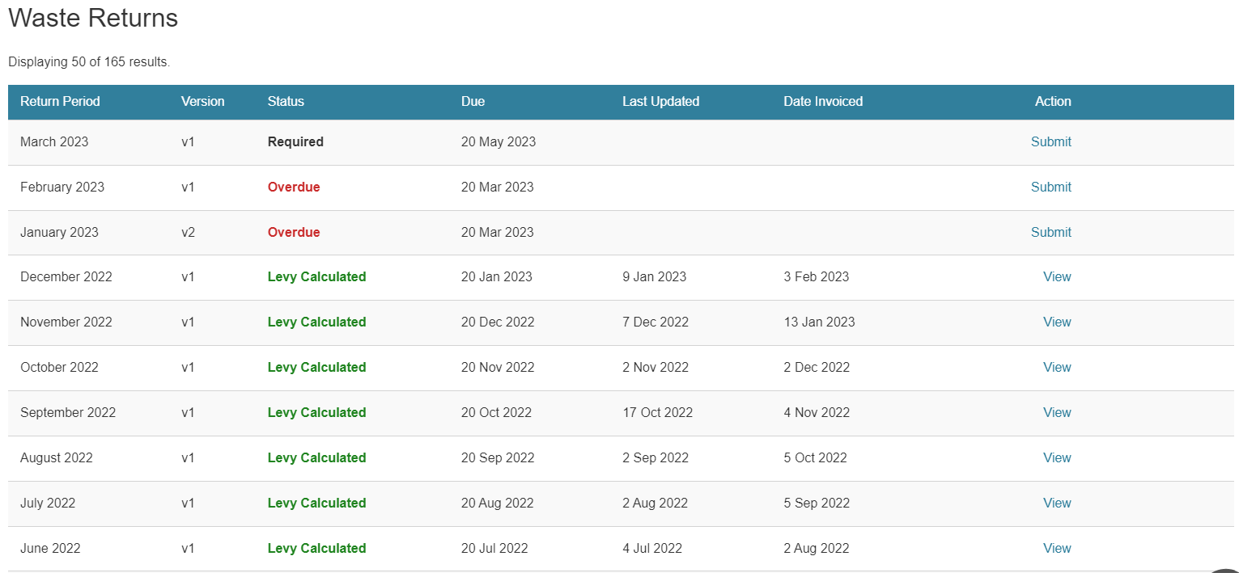
The status of the return or estimate determines the type of action a user may take.

Returns
The version number of the return indicates if:
- a return is the original required or completed return for the period (v1) or
- a return has been amended (v2 or higher).
Status | Description/action
Required | A blank return has been created by the system and requires completion.  - If no data has yet been entered, data entry users and verifiers can Submit the Return.  - If draft data has been entered and saved, data entry users and verifiers can Update the Return.
Overdue | A return is required, and the due date has passed. The same actions available for Required returns are available for Overdue returns.
Verification Required | A return has been submitted but needs to be verified before it can be used to calculate the levy.  - Data entry users can View the return until it is verified.  - Verifiers can Verify or View the return.
Tolerance Level Alert Assessment | A tolerance breach has been detected on a return. The return will be assessed by us.  We can reject the return if the tolerance alert reason is deemed insufficient, which will change the status of the return back to Required for v1 returns or to Rejected for amended returns.  Data entry users and verifiers can View a return while it is awaiting a tolerance assessment from us.
Verified | A return has been verified but the levy has not been calculated using the return because an estimate exists.  - Data entry users can View the return.  - Verifiers can update or View the return.
Levy Calculated | The return has been verified and if applicable the levy has been calculated, and an invoice generated for the return.  - Users can View the return.  Most returns will have the levy calculated immediately upon verification or approval of a tolerance alert assessment.
Rejected | A tolerance level alert has been detected on an amended return and the reason provided was not deemed sufficient, so the amended version of the return has been rejected.

Estimates (monthly reporting facilities only)
Status | Description/action
Initial Estimate | We have issued an Initial Estimate, and an email has been sent to the disposal facility.  Data entry users and verifiers can View the initial estimate. The estimate can only be updated if the facility submits/verifies the overdue return for the month.  Any return submitted may be taken into account when the Final Estimate is generated.
Updated Estimate | The disposal facility has submitted/verified the return after the due date, which has updated the initial estimate.  We may take the updated amount into account when generating the Final Estimate.  Data entry users and verifiers can View the updated estimate.
Final Estimate | We have approved the Final Estimate and the levy has been calculated and invoiced.  Data entry users and verifiers can View the final estimate. If the return for the month remains overdue or unverified, it can still be submitted. However, any return submitted once the Final Estimate has been generated will have no effect on the levy payment required.

Submitting a return

When to use
Use these steps to submit a return.
Refer to the Calculation and Payment of the Waste Disposal Levy guide for information about calculating gross and diverted tonnage, cover material and extensions for storage of material over six months.

Roles
- Site data entry – Can update returns that will placed in a status of ‘Pending Verification’
- Site verifier – Can update/verify returns
- Site verifier delegator – Can update/verify returns

Steps
Step | Action
1 | Click the Waste Returns link in the content menu.
2 | Click the Submit link in the Action column for the relevant month.  Result: The Waste Return screen displays.  The return header will display:  - the month and year of the return  - the version of the return (e.g., v1)  - the Site name  - class and class description of return (e.g., class 1 – Municipal Disposal Facility)  - Physical address of the Site  - due date of the return  - if applicable, when the return was last updated  - status of the return.  Note: If there are either multiple applicable levy rates or a storage time extension application has been granted for that month, additional diverted material columns will be displayed.
3 | Enter any Waste Materials Received (Gross Tonnage).  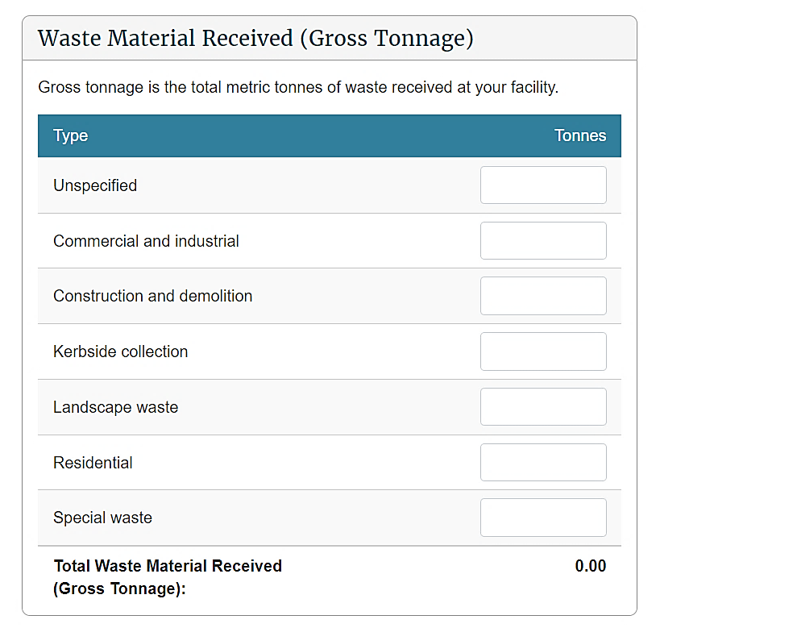
4 | Enter any Diverted Materials:  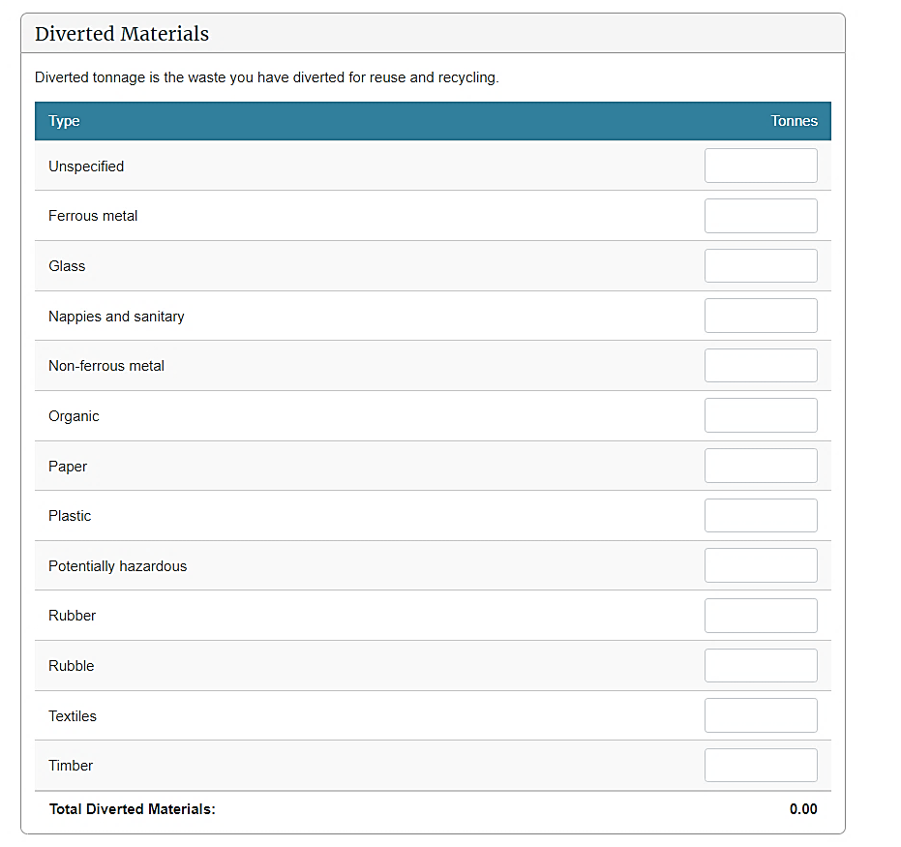
5 | Diverted Materials at old and new rate can be entered for six months after a new Levy rate is started. In this case enter Diverted Materials tonnage in the appropriate column  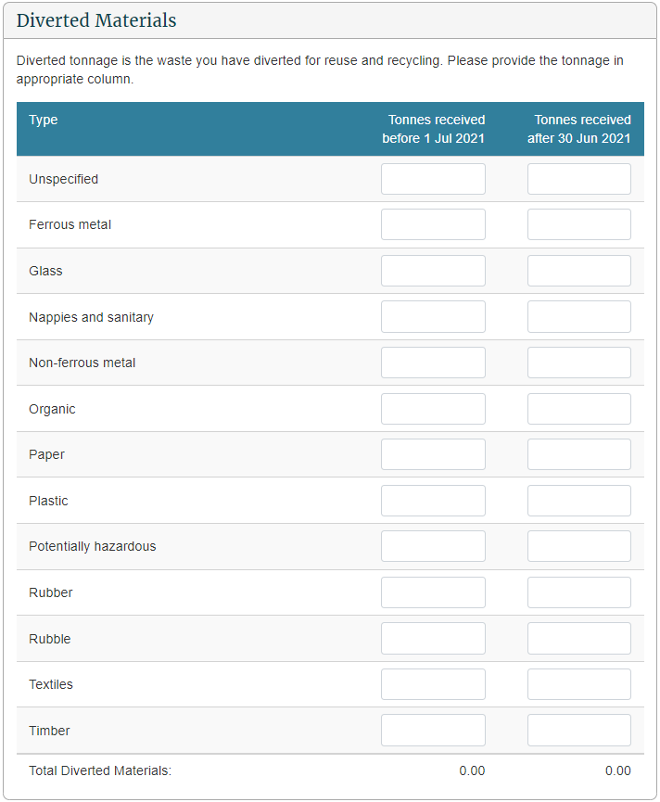
6 | If there is an approved Storage Time Extension Application at previous levy rate for this period, you can enter the Diverted Materials at that rate against materials from that application.  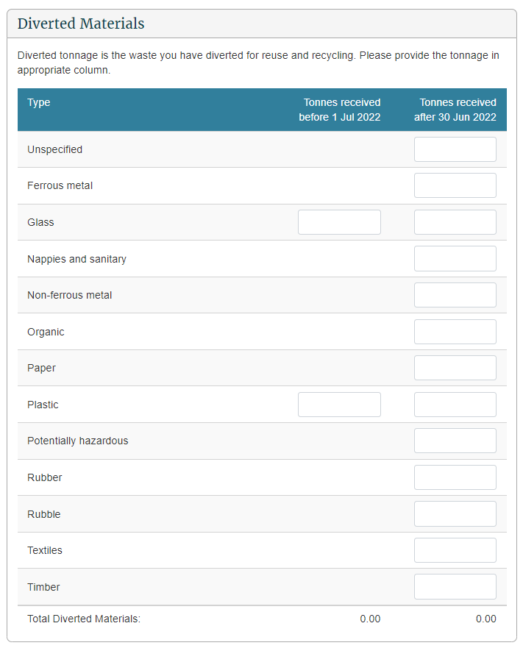
7 | Completing the details in the Cover Materials Used section is voluntary. All waste (including waste that is used as cover) should also be included as waste material received (gross tonnage) in your return, as this waste will still be liable for the levy as determined by your class.  Note: Should you decide not to report on cover material, leave the fields blank.
8 | If there was no activity at your facility during the month, click the check box after the Cover Materials Used section. Otherwise, enter the metric tonnes for each waste source you are reporting on.  Notes:  - The system calculates the sum of the amounts in the Total fields.  - If you select No Activity, any tonnages entered will be removed automatically.
9 | Check that the totals are correct, and then click the Continue button.  Result: The Waste Return Summary screen displays the net tonnage and levy due.  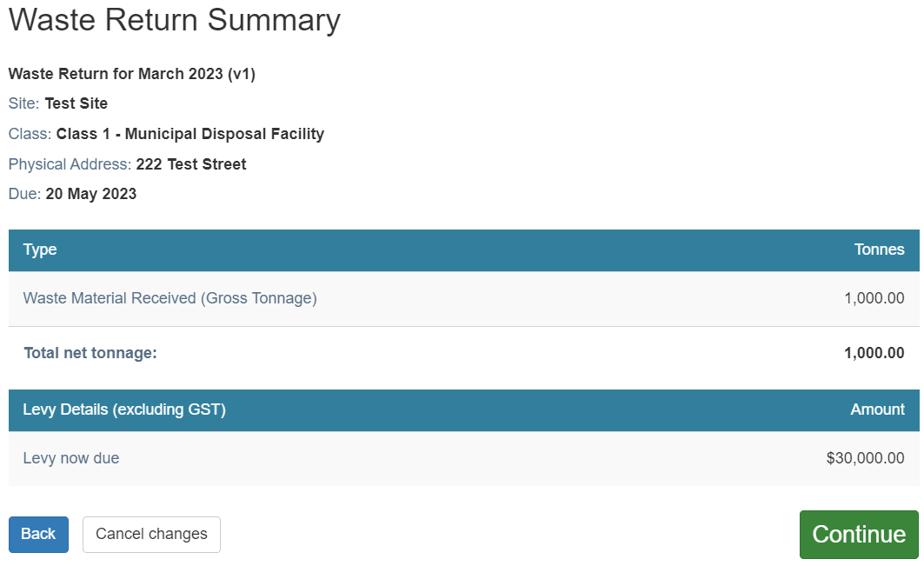  Note: Diverted Materials entered at different rates at Step 5 will be calculated at their respective rates and listed in Waste Return Summary  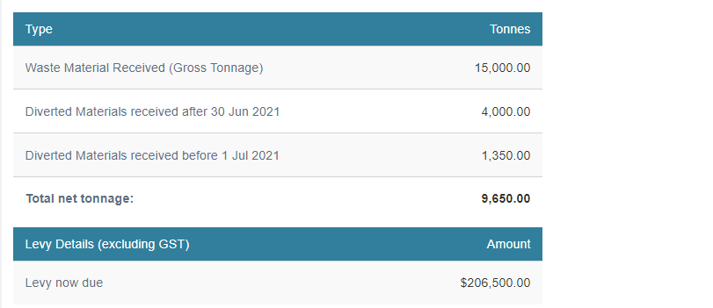  Note: If a waiver or exemption is applied, this will also appear on the return summary screen
10 | If there are irregularities in the return, you will need to provide additional information.  Text will display under the Additional Information header describing the irregularity.  Type an explanation of irregular activity.  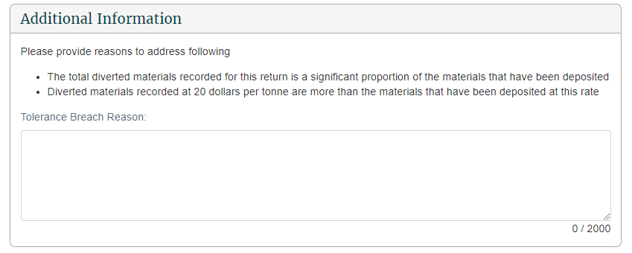
11 | Data entry users can click Save & Close to complete the return later OR click Ready for Verification to submit the return.  Result: You are taken back to the Return Summary screen and the return status will change.  If you clicked Ready for Verification, the status of the return will change to Verification Required. Data entry users can Update the return (and cover material) until it is verified.  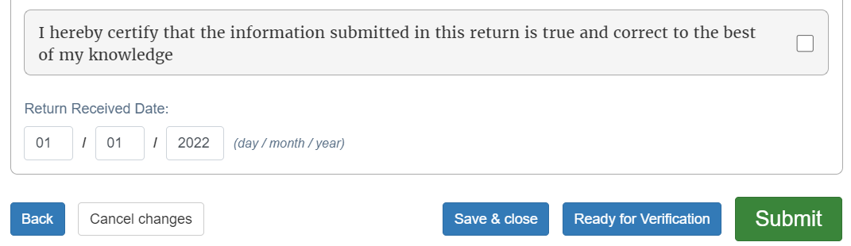  Note: If the entries are incorrect, click the Back button and edit them.
12 | Verifiers can click the Declaration check box and:  - click Save & Close to complete or update the return later  - click Ready for Verification to submit the return for verification  - click Submit to submit the completed return.  Result: You are taken back to the Return Summary screen and the return status will change.  If you clicked Ready for Verification, the status of the return will change to Verification Required.  If you clicked Submit, the status of the return will change to either Levy Calculated or Breach Assessment if the return has breached a tolerance level.  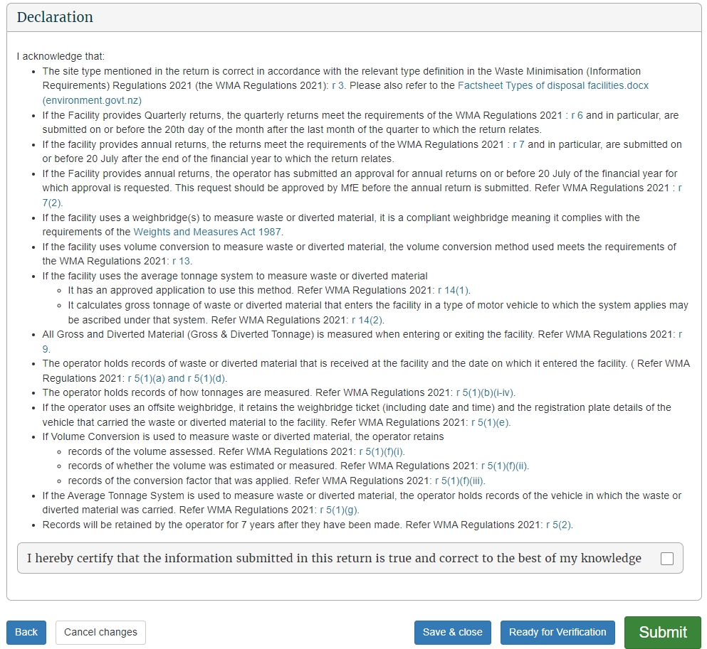

What happens next?
The verifier verifies the return.

Verifying a return

When to use
Use these steps to verify a return.
Note: If your facility reports monthly, you must verify the return before the return’s due date to ensure your disposal facility avoids being issued with an estimate.
Refer to the Calculation and Payment of the Waste Disposal Levy guide for information about calculating waste material received (gross tonnage) and diverted tonnage, cover material and extensions for storage of material over six months.

Role
- Site verifier – Can update/verify returns
- Site verifier delegator – Can update/verify returns

Steps
Step | Action
1 | Click the Waste Returns link in the content menu.
2 | Click the Verify link in the Action column for the relevant month (where the status is Verification Required).  Result: The Waste Return screen displays showing the original data entered.  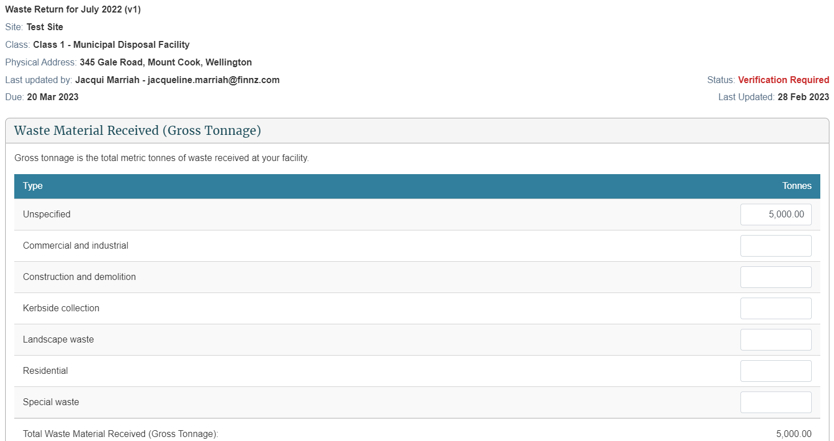
3 | Check that all entries are correct, and update if required.
4 | After you have checked all entries, click the Continue button.  Result: The Waste Return Summary screen displays.  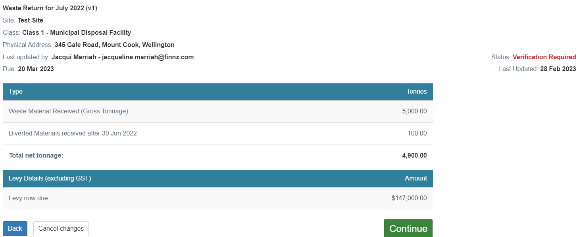
5 | If there was irregular activity on the return, a text box displays the explanation entered by the data entry user.  Update the explanation of the irregular activity if required.  Note: We may contact you for further clarification.  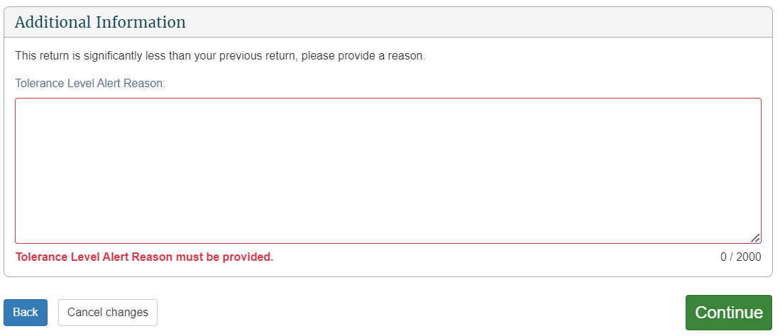
6 | Click the Declaration check box, and then click the Submit button.  Result: You are taken back to the Return Summary screen and the status has changed to Verified. You can update the return until the levy is calculated.  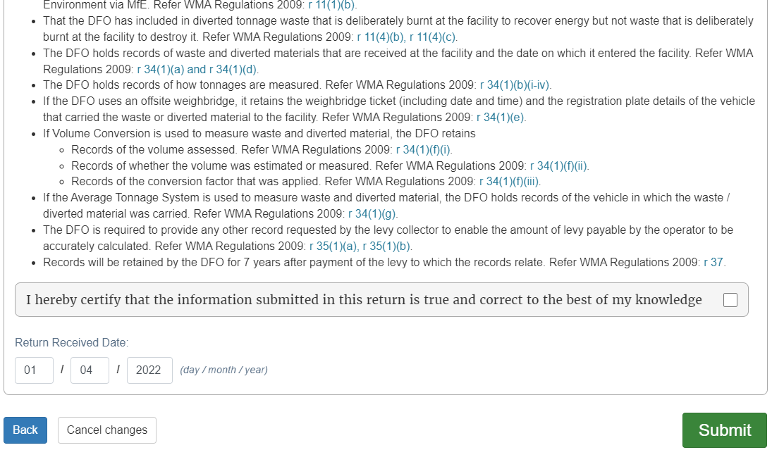

What happens next?
We process your return and calculate the levy payment due for that month.
If the return has a tolerance breach, we will need to assess it.
We can:
- accept the return and calculate the levy
- reject the return, in which case the disposal facility would be required to correct and re-submit the return.
Note: If you find you have made a mistake in your original return, you can request an amendment to the return after the levy is calculated. See Amend a return below.

Amending a return
Note: OWLS will no longer accept amendments to submitted waste returns directly from facility operators. If you have made a mistake, please contact the help desk at 0800 WDLEVY (0800 935 389).

View Tax invoice / Statement (monthly reporting facilities only)

When to use
Use these steps to view and/or download statement details. This includes previously issued invoices and any payments you have made since your last statement.
Statements are only available for download as PDF files.
Note: Charges and payments will display after you have submitted a return, and the levy for that period has been calculated.

Roles
- Data entry
- Verifier

Steps
Step | Action
1 | Click the Finance link in the content menu.  Result: The Finance Summary screen displays.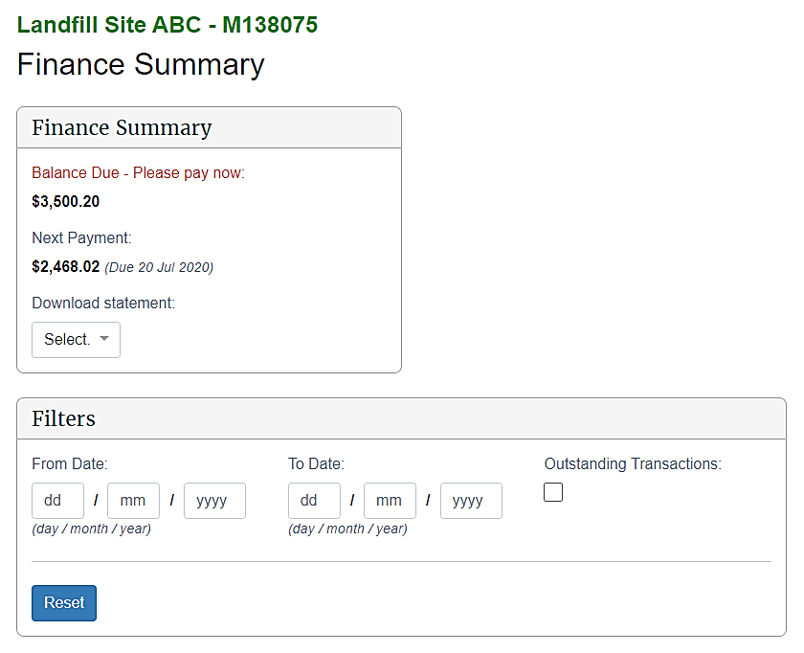
2 | The Finance Summary field will display:
 |  | Type | Description
 |  | Balance due  (please pay now) | Any transactions that are due in the current month or previous months that are still outstanding.
 |  | Next payment | The sum of the next transactions due including the due date (eg, Due 20 Aug 2020).
 |  | Download statement | A dropdown list of all statements the disposal facility has received.  To download a statement, please see step 5.
3 | Filters can be applied to narrow your search:  The following filters can be applied:
 |  | Type | Action/Description
 |  | From date | Displays transactions from this date.  By default these fields are empty.  To apply a date range filter, enter the Day (DD), Month (MM) and Year (YYYY).
 |  | To date | Displays transactions to this date.  By default these fields are empty.  To apply a date range filter, enter the Day (DD), Month (MM) and Year (YYYY) in the field.
 |  | Outstanding transactions | Display transactions that have a balance greater than $0.00.  By default this is left unchecked.  To display outstanding transactions, check the Outstanding transaction box.
 |  | Reset | To clear all filters and reset to default values, click Reset.
 | Result: Transactions matching the filters entered will display.
4 | The Results field displays all invoices and payments associated with a disposal facility:
 |  | Field | Description
 |  | Date | Displays the transaction date in format Day (DD), Month (MM) and Year (YYYY).
 |  | Reference | This is the unique identifier for a transaction (eg, PYT0000123).
 |  | Description | Includes a description of the type of transaction, such as interest or payment.  Levy transactions (Invoices & Credits) display related to a return month. For example, a June 2020 waste return generates a levy invoice that will display as Levy Invoice (Jun 2020).
 |  | Status | The following are transaction statuses:  - Due – the transaction is due over 10 days from now  - Due soon – the transaction due within 10 days  - Overdue – the transaction is overdue  - Paid – the transaction has $0.00 balance  - Paid late – the transaction has $0.00 balance, but was paid after its due date (overdue)  - In dispute – the transaction is being disputed  - Amount remaining – balance is greater than $0.00  - Fully remaining – balance is $0.00.
 |  | Due / Applied | Due indicates the due date of:  - Debit notes  - Interest  - Levy invoice/s  - Payment dishonour/s  - Waiver credit reversal transactions.  Applied indicates the date that a credit was applied:  - Credit notes  - Interest reversal  - Levy credit  - Payment  - Direct debit payment  - Waiver credit transactions.
 |  | Amount ($) | The full amount of a transaction.
 |  | Balance ($) | The amount of a transaction less any other transactions applied.  For example, a levy invoice of $200.00 where a payment of $50.00 has been applied. This would display as:  - Amount = $200.00  - Balance = $150.00.
Notes: Debit transactions are debit notes, interest, levy invoice/s, payment dishonour/s and waiver credit reversal/s.
Credit transactions are credit notes, interest reversal, levy credit/s, payment/s, direct debit payments and waiver credit/s.
- If a credit transaction is applied against a debit transaction, the credit transaction will appear underneath the debit transaction.
- The amount will be the applied amount to the debit.
- If a credit transaction has a balance remaining (balance > $0.00) and has been partially applied to a debit transaction, the credit transaction will appear twice:
1. Appear underneath the debit transaction that it is applied to
2. Its own line with a status of ‘Amount remaining’ and the remaining balance.
Selecting the View more button at the bottom of the results will display more transactions.
5 | To download a copy of a statement, select the relevant month from the Download statement drop-down list.  Result: Depending on your settings and internet browser, the file may download automatically and appear in the Downloads list.  Note: If a file pop-up displays, go to step 6.
6 | If a file download pop-up displays, click:  Open to open the PDF.  Save to save a copy of the report to your computer.  Result: If you clicked Open, the file will open. If you clicked Save, you will be prompted to select a folder to save the PDF in.

What happens next?
If you have any queries about your statement balance, invoices or payments, please call 0800 WDLEVY (0800 935 389).

Chapter 3: Annual and six-monthly returns
This chapter provides information on submitting annual and six-monthly returns.
Note: This chapter only applies to disposal facility operators who have approval to submit either an annual or six-monthly return.
This chapter contains the following topics:
Topic
Overview
Return Summary screen (annual returns)
Submit a final annual return
Verify a final annual return
Amend a final annual return

Overview

Introduction
Operators of small facilities can apply to submit returns annually instead of monthly. Beginning in 2022, more classes must begin reporting via OWLS 2.0 – Class 2 and Classes 3 and 4 facilities can apply for a six-monthly return in order to bring their reporting dates into line with the annual reporting cycle.
These six-monthly reporting periods are as follows:
- Class 2: Construction and demolition fill disposal facility – 1 January 2022 to 30 June 2022
- Classes 3 and 4: Construction and demolition fill disposal facility – 1 January 2023 to 30 June 2023
To be eligible to submit six-monthly returns, the expected tonnage for the applicable period must be 500 tonnes or less. To be eligible to submit annual returns, the expected tonnage must be 1,000 tonnes or less per annum.

Provisional and final annual/six-monthly returns
When the application is approved, we create a provisional return showing expected waste tonnage figures for the period. These figures are then used to calculate a flat monthly levy amount for sites that are subject to the levy. The return is created with the status of Approved Application and cannot be updated.
On 1 July, the Approved Application status changes to Required. The final return must be submitted by 20 July for actual waste deposited in the preceding period. We will use this return to calculate the difference between the actual and the expected annual return figures.
Refer to the Calculation and Payment of the Waste Disposal Levy guide for more information, or see Apply to submit annual returns in this guide for details on how to apply using OWLS 2.0.

Estimated returns (annual returns only)
If your site is subject to a levy, and you do not submit and verify a complete and accurate return by 20 July, we will issue an initial estimate of the amount of waste levy due for that year. If an estimate is issued, the levy for that year will be charged based on the estimate when it was finalised, even if the return is subsequently submitted.
If you submit a return after an initial estimate has been issued but before it has been finalised, the levy will not be charged against that return. However, we may choose to take the information provided on that return into account to update the estimated levy amount before the estimate is finalised. The final estimate will be issued within 15 days of the due date for the return. The final estimate will determine the final amount of levy you are required to pay for that year.
You can still submit or request an amendment to a return after the final estimate has been issued to keep return records complete and accurate. However, any returns submitted or amended after the final estimate is issued will not affect the amount you are required to pay for that year.
An estimate displays as an additional line on the Waste Return Summary screen.

Return Summary screen
Using the Return Summary screen, you can view the status of:
- pending and previously submitted returns
- any estimate records.
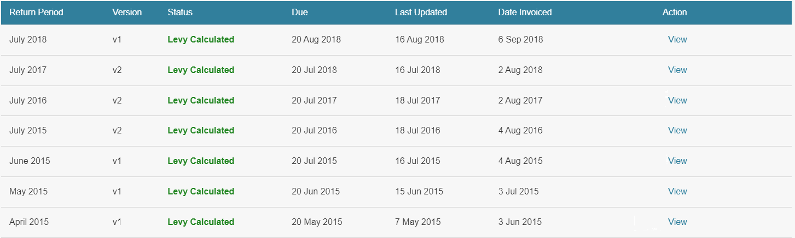
The status of the annual return or estimate determines the type of action a user may take.

Returns
The version number of the return indicates if:
- an application to submit annual/six-monthly returns has been approved (v1)
- an original final return is required or completed for the period (v2)
- a final return has been amended (v3 or higher).
Status | Description/Action
Approved Application | An application to submit annual/six-monthly returns has been approved, and a provisional return created. For annual returns, this is used to calculate a flat monthly levy amount.  Either the data entry user or the verifier can View the provisional annual return.
Required | A blank return has been created by the system and requires completion.  - If no data has yet been entered, data entry users and verifiers can Submit the Return.  - If draft data has been entered and saved, data entry users and verifiers can Update the Return.
Overdue | A return is required, and the due date has passed. The same actions available for Required returns are available for Overdue returns.
Verification Required | A return has been submitted but needs to be verified before it can be used to calculate the levy.  - Data entry users can View the return until it is verified.  - Verifiers can Verify or View the return.
Tolerance level Assessment | A tolerance level alert has been raised against a return. The return will be assessed by us.  We can reject the return if the tolerance level alert reason is deemed insufficient, which will change the status of the return back to Required for v2 final annual returns or to Rejected for amended annual returns.  Data entry users and verifiers can View a return while it is awaiting breach assessment from us.
Verified | A return has been verified but the levy has not been calculated using the return because an estimate exists.  - Users can View the return.
Levy Calculated | The return has been verified, the levy has been calculated, and an invoice generated for the return.  - Users can View the return.  Most returns will have levy calculated immediately upon verification or acceptance of a tolerance level alert.
Rejected | A tolerance level alert has been detected on an amended return and the reason provided was not deemed sufficient, so the amended version of the return has been rejected.

Estimates (annual returns only)
Status | Description/Action
Initial Estimate | We have issued an Initial Estimate, and an email has been sent to the disposal facility.  Data entry users and verifiers can View the initial estimate. The estimate can only be updated if the overdue return is submitted/verified for the year.  Any return submitted may be taken into account when the Final Estimate is generated.
Updated Estimate | The return has submitted/verified after the due date, which has updated the initial estimate.  We may take the updated amount into account when the Final Estimate is generated.  Data entry users and verifiers can View the updated estimate.
Final Estimate | We have approved the Final Estimate and the levy has been calculated and invoiced.  Data entry users and verifiers can View the final estimate. If the return for the month remains overdue or unverified, it can still be submitted, however any return submitted once the Final Estimate has been generated will have no effect on the levy payment required.

Submitting a final annual/six-monthly return
Use these steps to submit a final annual/six-monthly return.
Refer to the Calculation and Payment of the Waste Disposal Levy guide for information about calculating tonnage, diverted material, and extensions for storage of material over six months.
Note: To apply to change to annual reporting, see Apply to submit annual returns.

Roles
- Site data entry – Can update returns that will placed in a status of ‘Pending Verification’
- Site verifier – Can update/verify returns
- Site verifier delegator – Can update/verify returns

Steps
Step | Action
1 | Click the Waste Returns link in the content menu.
2 | Click the Submit link in the Action column for the relevant year.  Result: The Waste Return screen displays.  The return header will display:  - the period of the return (e.g., July 2019–June 2020)  - the version of the return (Note: A required final annual/six-monthly return will show as v2)  - class of return (e.g., class 1)  - due date of the return  - if applicable, when the return was last updated  - status of the return.  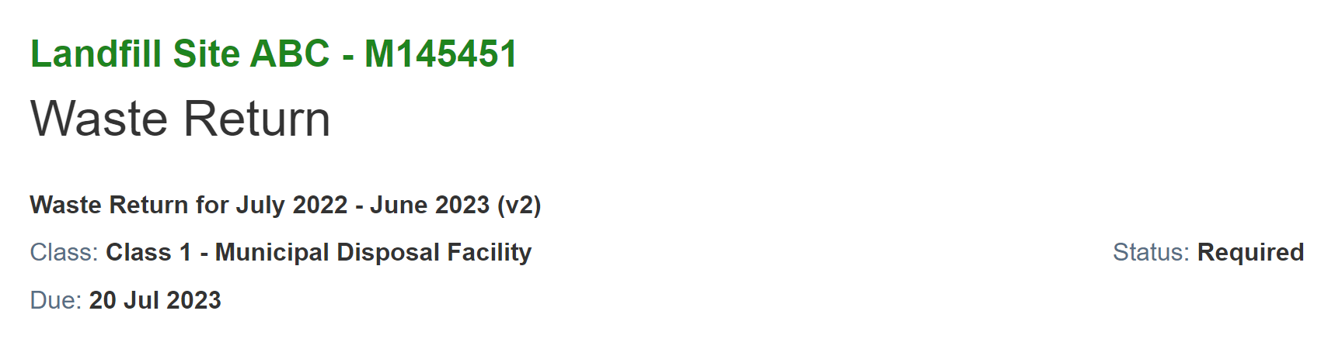
3 | In metric tonnes, type the gross tonnage in the relevant fields for the financial year:  Note: The estimated tonnage from a provisional return may display as Unspecified.
4 | Enter any Diverted Materials tonnage in the relevant fields for the financial year:  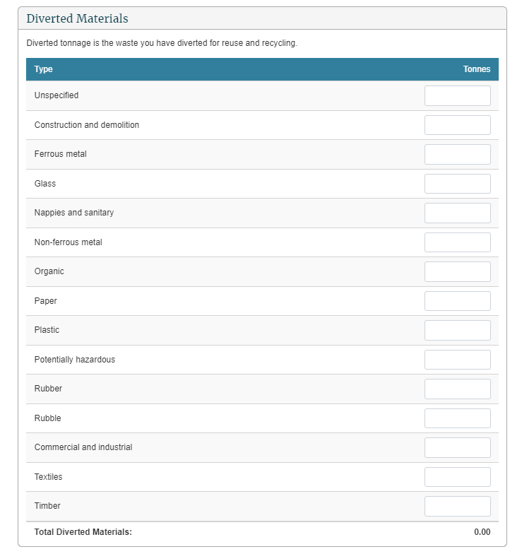
5 | Completing the details in the Cover Material Used section is voluntary. All waste (including waste that is used as cover) is liable for the Waste Disposal Levy and should also be included as gross tonnage in your annual return.  Note: Should you decide not to report on cover material, leave the fields blank.
6 | If there was no activity at your disposal facility during the financial year, click the check box under the Cover Materials Used heading. Otherwise, enter the metric tonnes for each waste source you are reporting on.  Notes:  - The system calculates the sum of the amounts in the Total fields.  - If you select No Activity, any tonnages entered will be removed automatically.
7 | Check that the totals are correct, and then click the Continue button.  Result: The Waste Return Summary screen displays the net tonnage and levy due.  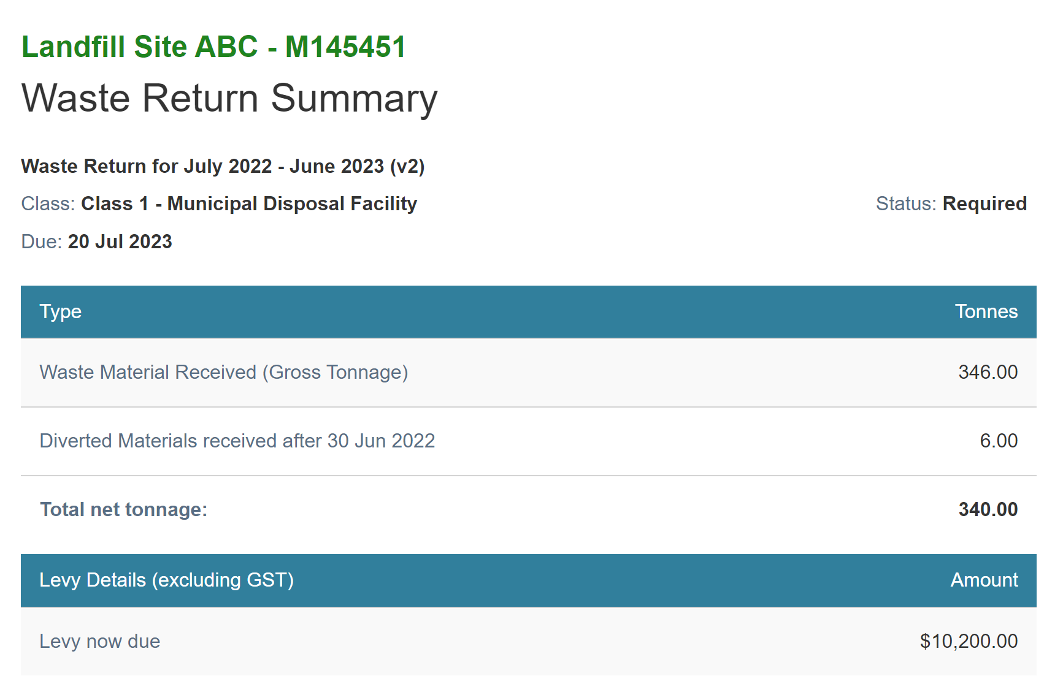  Note: If a waiver or exemption is applied, this will also appear on the return summary screen.
8 | If there are irregularities in the return, you will need to provide additional information.  Text will display under the Additional Information header describing the irregularity.  Type an explanation for irregular activity.
9 | Data entry users can click Save & Close to complete the return later OR click Ready for Verification to submit the return.  Result: You are taken back to the Return Summary screen and the return status will change.  If you clicked Ready for Verification, the status of the return will change to Verification Required. Data entry users can Update the return (and cover material) until it is verified.  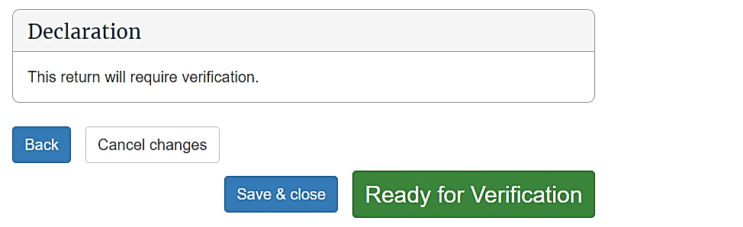  Note: If the entries are incorrect, click the Back button and edit them.
10 | Verifiers can click the Declaration check box and:  - click Save & Close to complete or update the return later  - click Ready for Verification to submit the return for verification  - click Submit to submit the completed return.  Result: You are taken back to the Return Summary screen and the return status will change.  If you clicked Ready for Verification, the status of the return will change to Verification Required.  If you clicked Submit, the status of the return will change to either Levy Calculated or Tolerance Assessment if the return has breached a tolerance level.

What happens next?
The verifier verifies the return.
Note: If the return is not verified by the due date, an estimate will be generated for your disposal facility.

Verifying a final annual/six-monthly return

When to use
Use these steps to verify a final annual or six-monthly return. You must verify the return before the due date of the return, to ensure your disposal facility avoids being issued with an estimate.
Refer to the Calculation and Payment of the Waste Disposal Levy guide for more information.
Note: If you want to continue to submit annual returns, you also need to complete an annual return application by the due date – this includes if you previously have submitted a six-month return. See Apply to submit annual returns.

Role
- Site verifier – Can update/verify returns
- Site verifier delegator – Can update/verify returns

Steps
Step | Action
1 | Click the Waste Returns link in the content menu.
2 | Click the Verify link in the Action column for the relevant year (where the status is Verification Required).  Result: The Waste Return screen displays showing the original data entered.  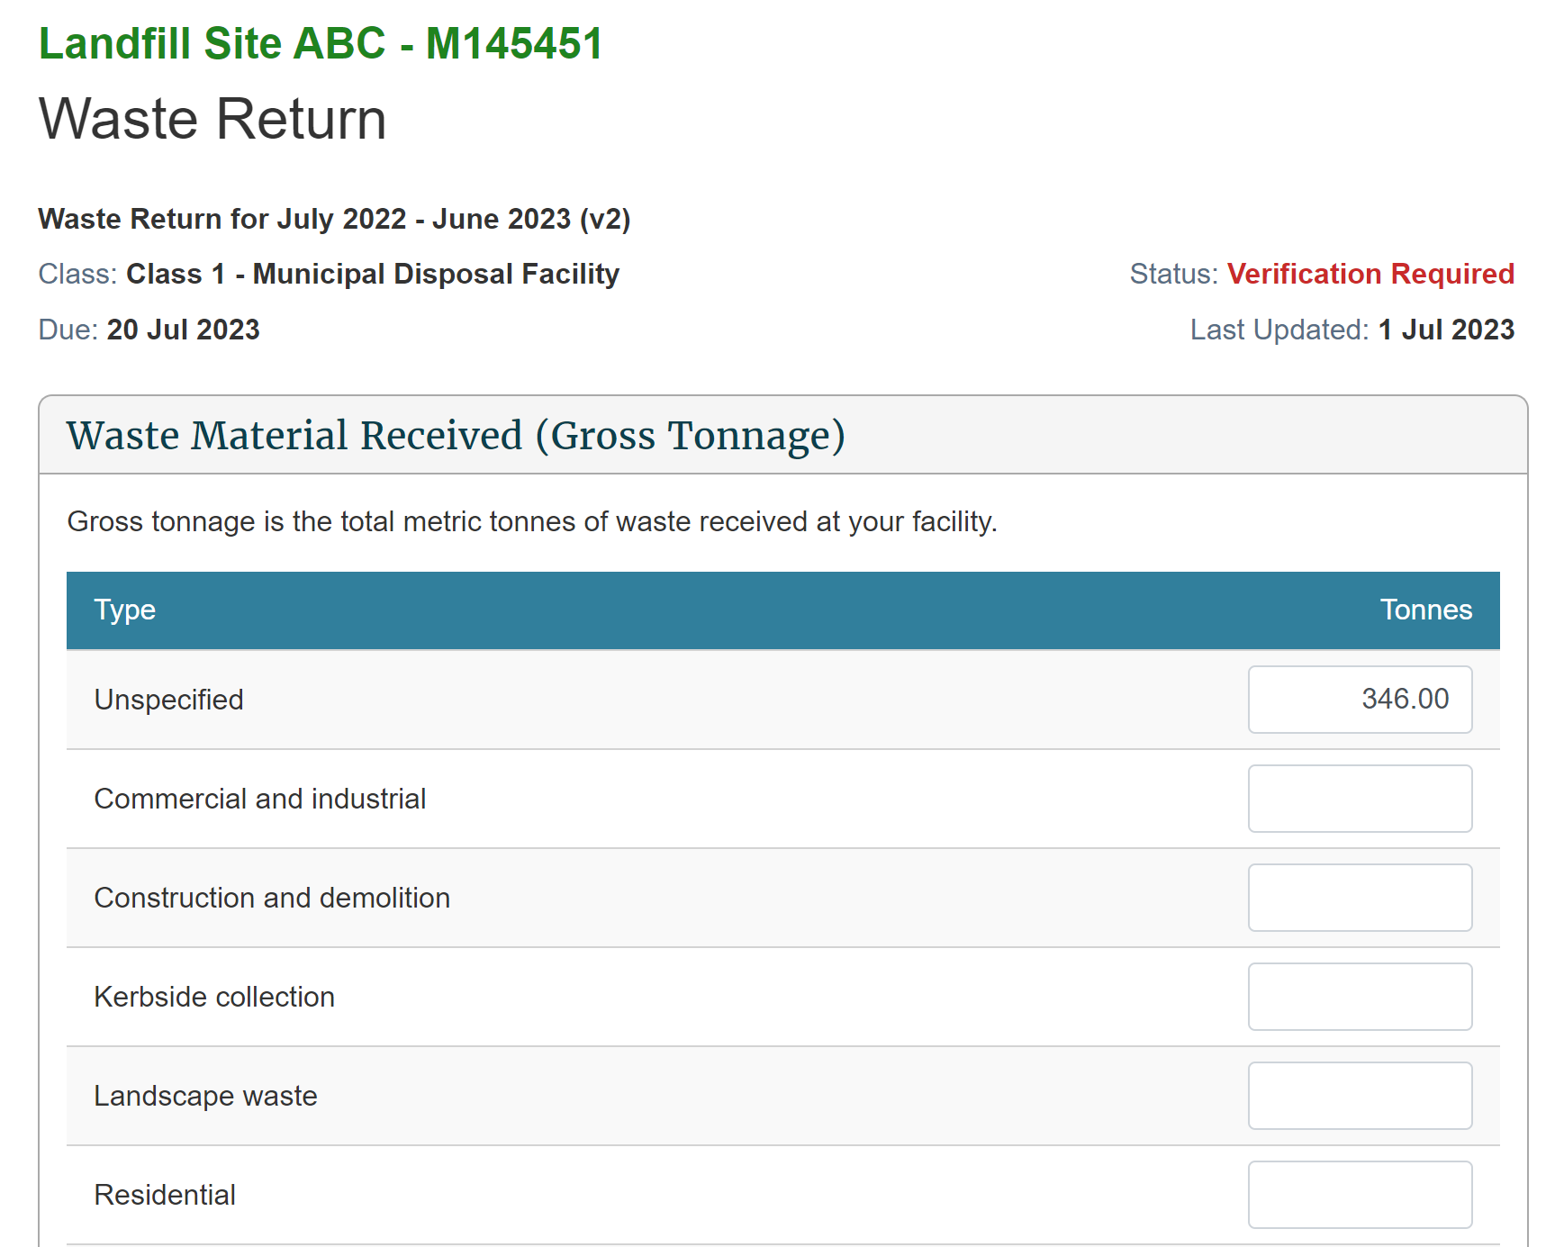
3 | Check that all entries are correct, and update if required.
4 | After you have checked all entries, click the Continue button.  Result: The Waste Return Summary screen displays.  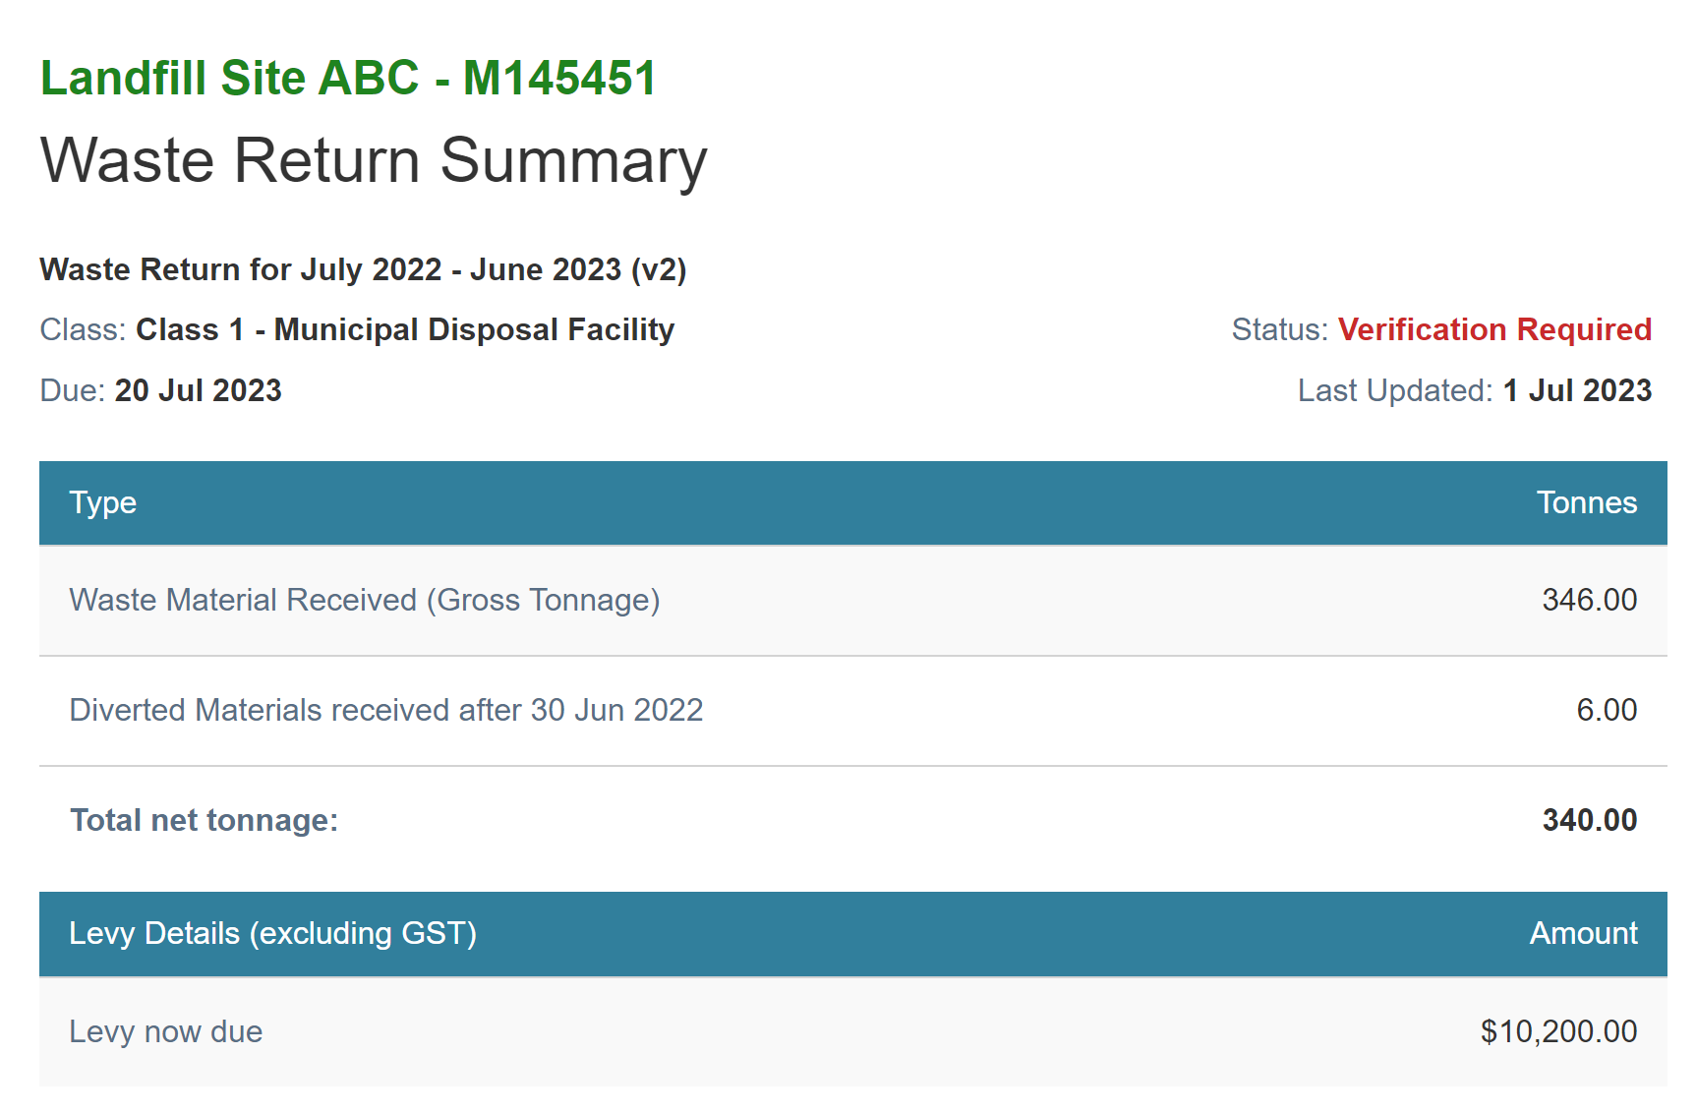
5 | If there was irregular activity on the return, a text box displays the explanation entered by the data entry user.  Update the explanation of the irregular activity if required.  Note: We may contact you for further clarification.
6 | Click the Declaration check box, and then click the Submit button.  Result: You are taken back to the Return Summary screen and the status has changed to Verified. You can update the return until the levy is calculated.  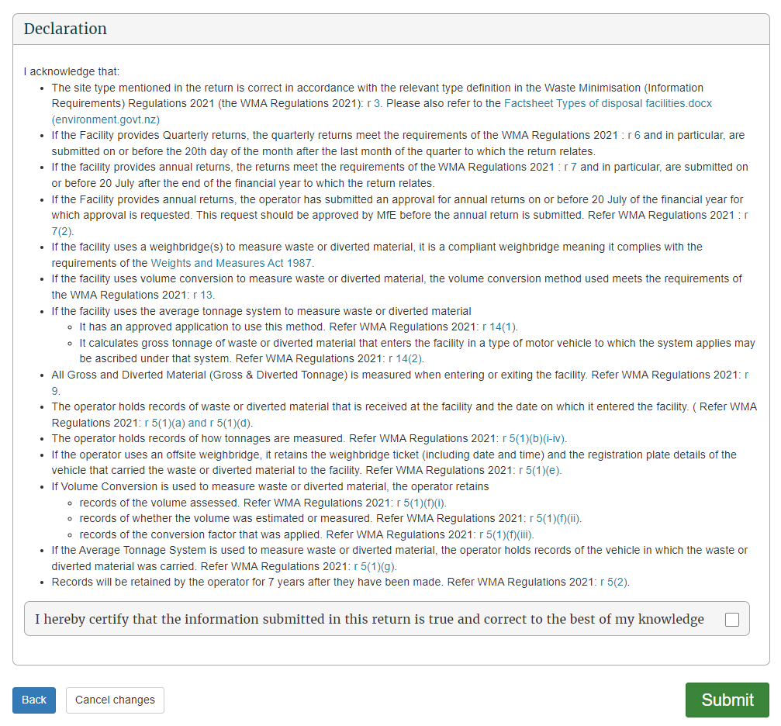

What happens next?
We process your return and generate the invoice. You can view your statements in the Charges and Payments screen. See View or download statements.
Note: If you find you have made a mistake in your original return, you can request an amendment to the return after the levy is calculated. See Amend a final annual return.

Amending a final annual/six-monthly return
Note: OWLS will no longer accept amendments to submitted waste returns. If you have made a mistake, please contact the help desk at 0800 WDLEVY (0800 935 389).

Chapter 4: Applications
This chapter provides information on the applications disposal facilities can make. It contains the following topics:
Topic
Overview
Apply to submit an annual return
Apply to submit a six-monthly return
Apply to use the average tonnage method for motor vehicles
Apply for an extension of time to submit your monthly return
Apply for an extension of time to pay
Apply for an extension of storage time for material on your disposal facility
Apply for a waiver
Apply for a refund
Apply for a site class change
Application summary screen
Methodologies

Overview

Introduction
OWLS 2.0 enables the authorised verifier for a disposal facility to make applications as listed below.
Note: Data entry users can only ‘view’ applications.
Application | When to use
Annual permission application | Apply to submit returns annually instead of monthly.  You are only eligible to apply if your disposal facility’s expected net tonnage for the year is 1000 tonnes or less.  Note: The application form to request annual permission for the following financial year is only available from 1 June to 20 July. You must submit the application on or before 20 July (for that financial year).
Average tonnage application | Apply to use an average tonnage method for selected motor vehicles.  If you want to apply to change any other type of method, call 0800 WDLEVY (0800 935 389).
Return extension application | Apply for an extension of time to submit a return.
Payment extension application | Apply for an extension of time to pay an invoice.
Storage time extension application | Apply to extend the time diverted material (which has previously been reported as gross tonnage) is stored on facility beyond the automatically allowable six months.
Waiver application | Apply to have some, or all, of the levy amount waived in exceptional circumstances.
Levy refund application | Apply for a refund of the levy money already paid on material for which a waiver was granted.  Note: Do not enter requests for reimbursements in OWLS 2.0. Direct any request for a reimbursement to 0800 WDLEVY (0800 935 389).

Applying to submit an annual return

When to use
Use these steps to apply to change from monthly returns to annual returns, or to apply to continue to submit annual returns.
Notes:
- You can only apply to submit annual returns between 1 June and 20 July.
- The change will only take effect at the start of a financial year.
Refer to the Calculation and Payment of the Waste Disposal Levy guide for more information.

Who is responsible?
- Site verifier – Can create/update personnel update/verify returns, update Client/Site details and create/modify applications.
- Site verifier delegator – Can create/update personnel update/verify returns, update Client/Site details, create/modify applications, and delegation access.

Steps
Step | Action
1 | Click the Applications link in the content menu.  Result: The Applications screen displays.  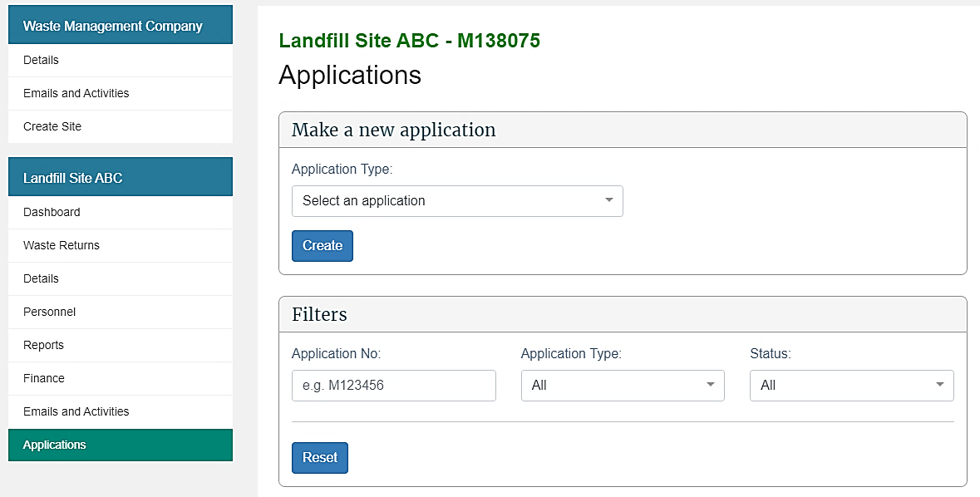
2 | Select Annual Permission from the Application Type drop-down list.  Click the Create button.  Result: The Annual Permission Application screen displays.  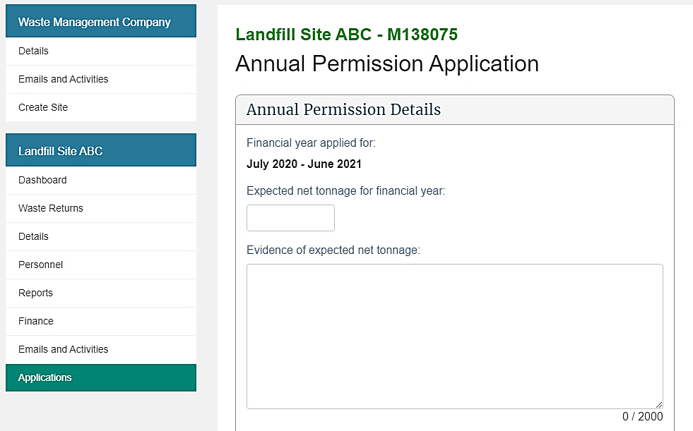
3 | Complete the following fields:  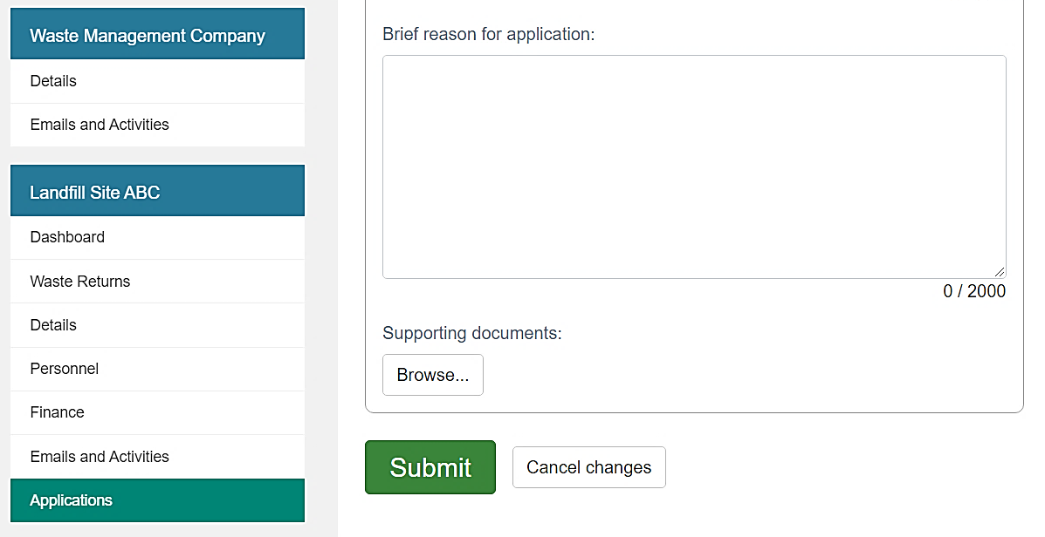
4 | Provide a Brief Reason for Application.  Field Description  Expected net tonnage for financial year Type your expected net tonnage for the financial year in metric tonnes.  Evidence of expected net tonnage Type a description of how you calculated this figure. If your evidence is longer than 2000 characters, please attach a file containing the details (see step 5).
5 | Attach evidence of how the expected net tonnage was calculated.  To attach a file to the application, click the Browse… button, select the relevant files, and click Open.  Note:  - To attach additional files, click the Browse… button.  - The maximum file size is 4 MB.
6 | Click the Submit button.  Result: You are returned to the Application summary screen and the Annual Permission application appears in the list with the status Submitted.

What happens next?
We will consider your application and let you know the outcome by 1 August.
If your application is declined, you will need to continue to submit monthly returns.
Notes:
A successful application will still receive monthly levy invoices.

Applying to submit a six-monthly return

When to use
Use these steps to apply to change from monthly returns to six-monthly returns.
Notes:
You can only apply to submit six-monthly returns during the following periods:
- Class 2: Construction and demolition fill disposal facility – 1 January 2022 to 20 January 2022
- Classes 3 and 4: Construction and demolition fill disposal facility – 1 January 2023 to 20 January 2023
If you want to submit annual returns after the six-month transitional period, you will need to complete an annual return application between 1 June and 20 July. See Apply to submit annual returns.

Who is responsible?
- Site verifier – Can create/update personnel update/verify returns, update Client/Site details and create/modify applications.
- Site verifier delegator – Can create/update personnel update/verify returns, update Client/Site details, create/modify applications, and delegation access.

Steps
Step | Action
1 | Click the Applications link in the content menu.  Result: The Applications screen displays.
2 | Select 6 Month Permission from the Application Type drop-down list.  Click the Create button.  Result: The 6 Month Permission screen displays.  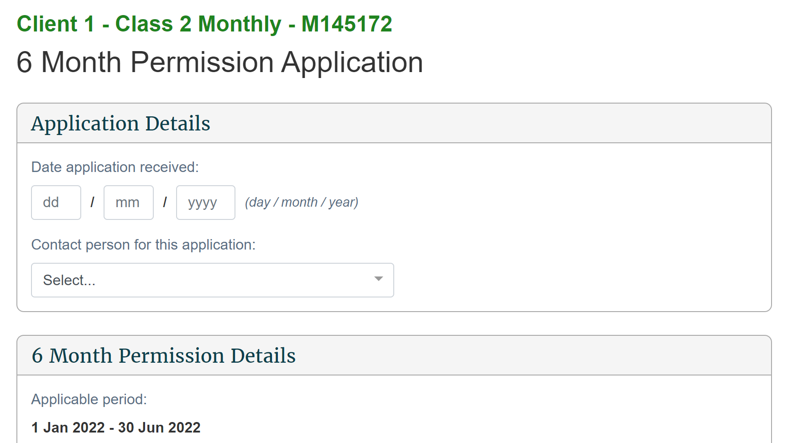
3 | Complete the following fields:  Field Description  Expected net tonnage for the applicable period Type your expected net tonnage for the applicable period in metric tonnes.  Evidence of expected net tonnage Type a description of how you calculated this figure. If your evidence is longer than 2000 characters, please attach a file containing the details (see step 5).  Brief Reason for Application Provide a brief reason for applying to submit six-monthly returns.
4 | Attach evidence of how the expected net tonnage was calculated.  To attach a file to the application, click the Browse… button, select the relevant files, and click Open.  Note:  - To attach additional files, click the Browse… button.  - The maximum file size is 4 MB.
5 | Click the Submit button.  Result: You are returned to the Application summary screen and the 6 Month Permission application appears in the list with the status Submitted.

What happens next?
We will consider your application and let you know the outcome by 1 February.
If your application is declined, you will need to continue to submit monthly returns.

Applying to use the average tonnage method for motor vehicles

When to use
Use these steps to apply to use the average tonnage method for your disposal facility. This method allows you to weigh a sample of the motor vehicles delivering waste to your disposal facility and calculate an average weight of waste carried.
Note: Please contact us on 0800 WDLEVY (0800 935 389) to discuss your situation before you submit an application, or to change your method to any other type.
Refer to the Calculation and Payment of the Waste Disposal Levy guide for more information about methods used to calculate tonnage.

Role
- Site verifier – Can create/update personnel update/verify returns, update Client/Site details and create/modify applications.
- Site verifier delegator – Can create/update personnel update/verify returns, update Client/Site details, create/modify applications, and delegation access.

Steps
Step | Action
1 | Click the Applications link in the content menu.  Result: The Applications screen displays.  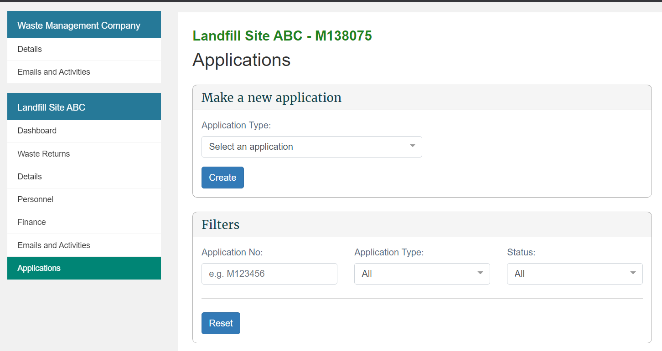
2 | Select Average Tonnage Methodology from the Application Type drop-down list.  Click the Create button.  Result: The Average Tonnage Application screen displays.  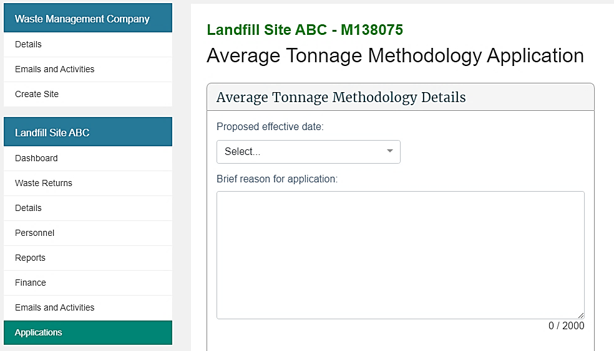
3 | Complete the following fields, including the motor vehicle details:  Field Description  Effective from date Select the date the change is to take effect from.  Brief reason for application Type the reason you wish to change to the average tonnage method. Note: If your reason is longer than 2000 characters, please attach a file containing the explanation (see step 8).  Vehicle type Type the light vehicle type (eg, car, van, trailer, lorry, truck and trailer).  Average tonnage Type the average waste tonnage for that vehicle type. Note: Ensure you type this figure in tons. For example, 50 kg will be 0.05.  How average tonnage calculated Type a description of how you calculated the average tonnage. Attach supporting evidence for your application. To do this, see step 8.  Evidence of statistical validity Type a description of the evidence of statistical validity of your average tonnage. If possible, attach supporting evidence for your application.  Note: If your calculations or evidence are longer than 2000 characters, please attach a file containing the details (see step 8).
4 | If you would like to add any other vehicles, click Add Another Vehicle. If not, skip to step 7.  Complete the following fields for that vehicle:  Field Description  Vehicle type Type the motor vehicle type (eg, car, van, trailer, lorry, truck and trailer).  Average tonnage Type the average waste tonnage for that vehicle type. Note: Ensure you type this figure in tons. For example, 50 kg will be 0.05.  How average tonnage calculated Type a description of how you calculated the average tonnage. Attach supporting evidence for your application. To do this, see step 8.  Evidence of statistical validity Type a description of the evidence of statistical validity of your average tonnage. If possible, attach supporting evidence for your application.  Note: If your calculations or evidence are longer than 2000 characters, please attach a file containing the details (see step 8).
5 | Once added, use the links in the Actions column to update the information. Use:  - Edit to update the vehicle information  - Remove to delete the vehicle information.  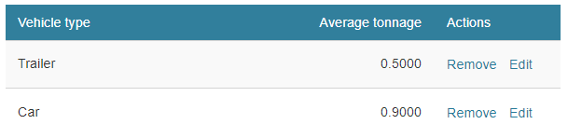
6 | If you want to add any additional vehicles, return to step 4.
7 | To attach supporting evidence to your application, click the Browse… button, select the relevant files, and click Open.  Supporting evidence may include:  - details about your survey method eg,:  - how and when you performed the survey  - who your survey groups were  - statistical data in Excel format (or similar) eg, weighbridge records.  Note:  - To attach additional files, click the Browse… button.  - The maximum file size is 4 MB.
8 | Click the Submit button.  Result: You are returned to the Application summary screen and the Average Tonnage application appears in the list with the status Submitted.

What happens next?
The Secretary for the Environment will consider your application and advise you of the outcome. If the application is declined, your existing calculation method will remain in force.
Approved Average Tonnage applications (and other methodologies) for the disposal facility are viewable on the Details screen, in the Methodologies field.

Applying for an extension of time to submit your monthly return

When to use
Use these steps to request an extension of time to submit a monthly return if, due to unusual circumstances, you cannot submit your return on time.
Notes:
- The deadline for an extension request is on or before the day that is 15 days before the due day for the return.
- An extension of time to submit your return does not change the date on which the levy must be paid.
- Only one extension can be granted for any return.
- This application is not applicable to annual returns.

Role
- Site verifier – Can create/update personnel update/verify returns, update Client/Site details and create/modify applications.
- Site verifier delegator – Can create/update personnel update/verify returns, update Client/Site details, create/modify applications, and delegation access.

Steps
Step | Action
1 | Click the Applications link in the content menu.  Result: The Applications screen displays.  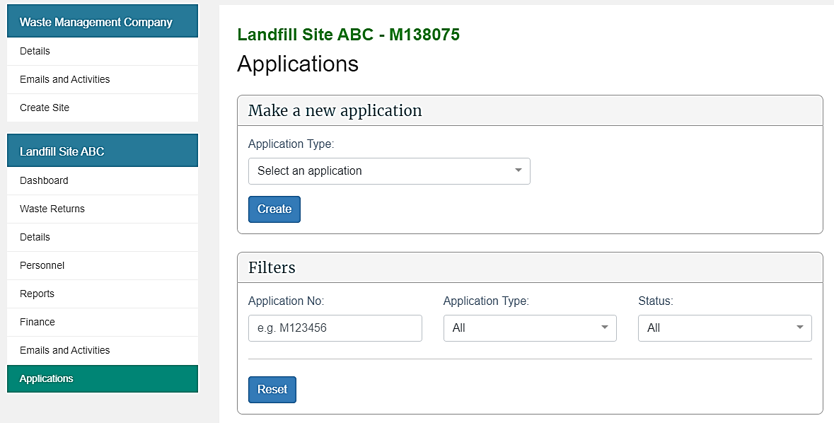
2 | Select Return Extension from the Application Type drop-down list.  Click the Create button.  Result: The Return Extension application screen displays.  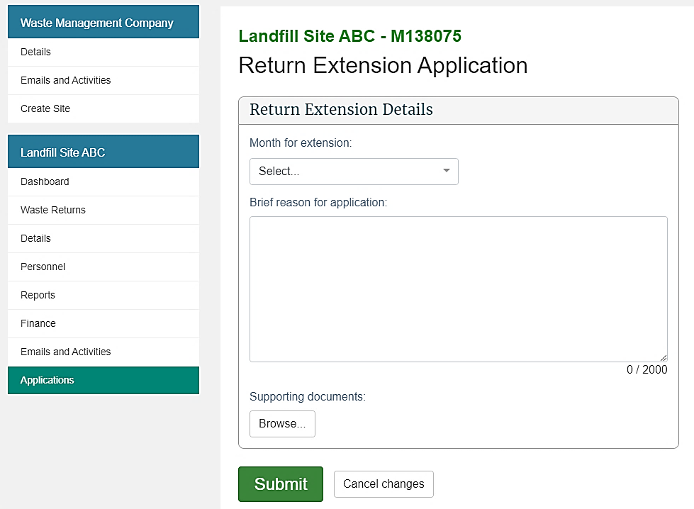
3 | Complete the following fields:  Field Description  Month for extension Select the month and year combination for which you are seeking the extension. You will only be able to select a period if: - there are more than 15 days until the due date for that return - an extension for that period does not already exist.  Reason for extension Type the reason you are unable to submit the return on time. Note: If your reason is longer than 2000 characters, please attach a file containing the explanation (see step 4).
4 | To attach supporting evidence to the application, click the Browse… button, select the relevant files, and click Open.  Notes:  - To attach additional files, click the Browse… button.  - The maximum file size is 4 MB.
5 | Click the Submit button.  Result: You are returned to the Application summary screen and the Return Extension application appears in the list with the status Submitted.

What happens next?
We will consider your application and advise you of the outcome at least five days before the return is due.
If your application is declined, you will need to submit a return before the due date.

Applying for an extension of time to pay

When to use
Use these steps to request an extension to the due date of the levy payment if, due to unusual circumstances, you cannot pay the levy on time.
You must submit the application no later than 15 days before the payment is due.

Role
- Site verifier – Can create/update personnel update/verify returns, update Client/Site details and create/modify applications.
- Site verifier delegator – Can create/update personnel update/verify returns, update Client/Site details, create/modify applications, and delegation access.

Steps
Step | Action
1 | Click the Applications link in the content menu.  Result: The Applications screen displays.
2 | Select Payment Extension from the Application Type drop-down list.  Click the Create button.  Result: The Payment extension application screen displays.  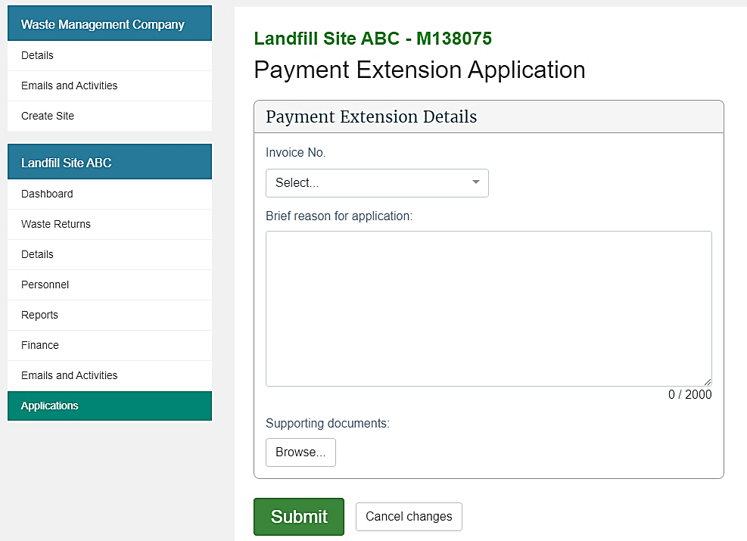
3 | Select the invoice number for which you want an extension from the Invoice No. drop-down menu.  Result: The system automatically populates the Amount Due and Due Date based on the invoice selected from the drop-down menu.
4 | Type the reason you are unable to pay the levy on time in the Reason for application field.  Note: If your reason is longer than 2000 characters, please attach a file containing the explanation (see step 5).
5 | To attach supporting evidence to the application, click the Browse… button, select the relevant files, and click Open.  Note:  - To attach additional files, click the Browse… button.  - The maximum file size is 4MB.
6 | Click the Submit button.  Result: You are returned to the Application summary screen and the Payment Extension application appears in the list with the status Submitted.

What happens next?
We will consider your application and advise you of the outcome at least five days before the payment is due.
If your application is:
- declined, you need to pay the levy by the due date.
- successful, you need to pay the levy by the extended due date.
Notes:
- If you do not pay by the approved due date, interest will be charged on the outstanding amount.
- No further extensions for the same payment will be given.

Applying for an extension of storage time for material on your facility

Introduction
An extension of storage time allows you to claim a credit on material (previously reported as gross tonnage) that is older than six months if it is being removed for recycling or further processing within the extension period. Only material that has been reported as gross tonnage can be reported as diverted tonnage.

When to use
Use these steps to apply to extend the time period for the storage of material for diversion beyond the six-month limit.
Note: You should submit your application at least a month in advance of the expiry date for that material (six months after it was received).
Refer to the Calculation and Payment of the Waste Disposal Levy guide for more information.

Role
- Site verifier – Can create/update personnel update/verify returns, update Client/Site details and create/modify applications.
- Site verifier delegator – Can create/update personnel update/verify returns, update Client/Site details, create/modify applications, and delegation access.

Steps
Step | Action
1 | Click the Applications link in the content menu.  Result: The Applications screen displays.
2 | Select Storage Time Extension from the Application Type drop-down list.  Click the Create button.  Result: The Storage time extension application screen displays.  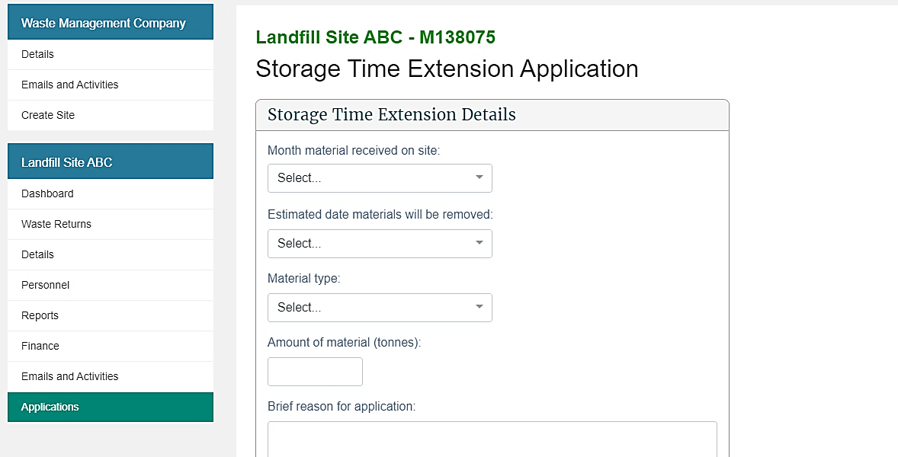
3 | Complete the following fields:  Field Description  Month material received on site Select the month and year the material was received. Note: The date must be within the last six months.  Estimated date materials will be removed This drop-down becomes available after selecting month material received on site. Select the month and year you want to extend the storage time to. Note: The extension must be within two years of the received date.  Material type This drop-down becomes available after selecting the estimated date materials will be removed. Select the type of material for which you require the extension.  Amount of material (tonnes) Type the weight of the material, in tonnes, for which you are requesting an extension.  Brief reason for application Type the reason you want to extend the storage time. Include a description of the material, if an appropriate selection is not available in the material type drop-down list. Note: If your reason is longer than 2000 characters, please attach a file containing the explanation (see step 4).
4 | To attach supporting evidence to your application, click the Browse… button, select the relevant files, and click Open.  Supporting evidence may include:  - photographs showing the segregation of materials  - agreement with a recycler  - evidence that the levy was paid on the material, if available.  Note:  - to attach additional files, click the Browse… button  - the maximum file size is 4 MB.
5 | Click the Submit button.  Result: You are returned to the Application summary screen and the Storage Time application appears in the list with the status Submitted.

What happens next?
The Secretary for the Environment will consider your application and advise you of the outcome.
If your application is granted, the column Diverted tonnage older than six months will display on your waste return for the approved period.

Applying for a waiver

When to use
Use these steps to apply for a waiver on the levy for certain materials when exceptional circumstances apply.
Note: You will need to provide evidence to justify the waiver of the levy.
Refer to the Calculation and Payment of the Waste Disposal Levy guide for more information.

Role
- Site verifier – Can create/update personnel update/verify returns, update Client/Site details and create/modify applications.
- Site verifier delegator – Can create/update personnel update/verify returns, update Client/Site details, create/modify applications, and delegation access.

Steps
Step | Action
1 | Click the Applications link in the content menu.  Result: The Applications screen displays.
2 | Select Waiver from the Application Type drop-down list.  Click the Create button.  Result: The Waiver Application screen displays.  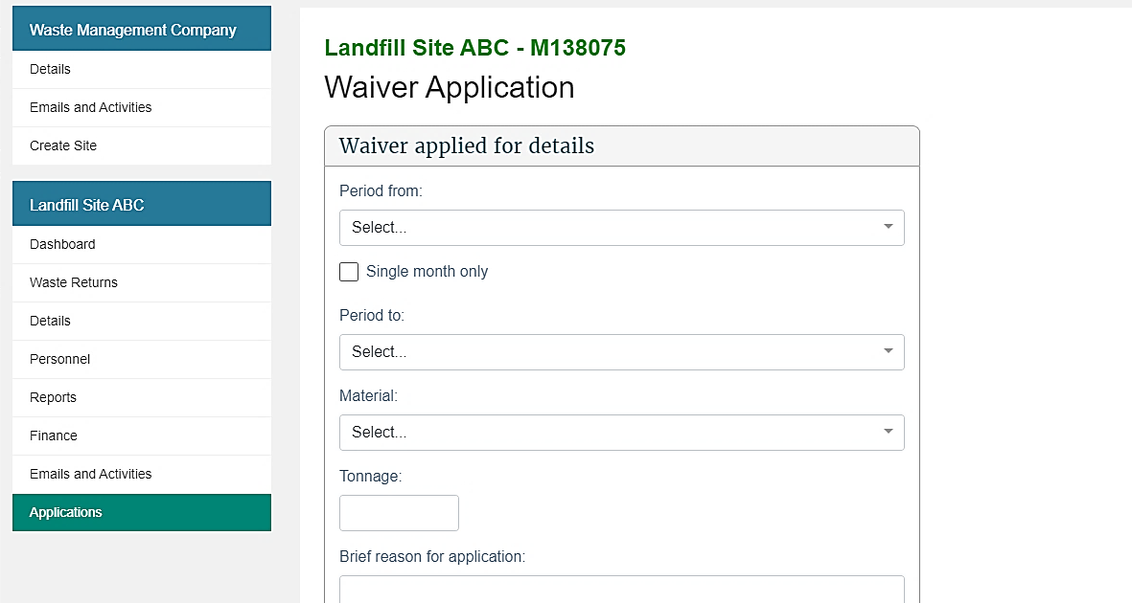
3 | Complete the following fields:  Field Description  Period from Select the starting month and year from the drop-down list.  Single month Click the check box if the waiver is required for one month. Note: When selected, the Period to field will default to the Period from date.  Period to If the waiver is required for more than one month, select the end date (month and year) from the drop-down list.  Material Select the relevant type of material.  Tonnage Type the tonnage of material you are applying to waive.  Brief reason for application Type a description of the event that led to the waiver request, including a detailed description of why the situation is exceptional. Note: If your reason is longer than 2000 characters, please attach a file containing the explanation (see step 4).  If any part of the waiver applied for… If you are applying for a waiver for material on an existing invoice(s), type the invoice number(s).
4 | To attach supporting evidence to the application, click the Browse… button, select the relevant files, and click Open.  Note:  - to attach additional files, click the Browse… button  - the maximum file size is 4 MB.
5 | Click the Submit button.  Result: You are returned to the Application summary screen and the Waiver application appears in the list with the status Submitted.

What happens next?
The Secretary for the Environment will consider your application and advise you of the outcome. The Ministry treats levy waivers as a priority and will respond to the applicant within 10 working days.
If a waiver is granted, a credit adjustment based on tonnage figures will be applied and included in your next invoice. A waiver number will also be provided for use when applying for a refund.

Applying for a refund

When to use
Use these steps to apply for a refund when your account is in credit following a waiver.
Note: Do not enter requests for reimbursements here. Any request for a reimbursement should be directed to 0800 WDLEVY (0800 935 389). An example of when a reimbursement can apply is when a return is amended, and the levy amount is less than what was paid.
Refer to the Calculation and Payment of the Waste Disposal Levy guide for more information.

Role
- Site verifier – Can create/update personnel update/verify returns, update Client/Site details and create/modify applications.
- Site verifier delegator – Can create/update personnel update/verify returns, update Client/Site details, create/modify applications, and delegation access.

Steps
Step | Action
1 | Click the Applications link in the content menu.  Result: The Applications screen displays.
2 | Select Levy Refund from the Application Type drop-down list.  Click the Create button  Result: The Levy refund application screen displays.
3 | Complete the following fields:  Field Description  Waiver number Type the waiver number to which the refund application relates. Note: This is the waiver number provided when the waiver was granted. This must be a number from an approved waiver application.  Maximum claimable amount This system-populated field shows the amount of waiver credit that has been applied or used based on the waiver number provided. This is the maximum amount you can claim back for this levy refund application.  Amount to be refunded Type the amount of money to be refunded.  Brief reason for application Type the reason you require a refund. Note: If your reason is longer than 2000 characters, please attach a file containing the explanation (see step 4).  If known, please provide any invoice… Enter the invoice number(s) to which the refund relates.
4 | To attach supporting evidence to the application, click the Browse… button, select the relevant files, and click Open.  Note:  - to attach additional files, click the Browse… button  - the maximum file size is 4 MB.
5 | Click the Submit button.  Result: You are returned to the Application summary screen and the Levy Refund application appears in the list with the status Submitted.

What happens next?
We will consider your application and advise you of the outcome.
An accepted application for a refund will result in money being paid to the disposal facility.

Applying for a site class change

When to use
Use these steps to apply for a change of the site class for a given facility.
Note: You will need to provide evidence to justify the change to a new site class.
Refer to the Calculation and Payment of the Waste Disposal Levy guide for more information on determining your site class.

Role
- Site verifier – Can create/update personnel update/verify returns, update Client/Site details and create/modify applications.
- Site verifier delegator – Can create/update personnel update/verify returns, update Client/Site details, create/modify applications, and delegation access.

Steps
Step | Action
1 | Click the Applications link in the content menu.  Result: The Applications screen displays.  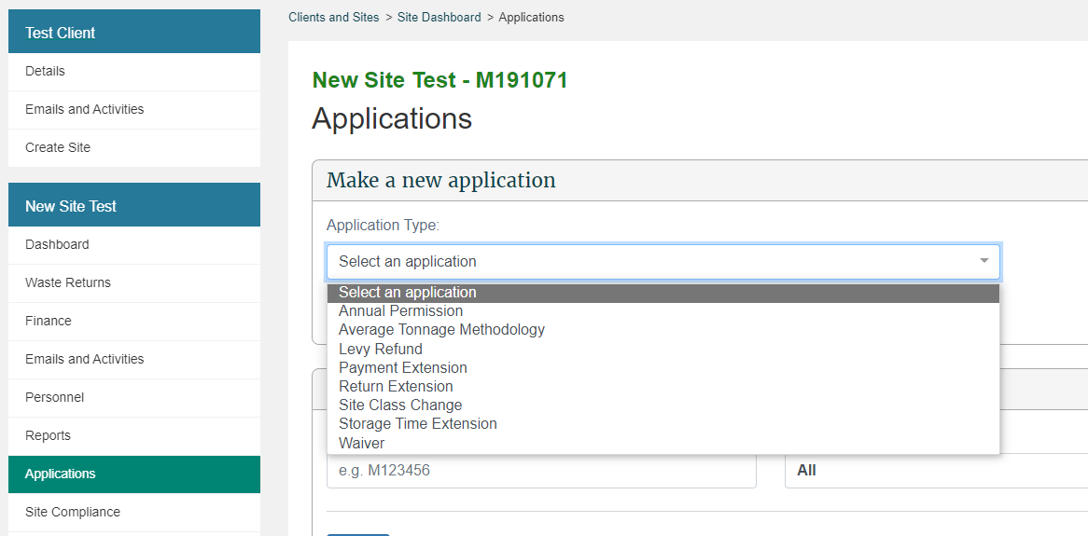
2 | Select Site Class Change from the Application Type drop-down list.  Click the Create button.  Result: The Site Class Change Application screen displays.  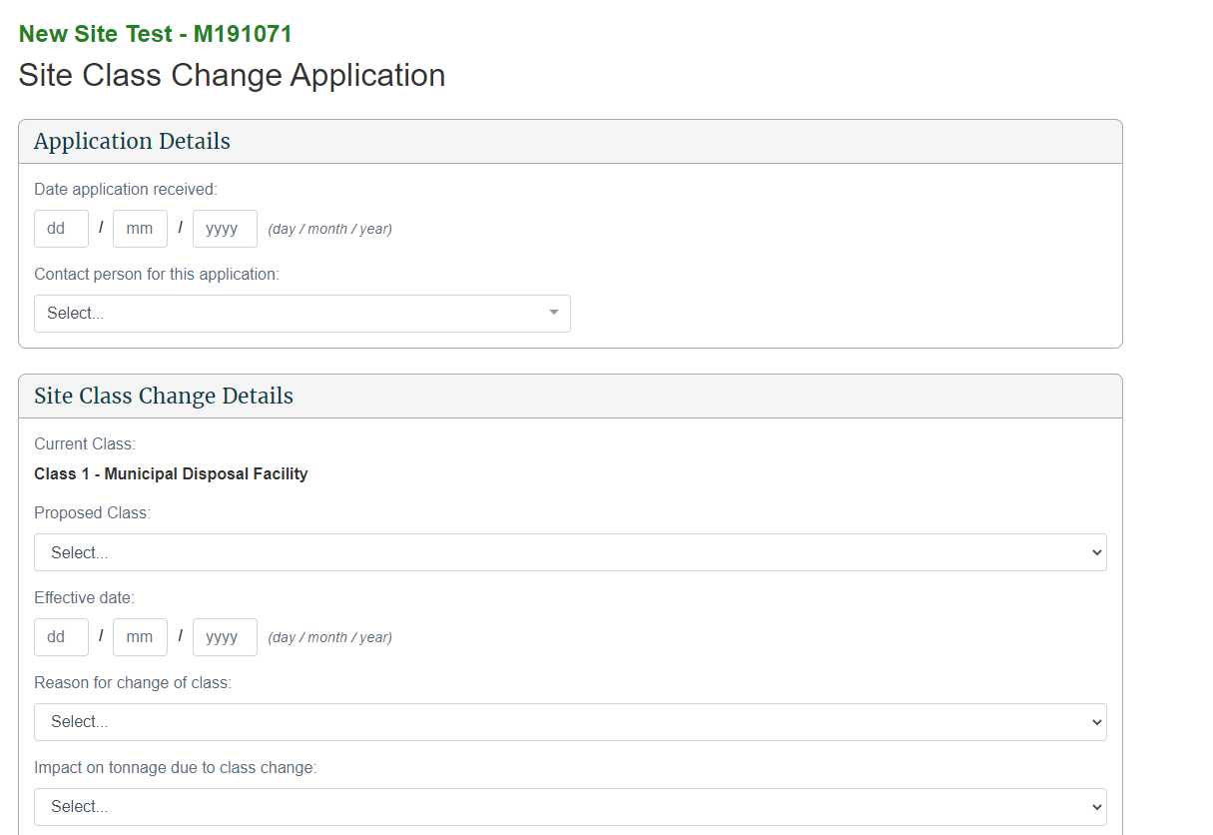
3 | Complete the following fields:  Field Description  Proposed Class: Select the site class you wish to be changed to.  Effective date: Select the date with which the site class change will go into effect at the facility.  Reason for change of class: Please select the reason that your site class is changing. Note: Depending on your selection, you may be asked to provide additional information, such as “New waste type accepted”  Any infrastructural changes to the current facility: Select if there are any infrastructural changes to the facility. If yes, have appropriate resource consents be obtained?  Any changes to the gate fees: Select if there are any changes to the gate fees, and if so, enter the revised fees per tonne.  Additional Comments: Please provide any additional comments that could help us assess your application for a site class change
4 | Check the box certifying that the information you are providing is true and correct and that you are authorised to submit the application on behalf of the DFO.
5 | To attach supporting evidence to the application, click the Browse… button, select the relevant files, and click Open.  Note:  - to attach additional files, click the Browse… button  - the maximum file size is 4 MB.
6 | Click the Submit button.  Result: You are returned to the Application summary screen and the Waiver application appears in the list with the status Submitted.

What happens next?
The Waste Levy team will assess your application to change class.
If a site class change is granted, you will be informed via the application as at which date the site class change will take effect. New Class returns will then be available for any months from that date.

Application summary screen
You can view the status of pending and previously requested applications by clicking the Applications link in the content menu.
The Results field will provide a summary of pending and previously requested applications.
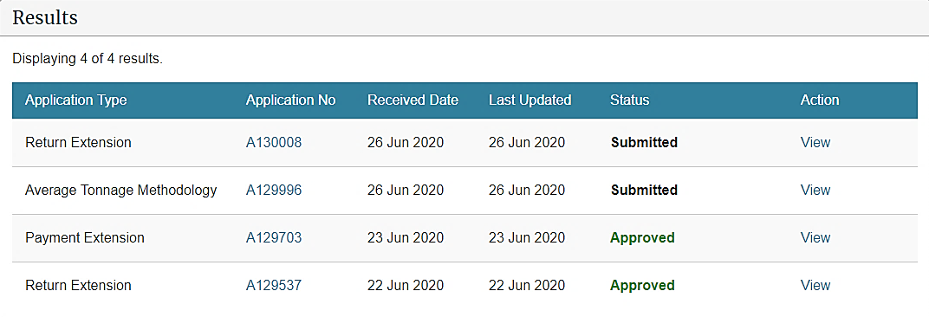

Status | Description/action
Submitted | The verifier has submitted the application and can View it.
Assessment in progress | We have begun assessment of the application.  The verifier can only View the application.
Resubmission required | We have requested that the verifier resubmit their application.  The verifier can Update the application.
Approved | We have approved the application.  The verifier can only View the application.
Declined | We have declined the application.  The verifier can only View the application.
Revoked | We have revoked an application after it had been approved.  The verifier can only View the application.

Methodologies
You can view the type and status of methods used for calculating tonnage at your disposal facility on the Details screen. This screen will display:
- approved Average Tonnage applications (with a link to that application), and
- other methodologies advised during registration or requested via the 0800 WDLEVY (0800 935 389) number.
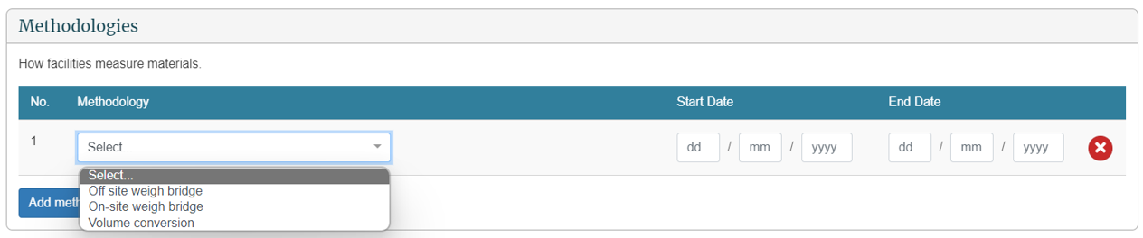

Field | Description
Methodology | The method used to measure materials at the disposal facility.
From Date | The date from which the disposal facility will use the methodology.
To Date | The date at which the method expires.

Chapter 5: Viewing and updating details
This chapter provides information on details available for operators, disposal facilities, contact people and users. This chapter contains the following topics:
Topic
Overview
Update client details
Update disposal facility details
View or update details for personnel
De-activate personnel
Emails and activities

Overview

Introduction
OWLS 2.0 enables the authorised users for a disposal facility to view and update their contact details. Data entry users only have view access to this functionality.
The table below provides details of each screen:
Screen | Description
Details (operator) | Contains the following details for the operator:  - general information such as name, trading name.  - physical address  - postal address (if applicable)  - contact email  - contact phone number.
Details (disposal facility) | Contains the following details for the disposal facility:  - general information such as name, disposal facility reference, status of disposal facility  - physical address  - contact email  - contact phone number  - finance information such as statement email, purchase order numbers.  You can view the following details for a disposal facility:  - operational information such as estimated annual tonnage and reporting frequency  - site classes  - methodologies or how the disposal facility measures materials.
Personnel | Contains the following details for users:  - name  - authorisation  - contact area such as general, finance and/or returns.  - contact email  - status.  A verifier can view user details and de-activate a user if required.
Emails and activities | Contains the following:  - activities performed by and for the disposal facility  - emails sent to the disposal facility and/or its personnel  - date of activity and/or email  - area such as applications, financial, personnel and/or returns  - description of the activity (eg, statement email, change of contact information)  - description of person who sent the email or performed the activity. If “OWLS 2.0” is listed, this indicates a system generated email and/or activity.
If you need to update or amend details such as operational information, site classes or methodologies, you must call our helpdesk at 0800 WDLEVY (0800 935 389) or email us at info@wastelevy.govt.nz.

Updating client details

When to use
Use these steps to update client details.

Role
- Site verifier – Can create/update personnel update/verify returns, update Client/Site details and create/modify applications.
- Site verifier delegator – Can create/update personnel update/verify returns, update Client/Site details, create/modify applications, and delegation access.

Steps
Step | Action
1 | Click the Details link in the content menu under the client’s name.  Result: The Details screen for the client displays.
2 | Click the Update button underneath the contact information to update.  Type Action  Postal address The postal address field becomes editable. Type the postal address. Note: You can select the appropriate address from the autocomplete results.  Physical address If the physical address is the same as the postal address, (and the postal address has already been populated), click the Same as postal address check box. If the physical address is not the same as the postal address, complete the fields as necessary. Note: You can select the appropriate address from the autocomplete results.  Email The email details field becomes editable. Type the email address.  Phone The phone details field becomes editable. Type the phone number.
 | Note: you can cancel any changes by clicking Cancel Changes.
3 | When you have finished updating the relevant information, click Save.  Result: The details update.

What happens next?
Update other contact details as required.

Updating disposal facility details

When to use
Use these steps to update the details for your disposal facility.

Role
- Site verifier – Can create/update personnel update/verify returns, update Client/Site details and create/modify applications.
- Site verifier delegator – Can create/update personnel update/verify returns, update Client/Site details, create/modify applications, and delegation access.

Steps
Step | Action
1 | Click the Details link in the content menu under your disposal facility name.  Result: The Details screen for your disposal facility displays.
2 | Click the Update button underneath the contact information to update.  When you have finished updating the relevant information, click Save.  Type Action  Physical address The screen displays the physical address. Note: You can select the appropriate address from the autocomplete results.  Email The email details field becomes editable. Type the email address.  Phone The phone details field comes editable. Type the phone number.  Result: The details update.
3 | You can also update Finance Information for a disposal facility.
4 | Click the Update button underneath the finance information to update.  When you have finished updating the relevant information, click Save.  Type Action  Statement Email (optional) The email address to which financial statements will be sent. This is optional.  Purchase Order No. (optional) The purchase order number becomes editable. Type the purchase order number. This is optional.  Result: The details update.

What happens next?
Update other contact details as required.

Viewing or updating details for personnel

When to use
Use these steps to view or update details for personnel of your disposal facility.
The level of authorisation will be indicated in the Authorisation column.
Personnel can be authorised as:
- Site data entry – Can update returns that will placed in a status of ‘Pending Verification’
- Site verifier – Can create/update personnel update/verify returns, update Client/Site details and create/modify applications.
- Site verifier delegator – Can create/update personnel update/verify returns, update Client/Site details, create/modify applications, and delegation access.
- Facility Administrator – can create/update personnel, has delegation and view access, cannot perform other functions in OWLS. Can be assigned to multiple Sites
The Status column will indicate whether personnel are active, cancelled, or invited.
- Active personnel will be indicated in green.
- Cancelled personnel will be indicated in red.
- Invited personnel will be indicated in black. Personnel with an “invited” status need to complete the login process.
Note: Personnel are not necessarily a user of the disposal facility.

Role
- Site verifier – Can create/update personnel update/verify returns, update Client/Site details and create/modify applications.
- Site verifier delegator – Can create/update personnel update/verify returns, update Client/Site details, create/modify applications, and delegation access.
- Facility Administrator – can create/update personnel, has delegation and view access, cannot perform other functions in OWLS. Can be assigned to multiple Sites

Steps
Step | Action
1 | Click the Personnel link in the content menu.  Result: The Personnel screen displays.
2 | To view the details for personnel and/or update their details, click the View link.  Result: The user’s details display.  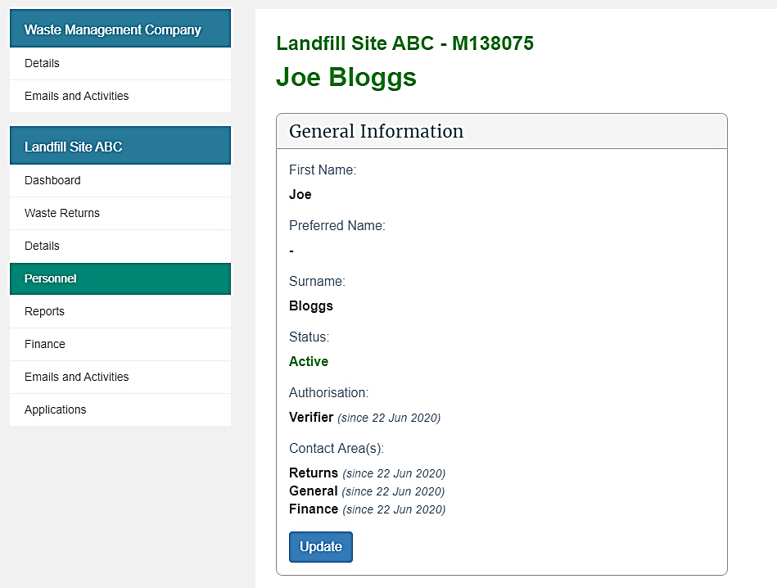
3 | You can edit the following General information by clicking Update:  Field Description  Contact type Select the contact type (mandatory): General – general contact person. Returns – the contact person for all areas regarding waste returns. Financial – the contact person for financial details and the person to whom the invoice will be sent. Note: You must have at least one ‘General’ contact person for your disposal facility.
4 | Click the Save button.  Result: The General information details are updated.
5 | You can edit Contact information for personnel by clicking Update:
6 | You can edit the following Contact information:  Field Description  Contact number Type the phone number (mandatory).  Other contact number Type another phone number (optional).  Email Type their email address (mandatory).
7 | Click the Save button.  Result: The Contact information details are updated.

What happens next?
Update other contact details as required.

De-activating personnel

When to use
Use these steps to de-activate personnel for your disposal facility.
Note: If you require a new user to be set up, see the Add a new user to OWLS 2.0 steps.

Role
- Site verifier – Can create/update personnel update/verify returns, update Client/Site details and create/modify applications.
- Site verifier delegator – Can create/update personnel update/verify returns, update Client/Site details, create/modify applications, and delegation access.
- Facility Administrator – can create/update personnel, has delegation and view access, cannot perform other functions in OWLS. Can be assigned to multiple Sites

Steps
Step | Action
1 | Click the Personnel link in the content menu.  Result: The Personnel screen displays.
2 | Click View beside the relevant user to view their details.  Result: The user’s details display.  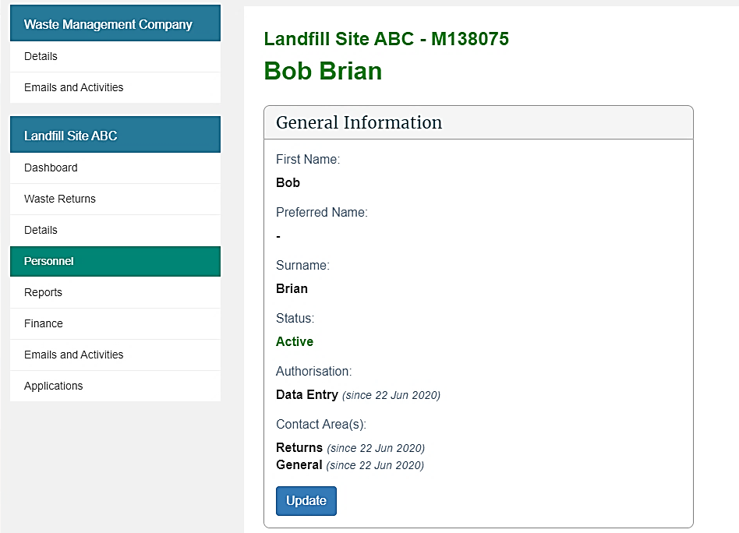
3 | Click Update.  Click the icon to cancel personnel authorisation.  Use the drop-down menu and untick the appropriate boxes to remove personnel as a contact type.  Result: Personnel authorisation will be removed. Contact type, if applicable, will be removed.
4 | Click the Save button.  Result: Personnel authorisation will be removed, and their status will change to Cancelled.

What happens next?
The personnel’s authorisations will be de-activated.

Emails and activities

When to use
Use these steps to view:
- records of activities performed by and for the disposal facility
- emails sent to the disposal facility and/or its personnel.

Roles
- Site data entry – Can update returns that will placed in a status of ‘Pending Verification’
- Site verifier – Can create/update personnel update/verify returns, update Client/Site details and create/modify applications.
- Mandatory to be the first user created when registering a Client and/or Facility.
- Site verifier delegator – Can create/update personnel update/verify returns, update Client/Site details, create/modify applications, and delegation access.

Steps
Step | Action
1 | Click the Emails and Activities link in the content menu.  Result: The Emails and Activities screen displays.  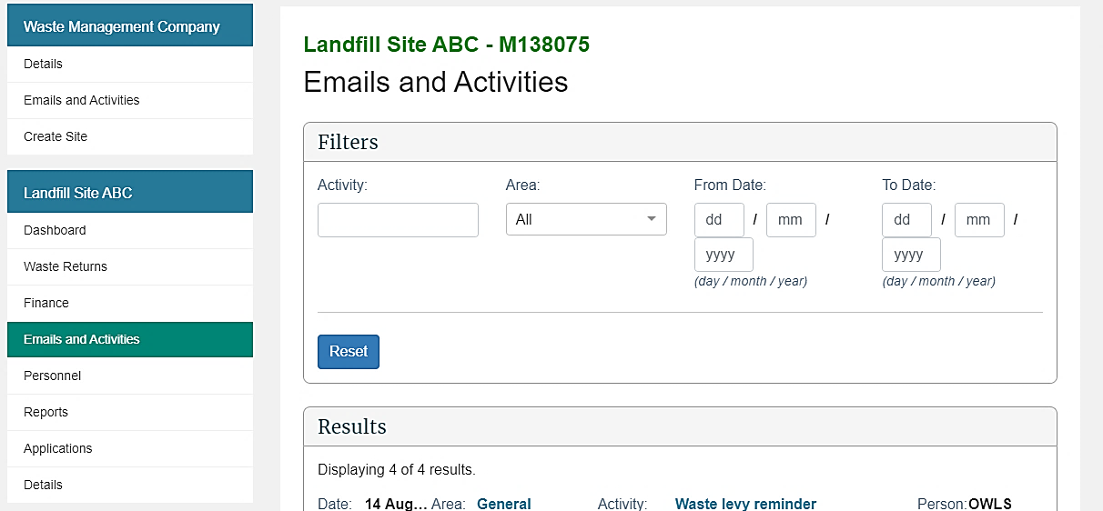
2 | Filters can be applied to narrow your search for a specific email and/or activity.
The following filters can be applied:
Field | Description
Activity | Filter for a specific activity and/or email, such as “waste levy reminder”.
Area | Filter by specific area (eg, Returns, Financial, General) by using the drop-down menu.
From Date | Display emails and activities from this date.  By default, these fields are empty.  To apply a date range filter, enter the Day (DD), Month (MM) and Year (YYYY).
To Date | Display emails and activities to this date.  By default, these fields are empty.  To apply a date range filter, enter the Day (DD), Month (MM) and Year (YYYY) in the field.
Reset | To clear all filters and reset to default values, click Reset.
Result: Emails and activities matching the filters entered will display in the Results field.
3 | The Results field displays all emails and activities associated with a disposal facility.  Field Description  Date Displays the date of action for the email and/or activity in format Day (DD), Month (MM) and Year (YYYY).  Area Displays the specific area the email and/or activity relates to, such as “general”, “returns”, financial”.  Activity Includes a brief description of the email and/or activity, such as “waste levy reminder”, “finance information updated” or “change of contact information”.  Person Person indicates who sent the email and/or who performed the activity described. Note: If “OWLS 2.0” is listed, this indicates a system-generated email and/or activity.
4 | Click the link that briefly describes the email and/or activity to view it in greater detail.  Result: The Email and Activity Details screen will display all information regarding the email and/or activity.  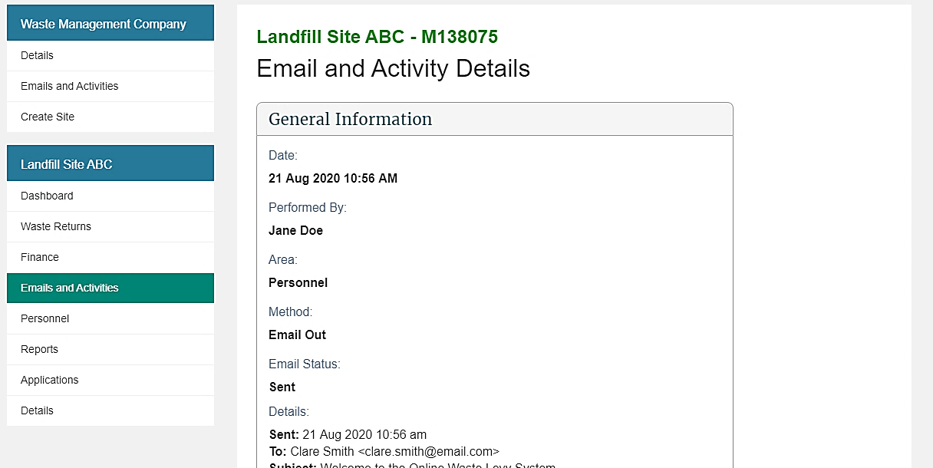

Chapter 6: Reports
This chapter provides information on the reports available for a disposal facility. It contains the following topics:
Topic
Overview
Generate or export a report

Overview

Introduction
OWLS 2.0 users can generate reports that provide information about their disposal facility. The table below summarises these reports.
Report | Information included
Active Users | Displays all the current active users for a disposal facility
Applications Summary | Summarises all applications submitted by the disposal facility
Invoices and Payments | Provides summary of all invoices and payments
Levy Returns Summary | Displays the most up-to-date information relating to a reporting period for the disposal facility, excluding information from estimates and reports on tonnages submitted for each period.

Accessing reports
Reports can be accessed from your disposal facility dashboard by:
- clicking View reports in the Quick Links field
- clicking Reports in the content menu.
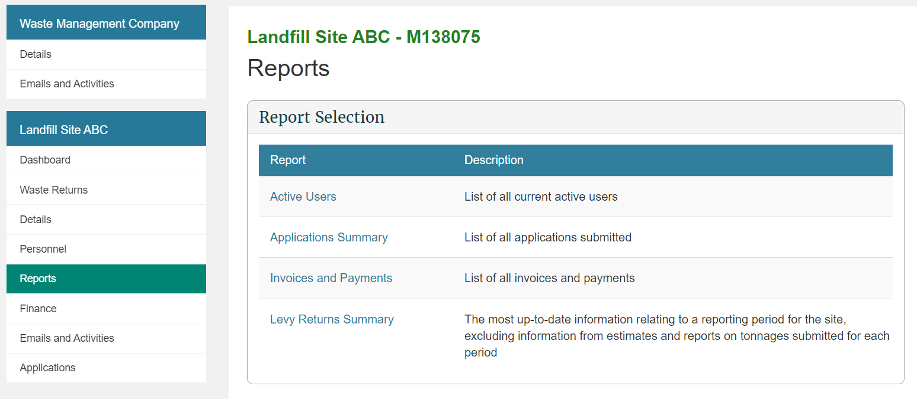

Generating or exporting a report

When to use
Use these steps to generate a report online or export the report as a Pdf or Excel document.

Roles
- Data entry
- Verifier

Steps
Step | Action
1 | Either:  - click View reports in the Quick Links field of your disposal facility dashboard  - click the Reports link in the content menu.  Result: The Reports page displays.  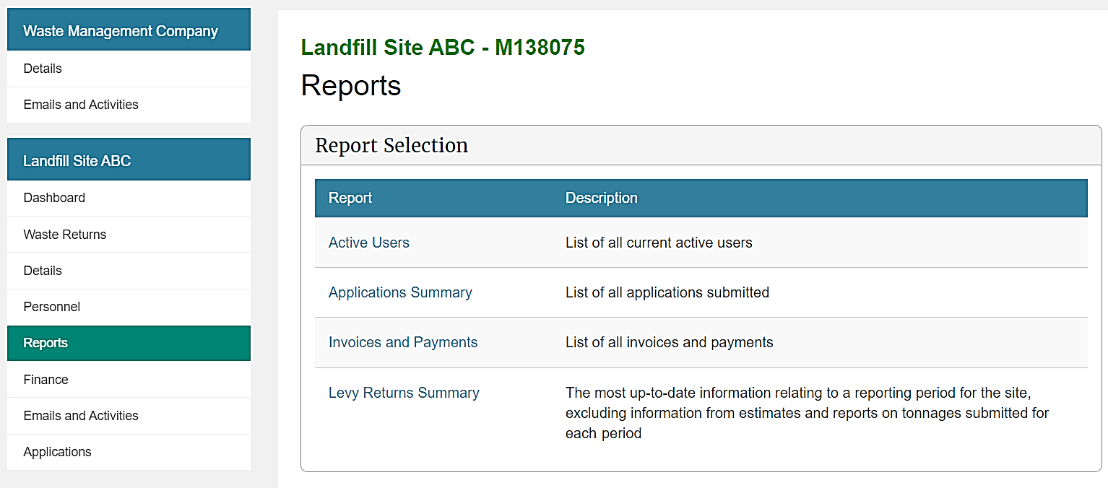
2 | Select which of the following reports you would like to view:  - Active Users  - Applications Summary  - Invoices and Payments  - Levy Returns Summary.  Result: The report will highlight, and the Run button will display.  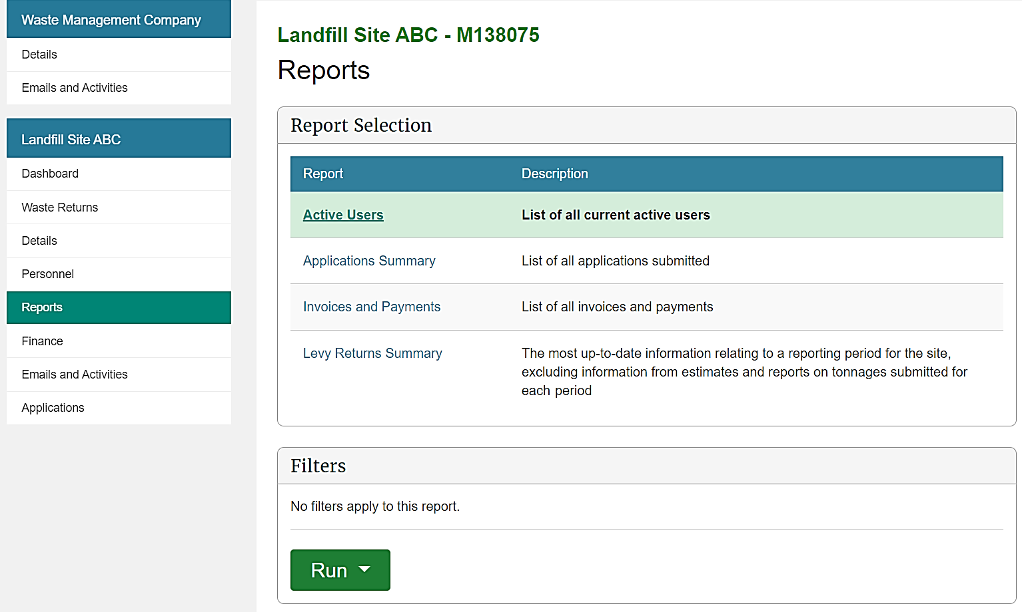
3 | Filters can be applied to some reports to narrow your search to specific periods. If you do not want to apply a filter, go to step 4.  The following filters can be applied:  Field Description  From Date Filter from this date. By default, these fields are empty. To apply a date range filter, enter the Day (DD), Month (MM) and Year (YYYY). Note: Some reports can only be filtered by Month (MM) and Year (YYYY).  To Date Filter to this date. By default, these fields are empty. To apply a date range filter, enter the Day (DD), Month (MM) and Year (YYYY). Note: Some reports can only be filtered by Month (MM) and Year (YYYY).  Reset To clear all filters and reset to default values, click Reset.  Result: The filters will be applied to the report.
4 | Click Run and a drop-down menu will display:  - To view the report on screen, click On Screen. Go to step 5.  - Click Excel Download to download the report as an Excel document. Go to step 6.  - Click PDF Download to download the report as a PDF document. Go to step 6.
5 | If you selected On Screen:  Result: The report will generate on screen.  Note: You can use the scroll bars to move around the report.
6 | If you selected either Excel Download or PDF Download:  Result: Depending on your settings and internet browser, the file may download automatically and appear in the Downloads list.  Note: If a file pop-up displays, go to step 7.
7 | If a file download pop-up displays, click:  Open to open the report  Save to save a copy of the report to your computer.  Result: If you clicked Open the file will open. If you clicked Save, you will be prompted to select a folder to save the report in.

What happens next?
Generate other reports as required.

Glossary
This glossary explains terms used in this guide.
Annual return | The process where an approved disposal facility submits waste figures to the Ministry for the Environment on an annual, rather than monthly basis. This provision only applies to waste disposal facilities that receive an annual tonnage of no more than 1000 tonnes and have been approved by the Ministry for the Environment to submit annual returns.
Amendment | A change to the amount of material received, diverted or disposed of at a facility for a particular return. The amendment creates a credit/debit adjustment as well as an amendment to previously submitted tonnage figures.
Average tonnage method | A method for calculating gross tonnage by recording the number of light vehicles delivering waste to the facility and applying an average weight per vehicle, rather than weighing every vehicle.
Client | The company or organisation operating one or more disposal facilities
Data entry user | The person registered to enter returns data for a disposal facility.
Diverted tonnage | Diverted tonnage is the tonnage of waste or diverted material that is reused or recycled at the disposal facility, or is removed from the facility, not later than six months after entering the facility (unless an extension has been approved by the Secretary for the Environment). Diverted tonnage must only include waste or diverted material that was previously measured as ‘gross tonnage’ in OWLS 2.0.
Estimate | The process where the Ministry for the Environment calculates the amount of levy payable when a disposal facility operator has failed to submit a valid return.
Methodology | The method(s) used to calculate waste and diverted material tonnage at a disposal facility.
Monthly return | The process where a disposal facility submits waste figures to the Ministry for the Environment on a monthly basis.
Operator | Operator means the person in control of a disposal facility or other facilities
Quarterly return | The process where a disposal facility submits waste figures to the Ministry for the Environment on a quarterly basis.
Return | The tonnage data entered by the disposal facility for the Ministry for the Environment to calculate the levy due.
Refund | The process where a disposal facility can apply for a refund of the levy money paid after a waiver was granted.
Reimbursement | The process where a disposal facility can request a reimbursement for an amount of money credited against the account.
Verifier | The person registered to enter, modify and submit returns and applications on behalf of a disposal facility. The verifier is responsible for declaring information entered is correct and accurate.
Waiver | A disposal facility can apply to have all or part of the levy waived. The amount of the waiver may be calculated from tonnage figures supplied by the disposal facility and may include other charges such as interest.

