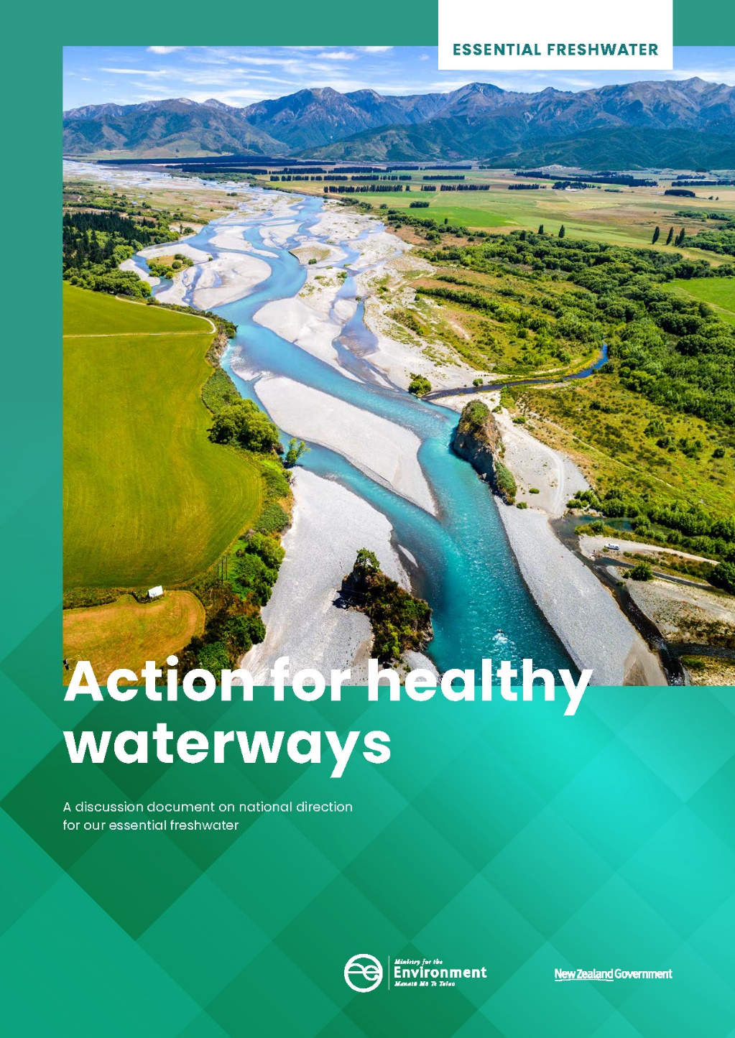

This document may be cited as: Ministry for the Environment. 2019. Action for healthy waterways – A discussion document on national direction for our essential freshwater. Wellington: Ministry for the Environment.

Published in September 2019 by the
Ministry for the Environment and Ministry for Primary Industries
Manatū Mō Te Taiao
PO Box 10362, Wellington 6143, New Zealand
ISBN: 978-1-98-857931-3 (print)
978-1-98-857934-4 (online)
Publication number: ME 1427
© Crown copyright New Zealand 2019
This document is available on the Ministry for the Environment website: www.mfe.govt.nz.
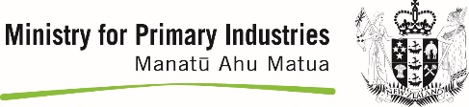

Contents
Message from the Ministers 5
1 Overview – the health of our nation depends on the health of our freshwater 8
1.1 Summary of proposals 10
1.2 Input from network of advisory groups 13
1.3 Broader reform of the freshwater management system 16
1.4 Advisory groups call for significant change 17
1.5 Path forward 18
1.6 Questions 19
2 Implementing improvements through the Resource Management Act 20
2.1 Central government sets direction for local government to follow 20
2.2 NPS-FM provides national direction for managing water 20
2.3 Iwi and hapū demonstrating leadership 21
2.4 Communities and water users taking action 21
2.5 New national direction 22
2.6 Interactions with other regulations 22
2.7 Interactions with Treaty settlement obligations 22
3 Context 24
3.1 Current state of our freshwater ecosystems 24
3.2 What are the challenges? 25
4 Setting and clarifying policy direction 27
4.1 Issues 27
4.2 Te Mana o te Wai 28
4.3 Strengthening Māori values 30
4.4 New planning process for freshwater through amending the RMA 33
4.5 Directing more integrated management of freshwater 34
4.6 Exceptions for major hydro schemes to support renewable energy targets 34
4.7 Questions 36
5 Raising the bar on ecosystem health 37
5.1 Issues 37
5.2 Focus on holistic ecosystem health – te hauora o te wai 38
5.3 Ecosystem health – new attributes and new management approach 39
5.4 Aquatic life – improving protection for threatened indigenous species 42
5.5 Aquatic life – providing for fish passage 43
5.6 Habitat – no further loss of wetlands 44
5.7 Habitat – no further loss of streams 45
5.8 Water quality – new bottom line for nutrient pollution 45
5.9 Water quality – reducing sediment 48
5.10 Water quality – a higher standard for swimming 50
5.11 Water quantity – clarifying requirements for minimum flows 51
5.12 Water quantity – real-time reporting of water use 51
5.13 Questions 52
6 Supporting the delivery of safe drinking water 54
6.1 Issues 55
6.2 Proposal 55
6.3 Questions 56
7 Better managing stormwater and wastewater 57
7.1 Issues 57
7.2 Wastewater 58
7.3 Stormwater 60
7.4 Questions 62
8 Improving farm practices 63
8.1 Issues 63
8.2 Restricting further intensification of rural land use 64
8.3 Improving farm practices through farm planning 65
8.4 Immediate action to reduce nitrogen loss 70
8.5 Excluding stock from waterways 73
8.6 Controlling intensive winter grazing 76
8.7 Restricting feedlots 79
8.8 Reducing pollution from stock holding areas 79
8.9 Questions 80
9 Support for improvement in catchments and on farms 82
9.1 Focusing on catchments at higher risk 82
9.2 Practical advice and support for farmers 83
9.3 Making good decisions based on good information 83
10 Impacts of proposals 84
10.1 Benefits and costs 84
10.2 Magnitude of the benefits and costs 86
10.3 Impact scenarios 89
11 Aligning RMA national direction 98
11.1 The role of national direction under the RMA 98
11.2 Alignment with other national direction under the RMA 98
11.3 Questions 101
12 How to have your say 102
12.1 Timeframes 102
12.2 How to make a submission 102
12.3 For more information 103
12.4 Publishing and releasing submissions 103

Message from the Ministers
New Zealanders value our freshwater. Our rivers and lakes, and how we care for and use them, are a fundamental part of who we are. We respect the mana of our freshwater
– Te Mana o te Wai.
New Zealanders want to be able to swim, fish, gather mahinga kai, and enjoy freshwater as our parents and grandparents did. We also need clean water to drink and irrigation to support a sustainable economy.
Freshwater quality has deteriorated seriously over recent decades. We have known about this since 2004 when the then Parliamentary Commissioner for the Environment Dr Morgan Williams published the Growing for Good report highlighting that water pollution was getting worse. Sadly, the problems are not yet under control and urgent action is needed.
This Government is committed to stopping the degradation of New Zealand’s waterways so that water quality is materially improving within five years, and to restoring them to a healthy state within a generation.
We need to reduce the amount of pollution (nitrogen, phosphorus, sediment, E. coli and other contaminants) entering our waterways from our cities and from our farms.
We are proposing new requirements to make real change as quickly as possible. However, freshwater degradation issues have been decades in the making, so we want to ensure the pace of change is manageable and appropriate support is in place.
New requirements must be practical and enduring. This means they need to be science-based, predictable, understood by the public, and underpinned by effective regulation and enforcement.
We acknowledge that many farmers have already started addressing the degradation of New Zealand’s rivers. This good work will be built on, with a focus first on catchments where the risk of further damage is greatest.
The proposals in this document have been developed with a view to upholding Te Mana o te Wai. This is a concept for all New Zealanders. It refers to the integrated health and wellbeing of waters as a continuum from the mountains to the sea. We acknowledge there will be more to do to achieve this.
We thank our advisory group Kāhui Wai Māori for its advice on these issues. We also thank the other advisory groups who have worked closely with us to test and advise on policy options – the Freshwater Leaders Group, the Science and Technical Advisory Group, and the Regional Sector Water Subgroup. All the members of these groups have made valuable contributions.
Advisory group views are reported in this document.
The proposals in this document will set clearer expectations for all New Zealanders to contribute to protecting and restoring freshwater. Some of the actions required will differ depending on where people live and how they make a living.

Farmers and growers make many day-to-day decisions that directly impact on land and water resources. We have drawn on the knowledge and expertise of farmers and growers on our advisory groups, and talked with many who have already made changes to reduce their environmental impact.
We believe we can take the necessary urgent action on freshwater while sustaining a viable primary sector.
We will continue to work with the primary sector through the transition to more sustainable land and water use. In the 2019 Budget we announced a significant investment of taxpayer funding to help.
We believe there is also a role for primary sector processors to play in achieving our freshwater outcomes. Some, such as Synlait and Miraka dairy companies, already provide financial incentives for good environmental management and we will be encouraging others to follow their lead. Positive recognition of good performance is as important as regulating poor performance.
Urban areas need to invest in better separating sewage from stormwater and stopping pollution and loss of streams and wetlands.
Some of our most degraded freshwater environments are in urban areas, even though these form a small proportion of overall waterways. With almost all of New Zealand’s population growth taking place in urban areas, it is important to ensure this growth isn’t at the expense of the environment. People in urban areas should be able to enjoy their local waterbodies. We are looking for feedback on options for improving how freshwater is managed in urban environments, including measures to protect streams from land reclamation.
Alongside the Essential Freshwater programme, the Government is also undertaking the Three Waters Review of drinking water, wastewater and stormwater services. This work is intended to ensure New Zealanders can be confident that drinking water is safe to use, sources of drinking water are adequately protected, and wastewater and stormwater are managed in environmentally sustainable ways.
Regulatory change developed within the Three Waters Review will be progressed through a number of avenues, and some proposals have been included in this document because they need to complement the Essential Freshwater reforms. We are seeking feedback on these proposals.
The Government is implementing policies to combat climate change, protect biodiversity, provide for sustainable urban development while protecting highly productive land for food growing, plant the right trees in the right places, and reduce waste. This includes reforming the Resource Management Act and establishing the independent Climate Change Commission.

Action for healthy waterways is one part of our broader plan to build a productive, sustainable and inclusive economy that supports the wellbeing of all New Zealanders.
There is a lot happening, and a lot to consider. We look forward to hearing your thoughts.

Hon David Parker
Minister for the Environment

Hon Damien O’Connor
Minister of Agriculture

Hon Nanaia Mahuta
Minister of Local Government

Overview – the health of our nation depends on the health of our freshwater
The health of our people, our environment, and our economy depends on the health of our freshwater. But our water is suffering as a result of human activity – urban development, agriculture, horticulture, forestry, and other activities – and because of a lack of robust regulation, monitoring, and enforcement.
Urgent action is required.
The Government has three objectives:
- Stop further degradation of New Zealand’s freshwater resources and start making immediate improvements so that water quality is materially improving within five years.
- Reverse past damage to bring New Zealand’s freshwater resources, waterways and ecosystems to a healthy state within a generation.
- Address water allocation issues having regard to all interests including Māori and existing and potential new users.
This document sets out a package of proposals to achieve the first two of these objectives. Beyond this, we will continue to work on broader system reform, including water allocation.
Within five years, the Government expects environmental reporting to show evidence of improvement in water quality. Because every catchment is different, the time required for improvements to show up will be different. It will take decades to restore the health of our waterways to the state our communities want, but these proposals set out a shared direction and get us started. Some catchments are under greater pressure and need more action,
more quickly.
Overall, this package strengthens the obligations on all New Zealanders to protect and restore our waterways. We describe this shared responsibility as upholding Te Mana o te Wai – the health and wellbeing of the water.
Te Mana o te Wai is a concept for all New Zealanders. It refers to the essential value of water, and the importance of firstly sustaining its integrity and health, before providing for essential human health needs and then for other consumption. The Government agrees with this concept.
The Government will continue to work with Māori to address their rights and interests in freshwater, particularly in the context of addressing allocation issues.
Further work is needed on institutional/oversight arrangements for the freshwater management system, together with strengthening compliance and enforcement, establishing more durable funding of the system, and improving science and information to inform
decision-making.
A healthy waterway is an ecosystem that includes the plants, fish, birds, insects and other invertebrates in and on the banks of the waterway, with enough clean water flowing through.
To encourage a holistic approach to managing water – ki uta ki tai – we are bringing together proposals to strengthen the regulation of both freshwater and three waters infrastructure (drinking water, wastewater and stormwater services).
Many people, including farmers and growers, are already taking action to reduce their impact on freshwater. However, their efforts are undermined by those who are not. We want to acknowledge positive efforts and follow good examples wherever we can, and make sure everybody contributes.
The proposals in this document put a stronger focus on improving all aspects of ecosystem health and set out proposed new processes and standards for reducing pollution within the current system. However, they will not deliver the improvements all New Zealanders want unless they can be translated into real actions on the ground. This is a big ask of councils, ratepayers, and land and water users. Budget 2019 included a significant investment in support for regional councils, and implementing aspects of the package such as farm planning.
While there will be costs in implementing this package, there are also costs from not acting. The environmental issues currently facing New Zealand have immediate significant costs (such as the costs of restoring degraded waterways) as well as future costs (such as decreased productivity due to soil erosion). Generally, environmental interventions are cheaper and more cost-effective the sooner they are implemented.
The proposals will be delivered through national direction under the Resource Management Act 1991 (RMA), in the form of a new National Policy Statement for Freshwater Management (NPS-FM), National Environmental Standards (NES) for Freshwater, Sources of Drinking Water, and Wastewater, and Section 360 regulations. We have restructured and redrafted the current NPS-FM to improve clarity and reinforce a holistic approach to freshwater management.

Summary of proposals
We are seeking your views on the proposals summarised below.
Proposal | RMA direction | What will be different
Set and clarify policy direction (section 4 of this document)
Introduce a new freshwater planning process that will require councils to have new plans in place no later than 2025. | RMA amendment bill | Better, faster, more nationally-consistent freshwater management plans and implementation.
Strengthen and clarify the requirement to manage freshwater in a way that gives effect to Te Mana o te Wai; this refers to the integrated and holistic health and wellbeing of waters as a continuum from the mountains to the sea. | NPS-FM | The health and wellbeing of the water will be put first in decision-making; providing for essential human needs, such as drinking water, will be second, and other uses will be third.
Restructure and redraft the NPS-FM to improve clarity and reinforce a holistic approach to freshwater management | NPS-FM | Councils and the communities they represent will find it easier to put the health and wellbeing of the water first because they will have stronger and clearer direction.
Strengthen the requirement to identify and reflect Māori values in freshwater planning, with two options set out in this document for feedback. | NPS-FM | Iwi and hapū values for freshwater in a region will be a focus for freshwater management.
Support renewable energy targets by exempting major hydro-electric schemes from some freshwater management requirements. | NPS-FM | Status of major existing hydro-electric schemes will be clarified. This is not expected to result in any change to current consent requirements for managing water flows and environmental impacts.
Raise the bar on ecosystem health (section 5)
Broaden the focus of national direction and planning to a more holistic view of ecosystem health and require better monitoring and reporting. | NPS-FM | Land and water resources will be managed so that in a generation our freshwater will be healthier for people, animals, native fish, trout and salmon, plants and other species that live in or alongside waterways.
New attributes (indicators of ecosystem health) to be monitored and maintained or improved:  - nutrients (nitrogen and phosphorus)  - sediment  - fish and macroinvertebrate numbers  - lake macrophytes (amount of native or invasive plants)  - river ecosystem metabolism  - dissolved oxygen in rivers and lakes. | NPS-FM | Land and water resources will be managed to maintain or improve ecosystem health in each catchment. This is likely to require different actions in different catchments, including reducing soil loss, reducing nutrient run-off, and/or investing in upgrading wastewater and stormwater infrastructure.
Higher standard for swimming in summer. | NPS-FM | Greater efforts to reduce contamination where people want to swim.
Protect urban and rural wetlands and streams. | NPS-FM and new Freshwater NES | There will be no more draining or development of wetlands.  Remaining streams in urban and rural areas will not be piped or filled in unless there is no other option, for example to provide a crossing.
Protect threatened indigenous freshwater species. | NPS-FM | Land and water resources will be managed in a way that helps indigenous species thrive.
Provide for fish passage. | NPS-FM and Freshwater NES | Fish that need access to the sea to breed will face fewer barriers.
Improvements to setting minimum water flows and reporting on water use. | NPS-FM and regulations | Better management of water allocation within the current system.
Support the delivery of safe drinking water (section 6)
Strengthen requirements to assess and control risks to drinking water sources. | Amended NES for Sources of Human Drinking Water | Tighter management of land use in areas that are sources of drinking water supply so drinking water is not contaminated.
Improve ecosystem health by better managing stormwater and wastewater (section 7)
Set minimum standards for wastewater discharges and overflows and require all operators to follow good practice risk management. | Proposed Wastewater NES and proposed Water Services Act | There is less pollution of rivers, lakes, groundwater and the sea from stormwater and wastewater.
Improve ecosystem health by improving farm practices where needed (section 8)
Ensure all farmers and growers have a plan to manage risks to freshwater. | Freshwater NES | There is less pollution of rivers, lakes and groundwater from agriculture and horticulture because all farmers and growers understand and manage environmental risks and follow good practice. All farmers and growers have a farm plan by 2025.
Tightly restrict any further intensification of land use through interim measures until all regions have operative freshwater management plans. | Freshwater NES | From June 2020, changes such as new irrigation or conversion to dairying will only happen where there is clear evidence it will not increase pollution.
Reduce nitrogen loss in catchments with high nitrate/nitrogen levels through interim measures until all regions have operative freshwater management plans. | Freshwater NES and/or farm plan | In catchments with high nitrate/nitrogen levels there will be a reduction in nitrogen loss within five years.
Exclude stock from waterways. | New regulations and farm plan | There will be more fencing and wider setbacks to keep stock out of waterways, reduce erosion, and capture contaminants before they reach the water.
Apply standards for intensive winter grazing, feedlots and stock holding areas. | Freshwater NES or industry standards | There will be less erosion and less pollution of waterways from nutrients, sediment and pathogens.
To support these proposals, the Government is investing in information, tools and advice that will help communities restore waterways and improve practices (section 9). The structure of this document follows these broad areas, shows how proposals would be implemented under the RMA (section 2), and discusses potential impacts (section 10) and interactions with other regulations (section 11).
These proposals are one part of the Government’s comprehensive approach to improving the state of our waterways and our environment, and moving to a sustainable, low-emissions economy.
Copies of the draft NPS-FM, Proposed Freshwater NES and Draft stock exclusion section 360 regulations are available on the Ministry for the Environment’s website.
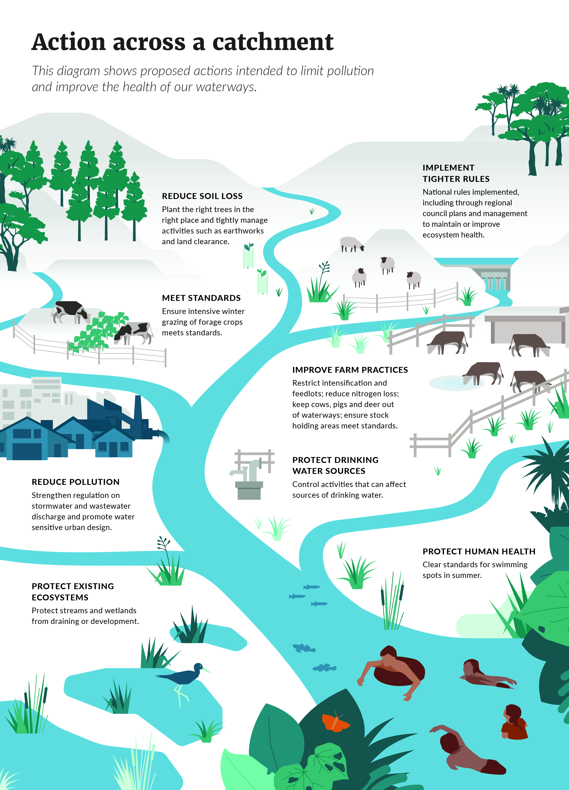

Input from network of advisory groups
The policy proposals outlined in this document arise from the Essential Freshwater work programme launched in October 2018, as set out in the documents Essential Freshwater: Healthy water, fairly allocated and Shared Interests in freshwater: A new approach to the Crown/Māori relationship for freshwater. This work programme was delivered by a multi-agency taskforce based at the Ministry for the Environment (MfE), informed by the views of a network of advisory groups which have all provided their own advice to Ministers on the regulatory package set out here and broader issues, set out in their reports. The views of these groups are noted throughout this document.

The Freshwater Leaders Group
The Freshwater Leaders Group (FLG) brings together expertise and input from leaders across the primary sector and agribusiness, environmental non-government organisations, and other voices from the community. It has acted as a sounding board for proposals and challenged analysis.
“New Zealanders have a deep connection to waterways. Freshwater is central to all New Zealanders whether as part of daily life, recreation, business or holding a special cultural significance. Over many years the quality of New Zealand’s waterbodies has become degraded. Although the Resource Management Act (RMA) has provided for sustainable management, water quality continues to decline in many catchments around New Zealand today. It is becoming increasingly clear that more must be done.
“The urgent need to take further action to stop our freshwater from becoming worse, and to return our freshwater bodies to a healthy state, is widely recognised. To improve water quality, major changes are needed to the way that we as a country protect and manage our land and water.
“Farming to provide food and fibre is a fit and proper activity and its use of water means that it will have an environmental footprint and some waterbodies will not be ‘pristine’. But it needs to be carried out within environmental limits.”
You can read the full Freshwater Leaders Group report on the Ministry for the Environment’s website.

Te Kāhui Wai Māori
Te Kāhui Wai Māori (KWM) has brought the insight, skills and perspectives of a broad range of Māori experts with significant experience and leadership in the primary sector and agribusiness, freshwater science and mātauranga Māori, local government, resource management law and policy, and flax roots whānau, hapū and iwi advocacy. It has built on previous work by the New Zealand Māori Council and the National Iwi Chairs Forum: Freshwater Iwi Leaders Group.
“Aotearoa New Zealand’s current resource management system is broken. It is failing to achieve its purpose and has become complex, dysfunctional and inaccessible. Our waters are sick. We must heed the cry to make our waters well again. Diverse communities all over Aotearoa New Zealand are hearing these cries. Te Mana o te Wai is the korowai that should frame and inform structural and system reform. We set out a programme of action for our nation to journey together in implementing a managed transition to a new system of care and respect for water. It is time for a new system.
The Kāhui Wai recommendations to restore the health of our wai are:
1. Embed Te Mana o Te Wai principles and obligations to guide all activities.
2. Recognise and resolve iwi/hapū customary title and rights in water within the next 3 years, including the implications in practice of this recognition.
3. Declare a moratorium on additional discharges and water-related consents for 10 years.
4. Reform the RMA in line with the directive of this paper.
5. Consider enacting a stand-alone complementary Water Act to reinforce the significance of water as a taonga for the nation.
6. Establish an independent national regulatory Te Mana o te Wai Commission.
7. Develop new accountability and partnership requirements for local government.
8. Develop mandatory Māori measures of wellbeing in the National Policy Statement for Freshwater Management National Objectives Framework.
9. Design and implement a national funding system that emphasises water user pays. Options for use of funds include an ongoing clean-up fund for at-risk catchments.
10. Implement a Te Mana o te Wai Capacity and Capability Strategy to guide the investment in, and development and empowerment of, the leaders of Te Mana o te Wai to enable this structural and system reform.
11. Implement a National Freshwater Science Strategy, that extends beyond biophysical factors and includes Māori measures of health, to underpin Te Mana o te Wai.
12. A new water allocation system must conform with Te Mana o Te Wai and iwi/hapū rights and obligations, including the recognition of the long held exercise of ahi kā by Māori landowners. No allocation based on grandparenting and no perpetual rights.
The KWM Te Mana o Te Wai Report makes a number of central system-wide and structural recommendations that reach beyond the package of regulation set out in this document. They are fundamental. Among them are reform of the RMA, consideration of a stand-alone Water Act, new requirements for local government, a strategy to develop Te Mana o te Wai capacity and capability, a science strategy that includes Māori measures of health and a new water allocation system that must conform with Te Mana o Te Wai and iwi/hapū rights and obligations.”
You can read the full Kāhui Wai Māori report on the Ministry for the Environment’s website.

The Science and Technical Advisory Group
The Science and Technical Advisory Group (STAG) has overseen the technical and scientific basis for proposals, and given extensive input into the ecosystem health measures and other proposals.
“This [STAG] report highlights a strong focus by STAG on the health of the environment and the waterbody. We recognise that recommendations in our report could, depending on the way they are incorporated into policy, have very significant economic and social implications for individuals and communities in some parts of New Zealand. At the same time, they will require substantial investment in both capacity and capability in freshwater science and management in New Zealand, especially in relation to regional council monitoring and reporting. However, it is explicitly not within our remit to consider such implications in developing our recommendations.
“Our focus has been on the freshwater ecosystems themselves and in this respect our recommendations are aligned with the first obligation of Te Mana o te Wai – the first obligation is to the water, to protect its health and its mauri.”
You can read the full Science and Technical Advisory Group report on the Ministry for the Environment’s website.

The Regional Sector Water Subgroup
The Regional Sector Water Subgroup (RSWS) has contributed views and experiences of regional councils, who are required to manage freshwater on behalf of their communities and to promote environmental, social, cultural and economic wellbeing.
The regional sector will ultimately be responsible for implementing and enforcing most of the proposals, and has substantial experience with the challenges of implementing the current NPS-FM, regional plans, and various Treaty settlement arrangements relating to freshwater management.
“In the early days of the Resource Management Act (1991), New Zealand’s water quality challenges were strongly linked to point source discharges. By improving technology and resource consent conditions, point source discharges have improved significantly, demonstrating that the current resource management system can work. However, the gains made by improving point source discharges have been largely overshadowed by land-use intensification. Successive governments, industry and the economic system encouraged land development and intensification, including subsidising large scale land clearance and wetland drainage.
“As New Zealand works to address the significant challenges these past behaviours have created, we all need to take responsibility to improve water quality. Major progress is being made to improve catchment management and tighten local environmental regulations in different parts of the country.
“The Regional Sector strongly supports the Government's intent to improve water quality and wants to ensure that the likely impacts of the new proposals on communities are well understood and factored into the pace of change. We need to take landowners and communities with us. It is also essential that the new proposals can be practically implemented in the stated timeframes, noting that significant capacity and capability issues exist across all sectors.”
You can read the full Regional Sector Water Subgroup report on the Ministry for the Environment’s website.

Broader reform of the freshwater management system
As well as the immediate steps proposed in this document, we are continuing to work more broadly on the future shape of the system for managing freshwater.
The proposals here are intended to better enable councils to set limits for a sustainable level of nitrogen (and other pollutants) in each catchment. To reduce nitrogen discharge levels to meet those limits, there needs to be a system for allocating allowances to discharge nitrogen into water. This would have to provide for new entrants and the development of currently underdeveloped land. We anticipate consulting on this issue at a later date.
Proposed targets for emissions in the Climate Change Response (Zero Carbon) Amendment Bill are also likely to result in changes in the decisions New Zealanders make at home, at work, and on the farm.
The proposals for freshwater also link with the Government’s priority to safeguard our indigenous biodiversity and reduce the extinction risk for 4000 threatened plant and wildlife species.
MfE is continuing to work with the Department of Conservation (DOC), the Ministry for Primary Industries (MPI) and others, to understand how climate, biodiversity and water policies interact and can deliver co-benefits.

Resource management reform
The Government has a two stage process for reforming the resource management system, including freshwater management.
Stage one is an amendment bill, later this year, to reduce complexity, increase certainty, restore previous public participation opportunities, and improve RMA processes.
Stage two is a comprehensive review of the resource management system, focused on
the RMA.
A panel of experts will lead the review and will deliver a plan for resource management reform by mid-2020.
The review will address urban development, environmental bottom lines, and effective participation, including by Māori.

Advisory groups call for significant change
The advisory groups KWM, FLG and RSWS are clear that significant change is required, and rapidly, to return waterways to the state that all New Zealanders want.
RSWS also considers that all New Zealanders, urban and rural, have a responsibility for improving freshwater ecosystems.
FLG, STAG and RSWS support the intent behind the proposals set out in this document, as taking immediate steps toward stopping further damage and improving ecosystem health.
KWM supports the need for reform to take immediate steps toward stopping further damage and improving ecosystem health, but are not confident that the current policy proposals will deliver on these outcomes.
All groups support Te Mana o te Wai as the overall framework for managing water resources. It is a concept that resonates across cultures.
FLG advises that a ‘precautionary approach’ should be applied; where there is uncertainty, regulations should favour the protection of freshwater values.
Managing the change
Advisory group members acknowledge proposed new rules would have an impact on land and water users in both urban and rural parts of New Zealand.
The RSWS supports many of the changes proposed, some of which the sector sought, such as the streamlined planning process and specialist water commissioners to sit with local accredited elected members to comprise freshwater hearings panels.
The RSWS has substantial concerns about the scale and speed of the impacts and capacity and capability throughout New Zealand to achieve the change.
It seeks careful assessment and consideration of these by government, and the need for targeted science support, before setting requirements and timeframes. Getting the detail right in regulatory settings will also be critical to ensure they are appropriately targeted, implementable and effective.
The RSWS wants to ensure that change is targeted to where it is needed most. Specifically, where the NPS-FM has already been given effect to, that transitional arrangements are provided so these plan provisions are not required to be reworked.
KWM and FLG are of the view that New Zealand society has failed to adequately protect ecosystem health, and must now front up to the changes required. Both KWM and FLG consider that all New Zealanders, both urban and rural, have a responsibility for improving ecosystem health.
KWM and FLG want the proposed new rules in this package to deliver swift change to poor practices that are contributing to high contaminant loads reaching waterways.
It is acknowledged that the transition to healthier ecosystems across all of New Zealand will take decades, but KWM and FLG support clearly setting expectations and direction so everyone has a clear view of the path forward, to inform their decision-making.
It will be essential to provide well-developed guidance material to assist and support farmers to meet expectations and operate in line with new regulations.
KWM, FLG and RSWS agree that monitoring and enforcement will be critical, to ensure New Zealand water resource users are doing what they are supposed to. KWM proposes a national approach to monitoring, compliance and enforcement, with hapū involvement.
The advisory groups have all raised concerns about whether there is adequate capacity and capability in the system to do what’s required as quickly as possible. KWM is clear that this is not an excuse for not making change. Commitment to rapid change requires leadership from central and local government through targeted resourcing.
The RSWS would like to see the Crown's investment in science refocused to prioritise and support improving freshwater quality.
New national body to oversee water
KWM and FLG recommend wider changes to the freshwater resource management system.
KWM says Aotearoa New Zealand’s current resource management system is broken. It is failing to achieve its purpose and has become complex, dysfunctional and inaccessible.
Both KWM and the FLG recommend the establishment of a new, independent national body to oversee freshwater management implementation. KWM proposes this is named Te Mana o te Wai Commission, with at least 50 per cent of the appointed Commissioners to be Māori. It should be independent of the government and be sustainably resourced to design and implement the Te Mana o te Wai Structure and Systems Reform.
The proposed commission’s role would include setting national direction, auditing or monitoring regional or local authority functions and duties, providing technical support, calling-in applications at the local catchment level where appropriate, and advice to regional councils and enforcing compliance.
See the KWM report (paragraphs 42-46) and the FLG report (paragraphs 67–70).
The RSWS believes that stronger central leadership and system stewardship is needed.
The RSWS recommends a review of the current system and consideration given to how the current system can work better, rather than creating a new institution. Existing institutions such as the Ministry for the Environment, the Parliamentary Commissioner for the Environment, and the Office of the Auditor General need to be strengthened.

Path forward
In the next 12 months New Zealanders can expect to see:
- whole-of-government investment in supporting actions that will stop further damage to our waterways and start to reverse past damage. This includes helping farmers understand and plan for improvements in farm practices, supporting councils to apply and enforce controls as quickly and effectively as possible, and investing in catchment-level protection and restoration activity and in systems and technology such as Overseer® that will help monitor and manage pollution
- public discussion and feedback on proposals outlined in this document, followed by decisions. Implementation of new rules by central government and regional councils would begin from June 2020
- detailed planning on how and when to implement support for new and improved practices
- debate on amendments to the RMA to speed up the process for regional councils to develop and implement regional water management plans
- a public conversation on nitrogen discharge allowances and discussions on more comprehensive reform of the RMA.

By 2025 New Zealanders can expect to see:
- evidence of material improvements in freshwater quality
- regional councils managing land and water resources in a way that reflects community/iwi/hapū values and will improve freshwater health in a generation
- catchment-level limits on resource use to better manage pollutants, set at a point that sustains ecosystem health
- urban water service providers and rural water users implementing plans to reduce their environmental impact and manage risk
- farmers and growers supported with information and advice as they move to more sustainable land use
- nationally-consistent measurement and monitoring in place to track progress, enforce limits where required, and inform further work.

Questions
The Government welcomes your feedback. The questions below, and at the end of each section, are a guide only. You do not have to answer all the questions and all comments are welcome. See section 12 for how and when to make a submission.
- Do you think the proposals set out in this document will stop further degradation of New Zealand’s freshwater resources, with water quality materially improving within five years?
- Do you think the proposals will bring New Zealand’s freshwater resources, waterways and ecosystems to a healthy state within a generation?
- What difference do you think these proposals would make to your local waterways, and your contact with them?
- What actions do you think you, your business, or your organisation would take in response to the proposed measures?
- What support or information could the Government provide to help you, your business, or your organisation to implement the proposals?
- Can you think of any unintended consequences from these policies that would get in the way of protection and/or restoration of ecosystem health?
- Do you think it would be a good idea to have an independent national body to provide oversight of freshwater management implementation, as recommended by KWM and FLG?
- Do you have any other comments?

Implementing improvements through the Resource Management Act
The Resource Management Act 1991 (RMA) is the main piece of legislation that sets out how we manage our environment. Its purpose is the sustainable management of natural and physical resources. For freshwater, the RMA regulates how water is taken, used, dammed or diverted, and how pollutants can enter water.

Central government sets direction for local government to follow
The Government is responsible for making regulations that councils and water users have to follow. As well as administering the RMA, the Government provides ‘national direction’ for water through national policy statements, national environmental standards, and other regulations.
These give councils specific instructions about how to achieve the outcomes the Government considers nationally important (eg, protecting the health of freshwater ecosystems and of people).

NPS-FM provides national direction for managing water
The National Policy Statement for Freshwater Management 2014 (NPS-FM), which was amended in 2017, is currently the main source of national direction about how regional councils should manage freshwater.
It contains a National Objectives Framework (NOF) which guides regional decision-making. This requires that every regional council, in consultation with its community, sets out a long-term vision for waterbodies in its region and identifies corresponding values for each freshwater management unit (FMU). The council must then set freshwater objectives and target attribute states to ensure those values are provided for.
The council must then work out what needs to be managed to achieve those target attribute states (eg, contaminants, flow, habitat or land use), set limits on these things, and develop rules about resource use to achieve the objectives they’ve set.
Councils must also monitor the extent to which the long-term vision and the target attributes states are being achieved.
Catchments and groundwater
The catchment of a waterbody, like a river, lake or estuary, is the area of land that catches rainfall and drains water to that waterbody. The boundary is usually defined by ridges. However, a surface waterbody can also be fed by groundwater, in which case the catchment might include the area for the groundwater system feeding the surface waterbody.
Groundwater is water that seeps below ground, where it is stored in the soil or in the space between rocks.
A freshwater management unit is all or any part of a waterbody or waterbodies and their related catchments, for management purposes.

Iwi and hapū demonstrating leadership
Many Treaty of Waitangi legislative arrangements, relationship and governance agreements, mātauranga Māori freshwater projects, and iwi and hapū planning documents are providing leadership by influencing freshwater management and community attitudes to water. These sit alongside the rules set by central and regional government.

Communities and water users taking action
Many communities and water users have established their own initiatives to protect and restore local waterways and catchments.
In towns and cities, ratepayers are investing millions in upgrading systems to reduce sewage and other pollution getting into rivers, lakes and estuaries. For example, Auckland Council is planning to spend $7 billion over 10 years to upgrade water infrastructure. More is needed, and through the Three Waters Review the Government is looking at how that can be achieved.
There are hundreds of catchment restoration groups operating across New Zealand.
Thousands of farmers have invested in measures to reduce water pollution – using new systems and technology to deal with effluent so it doesn’t pollute waterways; fencing streams and planting millions of plants; reducing fertiliser use; setting land aside for wetlands, bush reserves, or to prevent erosion; and investing through their industry groups in research to reduce their environmental footprint.
However, voluntary efforts by some are not going to be enough. Central and local government must set clear rules and regulations to ensure all land owners know what’s expected and why, and ensure everyone is contributing.

New national direction
In this document we are consulting on three types of regulation to strengthen national direction on freshwater:
- National policy statements (NPSs): NPSs are issued by the Government to provide direction to local government about matters of national significance which contribute to meeting the purpose of the RMA. NPSs are implemented in regional and district planning documents.
- National environmental standards (NESs): NESs are issued by the Government to set nationally-consistent rules for the ways particular activities or resource uses are to be carried out. NESs apply to all people undertaking activities regulated in the NES.
- Regulations made under section 360 of the RMA (section 360 regulations): section 360 regulations set technical and/or complex requirements for specific activities, duties or other RMA matters.
In addition, the Government has decided to introduce new reporting requirements on wastewater and stormwater network operators to provide greater transparency, and to require regional councils and water suppliers to monitor and report on changes to the quality of drinking water sources. These obligations (discussed in section 7) may be set out in a new Water Services Act as part of reforms to the regulation of Three Waters infrastructure.

Interactions with other regulations
The proposed NPS and NESs have been developed in the context of several other government resource management priorities, particularly the proposed National Policy Statement on Urban Development, the proposed National Policy Statement for Indigenous Biodiversity, and the proposed National Policy Statement for Highly Productive Land.
These national direction tools are intended to be compatible and to enable good decision-making that provides for New Zealand’s environmental, social, cultural and economic wellbeing. Throughout the development of all these national direction tools, there has been careful consideration of how they interact, and how they align with current national policy statements covering various matters of national significance (including transmission activities and renewable energy generation).
See section 11 for further analysis of interactions.

Interactions with Treaty settlement obligations
We have undertaken an initial analysis to ensure the Essential Freshwater policies are consistent with existing Treaty settlement obligations. For example, the Waikato River, Te Awa Tupua and Ngāti Rangi settlements include obligations on the Crown relating to specific aspects (ie, values and strategy documents) of their settlements when developing national direction.
The consultation period provides an opportunity for the Ministry for the Environment (MfE) and iwi/hapū to work together to ensure settlement obligations are being met, and resolve any issues that may arise.

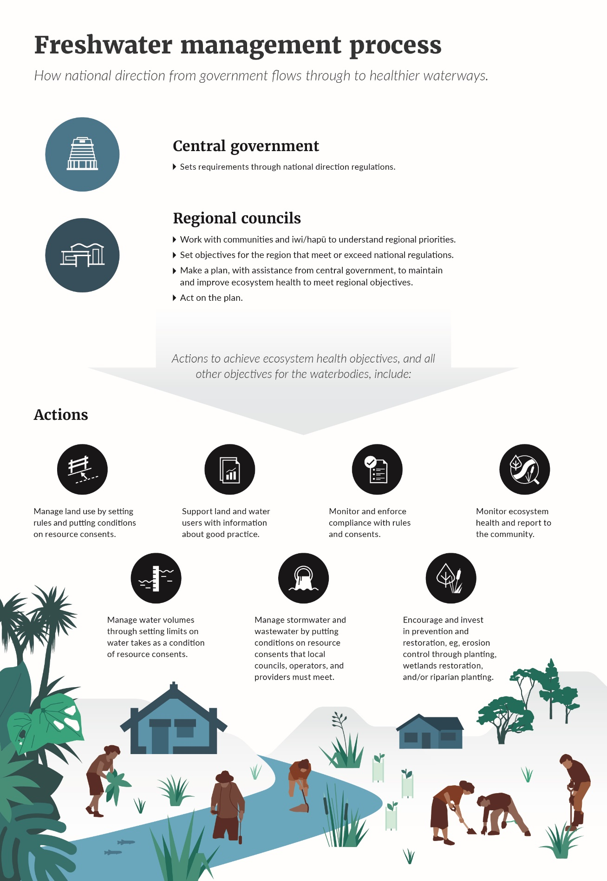

Context
The way New Zealanders live and make a living is having a serious impact on our environment, including precious water resources, as highlighted in the recent report Environment Aotearoa 2019.
The report identified nine priority issues – those that matter most to the current state of the environment. Four issues reflect the pressure we are putting on rivers, lakes, wetlands, estuaries and groundwater:
- Changes to vegetation on the land are degrading soil and water.
- Waterways are polluted in farming areas.
- The environment is polluted in urban areas.
- Taking water changes flows, which affects freshwater ecosystems.
The report also identifies that climate change is already affecting New Zealand.
These are not new issues. As the document Essential Freshwater (October 2018) outlines, the pressure on freshwater is the result of more than 150 years of population growth, and changes in the way we use the land. The damage to freshwater from intensification of agriculture in particular has been known since 2004, when the then Parliamentary Commissioner for the Environment Dr Morgan Williams highlighted it in the report Growing for Good.
Freshwater’s ability to support life is critical for our threatened indigenous species and ecosystem health in both freshwater and the receiving marine environment. It underpins our agricultural, electricity and tourism sectors.
New Zealanders care about freshwater. Recent research shows 85 per cent think it is the responsibility of all New Zealanders to improve water quality and 60 per cent agree everyone needs to share the cost.

Current state of our freshwater ecosystems
Waterways are polluted by excess nutrients, pathogens (disease-causing microorganisms), and sediment. Many have been physically changed, for example urban streams have been piped and other waterways have been dammed.
New Zealand has lost 90 per cent of its wetlands to agricultural and urban development.
Estuaries from Northland to Southland are being seriously damaged by sediment smothering the seabed and shellfish. Increasing sediment is also accelerating the expansion of mangroves.
Our freshwater fish and other species are under threat.
Based on models, over 90 per cent of river length in urban areas and about 70 per cent in pastoral farming areas have nitrogen levels that may affect the growth of some aquatic species.
About 46 per cent of New Zealand’s total river length is in pastoral farming areas (the pastoral land cover class) whereas only about 1 per cent of it is in urban areas (the urban land cover class). So while pollution levels are higher in urban areas, there are more rivers by length affected in pastoral areas.

What are the challenges?

Urban development
Urban waterbodies are highly valued ecosystems that offer refuge to some of our most threatened species. Unfortunately, some of these waterbodies are also amongst the most degraded.
The way we use land in our urban areas is putting pressure on these fragile freshwater ecosystems. Large areas of impervious surfaces such as roofs, roads and pavements can create extreme changes in flow conditions, which affect the habitats of freshwater species and can contribute to flooding.
Stormwater run-off from towns and cities carries contaminants such as pesticides, heavy metals, and litter into the waterways. Stormwater also infiltrates wastewater networks, causing untreated wastewater to overflow into urban streams and harbours. Urban growth and subdivision can lead to the loss of our waterways to culverting, diversions and reclamations. Earthworks can pollute streams with sediment, making them unliveable for many native plants and animals.
However, urban design done well has the potential to help improve freshwater outcomes, especially in greenfield areas where restoration and low-impact design approaches can be undertaken as part of development.
Almost all of New Zealand’s population growth will continue to be in urban areas, which provides an opportunity to improve how we manage the effects of urban development on freshwater, and to make more liveable cities – cities where people are connected to their local freshwater environment and enjoy it as a part of their everyday lives. This is already happening in some places. However, the challenge is holding the line on water quality while also enabling growth that keeps pace with demand.

Agriculture and horticulture
Farming brings similar challenges. Converting land to more intensive farming and growing can significantly increase the adverse cumulative effects of contaminant losses, and pollute waterways with sediment, nutrients (nitrogen and phosphorus), and pathogens like E. coli. Farm animals that can access waterways directly pollute them with faeces, and also trample stream banks, increasing susceptibility to erosion and destroying habitat for freshwater plants and animals.
Some farming methods have a high impact on waterways if not managed in line with good practice and effective regulations. This includes growing crops that require large quantities of fertiliser, intensively grazing stock on winter forage crops, and holding stock for long periods in constrained areas.
The impact on waterways is a complex interaction between land use, soil types, climates, and crop physiology.

Plantation forests
The sustainable management of forests has a key role to play in protecting New Zealand’s water resources. Both permanent and plantation forests play a significant role in providing freshwater resources and ecosystem services, such as water quality, water yield, recreation, and biodiversity. However, plantation forest harvesting can create risk of environmental damage if not managed well.
The National Environmental Standard for Plantation Forestry regulates the way some plantation forestry activities may be carried out and will be reviewed after decisions are made on proposals in this document, to ensure consistency for example in reducing sediment loss at harvesting. See section 11.

Cumulative impacts across catchments
In some cases, each land-use practice might not have a big impact in isolation. But as water travels down the catchment from the mountains to the sea, small individual impacts can have a large cumulative effect. By the time the river has been fed by many streams and drains, and run-off from many farms, these cumulative impacts can significantly degrade water quality and ecosystem health.
This is particularly noticeable in some of our estuaries. For example, historically, mangroves were found primarily in tidal creeks in upper regions of estuaries and harbours. Now increased sediment run-off has significantly increased the area of mangrove colonisation.
It is important to manage the catchment as a whole, and monitor ecosystem health along the way.

Climate change
The impact of climate change has to be considered in water management. Environment Aotearoa 2019 reported higher land and sea temperatures, more sunshine, drier soils, and altered precipitation patterns. The biggest impact on freshwater health is likely to come from more extreme weather events. Droughts can mean lower flows, while also increasing the demand for stored water, while storms can mean erosion and increased pressure on stormwater systems.
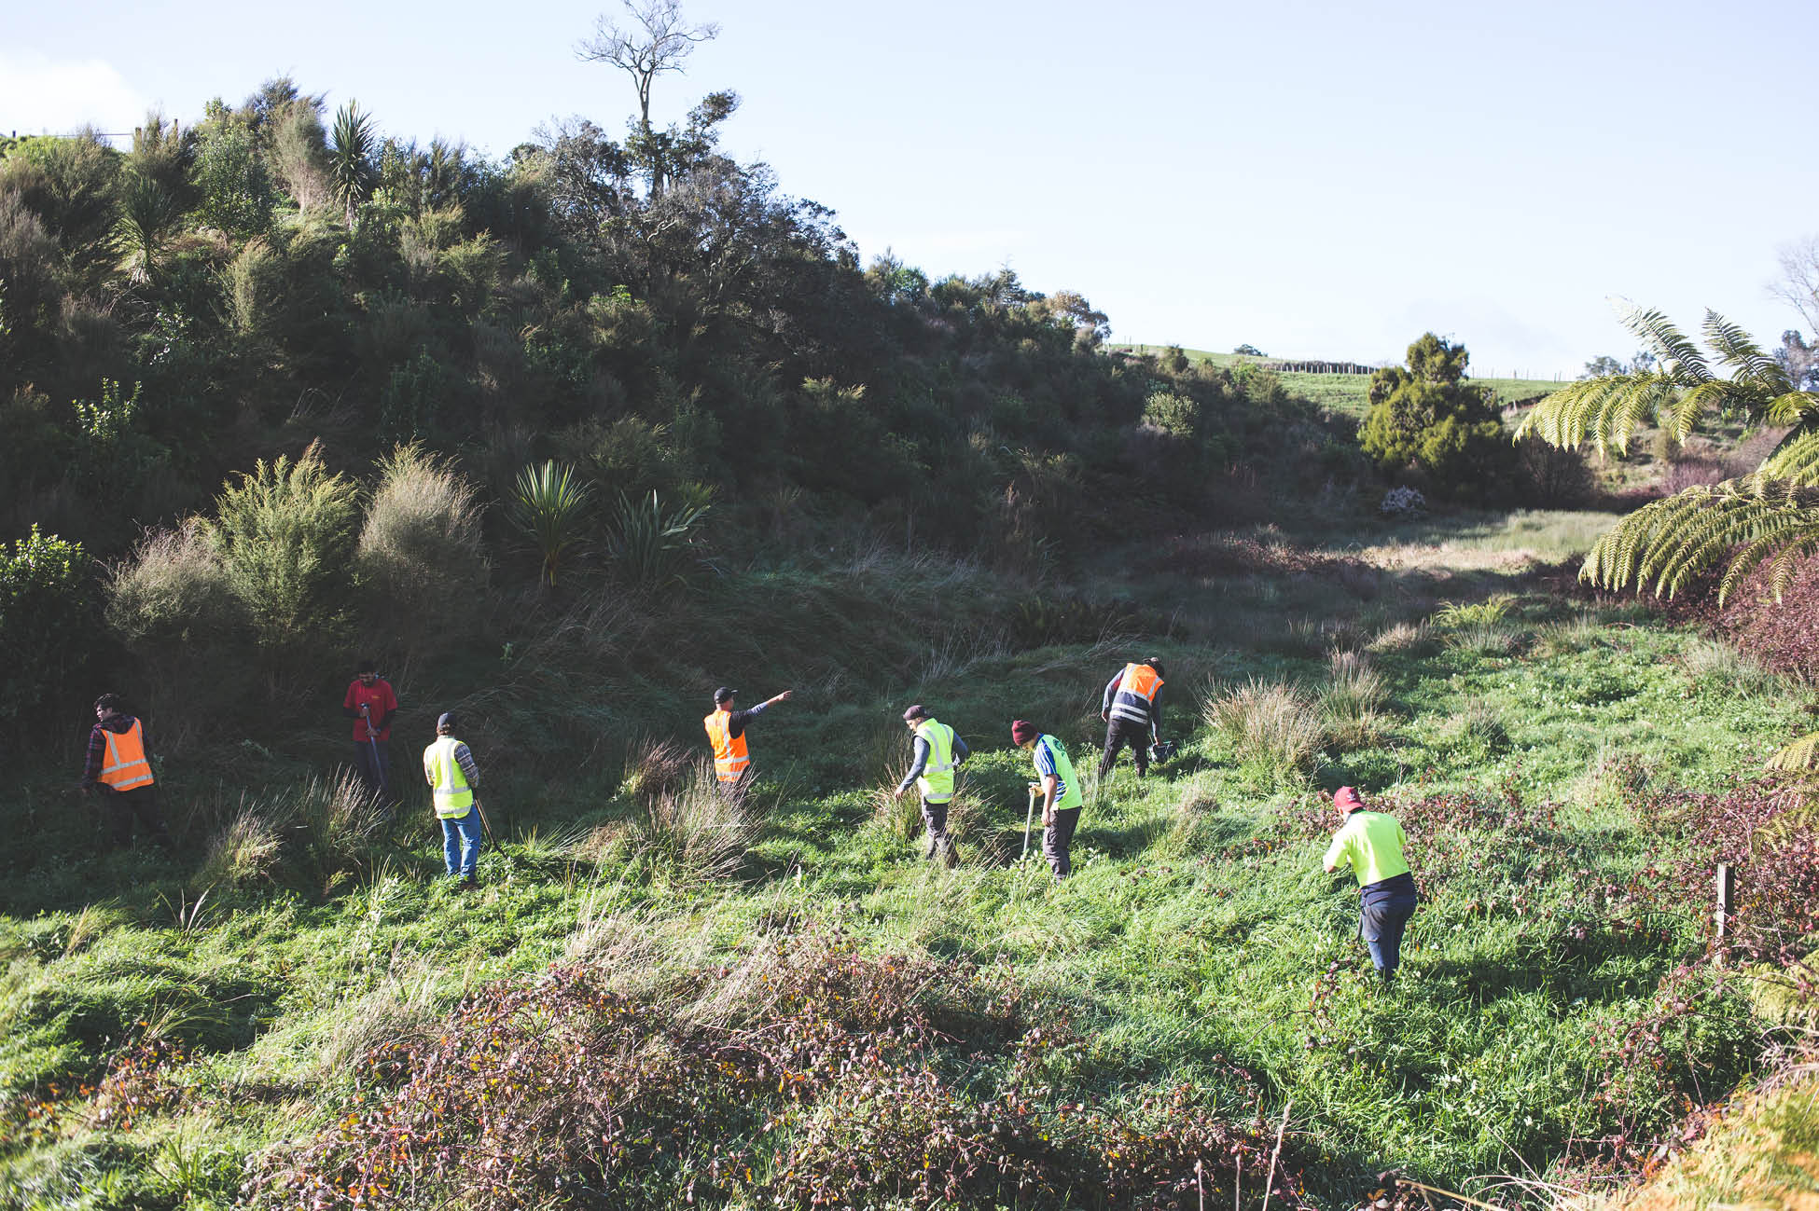

4 Setting and clarifying policy direction
Proposals to require a holistic view of managing land and water resources and enable faster planning.

Issues
For more than a decade, New Zealanders have been talking about how to limit our impact on freshwater, including through the multi-stakeholder Land and Water Forum that functioned from 2009 to 2018. The current National Policy Statement for Freshwater Management (NPS-FM) was introduced in 2011 and updated in 2014 and 2017, and councils are at various stages in developing water management plans. However, insufficient progress is being made.
Over half of regional councils are not confident of completing plan changes to give effect to the current NPS-FM by 2025. Most have either extended their timeframe to 2030 or indicated they might need to do so. This is far too long. Also, we need to consider the cumulative effect of individual consents under the RMA and the costs of pollution to society and the environment.
Proposed amendments to the NPS-FM set out in this section are intended to provide the clarity that is currently lacking. Changes are also proposed to the RMA to enable faster plan-making processes. By 2025 regional councils would be required to have made final decisions on plans and actions that will improve freshwater ecosystem health. There will be additional support for councils to implement change.
The current NPS-FM directs regional councils to consider and recognise Te Mana o te Wai in the management of freshwater, but local authorities remain uncertain as to what is expected, and how Te Mana o te Wai relates to or adds to other current direction in the NPS-FM.
Incorporating Māori values more strongly into freshwater management would create benefits for the entire community, including those who value freshwater for their own philosophical, spiritual or cultural reasons.

Te Mana o te Wai
Te Mana o te Wai or ‘the mana of the water’, refers to the integrated and holistic health and wellbeing of waters as a continuum from the mountains to the sea. It is the fundamental value and concept that protects New Zealanders’ special connection with freshwater, while simultaneously sustaining its ability to provide for the future wellbeing of people and our unique ecosystems.
Te Mana o te Wai was first introduced into the NPS-FM in 2014 and its role further strengthened in the 2017 NPS-FM amendments. This work resulted from discussions between the Iwi Leaders Group (ILG) and MfE and involved significant wider consultation. Kāhui Wai Māori (KWM) and MfE have worked together to further clarify the concept and intended outcomes. This understanding and policy development were informed by the current requirements and descriptor of Te Mana o te Wai in the NPS-FM.
In the context of freshwater management, Te Mana o te Wai is conveyed here as a national framework to understand water, that can be applied to inform how decision-making connected to the care and use of water should occur. The framework is broader than the context of the NPS-FM and is relevant across different regulatory and non-regulatory tools and activities, as well as individual actions in relation to the care of freshwater. The framework of Te Mana o te Wai is also not an end-point, but a means by which we make immediate and future decisions that protect and sustain the health and wellbeing of our freshwater now and for future generations.
Te Mana o te Wai establishes a three-tiered hierarchy of obligations, requiring that certain uses for water must be prioritised over others. The health of the water is the first priority. The second priority is providing for essential human health needs, such as drinking water, and the third priority is other consumption and use.
In the context of the NPS-FM, Te Mana o te Wai requires a series of approaches and decisions, including but not limited to:
- applying the hierarchy of obligations
- managing freshwater in an integrated and holistic way
- engaging and discussing with tangata whenua and communities, and incorporating their values into decisions relating to freshwater
- recognising broader values and systems of knowledge to the management of freshwater.
Embedding Te Mana o te Wai across freshwater management systems is a long-term trajectory. The following proposed amendments to the NPS-FM are further steps in that direction.
The objective is to provide meaningful direction to regional councils on how Te Mana o te Wai can inform freshwater management practice that prioritises the mana and mauri (life-force), and overall health and wellbeing, of freshwater bodies.
We recommend reframing Te Mana o te Wai in the NPS-FM by clarifying current provisions, further embedding the concept, and requiring an approach that prioritises the essential value, health, and wellbeing of freshwater bodies. Our proposals are:
- Clarify the descriptor of Te Mana o te Wai so that it more clearly underpins the whole framework of the regulation. Since expanding the description of the concept in 2017, MfE has been working further to understand better how the concept fits within the overall NPS-FM.
- Require regional councils to give effect to Te Mana o te Wai when implementing the NPS-FM.
- Clarify how new and existing components of the NPS-FM relate to Te Mana o te Wai.
- In particular, every regional council must develop, and articulate in its regional policy statement, a long-term vision that gives effect to Te Mana o te Wai. The long-term vision must:
- be developed through discussion with tangata whenua and communities about their long-term wishes for waterbodies in the region
- be informed by an understanding of the history of, and current pressures on, waterbodies in the region
- express what tangata whenua and communities want their waterbodies to be like in the future.
How these requirements will be reflected and given effect to in the management of freshwater will vary regionally. We have developed these policies with the intention of retaining the flexibility of Te Mana o te Wai to be applied locally, while reducing some of the ambiguity that currently exists.
See Parts 1, 2 and 3 of the draft NPS-FM.

Advisory groups’ comments
The Te Mana o te Wai policy framework has been developed through working with Kāhui Wai Māori. There is support in principle from all advisory groups for using Te Mana o te Wai as a framework for freshwater management.
Kāhui Wai Māori acknowledges the Government’s commitment to embedding Te Mana o Te Wai in the proposals in this package, but does not consider that the draft NPS-FM released with this discussion document, as currently drafted, yet achieves that aim.
Kāhui Wai Māori perspective
Kāhui Wai Māori have developed the following diagram to describe their framing of Te Mana o te Wai. They have recommended that the principles and obligations set out in the diagram guide all activities relating to the care of freshwater.
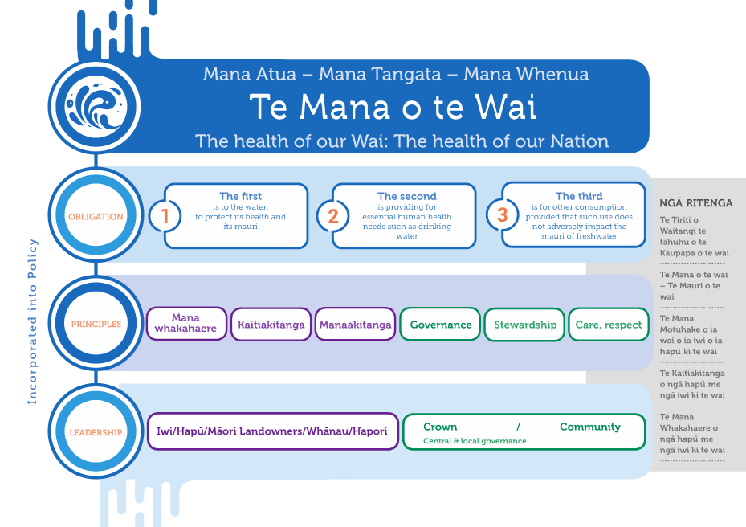

Strengthening Māori values
We have heard that Māori values for freshwater health are not being identified, reflected, incorporated or monitored adequately across the country. We want to improve the ability of iwi and hapū to express their values in freshwater management and planning, and to strengthen and clarify requirements on regional councils to incorporate this information into regional freshwater planning processes.
For tangata whenua, freshwater health focuses on the health of the connections between the environment, water and people, providing an opportunity for freshwater management to better address social values and issues connected to freshwater that are relevant to all New Zealanders. The development and application by tangata whenua of tools, frameworks and methods of identifying, giving effect to, and measuring freshwater health are a central aspect of implementing the NPS-FM.
The current NPS-FM provides national direction on relationships of tangata whenua with freshwater. It recognises the importance of involving tangata whenua in freshwater management, and identifying and reflecting tangata whenua values in freshwater planning. However, the NPS-FM does not compel regional councils to provide for tangata whenua values of freshwater health.
We have identified two ways of responding to the issues outlined. These two proposals are not mutually exclusive and could work together.
We acknowledge that KWM prefers the first proposal and the Government is also supportive of this proposal. We are seeking feedback on both proposals, including what changes may occur as a result, the potential benefits, and impacts.

Proposal 1. Elevate the status of mahinga kai to a compulsory value
Existing compulsory values prioritise biophysical attributes of freshwater health. Mahinga kai is a multi-faceted integrated indicator that addresses more than biophysical measures. This is reflected in the current NPS-FM which describes the mahinga kai values as: ‘kai are safe to harvest and eat’ and ‘kei te ora te mauri – the mauri of the place is intact’. These mahinga kai values are listed as ‘other national values’, rather than ‘compulsory national values’.
We propose to consolidate and elevate both mahinga kai values to become a single compulsory value. This would require regional councils to enable and support tangata whenua locally to develop attributes that represent the specific mahinga kai values in their local catchments. It is not recommended that mahinga kai values are represented by predetermined attributes and bands at a national level, as these values are invariably catchment specific and must align to the relevant species and methods in individual catchments.
Mahinga kai is a widely applicable freshwater value across the country. With mahinga kai already included in the current NPS-FM as an ‘other national value’, the multi-faceted aspects of mahinga kai are already familiar to regional councils. A number of hapū/iwi have already identified mahinga kai values and attributes in iwi management plans, regional planning documents, and kaupapa Māori assessment frameworks.
As a compulsory value, regional councils would be required to provide for the mahinga kai compulsory value in identified sites or waterbodies, in all freshwater management units, including enabling and supporting tangata whenua to identify attributes, targeting attribute states, and managing requirements for this value.

Proposal 2. Strengthen priority given to tangata whenua freshwater values
The second proposal would strengthen the priority given to tangata whenua values in freshwater planning.
The current NPS-FM requires regional councils to take reasonable steps to identify and then reflect tangata whenua values in management and decision-making.
The proposal is to create a new ‘tangata whenua freshwater values’ category in the NPS-FM, giving them the same priority as ecosystem health and human health for recreation.
This would provide stronger direction to regional councils that, where ‘tangata whenua freshwater values’ have been identified by iwi and hapū for the purposes of freshwater management within a freshwater management unit, then these values need to be incorporated into regional freshwater planning processes.
The policy intent is to maintain flexibility to take a local approach to freshwater management, and provide clearer and stronger direction to regional councils about how to work with hapū and iwi.

Summary of how proposal 2 would work in practice
- Tangata whenua freshwater values would be determined locally by iwi and hapū, and supported by regional councils.
- For all these values, the council would then be required to set attributes, target states, and management requirements. Regional councils would be required to support iwi and hapū to identify and develop this information.
- Regional councils would have to incorporate the outcome into regional freshwater planning processes subject to the RMA.

Draft NPS-FM
The draft NPS-FM provided alongside this document does not currently reflect either of these proposals. Drafting will be completed after consultation and once decisions are made on the preferred approach.
Kāhui Wai Māori comments
In relation to Proposal 1, the multi-faceted aspects of mahinga kai are universal for tangata whenua throughout Aotearoa and central to maintenance of tikanga and mātauranga. Proposal 1 compels regional councils to provide for mahinga kai values in a manner that provides greater certainty under a familiar process.
Proposal 2 complements the consolidation and elevation of mahinga kai to a compulsory value by providing for a broader range of tangata whenua values. As a new proposed value category in the NOF (it appears to sit somewhere between the 'compulsory values' and the ‘other values’) it is still unclear how this option will work in practice. Clarity is needed around the status of the values and attributes identified by Māori under this option; the express direction that will be given to regional councils to work with and support hapū/iwi to develop tangata whenua values and attributes; how hapū/iwi will be supported to participate; and how councils will be required to incorporate those values and attributes into planning documents.
Kāhui Wai Māori supports Proposal 1. This is because ensuring sufficient compulsion, both in respect of councils supporting hapū/iwi to identify and articulate tangata whenua values and attributes, and ensuring councils must incorporate these into freshwater planning documents, is fundamental to embedding Te Mana o te Wai. We think that clearly identifying mahinga kai as a compulsory value does this. We support Proposal 2 as a supplement to, but not a substitute for, Proposal 1. A critical aspect to the success of both of these options is supporting and resourcing iwi/hapū to ensure tangata whenua values are meaningfully incorporated.

New planning process for freshwater through amending the RMA
To enable better, faster, more nationally-consistent water management, we propose a new freshwater planning process that will require councils to have new plans in place, consistent with Te Mana o te Wai, no later than 2025 that fully give effect to the new NPS-FM.
This would be achieved through a Resource Management Amendment Bill due for introduction to Parliament in coming months.
Government-appointed freshwater commissioners with specialist skills would form a panel with local councillors, and tangata whenua-nominated representatives to consider council plans, hear submissions and make recommendations. There would be restricted avenues for appeal, balanced by this robust, independent hearing process.
Under this proposal, councils would still be responsible for developing their plans in consultation with local communities, and would make the final decisions following recommendations from the freshwater hearing panel.
Standard RMA planning steps, up to and including public notification, would apply. This includes, but is not limited to, requirements to consult with iwi, prepare evaluation reports, publicly notify planning documents, and call for submissions and further submissions.
There would be restricted avenues for appeal, balanced by this robust, independent hearing process. Existing Treaty settlements and water management agreements linked to those will continue to be honoured.
Full details of this proposal will be available when the Bill is introduced to Parliament.

Facilitating the shift to a new process
MfE would work with regional councils to facilitate the transfer of existing plans and ‘work in progress’ to the new process; including identifying where plans need updating to include new requirements from the new NPS-FM.
Advisory groups’ comments
The FLG, KWM and RSWS support the intent of this proposal, subject to further consideration of the detail. Detailed comments have been provided to MfE.
RSWS supports progressing planning with urgency, but notes there will be a tension between iwi/hapū and community engagement processes, and speed of implementation. There will be capacity and capability issues for participants across the country. In addition, giving effect to Treaty settlements relating to freshwater can take time and proceeding with regional plans too quickly could compromise these processes.

Next steps for proposed new freshwater planning process
This proposal requires amendments to the RMA so there is a different process for seeking feedback. This proposal would be implemented through the Resource Management Amendment Bill. It will then be referred to a select committee which will seek feedback at the appropriate time.

Directing more integrated management of freshwater
Regional councils have clear responsibilities for freshwater management under the NPS-FM. However, regional councils, unitary authorities, and territorial authorities (city and district councils) have overlapping roles in supporting integrated management of land and water.
City and district councils are uniquely placed to better integrate management, particularly in urban areas, due to their role in managing infrastructure and land use. We propose new policies for the NPS-FM to direct territorial authorities to manage the effects of urban development on water so they are supporting integrated management across freshwater management units.
See Part 3.4 of the draft NPS-FM.

Exceptions for major hydro schemes to support renewable energy targets
Maintaining adequate flow levels and variability in rivers is essential to ecosystem health. However, in some cases hydro-electric generation has changed water channels and flows to an extent that this can affect the health of downstream ecosystems.
Hydro-electric generation currently provides the majority of our electricity and has a critical role in the wider electricity system due to its size, flexibility and the potential of some schemes to store large amounts of energy.
Climate change action and freshwater health are both priorities for the Government and a careful balance needs to be achieved.
There are ambitious targets for the reduction of greenhouse gas emissions and renewable electricity generation (with electricity demand expected to grow significantly).
The current NPS-FM includes an exceptions mechanism, allowing regional councils to maintain water quality below a national bottom line if it is necessary to secure the benefits of hydro-electricity infrastructure as listed in Appendix 3 of the NPS-FM. However, this appendix has never been populated, and hydro-generators remain concerned over the regulatory risk and uncertainty this creates for them when renewing resource consents (beginning in 2025).
The continued operation of New Zealand’s hydro-electric baseload will be crucial in meeting emissions and renewable electricity goals. This includes its ability to operate in conjunction with increased production from wind. Storage flexibility is therefore expected to become more important, not less.
We propose to list the six largest hydro-electricity schemes as exceptions in the new NPS-FM
– that is the Waikato, Waikaremoana, Tongariro, Waitaki, Manapouri and Clutha schemes. This would cover about 90 per cent of New Zealand’s hydro-electricity capacity and regional councils would have clear direction on how to approach other existing schemes.
Regional councils would be required, when making plans or setting limits, to have regard to the importance of not adversely affecting the generation or storage capacity of a scheme or its operational flexibility.
While other schemes are significant in their own right, we believe there is a need for pragmatism – a general exception would allow too many rivers and lakes to potentially be exempt from national bottom lines.
Waterbodies containing infrastructure outside of the six largest schemes will have to meet national bottom lines under the NPS-FM. So would any future infrastructure within the six largest schemes that materially changed the nature of a scheme, or part of it.
The six largest schemes are built on waterbodies that are, or are likely to be, seen as taonga to local iwi, and are subject to various obligations in existing Treaty of Waitangi settlements. An assessment of this proposal, and others, against existing settlements will be critical and completed before final decisions. The proposal would not impact on the settlement legislation that creates specific regimes for the Waikato and Whanganui Rivers as the settlement legislation means those regimes prevail if the NPS-FM is inconsistent.
Regional councils will still be required to maintain or improve water quality within all waterbodies including, to the extent possible, those subject to this proposal.
All hydro-electricity schemes would remain subject to the RMA and resource consent requirements. Their consents typically include flow regimes and complex conditions designed to manage their environmental impacts, and the proposed exceptions will not lead to declines in water quality.
See Part 3, Subpart 4 of the draft NPS-FM.

Advisory groups’ comments
KWM and FLG are opposed to exemptions. The opposition is based on concern that exempting major hydro schemes as described here will work against the principles the Essential Freshwater programme is seeking and limit the effectiveness of measures to improve ecosystem health on rivers with hydro schemes, or may see increased pressure on councils to not seek appropriate mitigation of environmental effects.
RSWS acknowledges the need to maintain energy generation capacity, and seeks clearer direction on this. RSWS is opposed to blanket exemptions for these six schemes, and supports enabling exemptions and offset mitigation requirements at regional council discretion, as an option that can be applied only after full assessment of effects, causes, and management options, including offset mitigations.

Questions

Te Mana o te Wai
- Do you support the Te Mana o te Wai hierarchy of obligations, that the first priority is the health of the water, the second priority is providing for essential human health needs, such as drinking water, and third is other consumption and use?
- Do you think the proposals will have the desired effect of putting the health of the water first?
- Is it clear what regional councils have to do to manage freshwater in a way consistent with Te Mana o te Wai?
- Will creating a long-term vision change how councils and communities manage freshwater and contribute to upholding Te Mana o te Wai?

New Māori value
- Do you think either or both of these proposals will be effective in improving the incorporation of Māori values in regional freshwater planning?
- Do you foresee any implementation issues associated with either approach?
- What are the benefits and impacts of either of these approaches?
- What implementation support will need to be provided?

New planning process for freshwater
- Do you support the proposal for a faster freshwater planning process? Note that there will be opportunity to comment on this proposal in detail through the select committee process on the Resource Management Amendment Bill later this year.

More integrated management of freshwater
- Does the proposal make the roles and responsibilities between regional councils and territorial authorities sufficiently clear?

Exceptions for major hydro schemes
- Does the proposal to allow exceptions for the six largest hydro-electricity schemes effectively balance New Zealand’s freshwater health needs and climate change obligations, as well as ensuring a secure supply of affordable electricity?
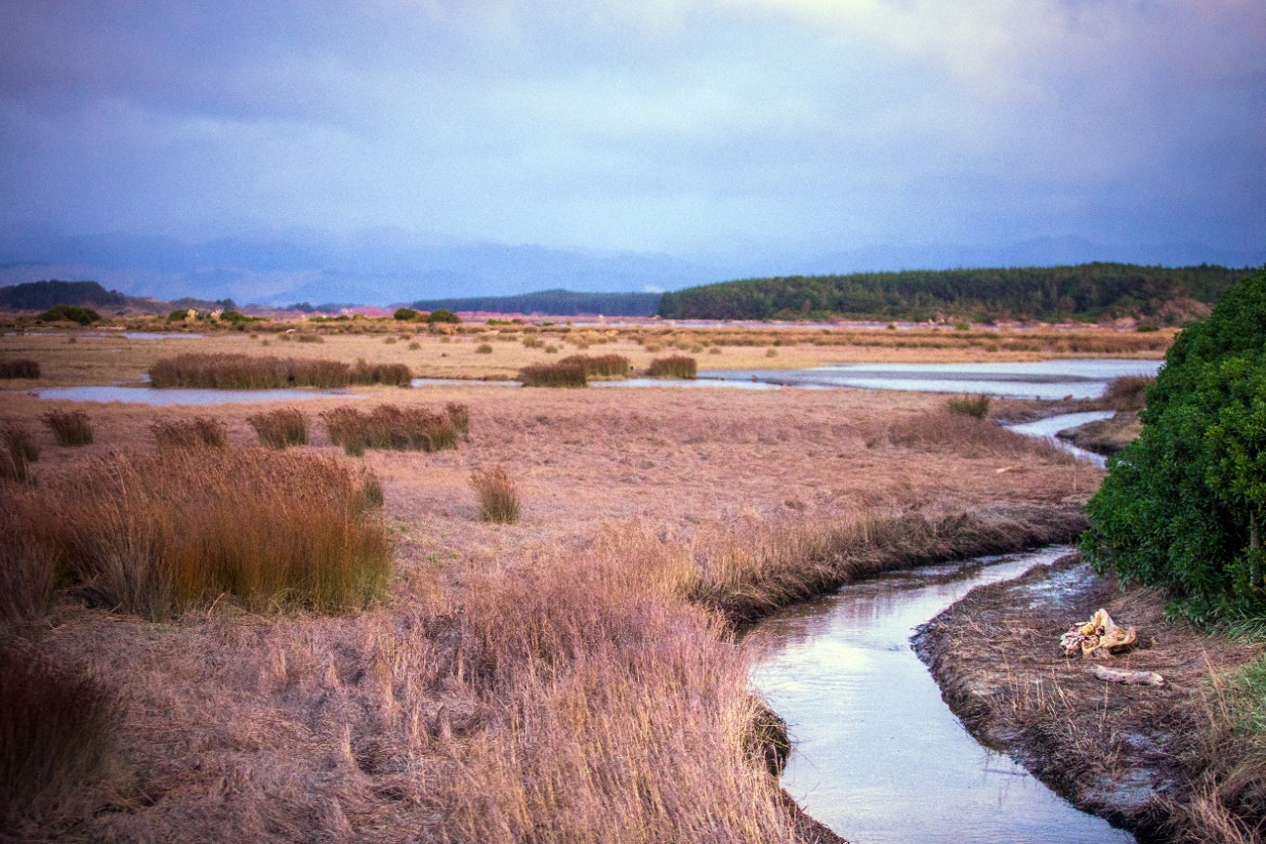

Raising the bar on ecosystem health
Proposals to strengthen the focus on ecosystem health, set more stringent bottom lines, and stop further loss of wetlands and streams.

Issues
Under the purpose of the RMA, regional councils are responsible for safeguarding the life-supporting capacity of water. Yet many waterways have become degraded over the past 25 years, to the detriment of ecosystem health. Further, the focus of the current NPS-FM means councils have not put adequate measures in place to protect all aspects of aquatic ecosystem health.
The Government recognises that safeguarding the life-supporting capacity of water is critical for the habitat of indigenous freshwater species as well as trout and salmon. Together, a number of proposals in this section clarify and strengthen direction to improve the habitat of both indigenous freshwater species and trout and salmon.
The current National Policy Statement for Freshwater Management (NPS-FM) includes bottom lines for nine indicators, known as attributes, which mostly relate to measures of physical and chemical water quality. In the most recent amendment (2017) a specific monitoring indicator for aquatic life was added (the macroinvertebrate community index).
The Science and Technical Advisory Group (STAG) has considered the available science and provided advice on updated, new attributes and bottom lines. These are set out in this section.

Focus on holistic ecosystem health
– te hauora o te wai
The intent is to broaden the focus of those making decisions that impact on our waterways; so they are considering and managing for all five components that contribute to the health of a freshwater ecosystem.
These are:
- Aquatic life – the abundance and diversity of biota including microbes, invertebrates, plants, fish and birds.
- Habitat – the physical form, structure and extent of the waterbody, its bed, banks and margins, riparian vegetation, and connections to the floodplain.
- Water quality – the physical and chemical measures of the water, such as temperature, dissolved oxygen, pH, suspended sediment, nutrients and toxicants.
- Water quantity – the extent and variability in the level or flow of water.
- Ecological processes – the interactions among biota and their physical and chemical environment such as primary production, decomposition, nutrient cycling, and trophic connectivity.
The draft NPS-FM clarifies the policy intent that freshwater is managed through a National Objectives Framework to ensure the health and wellbeing of waterbodies and freshwater ecosystems is maintained or improved.
In practice, this means regional councils are required to set objectives for each attribute at current state or better (to maintain or improve) and the objective must be above national bottom lines. If the current attribute state is below these bottom lines, it must be improved.
This may require land-use change in some catchments, where more intensive land uses must change to a lower intensity land use, and this brings associated challenges of which land uses must reduce, by how much, and over what time period.

Reporting on ecosystem health
Councils will be required to report against all five components of ecosystem health (aquatic life, habitat, water quality, water quantity, and ecological processes) using at least the new national indicators/attributes.
We are working on a template for a standard summary ‘report card’ that regional councils will be able to use.
See Part 2: Objectives and Part 3, Subpart 2: National objectives framework of the draft NPS-FM.

Advisory groups’ comments
In principle, KWM, FLG, STAG and RSWS endorse this holistic approach to ecosystem health, recognising that this is central to Te Mana o Te Wai.
RSWS supports the need to maintain or improve water quality and ecosystem health, but seeks further assessment of the implications. In catchments where water quality improvements are required, implementation and changing current practice will take time.
In some catchments with a large groundwater system, water quality may continue to decline for some time before changes made today take effect and water quality in spring fed streams improves.
In these circumstances, reporting on the actions in place, timeframes, and the trajectory toward improvement would be appropriate. A firm definition allows no headroom so, for example, farming/horticulture may not be able to establish on undeveloped land.

Ecosystem health – new attributes and new management approach
All attributes for ecosystem health are compulsory and have bottom lines set out in the draft NPS-FM.
The current system is based on setting objectives, or targets for contaminant levels, above bottom lines, and proactively managing land and water use to meet those objectives. We are proposing that councils are required to measure and manage a broader range of ecosystem health attributes, and some of these will require a different, adaptive management approach.
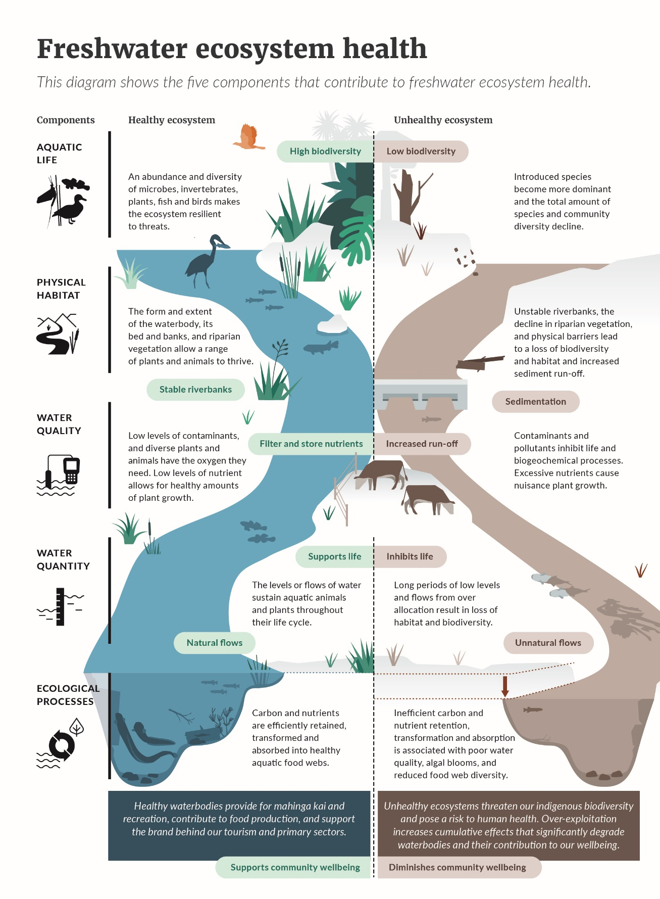

Proactive management
For existing attributes, and the proposed new suspended sediment and nutrient (nitrogen and phosphorus) attributes, regional councils are required to set a target that will ensure water quality is maintained or improved, and proactively manage land and water use towards that target.

Monitoring and responding
We also propose that councils be required to measure and monitor a broader range of ecosystem health attributes. In the event the attribute declines, or is below a national bottom line, regional councils would implement an action plan to achieve improvement.
This approach reflects that there may be a wide range of reasons for a deterioration, a variety of actions that might be taken, and the specific actions might depend on the catchment and situation. The best approach may be to undertake monitoring to learn about the catchment, detect possible issues, and then develop an action plan with management actions to respond. The results are evaluated, and actions adjusted on the basis of what has been learned. This allows for decision-making in the face of uncertainty.
An example is the proposed Deposited Fine Sediment attribute which is measured as the proportion of the stream bed smothered by sand, silt and clay. This relates to the Physical Habitat component of the Ecosystem Health Value. This sediment can come from a number of sources as a result of a wide range of processes, depending on the context of the location. The best approach is therefore to:
- investigate the problem (eg, determine that the sediment is mostly clay)
- understand processes leading to the problem in each case (eg, determine if a likely source could be recent earthworks that exposed clay to rainfall)
- develop responses (eg, require better erosion control such as settling ponds and diversion bunds)
- evaluate whether the responses are working.
The table on the following page sets out the six attributes that this adaptive management approach will apply to.
The NPS-FM would set the point at which action is required, using STAG recommendations.
These points are in the tables set out in the STAG report for dissolved oxygen, ecosystem metabolism, fish biotic integrity, macroinvertebrates, macrophytes (lake submerged plant index), and deposited fine sediment.
Indicator and waterbody | What it tells us
Fish (rivers – wadeable) | Fish health, including abundance and diversity of species
Macroinvertebrates (rivers – wadeable) | Health of macroinvertebrates  Macroinvertebrates are small animals without backbones that live on or just below the streambed and are an important part of the food chain
Dissolved oxygen (DO) in lakes and rivers | Inadequate dissolved oxygen can impair the growth and reproduction of aquatic organisms, and if low enough will kill them
Ecosystem metabolism (rivers) | Carbon and nutrients are efficiently retained, transformed and absorbed into healthy aquatic food webs
Deposited sediment (rivers) | Too much sediment can smother riverbeds
Macrophytes (lakes) | The amount of native or invasive plants growing

Advisory group comments
The STAG endorses the adaptive management approach proposed for these attributes.

Aquatic life – improving protection for threatened indigenous species
The current NPS-FM does not adequately protect the habitats of threatened indigenous species.
Three-quarters of New Zealand’s native freshwater fish species are threatened or declining. Some widespread migratory species, such as kōaro and īnanga (whitebait species), appear to be declining in both abundance and distribution. Fish habitat, including areas where populations are surviving in poor habitat such as farm drains and urban streams, is not always identified and managed.
In some circumstances, threatened species’ habitats may need more active management, because of their specific habitat needs and current distribution. For example, kōaro prefer rocky, tumbling streams, particularly in native bush, but may live in modified streams if there is the right habitat.
We propose a new compulsory national value for threatened species, as defined in the NPS-FM, to ensure regional planning identifies and manages threatened species.
See Appendix 1A of the draft NPS-FM.
This proposal aligns with the Government’s approach to protecting indigenous biodiversity. See section 11 for more detail.
Advisory groups’ comments
The advisory groups support a compulsory value for threatened indigenous species.
This provision focuses specifically on threatened indigenous species, but the advisory groups note that all the ecosystem health provisions together will help improve the environment for all freshwater species, including trout and salmon.

Aquatic life – providing for fish passage
Around one-third of New Zealand’s native freshwater fish species need access to the sea. Native fish species (such as tuna/eels and īnanga/whitebait) and sports fish (such as trout and salmon) require access between and within freshwater habitats to complete their life cycles. But many structures such as culverts, dams and tide gates can delay or prevent fish movement and stop them from getting to critical or otherwise suitable habitats.
There are voluntary guidelines for planning and designing new structures, and providing fish passage through existing structures, and an online assessment tool developed by the NZ Fish Passage Advisory Group, available on the Department of Conservation website.
We propose to require regional councils to provide for fish passage in line with these guidelines, both in plan-making and consenting, and in imposing design requirements on some types of new in-stream structures less than four metres high, including:
- ensuring that new structures such as weirs, culverts and tide flap gates be required to meet minimum design standards to enable fish passage
- identifying existing structures and prioritising changes to enable fish passage.
See Part 3 of the draft NPS-FM.
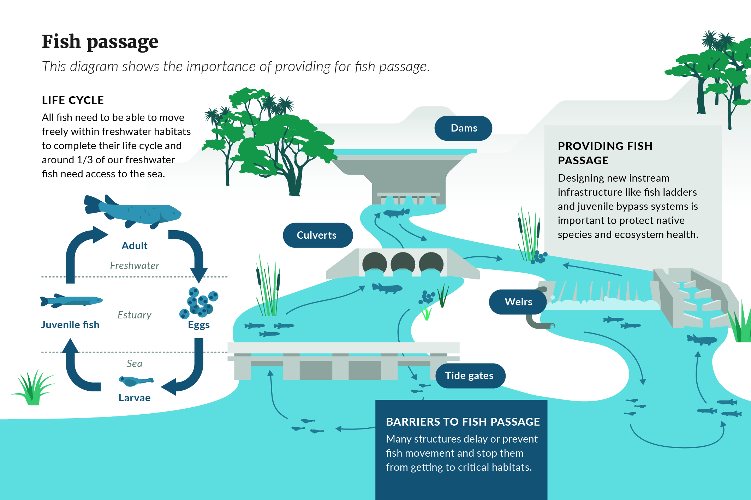

Habitat – no further loss of wetlands
The RMA defines ‘wetland’ as including permanently or intermittently wet areas, shallow water, and land water margins that support a natural ecosystem of plants and animals that are adapted to wet conditions. This does not include wet pasture or paddocks where water temporarily ponds after rain, or that contain patches of exotic sedge or rush species, or constructed wetlands.
Coastal wetlands are natural wetlands found around the margins of estuaries and intertidal areas, and include saltmarsh and mangrove areas.
Wetlands are one of our most valuable ecosystems.
Wetlands are an essential habitat for highly diverse flora and fauna, and support a high proportion of threatened species – 67 per cent of freshwater and estuarine fish species and 13 per cent of nationally threatened plant species, as well as critically endangered birds. They have strong cultural importance to Māori, and are a source food and water. They also act as the kidneys of the land and giant sponges by filtering contaminants, contribute to erosion control, carbon sequestration, and buffer against floods and storm surges.
These natural ecosystem services are estimated to be worth over $5 billion per year for inland wetlands and over $16 billion per year for coastal wetlands. However, less than 10 per cent of our original inland wetlands remain. Many coastal wetlands have been historically infilled for development and are under continual pressure from changing land use.
We propose to protect remaining natural wetlands and put tighter controls on certain activities that damage inland and coastal wetlands.
Through the NPS-FM, regional councils would be required to identify all existing natural inland wetlands, monitor their health, set policies to protect them, and think about how to make restoration easier.
Through the new Freshwater NES there would also be restrictions on activities considered the most destructive to inland and coastal wetlands: drainage, damming, diversion, water takes, reclamation, or disturbance of the bed, or clearance of indigenous vegetation. This would take effect from the date the NES-FM comes into force, expected to be June 2020.
See Part 3 of the draft NPS-FM and Part 2 of the proposed Freshwater NES.
These proposals build on the national policy direction for coastal wetlands set out in the New Zealand Coastal Policy Statement. They complement and reinforce proposals for wetland restoration in the proposed NPS for Indigenous Biodiversity (see section 11).
Advisory groups’ comments
KWM, FLG, STAG and RSWS support preventing further loss of wetlands. The groups consider that re-creation and restoration of wetlands is important and encourage further consideration of incentives for this work.

Habitat – no further loss of streams
In cities and towns, rivers and streams are often one of the last refuges for native vegetation, plants, birds and other biodiversity. They are the water most of us live next to and have the greatest connection to. But urban streams have been piped, straightened and channelled to a large extent.
It is more effective to avoid loss of habitats than to attempt to restore them at a later date.
We propose an approach based on a ‘mitigation hierarchy’; firstly preventing activities that cause the most damage to stream habitat; then secondly, at times where adverse effects cannot practically be avoided, replacing the stream habitat that is lost. Offsetting, which means that adverse effects in one location can be made up for by improvements in another location, is only appropriate to consider after all potential possibilities to avoid, remedy, or mitigate adverse effects of an activity have been ruled out.
The intention is to protect vulnerable habitats and species and so there is not a cumulative loss of habitat over time.
The NPS-FM will direct councils to avoid infilling of streams and rivers unless specific exceptions apply. Consent applicants will be required to demonstrate that they have exhausted all practical options to avoid, remedy or mitigate any proposed stream loss through infilling, and they will be required to offset or compensate for any stream loss. Councils will also be required to ensure culverting and permanent diversion of streams and rivers do not result in a net loss of extent or ecosystem health.
When stream loss through piping or reclamation cannot be avoided, remedied or mitigated, we propose to provide direction on how residual adverse effects can be offset or compensated for. It is also proposed that councils should report on losses and gains in stream and river habitat.
See Part 3 of the draft NPS-FM.

Interaction with NES for Plantation Forestry
The NES for Plantation Forestry contains its own rules for management of wetlands and streams. See section 11 for more details.
Advisory groups’ comments
Advisory groups support greater protection for streams and emphasise that every effort should be made to avoid stream loss, and to remedy or mitigate when it is unavoidable.

Water quality – new bottom line for nutrient pollution
High nutrient levels (nitrogen and phosphorus) damage ecosystem health. They contribute to algal growth, put pressure on the health of macroinvertebrates and fish and can be toxic at higher concentrations. It is more cost-effective to prevent degradation of waterways, by limiting nutrient pollution, than to attempt restoration after degradation has occurred.
Reducing nitrogen run-off from the land has benefits not only for aquatic ecosystem health, but also for reducing emissions of nitrous oxide, a greenhouse gas produced by bacteria in the soil. Actions that will reduce both nitrous oxide emissions and nitrate leaching to waterways include better management of fertiliser, stock and effluent, afforestation, protection of soil and capture of animal effluent during periods of high risk of run-off, and stock exclusion from streams and wetlands.
Under the current NPS-FM, nutrient limits have been set in some catchments, based on the current periphyton and nitrate toxicity attributes. It is not proposed to change these attributes.
Limiting the growth of periphyton (slime) in practice requires restrictions on nutrients in many waterways. However, this does not apply to all waterways because periphyton does not grow everywhere; it is unlikely to be present in soft bottomed rivers (eg, the Piako River across the Hauraki Plains). About 27 per cent of the length of streams and rivers in New Zealand are soft-bottomed. Currently in these soft-bottomed rivers some councils set objectives for managing nitrogen using the nitrate toxicity attribute – that is, the level that is toxic to some aquatic species.
Currently fewer than half of 16 regional councils have set nutrient limits in some catchments using the current attributes, and are working to implement rules that will gradually reduce nutrient run-off to meet those limits.
STAG considers that the current attributes and bottom lines are insufficient to provide for ecosystem health. It has proposed a new bottom line for nitrogen in rivers at an annual median of 1.0 milligrams per litre of dissolved inorganic nitrogen (DIN) which is a different measure to the toxicity attribute. STAG proposes a bottom line for phosphorus in rivers at an annual median of 0.018 milligrams per litre of dissolved reactive phosphorus (DRP).
Where there is more than one relevant attribute for managing the effects of nutrients, the more stringent one would apply. In hard-bottomed rivers (eg, the Manuherikia River in Otago) managing nutrients to prevent excessive periphyton growth would likely require tighter restrictions on nutrient run-off than the proposed new national bottom lines.
We are seeking feedback on whether to include the new nutrient attribute tables proposed by STAG in the NPS-FM. It is important to understand more about the ecological benefits from limiting nutrients, whether this varies by waterbodies, and what impacts the proposed new bottom lines would have on individuals and communities. Final decisions will not be taken until further analysis has been done.
Good farming practice can achieve some but not all of the reduction in nutrient pollution required to achieve ecosystem health.
Reaching the proposed new bottom lines across the country would mean tighter restrictions on nutrient run-off in some lowland agriculturally-dominated areas, beyond the existing limits, especially in parts of Waikato, Canterbury and Southland.
The map below, based on national scale modelling, gives an indication of how much further nitrogen loads would have to be reduced under the proposed new bottom lines, beyond the impact of the current attributes and bottom lines. The red/orange/yellow areas indicate where further reductions of more than 50 per cent may be required. However, these estimates are indicative only and further analysis is required to fully understand the impact.
Indication of impact of proposed new nutrient bottom lines
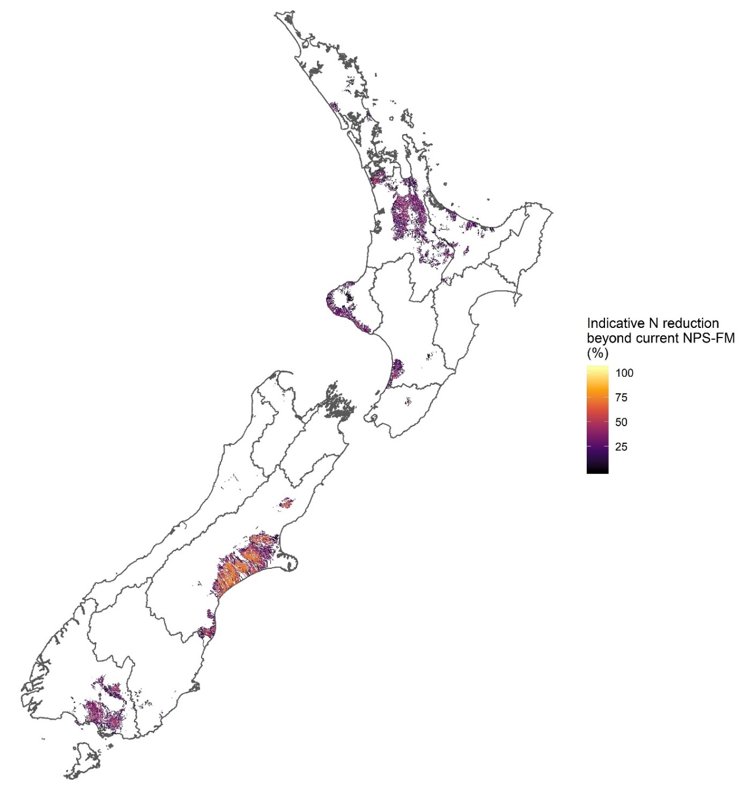

No direct comparison to drinking water standard
In Canterbury there has been public discussion about nitrate levels in drinking water. The bottom line for dissolved inorganic nitrogen proposed for freshwater by STAG cannot be directly compared to the current drinking water standard for nitrate; because the impact of chemicals in water is different for freshwater species than for humans. For example, humans can tolerate levels of zinc (eg, in sunblock) that would be toxic to some aquatic species. STAG has considered what level of dissolved organic nitrogen impacts on ecosystem health. STAG was not asked to consider the drinking water standard.

STAG proposes changes to the periphyton attribute
STAG has recommended amending the periphyton attribute in the NPS-FM to clarify the requirements for councils. The periphyton attribute currently allows for less stringent objectives to be set for rivers in a ‘productive class’.
These rivers are defined in the NPS-FM, based on assigned climate and geology categories. STAG has recommended that the provision for the ‘productive class’ be removed. The implication would be that councils could still set less stringent objectives in rivers that would naturally support high periphyton biomass, but these would not be defined for them by the NPS-FM. Councils would be required to conduct their own investigations to demonstrate that their use of less stringent objectives is appropriate.
We are seeking feedback on this recommendation.
STAG has also recommended requiring councils to use a default table to set periphyton biomass thresholds in cases where there are no robust, locally suitable, independently peer reviewed criteria. MfE proposes to publish these tables as guidance, alongside the analyses used to derive them, so they can be used by councils.
Advisory groups’ comments
The advisory groups agree that there is a need to reduce nutrient pollution from nitrogen and phosphorus but some had not had time to fully consider the bottom line proposed by STAG.
FLG supports dissolved inorganic nitrogen and dissolved reactive phosphorus being defined as attributes for ecosystem health.
RSWS want to ensure a robust evidence base supports any new bottom lines for nutrient pollution.

Water quality – reducing sediment
Excessive sediment is one of the most severe stressors on our freshwater and coastal ecosystems. Soil washes naturally into rivers and streams, but human activities have caused major increases in soil loss, which is harming freshwater plant and animal communities.
An example of the impact of increased sediment run-off is mangrove expansion. More sediment run-off has increased the suitability of many estuarine areas for mangrove growth, through increasing muddiness, reducing current flows and exposure, and increasing the height of tidal flats.
Effective long-term management of mangrove colonisation requires a reduction in sediment and nutrient loads from the catchment.
What we do on land has a huge impact on sediments which enter estuaries and raise the height of tidal flats, increasing the area that mangroves can colonise, as shown in this photo.  Photo: Guidelines for Managing Mangrove (Mānawa) Expansion in New Zealand (NIWA, 2017). |  | 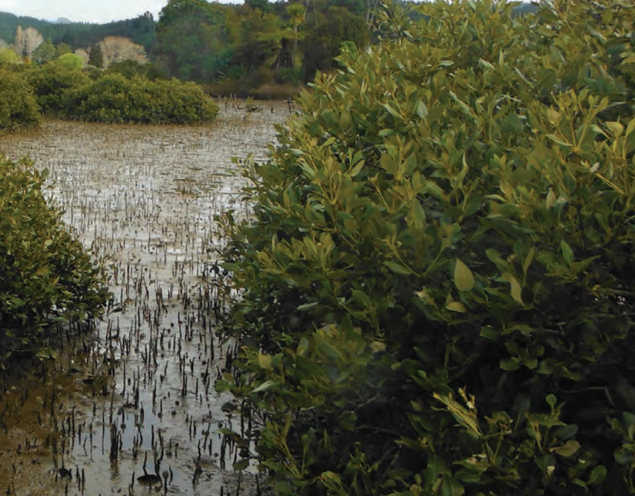

There are two types of sediment in waterbodies that need to be managed: suspended fine sediment – material that makes it hard to see through to the bottom; and deposited fine sediment – the material that settles out on the river bottom.
We propose to set new bottom lines for suspended sediment, so councils must set limits for each catchment or freshwater management unit, and manage land and water use to within those limits.

Deposited sediment
For deposited sediment, we propose to require adaptive management – that is, councils monitor levels, and if they exceed a threshold then they would have to take action.
If, after a period (say five years), the amount of sediment being deposited in an estuary is not significantly reducing, we propose that the council would be required to implement further measures each and every year until the issue is under control.

Suspended sediment
We propose to include an attribute for suspended sediment (as measured by turbidity) that includes bottom lines and bands setting out a range of ‘attribute states’, with a system for classifying rivers, reflecting that the natural levels of sediment in rivers varies widely across New Zealand.
This range is needed because the bottom line in parts of Northland, for example, is different than in Otago because natural conditions are different in the rivers of those regions. Current estimates are that more than 600 catchments have streams or rivers below bottom lines. However, MfE is still examining whether the proposed bottom lines are appropriate in all cases, based on the natural state that could be expected, for example around the Southern Alps.
See the table in Appendix 2A of the current NPS-FM; or the proposed attribute mapped spatially using an online application developed by NIWA, which is available on NIWA’s website.
In practice, councils are likely to target efforts to areas with a high risk of natural erosion, such as hill country, and to activities that generate more sediment, such as earthworks and land clearance.
Achieving bottom lines will take time and effort across the country and across sectors. Existing government programmes will support this. For example, sediment loss will be reduced by the One Billion Trees programme and major increases in the Hill Country Erosion Fund, which funds councils and land owners to control land erosion and some sources of sediment.
Proposals relating to stock exclusion and winter grazing (see section 8) will help to reduce sediment.
Interventions to reduce sediment may improve other aspects of ecosystem health. For example, planting stream banks to prevent erosion provides habitat for native species and shading, which improves water temperature.

Water quality – a higher standard for swimming
E. coli in water is an indicator of faecal contamination and risk of infection or illness from pathogens. High E. coli levels in rivers and lakes indicate that people may get sick after swimming.
Regional councils have already set targets for swimmable rivers and lakes, but there is confusion about what ‘swimmable’ means and whether the current threshold is stringent enough.
There is agreement of the need to review the science the current threshold is based on, through a proposed Quantitative Microbial Risk Assessment, which would enable an update of the 2003 microbiological guidelines.
In the interim, the proposal in this document sets clear standards for swimming in summer, at freshwater places where people popularly swim, or would if water quality was better. The bottom line for these places during the swimming season (1 November to 31 March) would be 540 E. coli per 100 ml, which is similar to the A band in the current NPS-FW.
Currently, councils monitor about 290 swimming spots, known as ‘primary contact sites’. They would now also prepare action plans that set out what will be done to manage, and where necessary reduce, E. coli levels at those sites.
The existing E. coli table will continue to apply to all other waterbodies, along with the existing requirement for councils to work towards reducing E. coli levels everywhere to contribute to achieving the national swimmability targets set in 2017.
The effect of the change would be that councils would increase their efforts to improve water quality where people want to swim. This may include placing stricter requirements on upstream discharges of wastewater, or on stock access close to popular and monitored swim spots.
Advisory groups’ comments
STAG and RSWS see this proposal as a ‘holding arrangement’ until a proposed Quantitative Microbial Risk Assessment is completed. This is essential and would establish the relationship between disease-causing organisms and bacterial indicator organisms, and would assist in setting thresholds to estimate risks of illness. See the STAG report, Recommendation 13.
STAG and RSWS want this work to be done as soon as possible.

Water quantity – clarifying requirements for minimum flows
Adequate water flowing through a waterway is an essential component of ecosystem health.
To date, regional plans have focused on setting minimum flows and levels, without describing the extent to which they are safeguarding ecosystem health, and how they will measure success.
Proposed changes will make the current requirements clearer:
- Objectives for freshwater quantity must state the desired ecosystem health outcome.
- Minimum flows and allocation limits must clearly relate to achieving those objectives.
For aquifers connected to rivers and lakes, councils would also be directed to set water levels and allocation limits to achieve the objectives for the groundwater and the surface waterbodies.
Swiftly implementing plans once operative is critical. Ensuring all resource consents are aligned with the newly established allocation limits and minimum flow regimes will be key to delivering the outcomes of this package. As part of the broader RMA reform package, MfE is exploring opportunities to streamline this process.
See Part 3 of the draft NPS-FM.
Advisory groups’ comments
The advisory groups see water volume and flow as a very important issue, requiring further work to understand what level of water flow and flow regime is required for ecosystem health.
The full effect of limits will take time to achieve, as it requires review of existing resource consents, either at the time they are renewed or sooner.

Water quantity – real-time reporting of water use
New Zealand has a mandatory requirement to record the amount of water taken for most water permits. However, there is still a lack of accurate data of the actual amount taken in many cases. These data quality issues have been identified by the Auditor-General and through the Environmental Reporting Programme.
The Resource Management (Measurement and Reporting of Water Takes) Regulations 2010 established a nationally-consistent regime for measuring water use. Since then, advances in technology have produced more effective options, so we propose to update the regulations.

As of November 2016, water permit holders for every consumptive consented water take over 5 litres per second are required to:
- install a water-measuring device (usually a water meter)
- have this device verified for accuracy
- send a continuous record of water use to their regional council.
Each region has now mostly installed and verified measuring devices. However, the data supplied to councils has often been of patchy quality, limiting its usefulness.
We are proposing to amend the regulations, to mandate telemetry (direct electronic transmission). This requires measuring water use every 15 minutes and transmitting daily electronic records. The requirement would be rolled out over time, starting with consents of 20 litres per second or more two years after the regulations come into force, through to six years for smaller consents.
Up to 11,000 water permits will be affected, though many larger permit holders have telemetry installed, so will already comply. A telemetry unit costs between $600 and $1800 to install. Data transmission may cost up to $20–$30 a month in areas of good cellular coverage, and up to $99 per month without coverage.
Advisory groups’ comments
All advisory groups support in principle improving the collection of data on freshwater.
The RSWS notes that having water use measured and reported in this way will help councils maintain healthy flows in waterways. It also notes there may need to be some exceptions, where technology/transmission does not enable telemetry.
KWM and some FLG members recommend also considering the total volume of water take when deciding which users are required to install telemetry devices to measure and report. This would mean that as well as covering those using more than 5 litres per second, the regulation would cover those using a high amount but at a lower rate.

Questions

Attributes
- Do you think the proposed attributes and management approach will contribute to improving ecosystem health? Why/why not?
- If we are managing for macroinvertebrates, fish, and periphyton, do we also need to have attributes for nutrients that have been developed based on relationships with aquatic life?

Threatened indigenous species
- Do you support the new compulsory national value? Why/why not?

Fish passage
- Do you support the proposed fish passage requirements? Why/why not?
- Should fish passage requirements also apply to existing instream structures that are potentially barriers to fish passage, and if so, how long would it take for these to structures to be modified and/or consented?

Wetlands
- Do you support the proposal to protect remaining wetlands? Why/why not?
- If this proposal was implemented, what would you have to do differently?

Streams
- Do you support the proposal to limit stream loss? Why/why not?
- If this proposal was implemented, what would you have to do differently?
- Do the ‘offsetting’ components adequately make up for habitat loss?

New bottom line for nutrient pollution
- Do you support introducing new bottom lines for nitrogen and phosphorus? Why/why not?
- If this proposal was implemented, what would you have to do differently?
- Do you have a view on the STAG’s recommendation to remove the ‘productive class’ definition for the periphyton attribute?

Reducing sediment
- For deposited sediment, should there be a rule that if, after a period (say five years), the amount of sediment being deposited in an estuary is not significantly reducing, then the regional council must implement further measures each and every year? If so, what should the rule say?
- Do you have any comments on the proposed suspended sediment attribute?
- If this proposal was implemented, what would you have to do differently?

Higher standard for swimming
- Do you agree with the recommended approach to improving water quality at swimming sites using action plans that can be targeted at specific sources of faecal contamination? Why/why not?

Minimum flows
- Is any further direction, information, or support needed for regional council management of ecological flows and levels?

Reporting water use
- Do you have any comment on proposed telemetry requirements?

Raising the bar on ecosystem health
- Do you have any other comments?

Draft NPS-FM (see the draft NPS-FM on the Ministry for the Environment’s website)
- Are the purpose, requirements, and process of the National Objectives Framework clearer now? Are some components still unclear?
- What are your thoughts on the proposed technical definitions and parameters of the proposed regulations? Please refer to the specific policy in your response.
- What are your thoughts on the timeframes incorporated in the proposed regulations? Please refer to the specific policy in your response.
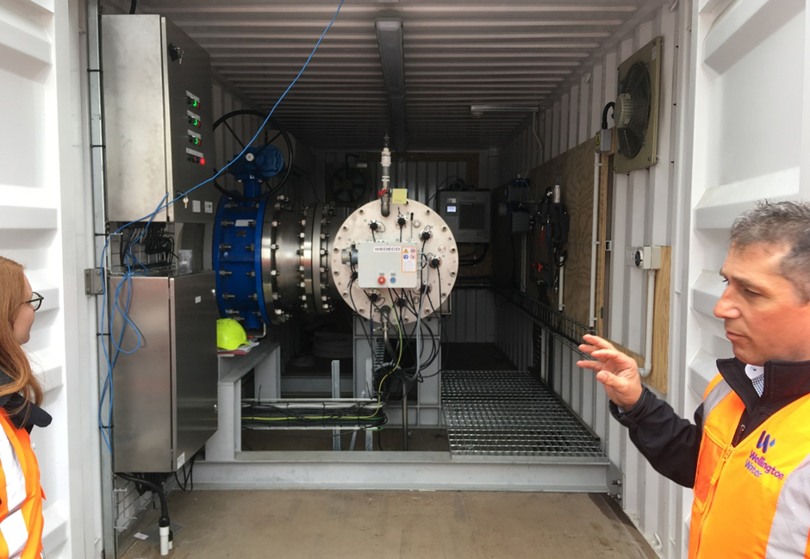

Supporting the delivery of safe drinking water
Proposals to amend the National Environmental Standard for Sources of Human Drinking Water.
These proposals arise from the Government review of the challenges facing drinking water, wastewater and stormwater services – the Three Waters Review.
As part of this review, the Government has agreed there will be legislation establishing a new framework for drinking water, headed by an independent regulator. This legislation is part of the Government’s response to drinking water safety following the lessons learned from the Havelock North incident in 2016 when a drinking water supply was contaminated with Campylobacter.
The proposals aim to ensure that better drinking source water protection arrangements are in place following the Havelock North incident.
We are looking for your feedback on the high level proposals on drinking water source protection, to support further policy work and ensure that it appropriately complements other proposals set out in this document. Detailed drinking water source protection proposals will be consulted on at a later date, likely in mid-2020.

Issues
A key principle of drinking water safety is the implementation of a multi-barrier approach for managing risks to public health. This includes proactively managing risks to source waters, such as rivers, lakes and groundwater, so these waterbodies can be used for community water supply. However, there are currently a number of deficiencies in the arrangements for managing these risks.
Source waters are currently regulated under the RMA and the National Environmental Standard for Sources of Human Drinking Water (Drinking Water NES), but the scope of the current regulation does not cover all activities that can pose risks of contamination. In practice, this means regional councils and territorial authorities are not consistently imposing appropriate controls on land-use activities that can affect the safety of drinking water supplies.

Proposal
We propose to strengthen the obligations on regional councils and territorial authorities for managing risks to source waters through amendments to the Drinking Water NES. We propose the following amendments:
- Provide direction on setting source water risk management areas, which will define the land area to which the regulations in the Drinking Water NES apply (that is, replacing ‘upstream’/‘up-gradient’ with a spatial criterion). These could be based on the approach proposed in the Pattle Delamore Partners 2018 report Technical Guidelines for Drinking Water Source Protection Zones.
- Define the types of activities that must be assessed as potential risks to source waters within the source protection areas, including consent applications that require public notification.
- Expand the scope of the regulations so they apply to all registered water supplies serving more than 25 people (for at least 60 days per calendar year).
- Develop a new approach for managing specific contaminants in source waters, including nitrate-nitrogen, that are challenging for drinking water suppliers to remove with conventional treatment processes.
- Require regional councils and territorial authorities to place appropriate controls on the development and use of land in source water risk management areas, to support the ongoing provision of safe drinking water.
- Require regional councils and territorial authorities to review plan rules for activities located within source water risk management areas, to ensure appropriate controls are in place.
Consequential amendments to other national direction instruments, including the National Policy Statement for Freshwater Management (NPS-FM), may be required to give effect to these proposals. We are also proposing that if a regional council or water supplier has sufficient data to prove that the default source water risk management areas prescribed in the Drinking Water NES are not appropriate for a particular water supply, then the regulations would allow for bespoke source water risk management zones to be established.
Regional councils and territorial authorities would be required to identify any relevant consent applications in source water risk management areas, and notify the relevant water supplier. They must then consider the potential risks to the relevant drinking water supply(s) and determine whether the application must be declined, or meet certain conditions, in accordance with the requirements of the Drinking Water NES.
The proposed amendments to the Drinking Water NES are intended to ensure that councils are placing appropriate controls on activities located within source water risk management areas. They are intended to work in tandem with the proposed changes to the NPS-FM and the new Freshwater NES, which are intended to improve water quality at a catchment scale. For example, regional councils would be expected to set clear and specific freshwater objectives for rivers, lakes and aquifers used for drinking water supply that enable the ongoing provision of safe and reliable drinking water.
Engagement with tangata whenua about their views on source water protection will be an important part of new arrangements. Councils have already likely had discussions on these matters with tangata whenua under the current NPS-FM – either in relation to Te Mana o te Wai, or in meeting their existing obligations on engagement.
The results of this continuing engagement will contribute to regional council decisions on how to regulate source water, which would be communicated to drinking water suppliers.

Next steps
After receiving feedback on these proposals, more work will be done on proposed amendments to the Drinking Water NES, followed by further consultation, likely in mid-2020.
Kāhui Wai Māori, the Freshwater Leaders Group, Science and Technical Advisory Group, and Regional Sector Water Sub-group were not consulted on this policy.

Questions
- Do you agree with the proposed amendments to the Drinking Water NES? Why/why not?
- Are there other issues with the current Drinking Water NES that need to be addressed?
- Do you have any other comments?

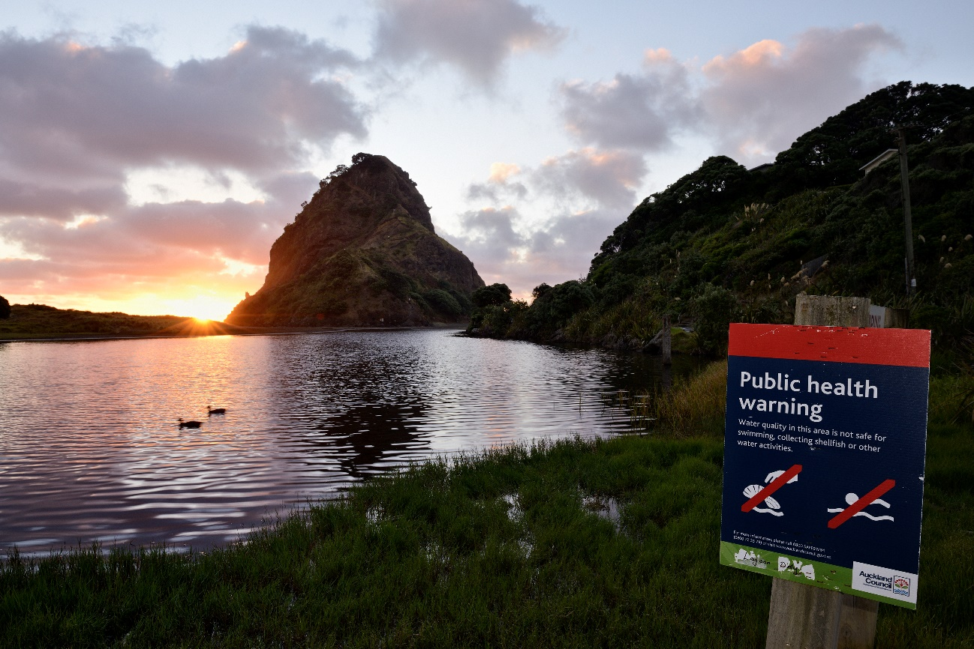

Better managing stormwater and wastewater
Proposals to require wastewater and stormwater operators to meet new standards and improve practices.
These proposals arise from the Government review of the challenges facing drinking water, wastewater, and stormwater services – the Three Waters Review. We are looking for your feedback on the high level proposals for wastewater and stormwater regulation, to support further policy work and ensure that it appropriately complements other proposals set out in this document.
Detailed wastewater and stormwater proposals will be consulted on at a later date, likely in mid-2020.

Issues
Wastewater refers to the contaminated water and sewage that goes down the drain from our homes, workplaces and other community spaces.
Wastewater piped networks and treatment plants in urban areas collect wastewater, treat it, and discharge treated wastewater to land or water. These discharges can still contain contaminants and can pollute aquatic ecosystems if not carefully managed. Unless wastewater is adequately treated, the discharge can also be contrary to the social and cultural values of Māori and communities.
Wastewater can also overflow from the piped networks. These overflows can occur in dry and wet weather either by design (engineered overflow points) or unintentionally (eg, leaky pipes). These overflows can pose short-term and long-term risks to human health and the environment if they are not managed and responded to effectively.
Stormwater refers to the run-off that occurs in built environments from paved or impervious surfaces (eg, roofs or roads) when rainfall cannot infiltrate into soil or vegetation. Stormwater networks are the pipes, rain gardens, and other green infrastructure systems that carry it away.
Historically councils have piped, filled in or reshaped many of the streams that used to carry stormwater away, and added networks of culverts and pipes to towns and cities. The quality of the water in urban waterbodies has declined as contaminants have been washed into them, making many unsafe for recreation or mahinga kai. A disconnect has been created between people and their local waterbodies.
The increase in paved or impervious areas means rain is not absorbed directly into the soil, but washes into stormwater systems, carrying contaminants from road surfaces, and off roofs. In some cases, stormwater systems will struggle to cope with the impact of climate change, as some areas of the country will face more extreme rainfall and the risk of flooding is expected to increase.
The current regulatory system does not provide assurance that wastewater and stormwater management risks are being appropriately managed, or that these services are delivering outcomes that are acceptable for communities and the environment.

Wastewater

National Environmental Standard for Wastewater Discharges and Overflows
Most wastewater discharges require resource consents from regional councils. A national assessment commissioned by the Department of Internal Affairs found significant variability in consent conditions for wastewater discharge across New Zealand and within regions. This situation makes it difficult for wastewater operators to identify exactly what is required when applying for discharge consents. It also makes it hard for regulators and communities to understand and compare the performance of their wastewater networks, and ensure good outcomes are being achieved for the environment and communities.
We are proposing a National Environmental Standard for Wastewater Discharges and Overflows (Wastewater NES). The new standard would prescribe requirements for setting consent conditions on discharges from wastewater treatment plants and engineered overflow points. These requirements could include:
- minimum treatment standards or ‘limits’ for nationally-applicable wastewater quality parameters, including biochemical oxygen demand, suspended solids and bacteria
- targets or limits on the volume and frequency of wet weather overflows
- methods for monitoring compliance with standards or limits and reporting breaches to regional councils and the public
- approaches for incorporating culturally-acceptable wastewater treatment processes.
Wastewater operators would also have to comply with any other regional council requirements under the National Policy Statement for Freshwater Management (NPS-FM) to ensure the health and wellbeing of waterbodies and freshwater systems is maintained or improved.
Wastewater operators would also be expected to participate in nutrient allocation regimes that may be established in the future.

Next steps
After receiving feedback on these proposals, more work will be done on the proposed new Wastewater NES, followed by further consultation, likely in mid-2020.

Risk management requirements
The management of risks to the environment, people and property is a key function of wastewater providers. However, there is significant variation in how wastewater operators document and report on how they manage these risks. This means regulators and communities can find it hard to understand what risks the wastewater network poses and the actions that are being taken to avoid, remedy or mitigate the risks.
We are proposing a new obligation on wastewater network operators to prepare a risk management plan (RMP).
A RMP would identify risks to the environment, people and property, then outline actions that the operator, territorial authority, and regional council have agreed to take to avoid, remedy or mitigate these risks. At a minimum the plan would account for the following risks:
- environmental – meeting resource consent and/or permitted activity requirements
- people – ensuring public health risks associated with wastewater discharges are reduced to acceptable levels
- social/cultural – demonstrating how community and Māori cultural values will be protected.
The plan would encompass the entire wastewater network and would also be required to consider future demand pressures on the system, such as climatic changes and urban growth and intensification.
In short we see the plan as being a ‘one stop shop’ for parties interested in the risks the networks pose and the actions being taken to address the risks.

Nationally-consistent measures for wastewater
Wastewater operators use a set of measures to monitor the overall performance of their networks. These can include:
- water quality parameters to assess the effect that a discharge is having on water (regional councils also do this)
- other parameters to assess the effect the operation of the plant is having on the wider environment
- the type, frequency and locations of network overflows
- other measures to assess community satisfaction with the network and the financial performance of the operator.
However, these are not always reported in a way that is accessible to the community, and in some cases do not reflect the communities’ expectations for the network. This makes it difficult for communities and regulators to understand how their networks are performing and to hold the network operator to account.
Regulators and communities can also find it difficult to compare and benchmark the performance of wastewater networks as there is no nationally-consistent set of performance measures.
We propose to introduce a new obligation for wastewater network operators to report annually on a set of nationally-prescribed environmental performance measures to both their communities and a regulatory agency. This obligation would be set out in a new Water Services Act.
The proposed measures could, for example, include:
- compliance with standards for wastewater discharges and overflows
- sludge disposal practices
- greenhouse gas emissions and energy use
- odour/air quality
- compliance and enforcement actions
- extent to which identified community and iwi values are being upheld.
We will be working with wastewater network operators, regulators, community and iwi to further develop this proposal, so the measures chosen reflect a wide range of community expectations and provide more transparency.

Stormwater

Risk management requirements
At present, stormwater is managed through multiple pieces of legislation, creating a confusing regulatory system. There is significant variation in the approaches used by stormwater operators to document and report on how they manage risks to the environment, people and property.
As with wastewater (above), this means regulators and communities can find it hard to understand what is being done to manage risk.
One way we propose to address this is requiring stormwater network operators to prepare a risk management plan (RMP).
This is similar to the proposal for wastewater operators outlined above, but would address specific stormwater risks, including at a minimum:
- environmental – meeting stormwater discharge resource consents and/or permitted activity requirements
- people – ensuring public health risks associated with stormwater are managed where community values exist, such as for recreation or mahinga kai
- property – proactively managing the risk of flooding in and around buildings and habitable areas.
The RMP would encompass an entire stormwater network, and would also be required to account for projected future demand pressures such as urban growth and intensification. The plan would also support the integration of land-use planning and three waters servicing.
A number of local authorities already have stormwater management plans that consider these risks. This proposal would formalise what is already emerging as good practice within the industry. We see the RMP as being an important tool to support integrated catchment planning and provide assurances to the wider community.
Stormwater operators would also have to comply with any other regional council requirements under the NPS-FM to ensure the health and wellbeing of waterbodies and freshwater systems is maintained or improved.

Nationally-consistent measures for stormwater
Stormwater operators commonly monitor aspects of their networks, including:
- water quality parameters to assess the effect that the discharge is having on the receiving environment (regional councils also do this)
- flooding events to assess the impacts the network is having on people and property
- other measures to assess community satisfaction with the network, the level of service, and the financial performance of the operator.
However, the measures differ around the country and are not always reported in a way that is accessible to the community. In some cases this monitoring does not cover a wide enough range of indicators which makes it difficult for communities and regulators to understand how their network is performing and hold the network operator to account.
As with wastewater (above) regulators and communities can also find it difficult to compare the performance of stormwater networks across a region or the country.
We are proposing to introduce a new obligation for stormwater network operators, in a new Water Services Act, to report annually on a set of nationally-prescribed environmental performance measures to both their communities and a central regulatory agency. These would cover stormwater discharges, environmental outcomes, resilience, social/cultural indicators, compliance metrics, and other relevant performance information.
We will be working with stormwater network operators, regulators, communities and tangata whenua to further develop this proposal.

National guidance on stormwater policy and network management
Many stormwater challenges can be resolved through applying best practices in water sensitive design and green infrastructure. There are many examples of this around the country, but there is significant opportunity for more consistent application of these practices at a national level.
Water sensitive design and green infrastructure – such as using raingardens instead of pipes
– offers many benefits over conventional piped infrastructure by:
- reducing the volume of stormwater through infiltration, attenuation and detention
- providing some level of treatment through uptake from plant species and deposition of sediment
- creating significant amenity benefits by providing green spaces for recreation and habitat.
There are several barriers to wider adoption of green infrastructure in New Zealand, one being a lack of capability to implement green infrastructure successfully over all scales of networks.
Some councils (Auckland Council, Wellington City Council) have developed guidelines to help stormwater practitioners implement water sensitive design at the ‘site’ scale – individual subdivisions and lots.
However, there is no clear national guidance on incorporating green infrastructure into policy and resource management plan provisions, or on stormwater network design and management. We believe it would be useful to have this guidance on a national scale to provide consistency in good practice and reduce the need for individual councils to ‘reinvent the wheel’.
Kāhui Wai Māori, the Freshwater Leaders Group, Science and Technical Advisory Group and Regional Sector Water Sub-group were not consulted on this policy.

Questions
- Does the proposed Wastewater NES address all the matters that are important when consenting discharges from wastewater networks? Will it lead to better environmental performance, improve and standardise practices, and provide greater certainty when consenting and investing?
- Do you agree with the scope of the proposed risk management plans for wastewater and stormwater operators? Are there other aspects that should be included in these plans?
- What specific national level guidance would be useful for supporting best practice in stormwater policy and planning and/or the use of green infrastructure and water sensitive design in stormwater network design and operation?
- What are the most effective metrics for measuring and benchmarking the environmental performance of stormwater and wastewater networks? What measures are most important, relevant and useful to network operators, regional councils, communities, and iwi?
- Do you have any other comments?

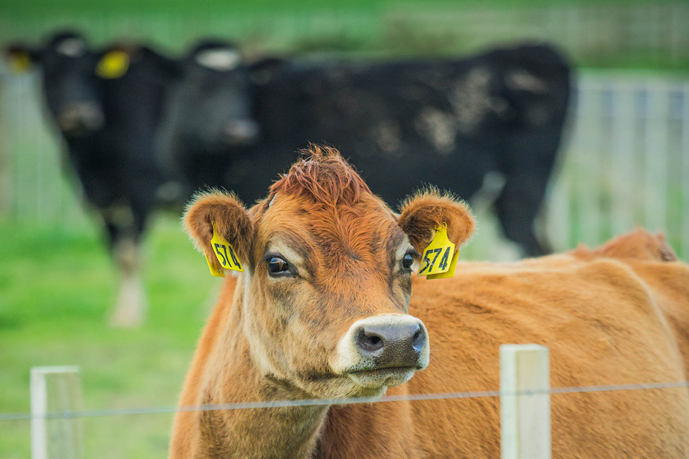

Improving farm practices
Proposals to restrict further intensification, set new standards for high-risk activities, and introduce freshwater modules in farm plans.

Issues
New Zealanders have become increasingly aware of their impact on the environment and understand the consequences of degraded ecosystems.
Environment Aotearoa 2019 says many studies at national, regional and catchment scales show that concentrations of nitrogen, phosphorus, fine sediment, and E. coli in rivers all increase as the area of farmland upstream increases.
The longer we leave it to reduce pollution, the more we lose – we put at risk our clean water for drinking and swimming, our sense of place, heritage and identity, and the economic benefits we get from products that depend on clean and available water.
It is more cost effective to prevent degradation of waterways than to restore them after degradation has occurred, particularly in systems that have passed ecological ‘tipping points’ due to ongoing degradation.
Many farmers and growers are good stewards of the environment, and understand the benefits to both their business and their community of environmentally-sustainable production.
To ensure all farmers and growers contribute, there needs to be good practice standards across the board and a way of ensuring they are followed.
In this section, we set out proposals to reduce pollution from farmland including horticultural land – both immediate steps to quickly reduce pollution from higher-risk activities, and an enduring approach based on farm planning to support continuous improvement in environmental management.
It will take until 2025 to develop regional plans and rules based on the new National Policy Statement for Freshwater Management (NPS-FM). Because every catchment and region is different, those plans will set different timelines for reducing pollution to meet regional objectives and targets.
To get a material improvement in water quality within five years, we need to start now with some immediate changes.

Restricting further intensification of rural land use
Intensification occurs when inputs such as irrigation, fertiliser and stock increase per hectare of land, or if a farm converts to a higher intensity land use (such as from sheep and beef farming to dairy farming). Intensification can increase pollution (nutrients, pathogens and sediment) entering waterways.
We are proposing tightly restricting further intensification, so it can only occur where there is evidence it will not increase pollution. The intent is to ensure that if there is any intensification, the net benefit to our people, our environment, and our economy is positive.
By 2025, it is anticipated that regional council implementation of the NPS-FM will prevent intensification beyond what is sustainable for our land and water.
In the meantime, we propose to tightly restrict land-use changes and increases in farm inputs by setting out the requirements that must be met before a resource consent is granted. The restrictions will apply until councils have implemented the new NPS-FM.
We propose to apply restrictions to the following activities:
- increases in the area of land in irrigated pastoral, arable or horticultural production above 10 hectares
- changes in land use above 10 hectares from:
- arable, deer, sheep or beef to dairy-support
- arable, deer, dairy-support, sheep, or beef to dairy
- woody vegetation or forestry to any pastoral use
- increases in forage cropping beyond the area in intensive winter grazing in the past five years; or if the applicant didn’t previously carry out intensive winter grazing, then beyond a minimum threshold. We are seeking feedback on this minimum threshold – whether it should be 30 ha or 5 per cent of the property, or 50 ha or 10 per cent of the property, or somewhere between.
For any of these activities, a resource consent will only be granted if the activity does not increase nitrogen, phosphorus, sediment or microbial pathogen discharges above the enterprise or property’s 2013–18 baseline (average for this period).

Commercial vegetable growing
We propose that any grower wanting to increase the area of land they use for commercial vegetable growing in a freshwater management unit (beyond their highest area over the past five years) would have to get a consent.
We are seeking feedback on options for resource consent requirements for change to commercial vegetable growing:
- Option 1: No increase in contaminant discharges – the applicant must have a freshwater module in a farm plan and cannot increase nitrogen, phosphorus, sediment or microbial pathogen discharges above the enterprise’s 2013–18 baseline (average for this period).
- Option 2: Operating above good management practice – the applicant must have a freshwater module in a farm plan and must operate above good management practice.
See Part 3 of the proposed National Environmental Standards for Freshwater.
Advisory groups’ comments
KWM recommends a 10-year moratorium on further intensification of land use and further consumptive water takes. Current intensification restrictions are considered incremental and not sufficient to improve the health of our waterways.
RSWS supports proposals to improve farm practices, including restricting intensification of rural land use where it impacts on water quality, but does not support a moratorium, stating that consent requirements are the appropriate means of assessing whether the intensification is likely to contribute to environmental effects. RSWS would like more detail about the rationale for using increase in irrigation area as a threshold for regulation.
FLG says changes in land use and intensification can result in large increases of contaminant discharge into freshwater. To avoid this, land-use change and intensification need to be restricted. See paragraphs 71–74 of the FLG report.

Improving farm practices through farm planning
We propose requiring all farmers to have a farm plan with a freshwater module.
Managing the environmental impact of agriculture and horticulture requires different actions depending on the farm type, the location and type of land, the stock and crops being grown, and other local circumstances.
Many farmers and growers are using farm plans to help them understand and respond to the unique environmental situation on their properties.
Modelling in the Horizons and Waikato regions suggests that improved farming practices can lead to large reductions in nitrate leaching (5-20%) and sediment loss (47-70%) while retaining farm viability.
Leading primary sector industry organisations are already committed to all farmers and growers having a plan by 2025, as part of efforts to reduce climate emissions.
MPI is working on a wider integrated farm planning approach that is intended to cover areas such as reducing climate emissions, biosecurity, animal welfare and health and safety. It is working on an online tool so farmers can easily see what their regulatory requirements are.
There is an opportunity to align implementation of farm planning practices to meet freshwater and climate obligations by 2025.
We acknowledge there are costs associated with farm planning – around $3,500 to develop a plan, depending on the degree of preparedness and complexity. We are interested in feedback on options for meeting this cost; and on financing options for other on-the-ground investments to improve freshwater quality.
To ensure farmers and growers have access to quality advice and support, work is progressing on a certification scheme for suitably qualified and experienced farm environment planners. The scheme will assess the competencies and knowledge base of rural professionals working on freshwater modules in farm plans and could be extended to include farm plan auditors. The scheme is intended to provide confidence in the quality of freshwater modules in farm plans prepared by certified farm planners and to help build the farm planning workforce. Certified farm planners will be required to undertake on-going professional development activities. The certification scheme is anticipated to support the requirements in the proposed Freshwater NES.

Mandatory farm planning proposal
The freshwater advisory groups support the concept of farm plans as a valuable tool for farmers, but there are different opinions about whether they should remain voluntary or become mandatory.
We are seeking feedback on whether farm plans should become mandatory.
Making plans mandatory builds on the current approach where farm plans are required in some circumstances by some regional councils including Environment Canterbury and the Hawke’s Bay Regional Council.

Freshwater module
The proposed mandatory freshwater module in farm plans would integrate with existing farm planning tools, resource consents, and regional plan rules. It would be signed off by a suitably qualified and experienced farm environment planner.
The freshwater module would have to include a:
- farm map identifying features such as waterways, critical source (discharge of contaminant) areas, highly erosion-prone areas, and other risks to the health of the freshwater ecosystem
- risk assessment across specific activities including irrigation, application of nutrients, effluent application, winter grazing, stock holding areas, stock exclusion, offal pits, and farm rubbish pits
- schedule of actions to manage identified features and address identified risks of on-farm contaminant losses that impact on freshwater ecosystems.
The freshwater module could also include risks to threatened plant and wildlife species, and how these could be addressed. Alternatively, this could be a separate farm plan module.
Existing industry body or agribusiness farm plans in use would be recognised provided they meet national standards.
Under this proposal, freshwater modules would be independently audited and progress would be reported to the regional council.
The introduction of the freshwater module requirements would be phased in, starting with higher-risk activities and catchments where pressure on freshwater is higher.
See Part 3, Subpart 3 of the proposed National Environmental Standards for Freshwater.

Longer-term development
Over time, as the number of qualified, certified farm environment planning advisors increases, and farmers and growers gain experience in working with these professionals and meeting environmental standards, it may be possible to reduce the reliance on national regulations and put greater emphasis on farm-level decision-making.
Consideration of this shift would depend on whether there is evidence that farm planning is effective in reducing pollution.
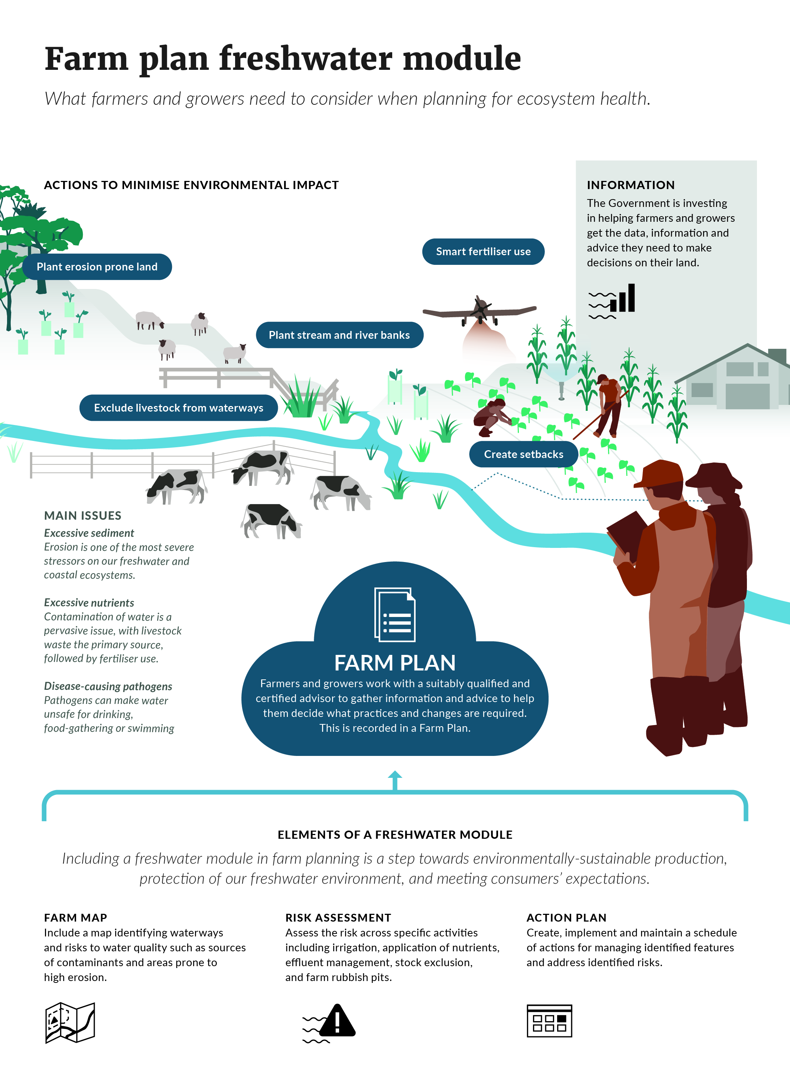

Advisory groups’ comments
The FLG is unanimously of the view that land and environment plans (LEP), or farm environment plans (FEP) are an important support tool for farmers.
The majority of the FLG hold the view that the regulatory regime for the implementation of rules and policies must not be delivered through farm environment plans, for the following reasons:
- It will be a resource-intensive regulatory framework and slow to implement given current capacity and capability constraints meaning measures to stop decline would be compromised.
- It is unproven and involves the possibly inappropriate devolvement of enforcement and natural resource management to commercial entities.
- The risk of a ‘black box’ effect where transparency for the public is restricted due to commercial sensitivity.
- Confusion and dilution of lines of responsibility where the regime has multiple levels of auditing leading to inconsistent and/or limited application/enforcement of rules.
- Farmers and land owners would be audited against on-farm actions that are not clearly related to environmental outcomes.
- A blurring of the role of farm planner – support person or enforcer/regulator?
Some FLG members support farm plans/LEPs being mandatory and used at least in part as a regulatory tool. Reasons include:
- Requiring everyone to have a plan is simple and unambiguous. Councils will retain accountability and can use industry capacity and capability to drive change.
- There is significant momentum at ground level to develop environmental plans with strong support from industries and leaders. It would be counter-productive to change the messaging about farm plans at this stage.
- Significant shifts in behaviour are occurring but making plans mandatory will be needed to shift slow movers.
KWM says that FEPs should be mandatory and the requirements for them should be developed using a risk-based approach, using the catchment or the sub-catchment as the basis for assessing risk. However, FEPs should not be used as a tool to ensure regulatory compliance. They can only be used as a tool to help farmers comply with limits and regulations set by central and/or local government. They cannot be used to set limits for environmental performance in their own right.
RSWS supports the use of FEPs by all farmers and growers.
FEPs dramatically improve council’s data and ability to model, target and manage environmental risk. RSWS supports FEPs being mandated by government regulation, but implemented in tranches over reasonable time based on risk, starting with those necessary to meet specific regulatory requirements such as stock exclusion or management of high-risk land-use activities. RSWS supports regional councils mandating FEPs through rules in plans where appropriate. RSWS supports regional sector ability to audit, monitor and enforce FEPs.
RSWS would like to see more detail on how implementation might occur and clarity about roles and responsibilities.

Immediate action to reduce nitrogen loss
Nitrogen contamination of water is a pervasive issue, with livestock effluent the primary source, followed by fertiliser use. It remains one of the most significant impacts of agriculture and horticulture on freshwater health.
Nitrate-nitrogen concentrations have increased in 55 per cent of monitored river sites between 1994 and 2013 with the most significant increases in Waikato, Canterbury, Otago and Southland.
By 2025, it is anticipated that regional council implementation of the current NPS-FM will mean that every council will have a process in place to reduce contaminant losses, including nitrate-nitrogen leaching.
In the interim, immediate action is needed to reduce excessive nitrogen leaching arising from poor management practices, to ‘hold the line’ on water quality. The catchments to which these interim measures would apply, and how they have been identified, is set out on page 72.
We are seeking feedback on whether other catchments should also be covered by this proposal.
Regions and catchments that have rules or proposed rules to reduce nitrogen leaching through an allocation regime or a good management practice-based cap are excluded from this interim proposal. Those excluded are Canterbury, Otago, Tukituki catchment (Hawke’s Bay), Manawatu and the Waikato/Waipa catchment (Waikato).
MfE will closely monitor the performance of these councils. The Government reserves the right to extend the interim measures set out in this section to these catchments, if it appears that council processes already underway are not achieving reductions within five years.
There are three options for rapid reduction of excessive nutrient leaching:
- Setting a cap in catchments with high nitrate-nitrogen levels, so farms with excessive losses will have to reduce to come under the cap.
- Setting a national nitrogen fertiliser cap.
- Requiring farmers in catchments with high nitrate-nitrogen levels to show, in the freshwater module in their farm plan, how they will rapidly reduce nitrogen leaching, and auditing their progress.

Option 1: Nitrogen-loss cap in high nitrate-nitrogen catchments
To stop excessive losses resulting from poor practice, we propose to set a per-hectare cap, or threshold, for nitrogen leaching for each sub-catchment with similar soil type and rainfall.
This option would apply in catchments where nitrate-nitrogen levels are in the highest 10 per cent of monitoring sites and regional rules implementing the NPS-FM are not in place. (See the list on the next page)
Every flat or gently rolling (low-slope) pastoral farm in the identified catchments would be required to provide an audited Overseer® nitrogen loss figure to their regional council. ‘Low-slope’ land is being mapped nationally for the purposes of this proposal and stock exclusion proposals in the following section, with options of mapping parcels with a mean slope of less than or equal to five degrees, seven degrees, or 10 degrees.
The threshold would be calculated based on Overseer® figures across the catchment.
For example, in a sub-catchment with 100 dairy farms, the Overseer® nitrogen losses from the farms would be ranked from lowest to highest. The threshold could be set at the 75th percentile; that is the Overseer® figure for the 75th farm in the ranking. The 25 dairy farms with Overseer® figures higher than the 75th farm would then have to change their practices to get below the threshold. Any sheep and beef farms in low-slope areas with Overseer® figures over the threshold would also have to get below the threshold.
We are seeking feedback on where the threshold should be set. It could be set at the 90th percentile (so the highest 10 per cent of farmers have to reduce nitrogen losses to reach the threshold) or at the 70th percentile, or a point between.
Properties over the threshold would have 12 months to either:
- reduce nitrogen losses to below the threshold
- apply for a resource consent that would only be granted with conditions requiring a plan to reduce nitrogen losses as soon as practical.
We recognise that this is a complex proposal, and we are seeking feedback on what would be required for it to be effectively implemented.
See Part 3, Subpart 4 of the proposed National Environmental Standards for Freshwater.

Option 2: National nitrogen fertiliser cap
Under this option, caps or thresholds for total nitrogen applied in fertiliser per hectare per year would be set, based on research findings and good management practice. The caps would be applied nationally, with a higher threshold set for higher nitrogen-demanding crops and land uses. Further work is needed to develop these caps. All farms and horticultural producers would have to use less than the threshold amount of nitrogen in fertiliser per hectare, or, if they wanted to exceed the threshold of nitrogen in fertiliser per hectare, they would have to get a resource consent.
We recognise that this is a complex proposal, and we are seeking feedback on what would be required for it to be effectively implemented.
If, following consultation, the Government decides on Option 2, then the proposed Freshwater NES would be changed to reflect this.

Option 3: Farm plan-based reductions
Under this option, farmers in catchments with high nitrate-nitrogen levels would have to show, in the freshwater module in their farm plan, how they will rapidly reduce nutrient leaching.
Progress against the plan would be monitored by independent auditors and the regional council could take enforcement action if required.
This option would apply in catchments where nitrate-nitrogen levels are in the highest 10 per cent of monitoring sites and regional rules implementing the NPS-FM are not in place. (See the list below.) Farmers in these catchments would be among the first required to have farm plans, within two years of the Freshwater NES coming into effect (expected to be June 2020).

High nitrate-nitrogen catchments
The catchments targeted in Option 1 and Option 3 have been identified based on having at least one monitoring site with high nitrate-nitrogen levels, and where regional plan or proposed regional plan provisions specifically addressing high nitrogen-leaching farms are not in place.
The list below does not include catchments with high nitrogen levels in Canterbury, Otago, Tukituki catchment (Hawke’s Bay), Manawatu and the Waikato/Waipa catchment because their regional council plans/proposed plans set out a pathway for reducing leaching.
The following catchments (or sub-catchments) have been identified as having high nitrogen levels derived from intensive pastoral farming rather than point sources or horticulture and they and any relevant tributaries are therefore subject to this proposal:
- Northland: Waipao Stream (in the Wairoa River catchment)
- Bay of Plenty: Upper Rangitaiki River (upstream of Otangimoana River confluence)
- Waikato region: Piako River, Waihou River
- Hawke’s Bay: Taharua River (in the Mohaka River catchment)
- Taranaki: Waingongoro River
- Wellington: Parkvale Stream (in the Ruamahanga River catchment)
- Tasman region: Motupipi River
- Southland: Mataura River, Oreti River, Waimatuku Stream, Aparima River, Waihopai River.

For Option 3, additional catchments with more diverse land uses would be added:
- Auckland region: Waitangi and Whangamaire Streams
- Wellington: Mangaone and Waitohu Streams.
See Part 3, Subpart 4 and Schedule 1 of the proposed National Environmental Standards for Freshwater.
Advisory groups’ comments
All advisory groups agree there is a need to reduce nitrogen losses in nitrogen impacted catchments. There is support in principle for rapid action in highly-impacted catchments.
RSWS supports a focus on nitrogen reduction in nitrogen-impacted catchments, and notes more work is required to determine where and how it should apply, and that it should not apply where there are already detailed nitrogen allocation and management frameworks in place (operative or proposed).
FLG sees targeting excessive nitrogen loss as key to stopping further decline. See paragraphs 55–64 of their report.
KWM considers those under the threshold should also be required to do their part, by being subject to a cap at the threshold and a catchment-based nitrogen reduction target of 10 per cent. Without this commensurate reduction KWM understands that there is no limit on nitrogen discharges from those farmers below the threshold, such that the benefits of the reductions achieved by those farmers over the threshold could be eroded, or even undermined.
FLG and KWM note that in some highly-impacted catchments, it will take more than improving practices to achieve ecosystem health, and some land-use change will be required.

Excluding stock from waterways
We propose new standards for when stock must be excluded from wetlands, lakes and rivers more than one metre wide.
We also propose that farmers are required to have a freshwater module in their farm plan setting out how and when they will exclude stock from rivers and streams less than a metre wide and drains.
Keeping livestock out of waterways is one of the simplest and most direct ways of protecting waterbodies from pollution.
Excluding stock (particularly those that have a natural inclination to wallow) results in a rapid reduction in faecal contamination and associated risks to human health. In practice, stock exclusion will mean permanent or temporary fencing, but the requirements will allow the use of other technology such as ‘virtual’ fencing and ‘smart’ stock collars.
Dairy farmers have made significant progress in voluntarily fencing an estimated 98 per cent of streams that are ‘deeper than a red band gumboot and wider than a stride’ through the Dairy Accord, and approximately 10,900 metres of streams less than a metre wide have also been fenced.
However, there remain many tens of thousands of kilometres of unfenced streams across New Zealand.
We recognise that the needs of the environment and ability of farmers to make change vary from place to place, and that setting aside land for setbacks and fencing all waterways would be costly – potentially up to $600 million over 10 years. This figure is based on 5 degrees slope and includes the costs associated with putting in new fences and loss of grazing land. The cost of replacing existing fences is also included, but the figure does not include any additional loss of grazing land from moving existing fences further back from the waterway.
We are therefore proposing a two-tier approach; national standards, enforced by regional councils for larger waterbodies; and using farm plans to develop bespoke approaches for excluding stock from smaller streams and drains.

National standards for larger waterbodies
We propose to set minimum requirements for excluding stock from wetlands, lakes and rivers more than one metre wide, in flat and gently-rolling (low-slope) areas within five years, or three years for dairy cattle and pigs; and in other areas where the concentration of cattle or deer is similar to dairy stocking rates.

Low-slope land
Low-slope land is being mapped nationally, and cadastral maps are available online through the Ministry for the Environment website. In the online maps, and the map on the following page, we have mapped three variants. These are based on land parcels with a mean slope of less than or equal to five degrees, seven degrees, or 10 degrees. We are seeking feedback on which variant should be used.

Land outside the low-slope category
In areas that are not mapped as low-slope, stock exclusion is still important, particularly where the land can sustain reasonably intensive uses. The stock exclusion requirements (that is to exclude cattle, pigs and deer) will therefore also apply to areas where:
- at the farm scale, the land has an average carrying capacity equal to or greater than
14 stock units per hectares
- at the paddock scale, the land has a carrying capacity equal to or greater than 18 stock units per hectare (regardless of the average carrying capacity of the farm)
- at the paddock scale, the land is or has previously been irrigated
- at the paddock scale, the land is used for fodder crops when cattle, pigs or deer are on
that land.
If these proposals are adopted, it would be necessary to develop a methodology (or identify an existing methodology) to calculate carrying capacity. The methodology could be based on the one used for calculating carrying capacity on Crown Pastoral Land.
National map of low-slope land
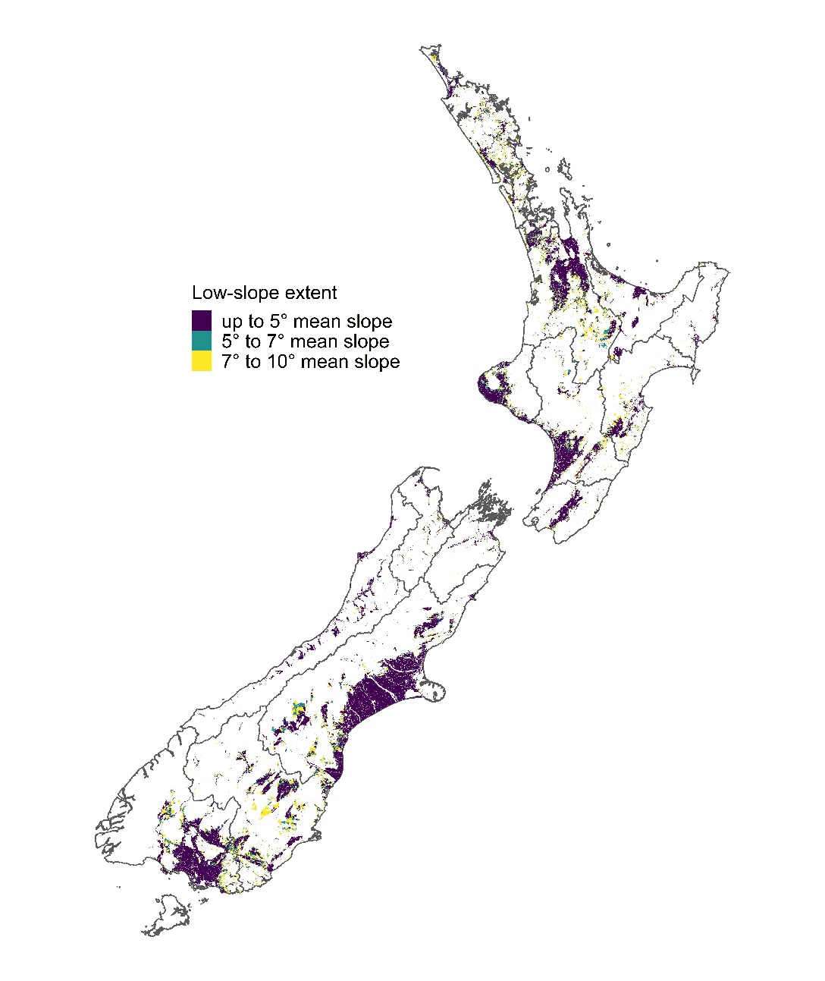

Setbacks
Setbacks (space between the fence and the waterway) prevents sediment loss from trampling, pugging and de-vegetation near the waterbody, and allows space for sediment to be filtered out of overland flows. The wider the setback, the more effective it is in removing sediment. Providing a setback also protects spawning areas for fish, and allows riparian plants to shade the waterbody.,
For large rivers and streams (more than one metre across) lakes and wetlands, we are proposing to require a setback of five metres, on average across a farm.
We are seeking feedback on where the setback should be measured from, for example the wet edge of the waterway or the top of the bank.
We are also seeking feedback on what barriers farmers may face in meeting these standards, for example where more time may be needed, or where the terrain makes a five metre setback unachievable.
The requirements would be set in regulations under the Resource Management Act. In practice this would mean regional councils would monitor and enforce compliance, likely using farm plans to record the requirements and timeframes for each individual farm.
Details of the proposed new standards are set out in the Draft Stock Exclusion Section 360 Regulations.

Farm plans for streams under a metre wide and drains
For streams less than one metre wide and drains, farmers would be required to set out a plan for fencing and setbacks in the freshwater module of their farm plan. The timetable, type of fencing and setbacks would be tailored to the individual circumstances of the farm.
This provides more flexibility to take account of individual farm conditions and the best value investment to improve the health of waterways, but less certainty about what stock exclusion and setbacks will be put in place, and when.
Farm plans would be signed off by a suitably qualified and experienced farm environment planner and audited. If the plan is not being implemented then the regional council would be able to take enforcement action.
Advisory groups’ comments
Keeping farm animals, and their effluent, out of waterways is seen as essential to uphold Te Mana o te Wai and protect human and ecosystem health.
The advisory groups support in principle defining low slope areas using cadastral based mapping.
KWM says compliance, monitoring and enforcement will also be critical.
FLG says the riparian margin for intensive farming areas and the stocking rate used to defining intensive farming must be soundly based. See also paragraphs 75-83 of its report.
For flood protection and drainage schemes RSWS seeks flexibility around fence placement, access, maintenance requirements, and vegetation management.

Controlling intensive winter grazing
We propose to require farmers to meet standards for intensive winter grazing.
Intensive winter grazing is on-paddock grazing of annual forage crops, and sometimes supplementary feed is also provided. Grazing a high number of animals in a relatively small area creates a lot of effluent which can contaminate waterways. There is also a risk that the land is trampled into deep mud (pugging), with both pollution and animal welfare consequences.
Photo shows an example of poor practice intensive winter grazing. |  | 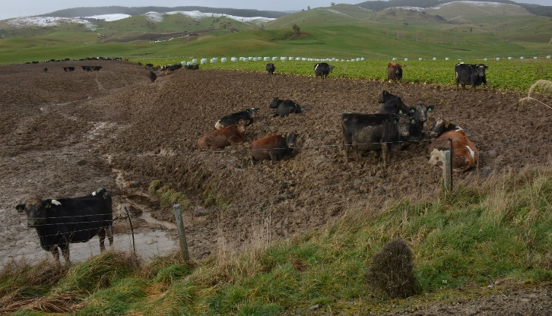
We propose that winter grazing would only be permitted if the area being grazed meets standards. Farmers would have six months to comply with the new standards after the regulations come into effect (expected to be June 2020).
There are two options for the standards that must be complied with:
- Nationally-set standards through regulation. A resource consent would be required for winter grazing above a defined area.
- Current industry-set standards.

Option 1: Nationally-set standards
Under this option, winter grazing would only be permitted if it was below a defined threshold in area and met standards. We are seeking feedback on where the threshold and national standards should be set within the range set out in the table below.
Intensive winter grazing on forage crops ranges for consultation
Factor | Range from | Up to
Threshold – if the area of winter grazing is below this threshold it is permitted, provided standards are met. A consent would be required for winter grazing above this threshold. | No more than 5 per cent of the property or  30 ha (whichever is larger) | No more than 10 per cent of the property or  50 ha (whichever is larger)
Slope threshold – permitted on land with a slope below: | 10 degrees | 15 degrees
Standard – all winter grazing must be setback from the edge of waterways: | 5 metres | 20 metres
Standard – pugging extent must be no more than: | 10 cm | 20 cm (over no more than half the paddock)
Other standards required are:
- grazing to be carried out progressively (top to bottom) of slopes
- stock to be excluded from critical contaminant source areas
- land to be re-sown as soon as possible.

Option 2: Industry-set standards
Primary sector industry organisations are providing advice to farmers on good practice winter grazing. Under this option, a resource consent would be required for winter grazing not meeting the following standards.
Intensive winter grazing on forage crops – industry standards
Factor | Proposed standard
Slope threshold permitted on land with a slope below | 20 degrees
Standard – all winter grazing must be set back from the edge of waterways by: | 5 metres
Standard – pugging extent must be no more than: | the depth of the ankle joint of stock (fetlock)
These standards would be supplemented by best practice standard guidance for issues such as strip grazing, protecting critical source areas, and crop cover as part of freshwater modules in farm plans.
If, following consultation, the Government decides on Option 2, then the proposed Freshwater NES would be changed to reflect this.
Any expansion of the area of winter grazing beyond a threshold may be subject to restrictions on intensification, as set out in section 8.2.
Advisory groups’ comments
KWM, FLG and RSWS are all deeply concerned at the environmental and animal welfare impacts of poor winter grazing practices. (This issue was outside the remit of STAG.) This is seen to have a negative impact on Te Mana o te Wai.
Some members of advisory groups strongly support regulation at the low end of the range set out in the table for consultation, and some consider pugging should be limited to 5 cm. They want to see standards for all winter grazing (even if the activity does not require a consent) to include:
- providing a dry place for animals to lie
- no activity at all on highly permeable soils where there is a high risk of preferential flow pathways (eg, mole and tile drains or gravelly soil).
RSWS seeks well managed farm systems that protect vulnerable soils and manage critical contaminant source areas. While the RSWS agreed 30 cm pug depth is inappropriately high, it generally doesn’t see a pugging depth standard as implementable, and sees this as more appropriately managed through a farm environment plan and applying good management practice.
Other high-risk activities
FLG believes that the following activities should be classed as high risk and regulated:
- irrigation on vulnerable soils
- winter grazing on highly permeable soils (such as gravels or river accretion) or mole and tile drained soils.
See paragraphs 65–70 of the FLG report.

Restricting feedlots
We propose requiring all feedlots to meet standards, as set out in a resource consent.
Feedlots are defined as areas where stock are confined in pasture-free areas and provided with feed, for more than 80 days in a six month period. This includes both covered and uncovered areas. Feedlots create a higher risk of pollution (nutrients, pathogens and sediment) entering waterways.
There are about five feedlots currently operating in New Zealand.
All new feedlots and any feedlots that do not have a resource consent will be tightly restricted. They will have to get a resource consent and meet standards for managing effluent and siting the feedlot at least 50 metres away from freshwater or coastal marine areas.
See Part 3 of the proposed National Environmental Standards for Freshwater.

Reducing pollution from stock holding areas
We propose requiring measures to control effluent and contaminant loss from areas where stock are held for a shorter time than in a feedlot but longer than in yards or milking sheds (more than 30 days in a year or more than 10 days in a row).
Holding stock in a concentrated area creates a higher risk of pollution (nutrients and pathogens) entering waterways. To mitigate that risk, stock holding areas would be required to get a resource consent that would set standards for permeability and managing effluent.
Stock holding includes management practices such as feed pads, wintering pads, standoff pads, and loafing pads.
Sacrifice paddocks will not require a resource consent, provided they are more than 50 metres from a waterway.
This proposal does not include stock yards, milking sheds, shearing sheds, or woolsheds.
We recognise this may lead to a large number of consent applications, and we are seeking feedback on what would be required to ensure this proposal could be effectively implemented.
See Part 3 of the proposed National Environmental Standards for Freshwater.
Advisory groups’ comments
There is support for national regulation of stock holding areas.

Questions

Restricting further intensification
- Do you support interim controls on intensification, until councils have implemented the new NPS-FM? Why/why not?
- For land-use change to commercial vegetable growing, do you prefer Option 1: no increase in contaminant discharges OR Option 2: farms must operate above good management practices. What are your reasons for this?
- How could these regulations account for underdeveloped land, and is there opportunity to create headroom?

Farm plan options
- Do you prefer mandatory or voluntary farm plans (acknowledging that farm plans may be required by councils or under other parts of the proposed Freshwater NES?) What are your reasons for this?
- What are your thoughts on the proposed minimum content requirements for the freshwater module of farm plans?
- What are your thoughts on the proposed priorities and timeframes for roll out of farm plans, as set out in the proposed Freshwater NES?
- Do you have any comment on what would be required to ensure this proposal could be effectively implemented, including options for meeting the cost of preparing, certifying and auditing of farm plans; and on financing options for other on-the-ground investments to improve water quality?

Immediate action to reduce nitrogen loss
- Which of the options (or combination of them) would best reduce excessive nitrogen leaching in high nitrate-nitrogen catchments? Why?
- If you are in a high nitrate-nitrogen catchment, what would you have to do differently under these options?
- In addition to those already identified, are there other high nitrate-nitrogen catchments that should be subject to these options?
- Do you think the action already underway in five regions (identified in section 8.4) will be effective in reducing excessive nitrogen leaching in those high nitrate-nitrogen catchments?
- Should there be higher thresholds for farms that produce food products in winter, and if so, which food products?
- What alternative or additional policies could contribute to reducing nitrogen loss?
- Do you have any comment on what would be required to ensure this proposal could be effectively implemented?

Excluding stock from waterways
- Do you support excluding stock from waterways? Why/why not?
- Do you have any comment on the proposed different approach for larger and smaller waterbodies?
- Do you have any comment on the proposed five metre setback, or where it should be measured from?
- Are there any circumstances that are appropriate for allowing exemptions to the stock exclusion regulations? If so, please give examples.

Controlling intensive winter grazing
- Do you prefer Option 1: Nationally-set standards or Option 2: Industry-set standards? Why?
- For the proposed nationally-set standards, which options do you prefer for the area threshold, slope, setback, and pugging depth components of the policy?

Restricting Feedlots
- Do you have any comment on the proposal to restrict feedlots?

Reducing pollution from stock holding areas
- Do you support the proposal relating to stock holding areas? Why/why not?
- Do you think sacrifice paddocks should be included?
- What would you have to do differently if this proposal was implemented?
- Do you have any comment on what would be required to ensure this proposal could be effectively implemented?

Draft proposed National Environmental Standards for Freshwater
- Are the definitions used in the policies accurate, and if not, how do you suggest improving them?
- What are your thoughts on the proposed technical definitions and parameters of the proposed regulations? Please refer to the specific policy in your response.
- What are your thoughts on the timeframes incorporated in the proposed regulations? Please refer to the specific policy in your response.

Support for improvement in catchments and on farms

Focusing on catchments at higher risk
Every catchment in New Zealand has different land uses and natural conditions, and faces different levels of risk.
There will always be uncertainty as to what pressures catchments face now and in the future, and what impact these pressures will have on our nation's freshwater rivers, lakes and wetlands. This is not a question that can be answered by science alone so we need to ‘triage’ information from a range of sources to decide where to invest limited resources.
Restoration of freshwater ecosystem health can be very expensive. Limited resources would best be spent stopping catchments from reaching a ‘tipping point’ (zone of irreversible change) rather than spending considerable resources restoring degraded catchments whilst others are heading towards a similar fate.
Biodiversity loss is permanent. A priority for action should be to prevent the extinction of flora and fauna that rely on our freshwaters, and protect their habitats.
Land use is the primary driver of water quality declines in New Zealand, and so information about land-use intensification must form the primary basis of informing a risk assessment of catchments.

National-level information on catchments
Together MfE and DOC have combined expertise about freshwater biodiversity, ecosystem health, and land-use intensification. This has resulted in the co-development of a model which builds on previous DOC work which prioritised the protection of freshwater biodiversity at the catchment-scale by adding in new information about where land-use intensification could happen and the relative impact of different land uses.
We are using this information to provide a joined up, risk-based approach to prioritising the protection of higher-risk catchments.
Over the coming months we will be sourcing and developing new science to further inform our national-level information. We will also build on existing science and recent data collated as part of Environment Aotearoa 2019. We expect this national-level information will be made publicly available.

Exemplar catchments
Alongside this national-level information we are moving to understand how best to leverage and accelerate community-led action, help target investment, and assist with access to a range of other funding support.
The Government recently announced Kaipara as the first catchment where we will be taking this approach. This and other ‘exemplar’ catchments will provide the opportunity to learn and make partnerships while we continue to build national-level information.
In these exemplar catchments MfE will work collaboratively with agency partners (DOC and MPI), regional councils, iwi/hapū, industry, and communities to identify appropriate measures to help improve the health of waterways from the bottom-up, and to identify gaps that could be filled by regulatory or non-regulatory interventions.
MfE will then help develop integrated catchment management plans and/or scoping projects for community-led activity and initiatives within these catchments that directly improve water quality at a catchment scale.
This exemplar programme complements and supports other work and partnerships already under way across government, industry and communities.

Practical advice and support for farmers
Budget 2019 provided additional funding for empowering land owners, businesses and Māori to transition to sustainable land use. This includes:
- practical advice, information and tools
- building farm advisor capability
- new farmer-to-farmer programmes for Māori land owner groups
- improving on-farm emissions data
- protecting high-value food exports, and updating the official assurances system.
The Government will work to ensure up-to-date qualifications are available for farm advisors, and improve skills development for rural professionals.

Making good decisions based on good information
Making good decisions depends on having the best possible information. The Government is investing in helping farmers, industry and central and local government improve the range and quality of the data that informs their decisions. For example:
- including environmental data in farm monitoring, collection and reporting
- improving data quality
- extending the Farm Monitoring Programme.
The Government will expand the range of farm systems and conditions modelled, connections between support tools, and accelerate the recognition of new, more environmentally-friendly technologies in tools, such as Overseer®.

Impacts of proposals

10.1 Benefits and costs
The proposals set out in this document outline steps towards stopping further degradation and reversing past damage to New Zealand’s waterways. The proposals have impacts in the form of both benefits and costs.
While there are costs in implementing the proposals, there are wide-ranging, long-term benefits for New Zealand’s environmental, social, cultural and economic wellbeing. The distribution of these costs and benefits will vary depending on how affected parties currently use natural resources, the characteristics of the natural environment they are operating within and the alternative land-use options available.
The following table illustrates why it is better to take action now to prevent further damage to freshwater ecosystems rather than remediate damage later.
Potential benefits of immediate action on freshwater
Example | Types of benefit | Estimated scale of benefit or problem | Strength of evidence
Te Waihora/Lake Ellesmere – an intermittently open and closed lake | Avoid cost of repairing the resulting damage.  Reduce risk to human health (through improved drinking water quality).  Improve environmental amenity.  Increase access to valued natural resources including for cultural purposes and recreational activities. | An estimated 76 per cent reduction in nitrogen and a 50 per cent reduction in phosphorus loads would be required to meet NPS-FM bottom line objectives for Te Waihora. | Strong
Rotorua Lakes | Avoid costs of lake restoration in future if conditions worsen.  Preserve and improve recreational values.  Avoid human health risks eg, toxic cyanobacteria blooms.  Lakes are sinks for nutrients and sediment and so are more costly to restore once impacted by nutrients. | A $40 million fund has been set up to ‘buy’ nitrogen off land owners who want to permanently lower their nitrogen discharge, with the aim of buying 100 tonnes of nitrogen by 2022. This is in addition to the cost of cleaning up the lakes. | Strong
Protection of irrigation schemes | Avoided costs. If irrigation water is pulled from waterbodies with high sediment content, it can harm crops and reduce agricultural productivity. | Sediment removal (10,000 m³/year) from one irrigation water scheme on the south island costs $160,000 per year. | Strong
Fishery resource being protected by ecosystem health objective | Maintain health of rivers and streams for recreation and tourism.  Protect fishery resource. | In 2011, DOC estimated the Taupo fishery alone was worth about $70 million annually, and Fish & Game says the total for the country is probably at least $250 million.  $20 million Marlborough pāua fishery in decline due to habitat loss, of which much is due to sediment deposition. | Medium
Sediment | Avoid additional treatment costs on hydro-electric facilities from sediment. | As noted in reports provided by a group of New Zealand generators, turbine replacement due to sediment occurs every 5 years at a cost of approximately $1.3 million. | Strong
To date we have focused our analyses of impacts on the proposals that will require the largest changes to land use and management practices. This includes:
- new attributes for nutrients and sediment in the NPS-FM
- proposals to establish practice standards within a new Freshwater NES, which could include limiting high risk land-use activities (stock-holding areas and feedlots), intensive winter grazing of forage crops, restricting intensification of rural land use, and stock exclusion.
Many of the other proposals aim to clarify roles, responsibilities and processes within the existing water management framework. There will be some additional costs to councils where they have to review plans earlier than they might have otherwise, but there are also potential savings where changes make requirements clearer.
There are significant positive social impacts (ie, benefits) associated with improving water quality and providing for Te Mana o te Wai. These include:
- impacts on people’s wellbeing, such as better physical and mental health, and the avoidance of water-borne illness
- increased access to valued natural resources, including for cultural purposes and recreation
- enhancing social connectivity and community cohesion, as farmers improve their social licence to operate
- the creation of new business opportunities derived from improving New Zealand’s environmental credentials overseas
- promoting intergenerational equity as we protect New Zealand’s natural capital on which future generations will depend upon.

Magnitude of the benefits and costs
The impact assessment work completed to date can give a general sense of the magnitude of benefits and costs associated with the proposals and how they might affect different groups. The Interim Regulatory Impact Analysis (RIS) provides more detail on anticipated benefits and costs of each proposal. Given the variability in the characteristics of the environment, the studies can’t fully represent any one group but they give an indication of the size of impacts and how they may fall.
The data for these studies come from a range of sources which are detailed in the RIS.
The table below provides a summary of the environment and economic benefits and costs that could result from action.
Adoption of best practice and continuing innovation will support the transition to healthier freshwater and more sustainable land management practices.
Proposal | What we get | Impact (positive and negative)
Water quality – new nutrient attributes in the NPS-FM. This includes new values for dissolved inorganic nitrogen and dissolved reactive phosphorus. | More stringent protection from the effects of nutrients, particularly in soft bottomed rivers.  Lower incidence of nuisance algal and plant growth.  Fewer adverse effects on sensitive macroinvertebrate and fish taxa.  Councils would be more strongly directed on how they manage nutrients for ecosystem health compared to the flexibility enabled by the status quo. | The proposed attributes would have the most effect in soft-bottomed rivers that do not have a receiving environment (such as a lake or estuary) downstream (approx. 27 per cent of the length of streams and rivers in New Zealand). The most affected regions would be Waikato, Canterbury, Southland and some catchments in Manawatū-Whanganui.  While there would be a small impact when viewed as a national average, it would require over 50 per cent additional load reductions in some catchments.  Modelling shows:  Under the status quo, once the rule is fully implemented by councils, the average catchment requires a 27 per cent reduction in nutrient loss, with over 80 per cent reductions required in nitrogen yield in some catchments which currently have high levels of nitrogen discharge into the water. This would require significant land management changes in some areas.  Benefit is avoided cost of remediation of waterways.
Water quality – reducing sediment.  Suspended sediment attribute with bottom lines and bands; deposited sediment monitoring requirement with trigger thresholds for action plans. | Fish and macroinvertebrate communities do not suffer severe degradation from long-term suspended and deposited sediment levels; where bottom lines are breached, the proposal will require improvement in sediment levels over time, which will improve ecosystem health. | This would be achieved through changes in farming practices and some afforestation. It is supported by government programmes like the Hill Country Erosion Fund and One Billion Trees Programme.  The impacts are anticipated to be primarily up-front intervention costs as well as longer-term benefits. Indicative results show strong benefit to cost ratios and we anticipate this will remain true in the final results.  Costs borne by resource users, local and central government will vary according to future policy choices related to implementation methods and funding for them (eg, the Hill Country Erosion Fund, regional council environmental grants that support freshwater, land and biodiversity initiatives).  Benefits are avoided cost of remediation of waterways; improvements in natural hazard resilience related to landslides and floods.
Improving farm practices: consenting requirements for land-use intensification. | Reduced contaminants entering waterbodies. | $3,000 per consent plus cost of expert opinion to support consent application.  Benefit is avoided cost of remediation of waterways.
Improving farm practices: Farm plans. | Reduced contaminants entering waterbodies from improved practices.  Some councils already require farm plans and primary sector bodies are already committed to developing farm plans.  This widens the use of farm plans to a larger number of farms. | About 28,000 more farm plans at an average of $3,500 per plan ($100 million).  Cost of auditing farm plans of $1,500 every 2 years.  Costs of implementing actions in farm plans will be variable depending on what is required and nature and size of business. Assume average $15,000 per annum, excluding one-off infrastructure costs.  Benefit is avoided cost of remediation of waterways.  Potential to increase resilience, could be part of a wider farm plan for managing the farm business.  May improve profitability for farm system changes (eg, identifying areas where it is possible to lower fertiliser costs).

Proposal | What we get | Impact (positive and negative)
Improving farm practices: reducing nitrogen losses (Option 1: Cap in high nitrate-nitrogen catchments). | Reduced nitrogen losses to waterbodies. | In high nitrate-nitrogen catchments, $3,000 per consent, $500–$5,000 per Overseer® run, plus costs of preparing, implementing and auditing farm plans.  Benefit is avoided cost of remediation of waterways.
Improving farm practices: stock exclusion. | Reduced contamination of waterbodies from nutrients, pathogens and sediment. | Nationally, fencing costs are estimated at $600 million for all affected streams over 10 years.  Benefits: $983 million if stock excluded only from streams over 1 metre.  Under the current proposal the benefits and costs would be larger.  Modelling of three types of farms for this proposal showed for a:  - 125 ha Waikato/Bay of Plenty dairy farm costs would be about $87,000  - 281 ha North Island intensive (lowland) beef farm cost would be about $89,000  - 571 ha central North Island hill country sheep and beef farm (based on 10 per cent of the farm triggering exclusion) cost would be about $17,000.
Improving farm practices: winter grazing of forage crops. (Option 1: National standards and consent requirements). | Reduced contamination as a result of good management practices. | About 2,000 additional consents at $3,000 per consent if farmers wish to operate outside new standards.  Benefits are reduced soil degradation, improved animal welfare, avoided cost of remediation of waterways.
Improving farm practices: stock holding areas and feedlots. | Reduced discharges from stock holding areas and feedlots (nitrogen, phosphorus, pathogens, sediment). | $3,000 per consent and an estimated $72 per cow per year to build infrastructure to hold stock.  Benefits are reduced soil degradation, improved animal welfare, avoided cost of remediation of waterways.  Good quality stock holding areas may improve productivity.

Limitations and assumptions of the modelling
The estimates above give an indication of the size of the impacts to help you make a submission as part of this consultation. Given the variability in the environment the studies can’t fully represent the impact on any one individual or group and ultimately the size of the impacts will be determined by the policies implemented following this consultation.
It should also be noted that the impact of the policies are not necessarily additive as interventions for one policy interact with interventions for other policies. For instance, any additional fencing that may be needed to meet stock exclusion requirements may also meet the need for fencing under the new bottom lines for nutrient pollution.
A key constraint on the nutrient attribute analysis is that it was based upon national-scale modelled predictions of nutrient concentrations. Zooming into smaller scales will introduce greater uncertainty. Such national-scale analyses are indicative only and cannot substitute more detailed catchment-scale investigations. The national models do not include the ‘load to come’ from groundwater that has become elevated in nutrients from past land uses.
This modelling assumes that the NPS-FM procedures for setting objectives and limits for periphyton are followed correctly so nutrient reductions to manage periphyton in upper catchments should translate to lower nutrient concentrations in the lower catchment, where rivers tend to be soft-bottomed. It also assumes that the effects of periphyton are managed solely by nutrient management and not by shading, flow manipulation, or other methods.
The full consequences of applying the current and proposed bottom lines have not been fully modelled and quantified. More analysis is required to confirm this national scale modelling at the catchment scale and to understand the significance of the impact at the farm scale.
Given these limitations, in the next section we have characterised how implementation of all the proposals may play out for some land types.

10.3 Impact scenarios
To provide an indication of how the proposals may impact, we have developed three scenarios based on a dairy farm, a sheep and beef farm, and a commercial vegetable growing operation, using average figures wherever available.
There are some policies in the package, such as feedlots, which only impact on small numbers of farmers and therefore have not been included in these scenarios. There are also a number of existing requirements in the current NPS-FM, such as the existing periphyton attribute, which are yet to be implemented in many catchments but have not been included in costing of new policies.

Scenario 1: Lowland dairy farm
Paul and Emma milk 430 cows on just over 150 hectares of low-lying, fertile land, with some rolling hills. This is about the average size for a New Zealand dairy farm. They have a total of 3.2 kilometres of permanent streams running through their property, one kilometre of intermittent streams, and one kilometre of drains. Their operating profit last year was $335,700. The farm is largely pasture, with around 32 hectares of forage cropping, including for winter feed. Paul and Emma have a consent to take groundwater, which they use for domestic use, stock water, and to irrigate the cropping land.
It’s expected the costs of just over five kilometres of fencing, installing culverts, installing fish passages, and getting a farm plan, providing regular Overseer® results, obtaining a resource consent for winter forage cropping (if needed), and the costs of installing and running a new telemetry unit, combined with retiring around two hectares of land, will be approximately $9,350 per year over 10 years. This equates to 0.8 per cent of gross revenue per year, and an annual reduction in before tax and interest profit from $335,700 to $326,350. If Paul and Emma decided to plant riparian margins, this would add an additional $4,400 per year, which is 0.4 per cent of gross revenue per year.
The end result achieves multiple environmental outcomes on the farm and for downstream communities. Over time, alongside improving habitat and water quality, and the visual appeal of the farm, the plantings provide shade and shelter to help meet animal welfare requirements. The fish passage and stock crossing measures have expanded the habitat and resulted in higher numbers of threatened freshwater species in the catchment.
Real-time water measurement helps Emma and Paul identify and fix leaks in their water supply infrastructure, reduces pumping costs, and provides them helpful data for the water take consent renewal process. Likewise, the riparian fencing has incurred costs but improved Emma and Paul’s pasture management. The measures around intensive winter-grazing management have resulted in greatly reduced sediment run-off into farm waterways.
Lowland dairy farm
Activity | Estimated costs over 10 years
Get a farm plan signed off by a suitably qualified and experienced planner by 2025 | $3,500
To have farm plan audited by a suitably qualified and experienced person (every two/three years over 10 years) | $7,500
New fencing on 1.5 kilometres of smaller and intermittently flowing waterways identified through their farm plan (other than drains) | $14,000
Fencing one kilometre of drains | $9,500
Replacing 200 metres of existing fencing on larger waterways by 2025 | $1,000
Retire about 2 hectares of riparian setback | $40,500
Install two single barrel culverts | $5,000
Riparian planting for two kilometres of the farm’s waterways [riparian planting at land owners’ choice] | [$44,000]
Annual Overseer® budget ($1,000 for five years) | $5,000
Resource consent for winter forage cropping activities | $3,000
New telemetry unit for their water meter | $4,000
Install two spat ropes | $500
Total over 10 years | $93,500
Optional riparian planting costs | [$44,000]

Scenario 2: Rolling hill country: sheep and beef farm
Ian and Jo run a family business with 370 hectares of pasture and 10 hectares of bush and scrub. There are about 50 hectares of flat land, and the rest is mostly rolling hill country with some steep land. They farm 2600 sheep and 350 cattle. This makes their farm about average for a New Zealand sheep and beef farm.
Over the next 10 years, it’s expected that the costs of just over five kilometres of fencing, installing stock reticulation and culverts, planting poplars, installing fish passages, and getting a farm plan, combined with retiring almost seven hectares of land will be a total cost of $14,850 per year. This equates to 3.2 per cent of gross revenue and an annual reduction in before tax profit from $90,600 to $75,750. If Jo and Ian decided to plant riparian vegetation, this would add an additional $4,200 per year, which is 0.9 per cent of gross revenue.
It will have taken time and effort, but after 10 years the benefits to Ian and Jo’s family, to the wider community, and to New Zealand at large will have been significant. Jo and Ian will have been able to explore ways of optimising how they use the property, given the new fencing and protection given to wetlands and streams.
Jo and Ian are likely to have noticed that riparian planting, fencing, stock exclusion, and associated water reticulation have meant stock health improvements, avoided stock loss, and given overall greater productivity. International recognition for New Zealand’s stronger environmental credentials means that their products are likely to be gaining in popularity in markets such as the European Union. Through Beef + Lamb NZ, Ian and Jo will also be able to access data around the increase in property value that clean, clear streams and lakes, abundant aquatic life, and protected riparian areas bring at sale time. The vegetation around the protected wetland and rivers will have added an attractive backdrop, while encouraging birds to return.
The Council’s riparian programme will have supported planting stream margins and wetlands to reduce the risk of weeds spreading, and to gain biodiversity benefits for terrestrial and freshwater. This will have reduced direct costs to Ian and Jo.
When facing extreme weather, the farm business will be more resilient. Storms will be less likely to cause landslides on their pastures, particularly in the hilly areas. This reduces the risk that farm buildings, fencing, and other infrastructure will be washed away in a major storm. It will also help Ian and Jo’s business recover more quickly following severe events, and reduce the risk of a decline in their long-term revenues due to natural hazards. Beyond the farm gate, reduced erosion benefits communities and businesses downstream through avoided dredging, improved fish habitat, increased availability of fish, and an overall increase in mahinga kai species population. This work is key for the protection of the natural environment, on which the livelihoods and wellbeing of current and future generations depend.
Rolling hill country: sheep and beef farm
Activity | Estimated costs over 10 years
Fence 500 metres of streams on flat land  [Riparian planting at land owners’ choice] | $20,000  [$11,000]
Fence 200 metres of streams on hill country  [Riparian planting at land owners’ choice] | $12,500  [$4,500]
Replace 500 metres of fencing by 2035  [Riparian planting at land owners’ choice] | $6,500  [$5,500]
Retirement of some productive land which reduces grazing area by about three-quarters of a hectare | $2,500
Fence wetland area over the next five years (at $13.02 per metre)  [and plant by choice] | $3,500  [$21,000]
Retire about half a hectare area around the wetland and an additional 15 metre riparian strip surrounding it | $3,000
Farm plan signed off by a suitably qualified and experienced planner | $3,500
Audit of farm plan by suitably qualified and experienced person (every two/three years over 10 years) | $7,500
Retire 5 hectares of erodible land | $17,500
Fence this land (3,000 metres at $16.64 per metre) | $50,000
Plant poplar poles, assuming a 50% subsidy from local/central government | $20,000
Install a fish ramp and two spat ropes by 2025 (timeframes will be set out by the regional council) | $2,000
Total over 10 years | $148,500
Optional riparian planting costs | [$42,000]

Scenario 3: Commercial vegetable grower on fertile flat land
Bev has a 45 hectare commercial vegetable-growing operation, with 30 hectares on her own property, and an average of 15 hectares of land leased from other landowners within her catchment. She grows squash, peas, sweetcorn, lettuces and beans on mostly flat fertile land. Forty-five hectares is about the average size for vegetable-growing operations in New Zealand.
Over the next 10 years, it’s expected that the changes to reduce sediment, reviews of her farm plan, costs of more accurate irrigation, and the upgrade to telemetry for her water take would cost around $9,200 per year. This equates to 1 per cent of total income and an annual reduction in Bev’s before tax and interest profit from $397,440 to $388,240. These figures exclude the costs of any actions Bev may need to take for the catchment to meet new nutrient limits.
Many of these initiatives which lead to improved environmental impacts would also lead to increased production and reduced input costs, including lower pumping costs for irrigation, lower fertiliser costs, and lower weed control costs.
The benefits both to Bev and the wider community are considerable, but harder to quantify. An example of this benefit is soil retained on the farm, which means there is less sediment in the river and estuaries downstream, benefitting communities and businesses through avoided dredging, improved fish habitat, and abundance of fish. Flow-on benefits to other businesses in the community would include more work opportunities for rural advisors.
Activity | Estimated costs over 10 years
Detailed erosion management plan for Bev’s 30-hectare farm plus detailed erosion management plans for 15 hectares of leased land (three times over 10-year period) | $10,000
Planting cover crops over 15 hectares (repeated each year over 10 years) | $12,000
Wheel track ripping for a 45-hectares farm (over 10 years) | $16,000
Installing 10 silt traps and annual maintenance | $17,500
Subscription service providing soil moisture monitoring and accurate irrigation application recommendations | $25,000
New telemetry unit for their water meter | $4,000
To have farm plan audited by a suitably qualified and experienced person | $7,500
Total over 10 years | $92,000

Impacts on councils
The proposed additional attributes for ecosystem health make it clear that all aspects of water health need to be managed to prevent decline. This provides clear direction that will reduce debate in hearings and ultimately in the court. Some other proposals remove ambiguity in the current NPS-FM. Together, these will help councils and communities better understand what needs to be done to set achievable and effective environmental outcomes for freshwater in their catchments.
The work required by councils to implement the new requirements will vary depending on the stage the council is already at in its planning. Many councils are staging their implementation of the current NPS-FM. Those that have started may need to update existing plans with new requirements and therefore undertake further modelling and consultation. This may require additional staff for planning and consents, engagement with communities and ongoing monitoring to ensure compliance with the new rules.
The Government is also progressing a new planning process for freshwater which will require councils to have plans in place by 2025. To achieve this the Ministry for the Environment intends to roll out an implementation package to support councils as announced in Budget 2019.
In developing their plans, councils may need resources to support monitoring and additional research to make sure the new objectives developed reflect the current science. Access to the current science is important as it may take a few years for the information needed by councils to become available and this data needs to be robust with defensible cause and effect relationships determined so it can be translated into plans.
Councils are not managing these changes in isolation. They have existing requirements for environmental management, flood protection, and other local authority roles.
Under the proposal ‘Direction for territorial authorities’ district and city councils have a greater role in influencing the effects of urban development on freshwater ecosystem health. This can be achieved as part of high quality urban design. It’s more efficient for this to be dealt with in district plans than for an extra set of rules to be developed by regional councils.
Where resource consents are required, councils can recover costs from consent holders or the additional cost will need to be covered by the ratepayers under the Local Government Act.

Impacts for Māori
While we have not specifically modelled the impacts for Māori at a local level (whānau, marae, hapū, Māori-owned businesses), we have begun a high-level initial assessment of impacts. More in-depth impact assessment will be conducted in the coming months.
It is important to consider the unique characteristics, governance and collective ownership of Māori land, cultural values, and rights under the Treaty of Waitangi in addressing water issues.
Māori identity is intrinsically linked to the environment including freshwater bodies, hence why Māori hold a responsibility of katiakitanga or stewardship of the environment. This relationship is described in different whakatauki and pepeha.
We anticipate that our efforts to stop further degradation and loss and reverse past damage will have a positive impact on the mauri and wairua of our waterways where these have been diminished. Halting degradation would also help restore the wellbeing and mana of Māori and the wider communities, and support Māori in strengthening their identity and connection to the water as well as exercising their role as kaitiaki.
In particular, strengthening the role of Te Mana o te Wai and the ability of tangata whenua to express their values and knowledge into the management of freshwater will help ensure Te Ao Māori is further recognised and ensuring that a more holistic and integrated approach is adopted that puts the essential value of the water as the first priority. It will further help ensure that tangata whenua are able to practice tikanga over the management of freshwater values, such as mahinga kai. These changes will influence local decisions that ensure these values are managed for and incorporated in freshwater planning, and for tangible actions to occur on the ground to protect these values.
We also acknowledge that some policies of the Essential Freshwater programme may not meet the possible higher expectations of water quality that Māori hold in relation to freshwater bodies. Additionally, while reduced timeframes (regional councils to give effect to the NPS-FM by 2025) would ensure more rapid action to halt degradation, this may also impact on engagement timeframes with iwi and hapū and their capability and capacity to participate in the process.
It is also important to note that efforts to stop further degradation and loss and reverse past damage will also affect Māori enterprises, particularly in rural communities and for agriculture industries and workers in some areas, and particularly where land may be underdeveloped.

Impacts on urban development
The proposals in this document are likely to have impacts for urban development, in particular the proposals to reduce sediment, prevent further loss of wetlands and streams, and improve integrated planning between regional councils and territorial authorities.
Preventing urban stream loss can result in a wide range of impacts based on the specific nature of the site. Retaining streams may reduce the amount of land available within some new urban developments, which could affect the supply of land and in some cases add to the cost of the development. In these cases, increased costs would likely be passed on to property purchasers.
Some of these development costs can however often be reduced or offset through careful design. Retaining natural stream channel form can reduce the need for expensive stormwater infrastructure and earthworks which can create cost savings. Incorporating stream corridors into green open space networks and reserves, and providing a mix of denser housing and smaller lot sizes can also offset costs while making these units more attractive. These types of approaches are consistent with the aims of the proposed National Policy Statement on Urban Development to provide quality urban environments, as well as with industry trends toward best practice in water sensitive and low impact design.
The proposed direction to territorial authorities in the NPS-FM to manage the effects of urban development on water is not specific about the types of interventions that should be used. However, it is intended that when taken alongside requirements to prevent stream loss and reduce sediment, the outcome would be more uptake of water sensitive design approaches in decisions about urban form and subdivision design.
The benefits of water sensitive design are site-specific, and rely heavily on determining the most appropriate solution for the individual development project. The cost implications of protecting urban streams and applying water sensitive design solutions vary greatly. A number of examples from around the country show that these approaches can be cheaper than conventional development approaches; however, in some cases these reforms may add to development costs.
Retaining and restoring urban streams, and adopting water sensitive design approaches, can provide a range of environmental and community benefits. They include creating shared space for recreation and active transport, improved resilience to natural hazard risk, reduced pressure on stormwater infrastructure outside of the development, improved water quality in downstream receiving environments, benefits for biodiversity and ecosystem health, opportunities for people to connect to the natural environment and express kaitiakitanga, and general amenity. Some of these benefits can even be linked to wider social and community benefits such as improved mental and physical wellbeing.

Managing these impacts
The proposals above include options to help manage these impacts, for instance phasing in of requirements over time, and targeting new requirements to high risk land uses or activities. The Government has also committed to invest in support for change as part of Budget 2019, including $229 million for the Productive and Sustainable Land Use package. This will help with implementation and managing the impacts.

Initiatives included within Budget 2019 provide for:
- on-the-ground advice to farmers
- supporting Māori agribusiness
- information, tools and advice to support farmers making change to more environmentally sustainable and higher value production
- better management of economic and urban growth within environmental limits
- increased tree planting by lowering planting barriers for land owners and improving incentives to support planting
- enhancing community wellbeing and strengthening local governance by funding additional staff to work with local government to make improvements to water services, develop strategies to manage natural hazards and climate change, and improve local government financial sustainability
- improving Crown land management practices to support lower impact land use on the approximately 1.2 million hectares of Crown pastoral land.

Post-consultation impact testing
As part of this consultation we are still exploring options for a number of the proposals included in this document and so don’t have total impacts across the package. Once the options are clearer additional impact analyses will be carried out, including assessment of the economic, social, cultural and environmental impacts of the package as a whole. Feedback from consultations will help inform the impact testing.

Aligning RMA national direction

The role of national direction under the RMA
Under the Resource Management Act (RMA), the Minister for the Environment can prepare national policy statements (NPS) that outline objectives and policies for matters of national significance.
There are several different national policy statements covering different matters of national significance (including water, coastal environments, and renewable energy generation), with others under development. Local authorities are required to give effect to all national policy statements through planning documents and must consider any relevant NPS when making decisions under the RMA. Interactions between NPSs should be considered by local authorities when undertaking these functions.

Alignment with other national direction under the RMA
In addition to this consultation on national direction for freshwater, the Government is consulting on a range of national direction instruments in 2019, including a:
- proposed National Policy Statement on Urban Development to replace the current NPS on Urban Development Capacity
- proposed National Policy Statement for Highly Productive Land
- proposed National Policy Statement for Indigenous Biodiversity.
These national direction instruments are intended to be compatible and to enable good decision-making that provides for New Zealand’s environmental, social, cultural and economic wellbeing.
There are also several different current national policy statements covering various matters of national significance (including transmission activities and renewable energy generation). The New Zealand Coastal Policy Statement addresses the coastal environment and is a mandatory policy document with the same effect as an NPS.
At a local level there will always be some trade-offs. Different environmental priorities will need to be resolved in district and regional plans, and this will still be the case even with consistent and well-integrated national direction.
The sections below outline some of the areas where the reforms developed through the Essential Freshwater and Three Waters programmes are likely to interact with other national direction (either proposed or current). These proposals are also taking place alongside other initiatives including the inquiry into local government funding and climate change mitigation and resilience.

National Policy Statement for Urban Development (NPS-UD)
The Government is consulting on a proposed National Policy Statement on Urban Development (NPS-UD). The proposed NPS-UD is intended to provide direction about when and how cities should plan for growth, and how to do this well. More information is available on the Ministry for the Environment website.
The proposed NPS-UD would direct councils to be more strategic about planning how and where development should occur, including identifying areas where evidence shows that urban development may not be appropriate.
Protecting urban freshwater ecosystems and providing for urban development requires local authorities to balance sometimes competing priorities. It is important that the national direction on both freshwater and urban development is well aligned, to give clarity to local authorities on how to balance these matters in urban planning. To do this:
- the NPS-UD provides a mechanism for local authorities to identify areas where development may not be appropriate because of the likely effects on highly valued freshwater environments
- proposals in the NPS-FM and the proposed Freshwater NES preventing further loss of urban streams may promote more compact urban form that recognises the natural values of urban waterways, and prioritises these values when planning
- direction in the NPS-FM to city and district councils is intended to help ensure decisions about managing freshwater in urban environments can be part of wider decisions about urban form
- the proposals related to wastewater and stormwater services will provide further direction and guidance on managing these essential infrastructure services in a way that upholds communities expectations related to freshwater.

Proposed NPS for Highly Productive Land
The Government is consulting on a proposed National Policy Statement for Highly Productive Land (NPS-HPL). More information is available on the Ministry for Primary Industries website.
The proposed NPS-HPL does not intend the absolute protection of highly productive land, or that there should be no net loss of such land in a region or district. Rather, the aim is to require local authorities to consider the value of this resource in their region or district both now and in the future.
There are several proposals within the Essential Freshwater and Three Waters programme that have clear interactions with this proposed NPS. This is because increasing intensive land use on highly productive land may in some areas create trade-offs related to water quality and ecosystem health outcomes.
In addition, the high-level proposals for amending the Drinking Water NES to better manage risks to drinking water sources may constrain land use in some areas, regardless of the land-use classification.

Biodiversity Strategy and National Policy Statement for Indigenous Biodiversity
As a party to the Convention of Biological Diversity, New Zealand prepared a biodiversity strategy in 2000, and is now reviewing and revising this to translate the principles into reality.
Improving habitat for threatened species through the proposed NPS-FM is intended to contribute to the objectives of that convention, by helping to conserve biological diversity.
The Government is consulting on a proposed National Policy Statement for Indigenous Biodiversity. Find out more on the DOC website.
Identifying and protecting the habitat of threatened species is consistent with the approach proposed in the draft National Policy Statement for Indigenous Biodiversity where ‘rarity and distinctiveness’ is one of the four criteria used to identify significant natural areas.
The proposals within the NPS-FM related to ecosystem health and the protection of wetlands will contribute to improved biodiversity outcomes, as will the new Freshwater NES provisions related to stream loss.

National Environment Standard for Plantation Forestry
The sustainable management of forests has a key role to play in protecting New Zealand’s water resources. The National Environmental Standard for Plantation Forestry (NES-PF) regulates the way some plantation forestry activities may be carried out and are intended to manage the environmental effects of these forestry activities.
The proposals in the NPS-FM relating to streams and wetlands will not override the NPS-PF. Once the outcomes of the Essential Freshwater consultation are known, the Government will look at how the rules in the NES-PF and the rules in the Freshwater NES work together.

National Policy Statement for Renewable Electricity Generation
The National Policy Statement for Renewable Electricity Generation 2011 (NPS REG) sets out the objectives and policies for renewable electricity generation under the Resource Management Act 1991. It will drive a consistent approach to planning for renewable electricity generation in New Zealand. It gives clear government direction on the benefits of renewable electricity generation and requires all councils to make provision for it in their plans. The NPS REG works alongside other government initiatives as part of New Zealand’s wider response to tackling climate change.
The relationship between the NPS-FM and the NPS REG is not clearly articulated. The proposal in this document relating to renewable generation is expected to assist local authorities to implement both pieces of national direction consistently.

New Zealand Coastal Policy Statement
The New Zealand Coastal Policy Statement (NZCPS) guides local authorities in their day-to-day management of the coastal environment.

There are some key interactions between the Essential Freshwater proposals and the NZCPS, in particular:
- the NPS-FM has policies on protecting estuaries and the downstream receiving environment. There will be a spatial overlap between freshwater and coastal environments
- protections for wetlands under the Freshwater NES will include coastal wetlands.

National planning standards
The national planning standards are a relatively new tool. Two key purposes are to:
- require national consistency across resource management plans
- support the implementation of national policy statements, national environmental standards, or other regulations made under the RMA.
The first set of national planning standards, gazetted in April 2019, focused on the core elements of plans’ structure and format, along with standardising common definitions and improving the electronic accessibility of plans. With these foundation standards in place, MfE expects it will be easier for any future planning standards to support the consistent implementation of other national direction in plans.
This discussion document proposes a new NPS-FM. There is a possibility that a planning standard may be required to support components of the NPS. We welcome your feedback on this as part of this consultation process.

Comprehensive review of the RMA
The steps we are taking now to improve freshwater, rural land use, and urban development, and to address climate change, will inform the wider review of the RMA that was announced in July. This will examine the broader and deeper changes we believe are needed to support the transition to a more productive, sustainable and inclusive economy.
The review will recommend ways the system can deliver better outcomes for our built and natural environments. It will be mindful of current challenges, and of those that we can expect from new technology and a changing climate.

Questions
- Do you think there are potential areas of tension or confusion between the proposals in this document and other national direction? If so, how could these be addressed?
- Do you think a planning standard is needed to support the consistent implementation of some proposals in this document? If so, what specific provisions do you consider would be effectively delivered through a planning standard tool?

How to have your say
The Government welcomes your feedback on this consultation document. The questions throughout the document are a guide only. You do not have to answer all the questions, and all comments are welcome.
To ensure others clearly understand your point of view, you should explain your reasons for your views and give supporting evidence if needed.

Timeframes
This consultation starts on 5 September 2019 and ends on 17 October 2019.
When the consultation period has ended, feedback will be collated and reviewed by officials and an independent advisory panel.
Cabinet will then consider final regulations for freshwater.
Consultation on detailed proposals for the National Environmental Standards for Drinking Water, Wastewater and Stormwater will take place later as part of the Three Waters Reform programme. No dates have yet been set for this.

How to make a submission
You can make a submission in two ways.
- Use our online submission tool, available at https://www.mfe.govt.nz/consultation/action-for-healthy-waterways.
This is our preferred way to receive submissions.
- Write your own submission.
If you are posting your submission, send it to: Freshwater submissions, Ministry for the Environment, PO Box 10362, Wellington 6143. Include:
- the title of the consultation (Action for healthy waterways)
- your name or organisation
- your postal address
- your telephone number
- your email address.
If you are emailing your submission, send it to consultation.freshwater@mfe.govt.nz as a:
- PDF
- Microsoft Word document (2003 or later version).
Submissions close at 5 pm on Thursday 17 October 2019.

For more information
Please direct any queries to:
Email: consultation.freshwater@mfe.govt.nz
Postal: Freshwater, Ministry for the Environment, PO Box 10362, Wellington 6143

Publishing and releasing submissions
All or part of any written submission (including names of submitters) may be published on the Ministry for the Environment’s website, www.mfe.govt.nz. Unless you clearly specify otherwise in your submission, the Ministry will consider that you have agreed to have your submission and your name posted on its website.
Contents of submissions may be released to the public under the Official Information Act 1982, if requested. Please let us know if you do not want some or all of your submission released, stating which part(s) you consider should be withheld and the reason(s) for withholding the information.
Under the Privacy Act 1993, people have access to information held by agencies about them. Any personal information you send to the Ministry with your submission will only be used in relation to matters covered by this document. In your submission, please indicate if you prefer we do not include your name in the published summary of submissions.

Attribute means a measurable characteristic that can be used to assess a particular component of a value applied to water, for example fish numbers, sediment or nutrients.
Ministry for the Environment Environmental Attitudes Baseline research 2018.
Mahinga kai generally refers to indigenous freshwater species that have traditionally been used as food, tools or other resources. It also refers to the places those species are found and to the act of catching them. Mahinga kai can also refer to freshwater resources being able to be used for customary practices and use.
In this context, wadeable means able to be accessed for monitoring purposes.
This is in addition to the existing dissolved oxygen attribute.
Shepherd M, Daigneault A, Clothier B, et al. 2017. New Zealand’s Freshwater Reforms: What are the Potential Impacts on Greenhouse Gas Emissions? Motu Economic and Public Policy Research.
Lundquist C, Carter K, Hailes S, Bulmer R. (2017) Guidelines for Managing Mangroves (Mānawa) Expansion in New Zealand. NIWA Information Series No. 85. National Institute of Water & Atmospheric Research Ltd.
https://www.oag.govt.nz/2018/irrigation.
Environment Aotearoa 2019, page 82.
Rohr JR, Bernhardt E, Cadotte MW, and Clements W. 2018. The ecology and economics of restoration: when, what, where, and how to restore ecosystems. Ecology and Society 23(2): 15.
Nitrogen found in water comes in different forms. Total nitrogen is the sum of all nitrogen forms found. Nitrate-nitrogen is highly soluble and leaches through soils very easily. It helps plants grow, but too much in freshwater causes problems, for example growth of slime. Sources include fertiliser and animal waste, and so this form is most relevant in farming catchments. Ammoniacal-nitrogen is another form. It is toxic at high quantities, and comes mainly from direct discharges of pollutants such as untreated sewage.
Ministry for the Environment & Stats NZ (2017). New Zealand’s Environmental Reporting Series: Our fresh water 2017.
Plans in these catchments are expected to deliver reductions in nitrogen leaching. For example in the Hinds catchment (Canterbury), properties with a nitrogen baseline exceeding 20kg/ha/yr must reduce nitrogen losses 15 per cent by 2025, 25 per cent by 2030, and 36 per cent by 2035.
Overseer® is software that captures information about how a farm is run and models it to produce nutrient budgets for seven key farm nutrients (including nitrogen) and greenhouse gas footprint reports.
This is similar to the approach in the Waikato Regional Council’s proposed Plan Change 1.
Map of catchments proposed to be covered by Option 1 and map of catchments proposed to be covered by Option 3 (includes additional horticulture-dominated catchments). These maps are also available through the MfE website.
Liu X, et al. 2008. Major factors influencing the efficacy of vegetated buffers on sediment trapping: a review and analysis.
Cawthron submission.
A sacrifice paddock is a small area of the farm used for stock to avoid damage to valuable pasture.
Harris S, and Davie T. 2017. Selwyn Te Waihora zone: Memorandum on the implications of meeting the National Policy Statement for Freshwater Management objectives for lake environments in Te Waihora. Prepared by Land & Water People for Environment Canterbury.
https://www.rotorualakes.co.nz/economic-impact.
Larned S, Booker D, Dudley B, Moores J, Monaghan R, Baillie B, … Short K. 2018a. Land-use impacts on freshwater and marine environments in New Zealand. NIWA Client Report No. 2018127CH. Christchurch, New Zealand.
For context, in Canterbury (the region with the largest increases) nitrogen leaching from livestock increased 117 per cent between 1990 and 2017 (from 15,000 to 33,000 tonnes). Ministry for the Environment and Stats NZ. 2019. Environment Aotearoa 2019.
Ministry for the Environment. 2019. Interim Regulatory Impact Analysis for Consultation: Essential Freshwater.
Ministry for the Environment. 2019. Interim Regulatory Impact Analysis for Consultation: Essential Freshwater. These estimated costs include stock exclusion as required by regulation and by farm environment plans.
Ministry for Primary Industries. 2016. National Stock Exclusion Study – Analysis of the costs and benefits of excluding stock from New Zealand waterways.
Ministry for the Environment. 2019. Modelling of Mitigation Strategies on Farm Profitability: Testing Ag Package Regulations on-Farm. Prepared for the Ministry for the Environment by AgFirst. Wellington: Ministry for the Environment.
Beukes PC, et al. Evaluating the benefits of standing cows off pasture to avoid soil pugging damage in two dairy farming regions of New Zealand. September 2013. New Zealand Journal of Agricultural Research 56(3).
Overseer® figures required in high nitrate-nitrogen catchments if a nitrogen-loss cap is introduced, see Option 1, section 8.4 of this document.
Price from $3,500, depending on the diversity of physical conditions and on what farmers want to/can do themselves. Figures from Ministry for the Environment interviews with farmers, March 2019.
Assuming an electric two wire fence, fencing both sides, on flat land at an average cost (labour and material) of $4.67/linear metre. Some farmers may choose to use higher cost fencing if they have sheep as well as dairy, or to reduce ongoing costs. This figure is based on Modelling for Mitigation Strategies on Farm Profitability: Testing Ag Package Regulations on-Farm (Ministry for the Environment, 2019), and the National Stock Exclusion Study – Analysis of the costs and benefits of excluding stock from New Zealand waterways (Ministry for Primary Industries, 2016),
Assuming a two wire electric fence, fencing both sides, on flat land at an average cost (labour and material) of $4.67/linear metre. This figure is based on Modelling for Mitigation Strategies on Farm Profitability: Testing Ag Package Regulations on-Farm (Ministry for the Environment, 2019), and the National Stock Exclusion Study – Analysis of the costs and benefits of excluding stock from New Zealand waterways (Ministry for Primary Industries, 2016).
Modelling for Mitigation Strategies on Farm Profitability: Testing Ag Package Regulations on-Farm (Ministry for the Environment, 2019), page 17; and National Stock Exclusion Study – Analysis of the costs and benefits of excluding stock from New Zealand waterways (Ministry for Primary Industries, 2016).
Cost calculated using $2,747 average earnings before interest tax and depreciation per hectare for dairy farm discounted over 10 years (Ministry for the Environment. 2019. Modelling of Mitigation Strategies on Farm Profitability: Testing Ag Package Regulations on-Farm. Prepared for the Ministry for the Environment by AgFirst. Wellington: Ministry for the Environment.)
www.mfe.govt.nz/publications/land/culvert-and-bridge-construction-guidelines-farmers/2-culvert-guidelines.
Three rows of planting on each side of the stream at $22.02 per metre – page 19. Ministry for Primary Industries Stock Exclusion Costs Report. MPI Technical Paper No: 2017/11, January 2016.
The immediate action to reduce nitrogen loss is an interim policy (see section 8.4 of this document)
Costs provided by Irrigation. NZ $1,000 for unit plus $25 per month over 10 years, noting that the monthly cost is expected to fall over time; if satellite connection required, the costs would be higher.
Following advice from members of the Fish Passage Advisory Group (S Bowie, Department of Conservation, pers. comm., 2019); and K Hughes, ATS-Environmental, pers. comm., 2019.
At $13.02 per metre each side, with reticulated stock drinking water and culverts. Ministry for Primary Industries. 2016. Ministry for Primary Industries Stock Exclusion Costs Report 2016. Prepared for the Ministry for Primary Industries by AgriBusiness Group. Wellington: Ministry for Primary Industries.
At $13.66 per metre each side, with reticulated stock drinking water and culverts. Ministry for Primary Industries. 2016. Ministry for Primary Industries Stock Exclusion Costs Report 2016. Prepared for the Ministry for Primary Industries by AgriBusiness Group. Wellington: Ministry for Primary Industries.
On the basis of $3,441 per hectare calculated from lost land value in Impact of possible environmental policy interventions on case study farms, Macfarlane Rural Business final report to the Ministry for the Environment, 31 May 2019, page 44.
Price from $3,500, depending on the diversity of physical conditions and on what farmers want to/can do themselves. Figures from Ministry for the Environment interviews with farmers, March 2019.
On the basis of $3,441 per hectare calculated from lost land value in Impact of possible environmental policy interventions on case study farms, Macfarlane Rural Business final report to the Ministry for the Environment, 31 May 2019, page 44.
3,000 metres of fencing at $16.64 per metre – AgriBusiness Group. 2016. Ministry for Primary Industries Stock Exclusion Costs Report 2016, page 4.
Macfarlane Rural Business, Impact of possible environmental policy interventions on case study farms, 2019.
Example costs provided by the Department of Conservation and private contractor show that the cost for this, depending on the specific local conditions, may range from $1,500 to $3,000.
This figure is based on a 2016 study by Horticulture New Zealand giving the average operating profit for a Hawke’s Bay vegetable grower was $8,832 per hectare. Using this figure, the estimated operating profit on a 45 hectare vegetable growing operation would be $397,440. Total income of $20,957 per hectare- Hawkes Bay Horticultural Nutrient and Financial Benchmarking Results. Prepared for: Horticulture New Zealand and Hawke’s Bay Regional Council by The AgriBusiness Group May 2016, page 14.
Costs for erosion management plan, cover crops, wheel track ripping and silt traps from. Erosion & Sediment Control Guidelines for Vegetable Production. Prepared by Andrew Barber for Horticulture New Zealand June 2014.
Costs provided by Irrigation. NZ $1,000 for unit plus $25 per month over 10 years, noting that the monthly cost is expected to fall over time, If satellite connection required, the costs would be higher.

