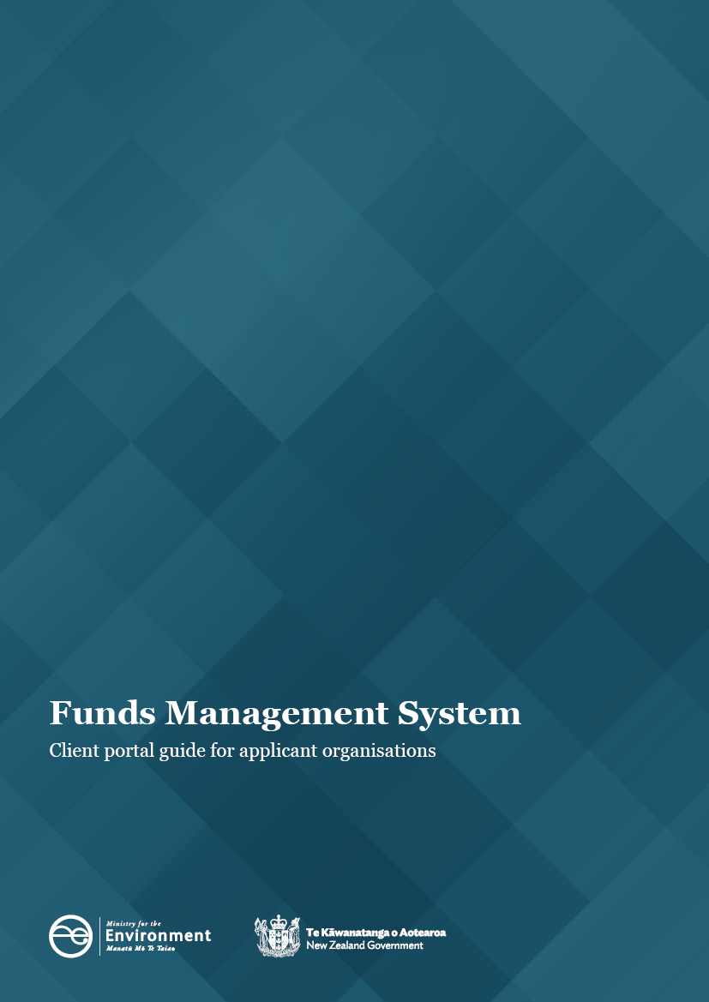

This document may be cited as: Ministry for the Environment. 2022. Funds Management System – Client portal guide for applicant organisations. Wellington: Ministry for the Environment.

Published in November 2020 by the
Ministry for the Environment
Manatū Mō Te Taiao
PO Box 10362, Wellington 6143, New Zealand
Updated November 2022
ISBN: 978-1-99-102587-6
Publication number: ME 1693
© Crown copyright New Zealand 2022
This document is available on the Ministry for the Environment website: environment.govt.nz.

Contents
The FMS client portal for applicant organisations 4
Getting started 4
Finding your way around the client portal 6
How to register as an FMS user via RealMe 8
How to register an account for your organisation 12
When you are not sure if you are already registered 12
How to create an account if your organisation isn’t already registered 13
How to save the accountable officer’s details 14
How to log out of client portal 14
Managing your organisation’s account 14
Roles overview 14
Nominated contacts 15
How do I invite others to join my organisation account? 15
How do I invite others who are already listed? 16
How to update your organisation account details 17
How to update your user profile details 18

The FMS client portal for applicant organisations
This guide supports applicant organisations using the Ministry for the Environment’s Funds Management System client portal to apply for waste investments funding and report on projects that are awarded funding. It covers:
1. getting started
2. navigation and terminology
3. registration via RealMe
4. registering an account for your organisation.

Getting started
The client portal is the external facing component of our Funds Management System (FMS). Through the client portal, organisations can apply for open grant funding rounds and provide the information requested for any successful applications.
Before you can use the FMS, you will first need to register as an FMS client portal user and you will need an account for your organisation.
Note:
The full version of this guide will be available once you have set up your FMS account.

Client portal terminology
Some of the key terms used in the client portal are:
- RealMe is a username and password management service provided by the Department of Internal Affairs. It allows you to use one username and password across many government digital services
- user profile is your own information
- contact is the contact details for anyone linked to your account
- account is the account for one organisation; you can belong to multiple organisations (for example, if you are a consultant or adviser)
- project is any application you make for grant funding, successful or unsuccessful
- report is an online form you need to complete to provide progress or other information about any successful project the Ministry is funding
- key contact is the person the Ministry will contact about any application, or funded project
- accountable officer is the signatory for your organisation.

Colour coding
Information on the forms is colour coded to help you quickly identify what type of information is displayed.
Section headers are shown in dark blue
Help text is shown in green
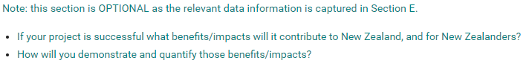
Read only fields are displayed with a blue background
Questions and field hints are shown in grey

Finding your way around the client portal
Once registered, your organisation’s homepage will be displayed. Wherever you are in the client portal, click on Home to get back to your homepage.
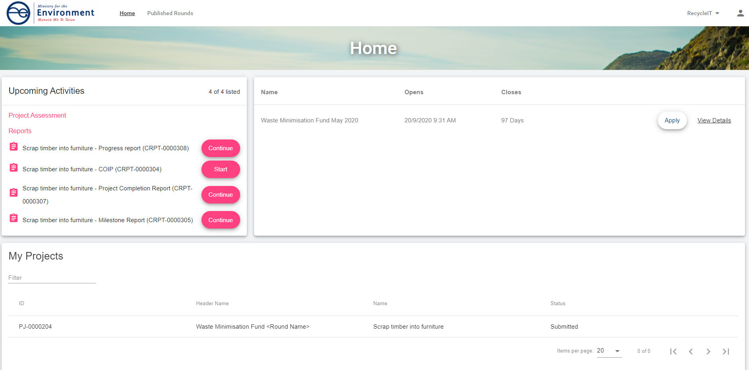
Manage your organisation account, or your own user profile here – on the top right of the homepage:
Events published, such as a grant round you can apply for are displayed here:
My Projects lists all draft applications you have started and the applications you have submitted. You can click on these application links either to resume a saved draft application, or to view a submitted one. If you have many application links, use the navigation options at the bottom of the My Projects section.
Reports will list any report we have sent you to complete.
Project Assessment is a section reserved for our panel members who also use the client portal.

How to register as an FMS user via RealMe
Before you can access the client portal, you will need to register. FMS uses RealMe to manage your login details. To register for FMS, you will first need a RealMe account.
If you already have a RealMe login, go to https://fms-cp.mfe-enquire.cloud/login and enter your RealMe username and password. Then login.
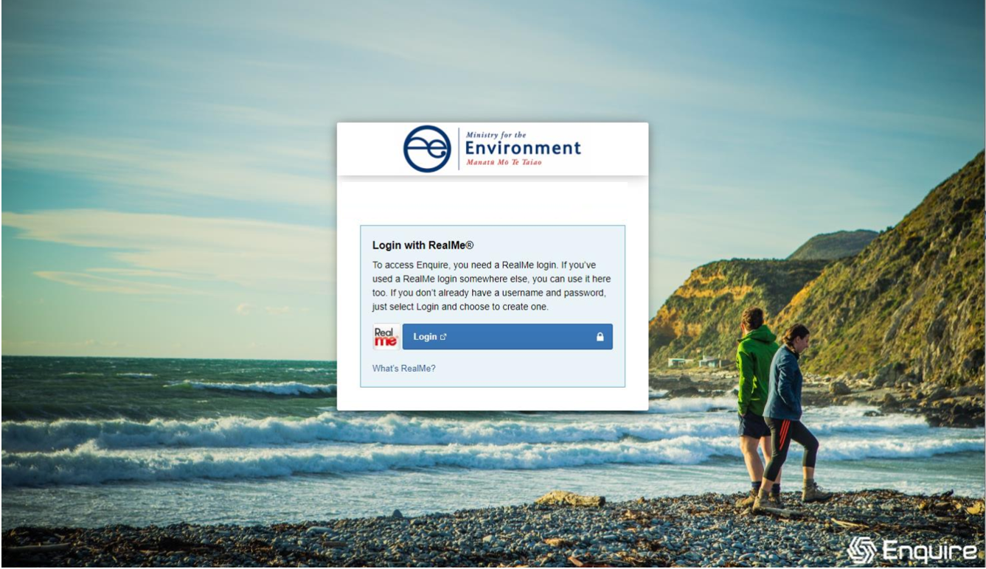
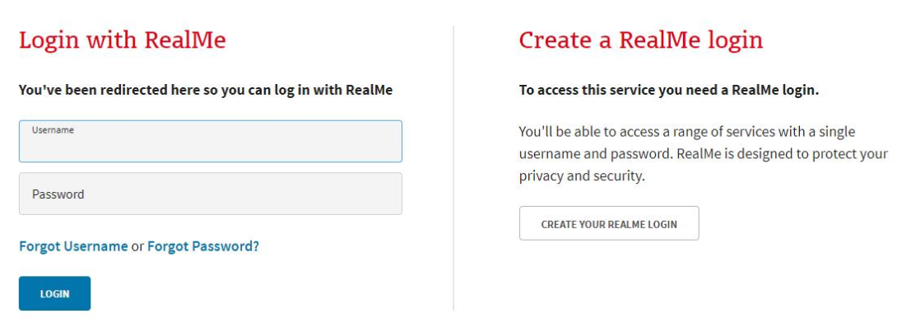
If you do not have a RealMe account, you will need to create one. Select Login, then select Create a RealMe login.
Complete the RealMe registration form. This will require you to provide a mobile number and alternative contact number in addition to a number of security questions to help you if you forget your RealMe username or password. Optionally, you can choose to add a PIN number to your RealMe account and submit.
If you are unsure at any stage of the RealMe process, refer to the RealMe help at: https://www.realme.govt.nz/help/.

Completing the 2-factor authentication requirements
RealMe requires you to provide either a mobile phone number or to use the Google Authenticator app to verify your registration. If you do not have Google Authenticator, but wish to use this option, then you will need to download it to your smartphone from your app store.
Once verified, each time you log in, RealMe will send you a unique code to your mobile (by text or the Google Authenticator app). To complete your login to FMS, you will need to enter a valid code.

Completing your FMS registration
Once you have registered with RealMe, you will be redirected back to FMS. RealMe does not share any of your personal registration details with FMS. It manages your username and password so that you do not need a different password for FMS than other New Zealand Government systems that use RealMe.
When you login to FMS using your RealMe login and password for the first time, you will be asked to complete an FMS user registration form. Please provide your contact details.

Register with FMS
Complete the FMS registration form with your contact details for grant applications/projects.
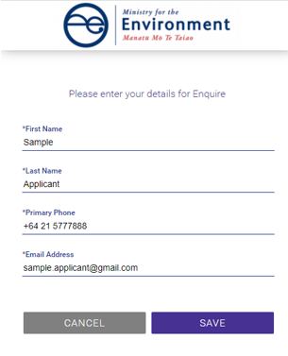

Complete your user profile
Your user profile will ask you for a few extra details such as your title and address. If you have any issues with the address finder, select the location icon to enter an address manually.
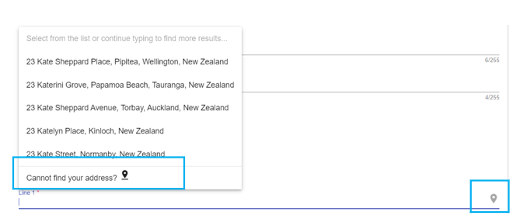
The acknowledgement response must be ticked before you press Save. This will provide further information about your registration.
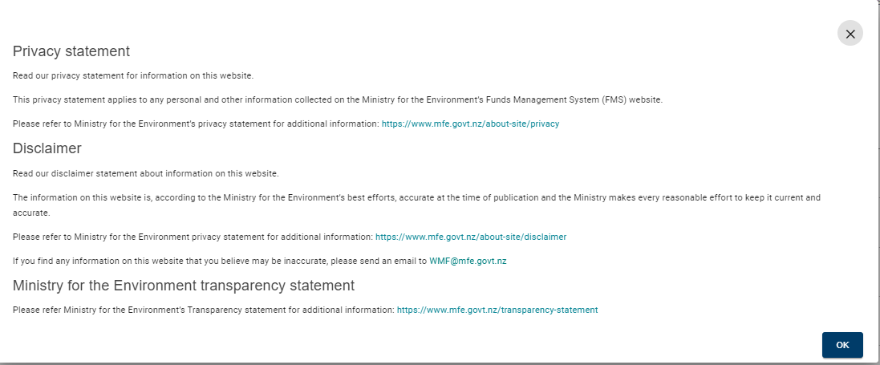

How to register an account for your organisation
Once you have registered as a user, you can create an account for your organisation. This will enable you to apply for grant funding on behalf of your organisation.

When you are not sure if you are already registered
Your organisation must only have one FMS account. If your organisation is unsure of its registration status, please contact us before creating a new organisation account. We can help you to connect your existing organisation account to your user login.
If your organisation has been registered previously and your account includes your NZ Business Number, FMS will prevent you from accidentally re-registering.
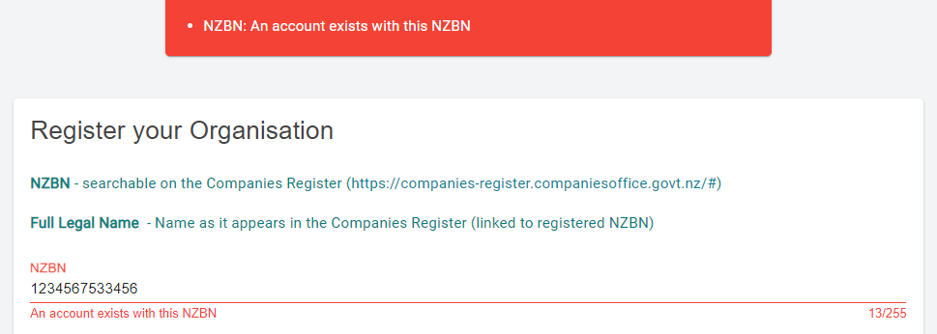
If someone else in your organisation has already registered your organisation account, this registered user can invite you and other staff to join the organisation’s account in the client portal.

How to create an account if your organisation isn’t already registered
From the Account Selection screen, select the Organisation option. Select Register to create a new organisation account.
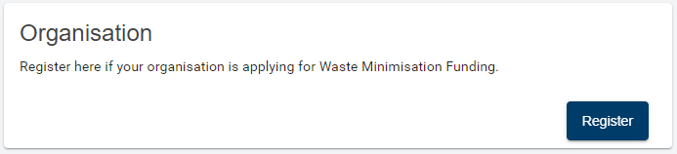
Complete the Register your Organisation form and Save.
Help text is shown in green.
By default, you will be listed as the key contact for your organisation and be assigned the role of account administrator. This role can be re-assigned later to another contact.
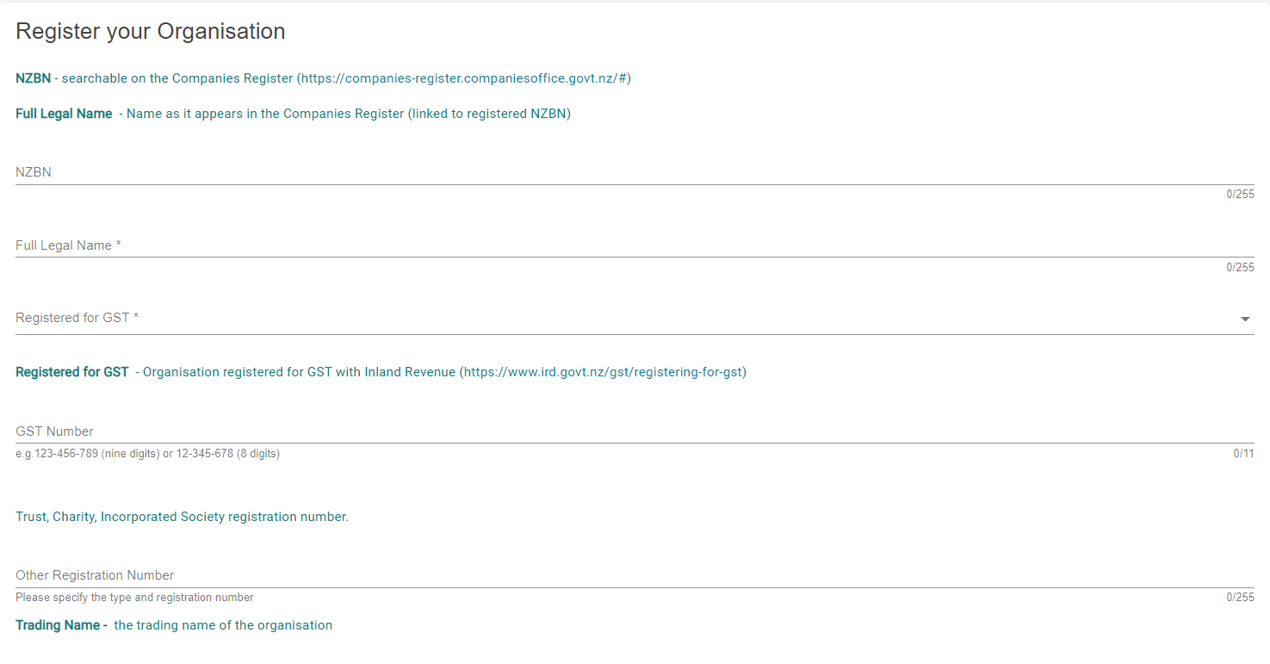

How to save the accountable officer’s details
If you are not the organisation’s accountable officer, then complete that person’s details and Save Contact. You will be able to invite this contact to join your organisation account at a later step.
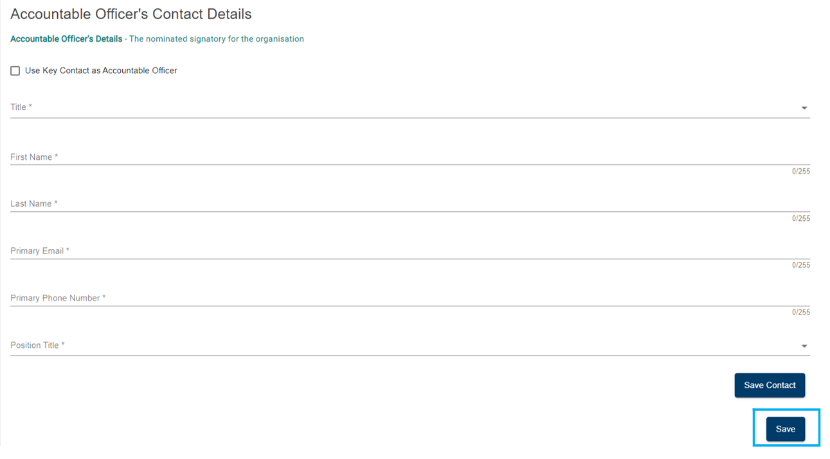

How to log out of client portal
Select the profile icon at the top right corner of the client portal, then Log Out.

Managing your organisation’s account

Roles overview
You may need to invite others to the client portal to make applications on behalf of your organisation or to collaborate on reports. The FMS allows you to assign different roles to help you manage what the contacts you invite to your account can do.
- An account administrator can update your organisation’s information and manage who has access to your organisation’s account.
- A standard user can view your organisation’s information and collaborate on the completion of an application form or a client report.
You can assign these roles to as many contacts as you need to effectively manage your account. At a minimum, your account must always have an account administrator.

Nominated contacts
Your organisation should nominate one contact each as:
- key contact – who will receive any notifications sent by the FMS
- accountable officer – normally the signatory for your organisation, this is the person who has overall accountability for the applications and reports submitted by your organisation.

How do I invite others to join my organisation account?
You must be an account administrator to invite contacts to your organisation’s account.
Click on your account name and then select Account Details.
If you do not see the person you wish to invite listed in the Contacts tab, select Create Contact.
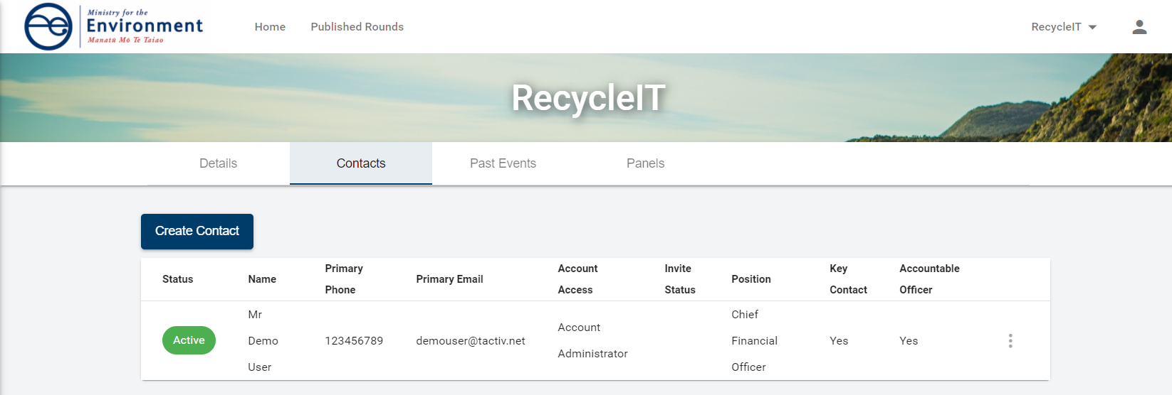
Complete the Create Contact form and select Send Invitation.
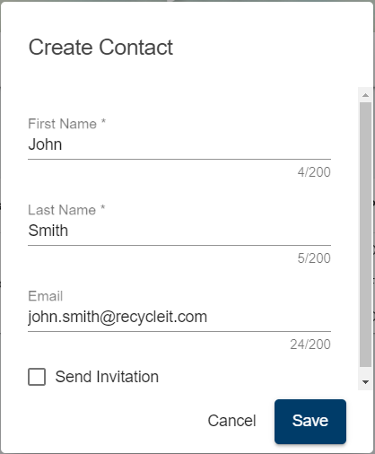
Select the Role in Account to assign then Save. An invitation email will be sent to the contact on behalf your organisation.
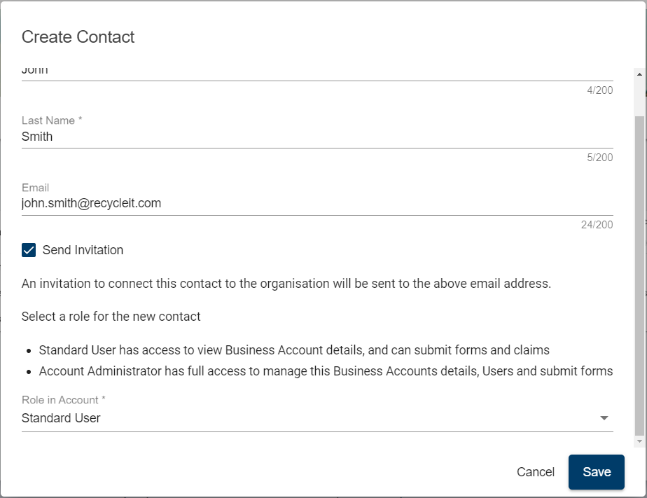

How do I invite others who are already listed?
If the person you wish to invite has already been created and shows in your contact list, select the more menu next to their name.
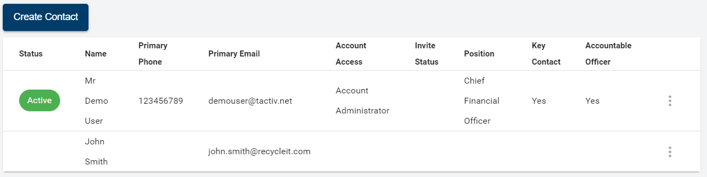
Then select Invite.
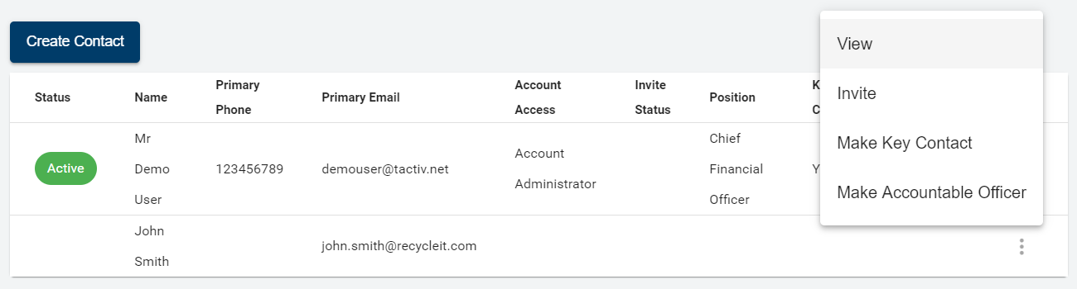
Select their Role in Account and Invite. An Invitation email will be sent to the contact on behalf your organisation.
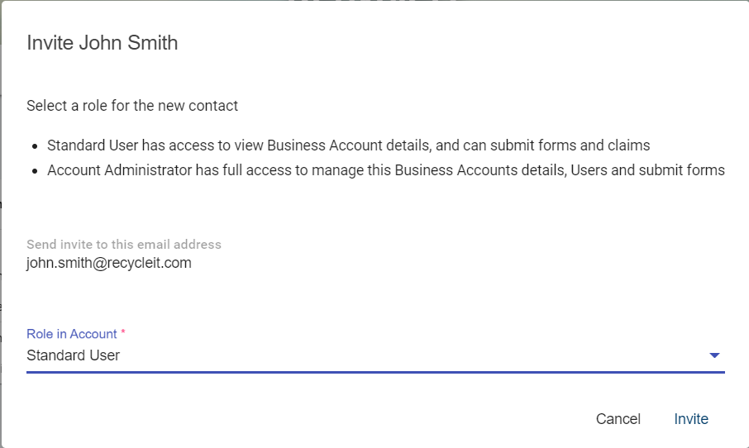

How to update your organisation account details
Select Account Details from the drop-down menu under your organisation’s name.
Select Edit on the card to update.
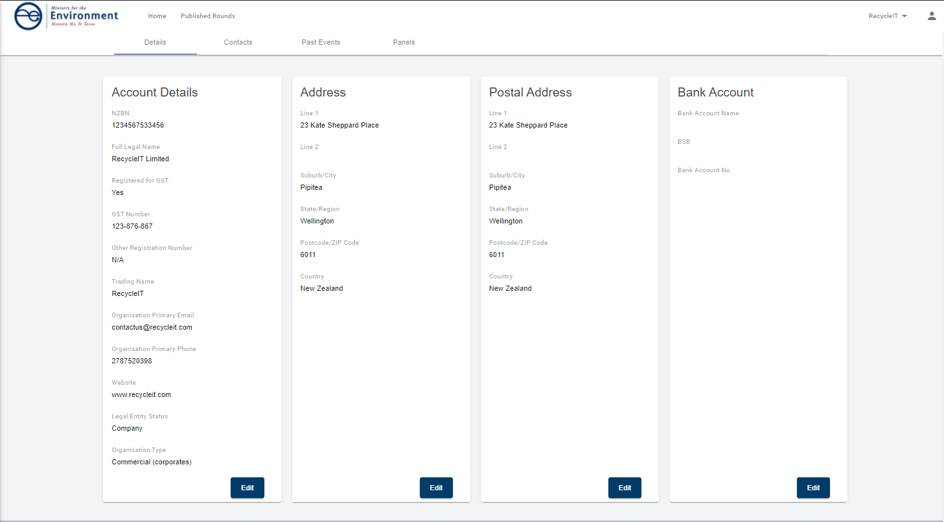
Make the required changes and select Save.
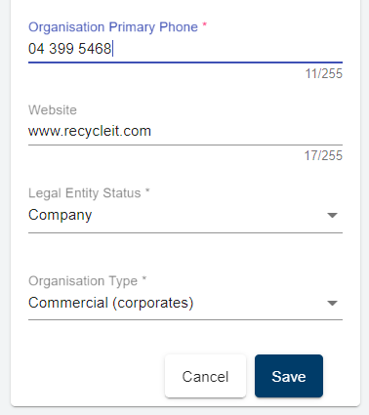
Organisation details will show the updated details after selecting Save.

How to update your user profile details
To update your user profile, click on the profile icon and then select User Profile.
Select Update at the right bottom of the Your User Profile card. If you are updating your email address or phone number, use the Update Email and Update Phone options.
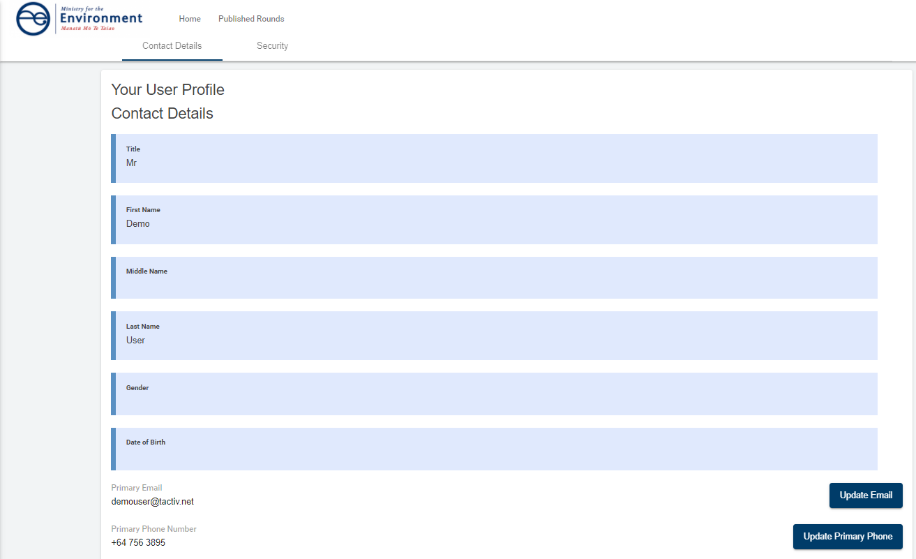
Make the necessary updates and then select Save.
Your user profile will now show the updates.
Note:
The full version of this guide will be available once you have set up your FMS account.

