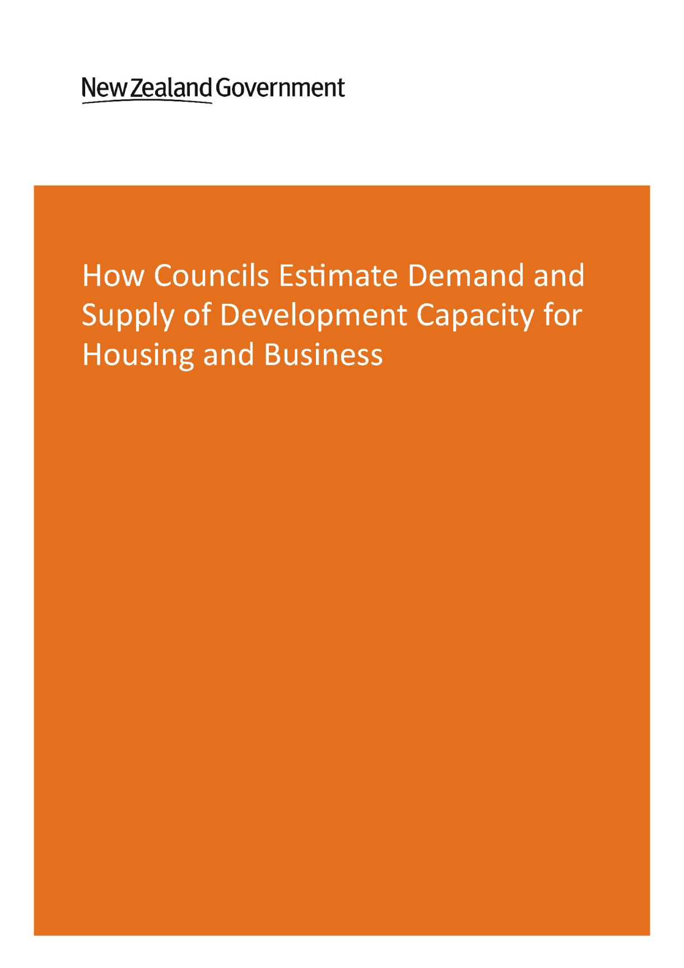

This document may be cited as: Ministry for the Environment, 2016. How Councils Estimate Demand and Supply of Development Capacity for Housing and Business. Ministry for the Environment: Wellington

Published in July 2016 by the
Ministry for the Environment
Manatū Mō Te Taiao
PO Box 10362, Wellington 6143, New Zealand
ISBN: 978-0-908339-46-4
Publication number: ME 1249
© Crown copyright New Zealand 2016
This document is available on the Ministry for the Environment’s website:
www.mfe.govt.nz.

Contents
1. Executive summary 5
2. Introduction 7
2.1 Information sources and attribution 8
3. Definitions 9
4. Role of information in council decision-making 11
4.1. Purpose of forecasting demand and capacity for residential and business land 11
4.2 Quality of information translated into decisions 12
4.3 Collaboration between councils that share jurisdiction over an urban area 13
5. Residential demand forecasting 15
5.1 Outputs 15
5.2 Residential demand methodology flow chart 16
5.3 Inputs: population and household growth projections 17
5.4 Estimating demands for different types of dwellings 18
5.5 Residential demand in existing urban areas 18
6. Residential development capacity analysis 20
6.1 Outputs 20
6.2 Residential development capacity methodology flowchart 20
6.3 Estimating capacity for greenfield development 22
6.4 Estimating capacity for infill or redevelopment in existing urban areas 22
6.5 Development feasibility and likelihood 23
7. Business land analysis 25
7.1 Outputs and impact on decisions 25
7.2 Estimating demand for business space 26
7.3 Measuring business land development capacity 27
8. Monitoring 30
8.1 Monitoring residential development capacity 30
8.2 Monitoring business development capacity 31
9. Costs to councils 34
9.1 Costs associated with assessing residential development capacity 34
9.2 Business forecasting and monitoring costs 35

10. Peer review and transparency of information 36
10.1 Transparency of process and reporting 36
11. Suggestions for the national policy statement 37
12. Conclusions 38
Appendix 1: Key informants 39
References 40

Executive summary
This report provides information about the way that nine ‘high growth’ councils in New Zealand estimate demand for housing and business land, and how they measure the development capacity available to meet that demand. The report summarises information provided by council officers and publicly available council reports and plans on the work carried out by councils to date. It also reflects the views of some participants about the adequacy of the information or how it is used; these are the personal views of interviewees, who are generally technical experts engaged in growth modelling at the moment, and do not necessarily represent the views of the councils they are employed by.
The work was undertaken to support the proposed National Policy Statement on Urban Development Capacity (NPS-UDC). Development capacity means the capacity of land available for development, that is, or is likely to be, supported by infrastructure, and taking account of all of objectives, policies and rules that constrain or enable its use.
Estimates of demand for, and supply of, development capacity are very important inputs to planning decisions, especially in high growth urban areas. This appears to be recognised by the planners and elected members of the councils reviewed. The resources applied, methods used and the uses of the information vary across different councils.
All of the councils surveyed use the information first and foremost for long-term strategic and infrastructure planning. The information is also an input to resource management planning decisions but the extent and way that this happens varies. The strength of connection between technical experts, planners and decision-makers affects how they use and understand the information.
Auckland Council invests the most, and undertakes the most complex and comprehensive modelling to forecast demand and supply of development capacity. This reflects its much larger size, and the scale and complexity of long-standing growth pressures. All of the councils surveyed use external consultants to varying degrees to assist them in doing this work.
The data inputs and methods used to estimate demand for housing at the aggregate level are similar across councils. Population and household projections are used to forecast the total number of dwellings required over given periods of time. Councils outside Auckland have concerns with Statistics New Zealand projections, and commission additional work to modify these or generate additional projections.
Most councils surveyed estimate how demand for housing might be distributed spatially within their jurisdiction, although the focus for most is on estimating demand for dwellings in greenfield areas. The urban councils analysed are now beginning to follow Auckland’s established practice of estimating the demand for new dwellings in existing urban areas. These councils also estimate demand for different types of dwellings (eg, standalone houses versus apartments). Currently only Auckland Council is modelling market demand in different price brackets, however. All of the councils surveyed calculate the capacity for future development usually in terms of the number of dwellings that could be developed, or number of years of demand that could be met. There is diverse practice, however, in how they do this. Some councils only calculate ‘theoretical’ capacity enabled in resource management plans and serviced with infrastructure. Others apply discount factors to take account of the fact that not all plan-enabled, serviced land will be developed. Recently, Auckland Council, Tauranga City Council, Wellington City Council and Queenstown-Lakes District Council have also begun to factor in how much plan-enabled capacity is commercially feasible to develop, to varying degrees. Christchurch City Council does this on an ad hoc basis.
Several of the councils surveyed invest in cross-boundary evidence to support joint strategic planning (such as SmartGrowth, FutureProof and the Greater Christchurch Urban Development Strategy). These do not however necessarily produce single forecasts for demand and capacity that are agreed by councils and infrastructure providers and subsequently reflected in resource management plans.
The councils surveyed place much less emphasis on forecasting business land demand and capacity than housing, and tend to rely on external consultants for this work. Forecasting business land demand and capacity is very challenging because of the diversity of demands for business space, the difficulty of forecasting local economic development, and poor data.
Councils also tend to devote less resource to monitoring what is happening on the ground, as well as reporting this, than to forecasting the future.
While there are good practices to build on, there is certainly scope to improve the information underpinning planning decisions about development capacity in urban areas. The NPS-UDC could encourage or require councils to:
- improve their understanding of land and development markets and how planning decisions affect them
- estimate current market demand for different locations and types of property (including business land), and the commercial feasibility of development ( as well as estimating projected future demand)
- use information provided by price signals to undertake frequent monitoring to gain a better understanding of development and land market conditions
It could also provide more common terms used to describe the availability of development capacity. These requirements would be most effective if the NPS-UDC was supported by an implementation programme, including guidance developed with councils.

Introduction
This report summarises the findings of research commissioned by the Ministry for the Environment (MfE) and the Ministry of Business, Innovation and Employment (MBIE) to support the development of a National Policy Statement on Urban Development Capacity (NPS-UDC).
The report describes how councils estimate demand for housing and business land and how they measure the capacity available in their areas for meeting that demand, or development capacity (refer to section 3 for a definition of development capacity). It also provides a broad evaluation of how this information is used in resource management decision-making. In general, it is a key part of the evidence base used by councils when they make resource management planning decisions that affect development capacity.
The research describes, at a high level, the following attributes of the work of councils to estimate demand and capacity:
- data inputs
- methodologies (ranging from one-off pieces of research, through to sophisticated models that can be used to test the outcomes of different planning rules and development controls)
- the extent to which councils do work to understand the interaction between planning and the market (and if so, what and how)
- the extent to which councils monitor the market, and the impact of their plans
- the level of integration between different experts within councils (technical experts and strategic, regulatory and infrastructure planners)
- the extent of any collaboration between councils
- resources applied
- the way that councils use the information, and the impact it has on planning decisions.
The research focuses on the similarities and differences in practice of nine ‘high growth’ councils and groupings of councils in New Zealand. These are the regional councils and territorial authorities that are currently projected to experience higher than average population growth: Auckland Council, Hamilton City, Tauranga City, Greater Wellington, Wellington City, Christchurch City, Selwyn District, Greater Christchurch and Queenstown-Lakes District. MfE and MBIE also contacted the Bay of Plenty Regional Council, Waimakariri District and Waikato Regional Council who were either unable to participate or considered that other councils were better placed to do so.

2.1 Information sources and attribution
The report summarises and evaluates the practices of councils based on information provided by interviewees, and publicly available council reports and plans. The report contains statements which are the views of MfE and MBIE based on an interpretation of publicly available information and the views shared by interviewees. None of the interviewees have been asked to endorse the statements in the report.
Several of the interviewees offered useful perspectives on areas where the national policy statement could improve or build on existing practice. It is important to note that the interviewees are a mixture of technical experts and planners involved in growth modelling at the moment, and the views they expressed do not necessarily represent the views of the councils they are employed by. A full list of people interviewed for this report is attached at Appendix 1, while a list of reports is listed in the References. MBIE and MfE thank the individuals and organisations who provided information and their views.

Definitions

Development capacity
Development capacity is the quantitative capacity for development on land, including the capacity to build ‘up’ as well as ‘out’. Residential development capacity can be expressed in a variety of different ways, including:
- the total number of dwellings
- hectares of land
- the number of years of estimated demand that can be accommodated.
Not all of these are comparable or are interpreted the same way. Business development capacity is often expressed in gross floor area (GFA) of vacant business land.
Beyond this, there is considerable variation in how councils define and calculate development capacity, and how this relates to development on the ground. The following diagram provides a notional illustration of:
- ‘plan-enabled’ capacity
- capacity that is serviced with infrastructure
- ‘commercially feasible’ development capacity
- development that actually occurs.
The ‘likelihood’ of development is another concept used to understand development capacity.
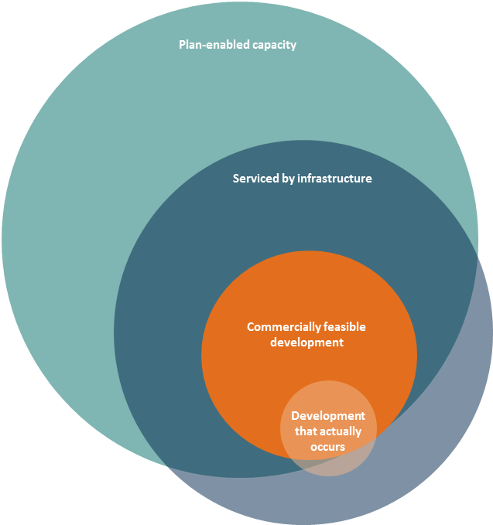

‘Plan-enabled’ development capacity
Plan-enabled development capacity is the amount of development capacity allowed by resource management plans within a council area, once all of the rules and development controls are taken into account (eg, overlays, zones, growth limits, height limits, etc). Plan-7enabled capacity may include:
- zoned, undeveloped land in green fields areas that is not yet serviced with infrastructure
- zoned, undeveloped land that is serviced with infrastructure
- zoned land in existing urban areas that already developed, but could be redeveloped to a greater height/density or for a different use under the rules.

Land that is serviced with infrastructure
This is land that is connected to the transport and water, wastewater and stormwater networks. Some councils specify certain standards of service that must be met, and/or other infrastructure. Existing infrastructure might theoretically support development (eg, such as 30-storey buildings) that is not permitted by the resource management plan.

‘Commercially feasible’ development capacity
Commercially feasible development capacity is plan-enabled capacity that developers could make a commercial return on at a particular point in time, given a certain set of assumptions about the costs of development and the necessary return. it is usually assessed at the current time or in the short-term; assumptions about commercial feasibility in the medium and long-term necessarily become less certain and more speculative in nature. Commercial feasibility takes into account likely market demand and therefore sales revenue, and costs, of building properties of particular types and scales in particular locations. Commercial feasibility is not a universally applicable concept, as social housing providers, for example, will have quite different development drivers.

Business land
Business land is land that is specifically zoned for productive economic uses. Every council has a distinct zoning typology, but ‘heavy industrial’, ‘light industrial’, ‘business park’ and ‘retail’ zones are common. Many councils have ‘mixed use’ zones that allow a mix of different types of businesses and often also residential development. Some productive economic uses take place in areas that are not specifically zoned for it eg, home childcare.

Greenfield land
Greenfield land is undeveloped land that is or has been used for agricultural or similar uses, but is zoned or will be zoned for development in future. Greenfield land is often located on the periphery of an established urban area and not necessarily yet served with infrastructure.

Existing urban land
Existing urban land is developed land in an existing urban area that has some potential for redevelopment.

Role of information in council decision-making

4.1. Purpose of forecasting demand and capacity for residential and business land
Good information is essential for good decisions, especially decisions that are long-lasting and can impact living standards and shape behaviour and investment decisions.
Councils in New Zealand make such decisions in relation to their most significant functions:
- the provision of infrastructure, and the ongoing maintenance and operation of it, which falls under the Local Government Act 2002 (LGA)
- land use regulation under the Resource Management Act 1991 (RMA).
Land is a scarce resource and in growing urban areas increasingly so. On behalf of their citizens, councils have a long-term interest in land being used efficiently, and being allocated in a way that best meets social, economic, cultural and environmental well-being. Councils balance these objectives against their imperatives to minimise the infrastructure costs and negative impacts that development and land use can create.
In this context, all councils surveyed do appear to devote resources to information about demand for and supply of land and development capacity, through council officer time and funding for external consultants. Those with the highest growth pressures appear to allocate the most resources to it.
Most of the people interviewed for this report are technical experts involved in producing the information. Some interviewees expressed their view that other council officers (including planners) and elected decision-makers may place less value on the information and weigh it up against other matters.
All of the interviewees considered that the primary use of the information is for long-term strategic planning, and the preparation of infrastructure plans and budgets under the LGA. Infrastructure is the main driver of local government expenditure. The information may also be used to calculate development contributions to help fund infrastructure.
The information can also be used as an input to joint strategic planning processes with other councils. Some interviewees considered that joint forecasting and analysis has led to a greater degree of ‘buy in’ from decision-makers at the local territorial authority level to the wider strategic direction and outcomes of joint strategic planning processes.
While all of the councils surveyed use the information to help develop and review resource management plans, the way this happens varies. For example, some of the interviewees noted that the information may not always show up in section 32 reports, although it was not within

the scope of this research to review section 32 reports. It is possible that this reflects a view that information about the environmental impacts of development is more important than information about demand and supply of development capacity. It may also indicate that some section 32 reports do not provide sufficient information for decision-makers to understand the full costs and benefits of proposed regulations.
In Auckland, forecasting of future demand and development capacity informed the Proposed Auckland Unitary Plan (PAUP) as documented in the relevant section 32 report. It appears that the modelling approaches (and in particular the commercial feasibility of development capacity) developed significantly after notification of the PAUP, following the direction of the Independent Hearings Panel for submitters to undertake expert conferencing.
Modelling undertaken before the PAUP was publicly notified estimated that it would be sufficient to meet demand and achieve the desired urban form. However, the additional expert conferencing directed by the AUPIHP on the analysis led to further work to estimate the commercial feasibility of available development opportunities. This expert conferencing assessed different PAUP provisions using several iterations of a model developed in collaboration with property development experts. The expert conferencing and modelling provided a wealth of information about the development capacity enabled by the PAUP, but it did not result in a single view of the expert conferencing group on whether the residential development capacity enabled was adequate, or an agreed set of assumptions for further modelling.
Relatively few councils appear to be using the information generated through demand forecasting and development capacity analyses to inform decisions on resource consent applications and plan changes.

4.2 Quality of information translated into decisions
Key informants interviewed for this report generally view the information developed by or on behalf of councils as high quality and providing a robust platform to support decision-makers.
However, it appears that some analysis has been subject to criticism in submissions and hearings on resource management plans. Submissions have raised issues such as:
- the high degree of variability between council approaches
- lack of transparency around assumptions
- unrealistic future expectations for a district
- poor understanding of the property market.
Estimating demand and development capacity, however, is a complex, data-centric technical process, and this means that the results may be at risk of being misunderstood, and even misused by non-technical audiences. These audiences include council officers commissioning external consultants, planners, elected members, plan submitters and the Environment Court.
Some interviewees considered that while the assumptions and limitations of analysis are well documented, they are generally poorly understood. It may be that planners do not always have the requisite technical knowledge to scope the relevant residential or business research, and they may interpret the information differently to technical experts. They may also over-rely on partial information or information that is only a snapshot in time. This would impact on the quality of policy advice and section 32 analysis. On the other hand, when analysis is scrutinised by external experts or legal counsel it can be undermined.
It appears that the more sophisticated the evidence, the more it is debated. In addition, it places greater demands on the capabilities of both those producing and those using the work. This has been evident during the PAUP hearings, as modelling has been expanded to take into account the commercial feasibility of development capacity.

4.3 Collaboration between councils that share jurisdiction over an urban area
The following table summarises the extent to which the councils surveyed collaborate with in undertaking demand and development capacity analysis. The degree of collaboration has been assessed on the basis of publicly available information and interviewees’ responses to questions about the contact between councils. High levels of collaboration involve the use of common data, joint research and modelling of both demand and development capacity, and shared results that influence decisions. Low levels of collaboration are limited to infrequent information sharing between councils.
Table 1: Level of council collaboration across shared urban areas
Council | Collaboration across shared urban area
 | High |  |  |  | Low
Auckland | N/A
Hamilton City
Tauranga City
Greater Wellington
Wellington City
Greater Christchurch
Christchurch City
Selwyn District
Queenstown-Lakes District | N/A
Auckland Council is a single unitary authority, and therefore its collaboration within Auckland is limited to council-controlled organisations (CCOs) that provide infrastructure (which has not been addressed in this report). Separate urban markets may also have an impact each other, which means there could be a case for councils to collaborate on a wider basis. For example, there is anecdotal evidence that the Auckland market is having a strong spill-over impact on upper North Island councils.
Collaboration between councils may not always be necessary or desirable. For example, Queenstown Lakes District Council (QLDC) is facing levels of growth and growth drivers that are unique within the Otago region. As the urban area of Queenstown is not contiguous with other urban areas, in this context there seems to be little benefit in collaboration with neighbouring councils on growth management.
Most of the councils surveyed do undertake technical research with other councils to support joint strategic planning processes. Some of this work looks across the region. For example, a large body of technical work has been generated to support the Waikato Spatial Plan, which involves the regional council and 9 territorial authorities.
Other processes focus on pan-regional or sub-regional areas of high population growth:
- The Upper North Island Strategic Alliance (UNISA) between the regional and city councils in Northland, Auckland, Waikato and Bay of Plenty has undertaken work on freight, ports and industrial land.
- Future Proof is a growth strategy for Hamilton City, Waipa and Waikato Districts underpinned by technical work on population growth, infrastructure, business land and developer perceptions.
- SmartGrowth is a spatial growth management strategy prepared by a collaborative effort between the Bay of Plenty Regional Council, Tauranga City, Western Bay of Plenty District and the region’s tāngata whenua. It has produced a range of research on population ageing, housing affordability, intensification, business land, development viability and infrastructure.
- The Greater Christchurch Urban Development Strategy was produced by Environment Canterbury (ECAN), Christchurch City Council (CCC), Waimakariri District Council (WDC) and Selwyn District Council (SDC), the New Zealand Transport Agency (NZTA) and Te Runanga o Ngai Tahu before the Christchurch earthquakes. The partners have since produced a housing market assessment and a freight study, advanced land-use matters through a range of recovery plans and programmes, and are now updating the strategy.
These joint strategic planning processes provide an agreed framework for growth management which influence the transport and infrastructure decisions of individual councils.The processes do not necessarily result in resource management decisions that are integrated across councils, however.
Councils involved in these processes tend to use the same models for estimating demand, but retain their own unique development capacity and monitoring processes, which vary in terms of frequency, type and method.
For example, the councils that are part of SmartGrowth have agreed to use common population, household and labour force projections, produced by the National Institute of Demographic and Economic Analysis (NIDEA). The FutureProof councils undertake joint research, modelling and strategic planning, but decision-making and monitoring are undertaken separately by the individual councils.
The degree of collaboration will necessarily be constrained by the resources (including staff time) that councils devote to it. It is possible that political incentives for councils to act independently also mean that joint work may not be prioritised. For example, despite the common issues facing councils in the Wellington Region, there is relatively infrequent interaction between them on demand and development capacity analysis.

Residential demand forecasting

5.1 Outputs
All of the councils surveyed estimate new housing demand, and half use consultants to some degree to help them with this work.
These are generally presented in terms of the number of dwellings and hectares required over time in different locations. They typically use a horizon of between 20 and 30 years (to meet requirements for the estimates to inform long term strategic and infrastructure planning, and because Statistics New Zealand population projections are projected 25 years into the future). Some councils also estimate demand for different types of dwellings, including demand for more redevelopment or infill development in existing urban areas. Auckland and Tauranga City also estimate market demand for different price brackets of residential development to varying degrees, while Queenstown-Lakes District has done work on this in the past.
The information outputs (and the data inputs and methods used to derive these outputs) appear to vary by council depending on:
- the level of growth the individual council is facing
- the scale and scope of submissions in statutory processes
- size: larger councils have more extensive datasets from which to draw information, as well as more complex models.
Table 2: Outputs of residential demand forecasting
Council | Residential demand estimates
 | Geospatial distribution | Greenfield | Existing urban areas | Dwelling type | Market demand by price
Auckland
Hamilton City
Tauranga City
Greater Wellington
Wellington City
Greater Christchurch
Christchurch City
Selwyn District
Queenstown-Lakes
Queenstown-Lakes District undertakes relatively comprehensive residential demand forecasting for its small population base. Greater Christchurch undertakes some forecasting on behalf of member councils (depending on what the outputs are and how they are going to be used), while Greater Wellington leaves most of this analysis to the territorial authorities in the Wellington region.

5.2 Residential demand methodology flow chart
The following flow chart provides an overview of all the steps that can be taken to forecast residential demand. Most councils only undertake some of these steps.
Figure 2: Residential demand methodology flow

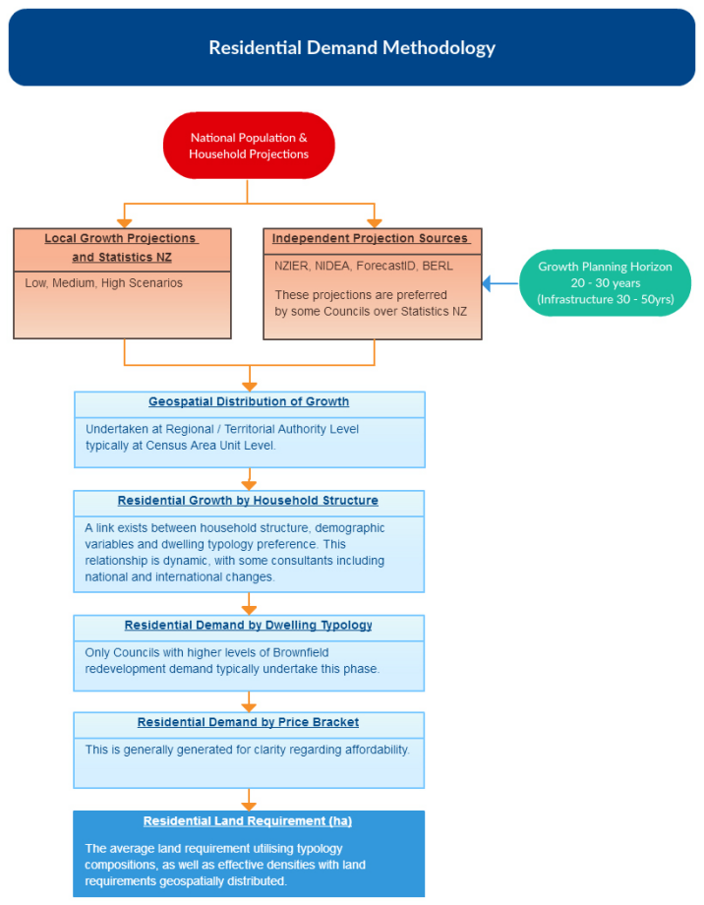

5.3 Inputs: population and household growth projections
Projections of population and household growth provide the basis for estimating residential demand; these projections are at a relatively fine level of geographic detail. Population and household projections differ from each other, reflecting the fact that dwelling occupancy rates vary between different places, and are falling over time in line with international trends. Some of the councils surveyed also use information about household structure to estimate demand for different types of dwellings.
All councils use Statistics New Zealand’s subnational population and household growth projections as a starting point. These are available as low, medium, and high scenarios which use different fertility, mortality, and migration assumptions.
However, outside of Auckland, councils (territorial authorities in general) consider these projections inadequate and source alternative projections from organisations such as ForecastID, BERL and NIDEA. For example, while Greater Christchurch are satisfied with the high-level projections provided by Statistics New Zealand, they require a greater level of detail to inform development of the Urban Development Strategy and the Canterbury Regional Policy Statement. In particular, the smaller councils have concerns about:
- accuracy, particularly in terms of geospatial distribution of growth at the sub-regional, district and suburb level, the further into the forecast period
- timeliness of the projections and infrequent updates
- accessibility of the information.
Statistics New Zealand uses information from councils themselves (about plans and consents) to inform its projections. The information provided by different councils varies, however, and there is some time delay between the provision of that information and when Statistics New Zealand releases its projections. However, one participant noted that Statistics New Zealand may not currently have the capacity to handle the amount of information that many councils include in their growth models in a consistent way.
Councils throughout New Zealand generally use ‘optimistic’ growth projections, or projections which are at the higher end of the range. It appears that these do not always match observed growth, although this may be more of an issue for places outside the areas surveyed for this study. When the projections are combined, they can exceed regional growth forecasts, reducing their usefulness for regional transport and infrastructure planning.
Some of the interviewees thought that it would be better if all councils consistently used Statistics New Zealand projections. Statistics New Zealand has the official mandate and resources to produce these projections, so they are perceived as independent and as being informed by a range of data sources. A suggestion was that the national policy statement could require all councils to use the range of scenarios (high, medium and low) in Statistics New Zealand projections, with any departure from this requiring robust justification.
Statistics New Zealand is progressing the preparation of stochastic subnational population projections, with the first projections scheduled to be published in 2017. This may help to address some of the concerns that councils have about the accuracy and timeliness of projections.

5.4 Estimating demands for different types of dwellings
Two thirds of councils surveyed break down residential demand forecasts by dwelling type (stand-alone, terraced homes, apartments/multi-unit). This is partly in recognition of changing households and preferences. In addition, different dwelling types have different needs for land area and infrastructure, which can have a significant impact in large areas. Estimates of demands for different dwelling types, therefore, provide important information for planning.
Methods to estimate demands by dwelling type vary:
- Some councils take estimates of household growth by different household types and allocate these to different dwelling types using preference assumptions based on historic data, international trends or recent research. They generally assume that provision of sufficient capacity would meet these demands, and do not factor in market demand for different prices and locations.
- Auckland and Tauranga City augment this with information about demand in different price bands based on research they have undertaken on affordability, while Queenstown-Lakes District has done some high-level work on this in the past through housing needs analysis. Auckland Council uses the most sophisticated approach, modelling demand responses to medium/high and changing prices.
In general, the participants indicated they have become more aware of these issues, and would like to improve their analysis to better account for housing demand by type and price band.

5.5 Residential demand in existing urban areas
Auckland Council (and its predecessor councils) has forecast residential demand in existing urban areas for many years. This reflects Auckland’s long-standing high growth rates, its ‘compact city’ policy and experience of urban redevelopment.
Other councils have been focused on forecasting demand for stand-alone houses in greenfield areas, however, and have only recently begun to forecast demand in existing urban areas, although there have been some ad hoc demand assessments.
The areas experiencing the highest growth areas (Auckland, Tauranga and Queenstown) are putting the most resources into this, and developing the most sophisticated methodologies. Wellington City is still developing its methodology. Auckland estimates demand for higher density multi-storey development (ie, redevelopment of existing urban land to a higher density), while other councils concentrate on infill.
Christchurch City assesses the potential for medium and high density residential development in the existing urban area, specifically in the medium density zoned areas and the central city. The results of this analysis have shaped the Central City Recovery Plan and influenced the development of the Replacement Christchurch District Plan. Existing zone and height controls were not a significant influence on this as a ‘blank canvas’ approach was taken, consistent with the desire to provide housing choice and diversity at a range of price points. Much of this work was happening pre-earthquake; however the Christchurch earthquake has significantly shaped these processes through changing the development environment, resulting in many more opportunities for development than otherwise possible. Likewise, the ‘blank canvas’ approach was only possible because of the earthquakes.

Residential development capacity analysis

6.1 Outputs
All councils surveyed produce estimates of the residential development capacity in their local areas. They express capacity in hectares of available land, the number of dwellings that could be supplied, and/or the number of years of demand for housing that could be met. Councils often distinguish between capacity that is ‘ready to go’ (ie, zoned for development and serviced with infrastructure) and zoned, unserviced capacity.
Estimates of development capacity are made to test whether projected demand can be accommodated within infrastructure and resource management plans. They enable councils to consider whether the proposed response is adequate, what the constraints are, what the market’s likely response will be and whether anything needs to change. Up-to-date knowledge of available development capacity is important for sound decision-making.
The starting point for most councils surveyed is theoretical plan-enabled development capacity, with limited checks on the commercial feasibility of development capacity. Most councils also focus on the capacity for greenfield areas to accommodate new development and where new infrastructure would most be required. Currently, the capacity for redevelopment in existing urban areas is assessed at a detailed level by Auckland, Wellington City, Christchurch City and Queenstown-Lakes District. Other councils surveyed have only recently embarked on this and their processes are evolving.

6.2 Residential development capacity methodology flowchart
The following flow chart sets out the steps in a comprehensive process for assessing residential capacity. Most of the councils in this study undertake only some of these steps.

Figure 3: Residential capacity supply methodology

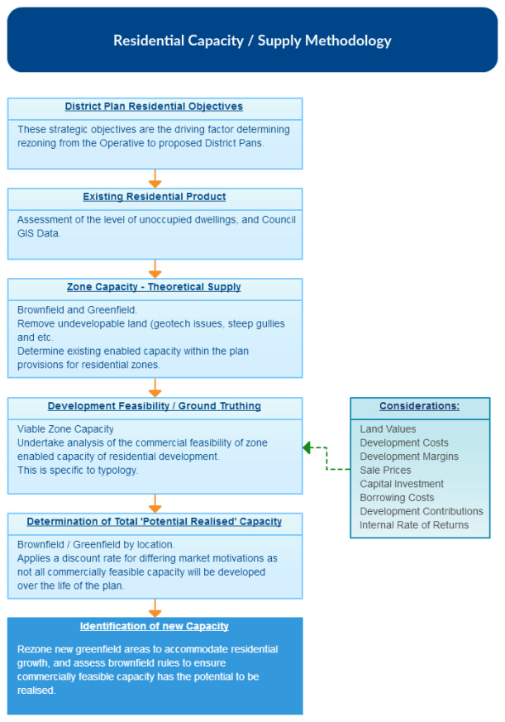

6.3 Estimating capacity for greenfield development
Different processes are used for assessing greenfield and development capacity in existing urban areas. Greenfield development capacity is commonly estimated using the following steps:
- Remove land zoned for roads (and road reserve), parks, water management systems
(ie, ponds), flood areas and small sites unsuitable for development.
- Multiply the remaining land area by an average residential density for the zone or, if a specific development proposal is planned, then apply those dwelling yields.
- Remove any known consented land parcels to obtain remaining development capacity.
- Separate into areas of serviced capacity and areas that are not serviced with infrastructure.

6.4 Estimating capacity for infill or redevelopment in existing urban areas
Methods to estimate development capacity in existing urban areas commonly include some or all of the following steps:
- Undertake a stocktake of existing urban development patterns evident in property boundaries and data (typically GIS-based, with maps and spreadsheet analysis taken from the council rating base).
- Assess the potential for redevelopment. This typically involves investigating land value to capital value ratios, with the higher the ratio the higher the propensity for redevelopment to occur. Recently developed sites would be removed during this phase on that assumption that these sites have too much capital invested in them to be redeveloped within the next 20 years.
- Assess the capacity of existing infrastructure networks and services to accommodate further urban development. For some types of infrastructure (in particular transport), whether an area has available capacity is often more complex than a simple ‘yes or no’.
- Remove physically undevelopable land parcels eg, steep gullies, land with geotechnical issues, flood areas.
- Apply a discount factor to account for the fact that only a proportion of plan-enabled opportunities will be taken up. Some councils do not apply any discount rate, while others have only recently begun to, and use a range of rates based on a best guess rather than research or monitoring.
- Overlay existing zones and density allowances within each zone.
Auckland Council, Christchurch City Council and Queenstown-Lakes have assessed brownfield capacity at a more detailed level. The reasons for this include:
- a response to land shortages
- the scale of growth
- pressures from the range of land uses
- a desire to protect certain areas (eg, for landscape value, or to achieve the council’s policy intent around urban form).
Queenstown-Lakes District assesses plan-enabled development capacity; most locations in and around central Queenstown are assessed with regard to its potential for apartment development; height is the primary consideration. Analysis of the market demand for this has resulted in the council increasing height limits in some zones to facilitate development of apartments.
Tauranga City and Hamilton City have started to carry out research on development capacity in existing urban areas (for residential uses): Hamilton City has carried out a study on the development capacity of all of its current high density zones. Tauranga City’s analysis has been confined to development opportunities in and around the central city area where early analysis has shown it is most commercially feasible. It is in the process of securing professional advice from an external consultant to better understand the opportunities and realities for redevelopment in the existing urban area.

6.5 Development feasibility and likelihood
Land owners will not take up all the development opportunities allowed by plans and supported by infrastructure over a given period of time, or as intended. Both commercial and non-commercial considerations impact the intentions of land owners, including incentives created by the financial system. Land owners and developers will actively assess the benefits of developing or not developing land for particular uses (and in certain ways) now or in the future.
The assessment of development feasibility and likelihood of development is an area of emerging practice; currently, approximately one third of the councils surveyed assess the commercial feasibility of development capacity.
Those councils that do assess development feasibility (Auckland, Tauranga City, Wellington City , Queenstown-Lakes and Christchurch City on an ad-hoc basis as needed) use external experts such as economists, property developers or valuers to assist with this; councils tend not to have all of the relevant ‘in-house’ skills or resource needed for such analysis. The councils surveyed also appear to have limited direct engagement with the development community to understand commercial feasibility.
External experts may draw on information about land values, financing costs, development costs, sale prices, capital investment requirement, capital borrowing costs, internal rates of return and developer margins to carry out these assessments.
As discussed in Section 4.1, Auckland Council has gone through an extensive process of modelling the commercial feasibility of development for each land title, using assumptions agreed during expert conferencing on the PAUP. Queenstown-Lakes District has used a spreadsheet to apply different assumptions about the relationship between commercial feasibility and plan-enabled development capacity. This led to different conclusions about development capacity, and highlighted the limited capacity in Queenstown’s high density zone. It directly influenced the decision to increase development heights in this zone before the plan was notified in August 2015.
Wellington City uses information on site-specific development costs for particular housing typologies based on information from quantity surveyors and evaluates average sale prices by area and housing typology. Developments that do not meet a certain threshold of profit margin are discounted from the assessment of development capacity.

Business land analysis

7.1 Outputs and impact on decisions
Analysis of business land provides useful information to support decisions about allocating land to different uses (eg, retail versus manufacturing, business versus residential). These decisions impact social and economic well-being and how efficiently land is used.
The councils surveyed devote less resource to understanding business land, however, than for housing. In many ways it is a more complex exercise: different types of businesses have markedly different demands for business space, it is inherently difficult to forecast economic development and activity, and the data on business land is poor. The community is generally more sensitive to and invested in the housing market and, as a result, the political profile tends to be higher for residential land. With the exception of Auckland Council, most councils do not have in-house expertise on business land and so rely on external consultants.
Auckland and Christchurch City have undertaken the most comprehensive and recent work to forecast business land demand and development capacity as part of their plan review processes. Christchurch City has undertaken a large amount of work on future business land capacity for the Urban Development Strategy. Business land modelling is also an important part of the development contributions policy in each long term plan.
As part of plan change processes over the last 10 years, Queenstown-Lakes District has evaluated business land development capacity; through the forthcoming second stage of its plan review, council officers will be looking at business land demand and development capacity in more depth. Other councils have only commissioned or undertaken work on specific sectors and not since the end of the recession in 2010.
This does not necessarily mean that their plans provide insufficient business land to meet demand. Research on business land also undertaken for the national policy statement finds that:
- In general, there does not seem to be the same shortage of capacity for business development in resource management plans for urban areas as there appears to be for housing; sufficient supply generally seems to exist in aggregate.
- In some instances outside of Auckland there may even be an over-supply of land zoned for certain types of business. This may create some different problems, including underused infrastructure assets or struggling town centres.
- For some sectors in some areas, however (eg, users of industrial land in Auckland), there may not be enough land zoned ‘in the right places’. This partly reflects the difficulty in meeting the specialised land requirements of these sectors, and their capital-intensive nature which makes relocation costly.
- Overall, it seems that planning may struggle to facilitate spatial change in urban areas in ways that encourage more efficient use of land and productivity growth.

7.2 Estimating demand for business space
The following flow chart outlines generalised methods used for forecasting business land.
Figure 4: Business land demand processes
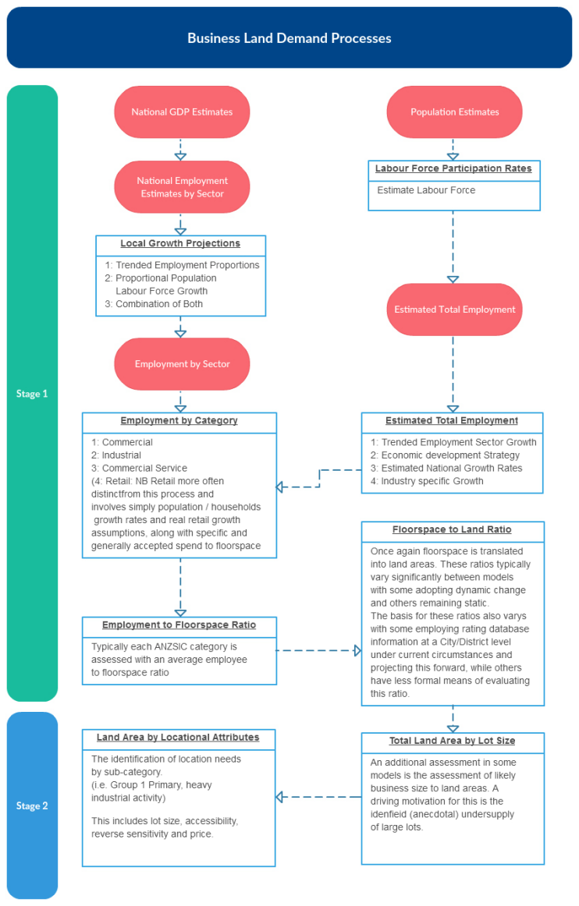
The two primary methods used are:
- to base estimates on population and household growth projections
- to use estimates of gross domestic product (GDP) and employment by sector.
The most comprehensive approach is to integrate these two methods. Auckland Council does this in a dynamic model based on changes in forecast economic structures, and it is in the process of building a more advanced model that integrates transport, land use and economic activity. This model will be able to respond to different economic inputs.
Other councils and sector-specific studies tend to draw on one of these methods depending on data availability. Statistics New Zealand estimates labour force participation, GDP and employment numbers by sector at the regional level and for large urban areas. Smaller urban areas such as Queenstown only have access to population and household projections, and must commission consultants to come up with estimates for the economic drivers of demand for business space.
Whichever method is used, assumptions need to be made in order to calculate demand for floor space of different economic sectors. The more sophisticated assumptions recognise that, for different sectors, there is wide variance in the amount of floor space needed per employee.
Outside of Auckland and Greater Christchurch, the councils surveyed focus on the demand for business land in greenfield areas. Auckland Council and Greater Christchurch have estimated total demand, including demands for different and more efficient use of land in existing urban areas.
Currently, all forecasting of demand for business land is a theoretical exercise, with no testing against the market realities of demand. Testing the commercial feasibility of business land is likely to be much more complex than for residential development (which is already complex). For example, none of the councils surveyed have explored whether location is a reason why some zoned business land remains vacant.

7.3 Measuring business land development capacity
Auckland, Christchurch City, Tauranga City and Queenstown-Lakes District have recently carried out or commissioned reviews of business land supply and development capacity (Queenstown-Lakes District as part of plan change processes over the last 10 years). These used similar processes to those used to assess residential development capacity, including:
- using land value to capital value ratios to determine the development potential of a site
- determining building area to land area ratios to quantify the extent of site coverage
- applying a ‘serviced’ or ‘not serviced’ overlay to business-zoned land.
This approach provides an estimate of the total land area available, and the total land area ‘ready to go’ at any point in time. None of the councils surveyed have undertaken formal testing to confirm whether development on zoned sites would be commercially feasible. Because the land is zoned, the councils assume they provide capacity for business. Modelling commercial feasibility for business land is likely to be more complex than for residential development.
The other councils surveyed have not recently analysed business development capacity and in general are not able to confirm how much vacant business land they have in their area, either in total, or as serviced and available land.
It appears that some councils tend to deal with business land issues reactively rather than proactively. Most thought they had sufficient business land to meet requirements for the foreseeable future, so further analysis was not a high priority.
One of the challenges in forecasting business land (both demand and development capacity) is to translate between definitions of economic activity and zoning typologies. The Australian and New Zealand Standard Industrial Classification (ANZSIC) is used to group economic activities that have similar input and process characteristics (eg, mining extracts natural resources, manufacturing processes resources, retailing is a service). Different zones are based on the environmental effects that are generated by those activities, however, such as air pollution, noise and traffic. Each council has its own classification of zones; some zones allow for a mix of economic activities.
Table 3 illustrates a typical translation of the ANZSIC classification into zones in resource management plans.
Table 3 Translating ANZSIC classifications into business zones
Economic sectors  ANZSIC | Business zones in resource management plans
Retail trade  Accommodation and food services  Information, media and telecommunications  Finance and insurance  Professional, scientific and technical services  Administrative and support services  Public administration and safety  Education and training  Health care and social assistance  Arts & recreation | Metropolitan centre  Town centre  Local centre  Neighbourhood centre  Retail  Mixed-use  General business  Business park
Rental and hiring services  Other services (eg, hardware stores, car repairs)  Manufacturing  Wholesale trade  Transport, postal and warehousing | Retail  Mixed-use  Light industry
Construction  Electricity, gas, water and waste services  Mining | Heavy industry
Interestingly, approximately half of the councils surveyed said they were aware of the issue of serviced industrial land supply being absorbed by non-industrial uses (possibly because of the practice of using more flexible business zones), but were unable to quantify the extent. It may be important to confirm whether development activity matches what is planned for to ensure that the district plan is working as intended and to address any economic impacts of such trends in a timely manner. As part of its hearings process, the Auckland independent hearing panel (IHP) commissioned a study that looked at, among other things, whether there was a match between areas zoned ‘light industrial’ in the PAUP and the actual activities taking place in them. The report concluded that there is a strong match between the light industry zone and industrial activity, but there are some areas that are outliers with a wider spectrum of activities.

Monitoring

8.1 Monitoring residential development capacity
Regular monitoring of residential development capacity and market activity will contribute to a better understanding of market trends. The sophistication and frequency of monitoring by the councils surveyed varied widely.
Table 4: Residential development capacity monitoring
 | Monitoring of residential development capacity
 | Vacant land register | Greenfield monitoring | Monitoring in existing urban areas
Queenstown
Greater Christchurch
Christchurch City
Greater Wellington
Wellington City
Hamilton City
Tauranga City
Auckland Council
Selwyn District

Table 5: Residential market activity monitoring
 | Monitoring of residential consents
 | Resource consents granted | Building consents granted
Queenstown
Greater Christchurch
Christchurch City
Greater Wellington
Wellington City
Hamilton City
Tauranga City
Auckland Council
Selwyn District
Most council participants applied practical, reasonably simplistic monitoring of available greenfield residential development capacity. Only Auckland, Queenstown Lakes District and Tauranga City currently monitor available residential development capacity in existing urban areas. Hamilton City does not have a regular programme of monitoring residential capacity in existing urban areas, but has monitored this on an ad hoc basis in recent years. Similarly, Christchurch City has historically monitored housing activity in existing urban areas.
Most of the councils surveyed maintain a vacant land register that is based on the relevant GIS system. The most common way of tracking the absorption of vacant land is to use new residential resource consents to remove land from the vacant land register rather than building consents. Christchurch City is the exception; it uses building consents issued to remove land from their vacant land register. If the consent has not been acted on over a period of time, the land will be returned to the register. Most other councils did not appear to follow up on whether the consent was actioned before removing the site from their vacant land register, however. Tauranga City also produces an annual report that looks at how much ‘infill’ capacity has been taken up and provides an estimate of remaining residential capacity. This data is used to inform the spatial allocation of future infill growth. All of the councils surveyed devoted less resources to monitoring residential development capacity and market activity than to assessing demand, and had allocated limited ‘in-house’ resources to monitoring. Some participants commented that Auckland Council’s recent experience in hearings on the PAUP had increased awareness of the issue for councils, and decision-makers were showing interest in knowing more about development capacity. Auckland has a monitoring system for market information, including property sales and Census data, but this data is not updated frequently.
No information was obtained on whether councils monitor other market information such as price information, which might indicate greater demand in particular locations, or how well land and development markets are functioning; this was outside the scope of this study.

8.2 Monitoring business development capacity
The availability or uptake of business development capacity is not well-monitored by councils, as other work generally takes priority. Monitoring of demand for greenfield business development capacity is not systematic and is typically in response to a specific issue or plan change. Similarly, only three councils (Auckland, Christchurch City and Tauranga City) carry out regular monitoring of business development capacity in existing urban areas. Updates to this monitoring are usually triggered by district plan review processes, but given little attention in between reviews.
In addition, many councils do not monitor the actual activities that occupy different business land zones, and whether they match. Around half of the councils surveyed said they were aware that industrial-zoned land may be being absorbed by non-industrial uses, but they were unable to quantify the extent. A recent analysis in Auckland has been undertaken, however, for the Independent Hearings Panel for the PAUP, which found that while retail activities are sometimes apparent on road frontages, most of the land zoned 'light industrial’ in Auckland is in fact occupied by activities of that type (for example, manufacturers, warehouses and car mechanics). The exception to this finding is that significant proportions of industrial land in a few of the highest-value, oldest parts of Auckland are now occupied by non-industrial uses.
Table 6 and 7 present information on monitoring of the supply of business development capacity and consents.
Table 6: Business development capacity monitoring
 | Monitoring of business development capacity
 | Vacant land register | Greenfield monitoring | Monitoring in existing urban areas
Queenstown
Greater Christchurch
Christchurch City
Greater Wellington
Wellington City
Hamilton City
Tauranga City
Auckland Council
Selwyn District
Table 7: Business market activity monitoring
 | Monitoring of consents for take up purposes
 | Resource consents granted | Building consents granted
Queenstown
Greater Christchurch
Christchurch City
Greater Wellington
Wellington City
Hamilton City
Tauranga City
Auckland Council
Selwyn District
Consistent with the residential vacant land register, most of the councils surveyed maintain a vacant land register of business-zoned sites. Similarly, for most councils, vacant sites are cross-checked against resource consents rather than building consents, and sites are taken off the vacant land register whether the resource consent has been actioned or not.
Few councils did anything more sophisticated than maintaining a vacant land register; for those that did, the process was generally more basic than for residential development capacity. Auckland Council and Tauranga City have more formal monitoring based on Census data and property sales, although the sporadic nature of this data limits their ability to maintain up-to-date information. For example, Tauranga City carries out an industrial land use survey which looks at rates of uptake and changes in the availability of vacant business development capacity. Hamilton City also annually surveys all business land in existing urban areas to establish vacancy rates, and uses the data to model business development capacity for setting development contributions. Auckland Council, Christchurch City, Queenstown Lakes District and Hamilton City monitor the uptake and usage of business development capacity by new greenfield developments, often as part of wider reporting on development trends. This survey work is complemented by data obtained from resource (and building) consents.
Many participants noted that information on business development capacity was not widely circulated within council. It appears that monitoring of business development capacity is not a high priority for councils. It is also possible that councils do not prioritise monitoring because there are fewer problems with business development capacity.

Costs to councils
The costs to councils associated with assessing and monitoring development capacity are not consistent on an annual basis; costs are higher during strategic planning exercises, the preparation of long term plans, and plan reviews. Similarly, it is sometimes difficult to split out the costs of monitoring development capacity from other monitoring carried out by councils. Nevertheless, participants provided some estimated costs.
The costs to councils associated with assessing and monitoring development capacity are split into staff costs and the additional, one-off costs of consultant reports. This report does not contain information on the costs of one-off external consultant reports, as they are commercially sensitive, and tend to be more discrete and infrequent.

9.1 Costs associated with assessing residential development capacity
All of the councils surveyed, with the exception of Auckland Council, noted that the cost of monitoring and work to estimate demand and supply of development capacity was low given the usefulness of the information it generates. Table 8 presents the range of council staff costs in full-time equivalents (FTEs), and the equivalent costs based on a standard salary. The figures exclude ‘one off’ external consultant costs as discussed above. This is likely to represent a higher cost to councils, as a number of more detailed pieces of work are contracted to consultants, particularly those carried out in support of a specific plan change.
The FTEs allocated depended on the extent of the work undertaken, and in particular whether there was any immediate issue to address. The ranges in table 8 exclude Auckland Council; its recent costs for modelling of demand and supply of development capacity are significantly higher and are discussed below.
Table 8: Estimates of council staff resource
Residential | Council staff resource (FTE) | Equivalent annual cost ($)
Modelling | 0.1 – 0.2 | Up to $16,000
Monitoring | 0.05 – 0.5 | Up to $40,000
FTE resource requirements are very low which flows through to low annual costs to councils. In general, councils did not allocate specific funding in annual budgets so funds had to be diverted from other council planning budgets.
Tauranga City is at the top end of the range of costs due to the monitoring and reporting system to support SmartGrowth.
The costs for Auckland Council were on a different scale compared to other councils. Over the last three years, to support hearings on the PAUP, Auckland Council has spent a figure in the order of $800,000 on modelling of residential demand, development capacity and monitoring. Most of these costs are ‘one off’ for setting up data sources and systems. Auckland Council anticipates an additional $200,000 is required to complete the process. Once established, ongoing annual costs are likely to be around $50,000 - $100,000 (1 – 1.5 FTEs).
The time involved in monitoring varies depending on whether the process is manual or automated, and whether setting up the monitoring was included. Once it is set up, the time involved in maintaining a monitoring system is relatively low, compared to the time taken to interpret and report the results.

9.2 Business forecasting and monitoring costs
Modelling and monitoring of business land capacity receives minimal specific funding and is generally done alongside monitoring and reporting on residential land capacity.
All of the councils surveyed on this question, with the exception of Auckland Council, said they had limited budget and resource for modelling and monitoring business land demand and development capacity. Updates generally only happened in response to a specific need, such as the development of long term plans under the LGA, strategic planning exercises, a plan change application, a specific business zone issue or a district plan review. This is reflected in Table 9 below, with minimal FTE resource allocated to such processes, although it should be noted that this data is based on a sample of only four council participants.
Table 9: Estimates of council staff resource
Business | Council staff resource (FTEs) | Equivalent annual cost ($)
Modelling | 0.05 | Up to $4,000
Monitoring | 0.05 | Up to $4,000
All councils agreed business development capacity is a complex issue that needs specialised economic inputs such as GDP forecasts, business productivities, changing labour force participation by sector and business sector trends. For this reason councils typically used external consultants, and these external costs are not reflected in Table 9 as they are commercially sensitive.
Councils do provide some base information to the consultants doing the forecasting, such as the location and land area (hectares) of business zoned land, but generally these inputs were minimal.
Auckland Council advised that their monitoring would need up to one FTE once the process was ‘up and running’, with an estimated annual cost of between $50,000 – $100,000.

Peer review and transparency of information
All councils surveyed carry out peer reviews of their residential and business forecasts, though the extent of this varied. Work by external consultants is not typically peer reviewed in detail by councils.
Forecasts generated by councils are typically internally reviewed by a council planner rather than an external expert. The review is focused on the extent to which the results can be used for planning purposes, or whether they address a specific issue, rather than being a critique of the forecasting inputs and assumptions.

10.1 Transparency of process and reporting
All councils make details of their assumptions and processes publicly available, in publications and on their websites, though some participants said these can be difficult to find. Councils also provide this information in response to specific requests.
All councils felt they achieved a high level of openness and transparency across all aspects of managing growth, policy responses and plan changes, as required under the Resource Management Act and other Acts (such as the Local Government Act). This applied throughout the forecasting process, from the inputs and methods applied, through to how policy is developed (and the issues the policy was responding to), and the information made available to councillors in the decision-making process.

Suggestions for the national policy statement
While not a focus of the survey, around half of the interviewees offered their views on the usefulness of a national policy statement for forecasting residential and business land demand and monitoring capacity. As with the rest of the views, it should be stressed that these were their personal views and not necessarily the views of the councils they are employed by.
Interviewees thought that any national policy statement would need to be carefully balanced. If it was too high level, it would not provide enough guidance; if too prescriptive, it could lead to inappropriate decisions and policy outcomes. It would need to be flexible enough for local issues to be taken into account.
In addition, some interviewees thought that a national policy statement should focus on what good analysis needs to do, that is:
- using a range of estimates of population growth,
- using robust assumptions
- including both greenfield development capacity and development capacity in existing urban areas
- having robust monitoring systems
- acknowledging areas that do not have well defined employment or housing markets
- addressing the feasibility of development.

Conclusions
In general, residential and business land demand forecasting and capacity analysis is an important tool and a ‘foundation stone’ for strategic planning by council. The main purpose of is generally to manage the direction of projected growth.
While the outputs of forecasting and analysis are important for strategic planning and decision-making by councils, it appears that there are differences in the weight given to these outputs. It is possible that councillors do not place as high a value on the information, because of the wider range of issues that influence their decisions. Nevertheless, all participants recognised these outputs as a core base of information on which councillors made their decisions. For example, some of the interviewees noted that the information may not always show up in section 32 reports, and that they therefore lacked a supporting rationale for the policy.
More complex analysis, including modelling which looks at economic concepts such as changing development feasibility over time (eg, some of the outputs of the expert conferencing carried out for the PAUP) will increase the challenge for councils and decision-makers in appropriately interpreting the information.
The degree of sophistication in the modelling of residential demand and development capacity varies between councils. It tends to be closely aligned to the magnitude of the growth facing a particular council. To a lesser extent, it was also impacted by the size of council and council area. Larger councils tend to devote more resources to this work and use a wider range of inputs (and input detail), whereas smaller councils use more basic inputs and methodologies.
Analysis of business land demand and development capacity does not appear to be highly prioritised for most councils surveyed. Communities are generally more sensitive to and invested in housing, and as a result the political interest in this information is higher.
The dominant focus of the analysis of business land demand undertaken by the councils surveyed (or by external consultants on behalf of councils) that appears to be on retail activities. This does not appear to be a decision based on issues with a lack of supply, but instead rather a consequence of the fact that councils consider that retail activity has more fundamental impacts on the wellbeing of communities, and more environmental effects (which is after all the premise of the RMA).
All business land demand forecasting based is theoretically based, and it appears there is limited information was gathered by direct observation testing of the commercial feasibility of development capacity.
All of the councils surveyed (with the exception of Auckland and Greater Christchurch) focused industrial land demand forecasting on greenfield land. Auckland and Greater Christchurch incorporated plan-enabled capacity within existing urban areas.
Finally, there appears to be good transparency of the information that is derived from forecasting inputs and methodologies applied, which is consistent with common council practice. However, sometimes information can be difficult to find.

Appendix 1: Key informants
- Greater Wellington – Nick Sargent
- Queenstown Lakes District Council – Blair Devlin
- Greater Christchurch – Keith Tallentire
- Christchurch City Council – David Price
- Selwyn District Council – Cameron Wood
- Tauranga City Council – Andrew Mead, Ayv Greenway
- Wellington City Council – David Mitchell, Nathan Stocker
- Auckland Council – Regan Solomon, Kyle Balderston
- Hamilton City Council – Michael Spurr
- Simpson Grierson – James Winchester (Christchurch, Queenstown, Wellington, plus a number of other councils not covered by this study)
- Property Group – Matthew Paetz (previously Queenstown-Lakes District Council)
- Market Economics – Doug Fairgray (Auckland, Christchurch, Hamilton), Greg Akehurst (Auckland, Christchurch)

References
013 Expert Group. 2015. Residential Developable Capacity for Auckland: A Report on the 013 Topic Urban Growth for the AUP Independent Hearing Panel. Auckland: AUP Independent Hearing Panel. Retrieved from https://hearings.aupihp.govt.nz/online-services/new/files/7d94SPVbOB64VQ0fbw0PvJ7eSaSwIFwonWLiqq1pMoM7.
Auckland Council. 2013. Capacity for Growth Study. Auckland: Auckland Council. Retrieved from www.aucklandcouncil.govt.nz/EN/planspoliciesprojects/reports/technicalpublications/
Pages/capacityforgrowthstudy.aspx.
Auckland Unitary Plan Independent Hearings Panel. 2014. Statement of modelling evidence of Kyle Oliver Balderston on behalf of Auckland Council. Auckland: AUP Independent Hearing Panel. Retrieved from https://hearings.aupihp.govt.nz/online-services/new/files/g2H1lRvgbyWp7WcZjYUMUqF31JpkbXfKxfvKcB7MXg2H.
Auckland Unitary Plan Independent Hearings Panel. 2014. Hearing Schedule Documents. Retrieved from https://hearings.aupihp.govt.nz/hearings (22 June 2016).
Christchurch City Council, Overview of household demand, targets and capacity, Proposed Christchurch Replacement District Plan, Residential chapter, Section 32 Report, Appendix 3, Retrieved from http://resources.ccc.govt.nz/files/TheCouncil/policiesreportsstrategies/districtplanning/districtplanreview/Appendix3-OverviewhouseholddemandtargetscapacityDOC.pdf.
Christchurch City Council. 2013. Proposed Christchurch City District Plan: Commercial and Industrial Chapters: Economic Analysis. Report for the Christchurch City Council by Property Economics. Christchurch: Christchurch City Council. Retrieved from http://resources.ccc.govt.nz/files/TheCouncil/policiesreportsstrategies/districtplanning/districtplanreview/Appendix8.3-PropertyEconomicsReport.pdf.
Christchurch City Council. 2014. Review of medium density residential zones around key activity centres and larger neighbourhood centre, Proposed Christchurch Replacement District Plan, Residential Chapter 14, Section 32 Report, Appendix 4, retrieved from http://resources.ccc.govt.nz/files/TheCouncil/policiesreportsstrategies/districtplanning/districtplanreview/Appendix4-MediumDensityAnalysisDOC.pdf.
Environment Canterbury.2013. Land Use Recovery Plan: Context paper. Christchurch: Environment Canterbury. Retrieved from www.developingchoices.org.nz/docs/corp-lurp-contextdoc-032013.pdf.
Fontein P. 2014. Auckland Industrial Land Fine Grained Analysis. Auckland: Studio D4. Retrieved from http://static1.squarespace.com/static/546d47b8e4b07b4ef0db4b25/t/
547ae229e4b0d6f577779f86/1417339445092/SD4+Industrial+FGA+2014+11+20+Final+Report.pdf.
Greater Christchurch. 2007. Greater Christchurch Urban Development Strategy and Action Plan 2007. Christchurch: Greater Christchurch. Retrieved from www.greaterchristchurch.org.nz/Strategy/index.aspx.
Greater Christchurch. 2013. Greater Christchurch Housing Market Assessment. Prepared for Greater Christchurch by Livingston and Associates Ltd. Christchurch: Greater Christchurch. Retrieved from www.greaterchristchurch.org.nz/News/PDF/Final-GreaterChristchurchHousingMarketAssessment-20130817.pdf.
Hamilton City Council. Unpublished. Submission by Hamilton City Council: New Zealand Productivity Commission’s November 2014 Issues Paper ‘Using land for housing’ 23 January 2015. Retrieved from www.productivity.govt.nz/sites/default/files/sub-using-land-for-housing-70-hamilton-city-council-377Kb.pdf.
Jones C, Smith F, Mead A, Greenway A, Taylor J. 2012. Housing Stock and Housing Demand: Tauranga City. Tauranga: SmartGrowth/Tauranga City Council. Retrieved from www.smartgrowthbop.org.nz/media/52877/draft_housing_stock_and_housing_demand_tauranga_2012.pdf.
Lees K. 2015. Land use regulation in New Zealand: Improving the evidence base. Report to the New Zealand Productivity Commission by NZIER. Wellington: NZIER. Retrieved from www.productivity.govt.nz/sites/default/files/using-land-nzier-land-use-regulation-report.pdf.
New Plymouth District Council. 2008. Final Framework for Growth. New Plymouth: New Plymouth District Council. Retrieved from www.newplymouthnz.com/NR/rdonlyres/06668575-85BD-4B5F-8D6C-BD52F5F398E3/0/FrameworkForGrowthFinal.pdf.
New Plymouth District Council. 2015. New Plymouth District Blueprint. Retrieved from www.newplymouthnz.com/CouncilDocuments/PlansAndStrategies/NewPlymouthDistrictBlueprint.htm.
Phil McDermott Consultants. 2008. Tauranga City and Western Bay of Plenty Retail and Commercial Strategy: Peer Review. Matakana: Phil McDermott Consultants. Retrieved from www.smartgrowthbop.org.nz/media/1327/Retail-and-Commercial-Strategy-Peer-Review-2008.pdf.
Productivity Commission. 2015. Using land for housing. Retrieved from http://www.productivity.govt.nz/inquiry-content/2060?stage=4.
Queenstown Lakes District Council. 2013. Review of District Plan Business Zones Capacity and Development of Zoning Hierarchy. Prepared for Queenstown Lakes District Council by McDermott Miller Strategies Ltd and Allan Planning and Research Ltd. Queenstown: Queenstown Lakes District Council. Retrieved from www.qldc.govt.nz/assets/OldImages/Files/District_Plan_Review_Brochures/Business_Zones_Capacity_15_Nov_2013.pdf.
Queenstown Lakes District Council. 2015a. Dwelling Capacity Model. Retrieved from www.qldc.govt.nz/planning/district-plan/proposed-district-plan/dwelling-capacity-model-dcm/.
Queenstown Lakes District Council. 2015b. District Capacity Fact Sheet. Retrieved from www.qldc.govt.nz/assets/Uploads/Planning/District-Plan/Fact-Sheets-and-other-resources/District-Capacity-March-2015.pdf.
Ralph A, Mead A, Smith F, Jordan L, Martelli P. 2012. SmartGrowth Strategy Update: Discussion Document: Review of Identified Residential Urban Growth Areas. Tauranga: SmartGrowth. Retrieved from www.smartgrowthbop.org.nz/media/50979/identified_uga_s_stream_report__final_091112_.doc.
Sanderson K, Stokes F, Dixon H, Fareti N, Williamson J. 2016. Business land: problems and causes. Wellington: Business and Economic Research Ltd and Ascari. Retrieved from www.mfe.govt.nz/sites/default/files/media/Towns%20and%20cities/research-report-to-support-proposed-NPS_0.pdf.
Selwyn District Council. 2014. Selwyn District Council Rural Residential Strategy. Rolleston: Selwyn District Council. Retrieved from www.selwyn.govt.nz/__data/assets/pdf_file/0004/139594/02-RRS14-Web.pdf.
SmartGrowth. 2013. SmartGrowth Strategy 2013: Spatial plan for the Western Bay of Plenty. Retrieved from www.smartgrowthbop.org.nz/2013-strategy.aspx.
SmartGrowth. 2013. SmartGrowth Strategy 2013: Part C: Settlement Pattern. Tauranga: SmartGrowth. Retrieved from www.smartgrowthbop.org.nz/media/63774/3-smartgrowth_strategy_2013_30aug_88-125.pdf.
Thompson A, Trigg A. 2015. Urban Feasibility Models: Methodology and Applications. Prepared for the Ministry of Business, Innovation and Employment by Urban Economics. Wellington: Ministry of Business, Innovation and Employment. Retrieved from https://hearings.aupihp.govt.nz/online-services/new/files/LCGAJFbTDyPdPddhRDm2nwSVZZqjVbkknN5ADqmNosLC.
Tremaine K. 2010. Future Proof Business Land Reconciliation. Hamilton: Future Proof, Retrieved from www.futureproof.org.nz/file/Business-Land-Review/future-proof-business-land-reconciliation-081210.pdf.
Waikato Regional Council. 2015. Waikato Population Projections 2013 to 2063: Report to Strategy and Policy Committee. Hamilton: Waikato Regional Council. Retrieved from www.waikatoregion.govt.nz/PageFiles/39490/Waikato_Population_Projections_Report_to_Strategy_and_Policy_Committee.pdf.
Waterfront Auckland. 2014. Environmental Scan – July 2014. Auckland: Waterfront Auckland. Retrieved from www.waterfrontauckland.co.nz/getmedia/01c99700-5262-46ed-82ed-bf575eea55ef/20140731-Environmental-Scan-July-2014.pdf/?ext=.pdf.
Wellington City Council. 2003. Northern area: A framework for growth management. Wellington: Wellington City Council. Retrieved from http://wellington.govt.nz/~/media/your-council/plans-policies-and-bylaws/plans-and-policies/a-to-z/northerngrowth/files/northerngrowth.pdf.
Wellington City Council. 2006. Quantifying the growth spine: Supply, demand and capacity for residential development in Wellington City (Wellington Urban Development Strategy, Working Paper 9). Wellington: Wellington City Council. Retrieved from http://wellington.govt.nz/~/media/your-council/projects/files/infill-growthspine.pdf.
Wellington City Council. 2010. Proposed District Plan Change 73 – Suburban Centres Review: Business Areas. Wellington: Wellington City Council. Retrieved from http://wellington.govt.nz/~/media/your-council/plans-policies-and-bylaws/district-plan/changes/active-changes-variations/files/change73-orv1chap33busobj.pdf.
Wellington City Council. 2013. Shaping up 2013: District Plan Monitoring and Research Report. Wellington: Wellington City Council. Retrieved from http://wellington.govt.nz/~/media/your-council/plans-policies-and-bylaws/district-plan/effectiveness-and-review/shapingup2013.pdf.
Wellington City Council. 2015. Wellington Urban Growth Plan: Urban Development and Transport Strategy, 2014–2043. Wellington: Wellington City Council. Retrieved from http://wellington.govt.nz/~/media/your-council/plans-policies-and-bylaws/plans-and-policies/a-to-z/wgtn-urban-growth/wgtn-urban-growth-plan2015.pdf.
Yeoman R, Huang T, Akehurst G. Unpublished PAUP Business Land: Land Demand by Activity and PAUP Supply. Report for the Independent Hearing Panel by m.e spatial and Auckland Council. Retrieved from https://hearings.aupihp.govt.nz/online-services/new/files/UA360wWBWgN8okbKeRcnrsPqpfGvVw1NSw7bIAoUA360.

Based on Statistics New Zealand medium growth projections over the period 2013-2023.
‘Greater Christchurch’ is a vehicle resourced by Christchurch City, Waimakariri District, Selwyn District and Environment Canterbury. It was set up to develop the Greater Christchurch Urban Development Strategy (UDS). A joint committee, consisting of those councils, the New Zealand Transport Agency (NZTA) and Te Runanga o Ngai Tahu (TRONT), is charged with implementing the UDS.
A report required under section 32 of the Resource Management Act 1991, which must accompany resource management planning proposals. This must define the problem, identify all options for addressing it (including the proposed plan provisions) and evaluate the costs and benefits of these options using strong supporting evidence.
Local authorities in the Wellington region are also working together to implement a Wellington Regional Strategy, and the councils of the Bay of Plenty region have a similar Bay of Connections. However, these are focused on economic development rather than joint work to support land use planning.
Auckland has relatively high occupancy rates, which are related to large family sizes for some ethnic groups, as well as the significant of its tertiary students, and also possibly in response to high house prices. Accordingly, Auckland Council has been questioning the estimates for falling occupancy.
Stochastic (probabilistic) population projections provide estimates of uncertainty. They are produced by combining 2,000 simulations of the assumptions. These simulations can be summarised by percentiles, which indicate the probability that the actual result is lower than the percentile. For example, the median projection (50th percentile) indicates an estimated 50% chance that the actual value will be lower, and a 50% chance that the actual value will be higher than this percentile. The 25th percentile indicates an estimated 25 percent chance that the actual value will be lower, and a 75% chance that the actual result will be higher than this percentile. 6 Seven alternative percentiles of probability distribution (5th, 10th, 25th, 50th, 75th, 90th, and 95th percentiles) will be available in these tables. Assumptions about fertility rates, life expectancy and migration will remain the key drivers of the projections and probabilities.
There are three different household types: one-person households, family households (including couples without children, two-parent families and one-parent families) and other multi-person households.
Tauranga City Council applies ‘target densities’ to determine residential capacity in new greenfield locations, rather than zone averages. It also monitors uptake of greenfield development to ensure residential yield assumptions are accurate.
However, local authorities recognise that redevelopment in existing urban areas is less likely than development of greenfield sites. Land in existing urban areas usually has higher land value (and therefore represent higher debt servicing costs) and are often in fragmented ownership. Redeveloping them may also involve demolition costs.
For example, manufacturing and wholesaling is very land extensive, often requiring large plots near motorways but buffered from other land uses. Meanwhile, business services firms often concentrate in high-rise buildings in main centres, to access each other and professional workers.
Business and Economic Research Ltd and Ascari 2016, Business land – problems and causes.
Work carried out by BERL and Ascari for the Upper North Island Strategic Alliance proposes a method that explicitly attributes floor areas per employee and hectare based on observed densities.
Building consents are likely to present a better picture of whether development is likely to occur than resource consents; obtaining a building consent requires some up-front investment in building and development design, whereas a resource consent does not.

