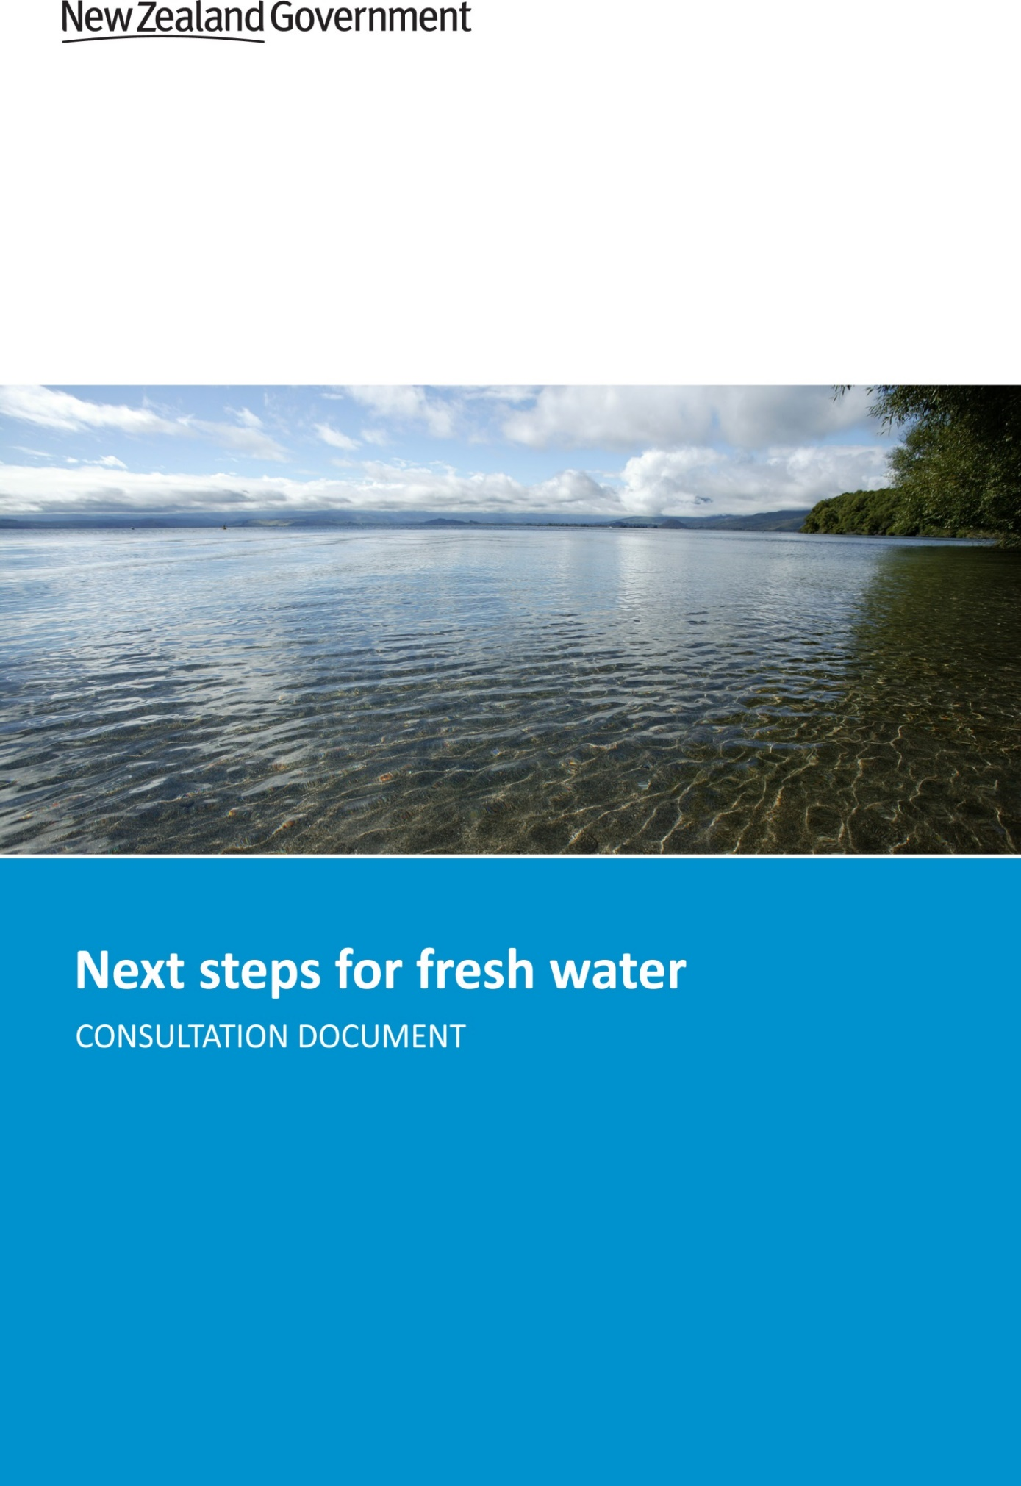

This document may be cited as: Ministry for the Environment. 2016. Next steps for fresh water: Consultation document. Wellington: Ministry for the Environment.

Published in February 2016 by the
Ministry for the Environment
Manatū Mō Te Taiao
PO Box 10362, Wellington 6143, New Zealand
ISBN: 978-0-908339-32-7 (print)
978-0-908339-33-4 (electronic)
Publication number: ME 1233
© Crown copyright New Zealand 2016
This document is available on the Ministry for the Environment website: www.mfe.govt.nz.
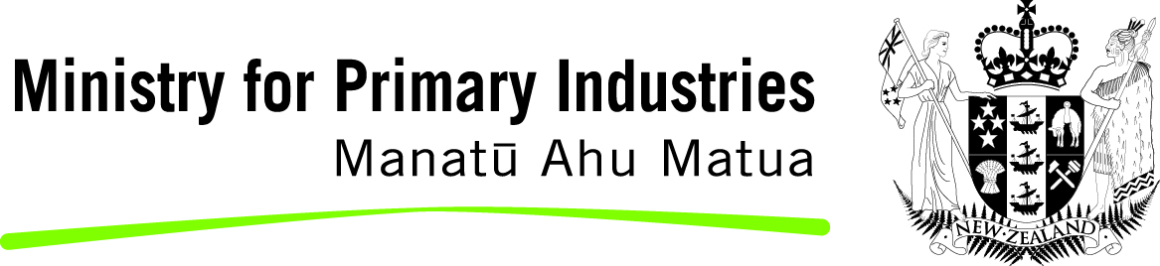
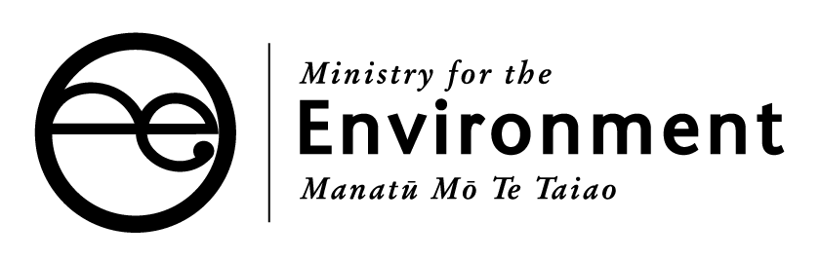

Contents
Message from the Ministers 4
Fresh water in New Zealand 6
The importance of fresh water 6
The pressures on our fresh water 6
The reforms so far 8
Proposals 10
Fresh water and our environment 11
Improving national direction 11
Proposals 12
Questions 21
Economic use of fresh water 22
A better water management system 22
Proposals 23
Questions 26
Iwi rights and interests in fresh water 27
Proposals 27
Questions 32
Freshwater funding 33
Private and public investment in fresh water 33
Proposal 36
Question 37
How to have your say 38
How to make a submission 38
Contact for queries 38
Publishing and releasing submissions 39
Questions to guide your feedback 39
Appendix 1: Proposals 40
Appendix 2: Questions 44

Message from the Ministers
This consultation document contains the next steps the Government proposes to improve the management of fresh water in New Zealand. Our objectives are better environmental outcomes, enabling sustainable economic growth to support new jobs and exports, and improving Māori involvement in freshwater decision-making. This is part of the Government’s long-term reforms which are based on supporting communities to identify and test solutions that meet their own challenges, but within a national framework.
New Zealand is richly blessed with fresh water. We have 145 million litres per person each year – six times as much as Australia, 16 times as much as the US, and 70 times as much as China or the UK. We take only 2 per cent but it is not always where we need it when we need it. This document proposes new criteria around efficient and sustainable use, supporting economic development, and encouraging good management practice, and sets out how Māori can be better involved in setting limits and planning for fresh water.
New Zealand’s water quality is generally good but there are problems we must address. Over the 25 years of the Resource Management Act 1991, councils have significantly reduced pollution from point source discharges (through pipes) for the likes of factories, municipal sewerage schemes, and from dairy sheds. However, the system has not been working in dealing with the more difficult problem of diffuse pollution. This includes nutrients, pathogens and sediments from intensive farming and from stormwater in towns.
The Government’s approach has been to work collaboratively with stakeholders, provide clearer national direction, and significantly invest in clean ups and water infrastructure. We commend the work of the Land and Water Forum whose work was pivotal in enabling us to introduce nationwide standards for water metering in 2010, the National Policy Statement for Freshwater Management in 2011 (NPS-FM), and the National Objectives Framework in 2014. The proposed next steps in this document strengthen the requirements for improved water quality and include the Macroinvertebrate Community Index in the NPS-FM. They also clarify the process for allowing exceptions for the national ‘bottom lines’ and how national standards apply to coastal lagoons.
Specific proposals include a programme to exclude stock from water bodies. We think a nationally consistent approach is more efficient than debating this issue region-by-region. The requirements, definitions and timeframes have been recommended by the Land and Water Forum. Our aim is an effective regime that will better protect freshwater quality but also one that is practical for the hugely diverse farming country across New Zealand.
A key aim has been to improve iwi involvement in freshwater decisions. These proposals are therefore the product of intensive and ongoing dialogue with the Iwi Leaders Group. Mana whakahono a rohe provides for iwi to enter into agreements with councils on how Māori can better participate in decisions on fresh water. Te Mana o te Wai sets overarching principles that are proposed to be included in the National Policy Statement for Freshwater Management. The proposed changes to water conservation orders ensure iwi have a say in how water bodies are protected.
We are also proposing to invest $100 million to improve water quality in our lakes, rivers and aquifers. The proposed funding criteria include ensuring proper measures are in place to prevent any further deterioration, that key stakeholders and iwi are involved, that others are contributing to the work, and that any funding proposal is backed by robust scientific support and advice.
Improving the management of our fresh water is a long-term task. Many of our water bodies have hydrological cycles that take decades to respond. This should not distract us from taking the necessary steps now to set sustainable limits, maximise the economic wealth within those limits, and get freshwater quality on to an improving path.
We welcome your feedback on these proposals. We must take this opportunity to do better with this precious resource.

Hon Dr Nick Smith Hon Nathan Guy
Minister for the Environment Minister for Primary Industries

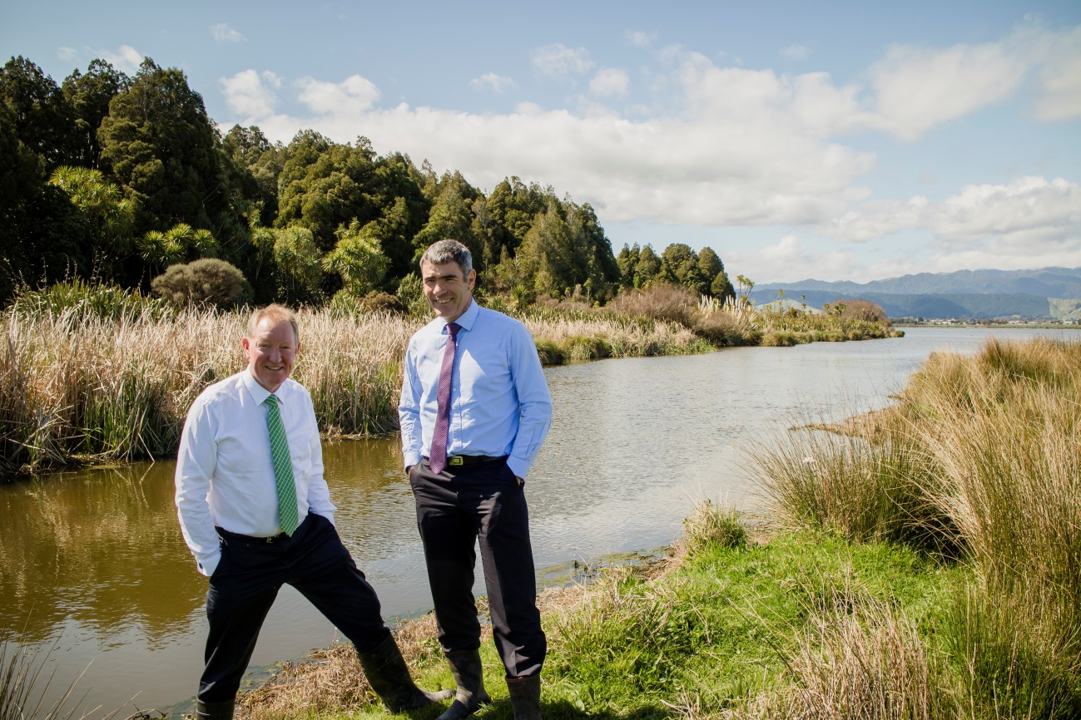

Fresh water in New Zealand
The Government’s long-term vision for fresh water
- Our lakes, rivers, wetlands and aquifers are suitable for the local and national values and aspirations of all New Zealanders, including tāngata whenua
- Fresh water is used efficiently and productively
- Freshwater quality is maintained or improved
- Te Mana o te Wai is respected and provided for with healthy freshwater resources supporting our long-term well-being and prosperity
- Our freshwater bodies are healthy places for aquatic plants and animals
- Our use of fresh water respects iwi/hapū values and honours the Treaty of Waitangi (Te Tiriti o Waitangi)
- Outstanding lakes, rivers and wetlands are protected
- New Zealanders take responsibility for their impact on fresh water and our environment

The importance of fresh water
Fresh water is New Zealand’s greatest natural and economic asset. Our lakes, rivers and wetlands are a defining feature of our landscapes, and many of the plants and animals they support can only be found in New Zealand. They are a key attraction for both domestic and international visitors, with tourism contributing $10.6 billion or almost five per cent of our GDP.
New Zealand is an expert producer of agricultural and horticultural products that are a core part of our economy and depend on reliable access to water. Meat, wool, dairy, forestry, wine, fruit, vegetables and flowers provide more than 22 per cent of our GDP, and over 67 per cent of our exports. And fresh water is a renewable source of more than half of our electricity.
Internationally, we are known and respected as world class rowers, kayakers, jet boaters, and fishers. All of us value fresh water for recreation and well-being, and regard it as a taonga, a treasure. We can all relate to the concept of Te Mana o te Wai which is about the necessity of ensuring the well-being of our lakes and rivers so they can sustain themselves and the life within them, and then sustain us.

The pressures on our fresh water
New Zealand has more than 425,000 kilometres of rivers and streams. We have about 4000 lakes and over 200 underground aquifers. While we have plenty of water per person compared to countries like Canada, the United States, Australia and the UK, it is not always where we need it when we need it. The West Coast of the South Island is the wettest area of New Zealand, whereas the area to the east of the mountains, just over 100 kilometres away, is one of the driest. Future climate projections are that this disparity is likely to become even more acute in the decades to come.
This means we need to manage our water carefully because in some places we are already approaching or exceeding limits to the amount of water we can sustainably use, and in some catchments – particularly where there is intensive land use – water quality is declining.
Our rivers, lakes, wetlands, and aquifers are affected by both natural events and human pressures. Human pressures include:
- discharges of pollutants from agriculture, industry, and urban areas into waterways
- erosion from farming, forestry, roading or building activity
- the effects of climate change such as increasing occurrences of floods and droughts
- the taking of water for irrigation and hydroelectric power generation.
These pressures can threaten the long-term health of our water resources, and the ability of water to sustain life and biodiversity – Te Mana o te Wai.
Land use and population growth have placed increasing pressure on waterways. This is especially evident with farming, because agricultural land surrounds 46 per cent of New Zealand’s rivers. Population growth has increased pressure on urban sewerage plants and pipes, and increased the level of polluting run-off from roofs and roads entering our rivers and streams.
This pressure on our freshwater resources is becoming increasingly evident:
- water quality has been declining
- water is over-allocated in some places
- decision-making can be litigious, resource-consuming, and create uncertainty
- we have lacked robust information on the impacts and outcomes of management decisions
- water is not always used or available for its highest value use
- iwi, hapū and whānau interests and values are not adequately considered in planning and resource management decision-making.
Where projects have begun to clean up or protect our iconic water bodies we are making progress, and even meeting targets several years ahead of schedule. And, where water users, communities, iwi, hapū, councils and the Government work together, we are getting better results. We’ve learned a lot from the mistakes of the past. Many of the issues we face today are a legacy of past poor or uninformed practices. New Zealanders are facing up to this reality and have big aspirations for restoring or improving water quality. We have an opportunity to improve the way we manage fresh water. We are building a pathway forward for communities to work together to protect our most important natural resource.
This issue is more complex than just requiring all water bodies to be swimmable all of the time. Water bodies frequently – in natural as well as developed catchments – breach swimmable water standards during high rainfall events, and achieving such an absolute standard would come at a cost way beyond what is realistic. Nor do people want to swim every day of the year, including when rivers are in flood. We need a more sophisticated approach that ensures freshwater quality improves but where communities, councils, iwi and business have an open and honest conversation about the implications and costs. We want an approach that improves water quality but is also realistic about the time, cost and impacts of achieving this important goal.

The reforms so far
Since 2009, the Government has been undertaking a comprehensive set of reforms to improve the way we manage fresh water in New Zealand. The reforms emphasise that local communities, through councils, are in the best position to make decisions about managing the fresh water in their region, taking local conditions, needs and aspirations into account.

A collaborative approach
The Government started by tasking the stakeholder-led Land and Water Forum (LAWF) with creating a blueprint for land and water management. LAWF released its first report in 2010, two more reports in 2012, and their fourth in November 2015. LAWF’s recommendations are the product of an ongoing collaboration involving more than 70 key water users and stakeholders across different sectors, including primary industries, electricity generation, tourism, environmental and recreational interest groups, and iwi.
This collaboration resulted in a thoughtful and cohesive representation of stakeholder views for Government to respond to. Based on the work done by LAWF, the Government has laid some significant foundations for changing the way we manage and use fresh water so it is more productive and sustainable.

Measuring what we use
In 2010, the Government introduced the Resource Management (Measurement and Reporting of Water Takes) Regulations, which apply to about 98 per cent of the total national volume of water use that is authorised by resource consents. The regulations apply to consent holders, such as a person taking groundwater for irrigation or a council taking water for water supply (but not to people who are supplied with water by a council or community supplier). Water takes of more than five litres per second must have a water meter installed by November 2016. As a result, we will have better information about how much water we are using.

Improving the way we manage fresh water
The Government responded to LAWF’s recommendations in 2011 by delivering the foundation of its reform programme: the National Policy Statement for Freshwater Management (NPS-FM). The NPS-FM provides national direction under the Resource Management Act 1991 (RMA). It requires councils to set objectives and limits for fresh water quality and quantity in a way that is consistent around the country. When setting limits, regional councils must ‘safeguard the life-supporting capacity, ecosystem processes and indigenous species including their associated ecosystems’ of fresh water. The NPS-FM also requires councils to ensure land use and water are managed in an integrated way, and that iwi/hapū are involved in freshwater management and their values are reflected in decisions about the management of fresh water. Councils are also required to maintain or improve water quality within a region.

Improving water quality
Addressing diffuse pollution is our greatest challenge for improving water quality. This will be tackled mainly through setting limits on the amount of water people can take and the level of contaminants allowed to be discharged into water. But we are also cleaning up pollution from historical activities. Since 2000, Government has committed half a billion dollars and there has been significant contributions from rates and private initiatives to improve water quality in our lakes and rivers. The Government has committed more than $350 million on projects to clean up or protect our most iconic lakes, rivers and wetlands. And we are getting results. Water quality in the Rotorua Lakes is improving, and we have achieved our goals for reducing the nitrogen load in the Lake Taupō catchment years ahead of schedule.

Using water more efficiently
Modern irrigation systems enable high-value land use and control the amount of water applied. They provide more reliable water to crops and pasture in summer. Water storage and irrigation can make land more productive and support regional economic development by making access to water more reliable, enabling greater investment in high value crops. Irrigation can help both environmentally and economically – and it is essential for communities that are subject to droughts.
The Government is investing in irrigation projects, with environmental sustainability as one of the key criteria for funding eligibility. Since 2011, the Irrigation Acceleration Fund has granted $31.8 million to support 19 projects, and Budget 2015 extended the fund by a further $25 million. Collectively, these projects provide a potential 260,000 hectares of irrigation. Other projects are at the concept development stage.
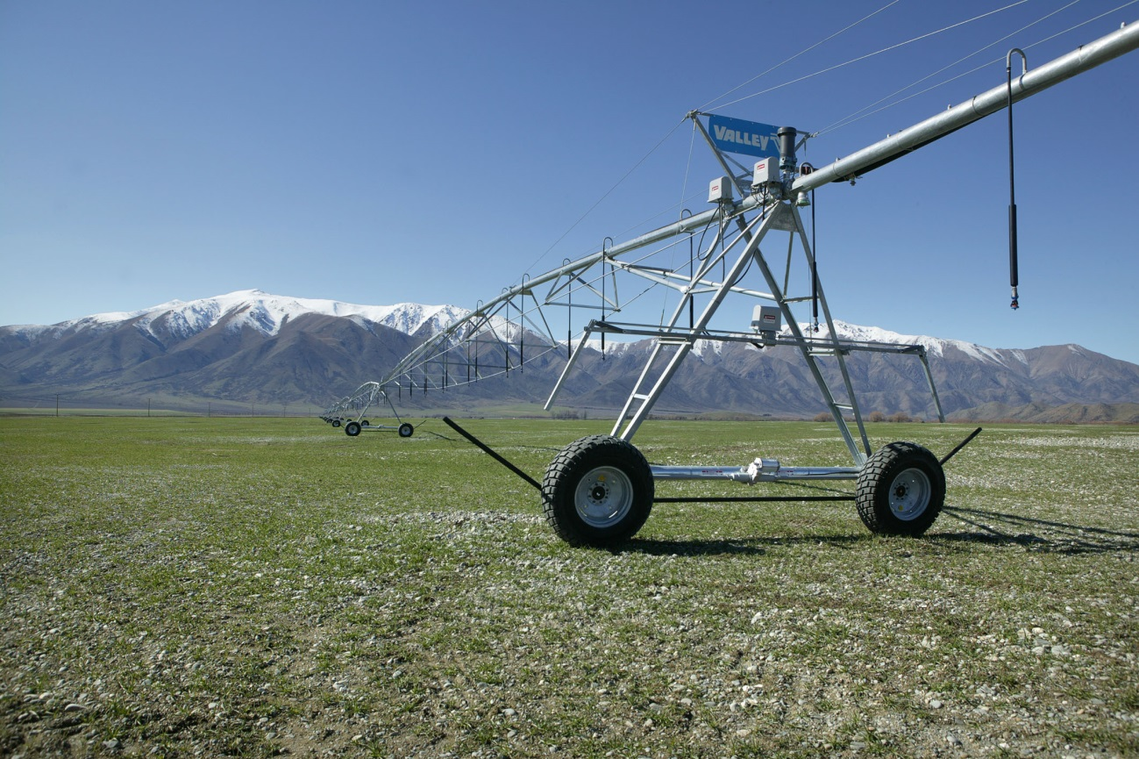

Iwi and hapū are playing an important role
The Government recognises that iwi have rights and interests in fresh water. As Treaty of Waitangi partners we are working together towards a freshwater management system that benefits everyone.
Iwi and hapū have traditional and cultural connections with freshwater resources, as well as significant economic interests across a range of industries contributing to the New Zealand economy. For iwi and hapū, core objectives are active protection of Te Mana o te Wai and upholding their guardianship (kaitiaki) obligations towards the water bodies in their rohe.

Supporting implementation
Councils are primarily responsible for managing fresh water in their local catchments. It is up to them to work with their communities and iwi to determine their region’s environmental aspirations for waterways and to allocate water for economic use. The Government is providing guidance, capability-building and other support to help implement the reforms.
We need to be realistic about timeframes. Setting freshwater limits will have long-term impacts. Communities will need to understand what their choices around water will mean for the environment, existing businesses, and future opportunities. Delays in tackling management of our water will only make environmental damage or lost economic opportunities more costly to fix, or even irreversible. Equally, the impacts of reform on water users and communities will be far reaching, so the Government needs to ensure that any proposals are workable and meet community needs. For that reason we continue to take a measured and step-by-step approach to the reforms. The proposals in this document are the next steps. We have an opportunity now to set up a way of managing our fresh water to generate new and expanded opportunities for all New Zealanders, but we need to take care that the costs and impacts are spread equitably across sectors and generations.

Proposals
The Government has set up a solid foundation for the reforms. Now, we need to build on it. The rest of this document outlines how we propose to do this, and we want your views.
Table 1: Summary of key proposals
Fresh water and our environment
Amend the NPS-FM to improve direction on:
- exceptions to national bottom lines for catchments with significant infrastructure
- using the Macroinvertebrate Community Index as a mandatory monitoring method
- applying water quality attributes to intermittently closing and opening lakes and lagoons
- what it means to ‘maintain or improve overall water quality’.
Exclude stock from water bodies through regulation.
Economic use of fresh water
Require more efficient use of fresh water and good management practice.
Iwi rights and interests in fresh water
Strengthen Te Mana o te Wai as the underpinning platform for community discussions on fresh water.
Improve iwi/hapū participation in freshwater governance and management.
Better integrate water conservation orders (WCOs) with regional water planning and allow for increased iwi participation and decision-making on WCOs.
Freshwater funding
Set up the ‘Next Steps for Freshwater Improvement Fund’.
The full list of proposals is in appendix 1.

Fresh water and our environment

Improving national direction
The National Policy Statement for Freshwater Management (NPS-FM) was introduced in 2011 to give national direction to councils managing our freshwater resources. It requires that overall water quality must be ‘maintained or improved’ within a region. It also requires councils to:
- safeguard fresh water’s life-supporting capacity, ecosystem processes, and indigenous species, by setting freshwater objectives and limits on resource use
- take an integrated approach to land use, fresh water, and coastal water
- involve iwi and hapū in freshwater management.

The National Objectives Framework
The NPS-FM was amended in 2014 to put in place the National Objectives Framework (NOF). This sets out a list of national freshwater values, and describes attributes associated with them. Attributes are measurable characteristics of fresh water’s physical, chemical or biological properties (eg, E.coli for human health or total nitrogen for ecosystem health).
Human and ecosystem health are two mandatory values that all regions must manage for fresh water. The NOF sets out numeric values for each attribute where nationally possible, or a process where this must be determined locally. It directs councils to provide nationally consistent information on what standards they need to achieve to meet specific community values for water.
Compulsory NOF values
- The health and life-supporting capacity (mauri) of water (Ecosystem health) / Te hauora o
te wai
- The health and wellbeing (mauri) of the people (Human health) / Te hauora o te tangata
Additional national values
- The health and mauri of the environment / Te Hauora o te taiao
- Food gathering, places of food / Mahinga kai
- Cultivation / Mahi māra
- Sacred waters / Wai tapu
- Municipal and domestic water supply / Wai Māori
- Economic or commercial development / Āu putea
- Navigation / He ara haere
Source: Appendix 1 of the National Policy Statement for Freshwater Management 2014
The framework also contains national bottom lines to tell councils where they must improve water quality.
Figure 1: The NOF attributes for human health
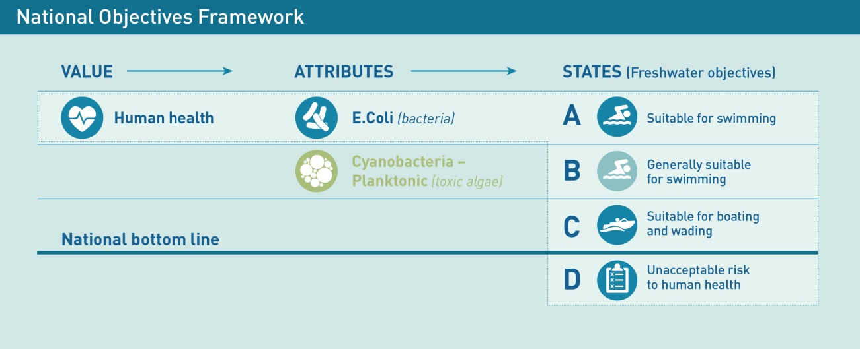
We are developing new attributes including sediment, temperature, benthic cyanobacteria (toxic algae), and wetlands. We also plan to develop attributes for water supply, fishing and for cultural indicators.
Finally, the framework also includes instructions on how to set freshwater objectives.

Proposals

‘Maintain or improve overall’ water quality
Proposals
1.1 Amend Objective A2 of the National Policy Statement for Freshwater Management so that it applies within a freshwater management unit, rather than across a region.
1.2 Clarify that councils have flexibility to maintain water quality by ensuring water quality stays within an attribute band, where it is specified in the National Objectives Framework, or demonstrating that the values chosen for a freshwater management unit are not worse off, where an attribute band is not specified in the National Objectives Framework.
Freshwater management units (FMUs) are catchment-based areas for which community values will be identified for freshwater objectives and limit-setting. They are most commonly a whole catchment but for very large rivers may be sub-catchments. A FMU may be a group of similar lakes or rivers where a consistent management framework makes common sense.

Freshwater management units versus a whole region
The concept of freshwater management units was introduced in the 2014 amendments to the NPS-FM to define the areas for managing water. The Government proposes to amend the NPS-FM to clarify the scale at which ‘overall quality of fresh water’ should be maintained or improved. This means aligning the requirement to maintain or improve overall water quality within the area of an FMU rather than across a region.
Regional councils have administrative boundaries that do not necessarily provide a sound basis for comparing water quality ‘overall’. We think this is better done within FMUs because this is the scale at which communities will set freshwater objectives and limits, and monitor water quality.

What is intended by maintaining or improving ‘overall’ water quality
While the NPS-FM requires regional councils to at least maintain overall water quality, there is very little direction on how to do this or how to know if it has been done (ie, when is overall water quality maintained?). The provision is intended to allow some flexibility when councils set objectives by using trade-offs, or ‘unders and overs’, across a region.
However, under the NPS-FM, there is no clear test or method to determine when overall water quality is maintained. This is proving difficult when it comes to setting objectives and limits. Some approaches may unduly constrain economic growth or may not adequately protect water quality. Furthermore, there is the potential for litigation and debate about councils’ ability to compare water quality between FMUs to determine the overall water quality in the region as a whole.
First, we are interested in your views on applying the requirement to maintain or improve overall water quality within an FMU, rather than across a region which is what the NPS-FM currently says.
Secondly, we propose to clarify that councils have the flexibility to ensure water quality is maintained or improved through a number of routes, specifically including:
- ensuring attributes remain within their current bands as defined in the National Objectives Framework. For example, with periphyton a council might ensure a freshwater body remains in the B band – this means it experiences no more than occasional blooms reflecting low nutrient enrichment
- where attributes do not have defined bands, demonstrating that a value is no worse off. For example, a council might identify a value that doesn’t have attributes or bands defined in the National Objectives Framework, such as recreational fishing. The council could demonstrate maintenance of the value by using a number of measures (eg, catch levels, health of the fish).

Macroinvertebrate Community Index as a measure of water quality
Proposals
1.3 Require the use of Macroinvertebrate Community Index as a measure of water quality in the National Policy Statement for Freshwater Management by making it a mandatory method of monitoring ecosystem health.
1.4 Work with the Land and Water Forum on the potential benefits of a macroinvertebrate measure for potential inclusion into the National Objectives Framework as an attribute.
Macroinvertebrate Community Index (MCI) scores the presence of aquatic insects living in a freshwater ecosystem. It can be used as a way of assessing the ecological health of rivers. Higher MCI scores generally indicate better river condition.
The Government proposes to make the use of the MCI mandatory for monitoring so there is a consistent approach to measuring the ecological health of rivers. Councils will be required to use MCI consistently and regularly.
The MCI is a holistic indicator of a water body’s ecological health, which is an integral element of Te Mana o te Wai. Using the MCI as a measure of water quality can help councils target investigations to find and tackle sources of pollution that affect macroinvertebrates that live in rivers, such as mayflies and aquatic snails.
A wide range of submitters on previous consultations supported the introduction of the MCI as an attribute in the National Objectives Framework, but in its current form the MCI does not lend itself to this. However, we will continue working with the Land and Water Forum and the science community to investigate how measures of macroinvertebrates could be included as an attribute. In the interim, monitoring of macroinvertebrates will provide evidence to support how the MCI might be incorporated.
Figure 2: Aquatic insect
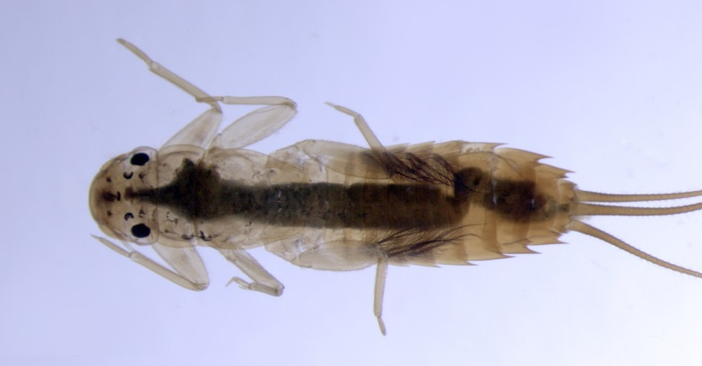
Image courtesy of Brian Smith, NIWA

Significant infrastructure and water quality
Proposal
1.5 Provide further direction on providing evidence when councils or infrastructure owners request that the Government include specific significant infrastructure in Appendix 3 of the National Policy Statement for Freshwater Management.
Significant infrastructure is large built structures like hydro-electricity generation plants or dams that affect river flows or the availability of water to downstream users.
New Zealand derives huge environmental, economic and social benefits from hydro-electricity generation. In 2014, about 57 per cent of our electricity was generated by hydro-electric power schemes. Almost 80 per cent of New Zealand’s electricity is generated from renewable resources; hydro-electricity is pivotal to the Government’s goals of increasing renewable electricity generation to 90 per cent by 2025 and transitioning to a low-carbon economy.
The NPS-FM allows councils to set freshwater objectives below a national bottom line if:
- water quality in the FMU is below that national bottom line, and
- infrastructure contributes to the degraded water quality, and
- the infrastructure is listed in Appendix 3 of the NPS-FM.
If the existence of any bottom line means hydro-generators (for example) are required to flush water through the river system to control slime, rather than optimal electricity generation, it might sometimes be more appropriate to allow the water quality to breach the bottom line. Allowing councils to set a freshwater objective below a bottom line in an FMU can recognise and secure the significant benefits provided by this kind of infrastructure (such as high levels of electricity from a renewable source).
Some iwi/hapū/whānau have raised concerns over the cultural and environmental impacts of hydro-electricity generation – for example: where tribal lands and burial caves have been flooded; the flow of traditional waterways has been diverted; there is significant weed in their waterways caused by the dams; or the migration of traditional fisheries is impeded by dams.
However, Government needs information to determine where exceptions should be considered, including:
- where FMUs have been set
- the values that a regional council has identified in the FMU
- their impact on Te Mana o te Wai of a water body
- ongoing impacts on iwi/hapū rights and interests
- evidence of current water quality and sources of contaminants
- which FMUs, if any, breach any national bottom lines
- whether infrastructure contributes to any breaches
- the nature and extent of any benefits derived from infrastructure (eg, security of electricity supply)
- the level of existing investment and economic impacts of achieving national bottom lines
- the range of options available to improve water quality at least to the national bottom line.
Councils will gather this information as part of limit setting under the NPS-FM. Rather than populating Appendix 3 of the NPS-FM with specific infrastructure in the absence of evidence, we propose to enable regional councils or owners of significant infrastructure to seek exceptions based on evidence gathered during the limit-setting process where a need has been identified. Any exceptions would require public consultation.

Coastal lakes and lagoons
Proposals
1.6 Amend the attribute tables in Appendix 2 of the National Policy Statement for Freshwater Management so that attributes clearly apply to intermittently closing and opening lakes and lagoons, with the same band thresholds and national bottom lines as lakes.
1.7 Provide direction to councils on how to request that, after meeting evidential thresholds, a freshwater management unit be allowed to use a transitional objective under Appendix 4 of the National Policy Statement for Freshwater Management.
Intermittently closing and opening lakes and lagoons (ICOLLs) are coastal lakes and lagoons that open up to the sea from time to time. The water can be salty or fresh, and can shift from one to the other for periods of weeks, months, or years. ICOLLs are particularly vulnerable to degradation because they are at the bottom of water catchments and are typically shallow.
It is currently not clear whether the lake attributes in Appendix 2 of the NPS-FM apply to ICOLLs. This means that councils may take variable scientific approaches to managing these water bodies that could be contested in the Environment Court. Expert scientific advice is that the lake attributes and their bottom lines are able to be applied to ICOLLs.
The Government proposes to amend the NPS-FM so that water quality attributes, including their national bottom lines, apply to coastal lakes and lagoons that are intermittently open to the sea.
Figure 3: Map of New Zealand’s intermittently closing and opening lakes and lagoons that are managed as fresh water
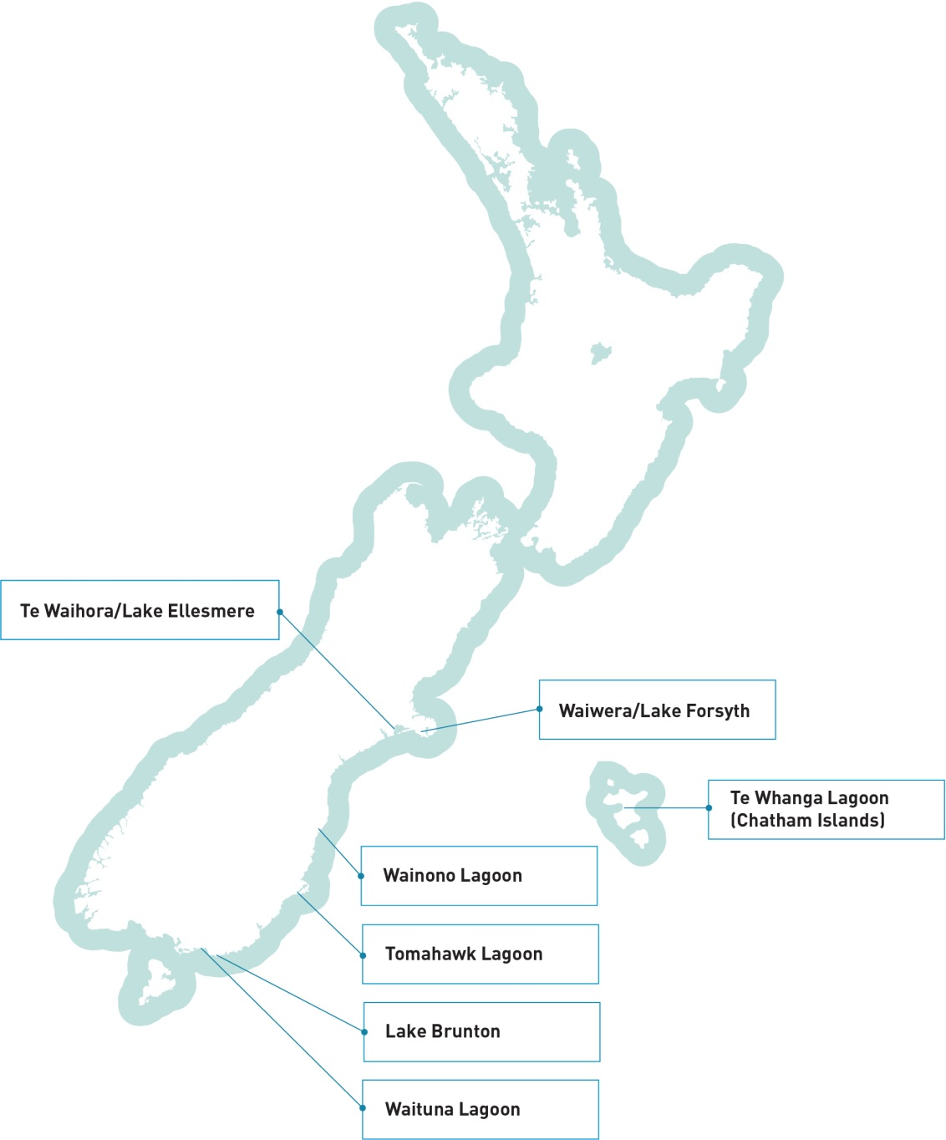

Why are these changes being proposed?
Good decision-making about freshwater management requires community-based judgments supported by scientifically robust technical information and an assessment of economic impacts. This is the reason attributes and national bottom lines have been included in the NPS-FM. They provide non-contestable nationally agreed science when setting freshwater objectives.
The requirement to set objectives above national bottom lines would ensure that councils put measures in place to prevent an ICOLL degrading to the point where it ‘flips’. When a lake has ‘flipped’ it shifts from a clear water state, characterised by submerged aquatic plants to a turbid state characterised by a lack of, or a distinct reduction in, aquatic plants.
The four councils with ICOLLs in their regions are working with their communities to set realistic timeframes for achievable water quality improvements. However, councils are unlikely to be able to meet the national bottom lines for some ICOLLs for decades.
Case Study: Waituna Lagoon
Waituna Lagoon is a large lagoon east of Bluff in the lower South Island. It is part of the 20,000 hectare Awarua Wetlands, which have high ecological habitat diversity, internationally important bird life, and large areas of relatively unmodified wetland and terrestrial vegetation. The wider Awarua Wetlands complex was listed as internationally significant in 2008 under the Ramsar Convention on Wetlands. They are one of six New Zealand sites listed under the Ramsar Convention.
The narrow sand bar separating the lagoon from Foveaux Strait is periodically opened to reduce flooding risk and allow flushing. The intermittent opening and closing of the sand bar gives Waituna Lagoon characteristics typical of both lakes and estuaries.
Environment Southland, with funding assistance from the Government, has been working with land owners in the catchment to reduce sediment and nutrient loads to the lagoon.
Figure 4: Waituna lagoon
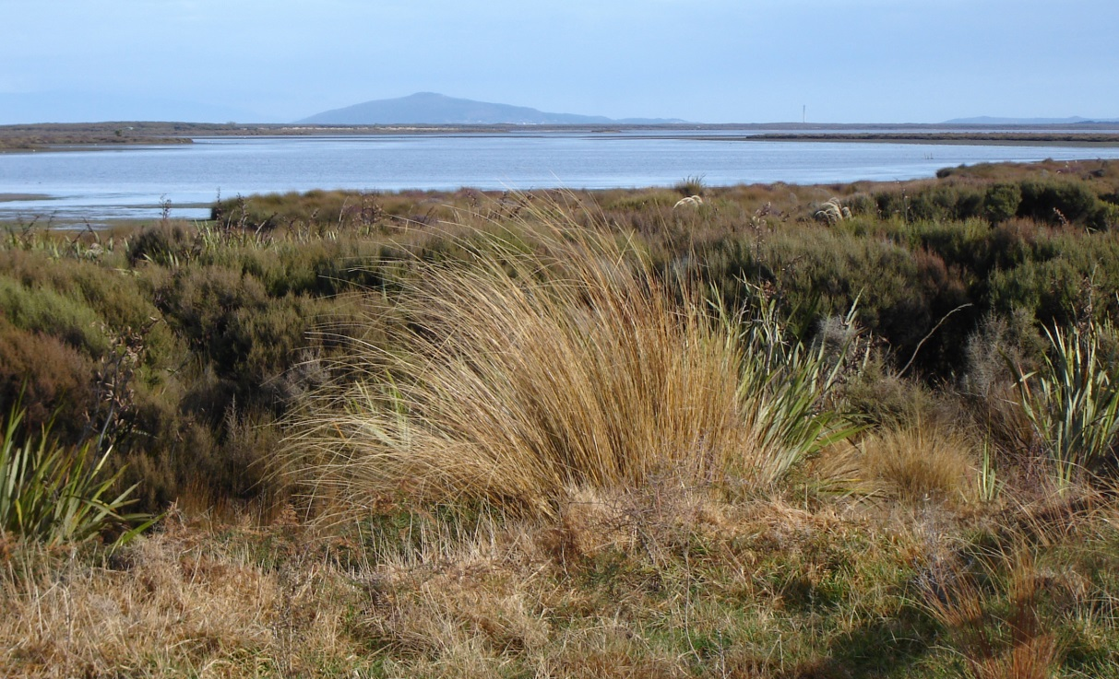
Image courtesy of Environment Southland

What about ICOLLs that will be unable to meet national bottom lines?
The NPS-FM allows communities to set water quality objectives below a national bottom line temporarily, provided the water body is listed in Appendix 4 of the NPS-FM. This would include a review date for when the transitional arrangement would be reconsidered. Adding a water body to Appendix 4 requires an amendment to the NPS-FM after public consultation.
The Government could base a decision to include a water body in Appendix 4 on a number of factors. These could include, for example, evidence that a council and its community has examined all feasible options to improve water quality to above a bottom line and concluded that the required interventions would place an unmanageable burden on the community or are too uncertain to properly quantify.

Stock exclusion from water bodies
Proposal
1.8 Create a national regulation that requires exclusion of dairy cattle (on milking platforms) from water bodies by 1 July 2017, and other stock types at later dates (see table 2).
Milking platforms are dairy farms where cows are being milked daily during the season, as opposed to dairy support land that includes farms where dairy cattle are dried off and wintered.
The Government proposes to introduce a requirement for farmers to ensure their stock cannot enter streams, rivers, lakes and wetlands.
The dairy industry has made progress in voluntarily keeping stock out of water bodies. The Sustainable Dairying: Water Accord has resulted in over 24,000 kilometres of fencing to keep dairy cattle on milking platforms out of more than 94 per cent of streams over 1 metre wide and 30 centimetres deep. In 2014, the Government committed to requiring the exclusion of dairy cattle from waterways by 1 July 2017.
Excluding stock from a water body can improve water quality, improving its suitability for recreation, harvesting food, and as a habitat for fish. Livestock with access to water bodies can trample the banks, causing erosion and more sediment in the water. Water quality and the risk to human health are affected by stock faeces and urine. Riparian areas are important to filter the effects of adjacent land use, as habitats and for recreation.

What stock will be excluded from water bodies?
The Government proposes to regulate to exclude dairy cattle on milking platforms from water bodies by 1 July 2017. We intend to extend this to land used for dairy support, beef cattle and deer at a later date (see table 2) to give these farmers time to comply. Sheep and goats will not be covered by this proposal as they do less damage to our streams and rivers.
Stock will only be nationally required to be excluded from water bodies on flat land and lowlands and rolling hills (< 15˚ slope) due to the practicality of fencing on steep country and the high costs relative to the environmental benefits. This would not override more stringent council rules and councils will still have the ability to apply stock exclusion rules more widely where they see this as necessary or desirable.

Table 2: Proposed deadlines for stock to be excluded from water bodies
Farm type | Plains (0–3°) | Lowland/rolling hills  (4–15)°
Dairy cattle on milking platform | 1 July 2017
Dairy support (owned by dairy farmer) | 2020
Dairy support (third party grazing) | 2025
Beef | 2025 | 2030
Deer | 2025 | 2030*
Pigs | 1 July 2017
*Intensive farms only

How stock will be excluded
Farmers will need to put up permanent fences unless there is a natural barrier preventing stock from getting to the water. Temporary fencing will be allowed where this is more appropriate, for example, for short-term grazing or where flooding is a problem.

Water bodies where stock will be required to be excluded
We propose to apply a national stock exclusion regulation to:
- permanently flowing waterways and drains greater than 1 metre wide and 30 centimetres deep, (and smaller ones on the plains, but giving these landowners until 2020 to comply)
- natural wetlands, but not including damp gully heads or places where water temporarily ponds, or built structures, such as effluent ponds, reservoirs or channels.

What enforcement will there be for the proposed stock exclusion regulations?
Some councils already have some degree of stock exclusion requirement in their regional plans. There are problems with practical enforcement because the expense to councils and ratepayers of taking a Court prosecution can seem excessive. The Resource Legislation Amendment Bill currently before Parliament provides explicit provision for these proposed national regulations. It also introduces a nationally standardised infringement regime with instant fines.

Will riparian buffers be required?
It is not proposed to require a riparian buffer between a fence and the waterway. If managed well, riparian buffers can benefit water quality, bank stability, and biodiversity. However, the optimum buffer width and how it should be managed depends on the circumstances and aims. The high cost of managing riparian buffers (eg, planting, weed control) is not justified by the environmental benefits in all cases. Some councils are already working with farmers to promote riparian management in high value and at-risk areas.
Read LAWF’s recommendations on stock exclusion.

Questions
- Do you agree that overall water quality should be maintained or improved within a freshwater management unit rather than within a region? Why or why not?
- How should the attributes be applied, or the values protected, in giving effect to the requirement to maintain or improve overall water quality? Please explain.
- What is an appropriate way to include measures of macroinvertebrates in the National Policy Statement for Freshwater Management? What alternative measures could be used for monitoring ecosystem health?
- What information should be required in a request to include significant infrastructure in Appendix 3 of the National Policy Statement for Freshwater Management, and why would this information be important?
- Do you agree with applying lake attributes and national bottom lines to intermittently closing or opening lakes or lagoons? Why or why not?
- What information should be required in a request to list a water body in Appendix 4 of the National Policy Statement for Freshwater Management, and why would this information be important?
- Do you agree with the proposed requirements and deadlines for excluding livestock from water bodies? Why or why not?

Economic use of fresh water

A better water management system
The Government wants to develop a better way to manage water across New Zealand. Greater efficiency will be good for the environment, encourage innovation and economic growth, and free up resources for new users.
The systems we have been using for managing water quality and allocating water have not been serving New Zealand well as limits to water use and discharges are introduced. For both water quantity and quality, the management systems being used are not flexible or effective enough.
Water is currently allocated on a ‘first in, first served’ basis, meaning applications for water are assessed in the order they are received. This approach works when available water can meet the needs of all users. However, once water becomes scarce, higher value or more efficient uses can’t be prioritised.
Water quality is managed by councils through rules on discharges or land use, voluntary initiatives by users, and incentives, for example, part funding. In some cases nitrogen is managed using nitrogen discharge allowances. These approaches do not always deliver the water quality that iwi, water users and the community want and councils have set in limits.
New users cannot always obtain the resources they need to establish high value enterprises, because all the available water has been allocated or no new discharges are allowed. However, if users become more efficient in their water use and reduce discharges it will create room for new users.

More policy to come
New Zealand needs to increase the productivity of the way we use our natural resources, including for continued regional and national economic development. The Government is still finalising the package of allocation policy proposals that will fully address the range of interests of those wishing to access freshwater resources, including iwi/hapū, as further work is required to develop options that the Government and stakeholders can support. These will be progressed over the coming months with a technical advisory group. At this stage, however, it is still useful to consult on the other elements of reform as foundation measures that would support any future water allocation proposals.

Proposals

Technical efficiency and good management practice standards
Proposals
2.1 Require councils to apply technical efficiency standards in catchments that are at, or approaching, full allocation of water.
2.2 Where councils have elected to allocate discharge allowances, require them to apply good management practice standards in catchments that are at, or approaching, full allocation of contaminants.
2.3 Require councils to apply these standards at defined times, for example, at initial limit setting, on consent expiry, and/or on application to permanently transfer consents for water or discharge allowances.
Technical efficiency standards will define the amount of water that would be used by an efficient user in different climates, soils, and end uses, for example, urban, hydro, irrigation.
Good management practice (GMP) standards will set measures, such as for the acceptable amount of diffuse nitrogen discharges in different climates, soils and uses.
Full allocation means there is no more water available for new consents or room for the discharge of contaminants because this will breach limits or prevent others from getting the water they have been permitted to take under their existing resource consents.

Technical efficiency standards improve efficiency
The Government proposes to develop technical efficiency standards. They will help address over-allocation, and free up water for new users. In catchments that are at or approaching full allocation, or are over-allocated, councils will be required to apply the technical efficiency standards over time to all consents.

Good management practice helps manage discharges better
The Government proposes to consult with industry to develop good management practice standards for discharges of contaminants to water for different sectors, climate and soil types.
Where councils have chosen to allocate nitrogen and catchments are at or approaching full allocation, or are over-allocated, councils will be required to apply the standards over time.
The GMP standards will provide guidance to councils for managing diffuse discharges even when they are not allocated, as they can inform requirements in regional plans, or consent conditions.

Standards will be developed collaboratively
The Government will coordinate the development of the standards, building on standards that are already being developed by councils and sectors. Nationally developed standards will include a wider range of expertise in consultation with users, councils, iwi and scientists, and avoid the duplication of councils each developing their own standards.

Urban areas
Councils are also required to manage water allocation and discharges of contaminants in urban areas. GMPs and technical efficiency can apply as equally to an urban environment as to a rural one. The management of water takes and discharges in urban areas is largely the responsibility of district and unitary councils (through reticulated water supply and storm and waste water discharges), but everyone has a part to play. Water-sensitive urban design provides a basis for developing management practices for urban areas and will be explored further.

Transferring consents to more efficient, higher valued uses
Proposal
2.4 Investigate a package of measures to better enable transfers between users so allocated water and discharge allowances can move to higher valued uses, such as:
• standardising consent specifications to better enable transfer, such as separating ‘take and use’ components of a consent
• making information available, including public registers of consented and used water and discharge allowances
• model plan provisions specifying where and in what circumstances transfers are permitted
• enabling water user groups and nutrient user groups to provide for low cost transfers.
Higher value use means a use where the economic returns are higher per unit of water used or nitrogen discharged.
Allowing water and contaminant discharge allowances to be transferred between users enables resource users to adapt to changing circumstances, market conditions, technologies and business practices. Enabling such transfers will increase incentives for existing users to invest in efficiency improvements beyond those specified in the technical efficiency standards, and transfer excess water or discharge allowances to others. It will also provide incentives for existing users to temporarily transfer water or discharge allowances if they do not need them for a while. This would increase the economic value that we get from the available resource.

Addressing over-allocation and over-use at least cost
Proposal
2.5 Develop guidance on different methods of addressing over-allocation of water quality and/or quantity, if technical efficiency standards and good management practice standards are insufficient.
The NPS-FM requires that councils phase out and avoid further over-allocation. Over-allocation imposes costs on the environment and on water users by reducing security of supply. However, the best way to address over-allocation depends on the issue and varies between catchments. We propose to provide councils with guidance on a range of methods to use if technical efficiency standards and GMP are insufficient to address over-allocation. These methods could apply at individual or catchment scale.
When catchments are over-allocated, water supply becomes less reliable for all users because minimum flows are reached more often. When this happens, water can no longer be taken, and this is often when irrigation demand is greatest. As a result, some high value crops will not be grown because they require irrigation water at critical times. Low water reliability tends to drive land users to less water-sensitive crops, or to pasture-based systems.
There are a number of ways water reliability can be better managed. Some councils, for example, use ‘reliability bands’ to classify allocated water. This means some consents provide more reliable access to water than others. While this provides certainty to existing holders of high reliability water permits, potential new users may not be able to obtain water in a high reliability band, because it has all been allocated to existing users. Reducing the amount of water allocated will increase reliability, but users are likely to have less water to use. Water storage and infrastructure (eg, pipes) can be used to increase the overall supply and reliability of water for both existing and new users, so land uses which rely on higher security of water supply can be established.

Council funding for freshwater management
Proposal
2.6 Increase the ability of councils to recover costs from water users for monitoring, enforcement, research and management.
The Government recognises that effective implementation of the existing freshwater management system will require local councils to spend more on science, monitoring, management, and enforcement.
Councils say that meeting these increased costs equitably can be challenging. Some are unwilling to spend additional general ratepayer funding to focus on water users who impose costs on the freshwater management system. Increasing the ability for councils to recover costs from those water users will give more flexibility in how councils meet the costs of improving freshwater management. They may therefore be better able to resource changes to the freshwater management system.

Questions
- Should standards for efficient water use be developed? Should standards for good management practices for diffuse nitrogen discharges be developed? Who should be involved in their development? When should they be applied to consents (eg, on consent expiry and/or on limit setting and/or permanent transfer)?
- Do you support easier transfer of consents? Do you think the changes outlined in Proposal 2.4 would better enable transfers? What other changes would better enable transfers?
- How should the Government help councils and communities address over-allocation for water quality and water quantity? Should it provide guidance, rules or something else (please specify)?
- Should councils have greater flexibility in how they meet the costs of improving freshwater management? For example, by recovering costs from water users and those who discharge to water? Please provide examples.

Iwi rights and interests in fresh water
The Government’s position is that no-one owns fresh water – it is a resource that we must look after for the benefit of all New Zealanders. At the same time, our freshwater management system can be improved to recognise and provide for iwi and hapū rights and interests. From the Government’s perspective this means ensuring:
- freshwater management gives effect to Te Mana o te Wai
- the relationship of iwi and hapū with, and values for, particular freshwater bodies is recognised
- iwi and hapū are able to participate in decision-making about fresh water in their rohe
- marae and papakāinga have access to clean, safe drinking water.
The Government is committed to addressing iwi and hapū rights and interests in fresh water and recognises the relationship of Māori with water.
The Waitangi Tribunal found that the proprietary right guaranteed to iwi and hapū by the Treaty of Waitangi in 1840 was the exclusive right to control access to and use of the water while it was in their rohe. However, the Tribunal also accepted that the Treaty changed Māori rights by giving the Crown governance powers, which includes the right to manage fresh water in the best interests of all. The Tribunal found that Māori still have ‘residual proprietary rights’ today.
Proposals have been developed through engagement between Ministers and the Freshwater Iwi Leaders Group. Both parties acknowledge the proposals do not address all aspirations of iwi/hapū, nor does the engagement represent all iwi/hapū/whānau perspectives.

Proposals

Te Mana o te Wai in freshwater management
Proposals
3.1 Include a purpose statement in the National Policy Statement for Freshwater Management which provides context about the meaning of Te Mana o te Wai and its status as the underpinning platform for community discussions on freshwater values, objectives and limits.
3.2 Require regional councils to reflect Te Mana o te Wai in their implementation of all relevant policies in the National Policy Statement for Freshwater Management.

Te Mana o te Wai is a core concept for fresh water. It encompasses the integrated and holistic health and well-being of a water body. It represents the innate well-being and vitality (mauri) of a water body and its ability to provide for the health of the water (te hauora o te wai), the health of the environment (te hauora o te taiao), and the health of the people (te hauora o te tangata).
The health and well-being of our water bodies is integral to the health and well-being of our land and other resources (including fisheries, flora and fauna) and to our health and well-being both as communities and as a nation.
When Te Mana o te Wai is given effect, the water body will sustain the full range of environmental, social, cultural and economic values held by iwi and the community. This is a concept that is relevant to all New Zealanders.
The NPS-FM currently refers to Te Mana o te Wai. However, feedback from regional councils and the Freshwater Iwi Leaders Group through over 100 regional iwi hui is that the status of this reference is unclear and provides ambiguous and inadequate direction.
More clarity will be provided in the NPS-FM to ensure that the concept of Te Mana o te Wai is implemented in a way that is meaningful for the whole community and is used as the basis for community discussions on freshwater management.

Iwi and hapū relationships with, and values for, water bodies
Proposals
3.3 Councils must, at the outset of their freshwater planning process, engage with iwi and hapū to ensure all iwi and hapū relationships with water bodies in the region are identified in regional planning documents.
3.4 Councils must, when identifying values and setting objectives for particular freshwater management units, engage with any iwi and hapū that have relationships with water bodies in the freshwater management unit.

Recognition of relationships
Every iwi and hapū has associations with particular freshwater bodies – streams, springs, rivers, lakes, wetlands – which have developed over their tribal history and are reflected in their whakapapa and kōrero tuku iho (stories of the past).
Some special associations have been recognised through settlement acts, which are the culmination of the Treaty of Waitangi settlement process. This may take the form of a statutory acknowledgement over a defined site. Alternatively, in the case of rivers and lakes of great significance, recognition may include vesting of the lakebed or riverbed in the iwi or establishment of a new legal personality, such as Te Awa Tupua of the Whanganui River. Settlement acts can also create certain requirements for decision-makers including, for example, attaching information on statutory acknowledgements to any relevant plans.
However, not all iwi and hapū associations with particular freshwater bodies have been recognised. We propose to require regional councils to identify iwi and hapū relationships with freshwater bodies through their planning process.

Recognition of iwi and hapū values
Some iwi and hapū values are reflected in the national values that were introduced by the 2014 amendment to the National Policy Statement for Freshwater Management, including food gathering (mahinga kai), cultivation (mahi māra), sacred fresh water where rituals and ceremonies are performed (wai tapu), and economic or commercial development (āu putea).
Regional councils must already consider how these values apply to local and regional circumstances as part of their regional planning process. In addition, regional councils are asked to work with iwi and hapū to identify tāngata whenua values and interests in fresh water and freshwater ecosystems in the region and to reflect those values and interests in freshwater management and decision-making. We propose to require regional councils, when setting freshwater objectives, to identify the values of the iwi and hapū that have associations with those freshwater bodies.

Participation in freshwater decision-making
Hand-in-hand with recognition of their association with water bodies, there needs to be ways for iwi and hapū to participate in decision-making about those water bodies. This decision-making occurs through development of regional policy statements, regional plans, catchment plans, and consenting.

Enabling iwi and councils to agree how to work together
Proposal
3.5 The Government will amend the Resource Management Act to establish provisions for a new rohe (region or catchment)-based agreement between iwi and councils for natural resource management – a ‘mana whakahono a rohe’ agreement. The mana whakahono a rohe will:
• be initiated by iwi through notice to the councils
• be available to all iwi but will not override or replace existing arrangements for natural resource management in Treaty of Waitangi settlements nor preclude agreement of different arrangements under a Treaty settlement
• provide for multiple iwi involvement where appropriate and agreed
• set out how iwi and council(s) will work together in relation to plan-making, consenting, appointment of committees, monitoring and enforcement, bylaws, regulations and other council statutory responsibilities
• include review and dispute resolution processes.

Iwi participation arrangement (IPA) is a provision under the Resource Legislation Amendment Bill that was introduced into Parliament in December 2015. An IPA will require councils to invite iwi to discuss and agree on how iwi may participate in planning. IPAs will improve consistency in councils’ engagement with iwi on plan development.
Mana whakahono a rohe in this context is an alternative to an IPA. It differs from an IPA in that it can be initiated by iwi.
The call from iwi for greater participation in natural resource management has been addressed in some instances through Treaty of Waitangi settlements, for example, through establishment of a joint committee with a regional council, an advisory committee to the council and specific requirements to appoint accredited iwi commissioners to consent hearing committees.
However, there is a still a need to consistently provide opportunities for iwi engagement in council decision-making about natural resources. For this reason, the Government included a new provision for iwi participation arrangements in the Resource Legislation Amendment Bill introduced in 2015. An IPA will require councils to invite iwi to discuss and reach agreement with them on how they may participate in planning processes.
However, as part of our discussions with the Freshwater Iwi Leaders Group on improving iwi participation in freshwater decision-making, we discussed an alternative proposal to the IPA. Under this proposal, iwi could invite councils to agree how iwi and councils will work together on natural resource management. The name the Freshwater Iwi Leaders Group proposed for this agreement is ‘mana whakahono a rohe’. This has many similarities to the IPA, but a key difference is that would be up to iwi to decide if and when they would like to develop such an agreement with the relevant council(s).
We will consider public feedback on the mana whakahono a rohe proposal and do further work on how it should be reflected in legislation.

Water conservation orders
Proposal
3.6 The Government will amend the Resource Management Act to:
• require water conservation order (WCO) applications to provide evidence of consultation with relevant iwi and have one person nominated by the relevant iwi represented on the Special Tribunal convened to hear the application
• require the Special Tribunal for a WCO (and, where relevant, the Environment Court) to consider the needs of iwi/tāngata whenua
• require WCO applications to consider any planning processes already underway
• allow the Minister for the Environment to delay an application if there will be a conflict with a regional planning process
• allow councils to recommend to the Minister for the Environment that a WCO be created over an outstanding water body that has been identified through regional planning, and allow the Minister to consider recommendations under a streamlined procedure.
Water conservation orders (WCOs) preserve and protect New Zealand’s most valued and outstanding geothermal or freshwater bodies. Fifteen WCOs are in place for our rivers and lakes. The first WCO was made in 1984 to protect the Motu River in the Bay of Plenty and the legal process for making a WCO has essentially remained unchanged since.
The Government considers the process for creating WCOs has some weaknesses. For example, it does not require the involvement of tāngata whenua. This does not ensure that their values are considered in decision-making. In addition, WCOs are not well integrated into regional planning, creating some duplication of effort.
We propose to amend the RMA to provide a greater role for iwi and to ensure WCOs are better integrated into regional planning processes. We also propose to allow councils to recommend to the Minister for the Environment that a WCO be created over a water body that they have identified as having outstanding values during regional planning. This would provide an alternative way of creating WCOs to the Special Tribunal.

Implementation support
Proposal
3.7 The Ministry for the Environment will facilitate and resource programmes to support councils and iwi/hapū to engage effectively in freshwater planning and decision-making, including collaborative planning.
Most iwi and councils will need additional capacity and improved capability to ensure these proposals can be implemented and are effective. It is proposed the Ministry for the Environment facilitate and resource programmes over the next several years to build this capacity and capability.

Clean, safe drinking water for marae and papakāinga
Proposal
3.8 The Government will consider if additional funding is required to develop or improve water infrastructure at marae and papakāinga.
Papakāinga is a form of housing development which occurs on multiply-owned Māori or ancestral land. Traditionally, the literal meaning of papakāinga housing is, 'a nurturing place to return to'.
The provision of clean, safe drinking water is a fundamental requirement for human health and a right of all New Zealanders. Marae and papakāinga are traditional community settings at the heart of the Māori way of life which need a secure supply of potable (safe to drink) water just as any household does. Most marae were built close to a freshwater source, such as a spring, river or lake. However, demands on fresh water in some areas have resulted in either the water becoming unsuitable for drinking or springs drying up.
More work is needed to ensure all marae and papakāinga have clean, safe drinking water. For example, a sample of 21 marae in the Tūranganui-a-Kiwa (Gisborne) region found that four marae have no water supply at all and three marae did not have safe drinking water.
We want to ensure there is cost-effective access to clean, safe drinking water and adequate wastewater infrastructure at marae and papakāinga. We seek feedback from those involved with marae or who live at papakāinga to enable us to determine what additional funding may be required to support this.

Questions
- How can the Government help councils and communities to better interpret and apply Te Mana o te Wai in their region?
- Should councils be required to identify and record iwi/hapū relationships with freshwater bodies, and how should they do it?
- What would support councils and iwi/hapū to engage about their values for freshwater bodies?
- What are your views on the proposal for a new rohe-based agreement between iwi and councils for natural resource management? What type of support would be helpful for councils and iwi to implement these to enable better iwi/hapū engagement in natural resource planning and decision-making?
- What are your views of the proposed amendments to water conservation orders? Outline any issues you see with the process and protection afforded by water conservation orders.
- If you are involved with a marae or live in a papakāinga, does it have access to clean, safe drinking water? What would improve access to clean, safe drinking water for your marae or papakāinga?

Freshwater funding

Private and public investment in fresh water
Water users, councils and the Government all make significant investments in measures to improve the quality and availability of fresh water.
The Government has a complementary role to both private users and councils in freshwater investment. The Government finances investments that will deliver environmental and economic benefits that would not otherwise be achieved. For example, there are environmental benefits from dealing with the legacy effects of degraded water bodies that would not be paid for by private users, or councils in sufficient numbers, or in a timely way. There are also economic benefits from water investments, particularly irrigation infrastructure, which the Government has a role in facilitating because, for example, irrigation investments that are commercially viable may still face difficulties in raising finance in capital markets.
In the next few years, there will be a number of desirable investments, beyond what the Government could fund given competing expenditure priorities. This means that the Government will need to make choices about where to invest. This is the focus of this chapter.

Government funding
So far, the Government has committed more than $350 million to freshwater projects on water quality of which $114.6 million has been spent since 2009.
Figure 5: Government investment in freshwater protection and clean ups, 2000–2015
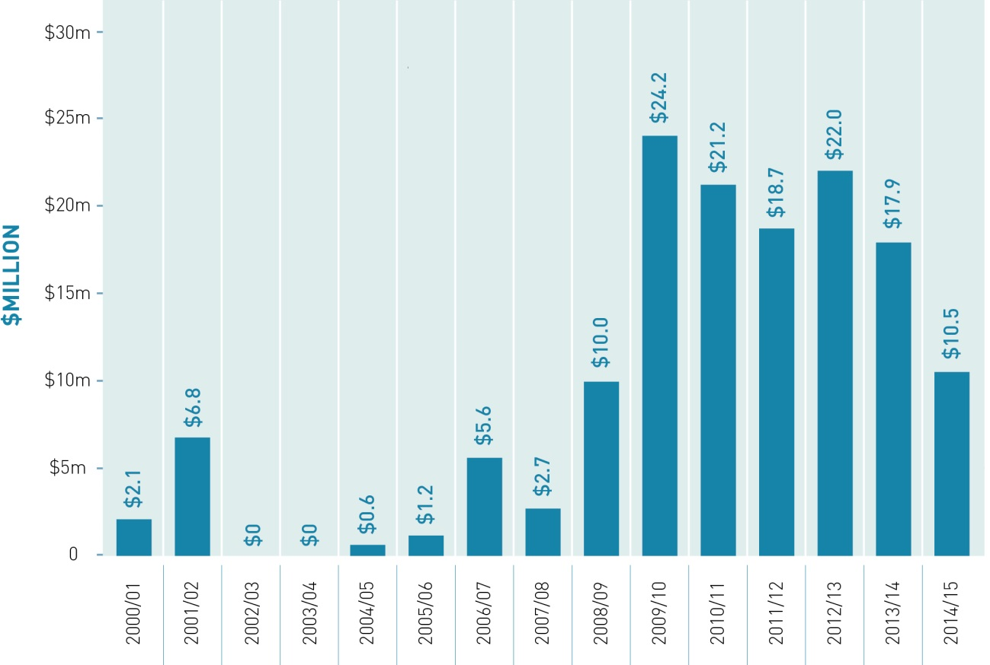
This government funding has leveraged significant additional funding from councils. In addition to these investments, the Government has announced $97 million of funding to the ‘Our Land and Water’ National Science Challenge over 10 years.
Figure 6: Examples of significant Government investment in freshwater protection and clean ups
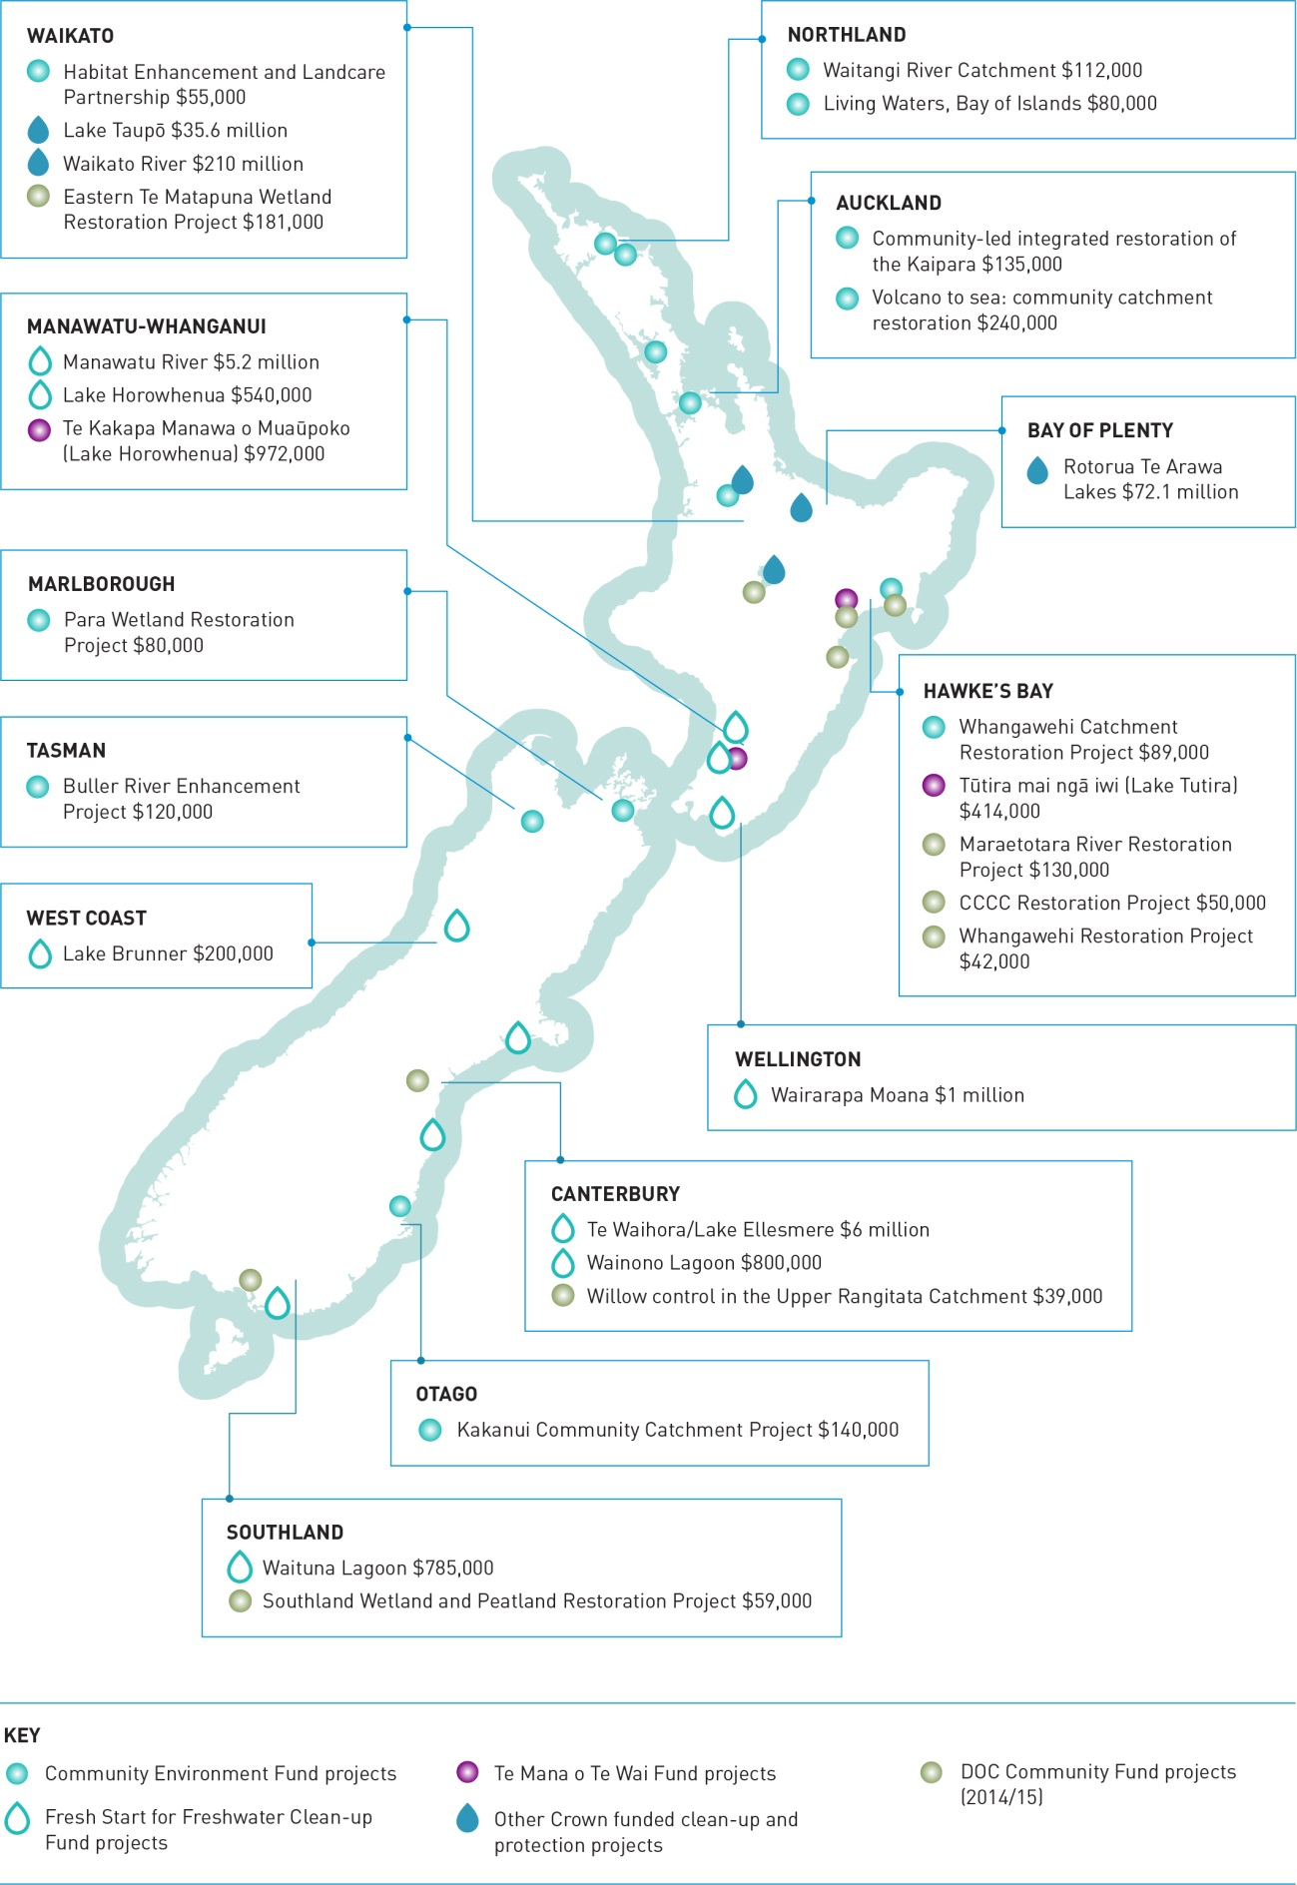
Case study: Rotorua Lakes
The Rotorua Te Arawa Lakes Programme focusses on lakes and surrounding land that are rich in history and significance for iwi, provide fertile farmland, and are the jewel of the local area. From the 1960s onwards, water quality was declining largely due to a combination of land use around the lakes, sewage, stormwater, and internal lake sediments.
Local actions to maintain and improve the quality of the lakes worked until the late 1990s. In the early to mid-2000s even the state of the region’s healthiest lake, Lake Ōkāreka, was deteriorating. With the cultural, environmental and economic importance of the lakes in mind, the Rotorua community decided it was time to come together and take action to save their treasured lakes.
An Act of Parliament set up a group to tackle the clean up of these nationally-significant lakes. The regional and district councils committed $72.1 million to match the Government’s contribution to the clean up of four of the lakes identified as priorities: Rotorua, Rotoiti, Ōkāreka and Rotoehu.
Collaboration between councils and the community (including farmers, iwi, forestry owners, recreational-users, conservationists and land-owners) came up with innovative solutions to clean up their lakes. This has included building floating wetlands, upgrading the wastewater plant, geothermal nutrient removal, a diversion wall, land use and land management change.
By working together, councils and the community have successfully improved the water quality in the lakes. The challenge remains to continue to improve the water quality of these iconic culturally and economically important lakes; decisions on land use around the lake will be critical in this.
The Government will contribute up to $400 million in equity funding to Crown Irrigation Investments Limited, of which $160 million has already been allocated. Crown Irrigation has a mandate and funding to invest in irrigation schemes which are environmentally sustainable and will provide economic benefits to New Zealand. Crown Irrigation’s focus is on investing in schemes where the initial shortfall in irrigator uptake makes it difficult to fully source finance from capital markets.
These public investments have been guided by the best available scientific evidence about what types of projects can most cost effectively improve water quality. Obtaining sustainable improvement in degraded freshwater environments is a long-term process. Results may not show for years, even decades. This makes it difficult to measure the effectiveness of freshwater funds that have been operating for less than a decade. Scientific analysis of freshwater quality against project goals is the best practical indicator available for a project’s effectiveness, together with real-time freshwater monitoring.
Case study: Central Plains Water
The opening of the Central Plains Water Scheme Stage 1 in August 2015 was a significant milestone in providing a reliable supply of irrigation water to the upper central Canterbury plains.
Since 2008, 15,000 hectares has changed from being irrigated from ground water to irrigation from surface water which is distributed in pipelines by gravity (saving a significant amount of electricity). This scheme is the result of collaborative catchment-wide water management by Central Plains Water Ltd, Environment Canterbury, and the Government, boosted by rising confidence in the primary sector. When the scheme is fully operational (covering 60,000 hectares), 300 million m³ of alpine river water will be introduced into the catchment each year. This will end 75 million m³ of groundwater abstraction and replenish deep aquifers. This will lead to a 15 to 20 per cent drop in the use of groundwater within the catchment, addressing over-allocation, increasing flows in lowland streams and contributing to water quality improvements in Lake Ellesmere/Te Waihora.
Central Plains Water Ltd will manage within a nutrient discharge load limit under the RMA, and require its farmers to improve farm practices over time under an audited farm environment plan system. The 110 farms in Stage 1 have completed their farm environment plans and the company has an extensive water monitoring programme in place to assess the effects. The stock water supply system will be systematically replaced. This will improve efficiency as the old stock water races can lose up to 95 per cent of their flow. Water from the pipelines will be released in a managed way to improve flows in lowland streams in dry times, providing both environmental and cultural benefits.
The key long-term spinoff from infrastructure delivering reliable water is that farmers will have the tools needed to adjust land use to the greatest return per unit of water used and per unit of nutrient lost. The link between these metrics and the regulatory system through the consents and monitoring systems will be transparent to everyone. Adaptive management by the farmers and the regulatory system will occur continually in response to changing market, climatic and environmental pressures.

Proposal

Freshwater Improvement Fund
In 2014, the Government announced that it would allocate $100 million over 10 years to buy and retire selected areas of farmland next to important waterways to create an environmental buffer that helps improve water quality.
The Government proposes to retain the intent of this funding commitment, but to broaden the focus of the funding to include other initiatives beyond purchasing land for retirement.
The new fund will focus on supporting projects that will help water users move to managing within environmental limits. In environmentally vulnerable areas, funding will help ensure desirable water quality and quantity limits will be achieved faster, or there will be lower transitional costs imposed on users to achieve imposed limits. This focus for the fund recognises that changes in water use to manage within quality and quantity limits are necessary, and may be profitable over time, but also that change carries costs.
The fund will focus on projects that deliver clear environmental benefits. This means that the economic benefits of irrigation projects will not be funded but it is recognised that some irrigation schemes can be designed to provide significant environmental benefits. Currently, the cost of providing environmental benefits through irrigation schemes is largely born by private individuals, which can increase the cost of irrigated water and reduce the financial viability of irrigation schemes.
Proposal
4.1 The Government proposes that eligible projects will need to meet the following criteria:
• only projects that support users to move to managing within quality and quantity limits will be considered
• projects will need to demonstrate that they produce environmental benefits
• projects will be considered if the overall public and private benefits are clearly demonstrated to be greater than the public and private costs
• irrigation projects will be eligible for funding only commensurate with any environmental benefits that would not be achieved by the funding available from other sources
• any legal entity will be eligible for funding
• changes in resource use or other business practices, or installed infrastructure, will all need to be sustainable beyond the length of the project without ongoing Government funding
• extension programmes will only be funded where there are clearly public benefits and the barriers to success are about adaption and roll out at scale. These projects must continue to meet the initial objectives after the extension funding has stopped
• if comparable projects achieve similar economic and environmental objectives cost-efficiently, preference will be given to projects that achieve co-benefits, such as improvements in ecosystem health, conservation and climate change
• government funding should reflect the public benefits of each project and be limited to a maximum of 50 per cent of the cost of any project. Other sources of government funding will not count towards the co-funding requirement. Priority will be given to projects with funding sourced from either business or philanthropic funds, in addition to funding sources from local government
• the minimum government contribution for projects will be $250,000. There will be no maximum contribution.

Question
- Do you agree with the proposed criteria for the Freshwater Improvement Fund? Why or why not?

How to have your say

How to make a submission
The Government welcomes your feedback on this consultation document. The questions posed throughout this document are summarised in appendix 2. They are a guide only and all comments are welcome. You do not have to answer all the questions.
To ensure your point of view is clearly understood, you should explain your rationale and provide supporting evidence where appropriate.
There are three ways you can make a submission:
- Use our online submission tool, available at www.mfe.govt.nz/consultation/next-steps-fresh-water.
- Download a copy of the submission form to complete and return to us. This is available at www.mfe.govt.nz/consultation/next-steps-fresh-water. If you do not have access to a computer we can post a copy of the submission form to you.
- Type up or write out your own submission.
If you are posting your submission, send it to Freshwater Consultation 2016, Ministry for the Environment, PO Box 10362, Wellington 6143 and include:
- the title of the consultation (Freshwater Consultation 2016)
- your name or organisation name
- postal address
- telephone number
- email address.
If you are emailing your submission, send it to watersubmissions@mfe.govt.nz as a:
- PDF
- Microsoft Word document (2003 or later version).
Submissions close at 5.00pm on Friday 22 April 2016.

Contact for queries
Please direct any queries to:
Phone: +64 4 439 7400
Email: watercomments@mfe.govt.nz

Publishing and releasing submissions
All or part of any written submission (including names of submitters), may be published on the Ministry for the Environment’s website www.mfe.govt.nz.
Unless you clearly specify otherwise in your submission, the Ministry will consider that you have consented to posting of both your submission and your name on our website.
Contents of submissions may be released to the public under the Official Information Act 1982 following requests to the Ministry for the Environment (including via email). Please advise if you have any objection to the release of any information contained in a submission and, in particular, which part(s) you consider should be withheld, together with the reason(s) for withholding the information. We will take into account all such objections when responding to requests for copies of, and information on, submissions to this document under the Official Information Act.
The Privacy Act 1993 applies certain principles about the collection, use and disclosure of information about individuals by various agencies, including the Ministry for the Environment. It governs access by individuals to information about themselves held by agencies. Any personal information you supply to the Ministry in the course of making a submission will be used by the Ministry only in relation to the matters covered by this document. Please clearly indicate in your submission if you do not wish your name to be included in any summary of submissions that the Ministry may publish.

Questions to guide your feedback
Appendix 2 contains a complete list of the questions posed in each section of this discussion document, to help guide your feedback.

Appendix 1: Proposals

Fresh water and our environment
1.1 Amend Objective A2 of the National Policy Statement for Freshwater Management so that it applies within a freshwater management unit, rather than across a region.
1.2 Clarify that councils have flexibility to maintain water quality by ensuring water quality stays within an attribute band, where it is specified in the National Objectives Framework, or demonstrating that the values chosen for a freshwater management unit are not worse off, where an attribute band is not specified in the National Objectives Framework.
1.3 Require the use of Macroinvertebrate Community Index as a measure of water quality in the National Policy Statement for Freshwater Management by making it a mandatory method of monitoring ecosystem health.
1.4 Work with the Land and Water Forum on the potential benefits of a macroinvertebrate measure for potential inclusion into the National Objectives Framework as an attribute.
1.5 Provide further direction on providing evidence when councils or infrastructure owners request that the Government include specific significant infrastructure in Appendix 3 of the National Policy Statement for Freshwater Management.
1.6 Amend the attribute tables in Appendix 2 of the National Policy Statement for Freshwater Management so that attributes clearly apply to intermittently closing and opening lakes and lagoons, with the same band thresholds and national bottom lines as lakes.
1.7 Provide direction to councils on how to request that, after meeting evidential thresholds, a freshwater management unit be allowed to use a transitional objective under Appendix 4 of the National Policy Statement for Freshwater Management.
1.8 Create a national regulation that requires exclusion of dairy cattle (on milking platforms) from water bodies by 1 July 2017, and other stock types at later dates (see table 2).

Economic use of fresh water
2.1 Require councils to apply technical efficiency standards in catchments that are at, or approaching, full allocation of water.
2.2 Where councils have elected to allocate discharge allowances, require them to apply good management practice standards in catchments that are at, or approaching, full allocation of contaminants.
2.3 Require councils to apply these standards at defined times, for example, at initial limit setting, on consent expiry, and/or on application to permanently transfer consents for water or discharge allowances.

2.4 Investigate a package of measures to better enable transfers between users so allocated water and discharge allowances can move to higher valued uses, such as:
- standardising consent specifications to better enable transfer, such as separating ‘take and use’ components of a consent
- making information available, including public registers of consented and used water and discharge allowances
- model plan provisions specifying where and in what circumstances transfers are permitted
- enabling water user groups and nutrient user groups to provide for low cost transfers.
2.5 Develop guidance on different methods of addressing over-allocation of water quality and/or quantity, if technical efficiency standards and good management practice standards are insufficient.
2.6 Increase the ability of councils to recover costs from water users for monitoring, enforcement, research and management.

Iwi rights and interests in freshwater
3.1 Include a purpose statement in the National Policy Statement for Freshwater Management which provides context about the meaning of Te Mana o te Wai and its status as the underpinning platform for community discussions on freshwater values, objectives and limits.
3.2 Require regional councils to reflect Te Mana o te Wai in their implementation of all relevant policies in the National Policy Statement for Freshwater Management.
3.3 Councils must, at the outset of their freshwater planning process, engage with iwi and hapū to ensure all iwi and hapū relationships with water bodies in the region are identified in regional planning documents.
3.4 Councils must, when identifying values and setting objectives for particular freshwater management units, engage with any iwi and hapū that have relationships with water bodies in the freshwater management unit.
3.5 The Government will amend the Resource Management Act to establish provisions for a new rohe (region or catchment)-based agreement between iwi and councils for natural resource management – a ‘mana whakahono a rohe’ agreement. The mana whakahono a rohe will:
- be initiated by iwi through notice to the councils
- be available to all iwi but will not override or replace existing arrangements for natural resource management in Treaty of Waitangi settlements nor preclude agreement of different arrangements under a Treaty settlement
- provide for multiple iwi involvement where appropriate and agreed
- set out how iwi and council(s) will work together in relation to plan-making, consenting, appointment of committees, monitoring and enforcement, bylaws, regulations and other council statutory responsibilities
- include review and dispute resolution processes.
3.6 The Government will amend the Resource Management Act to:
- require water conservation order (WCO) applications to provide evidence of consultation with relevant iwi and have one person nominated by the relevant iwi represented on the Special Tribunal convened to hear the application
- require the Special Tribunal for a WCO (and, where relevant, the Environment Court) to consider the needs of iwi/tāngata whenua
- require WCO applications to consider any planning processes already underway
- allow the Minister for the Environment to delay an application if there will be a conflict with a regional planning process
- allow councils to recommend to the Minister for the Environment that a WCO be created over an outstanding water body that has been identified through regional planning, and allow the Minister to consider recommendations under a streamlined procedure.
  - The Ministry for the Environment will facilitate and resource programmes to support councils and iwi/hapū to engage effectively in freshwater planning and decision-making, including collaborative planning.
  - The Government will consider if additional funding is required to develop or improve water infrastructure at marae and papakāinga.

Freshwater funding
  - The Government proposes that eligible projects will need to meet the following criteria:
- only projects that support users to move to managing within quality and quantity limits will be considered
- projects will need to demonstrate that they produce environmental benefits
- projects will be considered if the overall public and private benefits are clearly demonstrated to be greater than the public and private costs
- irrigation projects will be eligible for funding only commensurate with any environmental benefits that would not be achieved by the funding available from other sources
- any legal entity will be eligible for funding
- changes in resource use or other business practices, or installed infrastructure, will all need to be sustainable beyond the length of the project without ongoing Government funding
- extension programmes will only be funded where there are clearly public benefits and the barriers to success are about adaption and roll out at scale. These projects must continue to meet the initial objectives after the extension funding has stopped
- if comparable projects achieve similar economic and environmental objectives cost- efficiently, preference will be given to projects that achieve co-benefits, such as improvements in ecosystem health, conservation and climate change

- government funding should reflect the public benefits of each project and be limited to a maximum of 50 per cent of the cost of any project. Other sources of government funding will not count towards the co-funding requirement. Priority will be given to projects with funding sourced from either business or philanthropic funds, in addition to funding sources from local government
- the minimum government contribution for projects will be $250,000. There will be no maximum contribution.

Appendix 2: Questions

Fresh water and our environment
1. Do you agree that overall water quality should be maintained or improved within a freshwater management unit rather than within a region? Why or why not?
2. How should the attributes be applied, or the values protected, in giving effect to the requirement to maintain or improve overall water quality? Please explain.
3. What is an appropriate way to include measures of macroinvertebrates in the National Policy Statement for Freshwater Management? What alternative measures could be used for monitoring ecosystem health?
4. What information should be required in a request to include significant infrastructure in Appendix 3 of the National Policy Statement for Freshwater Management, and why would this information be important?
5. Do you agree with applying lake attributes and national bottom lines to intermittently closing or opening lakes or lagoons? Why or why not?
6. What information should be required in a request to list a water body in Appendix 4 of the National Policy Statement for Freshwater Management, and why would this information be important?
7. Do you agree with the proposed requirements and deadlines for excluding livestock from water bodies? Why or why not?

Economic use of fresh water
8. Should standards for efficient water use be developed? Should standards for good management practices for diffuse nitrogen discharges be developed? Who should be involved in their development? When should they be applied to consents (eg, on consent expiry and/or on limit setting and/or permanent transfer)?
9. Do you support easier transfer of consents? Do you think the changes outlined in Proposal 2.4 would better enable transfers? What other changes would better enable transfers?
10. How should the Government help councils and communities address over-allocation for water quality and water quantity? Should it provide guidance, rules or something else (please specify)?
11. Should councils have greater flexibility in how they meet the costs of improving freshwater management? For example, by recovering costs from water users and those who discharge to water? Please provide examples.

Iwi rights and interests in freshwater
12. How can the Government help councils and communities to better interpret and apply
Te Mana o te Wai in their region?
13. Should councils be required to identify and record iwi/hapū relationships with freshwater bodies, and how should they do it?
14. What would support councils and iwi/hapū to engage about their values for freshwater bodies?
15. What are your views on the proposal for a new rohe-based agreement between iwi and councils for natural resource management? What type of support would be helpful for councils and iwi to implement these to enable better iwi/hapū engagement in natural resource planning and decision-making?
16. What are your views of the proposed amendments to water conservation orders? Outline any issues you see with the process and protection afforded by water conservation orders.
17. If you are involved with a marae or live in a papakāinga, does it have access to clean, safe drinking water? What would improve access to clean, safe drinking water for your marae or papakāinga?

Freshwater funding
18. Do you agree with the proposed criteria for the Freshwater Improvement Fund? Why or why not?

