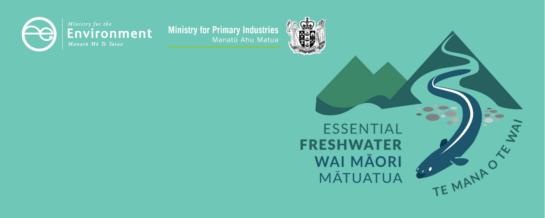

Te Mana o te Wai factsheet
Essential Freshwater is part of a new national direction to protect and improve our rivers, streams, lakes and wetlands. The Essential Freshwater package aims to:
- stop further degradation of our freshwater
- start making immediate improvements so water quality improves within five years
- Reverse past damage to bring our waterways and ecosystems to a healthy state within a generation.

Who should read this factsheet
This factsheet is part of a series and provides information about Te Mana o te Wai – the central concept for freshwater management. It is intended for anyone with an interest in freshwater policy such as council staff, iwi, land users, the agricultural industry, farm advisors and consultants.

What is Te Mana o te Wai and what does it mean?
Te Mana o te Wai refers to the vital importance of water. When managing freshwater, it ensures the health and well-being of the water is protected and human health needs are provided for before enabling other uses of water. It expresses the special connection all New Zealanders have with freshwater. By protecting the health and well-being of our freshwater we protect the health and well-being of our people and environments. Through engagement and discussion, regional councils, communities and tangata whenua will determine how Te Mana o te Wai is applied locally in freshwater management.
Te Mana o te Wai has been part of the National Policy Statement for Freshwater Management since 2014, though there are changes to how the concept is described and how it must be applied.
The National Policy Statement for Freshwater Management 2020
The National Policy Statement for Freshwater Management 2020 (NPS-FM 2020) is part of the Essential Freshwater package. It provides national direction which regional councils translate into action on the ground through their regional policy statement and regional plans and city and district councils through their district plans. It replaces the NPS-FM 2017.

Overview of Te Mana o te Wai
The NPS-FM 2020 strengthens and clarifies Te Mana o te Wai by providing stronger direction on how Te Mana o te Wai should be applied when managing freshwater.
- Te Mana o te Wai must inform how the NPS-FM 2020 is implemented
- Te Mana o te Wai imposes a hierarchy of obligations. This hierarchy means prioritising the health and well-being of water first. The second priority is the health needs of people (such as drinking water) and the third is the ability of people and communities to provide for their social, economic and cultural well-being. The hierarchy does not mean, however, that in every case the water needs to be restored to a pristine or pre-human contact state before the other needs in the hierarchy can be addressed.
- The six principles of Te Mana o te Wai in the NPS-FM 2020 inform its implementation (see text box below).
The six principles
Mana whakahaere: the power, authority, and obligations of tangata whenua to make decisions that maintain, protect, and sustain the health and well-being of, and their relationship with, freshwater
Kaitiakitanga: the obligation of tangata whenua to preserve, restore, enhance, and sustainably use freshwater for the benefit of present and future generations
Manaakitanga: the process by which tangata whenua show respect, generosity, and care for freshwater and for others
Governance: the responsibility of those with authority for making decisions about freshwater to do so in a way that prioritises the health and well-being of freshwater now and into the future
Stewardship: the obligation of all New Zealanders to manage freshwater in a way that ensures it sustains present and future generations
Care and respect: the responsibility of all New Zealanders to care for freshwater in providing for the health of the nation
- Giving effect to Te Mana o te Wai
Regional councils must give effect to Te Mana o te Wai by actioning the five key requirements of Te Mana o te Wai - for example, regional councils must apply the hierarchy of obligations when implementing the NPS-FM 2020. See figure 1 for further detail on the requirements.
- Long-term visions for freshwater
To give effect to Te Mana o te Wai regional councils must develop a long-term vision through discussion with communities and tangata whenua. Establishing a long-term vision for a waterbody means capturing the needs and aspirations of the community and tangata whenua in each region. Long-term visions identify a time frame that is both ambitious and reasonable (for example 30 years).
The long-term vision needs to be based on the history of, and current pressures, on local waterbodies and catchments. Regional councils also need to regularly report on their progress against the long-term vision.
- Tangata whenua involvement
Local authorities must actively involve tangata whenua in freshwater management (including decision-making processes, and monitoring and preparation of policy statements and plans). Regional councils must investigate the use of tools in the Resource Management Act 1991 (RMA) such as joint management arrangements, Mana Whakahono ā Rohe, and transfer of powers – as a way of involving tangata whenua.
- Integrated management
Local authorities must take an integrated management approach to freshwater management in accordance with the principle of ki uta ki tai (‘from the mountains to the sea’). This principle recognises the interconnectedness of the environment, the interactions between its parts, and requires integration between freshwater management and land use to avoid adverse effects (including cumulative effects) on the health and well-being of freshwater environments.

Giving effect to Te Mana o te Wai
The requirements of Te Mana o te Wai affect how local authorities will manage freshwater and direct other New Zealanders to do so through regional and district plans and regional policy statements.

Regional councils
Through engagement with communities and tangata whenua, regional councils need to give effect to Te Mana o te Wai. This must include applying the five requirements described in figure 1. Te Mana o te Wai (including the hierarchy of obligations and the six principles), must inform councils’ implementation of the NPS-FM 2020.
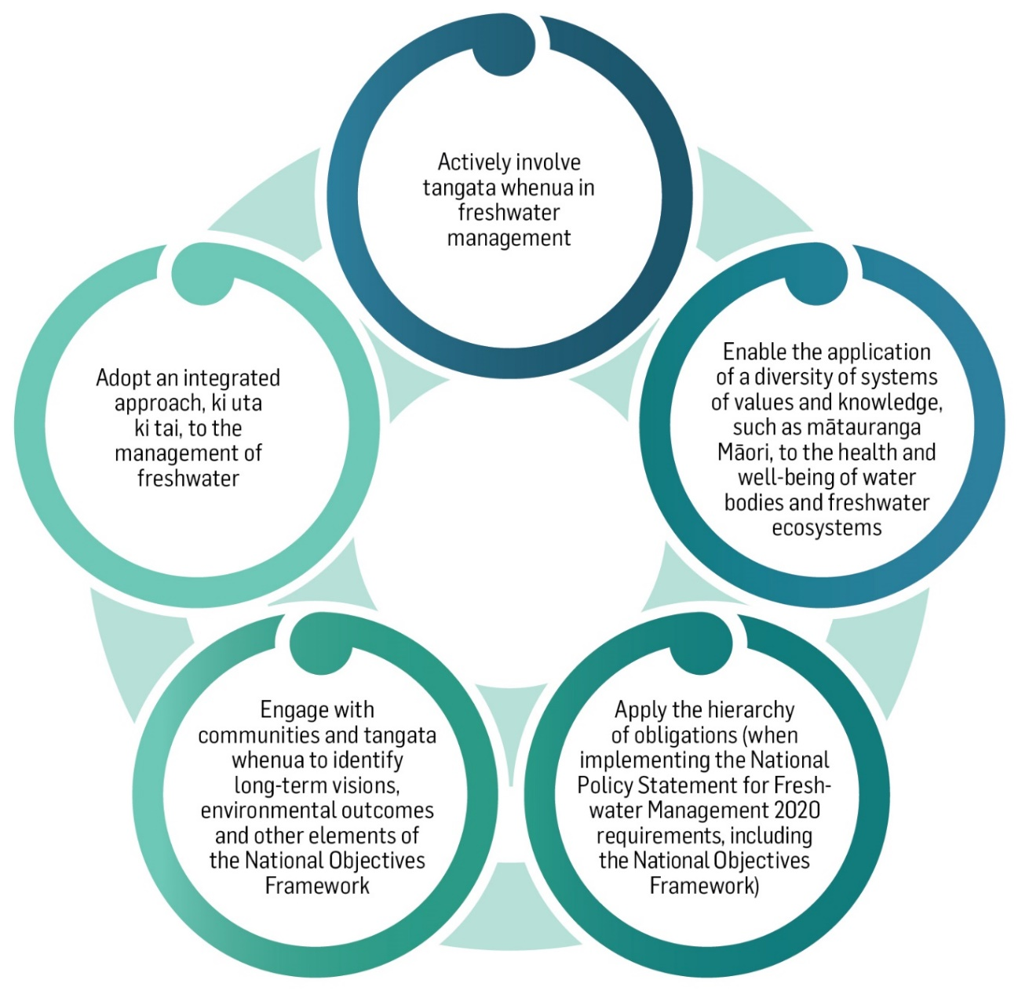
Figure 1: How regional councils must give effect to Te Mana o te Wai
Councils must also give effect to Te Mana o te Wai when making or changing regional policy statements and plans by, for example:
- ensuring that their regional policy statements and plans reflect tangata whenua and communities’ values
- stating in their regional policy statements the long-term vision that reflects people’s values for the future of their waterbodies
- including an objective in its regional policy statement that describes how the management of freshwater in the region will give effect to Te Mana o te Wai.

Tangata whenua
The NPS-FM 2020 intends for tangata whenua to be involved in the management of freshwater (including decision-making processes). Giving effect to Te Mana o te Wai requires local authorities to actively involve tangata whenua (to the extent they wish to be involved) in freshwater management.
In the context of waterbodies and freshwater ecosystems this means tangata whenua will, for example:
- work with local authorities to identify matters that are important to them. This will include identifying both how Te Mana o te Wai will be applied locally and the outcomes that tangata whenua want for relevant waterbodies in the future
- be enabled to apply different systems of knowledge for freshwater care and be involved in monitoring (such as mātauranga Māori)
- work with regional councils to implement the National Objectives Framework (NOF).

National Objectives Framework
The National Objectives Framework (NOF) requires that every regional council identifies values for each freshwater management unit in its region; sets target attribute states, and flows and levels, for waterbodies; develops interventions (limits specified in rules, or action plans) to achieve the target attribute states, flows, and levels; monitors waterbodies and freshwater ecosystems; and takes steps if deterioration is detected.

Farmers and growers
As key land-users in catchments, farmers and growers must manage land in relation to waterways in a way that complies with how Te Mana o te Wai is given effect to locally.
In order to give effect to Te Mana o te Wai, regional councils will develop rules for land-use and freshwater use that farmers and growers need to follow. Farmers and growers will be able to be part of this process through regional council plan development.

Communities
Regional councils are responsible for engaging with communities to determine how Te Mana o te Wai applies to waterbodies and freshwater ecosystems in the region.
To meet this obligation councils and communities – including tangata whenua - will discuss the values and aspirations they hold for the freshwater bodies and ecosystems in their region. Communities will also have a key role in setting a long-term vision for their region.

Te Mana o te Wai applies to all freshwater management
Te Mana o te Wai applies to all freshwater management, and not just the specific aspects of freshwater management referred to in this factsheet. Te Mana o te Wai informs all other parts of the Essential Freshwater package aimed at protecting the health and well-being of waterbodies and freshwater ecosystems.

More about the Essential Freshwater package
The package includes a number of new provisions including:
- new National Environmental Standards for Freshwater
- new stock exclusion regulations under section 360 of the RMA
- amendments to the Resource Management (Measurement and Reporting of Water Takes) Regulations 2010
- the National Policy Statement for Freshwater Management 2020 which replaces the NPS-FM 2017
- amendments to the RMA to provide for a faster freshwater planning process
- amendments to the RMA to enable mandatory and enforceable freshwater farm plans, and the creation of regulations for reporting nitrogen fertiliser sales.
Factsheets in this series
The full set of Essential Freshwater factsheets is available on our website.
Find out more and give us feedback
Contact us by emailing freshwater@mfe.govt.nz, or visit the Essential Freshwater page on our website.

Disclaimer
The information in this publication is, according to the Ministry for the Environment’s best efforts, accurate at the time of publication. The information provided does not alter the laws of New Zealand and other official guidelines or requirements. Users should take specific advice from qualified professional people before undertaking any action as a result of information obtained from this publication.
The Ministry for the Environment does not accept any responsibility or liability whether in contract, tort, equity or otherwise for any action taken as a result of reading, or reliance placed on the Ministry for the Environment because of having read any part, or all, of the information in this publication or for any error, or inadequacy, deficiency, flaw in or omission from the information provided in this publication.
Published in September 2020 by the
Ministry for the Environment and Ministry for Primary Industries
Publication number: INFO 968
