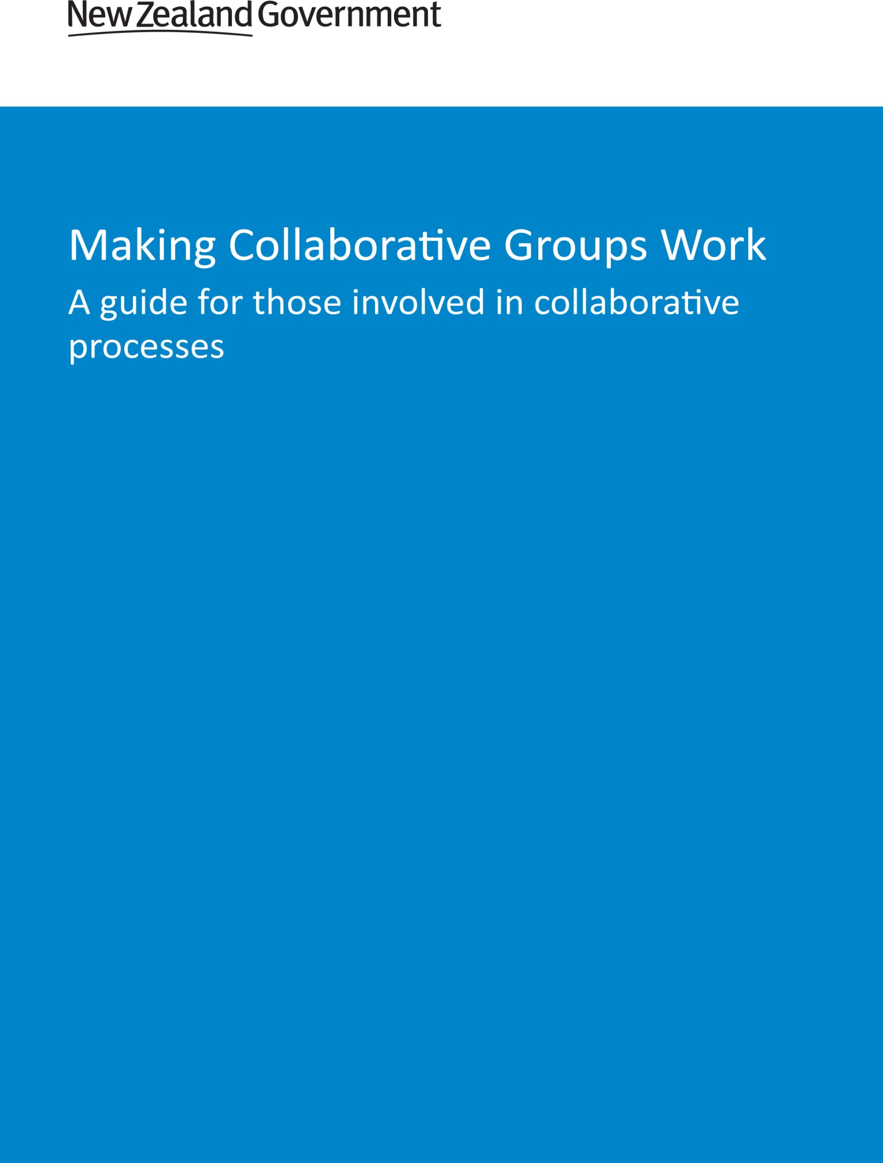

Acknowledgements
Many thanks to the following who were integral to the development of this document: Ian Whitehouse, David Wilson, Natalie Blandford, Raewyn Sendles, Michael Meehan, Barry Gilliland, Jonathan Streat and Tim Sharp.

This guide may be cited as: Ministry for the Environment. 2015. Making Collaborative Groups Work: A guide for those involved in collaborative processes. Wellington: Ministry for the Environment.

Published in September 2015 by the
Ministry for the Environment
Manatū Mō Te Taiao
PO Box 10362, Wellington 6143, New Zealand
ISBN: 978-0-908339-02-0
Publication number: ME 1208
© Crown copyright New Zealand 2015
This document is available on the Ministry for the Environment website: www.mfe.govt.nz.
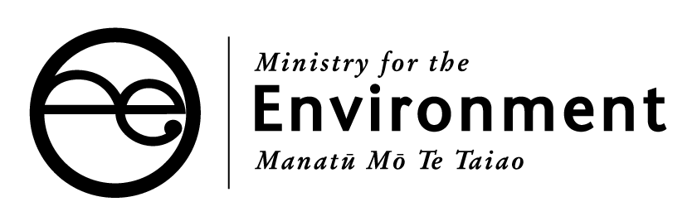

Contents
Foreword 4
About this guidance 5
Introduction 6
Establishing collaborative groups 7
Is collaboration appropriate? 7
Clarifying the nature of collaboration 7
Terms of reference 7
Political and community support for the collaborative process 8
Resources to support collaborative processes 9
The role of councillors in the collaborative process 9
Community or stakeholder models of representation 9
The roles within collaborative groups 10
Running collaborative groups 11
Induction processes 11
Managing group expectations 11
Communicating complex information to participants 11
Managing power differences between participants 12
Managing ‘difficult’ behaviour 12
Managing changes in personnel 13
Interests outside of the collaborative process 13
Communication between group members and the community 13
Workshops 14
Regular evaluation 14
Reaching an outcome 14
Concluding collaborative groups 15
Implementing the collaborative group’s recommendations 15
Putting collaborative groups’ recommendations into council plans 15
The ongoing role of the collaborative group 15
Useful resources 16

Foreword
In an increasingly adversarial age, the notion of collaboration can seem rather novel. It is, however, the most effective way of securing enduring community support for decisions that have to be taken by councils in the longer term interests of those communities.
Experience gained in this country, notably that of the Land and Water Forum, shows that it is possible to assemble the full range of perspectives on even the most difficult of issues, and work towards a genuine consensus. That consensus invariably results from a willingness to accept at the outset that the goal has to be the best interests of the community involved, and that participants must leave their personal or institutional ideology at the door if a consensus is to be achievable.
Collaboration works best when there is continuous outreach beyond the group charged with working for consensus into the wider community, in order to enlarge the ambit of ownership as widely as possible. It is vital that interested parties feel that they too can make inputs into the deliberations. It is equally vital that the findings and recommendations of the collaborative group are honoured by councils in their subsequent policy-making.
Getting collaborative results can be painstaking and requires careful attention to process. What follows is a very useful guide for success.

Chris Laidlaw
Chair Greater Wellington Regional Council
April 2015

About this guidance
Getting members of a collaborative group to work most effectively is crucial to the success of a collaborative planning process. This guidance uses real life experiences, moving through the stages of effective collaborative groups – from their establishment, through their running, and on to their conclusion. At each stage, areas to keep ‘front of mind’ are highlighted, and ways to address the challenges are described.
This guidance is an outcome of a Collaborative Exchange working group. The Exchange is a community of practice, with the Ministry for the Environment and councils who are involved in collaborative processes sharing their knowledge and experiences. The Ministry would like to thank the regional councils involved for their time and effort in writing and reviewing this guidance.

Introduction
Collaboration is being used both internationally and in New Zealand by local government as an effective way to harness the wisdom of the community and address complex resource management issues. Its use in New Zealand is relatively recent, but increasing.
A collaborative process has the community at its core, moving away from the traditional model of consultation on council-generated solutions to generating community-designed outcomes. From the outset of the collaborative process, councils partner with their communities to understand the challenges they face and develop, evaluate, agree to, and implement solutions to those challenges. Collaboration is an iterative process, using the knowledge of the community to develop community-supported solutions, no matter how unexpected some might be.
A collaborative process is enhanced by changes to some of the ways councils and their staff interact with the community. Making Collaborative Groups Work has been compiled by blending theory and practice. Theory of collaborative processes has been evaluated for context, but the guidance is primarily based on the experiences of local authorities from New Zealand that have used, or are using, collaborative processes to develop resource management plans or policies. The practical lessons learned by these early adopters in New Zealand will be valuable to those considering using the collaborative process.
It is important to recognise from the outset that there is no single correct approach to collaboration; each process will develop in response to the individual circumstances under consideration. The information in this document is intended to help guide council staff, facilitators and participants as they establish, engage in, or move towards concluding collaborative processes. It is not a ‘how to’ guide to collaboration, but rather a tool to assist councils and their communities travel through the collaborative process.

Establishing collaborative groups
Experience gained from the local case studies demonstrates that the work done establishing a collaborative group is critical to how they work once they start the task laid out before them. Essentially, the secret is ‘no surprises’.

Is collaboration appropriate?
Councils and their communities must decide whether a collaborative process is the most effective and efficient approach to resolve the issue. Important matters to consider are:
- the complexity of the issue(s) under consideration
- the decision-making uncertainty
- the size and diversity of the affected community
- whether the community wants to engage in resolving the issue.
In New Zealand collaboration has generally been used to resolve complex issues that potentially have a significant impact on the community. While it might not solve all of the community’s concerns, collaboration can decrease the likelihood of issues escalating to the courts, improve community awareness of the issue under consideration, and develop an understanding of others’ positions and views. In the long term, collaboration can increase the capacity of the community to engage in council planning processes, help develop new community leaders, and improve implementation of resource management programmes.

Clarifying the nature of collaboration
Clearly defining the issue(s) and outcome(s) expected of a collaborative group is fundamental. It is also good practice to upskill members of the group on how collaborative processes work, the expected behaviour of team members, and what the participants’ workload will be like. Clarifying the implications of the expected outputs of the collaboration is useful to engender engagement in the process. It should be clear who collaborative groups report to, and what decision-making powers – formal or informal – a group has from the outset.

Terms of reference
Experience of collaboration in New Zealand demonstrates that clear terms of reference or other such guiding document is critical to establishing and operating collaborative groups. Participants must understand and support the terms of reference, as this document will guide the collaborative process through to its completion, and be a constant reference point for the group as it moves through the collaborative process.
In most New Zealand examples, councils have presented terms of reference to collaborative groups to consider and agree on at the beginning of the process. In cases where councils preferred that collaborative groups develop their own terms of reference, there was a longer period before specific work on the tasks began. In such cases, sufficient time needs to be both available and set aside for this process to be completed before the group begins its substantive work.
Terms of references used in the case study examples have considered the following matters:
- purpose of the group
- intended outcome of the collaborative process
- who the collaborative group reports to
- decision-making authority of the collaborative group
- how material produced by the collaborative group will be used in subsequent decision-making processes
- timeframes for the collaborative process
- who has the final approval of the terms of reference
- membership of the collaborative group
- appointment and role of officers, such as chairs and facilitators
- role of councillors or other elected members
- how conflicts of interest will be managed
- protocols for collaborative deliberation within the group
- external engagement protocols, including engagement with the media
- whether meetings will be held in public or private
- whether collaborative groups are formal or informal committees of council
- processes for when consensus cannot be reached
- council expectations for the group once their ‘purpose’ has been achieved.

Political and community support for the collaborative process
Political support over the life of a collaborative process provides the group with a mandate for its work, and increases the likelihood of its success. Regular communication about the collaborative process and its progress is needed to ensure political stakeholders remain informed and supportive.
Political stakeholders must understand that collaborative processes can affect the role of traditional decision-makers, and agree about the level of decision-making being devolved to the collaborative group from the outset. Councils also need to be mindful of electoral cycles and their potential impact on the ongoing political support for collaborative processes.
Support from the wider community for the collaborative process is important too. Councils should endeavour to secure support from community leaders and other appropriate people who represent different interests in the community. Giving a collaborative group an opportunity to develop its own unique brand distinct from the council can be a useful way to foster community support for collaborative processes.

Resources to support collaborative processes
Participating in collaborative processes can be resource intensive for all parties involved. Councils must be confident from the outset that sufficient resources will be made available to support collaboration throughout the process. Costs may include those associated with running meetings, field trips, hiring a facilitator, or providing technical information.
If they are in a position to do so, councils could consider recognising the demand on participants through remuneration or reimbursements. Providing remuneration or reimbursements can encourage participants to engage more thoroughly in the process and result in regular attendance at meetings. Providing volunteer representatives with remuneration demonstrates their contribution is valued as much as paid employees of professional organisations.

The role of councillors in the collaborative process
Elected councillors can be active participants in collaborative groups. New Zealand experience indicates that participation from councillors in collaborative groups can help with communication and increase council commitment to the group’s recommendations. It can also lend weight to the process and, especially in its formative stages, encourage other community leaders to take part.
Councils should be clear, however, about the role of councillors in collaborative processes and understand that conflicts of interest might occur as a collaborative group’s recommendations go through formal council processes.

Iwi engagement in the collaborative process
Iwi engagement with the collaborative process is critical to its success. Lessons from local authorities who have used collaborative processes show it is important iwi are engaged in the process from the outset. Other success factors include:
- identifying and securing participation of all iwi, hapū or rūnanga with mana whenua in the area under consideration
- engaging with Māori organisations at the appropriate level from the outset of the collaborative process, to ensure their representatives in collaborative groups have the appropriate mandate for decision-making
- resolving the effect of the engagement duties some councils have as a result of the Treaty of Waitangi with the role of iwi, hapū or rūnanga representatives in collaborative groups.

Community or stakeholder models of representation
Councils in New Zealand have used the community or stakeholder models for representation when setting up collaborative groups – and sometimes a mix of both. In reality, whatever the approach, it is impracticable to form a group that is fully representative of all community interests. Retaining some flexibility around the composition of collaborative groups, especially at their formative stages, can help ensure the appropriate people participate. One way of checking representation is to ask participants at initial meetings “who is not at the table that should be at the table?” and “do we have a full range of community interests and values covered within the group?”
The community model requires participants to remove their stakeholder ‘hats’ and participate in the process with the interests of ‘the community’ in mind. Using the community model can limit the size of collaborative groups and give councils more control over who participates in the process. Although councils can use the selection process to ensure the participants represent a wide cross-section of the community, the composition of the group might still be subject to criticism from interest groups that are not expressly included. Experience in New Zealand shows putting stakeholder interests aside for the greater good of the community is challenging for some participants. By putting community values at the centre of the collaborative process, however, the community model can empower participants to find solutions that overcome common disputes between stakeholders.
The stakeholder model expressly asks participants to take part with their stakeholder ‘hat’ on. The stakeholder model can engender wider support for collaborative groups, as interest groups are more likely to be confident they are represented in the process. Councils will likely have less control over who participates in the process, and the size of the group can become quite large. Collaborative groups using the stakeholder model will need to consider the impact of having national or local representatives of national organisations. While it is important that a representative has the mandate to speak on behalf of their organisation, local knowledge can be equally as important to the success of a collaborative process.
Collaborative group members are often lay community members, given the task of reaching decisions on difficult resource management issues. Regardless of the representation model, group members should bring a useful knowledge, a positive attitude to others, and have the time and energy to effectively participate in the collaborative process. It is important that group members can work collaboratively and see things through other people’s eyes.

The roles within collaborative groups
There is no standard formula for the structure of collaborative groups. In some New Zealand cases the group is chaired by someone elected from the group’s participants, but in others the chair is independent of the group. Chairs are not universally used; most groups had one or more facilitators. These are often council staff, but could also be professionals. Where the role is used, a skilled and experienced facilitator is viewed as a key success factor for the collaborative process.
Where both are used, it is important the facilitator and chair work well together and are respected and trusted by group members. The roles of the chair and the facilitator should be made clear in the terms of reference or other such guiding document. In some New Zealand examples, chairs are responsible for the formal management of group meetings and external communication, while the facilitators oversee the overall process and ensure it meets council requirements. Facilitators and chairs, whether they are independent or council staff, need to be willing to adapt to the requirements of individual collaborative groups.

Running collaborative groups
There is no one-size-fits-all solution for running collaborative groups, but the issues below have been identified as important to the success of these groups. Many of these issues are applicable to all forms of community engagement, collaborative or not.

Induction processes
New Zealand experience indicates it is good practice to hold an orientation or induction session with the collaborative group before the ‘official’ process begins. This is a key stage in managing expectations, while ensuring all participants have the same understanding of how the collaborative process will work, the expected behaviours, and the intended outcome of the process. It is also an opportunity for participants to discuss their connection to the issue under consideration, beginning the critical process of participants understanding each other’s perspectives.
Such sessions do not need to be held in formal settings. If resources allow it, it can be helpful to engage an expert in collaborative processes in the induction phase, to provide participants with further clarity about what is expected as they take part in the collaborative process.

Managing group expectations
Experience of collaboration in New Zealand shows the key document governing the collaborative process is the terms of reference, or similar guiding document. The terms of reference must be clear about the scope of the group’s work, and is a very important reference for bringing the group back into scope if it begins to stray.
It is also good practice for collaborative groups to regularly check whether proposed solutions or recommendations can be implemented in light of other constraints, including councils’ other legislative or consultative responsibilities. Regular checking means participants become aware of any such limitations on their recommendations as soon as possible. Where they are known from the outset, these constraints should be included in a group’s terms of reference or other guiding document.

Communicating complex information to participants
Communicating complex information in a way that all participants understand is critical to the success of collaborative processes. This can be challenging, as there will inevitably be a wide range of understanding in the group, and having to re-explain information is frustrating for group members who understand it well. The following techniques are helpful for communicating complex information:
- providing a range of information, from high-level through to in-depth background documents, to satisfy the requirements of all group members
- ensuring subject matter experts communicate information in an appropriate way for the audience
- if participants are having difficulty understanding certain information, holding sessions between the participants and a subject matter expert to build their capacity
- a mentoring programme was successfully used in one New Zealand case to ensure all participants had the same level of understanding for their deliberations
- tasking smaller groups from within the wider collaborative group to consider technical information and report back to the wider group in plain language.

Managing power differences between participants
There are inevitably perceived power differences when collaborative groups are formed. Successful collaboration requires that these power differences be identified and managed. Building trust between participants limits the impact of power differences in collaborative groups, and field trips or other social activities are effective tools to help build trust and empathy between participants.
It is helpful at the outset to emphasise that all participants in a collaborative process are on an even footing, and that council will actively address any perceived imbalance. Facilitators, chairs and council staff should be proactive and mindful of participants who are not fully taking part in group discussions and encourage them to raise their opinions. Other settings, such as smaller groups, whiteboard or ‘stickering’ exercises, might encourage reluctant participants to put forward their viewpoints. Reinforcement of agreed ‘‘engagement etiquette’ at the beginning of meetings may be a useful approach to encourage all participants to engage in group meetings.

Managing ‘difficult’ behaviour
A number of behaviours can hamper collaboration and disrupt meetings. This includes participants who display disengaged, unprepared or uncooperative behaviour. It is important to recognise such behaviour early and take steps to manage it. The best response is if other participants are both empowered and confident enough to respond to the disruptive behaviour. One-on-one conversations between people exhibiting ‘difficult behaviour’ and the group’s chair or facilitator can be useful to highlight the negative impact of their behaviour on the collaborative process.
A less obvious form of difficult behaviour experienced in some New Zealand examples is participants repeatedly asking for more information when collaborative groups are heading towards an outcome, in an effort to delay decision-making. One way of addressing this is for facilitators or chairs to ask the participant how the additional information will affect their decision. If the new information would not have a material impact, waiting for it is not likely to benefit the collaborative process.
If facilitators, chairs or council staff are struggling to re-engage a difficult person, they could consider seeking assistance from higher levels of management. Wherever possible, people exhibiting difficult behaviour need to remain engaged in the collaborative process, as any outcome reached without the support of such people is less likely to be enduring.
The views and behaviour of interested parties from outside the collaborative group may disrupt or undermine the work of a collaborative group. Encouraging and helping group members who represent similar interests to respond publicly and privately to outside criticism has been an effective approach to limit its impact. Chairs, facilitators and council staff have also worked proactively with those outside interests to foster their support for the collaborative process.

Managing changes in personnel
Given collaborative processes can be quite long (in some instances years, not months), group membership is likely to change. Such changes are potentially disruptive to the process, and it is good practice to have a succession strategy in place. This should be outlined in the terms of reference or other such guiding material. Strategies used in New Zealand examples include:
- agreeing that the departing participant is responsible for upskilling their successor
- chairs, facilitators or council staff meeting with new participants one-on-one before they begin to take part in the collaborative process, to ensure they fully understand the position the group has reached and the process used to reach it
- if councils have elected to use a community model, putting an extra participant on the group at the start to cover possible losses of personnel so there is no need to replace a withdrawn participant later in the process.
As other interests become engaged in the work of the collaborative process, participants and councils could consider widening the membership to include those interests, using the same capacity-building techniques as for replacement members. When considering widening membership, you should take into account the overall group size, meeting logistics and administrative requirements, and the overall effectiveness of a larger group.

Interests outside of the collaborative process
New Zealand experience indicates that it’s unlikely that all possible interests will be represented by collaborative groups. To reach an enduring outcome, chairs, facilitators and council staff should recognise that there are interests that are not represented at any stage during the collaborative process. In some New Zealand examples the facilitator had the role of ‘holding the space’ for those interests. If resource capacity allows it, councils could consider engaging with the community concurrently to the collaborative process, and feeding the findings of that engagement into the collaborative process.

Communication between group members and the community
It is good practice to outline protocols for release of information to the media and engagement with the community, especially when collaborative group meetings are not held publicly. Group members must be encouraged to engage with their communities throughout the process, and feed the content of that engagement back into the collaborative process. This responsibility needs to be made clear to participants at the outset.
It is good practice to ask about community feedback in each meeting of the group and flag opportunities for community and special interest engagement as they arise in the collaborative process. It might be helpful for councils to provide an online tool to share collaborative group records. The New Zealand experience demonstrates that field trips or information days can create strong links between the collaborative group and the wider community. Appointing someone to take responsibility for implementing a communications strategy in the process is good practice.

Workshops
Workshops have proven to be an effective way to address difficult or off-topic issues in the collaborative process, especially where meetings of collaborative groups are public. The benefit of workshops is they can be convened to consider contentious issues in smaller groups and/or provide an environment where members feel more comfortable considering innovative ideas.
Workshops can also be used to engage the wider community in the collaborative process, as membership of these groups could include people from outside the main collaborative group. This can be particularly helpful when those people are significantly affected by the topic under consideration.
Successful workshops have a clear mandate, and responsibility to publicly report their findings back to the wider collaborative group.

Regular evaluation
It is good practice to continue to evaluate the collaborative process throughout to ensure it remains on track to meet its objectives and that its outcomes are both practical and lawful to implement. Techniques used by case study groups included:
- surveys of the group
- one-to-one conversations between participants and council staff
- informal project team debriefs in the days immediately following a collaborative group meeting or event, to reflect on what worked and what did not
- regular checks that group members continue to hold a mandate to represent their communities
- legal and planning audits of recommendations.

Reaching an outcome
Collaboration is an iterative process. The New Zealand collaborative experience demonstrates that proposed solutions will likely need to be built up, broken down and built up again, until a satisfactory outcome is achieved.
It has proven helpful if chief executives, council chairs or mayors meet with collaborative groups when challenging issues or people are halting the progress, or motivation in the group appears to be waning.
Reaching a consensus is very important in the collaborative process, and collaborative groups and councils should be clear about their options if consensus cannot be reached. The options in circumstances where consensus cannot be reached should be specified in the terms of reference or other such guiding document.

Concluding collaborative groups

Implementing the collaborative group’s recommendations
It is critical that a collaborative group’s recommendations are implemented in good faith, and in accordance with the terms of reference or other such guiding documents. If this is not done, it will create a culture of distrust and have an impact on future community engagement in collaborative processes and resource management issues.
The best protection is to ensure implementation is dealt with very clearly in the terms of reference, and that recommendations stay within the project scope and are legal and practical to implement. Implementing a collaborative group’s recommendations is important because it will help sustain the consensus reached by the participants.
Collaborative groups could consider making their recommendations time bound, to increase the certainty of their implementation.

Putting collaborative groups’ recommendations into council plans
Engaging the appropriate council staff throughout the collaborative process means they will better understand the context of the group’s recommendations when it comes to amending council plans and policies. The Ministry for the Environment is working with a group of council staff to produce some specific guidance about putting collaborative groups’ recommendations into council plans and policies.

The ongoing role of the collaborative group
There should be clarity about what the ongoing role – if any – will be for the collaborative group. It is likely the community–council engagement fostered through the collaborative process will continue, whether or not the group continues to retain an ‘official’ status, which councils should recognise and plan for. The Ministry for the Environment is working with a group of council staff to develop guidance, about the ongoing role of collaborative groups.

Useful resources
Publicly available examples of terms of reference include those for the Whangarei Harbour process in Northland and the Ruamahanga Whaitua process in the Wairarapa.
The Resources Page on the Land and Water Forum’s website has some useful information, including the Forum’s Terms of Reference, its participation protocols, and notes on the nature of collaboration.
The Spectrum of Public Participation by the International Association for Public Participation defines collaboration as decision-makers “partner[ing] with the public in each aspect of the decision including the development of alternatives and the identification of the preferred solution”.
Landcare Research has a number of useful policy briefs about collaboration, based on research it has done on collaborative processes in New Zealand. Topics covered include:
- establishing collaborative processes
- evaluating collaborative processes
- the role of council in collaborative processes.
The Cawthron Institute has a number of reports about collaboration in relation to the National Policy Statement on Freshwater Management, including the roles of councils and the criteria for choosing collaboration.
Collaboration in the Waikato catchment is a case study, co-funded by the Ministry for the Environment which sets out the collaborative processes the Waikato Regional Council and the Waikato and Waipa River iwi used as part of their freshwater planning and management processes in the Waikato catchment.
Information on some of the collaborative processes under way in New Zealand can be accessed using the following links:
- Wai Ora, Northland Regional Council
- Collaborative Stakeholder Group, Waikato Regional Council
- TANK Project, Hawke’s Bay Regional Council
- Whaitua Committees, Greater Wellington Regional Council
- Zone Committees, Environment Canterbury Regional Council.

