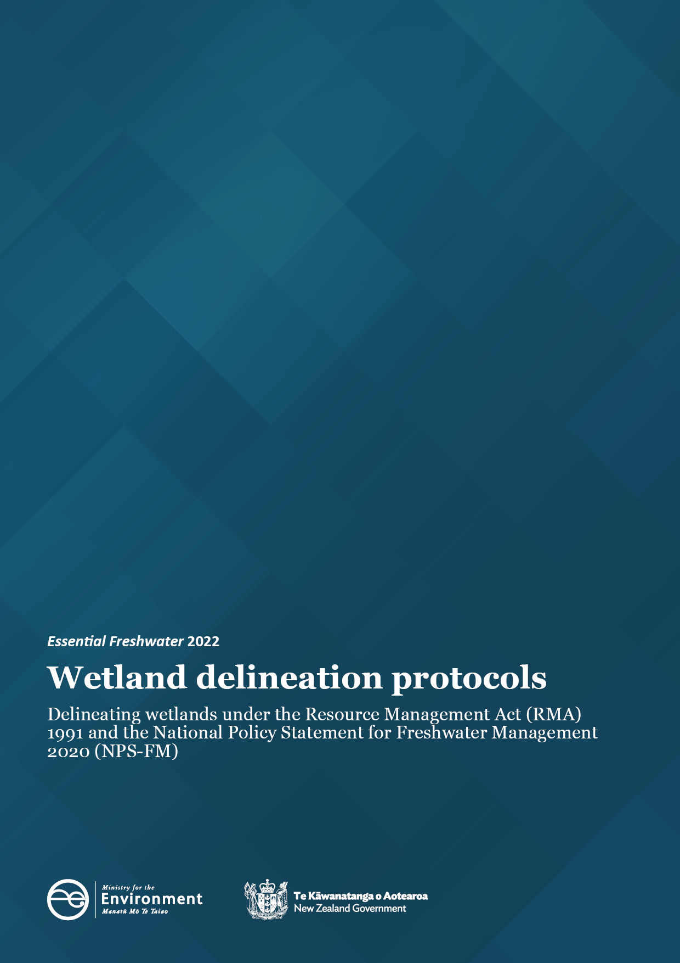

Disclaimer
The information in this publication is, according to the Ministry for the Environment’s best efforts, accurate at the time of publication. The Ministry will make every reasonable effort to keep it current and accurate. However, users of this publication are advised that:
- the information does not alter the laws of New Zealand, other official guidelines, or requirements.
- it does not constitute legal advice, and users should take specific advice from qualified professionals before taking any action based on information in this publication.
- the Ministry does not accept any responsibility or liability whatsoever whether in contract, tort, equity, or otherwise for any action taken as a result of reading, or reliance placed on this publication because of having read any part, or all, of the information in this publication or for any error, or inadequacy, deficiency, flaw in, or omission from the information in this publication.
- all references to websites, organisations or people not within the Ministry are for convenience only and should not be taken as endorsement of those websites or information contained in those websites nor of organisations or people referred to.

Acknowledgement
The Ministry would like to thank Beverley Clarkson (Manaaki Whenua Landcare Research) for authoring the initial versions of this document and providing peer review for this update.

This document may be cited as: Ministry for the Environment. 2022. Wetland delineation protocols. Wellington: Ministry for the Environment.

Originally published in December 2022 and Appendix 1 updated in January 2024 by the Ministry for the Environment
Manatū Mō Te Taiao
PO Box 10362, Wellington 6143, New Zealand
ISBN: 978-1-991077-04-2
Publication number: ME 1713
© Crown copyright New Zealand 2022
This document is available on the Ministry for the Environment website: environment.govt.nz.

Contents
1. Introduction 5
2. Background 6
3. Wetland delineation —overview 7
4. Wetland delineation – full procedure 8
Glossary 12
Appendix 1 — New Zealand wetland delineation data form 13
References 14

Figures
Figure 1: Flow chart of steps for determining an RMA wetland using the hydrophytic vegetation, hydric soils and wetland hydrology tools 6
Figure 2: Hydrophytic vegetation determination 9
Figure 3: Simple key to identifying hydric soil features (from Fraser et al, 2018) 10
Figure 4: Simple key to describing wetland hydrology 11

1. Introduction
This document outlines the process for using three protocols (vegetation, hydric soils and hydrology) to delineate wetlands as defined in the Resource Management Act (RMA) 1991, known as ‘RMA wetlands’.
The protocols have been developed to allow for both off-site wetland identification by experienced wetland ecologists in cases that are clearly wetlands, and on-site delineation of areas that are less clear-cut.
A robust national method for delineating wetlands is also required for implementing policy for ‘natural inland wetlands’ under the National Policy Statement for Freshwater Management 2020 Amendment 1 (NPS-FM).
The New Zealand Resource Management Act 1991 defines wetlands as:
‘permanently or intermittently wet areas, shallow water, and land water margins that support a natural ecosystem of plants and animals that are adapted to wet conditions’.
Under the NPS-FM, the definition of a natural inland wetland is a subset of the RMA definition, with several exclusions. It defines a ‘natural inland wetland’ as:
natural inland wetland means a wetland (as defined in the Act) that is not:
a. in the coastal marine area, or
b. a deliberately constructed wetland, other than a wetland constructed to offset impacts on, or to restore, an existing or former natural inland wetland, or
c. a wetland that has developed in or around a deliberately constructed water body, since the construction of the water body, or
d. a geothermal wetland, or
e. a wetland that:
i. is within an area of pasture used for grazing; and
ii. has vegetation cover comprising more than 50% exotic pasture species (as identified in the National List of Exotic Pasture Species using the Pasture Exclusion Assessment Methodology (see clause 1.8)); unless
iii. is a location of a habitat of a threatened species identified under clause 3.8 of this National Policy Statement, in which case the exclusion in (e) does not apply.
To confirm ‘natural inland wetland’ status under the NPS-FM, you will need to carry out an assessment to check whether any of the exclusions from the definition of ‘natural wetland’ apply.
Wetlands in pasture areas used for grazing that are dominated by exotic pasture species may fall under exclusion e) and should initially be assessed using the Pasture Exclusion Assessment Methodology (or latest update) and the National List of Exotic Pasture Species (or latest update) to check if they meet criteria for this exclusion. Further information on this process is contained in the Pasture exclusion assessment methodology.

2. Background
The approach to wetland delineation protocols is based on the US wetland delineation system for regulatory purposes (Environmental Laboratory 1987, and US Army Corps of Engineers updates). The US system uses three criteria: vegetation, soils and hydrology. These criteria have been adapted for New Zealand conditions and are available as the Vegetation Tool (Clarkson, 2014), the Hydric Soil Tool (Fraser et al, 2018) and the Hydrology Tool (Ministry for the Environment, 2021).
Wetland delineation should follow the four main steps outlined in figure 1. The procedure involves assessing hydrophytic vegetation, hydric soils and wetland hydrological characteristics. A detailed recommended procedure is provided in section 4.
The New Zealand Wetland Delineation Data Form (appendix 1) should be completed to identify hydrophytic vegetation, hydric soils and wetland hydrology.
Examples of completed forms that consider all three sets of characteristics can be found in Wetland Delineation Hydrology tool for Aotearoa New Zealand (see appendix 4: Data sheets from field trials).
Figure 1: Simple flow chart of steps for determining an RMA wetland using the hydrophytic vegetation, hydric soils and wetland hydrology tools.
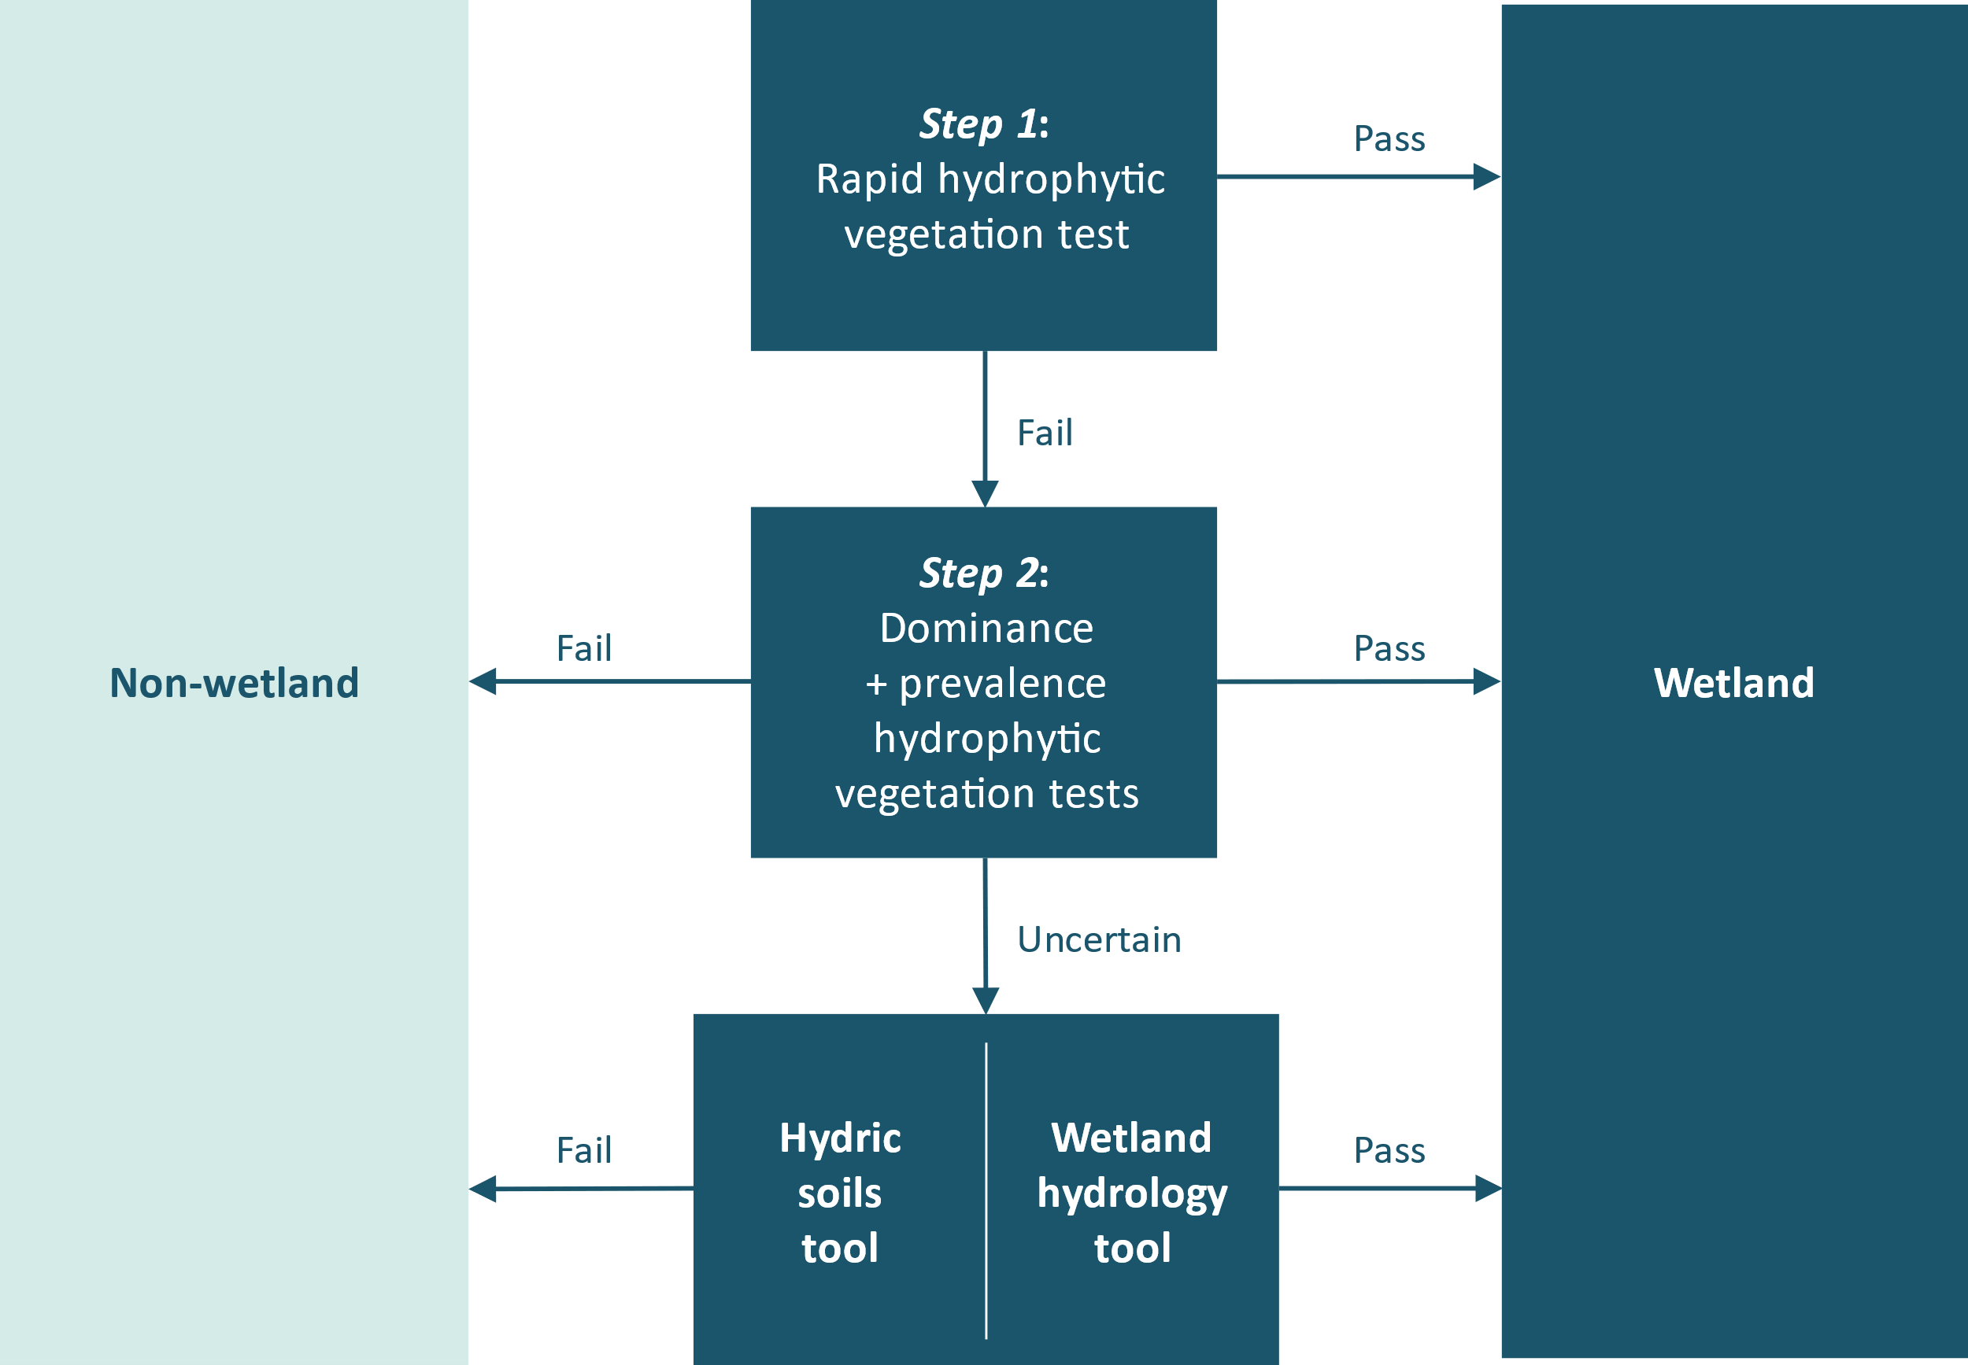
(See figure 2 for more details.)

3. Wetland delineation —overview

Step 1
The Rapid Test for vegetation is a simple first step for assessing obviously-wetland vegetation (eg, raupō reedland) that can be conducted off-site.

Step 2
The vegetation tool applies the dominance test and the prevalence index to a plant community to determine whether the vegetation is hydrophytic (wetland).
When the vegetation tool is used on its own, both the dominance test and the prevalence index must be satisfied for the site to be categorised as a wetland. In the absence of wetland soil and hydrology tools, these two plant-based tests applied together are considered to provide the on-site quantitative data necessary for delineating wetlands and their boundaries.
A third vegetation procedure, the US Rapid Test (Environmental Laboratory, 1987), which requires less quantitative data and less effort, was not used in the 2014 New Zealand Vegetation Tool.

Step 3 and 4
The hydric soils and hydrology tool provide supporting evidence for the hydrophytic vegetation tool and are particularly valuable where this yields uncertain results. Some overlap occurs between the hydric soils and hydrology tools, and we suggest the hydrology tool should be used at the same time as the hydric soils tool.

4. Wetland delineation – full procedure

Equipment you will need
- 2-metre x 2-metre quadrat or four poles to demarcate plots
- 10-metre tape measure
- diameter tape
- plant indicator status ratings list as per Clarkson (2021 or the latest update)
- thermometer
- hand lens
- spade
- soil auger
- soil colour charts (eg, Munsell Soil Color Book 2009)
- The New Zealand Soil Description Handbook (Milne et al, 1995)
- laminated copy of the field identification guide sheet as per Fraser et al (2018)
- copies of the wetland delineation data form and the quick reference guide to the wetland delineation data form (appendix 1).

Recommended procedure
- Determine the project area (the putative wetland).
- Identify the growing season for the area of interest.
- Assess weather conditions. Establish a suitable time to visit the site within the growing season and during normal weather conditions, that is, not immediately after heavy rainfall or during or immediately after drought conditions (we suggest a minimum of two weeks after extreme weather events).
- Decide if ‘normal circumstances’ are present, ie, typical climatic/hydrologic conditions, and no recent disturbances or modifications to the project area. If yes, proceed to step 5. If no, proceed to step 10.
- Identify and map the major vegetation types using aerial photographs, maps, contours, inventory reports, other data, and, if necessary, on-site field verification.
- Use off-site methods to identify wetland presence and sketch approximate boundaries. Wetlands may be confirmed without an on-site inspection depending on:
    - the amount and quality of existing data (vegetation, soils, hydrology, topography)
    - wetland ecological expertise to interpret the data.
- Use on-site methods to delineate wetland presence and accurate boundaries as follows:
    - for small areas (≤2 ha), establish a representative plot in each major vegetation type and record the plot vegetation in three strata: tree, sapling/shrub and herb
    - for larger areas, establish representative plots along transects (as per Clarkson, 2014) and sample the vegetation in three strata: tree, sapling/shrub and herb.
- Hydrophytic vegetation determination. Based on the data you have gathered, complete an assessment for hydrophytic vegetation as per section B of the wetland delineation data form (appendix 1) and referencing the following flow chart. Where the vegetation tool is inconclusive, move to step 9 (an assessment of hydric soils and wetland hydrology).
Wetland indicator status ratings for species are in Clarkson et al, 2021, and subsequent updates. An Excel spreadsheet list of species is available on the Landcare Research website.
Figure 2: Hydrophytic vegetation determination
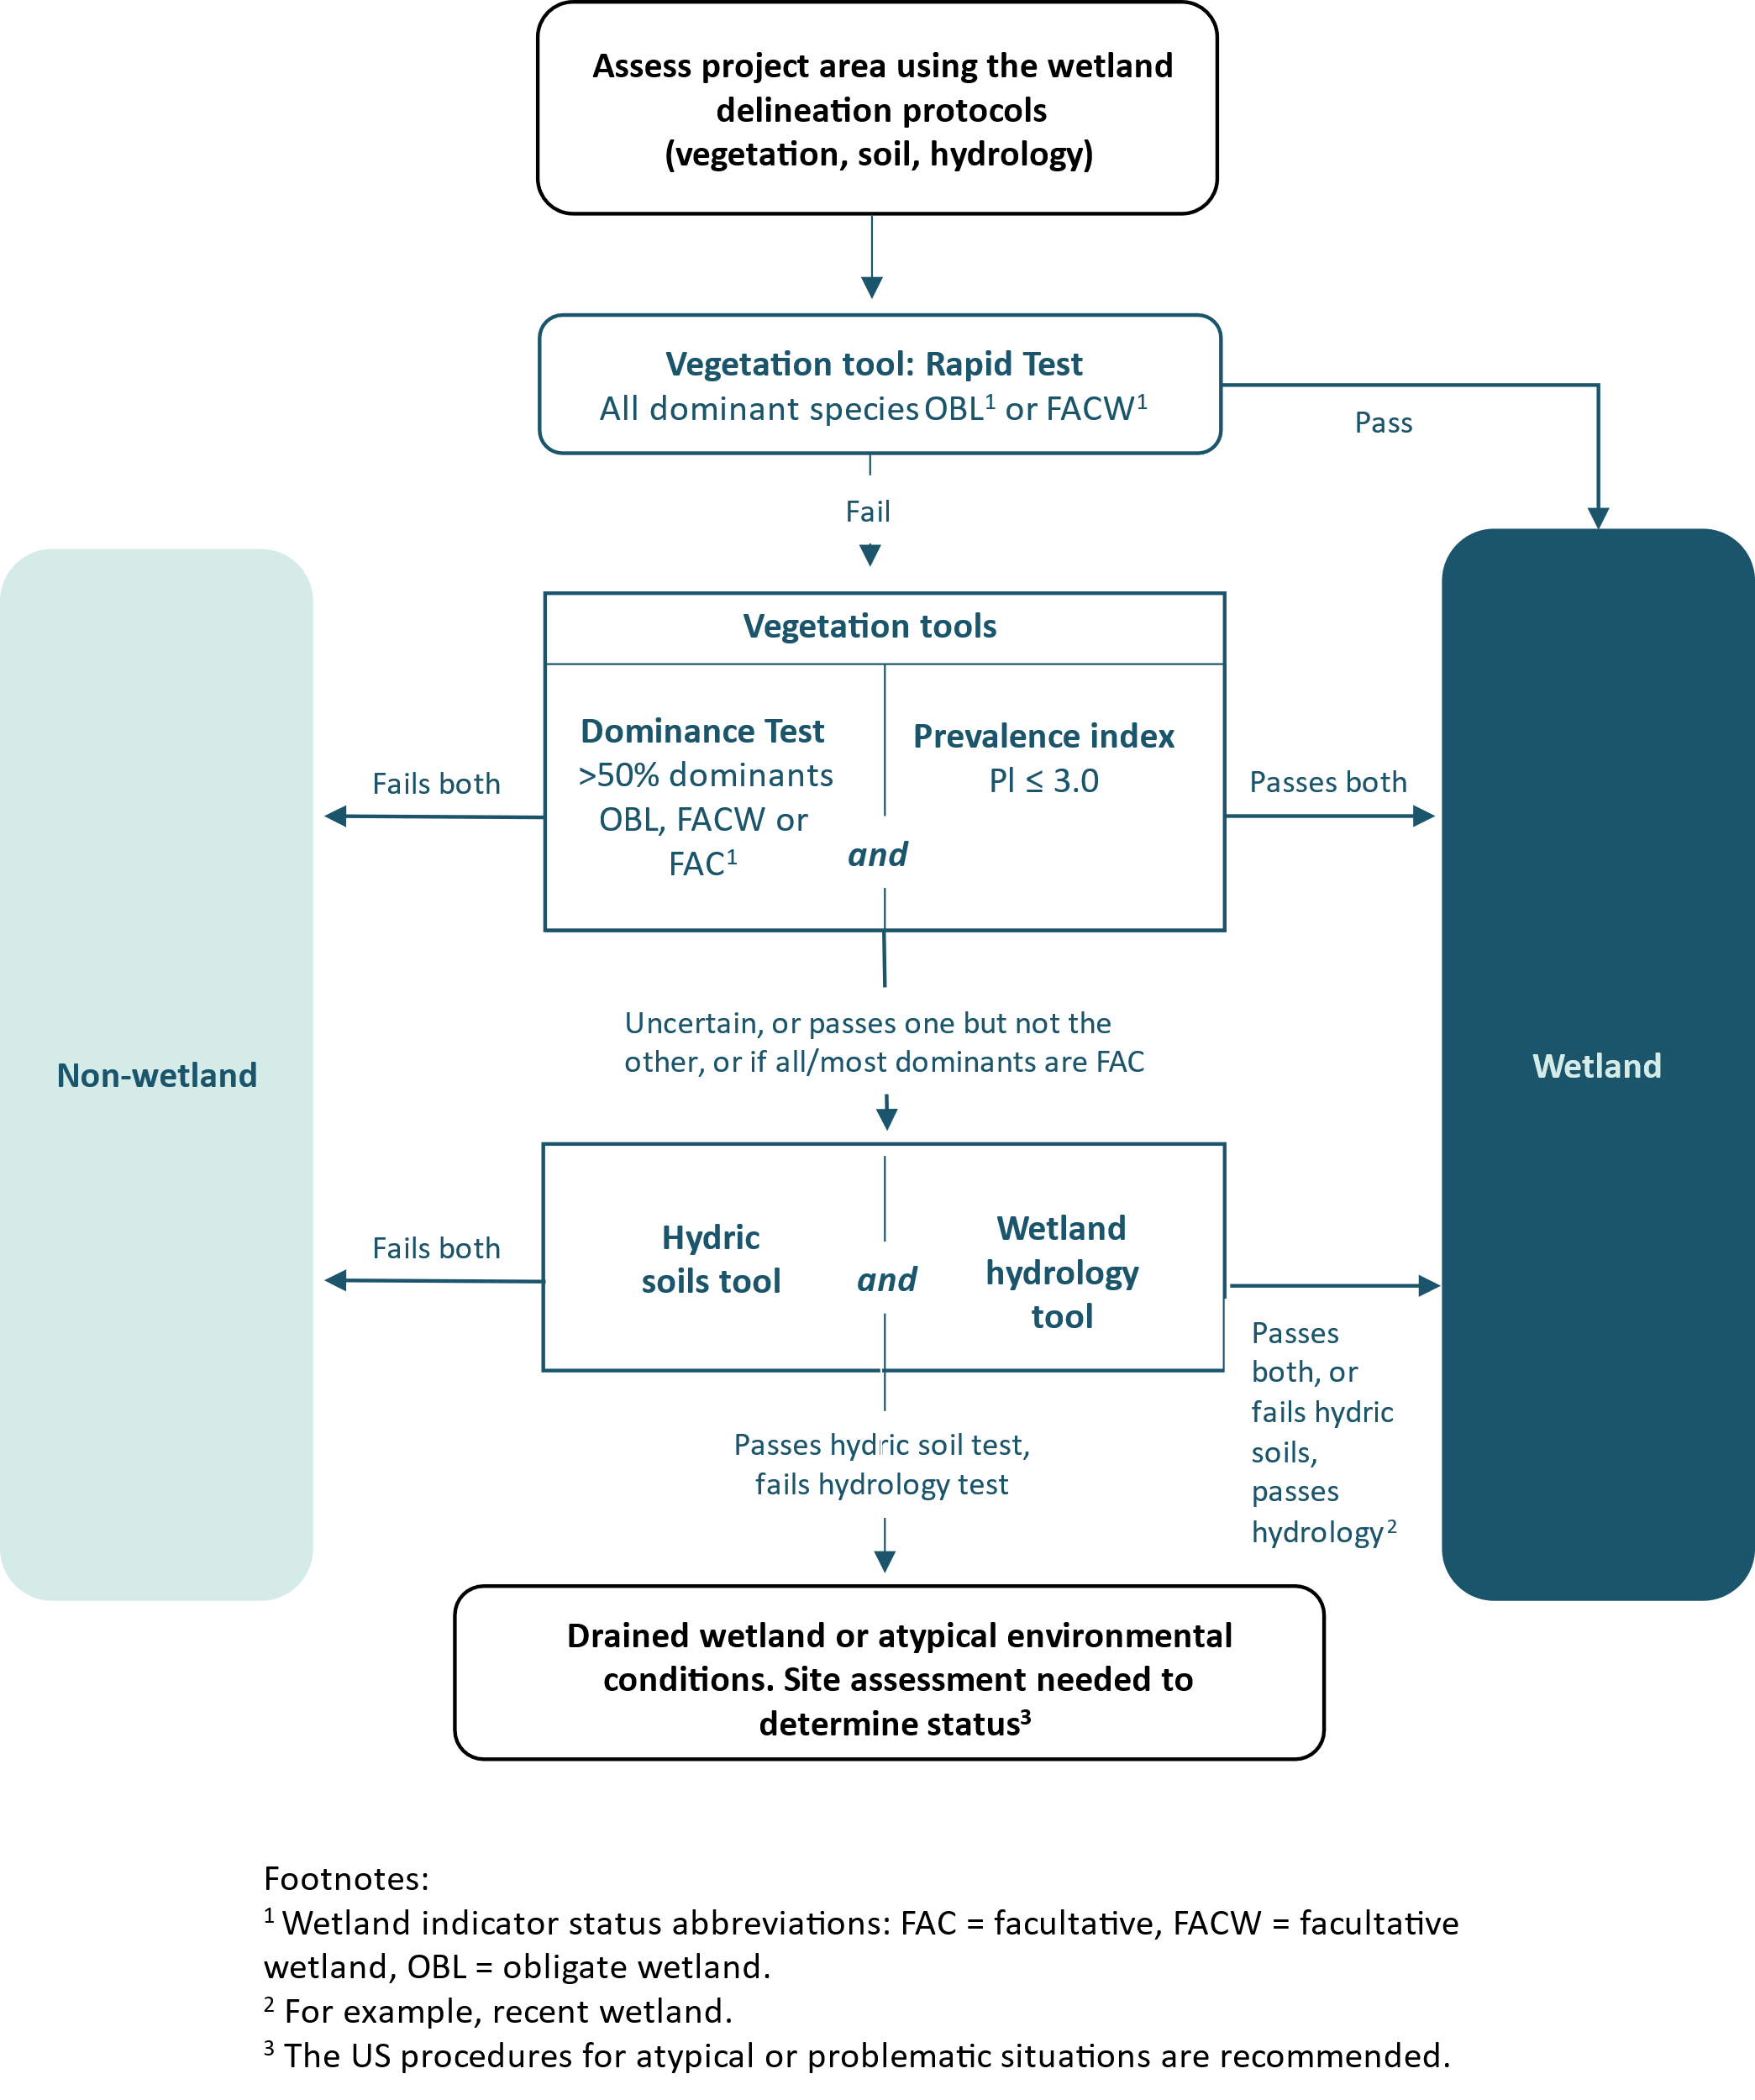

- Hydric soils assessment. Where the vegetation tool is inconclusive, complete the assessment for hydric soils as per section C of the wetland delineation data form (appendix 1) using the established guideline (Fraser et al, 2018) and figure 3 (below). We recommend you carry this assessment out simultaneously with the hydrology assessment (step 9) as they have some overlap.
Figure 3: Simple key to identifying hydric soil features (from Fraser et al, 2018)
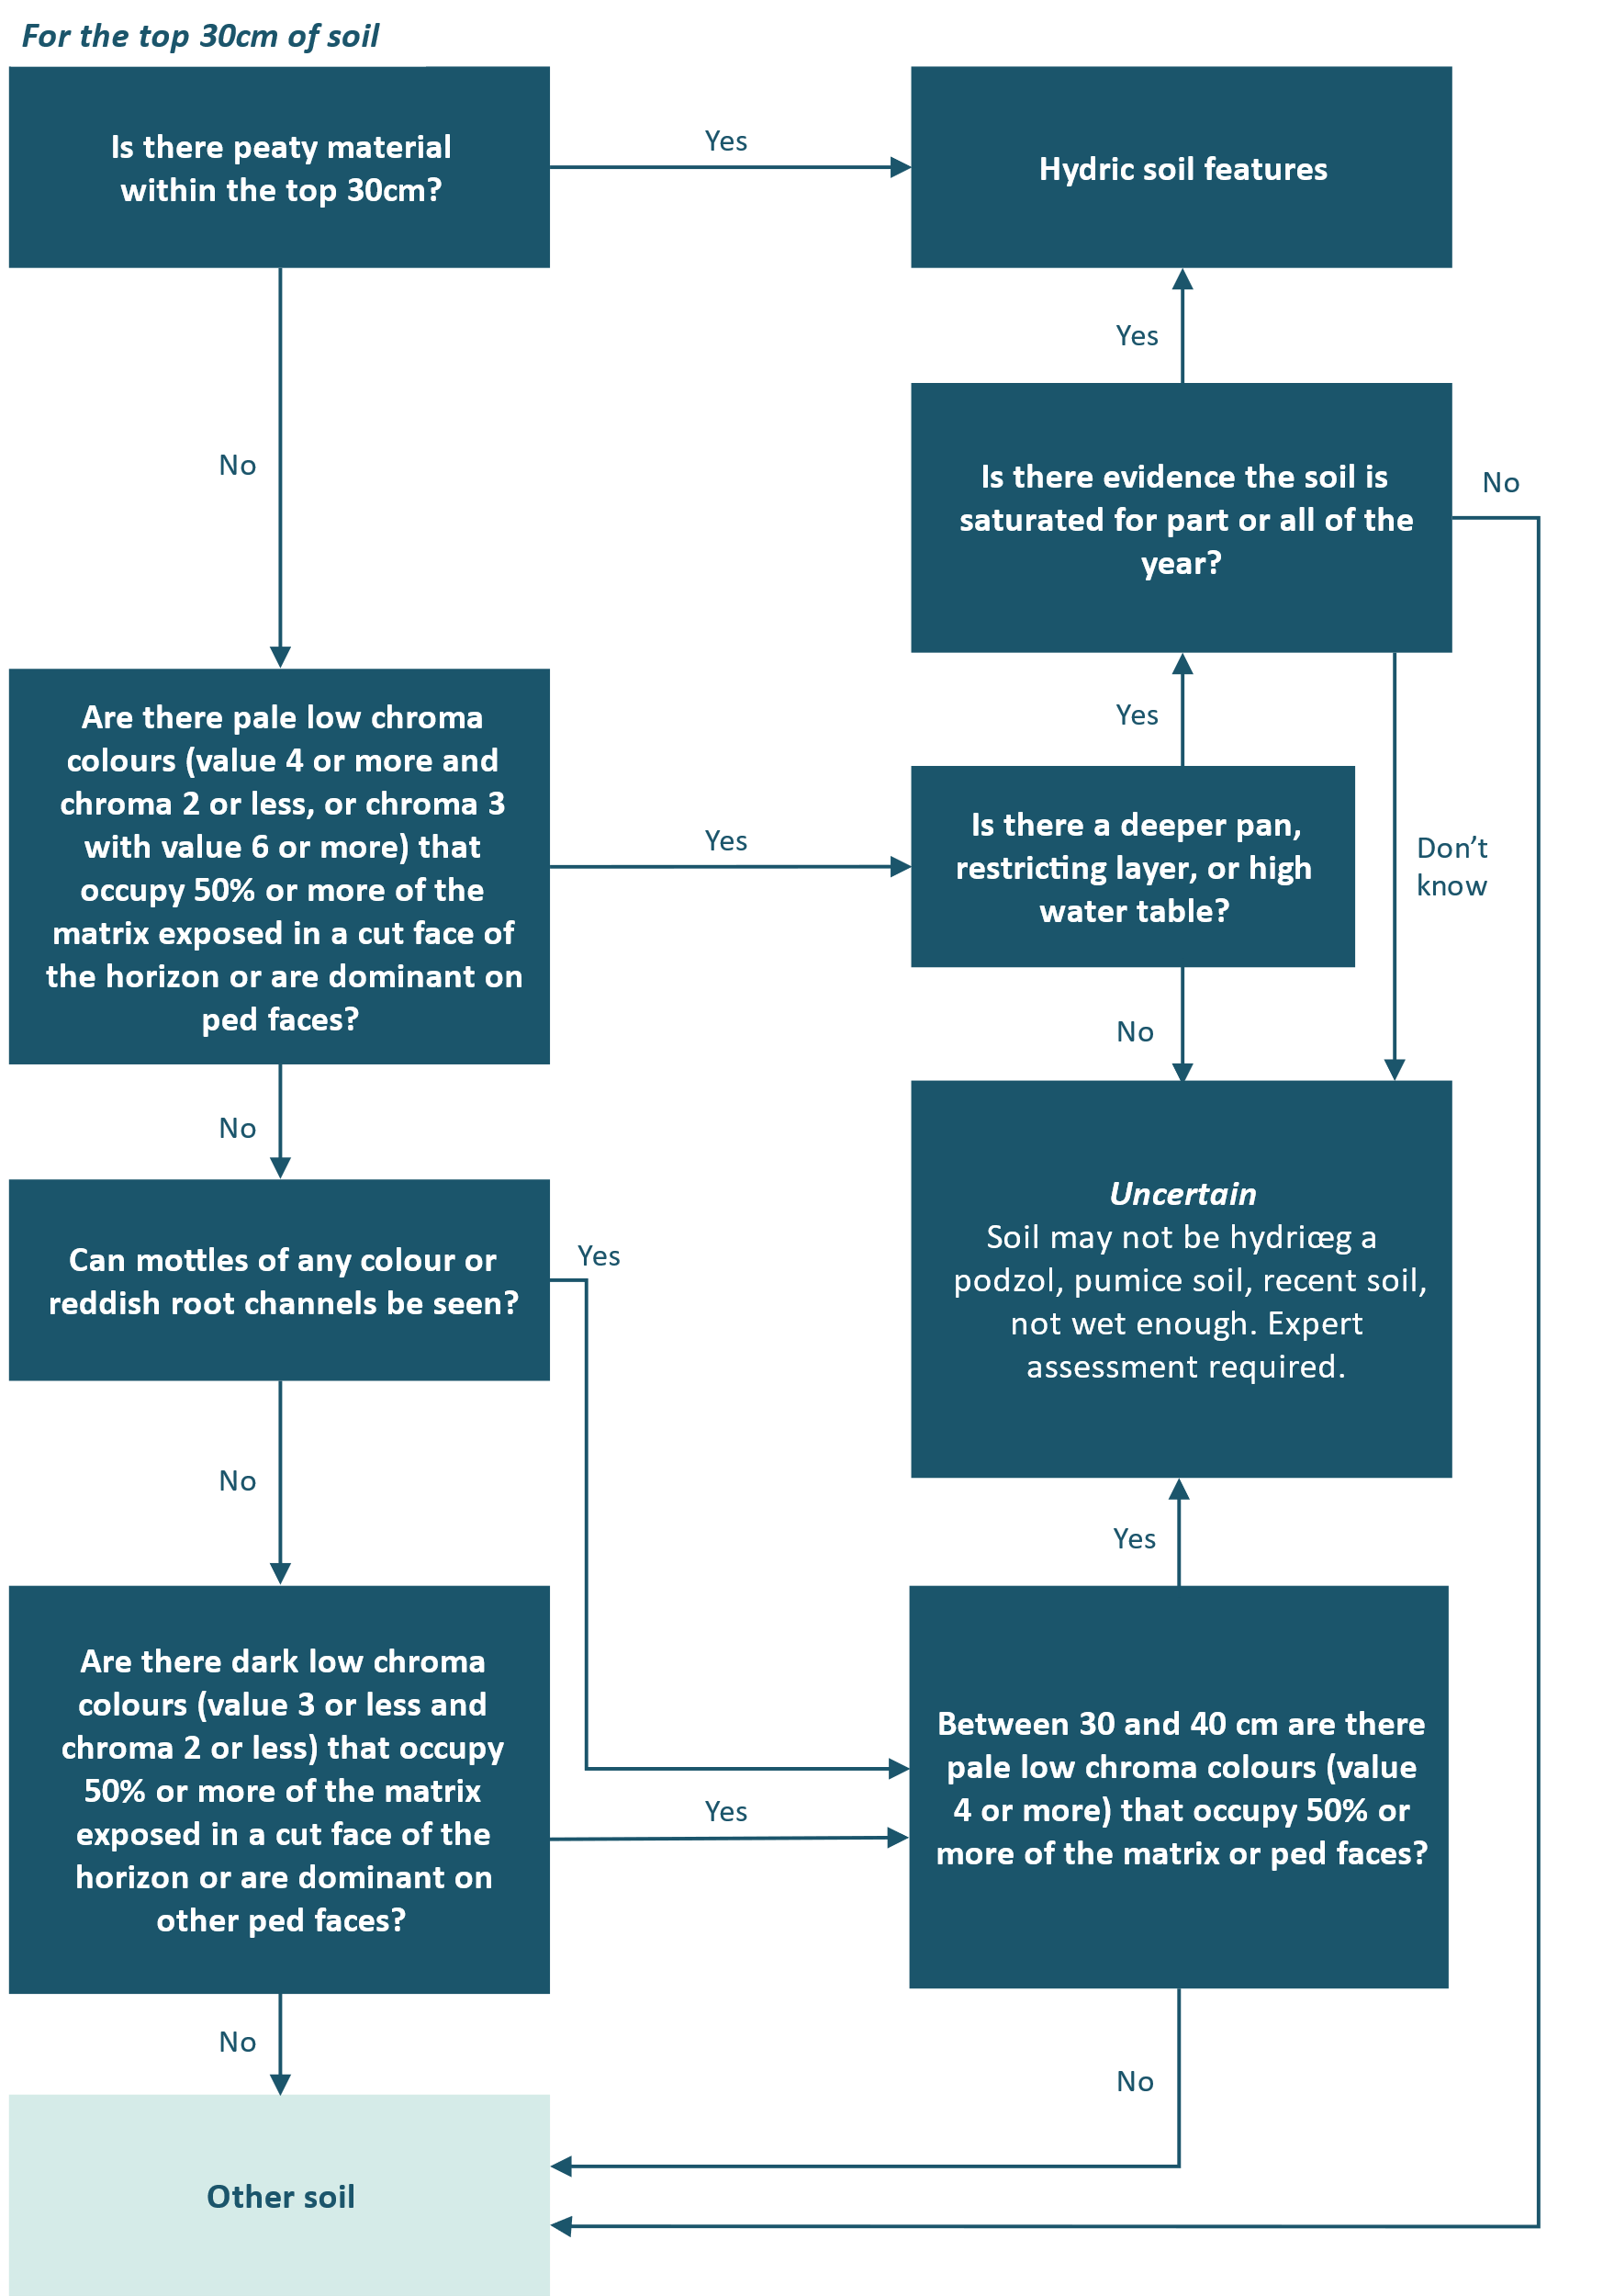
- Hydrology assessment. Complete section C of the wetland delineation data form (appendix 1) and identify the presence or absence of hydrology indicators (figure 4). One primary or at least two secondary indicators confirm the presence of wetland hydrology.
Figure 4: Simple key to describing wetland hydrology
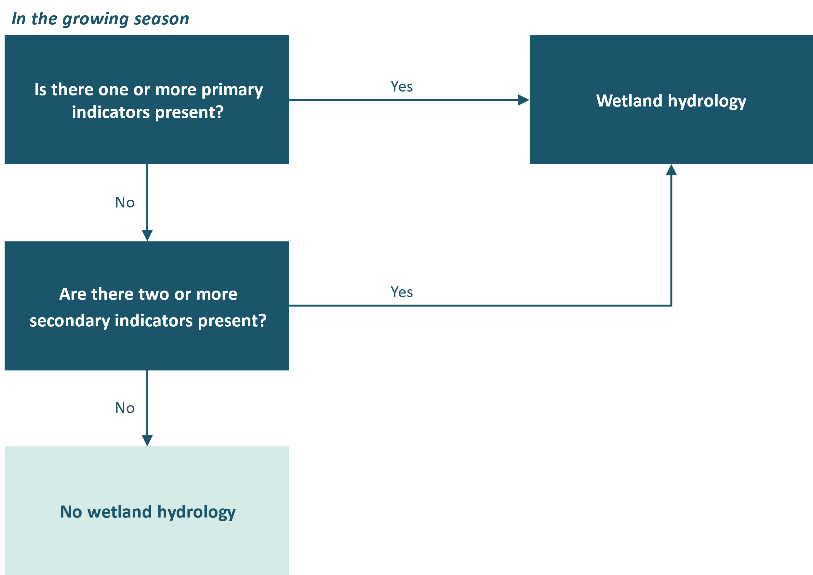
- Recent disturbance or abnormal environmental conditions. The above procedure will be used in the vast majority of wetland delineations. However, recent disturbance or abnormal environmental conditions may result in atypical or problematic wetland situations in which one or more of the three criteria (vegetation, hydrology and soils) is/are absent. In these cases, you will need more information and quantitative data and the US procedures for these situations are recommended (see Comprehensive Method [sections E–G] in Environment Laboratory 1987, and subsequent updates). More examples on how to assess areas of problematic hydrophytic vegetation including those affected by grazing, managed plant communities, aggressive invasive weeds, sparse and patchy vegetation, and temporal shifts in vegetation, are provided in the Wetland Delineation Regional Supplement for the Western Mountains, Valleys, and Coast Region, US (US Army Corps of Engineers, 2010).

Glossary
Atypical situations | Where ‘normal circumstances’ do not apply, and one or more of the three criteria (vegetation, hydrology, soils) may be absent. Atypical situations include abnormal environmental conditions (eg, drought, flood) or recent disturbances, such as landslides, or mechanical disturbance of vegetation (eg, clearance, mowing), or wetlands that have recently been filled, drained or cleared. In these situations, more comprehensive information and data, including evidence of conditions that existed immediately before the disturbance, are required and the US procedures for these situations are recommended (sections E–G in Environment Laboratory 1987, and subsequent updates).
Dominance test | More than 50 per cent of dominant species across all strata are rated OBL, FACW or FAC using the 50/20 rule.
Dominant species | The most abundant plant species (when ranked in descending order of abundance, eg, in a plot, and cumulatively totalled) that immediately exceed 50 per cent of the total cover for the stratum, plus any additional species comprising 20 per cent or more of the total cover for the stratum. This is known as the 50/20 rule, and is calculated for each stratum (tree, sapling/shrub and herb).
Growing season | The portion of the year when soil temperatures at 30 centimetres below the soil surface are higher than biologic zero (5 degrees Celsius), approximated as the period between the last frost day and the first frost day.
Hydric soils | Soils that have formed under conditions of saturation, flooding or ponding long enough during the growing season to develop anaerobic (low oxygen) conditions in at least the upper 30 centimetres of the soil.
Hydrophytes (hydrophytic vegetation) | Plant species capable of growing in soils that are often or constantly saturated with water during the growing season. The hydrophyte categories (wetland indicator status ratings: Clarkson et al, 2013 and subsequent updates) are:  - Obligate (OBL): occurs almost always in wetlands (estimated probability >99 per cent in wetlands)  - Facultative wetland (FACW): occurs usually in wetlands (67–99 per cent)  - Facultative (FAC): equally likely to occur in wetlands or non-wetlands (34–66 per cent)  - Facultative upland (FACU): occurs occasionally in wetlands (1–33 per cent)  - Upland (UPL): rarely occurs in wetlands (<1 per cent), almost always in ‘uplands’ (non-wetlands).
Normal circumstances | The long-term or stable condition of a site including any legal alterations, such as highways, dams and other relatively permanent development. The concept also includes the soil and hydrologic conditions that are normally present, in cases where the vegetation has been altered or removed.
Off-site wetland delineation | Assessment is made as a desktop exercise using pre-existing information (ie, does not require a field inspection).
On-site wetland delineation | Assessment is made based on information gathered from a field visit to inspect the area under investigation.
Prevalence index (PI) | A plot-based algorithm derived from the unique combination of OBL–UPL plants and their cover. The vegetation is considered to be hydrophytic (wetland) if PI ≤ 3.0, but values around 3.0 should be used alongside other wetland indicators.
Problematic wetland situations | Areas in which one or more of the three criteria (vegetation, hydrology, soils) is/are absent. In these cases, more information and quantitative data will be required (see Comprehensive Method of Environmental Laboratory 1987, and subsequent updates).
Rapid test | All dominant species across all strata are rated OBL and/or FACW.
Wetland boundary | This is the point on the ground at which a shift from wetlands to non-wetlands or aquatic habitats occurs. These boundaries usually follow contours.

Appendix 1 — New Zealand wetland delineation data form
The New Zealand wetland delineation data form and the Quick reference guide for New Zealand wetland delineation data form are available on the Ministry for the Environment website.

References
Clarkson BR. 2014. A vegetation tool for wetland delineation in New Zealand. Landcare Research Contract Report LC1793.
Clarkson BR, Champion PD, Rance BD, Johnson PN, Bodmin KA, Forester L, Gerbeaux P, Reeves PN. 2013. New Zealand wetland indicator status ratings: Checklist. Retrieved from https://www.landcareresearch.co.nz/uploads/public/Discover-Our-Research/Biodiversity/Species-ecosystem-services/Restoring-wetland-ecosystem-functioning/wetland_rating_species_December_2013-v2.pdf?vid=3cember_2013.pdf (25 November 2022).
Clarkson BR, Fitzgerald NB, Champion PD, Forester L, Rance BD. 2021. New Zealand wetland plant list 2021. Manaaki Whenua – Landcare Research Contract Report LC3975 for Hawke’s Bay Regional Council.
Environmental Laboratory. 1987. Corps of Engineers Wetlands Delineation Manual Technical Report Y-87-1. US Army Engineer Waterways Experiment Station, Vicksburg, Mississippi. Updated online edition: https://pdhonline.com/courses/c438/USACOE%20Wetland%20Delineation%20_%20Course.pdf
Fraser S, Singleton P, Clarkson B. 2018. Hydric soils – field identification guide. Manaaki Whenua – Landcare Research Contract Report LC3233 for Tasman District Council.
Milne JDG, Clayden B, Singleton PL, Wilson AD. 1995. Soil description handbook. Lincoln NZ: Manaaki Whenua Press.
Ministry for the Environment. 2021. Wetland delineation hydrology tool for Aotearoa New Zealand. Wellington: Ministry for the Environment.
Morse T. 2016. Wetland delineation and technical criteria. US Army Corps of Engineers, Colorado Regulatory Branch, Colorado.
U.S. Army Corps of Engineers 2010. Regional Supplement to the Corps of Engineers Wetland Delineation Manual: Western Mountains, Valleys, and Coast Region (Version 2.0). ERDC/EL TR-08-28. Vicksburg, MS: U.S. Army Engineer Research and Development Center, Environmental Laboratory.

