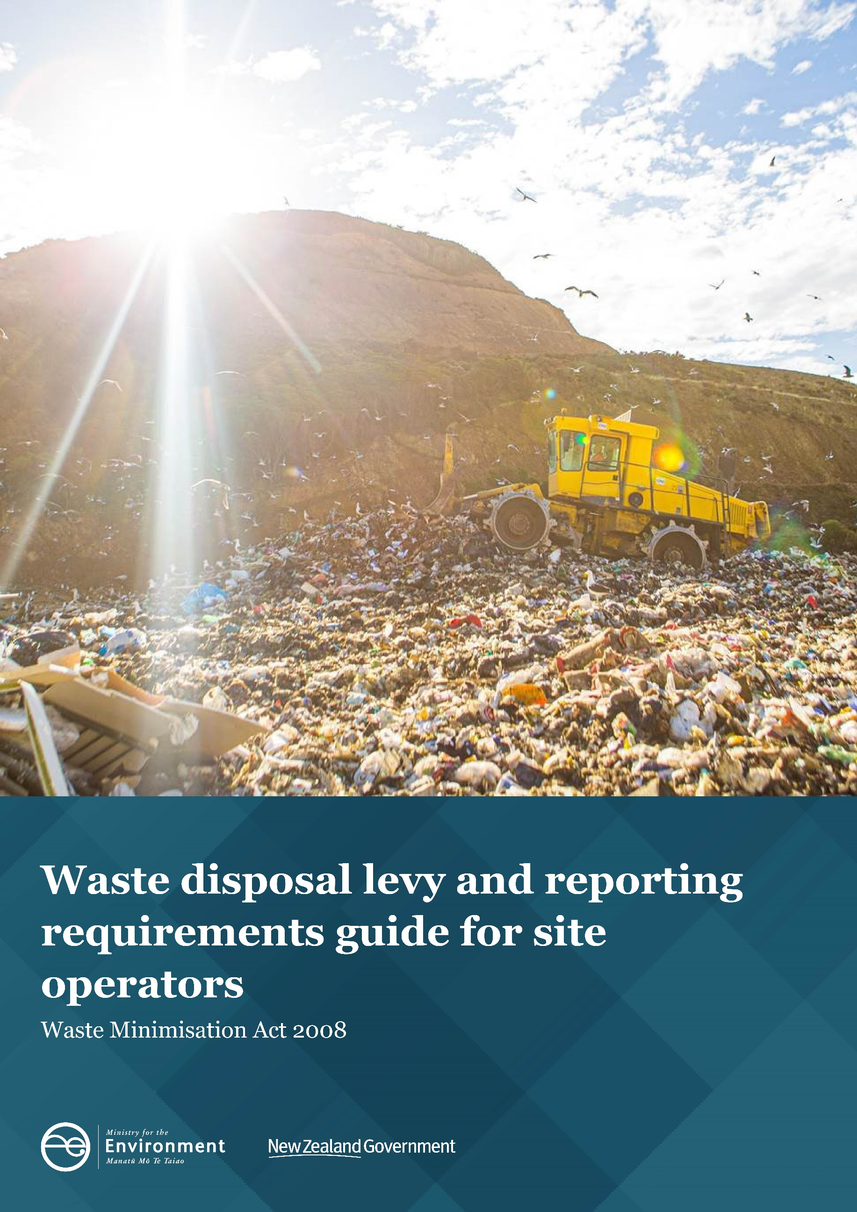

Disclaimer
The information in this publication is, according to the Ministry for the Environment’s best efforts, accurate at the time of publication. The Ministry will make every reasonable effort to keep it current and accurate. However, users of this publication are advised that:
- The information does not alter the laws of New Zealand, other official guidelines, or requirements.
- It does not constitute legal advice, and users should take specific advice from qualified professionals before taking any action based on information in this publication.
- The Ministry does not accept any responsibility or liability whatsoever whether in contract, tort, equity, or otherwise for any action taken as a result of reading, or reliance placed on this publication because of having read any part, or all, of the information in this publication or for any error, or inadequacy, deficiency, flaw in, or omission from the information in this publication.
- All references to websites, organisations or people not within the Ministry are for convenience only and should not be taken as endorsement of those websites or information contained in those websites nor of organisations or people referred to.

This document may be cited as: Ministry for the Environment. 2022. Waste disposal levy and reporting requirements guide for site operators. Wellington: Ministry for the Environment.

Published in June 2022 by the
Ministry for the Environment
Manatū Mō Te Taiao
PO Box 10362, Wellington 6143, New Zealand
ISBN: 978-1-99-003370-4
Publication number: ME 1584
© Crown copyright New Zealand 2022
This document is available on the Ministry for the Environment website: www.mfe.govt.nz.

Contents
Chapter 1: Introduction and overview 6
What is the purpose of the guide? 6
Overview of the Act, levy and reporting 7
Chapter 2: Overview of obligations 10
Chapter 3: Types of facilities 11
Registering on the waste levy website 18
Chapter 4: Calculating and recording tonnages and other information 19
Record-keeping 19
Calculating the amount of waste subject to the levy and/or reporting requirements 20
Methods applicable to all facilities 24
Using an on-site weighbridge 25
Using an off-site weighbridge 25
Using conversion factors 26
Using the average tonnage system 27
Chapter 5: Submitting returns and paying the levy 30
Submitting a return 30
Paying the levy 34
Closing up or selling 37
Passing on the levy to your customers 37
Chapter 6: Annual returns 38
Chapter 7: Six-month returns – transitional arrangements 43
Chapter 8: Applications for waivers and refunds 44
Chapter 9: Monitoring and enforcing levy and reporting requirements 46
Auditing 46
Regulatory compliance 46
Appendix 1: Glossary 48
Appendix 2: Vehicle classification: Average tonnage method 51
Appendix 3: Schedule of conversion factors 53

Tables
Table 1: Facility Types 7
Table 2: Other waste facilities 7
Table 3: Facility classes 11
Table 4: Other waste facility types 13
Table 5: Examples of materials that may/may not be diverted tonnage if reused on site 22
Table 6: Disposal facilities that may seek approval for a one-off six-monthly return 42

Figures
Formula 1: Net tonnage 20
Formula 2: Calculating waste tonnage using a conversion factor 25
Formula 3: Calculating the volume of a container 25
Formula 4: Calculating monthly payments due when submitting an annual return 39

Chapter 1: Introduction and overview

What is the purpose of the guide?
This guide is intended to help operators of facilities who have obligations under the Waste Minimisation (Calculation and Payment of Waste Disposal Levy) Regulations 2009 (the Levy Regulations) and the Waste Minimisation (Information Requirements) Regulations 2021 (the Reporting Regulations). This includes:
- operators of class 1 (municipal) landfills, class 2 (construction and demolition) landfills and class 3/4 (controlled/managed) landfills – who have reporting and levy obligations; and
- operators of transfer stations, class 1 industrial monofills and cleanfills – who have reporting obligations.
This guide will also help to steer facilities through the expansion of the waste disposal levy (the levy) and reporting requirements from 2021 to 2024, including:
- how different landfill classes and transfer stations are defined, and which classification fits their operation
- changes to the existing levy rate
- phased introduction of new sites into the levy and/or reporting requirements regime.
This guide gives practical advice. It includes examples of how to calculate the tonnage of waste, submit returns, and make payments to the levy collector.
Consult the OWLS user guide for guidance on how to use the Online Waste Levy System (OWLS).

Further information
For further information about the levy:
- Phone: 0800 WDLEVY (0800 935389)
- Email: info@wastelevy.govt.nz
- Ministry website: https://environment.govt.nz/what-government-is-doing/areas-of-work/waste/waste-disposal-levy/waste-disposal-levy-information-for-site-operators/
- Online Waste Levy System 2.0 (OWLS): www.wastelevy.govt.nz
If you are a registered user phoning 0800 WDLEVY (0800 935 389), we may need to verify your identity. We will use information provided when you registered.

Overview of the Act, levy and reporting

What is the purpose of the Waste Minimisation Act?
The purpose of the Waste Minimisation Act 2008 is to encourage waste minimisation and a decrease in waste disposal to:
- protect the environment from harm
- provide environmental, social, economic and cultural benefits.

What is the purpose of the levy?
The purpose of the levy is to:
- raise revenue to promote and achieve waste minimisation
- increase the cost of waste disposal to recognise that disposal imposes costs on the environment, society and economy.
The levy provides an economic incentive to change behaviour and reduce the amount of waste generated because it applies only to waste disposed of, not material that is diverted for reuse and recycling.

What is the purpose of the reporting requirements?
The purpose of the reporting requirements is to:
- enable amounts of levy payable by facility operators to be accurately calculated (where relevant)
- help assess our performance in waste minimisation and decreasing waste disposal.

Coverage of the levy and reporting requirements
The levy applies to waste disposed of at a facility (table 1). The levy came into effect on 1 July 2009 at a rate of $10 per tonne for certain facilities. Between 2021 and 2024 the levy is increasing and expanding to additional facilities.
Class 1 municipal facilities are already subject to the levy. From 1 July 2022, a levy will apply to construction and demolition landfills (class 2). From 1 July 2023, a levy will also apply to controlled and managed landfills (class 3 and 4).
Different levy rates apply to different facility types. Tables 1 and 2 provide an overview of facility types and the waste they accept. More detail on site classification is provided in chapter 3 of this guide.
The ‘operator’, or the person who is in control of a facility, is liable to pay the levy to the Secretary for the Environment (the ‘levy collector’).
Transfer stations, cleanfills and industrial monofills do not have levy obligations but are subject to reporting requirements (table 2).
All facilities are obligated to register with the OWLS by 1 July 2022, regardless of when their levy and/or reporting requirements begin.

Table 1: Facility Types
Landfill class | Waste types | Levy rates/key dates
Municipal facilities (class 1) | Accepts mixed municipal wastes from residential, commercial and/or industrial sources. | - 1 July 2021 – 30 June 2022: levy rate is $20 per tonne.  - 1 July 2022 – 30 June 2023: levy rate is $30 per tonne.  - 1 July 2023 – 30 June 2024: levy rate is $50 per tonne.  - 1 July 2024 onwards: levy rate is $60 per tonne.
Construction and demolition facilities (class 2) | Accepts solid waste from construction and demolition activities, including rubble, plasterboard, timber and other materials. | - From 1 January 2022: class 2 facilities are subject to record-keeping requirements and must submit returns to the levy collector, with the first return due in February 2022.  - From 1 July 2022 – 30 June 2024: class 2 facilities are subject to a levy of $20 per tonne.  - From 1 July 2024 onwards: levy rate is $30 per tonne.
Managed or controlled fill facilities (classes 3 and 4) | Accepts:  - contaminated but non-hazardous soils and other inert materials (eg, rubble)  - soils and other inert materials. | - Must register with OWLS by 1 July 2022.  - From 1 January 2023: class 3 and 4 facilities are subject to record-keeping requirements and must submit returns to the levy collector with the first return due in February 2023.  - From 1 July 2023 onwards: levy rate is $10 per tonne.

Table 2: Other waste facilities
Facility | Description | Key dates
Transfer station facility | A facility:  - that contains a designated receiving area for waste  - from which waste or any material derived from that waste is:  − transferred to a final disposal site  − transferred elsewhere for further processing  - that does not itself provide long-term storage for waste or any material derived from that waste. | - From 1 January 2022 onwards, transfer station facilities are subject to record-keeping requirements and must submit returns to the levy collector, with the first return due in April 2022.
Cleanfill facility (class 5) | - Accepts only virgin excavated natural material (such as clay, soil or rock). | - Must register with OWLS by 1 July 2022.  - From 1 January 2023 onwards, cleanfill facilities are subject to record-keeping requirements and must submit returns to the levy collector, with the first return due in April 2023.
Industrial monofill facility | Accepts disposal waste that:  - discharges or could discharge contaminants or emissions  - is generated from a single industrial process (eg, steel or aluminium-making, or pulp and paper-making) carried out in one or more locations. | - Must register with OWLS by 1 July 2022.  - From 1 January 2023 onwards, industrial monofill facilities are subject to record-keeping requirements and must submit returns to the levy collector, with the first return due in April 2023.
For further definitions of terms used in this guide, see the glossary in appendix 1.
Chapter 3 describes the classes of facilities in more detail, including how to determine the class of a facility.

Online Waste Levy System
The Online Waste Levy System (OWLS) has been designed to help facilities meet their levy and/or reporting obligations. It provides secure access to information for operators, and those administering the levy. Through the online system you can register, send returns and apply for extensions of time, waivers, and measuring methodologies. This is your main point of contact for all activities and correspondence related to reporting requirements and the levy. The OWLS user guide shows how to use the system, including how to file a return. You can also contact the Ministry’s operator of OWLS, Fishserve Innovation New Zealand, at 0800 935 389 if you have any questions.

How are funds from the levy used?
Money collected from the levy is to be spent on waste minimisation. Levy money must be distributed and spent as follows:
- First, any refunds due are paid to operators of levied facilities. This occurs when a levy payment has been waived.
- Next, half of the remaining levy money will be allocated to territorial authorities on a population basis. They must spend the money on promoting or achieving waste minimisation as set out in their waste management and minimisation plans.
- Next, administration costs are paid. These are the costs of collecting the levy and distributing funds to territorial authorities or through the Waste Minimisation Fund (WMF).
- Finally, remaining levy money will be allocated to waste minimisation projects, generally through the WMF.

Chapter 2: Overview of obligations
The WMA and the Levy and Reporting Regulations place the following broad obligations on the operators of facilities, cleanfills, industrial monofills and transfer stations:
- Determine the type of facility they operate (this will determine what levy rate needs to be paid (if any)).
- Register as a facility or other waste site with the Ministry for the Environment through the OWLS.
- Keep records of waste and other information, including the measurements of gross and diverted tonnage that enters the facility either using an on-site or off-site weighbridge, conversion factors or an average tonnage system.
- Submit returns to the Ministry for the Environment through the OWLS on a:
- monthly or annual basis in order for the levy due to be calculated (class 1–4 facilities)
- quarterly or annual basis (class 5 facilities, industrial monofills and transfer stations).
- In addition to the obligations above, levied facilities must:
- apply for approval from the Ministry where certain circumstances arise, such as:
- seeking waiver of levy payable
- extension to the stockpiling time limit of six months for diverted materials
- seeking more time to submit waste returns or pay invoices.
- pay the required amount of levy based on the invoice provided to the facility
- advise the Ministry when an operator ceases to operate a facility or when the facility closes.
These obligations are discussed in detail later in this document.

Chapter 3: Types of facilities
This chapter provides guidance on:
- the different classes of facilities
- how to determine what type of facility you operate
- how to register a facility with the Ministry.
The WMA provides for four classes of facilities that are subject to the levy (table 3) and three classes of facilities that are not subject to the levy but have reporting requirements (table 4). The levy is expanding progressively from 2021 to 2024, with differing rates of levy depending on the class of facility. Table 3 sets out the types of facilities, their description, the types of waste not accepted, and examples of the types of waste that may be accepted. The classes are a based on a cascade where the higher class of landfill can generally accept the waste from lower landfill classes plus some additional classes of waste.

Table 3: Facility classes
Facility | Description | Types of waste not accepted | Examples of types of waste accepted
Class 1: Municipal disposal facility | A facility, including a landfill:  - where waste is disposed of  - that operates, at least in part, as a business to dispose of waste  - accepts waste that is or includes any one or more of the following:  - household waste  - waste from commercial or industrial sources  - waste from institutional sources (eg, hospitals, educational facilities and aged-care facilities)  - green waste (eg, degradable plant materials such as tree branches, leaves, grass, and other vegetation matter)  - waste that is not accepted at other disposal facilities in the WMA.  It is not a:  - class 2: construction and demolition disposal facility  - class 3 and 4 managed or controlled fill disposal facility  - industrial monofill facility  - cleanfill facility. |  | Types of waste may include (but not limited to):  - mixed municipal waste from residential, commercial and industrial sources  - construction and demolition waste  - contaminated soils  - rocks, gravel, sand, clay  - sludges  - slurries  - putrescible waste  - green waste  - biosolids  - clinical waste  - treated hazardous waste  - incidental hazardous waste.
Class 2: Construction and demolition disposal facility | Accepts waste from construction and demolition activity.  It is not a:  - class 3 and 4 managed or controlled fill disposal facility  - an industrial monofil facility  - a cleanfill facility. | Does not accept any of the following for disposal:  - household waste  - waste from commercial or industrial sources  - waste from institutional sources (eg, hospitals, educational facilities, and aged-care facilities)  - waste generated from a single industrial process (eg, steel or aluminium-making, or pulp and paper-making) carried out in one or more locations  - Is not a class 3 and 4 managed or controlled fill facility. | Mixed construction and demolition waste including:  - rubble, plasterboard, treated and untreated timber  - wood products,including softboard, hardboard, particle board, plywood, MDF, customwood, shingles, sawdust  - concrete, including reinforced or crushed concrete blocks  - clay products including pipes, tiles  - asphalt (all types), and roading materials, including road sub-base  - plasterboard and Gibraltar board  - masonry, including bricks, pavers  - metal, or products containing metals, including corrugated iron, steel, steel-coated tiles, wire, wire rope, wire netting, aluminium fittings  - plastic products, including plastic bags, pipes, guttering, building wrap  - insulation products  - laminate products, including Formica  - flooring products, including carpet and underlay, vinyl/linoleum, cork tiles  - paper and cardboard products, including wallpaper, lining paper, building paper  - site clearance and excavation materials including soils, clays, rocks, gravel, tree stumps.
Classes 3 and 4: Managed or controlled fill disposal facilities | Accepts any one of the following for disposal:  - inert waste material from construction and demolition activities  - inert waste material from earthworks or site remediation. | Does not accept:  - household waste  - waste from commercial or industrial sources  - waste from institutional sources (eg, hospitals, educational facilities, and aged-care facilities  - waste generated from a single industrial process (eg, steel or aluminium-making, or pulp and paper-making) carried out in one or more locations  - waste material from construction and demolition activity (except for inert waste material). | Types of waste may include (but not limited to):  - lightly contaminated soil below applicable consent limits and inert construction and demolition materials, including:  - site clearance and excavation materials including soils, clays, rocks, gravel, tree stumps  - masonry, including bricks and pavers  - clay products, including pipes, tiles  - concrete, including crushed concrete and blocks (for reinforced concrete, exposed reinforcing must be removed)  - asphalt (bitumen-based only)  - road sub-base.

Table 4: Other waste facility types
Other facilities not subject to the levy but subject to record-keeping requirements
Facility | Description | Types of waste not accepted | Examples of types of waste accepted
Class 5: Cleanfill facility | A facility that accepts only virgin excavated natural material (such as clay, soil or rock) for disposal. | Materials that are or contain:  - combustible, putrescible, degradable or leachable components  - hazardous substances or materials (such as municipal solid waste) likely to create leachate by means of biological breakdown  - products or materials derived from hazardous waste treatment, stabilisation or disposal practices  - materials such as medical and veterinary waste, asbestos, or radioactive substances that may present a risk to human health if excavated  - contaminated soil and other contaminated materials; and liquid waste. | Virgin excavated natural materials such as clay, soil and rock.
Industrial monofill facility | A facility that accepts for disposal waste that:  - discharges or could discharge contaminants or emissions  - is generated from a single industrial process (eg, steel or aluminium-making, or pulp and paper-making) carried out in one or more locations. | - household waste  - waste from commercial or institutional sources (eg, hospitals, educational facilities, and aged-care facilities)  - waste not generated by a single industrial process. | Waste generated by industrial processes such as:  - steel-making  - aluminium-making  - pulp and paper  - oil exploration and extraction.
Transfer station | A facility:  - that contains a designated receiving area where waste is received  - from which waste or any material derived from that waste is:  - transferred to a final disposal site  - transferred elsewhere for further processing  - that does not itself provide long-term storage for waste or material derived from that waste. | N/A (no disposal of waste occurs). | N/A

The class depends on the activities carried out by the facility, including the types of waste that are disposed of at the facility. To assist you in determining your facility type, you can use the following flow chart:
 |  | If yes | If no
Q1 | Is your facility a dedicated recycling or composting facility, where waste is not disposed of? | The facility will not be subject to the levy or reporting requirements. | Go to Q2.
Q2 | Is it a transfer station? | The facility will not be subject to the levy but will be subject to reporting requirements from 1 January 2022. | Go to Q3.
Q3 | Is it an industrial monofill facility? | The facility will not be subject to the levy but must register with the OWLS by 1 July 2022, and will be subject to other reporting requirements from 1 January 2023. | Go to Q4.
Q4 | Is it a class 5 cleanfill? | The facility will not be subject to the levy but must register with the OWLS by 1 July 2022, and will be subject to other reporting requirements from 1 January 2023. | Go to Q5.
Q5 | Is it a managed or controlled fill disposal facility? | The facility must register with the OWLS by 1 July 2022, and will need to provide returns to the Ministry from 1 January 2023 and pay the levy of $10 per tonne from 1 July 2023. | Go to Q6.
Q6 | Is it a construction and demolition fill disposal facility? | The facility will need to provide returns to the Ministry from 1 January 2022 and pay the levy of $20 per tonne from 1 July 2022, $30 from 1 July 2024 onwards. | Go to Q7.
Q7 | Is it a class 1 municipal disposal facility? | The facility will need to provide returns to the Ministry and pay the levy of $20 from 1 July 2021, $30 from 1 July 2022, $50 from 1 July 2023 and $60 from 1 July 2024. | The facility is likely not subject to the WMA.
It is the responsibility of facility operators to correctly identify what type of waste facility they are operating. If you are uncertain about the type of facility you are operating after consulting this guide, you should seek legal advice.

Example 1: Determining class of disposal facility – class 2
A disposal facility has a resource consent to receive waste and dispose of it in accordance with accepted landfill management practices. The disposal facility receives mostly managed and controlled fill materials, such as lightly contaminated soils (within acceptable limits) and asphalt. The facility also receives mixed concrete and demolition waste from time to time, such as treated and untreated timber.
As the disposal facility receives some construction and demolition fill (class 2) materials, it is classified as a class 2 facility. It must identify this in its returns in OWLS and pay the applicable rate of levy for class 2 facilities on all waste disposed of at the facility.

Example 2: Change in class of facility
A disposal facility receives all types of construction and demolition waste and has been paying the applicable levy rate on all waste disposed of at the site. The site is granted resource consents from the relevant authorities to receive industrial and commercial waste alongside the usual construction and demolition waste it receives. It starts to receive this material each month.
As the disposal facility now receives class 1 waste it must notify the Ministry in its monthly returns that it is now a class 1 facility and it must pay the applicable rate of the levy for class 1 facilities.

Example 3: Cleanfill facility
A site is consented to receive cleanfill materials. It only receives virgin excavated natural material, such as clay and soil that are free from contaminants. It has processes in place to ensure that the material deposited on site meets this condition.
The site, therefore, has reporting requirements that it must comply with, but it does not have to pay the levy on cleanfill deposited on site.

How does this relate to my resource consent?
The levy and reporting regulations may classify sites in a different way to the rules your local council has in place for the Resource Management Act. Facility operators must still comply with all relevant resource management requirements and should consider this when accepting waste, recording volumes or tonnages of waste entering the site and/or numbers or types of trucks.

What happens if I accept waste from a different facility class?
It is the responsibility of facilities to correctly identify what class of facility they are operating and to identify this when they register and submit returns in the OWLS.
If a facility accepts material outside of what is allowed within its current class of facility, it will need to pay the higher rate of levy on all material disposed of at the facility. You will need to identify in your returns in the OWLS that you have changed class of facility and accepted this type of waste.
Where a facility has changed status, it must be able to clearly show that it is now operating a different class of facility in the records it keeps and the returns it provides.

If a facility fails to correctly report the class of disposal facility it operates, it may be in breach of the Regulations. This may result in an investigation by the Ministry in its regulatory role. What do I do if I meet one of these definitions?
You will need to contact the Ministry for the Environment if you are:
- opening a new facility
- taking over the operation of an existing facility
- operating a facility that will soon become subject to the WMA
- operating a cleanfill, industrial monofill or transfer station
- changing the type of waste accepted at an existing facility so that it now comes under the definition of a disposal facility in the Act
- operating a facility that is prescribed as a disposal facility in Regulations.
If any of these circumstances apply, you should contact us before you begin your activities.
The Ministry will also be proactively contacting facilities to ensure that operators are aware of their obligations. This will include working with territorial, regional and unitary authorities to gain relevant information.
If you meet any of the above criteria or are uncertain, please contact us on 0800 WDLEVY (0800 935 389) or email info@wastelevy.govt.nz to begin the registration process.

Registering on the waste levy website
Once you have contacted us, you will be given access to the Online Waste Levy System 2.0 (OWLS). This is a secure website. The only people who can access your information are people you authorise and Ministry for the Environment staff or contractors authorised to administer the levy. User accounts will be set up giving your people permission to:
- enter and view data
- confirm a return is correct
- submit returns
- make applications.
To maintain security, we will use the information you provide when setting up your user accounts to verify your identity when you call us. It is important that you update OWLS as soon as possible with all new staff using the system as either data entry or verifiers, and remove users who have left the role.
Once you are registered, you will need to tell us how you measure or assess waste. If you want to use an alternative method to weighing or measuring every load, you may need to get approval for that method. This is discussed in chapter 4.
Where relevant, we will agree a payment method with you, preferably by electronic funds transfer, and give you the details you need to include with your payment.
The OWLS is also used by cleanfills, industrial monofills and transfer stations to meet their reporting obligations.

Chapter 4: Calculating and recording tonnages and other information
This chapter explains:
- the records that facility operators need to keep
- the different ways the weight of waste or diverted material can be measured or calculated.

Record-keeping
The WMA and the Levy and Reporting Regulations require facility operators to keep records as they carry out their business. These records are then used to submit returns to the Ministry in order to meet reporting requirements and where applicable, calculate the amount of levy payable. The records may also be audited by the Ministry as part of its compliance, monitoring and enforcement work.

What records do I need to keep?
The following information is applicable to all facilities regardless of whether they have only reporting requirements or are subject to the levy.
You must keep records (electronic or paper) for individual measurements for all of the following items:
- the tonnage of the waste or diverted material that makes up gross tonnage and diverted tonnage for the facility
- whether the tonnage was measured by:
- weighing it using a weighbridge at the facility
- weighing it using a weighbridge not at the facility
- using a conversion factor to convert volume into weight
- using the average tonnage system
- a combination of these methods
- for facilities applying for approval to submit annual returns, any formula and/or methodology used to calculate the expected net tonnage
- the date the waste or diverted material entered the facility (or for an approved facility submitting annual returns, the period during which the waste or diverted material entered the facility)
- the date and time the tonnage of the waste or diverted material was measured
- if the tonnage of the waste was weighed using an off-site weighbridge, the weighbridge ticket and the registration plate details of the motor vehicle that transported the waste or diverted material to the facility
- if the tonnage of the waste was measured using a conversion factor to convert volume to weight:
- the volume of the waste or diverted material as assessed
- whether the volume was assessed by measuring it (using a compliant measuring instrument) or by estimating it
- the conversion factor applied to the waste or diverted material
- if the tonnage of the waste or diverted material was assessed under an average tonnage system, the type of motor vehicle it was carried in. Levied facilities are also required to keep all information about methods you may have used to calculate the amount of levy payable in electronic and/or hard copy including:
- the returns for waste disposed (the return that the facility operators submit to the levy collector on a monthly basis or annual basis, for example, a levy calculation spreadsheet)
- amount of levy paid for the month
- any applications to make annual returns
- details of any average tonnage system.

When do I need to provide records?
If requested, you must provide the Ministry with the following records and information as soon as practical:
- any records the Regulations require you to keep
- any other records and information to enable the levy collector to accurately calculate the amount of levy payable and/or understand how reported tonnages have been calculated.

How long do I need to keep records?
You should retain records for at least seven years after payment of the levy to which the records relate.

What if I do not make or keep the required records?
There are offences under the WMA relating to breaching Regulations that place record-keeping requirements on facility operators. If you fail to make records, or make inaccurate records, you may be in breach of this section. Depending on the circumstances of the breach, the Ministry may investigate the matter and take enforcement action.

Calculating the amount of waste subject to the levy and/or reporting requirements

What do I pay the levy on?
The applicable levy is payable on the net tonnage of waste disposed of at a facility. The levy is payable on all waste disposed of at a facility at the same rate.
Facilities that are not levied are required to report on waste using the same methods as levied facilities.

How do I calculate the net tonnage?
The net tonnage is the ‘gross tonnage’ minus the ‘diverted tonnage’.
Formula 1: Net tonnage
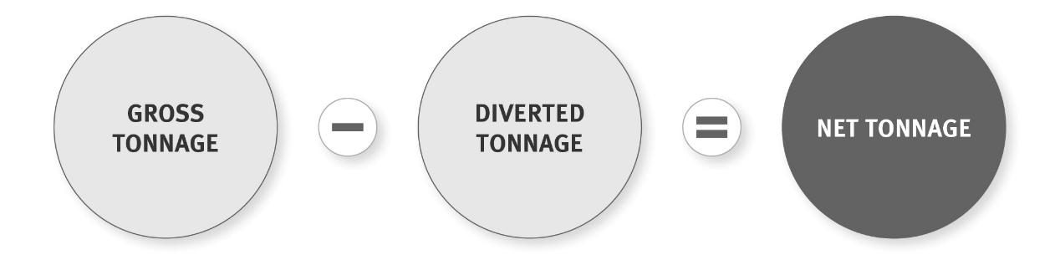

How do I calculate the gross tonnage?
The gross tonnage is the total tonnage that enters the facility – both waste and material that will be diverted, stockpiled or used for any other purpose. This chapter advises how to measure these tonnages.
If there is a compliant and functioning weighbridge at the facility, you must use it to measure gross and diverted tonnage, unless you have approval to use an ‘average weight per vehicle’ method.
If the facility does not have a weighbridge, you can:
- use a compliant weighbridge located off site, or
- measure or estimate the volume of waste and diverted material arriving at the facility and use an approved conversion factor to convert the volume to equivalent tonnage (conversion factors are listed in appendix 3).
If you have access to a compliant weighbridge (on or off site), you can apply to the Ministry to use an ‘average weight per vehicle’ for the vehicles set out in appendix 2, using an approved method. Operators approved to submit annual returns can use alternative methods of assessing tonnage.
These methods are discussed later in this chapter.

How do I calculate the diverted tonnage?
Diverted tonnage is the tonnage of material that enters the facility as gross tonnage but is either reused or recycled in accordance with the definitions set out below, or removed from the facility within six months. All diverted tonnage, even if it is stockpiled on site, must be measured, even if it was previously classified as immediately diverted.
- Reuse means the further use of waste or diverted material in its existing form for the original purpose of the materials, or for a similar purpose.
- Recycling means the reprocessing of waste or diverted material to produce new materials.
For a transfer station, diverted tonnage means material that is sent to be re-used or recycled.
Whether material meets these definitions will depend on the circumstances in each case.
The Secretary for the Environment can agree in writing to extend the six-month timeframe (see below). It is recommended that you keep good records of waste that is to be stockpiled so that it can be easily identified.
Diverted tonnage must be weighed using a compliant weighbridge, or a conversion factor must be used to convert the measured or estimated volume into weight. You can only include material in your diverted tonnage figure if you previously counted the material as gross tonnage.

How should I measure loose recycled material that is collected at a facility?
Some facilities have separate collection areas where members of the public can drop off loose materials intended for recycling. These may be, for example, large bins to collect glass bottles, cardboard or plastic. For practical reasons, the Ministry does not require facility operators to weigh each instance of materials being dropped off (for example, each car load of glass bottles for recycling or the individual loads of cardboard for recycling).
The collected material must still be weighed, however, to form part of gross tonnage using one of the methods outlined in this section, even if it is to be removed from the site as diverted material. How this is done will depend on the nature of the operation and the throughput of waste at the site. However, operators should measure material deposited in the collection bins (either by weighbridge or using a conversion factor) within the month that it is received so that recent and correct tonnages are recorded and submitted in the OWLS returns for that period. Where operators have bins that are filled and emptied more regularly, these should be measured each time the bin is emptied.
It is good practice for this material to be recorded by the operator using a separate product code so that these quantities can be differentiated from material that is collected in bulk and measured immediately upon entry in kerbside collection vehicles (ie, kerbside recycling collection).
An example of how this may apply to glass:
Glass kerbside – gross | This product code would indicate glass that has been collected at kerbside and weighed in the collection vehicle on landfill entry.
Glass landfill dropped off – gross | This product code would indicate glass that has been dropped off by the public at landfill collection bins before having its residual waste weighed.
Glass – diverted | This product code would indicate glass that has been combined from the ‘glass kerbside – gross’ and ‘glass landfill dropped off – gross’, potentially stockpiled and subsequently diverted.
This enables the operator to easily identify the source of the material when filing returns and when the operator’s records are audited by the Ministry.

What if I use materials deposited on site for landfill management?
In some occasional instances, facility operators may use waste material that they receive on site for landfill management purposes (eg, cover material) and treat this as diverted tonnage (and therefore, is not subject to the levy).
The key consideration is whether the use of the waste on site is for the material’s original or similar purpose (for example, using suitable soil or clay within acceptable levels for daily, immediate or final cover material or crushed concrete as roading material, provided there is a need for that material on the site itself). Other waste used on site for cover, such as shredder flock, slurry or crushed glass, is still considered as waste and should not be recorded as diverted tonnage. Each case will depend on the circumstances.
If waste material used for landfill management does not meet the definitions of recycling or reuse, then it should not be included as diverted tonnage and would, therefore, attract the levy (if applicable). This does not preclude using material in that way, however, the levy should be paid. The facility is able to pass the levy on to customers disposing of these materials.
The Ministry does not consider the use of waste materials disposed of at the landfill for landfill construction activities, such as using waste materials as aggregate or cover material on the site itself, as meeting the definition of recycling (for example, using materials for site construction, such as access roads).
If you are planning to reuse any waste material on site and wish to consider this to be diverted material, please contact the Ministry.

Example 4: Reuse on site that does not attract the levy
A class 1 facility receives a wide variety of waste. It regularly receives virgin excavated clay and soil from uncontaminated sites, which is disposed of at the site. The operator ensures that the clay and soil is not contaminated. This material is weighed as gross tonnage as it enters the facility, however, it is separated from the other waste received. The facility uses the separated clay and soil as daily and interim cover on the landfill itself. The clay and soil are weighed and reported as diverted tonnage in the month it is used. The operator does not have to pay the levy the on this material.

Example 5: Reuse on site that attracts the levy
A facility regularly receives glass from kerbside collection. The facility crushes the glass and mixes it in with daily cover to cover waste. As the original or similar purpose of glass is not as cover material, it is recorded as gross tonnage but cannot be recorded as diverted tonnage, which is reported to the Ministry through the OWLS. The facility operator pays the levy on the glass it receives.
Table 5: Examples of materials that may/may not be diverted tonnage if reused on site
Reused materials that may be diverted tonnage | Reused materials that should not be diverted tonnage
Soil or clay that is within acceptable levels and is used for daily, interim or final cover | Crushed glass or shredder flock used as cover material
Crushed concrete that is used for landfill roading, providing it is fit for the purpose | Contaminated soils used as cover material
 | Waste used as hardfill, such as slurry, rubble or demolition material

What if I need to stockpile materials?
Material that was weighed as gross tonnage when it arrived at the landfill but was removed for recycling or further processing within six months of that date, can be included in diverted tonnage.
It is, therefore, possible for facilities to stockpile materials on site that may be diverted later, provided it is diverted within six months or an operator applies to the Ministry for an extension to this time limit.
It is important that operators are able to identify when amounts of materials go into a stockpile and when it is removed from the stockpile. This can be done by coding stockpiled material separately when it comes into the facility and when it is ultimately diverted (for example, coding as ‘metal in – gross’ and ‘metal out – diverted’). This can be particularly useful when a facility is audited by the Ministry.
When applying to the Ministry for an extension to the six-month time period for stockpiling material, we suggest that you provide the following information:
- the latest date for removal of the material
- date (month/year) the levy was first paid on the material
- reason the extension is requested, including details on the removal contractor
- weight and type of material for which the extension is sought (tonnes).
We suggest that you submit your application at least a month in advance, so that the Secretary has time to consider your application before the six-month storage deadline is due. We will notify you of the Secretary’s decision and, if approved, how long the material can be stored.

What happens when materials are received at one levy rate and then diverted later when the levy rate has changed?
The diverted tonnage that had the levy paid at a lower rate as gross tonnage must have the levy reduced at the same rate. You must identify in your return to the Ministry the diverted tonnage that entered the facility at a lower rate.

Do the levy and reporting requirements apply to liquid waste?
Yes – gross tonnage applies to both liquid and solid waste or material. It is based on the weight of waste or material in the vehicle or container at the time it is weighed at a facility, irrespective of whether it is liquid or solid waste.

Methods applicable to all facilities

Why do I need to specify how I will calculate tonnages?
The levy is calculated on the net tonnage of material disposed of at a facility. To enter your returns on the levy website, you must have the information in tonnages. Facilities that only have reporting obligations enter returns in the same way and thus must also have information in tonnages.
Operators of facilities that do not record the weight of every load of waste need to choose a reliable method that converts the information you collect to a tonnage value. The options you can use are listed in the Levy and Reporting Regulations and described below.

What are my options for calculating the tonnage?
If there is a compliant and functioning weighbridge at the facility, you must use it to measure gross tonnage, unless you have approval to use an ‘average weight per vehicle’ method.
If the facility does not have a weighbridge you can:
- use a compliant weighbridge located off site, or
- measure or estimate the volume of waste and diverted material arriving at the facility and use an approved conversion factor to convert the volume to equivalent tonnage (conversion factors are listed in appendix 3).
If you have access to a compliant weighbridge (on or off site), you can apply to use an ‘average weight per vehicle’ for light vehicles, medium and heavy goods vehicles and trailers, using an approved method. You can also apply for approval to use an average weight method based on assessment of the volume and use of conversion factors. This is explained in more detail below.
Operators approved to submit annual returns can use alternative methods of assessing tonnage, as set out below.

How do I inform you of my method for calculating the quantity of waste?
You will need to tell the Ministry of the method you use for calculating the quantity of waste when you register with the OWLS.
If we don’t hear otherwise, we will assume you are using an on-site weighbridge to measure tonnage.
If you want to use a method other than weighing all waste and diverted material using an on-site weighbridge, you need to apply through the OWLS.

How do I change my method?
You should notify us of any changes to your method by contacting 0800 WDLEVY (0800 935389) or info@wastelevy.govt.nz

Using an on-site weighbridge
If you are using an on-site weighbridge, you must keep weighbridge records that specify:
- the date the waste or diverted material entered the facility
- the date and time the waste or diverted material was weighed
- the weight of the waste or diverted material
- gross and diverted tonnage.
The weighbridge must also comply with the Weights and Measures Act 1987 and display a mark of verification. For further information on compliance with this Act, please contact the Ministry for Business, Innovation and Employment at tradingstandards@mbie.govt.nz.

Using an off-site weighbridge

How should I use an off-site weighbridge?
If your facility does not have a weighbridge, you can accept waste that has been weighed using a weighbridge located somewhere else. To accept the tonnage measurement from an off-site weighbridge, the customer will need to present a weighbridge ticket that shows the:
- date and time the waste or diverted material was weighed
- weight of the waste or diverted material in tonnes
- registration plate details of the vehicle transporting the waste or material to the facility.
Off-site weighbridges can also be used where the on-site weighbridge is out of service. Off-site weighbridges must comply with the provisions of the Weights and Measures Act 1987.

Using conversion factors

How should I use conversion factors?
You can use a conversion factor to convert the volume of waste or diverted material into weight. A schedule of these conversion factors is found in the Regulations and appendix 3 of this guide.
Formula 2: Calculating waste tonnage using a conversion factor
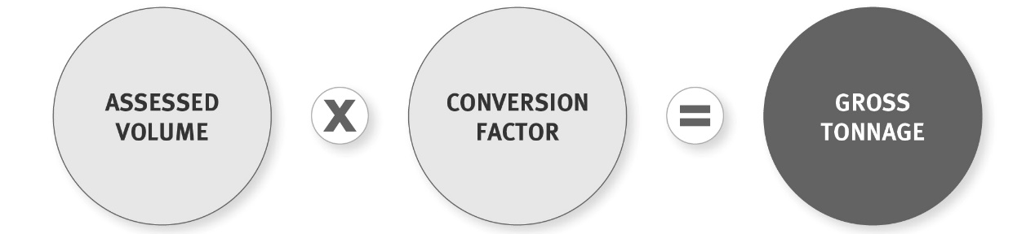

How do I calculate assessed volume?
You can measure the volume of waste by:
- using a compliant measuring instrument, such as a tape measure, to measure the volume of the waste in the container
- estimating the volume as accurately as possible, for example, using a container such as a skip bin with a measured volume
- using information on the volume capacity of types of vehicle.

Using a compliant measuring instrument
You will have to measure the volume of waste or the dimensions of the container and assess how full the container is.
Formula 3: Calculating the volume of a container

Using a container of known volume
You can use a skip bin or any other container of which the volume has previously been measured. Customers using your facility dump their waste into the container. When the container is full, you record the volume of waste.

Estimating the volume using knowledge of volume capacity of vehicles
As a last resort, you can use your past experience of how much material can fit inside trailers, car boots, skip bins and other containers for which the volume can be easily calculated. Using this knowledge, you will then be able to assess as accurately as possible the volume of that waste.
You must have formulas for this that are robust and can stand up to the scrutiny of an audit process. We do not recommend that this method is used at large landfills.

How do I apply the conversion factors?
Once you have calculated the volume of waste in the container (using one of the methods outlined above), you will need to identify its contents. This is critical to calculating its weight.
You can identify the contents by:
- asking the customer
- checking yourself if the contents are easily visible
- making an educated guess if the container has come from a known supplier.
The operator’s judgement of the contents plays a large role, as most loads arriving at facilities are mixed loads and it will be up to the operator to use their discretion to ensure that the appropriate conversion factor is applied.
Once you know what the waste is made up of, multiply its calculated or estimated volume by the appropriate conversion factor.

Example 6: Gross tonnage calculated using conversion factors
Car boot with rubbish from a clean-up at home:
- A car arrives at the facility.
- The volume capacity (in cubic metres) of car boot is measured using a measuring instrument.
- Apply relevant conversion factor in Regulations for waste carried in rubbish bags or cars – 0.130 tonnes/m³.
- The tonnage of waste to be disposed of is: Volume of car boot (m³) x 0.130 tonnes/m³.
High-density waste, such as a truck and trailer with abattoir waste:
- A truck arrives at the facility.
- The volume of material carried by the truck is measured by the operator.
- Apply relevant conversion factor in Regulations for high-density waste – 1.5 tonnes/m³.
- The tonnage of abattoir waste to be disposed of is: Volume of truck x 1.5 tonnes/m³.

Using the average tonnage system
An average tonnage system allows you to weigh a sample of the vehicles delivering waste to the facility, and calculate an average weight of waste carried either for specific types of vehicles set out in appendix 3 (for example, cars, vans, medium and heavy goods vehicles). Then you would record the number of each type of vehicle delivering waste and apply the average weight per vehicle to these vehicles, rather than weighing every vehicle. This method cannot be used for assessing diverted tonnage.
You may use an average tonnage system to calculate the gross tonnages entering the facility. You may wish to use this method if it is not feasible to weigh all vehicles coming in and out of your facility, for example, if you have a single weighbridge and/or large numbers of private vehicles delivering waste directly to the facility during specific times, such as during weekends or public holidays.

How do I apply to use the average tonnage system?
You must have approval from the Secretary for the Environment to use the average tonnage system for levy returns.
If you need to apply to use average tonnage for vehicles, an application form is on the Online Waste Levy System 2.0 (OWLS): www.wastelevy.govt.nz. The form specifies the information that must be provided, including survey data.
If you wish to switch to an average tonnage system, please contact us before applying so we can provide advice on whether your application is likely to meet the criteria.
If approval is given for an average tonnage system, a facility must operate within the boundaries of the system that is approved (for example, if it is approved to be used only on certain days of the week or for certain periods of the year).

How do I calculate average tonnage?
The most straightforward way to calculate the average load weight is by weighing a number of vehicle loads, either at random or consecutively.
The load weight of each vehicle must be worked out by weighing the vehicle before and after the waste has been dropped off. Operators can use either an on-site or off-site weighbridge or conversion factor. We strongly recommend you use a weighbridge.
The average load weight is then calculated by dividing the sum of the net load weights by the number of vehicles surveyed.
It is important that the timing of the survey caters for fluctuations over time in the type and weight of material received at a facility. For example, it is more likely that commercial users will use a municipal landfill during the week, while at weekends more householders are likely to bring waste.
We recommend that when undertaking a survey:
- measurements should take place on weekdays and on weekends if there is variability between times of the week
- measurements should be taken during what you consider to be a ‘typical’ period. For example, surveys during summer holidays or following a major storm would probably not deliver results typical of waste flows throughout the year
- at least 100 vehicle loads are surveyed to provide a sufficient degree of accuracy for us to approve your application
- you can calculate average load weights for specific vehicle types, and these do not need to be the same groupings as the vehicle classes listed in appendix 2. For example, you could combine utes (class MA) and four-wheel-drive vehicles (class MC) as a vehicle type
- if more specific vehicle types are weighed (such as cars, utes and trailers), there will be less variability in the load weights, and fewer than 100 loads of each vehicle type may need to be measured.

Does approval for using average tonnage expire?
Approval to use the average tonnage system will be granted for a specified period of three years or less. We recommend that you apply to renew your approval at least a month before your term expires. This will give the Secretary time to respond to your application.
If further approval is not granted by the time the previous approval expires, you must use an assessment of the weight of each vehicle load, either an on-site weighbridge, off-site weighbridge or conversion factors, and let us know which one you’ve chosen.

Chapter 5: Submitting returns and paying the levy
This chapter provides information that all operators of facilities need to know, including:
- how to get the information you need to complete a return, and when and how to submit it
- information about submitting monthly and annual returns
- how to pay the levy for class 1–4 facilities, when to pay, and what happens if you don’t pay on time.

Submitting a return

Who needs to submit a return?
All facility operators must submit returns to the levy collector. The default position is submitting monthly returns for class 1–4 facilities, and quarterly returns for class 5 facilities, industrial monofills and transfer stations. Operators of small facilities (no more than 1,000 tonnes of waste deposited a year) can apply to submit returns annually.

What information will I need for my return?
Monthly and quarterly returns must contain:
- name and type of your facility
- name, contact details and client number (if applicable) of the operator
- name and contact details of the person who prepared the return (unless it was the operator)
- month and year for which the information is being provided
- gross tonnage for the month
- diverted tonnage for the month
- if you are diverting waste that was included as gross tonnage at a lower levy rate, the amount of diverted tonnage for the month that relates to the earlier period
- net tonnage for the month.
The requirements for annual returns are discussed later in this document.
Returns will cover the entire month or year’s tonnage – you do not need to break the information down to a daily tonnage for the purposes of the return. You will, however, need to keep records of the individual measurements you use to get your gross and diverted tonnages.

When are returns due?
Class 1–4 Facilities
Monthly returns are due on the 20th of the month after waste has been deposited.
For example, a monthly return is due on 20 August, for waste deposited in July.
Annual returns are due on 20 July, for waste deposited in the previous financial year.
If you wish to continue providing annual returns, you must submit an application each year to do so and provide an ‘expected net tonnage’ for the coming year. Your application is due on 20 July at the beginning of each financial year. See chapter 3 for more information.
Class 5 facilities, industrial monofills and transfer stations
Quarterly returns are due on the 20th of the month after the last month of the quarter to which the return relates.
The first quarterly return is due on 20 April, which covers the period of 1 January to 31 March. Additional returns are due as follows:
- 20 July (covers 1 April – 30 June)
- 20 October (covers 1 July – 30 September)
- 20 January (covers 1 October – 31 December).
If you want to provide annual returns, you must submit an application each year to do so and provide an ‘expected net tonnage’ for the coming year. Your application is due on 20 July at the beginning of each financial year. See chapter 6 for more information.

How do I submit a return?
Returns are submitted electronically using the Online Waste Levy System 2.0 (OWLS): www.wastelevy.govt.nz
This is a secure website with a RealMe login name and password required for access.
All facility operators must declare that the information on the returns is correct. This declaration is to be made by the operator or a person authorised to act on behalf of the operator. Some facilities may want to set up a formal internal process that ensures that information entered on the return is accurate. The OWLS website helps you do this by allowing multiple levels of authorisation at a facility.

Example 7: Internal validation process
Operators can have a dual process where:
- one staff member inputs the data fields (data entry) required on the website. This person’s access allows them to input the required figures
- another person (the verifier), preferably at managerial level with appropriate delegated authority, checks the return for accuracy and then authorises the return to be sent to the levy collector.

What if my tonnages are significantly different from my usual return?
Any time you make an unusual or atypical entry on your return (for instance, the monthly tonnage is significantly different from previous months), the website will prompt you for an explanation. If you have made a mistake, this is your opportunity to correct it before submitting the return.
The levy collector will note your explanation and may contact you for further clarification. If not satisfied that the information is correct or complete, the levy collector may issue an estimate instead (see later in this chapter for what an ‘estimate’ is).

What happens if I make a mistake?
If you discover that you have made a mistake in calculating the tonnages after you have submitted your return, or have entered incorrect information, you can supply the levy collector with updated figures. This is called an amendment and can only be entered by the verifier. Where relevant, your account may be debited or credited based on your updated figures.

Can I submit a paper return?
The collection, calculation and payment of the levy is designed to operate almost exclusively electronically, via the Online Waste Levy System 2.0 (OWLS): www.wastelevy.govt.nz. This helps us keep administration costs as low as possible, and it means you will be able to access your previous returns and other information online. Electronic returns are preferred. If you submit a paper return, an authorised person must sign the return and make a declaration that they believe the information is correct.

Can I get an extension of time to submit my return?
If you submit monthly returns and cannot send your return on time due to unusual circumstances, you can apply for an extension of up to one month. If you submit annual or quarterly returns, you cannot apply for an extension.
You must send your application to the levy collector no later than 15 days before the return is due. To assess your application, the levy collector will need the:
- name and site number (if applicable) of the facility
- full name, contact details and client number (if applicable) of the operator
- full name and contact details of the person submitting the application
- levy return the application relates to
- reason why you are unable to submit the return on time.
The levy collector assesses applications on a case-by-case basis. Extensions will be granted at the levy collector’s discretion, and on any terms and conditions the levy collector imposes.
The levy collector will notify you in writing of the decision at least five days before the return is due. If an extension is granted, you cannot apply for a further extension for the same return, and it does not extend the date payment is required (the invoice may be based on an estimate issued by the levy collector).
If an extension is not granted, you will be expected to submit a return on the due date. If this does not happen, the estimate process will be followed (see below).

Example 8: Application for extension of time to submit a return for a facility that reports monthly
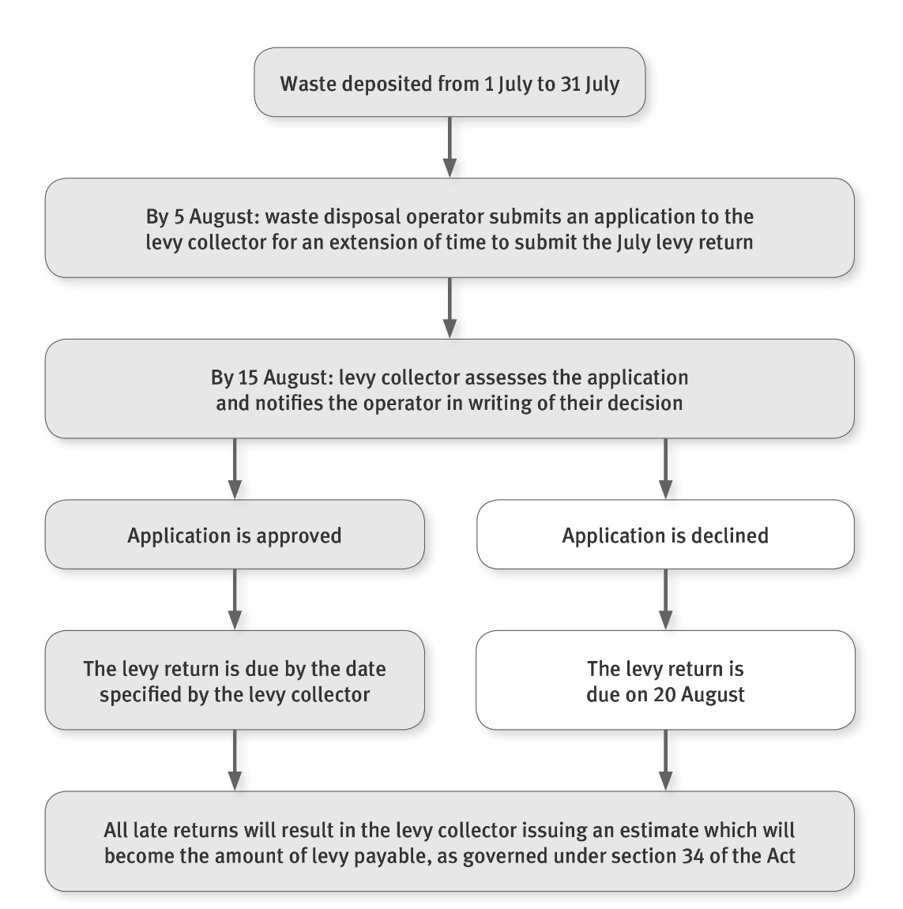

What happens if I don’t submit a return?
If you don’t provide an annual or monthly return by the due date, or if the levy collector considers your return is incomplete or incorrect, then the amount of levy payable will be estimated and you may be sent an invoice and written demand.
It is an offence under the WMA if a person contravenes Regulations relating to keeping records and making returns. For more information, see the section on monitoring the payment of the levy later in this guide.

How is an estimate calculated?
The method used to estimate your levy will depend on how much information we have about your facility, gathered from your previous returns. If there isn’t enough information from previous returns on which to base an estimate, the levy collector will use other information, such as surveys of landfill sites, resource consent terms and conditions, and the number of people and businesses using your facility.
We strongly encourage you to submit your returns, so you pay the correct amount of levy.
Your information will allow us to keep an accurate record of the types of waste and amounts of waste being disposed of or discarded, which is important to support our efforts to minimise waste.

What is the process for issuing an estimate?
The levy collector uses a two-step process when issuing an estimate.

Initial estimate
If you do not submit a complete and accurate return, then five days after the return is due you will be issued an initial estimate. When you receive this, you can provide us with further information. If your additional information is deemed correct, the final estimate and invoice will be based on it.

Final estimate
The final estimate will be issued 15 days after the due date for the return (around the 5th of the following month), whether or not you submit any further information. The final estimate is the amount that you must pay by the due date.

Example 9: Estimates timeline
Waste deposited from 1–31 July
Date | Action
20 August | Either no return is received from the facility operator, or the return received is deemed not to be a fair assessment of the levy due.
25 August | The levy collector issues an initial estimate.
25 August – 3 September | The operator may provide additional information to the levy collector.
4 September | The levy collector issues the final estimate and invoice for the amount payable.
20 October | The payment is due to the levy collector.

Paying the levy

How do I know how much to pay?
After you have submitted your return, you will receive an invoice setting out the amount of levy you have to pay. If the invoice is based on a final estimate, there is no opportunity to have the estimate changed.

When will I receive the invoice?
You will receive an invoice every month, regardless of whether you submit monthly or annual returns. If you submit monthly returns, invoices will be sent by the 15th day after the day the return is due and will apply to waste deposited two months before. For example, an invoice sent on 1 September will relate to a return submitted on 20 August for waste deposited in July.
If you submit annual returns, you will receive an invoice by the 5th day of the second month after the month for which the levy is payable. For example, for waste deposited in July, you will receive an invoice by 5 September.
The invoice will be sent to the email address of the person you have designated as your ‘finance contact’. If there is no finance contact designated, it will go to the email address you have designated for your ‘verifier’.

How do I pay the levy?
You can pay the levy to the levy collector either by bank transfer, cheque, or other method, as agreed with the levy collector when you register as an operator. Electronic payment is strongly preferred. The bank account number and postal address are on the invoice.
You must make sure that your payment is received on or before the due date.
Please ensure your operator number is recorded with all payments.

When are payments due?
Payments are due on the 20th of the third month after the month waste has been deposited. For example, the levy for waste deposited in July must be paid by 20 October.
Operators of smaller facilities submitting annual returns must still pay monthly (this is further explained in chapter 6).

Can I get more time to pay the levy?
If you cannot pay the levy on time due to unusual circumstances, you can apply to the levy collector for an extension. Extensions will be for no more than one month.
You must send the application through OWLS to the levy collector no later than 15 days before payment is due. To process the application, we will need the:
- name and site number (if applicable) of the facility
- full name, contact details and client number (if applicable) of the operator
- full name and contact details of the person submitting the application
- levy payment the application relates to
- reason why you are unable to pay the levy on time.
The levy collector assesses applications on a case-by-case basis. Extensions will be granted at the levy collector’s discretion, and on any terms and conditions the levy collector sees fit. It is not anticipated that extensions will be granted routinely.
The levy collector will notify you of the decision in writing at least five days before the payment is due. If an extension is granted, you will be advised of a new date for payment. You cannot apply for a further extension for the same payment. If an extension is not granted, you must pay the levy on the due date.
If you do not pay on the original or extended due date, normal interest charges will apply, and debt-recovery procedures will be followed.

Example 10: Application for an extension of time to pay the levy
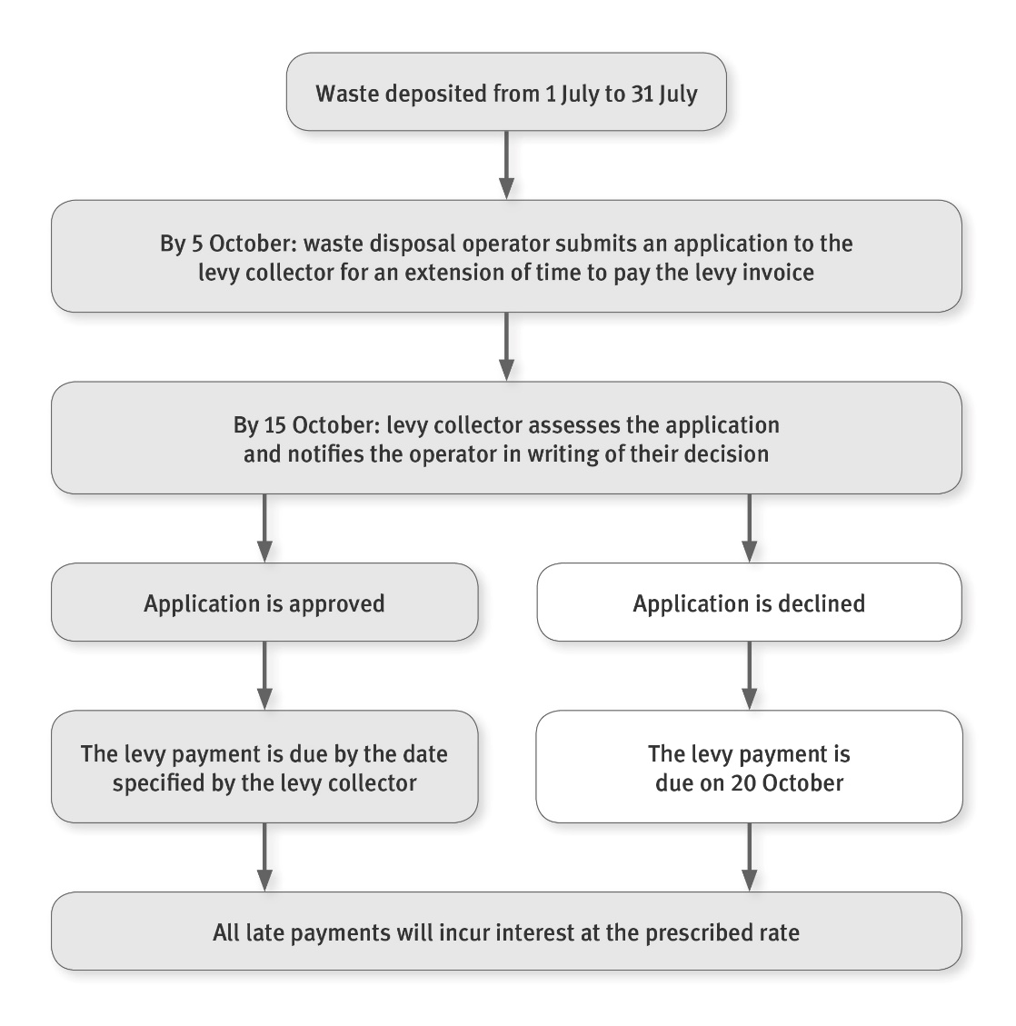

Will I be charged interest if I don’t pay the levy?
Interest is due on the levy the day after payment was due. Interest is calculated daily, using simple interest – that is, interest will not be due on the interest. If you have been granted an extension of time to pay the levy, you will be charged interest if you do not pay by the new due date.
The invoices and statements issued to you will show any outstanding debt and interest to be paid.
The interest rate is the business lending rate set by the Reserve Bank of New Zealand every year.

What happens if I don’t pay the levy?
All outstanding levies are a debt that you are liable to pay. We will use debt-collection procedures to recover outstanding debt.

Does GST apply to the levy?
Goods and Services Tax (GST) is payable on the levy.

What happens if I pay the wrong amount?
We can, in certain circumstances, make corrections to the amount a facility operator has been invoiced. This can arise where the operator was invoiced for an incorrect amount, information in the operator’s return was incorrect, or we miscalculated the levy payable.
In this case, a credit or debit balance will appear on your next invoice and this will reduce or increase the amount of levy money payable in the following month.

Closing up or selling
For levied facilities, if you are selling, otherwise transferring ownership, or closing your facility, you are required to provide written notice of the date you will stop being the facility’s operator. This notice must be sent to us at least 10 days before the facility is closed or sold. To obtain a closure form, contact us on 0800 WDLEVY (0800 935389) or email: info@wastelevy.govt.nz.
If you are closing the facility, you will need to send the levy collector a return for the final month of operation. The levy collector will then send you a final invoice.
If you are selling the facility, or for some other reason you cease to be the operator of the facility, you will need to send a final return for the last complete month during which you were the operator of the facility. The levy collector will also need to know who the new operator is, so that they can be set up in the Online Waste Levy System 2.0 (OWLS).
The new operator will be responsible for the whole of the first month in which they took over the facility. If you operated the facility for part of the month, you will need to provide the new operator with records of all waste deposited during that time (or you can provide the information directly to us).

Passing on the levy to your customers
If you decide to pass on the levy to customers, you do not need to show it as a separate item on the customer’s invoice. However, if you do, the levy rate should be no more than the rate specified in Schedule 2 of the Regulations (plus GST) per tonne. If the rate is higher, you could be in breach of the Fair Trading Act 1987, which prohibits misleading or deceptive conduct in trade and other unfair business practices.

Chapter 6: Annual returns
This chapter provides information for smaller facilities – those receiving no more than 1,000 tonnes of waste a year – who have approval from the levy collector to send annual returns.

Who can submit an annual return?
To reduce compliance costs, operators of smaller facilities can apply to provide annual returns. This option is only available to these small facilities – for instance, those of which the expected net tonnage for the financial year (1 July to 30 June) is 1,000 tonnes or less.
Before 20 July, you will need to submit a final return of actual tonnage of waste deposited/transferred for the previous financial year. At the same time, if you want to provide an annual return for the coming year, you will need to submit a new application. This is also due by 20 July.
Note that if you are approved to submit annual returns, levied facilities still need to pay monthly (where applicable). Payments will be calculated as one-twelfth of the annual expected net tonnage.

How do I apply for annual return status?
Applications are made using the Online Waste Levy System 2.0 (OWLS): www.wastelevy.govt.nz.
Your application to provide an annual return must be supported by your assessment of the expected net tonnage of waste to be deposited that year.
You will need to provide the following information:
- the name and site number (if applicable) of the facility
- the name, contact details and client number (if applicable) of the operator
- the name and contact details of the person submitting the application
- the financial year the application relates to
- the expected net tonnage for the financial year
- evidence of how the expected net tonnage was calculated.
Applications must be received by 20 July of the financial year the application relates to. The levy collector will give you a decision by 1 August.
You can apply at any time to be approved to submit annual returns. However, you can only change to annual returns at the start of a financial year.
If your application is declined, you must submit more frequent returns, and your next return (for waste deposited in July) will be due on 20 August for class 1–4 facilities and 20 October for class 5 facilities, industrial monofills and transfer stations.

How do I estimate expected net tonnage?
You can determine your expected net tonnage by using historical records, or any of the methods described below.
Please note that the following methods are only for estimating net tonnage for an annual return application. Operators still need to measure actual tonnages using one of the methods set out in chapter 4 to complete their annual return.
If you have historical waste records for your facility (whether calculated by weighbridge, conversion factors, surveys of the volume of waste disposed of, or average tonnage), you can use this data to estimate the expected net tonnage.
If you do not have historical records, you can use other methods of estimation.
We recommend that you use all the relevant data you have. If the amount of waste deposited each year is constant, you should calculate the expected net tonnage based on the average tonnage received in these years. If it is increasing or decreasing, you will need to allow for that in your calculation.

Example 11: Calculating expected tonnage using weighbridge records for the previous three years (1 July – 30 June)
The total weight of waste disposed of at the facility:
800 tonnes (2019/2020) + 1090 tonnes (2018/2019) + 840 tonnes (2017/2018)
= 2730 tonnes ÷ 3 years
= 910 tonnes annual average
The levy collector will determine your expected net tonnage. If the levy collector thinks the information you provided is inaccurate or incomplete, your expected net tonnage may be revised, and your invoices will be based on this revised estimate (where relevant).

Alternate methods for estimating annual tonnage
The request to use an annual return must include evidence of how the operator has determined the expected net tonnage. Methods of estimation include:
Volumetric surveys (for facilities, industrial monofills, and class 5 cleanfill sites)
Volumetric surveys use topographical measurements to measure the volume of waste in a facility. To estimate the annual tonnage received, a survey must be done at the beginning and end of the year.
To get tonnage figures, first you must measure the volume of waste deposited into the landfill during the year, from the topographical survey.
Next, you must apply the appropriate conversion factor specified in the Schedule to the Regulations (see appendix 3). To select the appropriate conversion factor, you will need to know the density of the landfill. Density can be estimated by excavating a hole of a measured size and weighing the waste that has been removed. Several samples need to be excavated and weighed to arrive at a reliable average density figure. This is then compared to the conversion factors in Schedule 1 of the Regulations to apply the best conversion factor for the tonnage in the landfill.
Keep appropriate documentation when using volumetric surveys for levy-related calculations. The documentation should include survey results signed off by a registered surveyor, and waste density measurements signed off by the facility operator.
Per capita waste disposal (for municipal sites)
If your facility is unstaffed and records are limited, per capita waste disposal may be used for municipal (class 1) sites. This method is only suitable for facilities receiving no more than 1,000 tonnes of waste per year from small, isolated communities (where it is possible to reasonably infer the disposal patterns of residents).
This method estimates the tonnage received, or expected to be received, in a facility by estimating the population of the facility catchment (for instance, the number of people for whom this facility is the most convenient means of disposing of waste, and who would use it regularly to dispose of most of their waste), and multiplying that population by standard per capita waste generation figures.
The quantity of waste disposed of per person will depend on whether or not your facility is used for waste other than that generated by residential and agricultural activity. So, as part of the assessment process, you need to determine if the facility is used:
- only by local rural residents
- by residents of small rural centres
- for cleanfill disposal
- for disposing of construction and demolition material
- for disposing of commercial/industrial waste.

What evidence do I need to provide of how the expected net tonnage was calculated?
You need to include evidence of how the expected net tonnage was determined. We recommend that you provide evidence of the process you used, including:
- a written explanation of the estimation method chosen, and why
- the evidence, such as previous records, maps of the catchment, Stats NZ maps and data
- a written explanation of the results of any other investigations.

What happens if I don’t send an expected net tonnage with my application?
Your request to submit annual returns must include the expected net tonnage and evidence of how this was determined. If you don’t supply this information, we will not be able to approve your request.

How and when should I pay the levy? (levied facilities only)
If approval has been granted for you to submit an annual return, we use the levy collector’s determination of your annual expected net tonnage to calculate the monthly levy that is due.
The amount of levy payable for a month of the financial year is calculated using the formula below.
Formula 4: Calculating monthly payments due when submitting an annual return
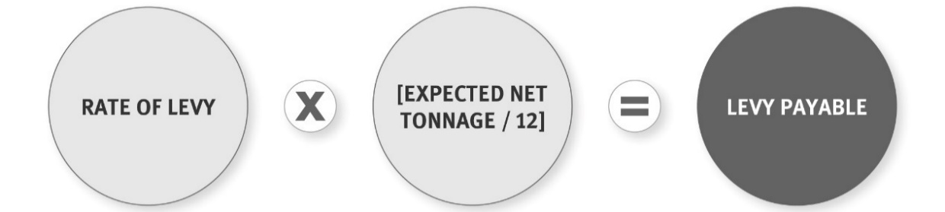
You will receive your first invoice by 4 September and must make your first monthly payment by 20 October. This timeline matches the monthly payment cycle for other facilities.

Example 12: Timeline for payment for small facilities
For waste deposited from 1 July – 30 June in any given year
Date | Action
20 July | The operator must lodge an application for approval to submit annual returns.
1 August | The levy collector will notify the operator of the decision to approve or decline the application.
4 September | If approval is given, an invoice of the amount payable will be issued.
20 October | The first monthly instalment of the levy is due.

Do I need to provide actual net tonnage as well as estimated?
By 20 July, you must provide the levy collector with the actual net tonnage received by your facility during the previous financial year.
The annual return will specify the:
- name and site number (if applicable) of the small facility
- name, contact details and client number (if applicable) of the operator
- name and contact details of the person who prepared the return (unless it was the operator)
- dates on which the financial year started and ended (for example, 1 July 2021 to 30 June 2022)
- actual gross tonnages for the financial year
- actual diverted tonnages for the financial year (if applicable)
- actual net tonnages for the financial year.
The levy collector will use this information to issue a final invoice on 5 August (where applicable). The invoice may include a credit or debit adjustment to reflect the difference between the expected net tonnage and the amount owed based on the actual annual return.

How do I calculate actual net tonnage?
You must calculate the actual net tonnage from data collected over the year using one of the methods described in chapter 4. These methods are:
- weighbridges either on site or off site
- volume conversion factors applied to measurements of individual loads
- average tonnage system for vehicles and trailers towed by vehicles.
You cannot use a population-based method to determine your actual net tonnage.

What happens if I don’t send a final return?
For levied facilities, if you don’t provide a final actual tonnage return by 20 July, or the levy collector believes your return is incorrect or incomplete, the levy collector may make an estimate of the annual tonnage based on your previous returns and any other relevant information. The levy collector will send you an initial estimate by 25 July.
The levy collector will then issue a final estimate by 5 August, considering any further information you may have provided. This final estimate then becomes the amount of levy payable for the year. Estimates are discussed in more detail in chapter 2.

What happens if I don’t reapply to provide returns annually?
You must reapply each year if you want to submit your returns annually. If you don’t, you will need to submit monthly/quartlery returns. Your first monthly return will be due on 20 August for waste deposited in July for class 1–4 facilities. Your first quarterly return will be due on 20 October for class 5 facilities, industrial monofills and transfer stations.

Chapter 7: Six-month returns – transitional arrangements
From 2021 to 2024, while the levy is expanding to classes 2 to 4 facilities, certain sites that are becoming subject to obligations under the WMA will be able to file a one-off six-monthly return (table 6).
Table 6: Disposal facilities that may seek approval for a one-off six-monthly return
Type of facility | Required tonnage
Class 2: Construction and demolition fill disposal facility | Expected net tonnage for 1 January 2022 to 30 June 2022 is 500 tonnes or less
Classes 3 and 4: Managed or controlled fill disposal facility | Expected net tonnage for 1 January 2023 to 30 June 2023 is 500 tonnes or less
If a facility meets these criteria, the operator may apply in writing to the Ministry to provide a return for the estimated period set out in the table. The request must be submitted to the Ministry by 20 January of the applicable year. In that application you must include:
- the name and site number (if applicable) of the facility
- the name, contact details and client number (if applicable) of the operator
- the name and contact details of the person submitting the application
- the period the application relates to
- the expected net tonnage for the period
- evidence of how the expected net tonnage was calculated.
If the application is approved by the Ministry, the operator does not need to provide a monthly return and must instead provide a return on or before 20 July after the end of the period stated in the above table (for instance, a class 2 facility that receives 500 tonnes or less for that period must file its return by 20 July 2022).
Facilities that meet the criteria to file a six-month return should follow the sections of this guide on estimating expected tonnage that relate to annual returns.

Chapter 8: Applications for waivers and refunds
This chapter provides information on how to apply for waivers and a refund, and is only appliable to class 1–4 facilities that have levy obligations.

When can I apply for a waiver?
You can apply to the Secretary for the Environment to waive the requirement to pay a levy. This must be due to exceptional circumstances – something that couldn’t reasonably be predicted to happen and isn’t a regular event, such as a natural disaster. It will not permanently exempt you from paying the levy on that type of waste or in that particular circumstance.
You can apply for a waiver at any time – before the waste is received, before the levy is paid on it, or after the levy is paid on it. You must demonstrate why the situation justifies a waiver of the levy.
Your application should include the:
- dollar amount of levy to be waived
- start date of period being applied for (month and year)
- end date of period being applied for (month and year)
- material type
- tonnage
- situation (description of event that led to waiver request), including a detailed description of why the situation in question is exceptional.
Application forms can be found on the Online Waste Levy System 2.0 (OWLS): www.wastelevy.govt.nz.
The Secretary will examine waiver applications on a case-by-case basis to see if they meet the requirement of ‘exceptional’ circumstances.
We will notify you in writing of the decision within 10 working days. If a waiver is granted, a credit adjustment based on tonnage figures will be applied to the facility and included in your next invoice.

How do I receive a refund?
In the unlikely event that you have paid the levy after the waiver was granted, you can apply to the levy collector for a refund.
Written applications for refunds must demonstrate that at the time the levy was paid, a waiver had been granted by the Secretary. We recommend that you include in your application:
- the invoice the application relates to
- the amount to be refunded
- the details of the waiver for which a refund is being requested
- the date the money was paid and date the waiver was granted
- any other supporting information.

What if my account is in credit and I want a reimbursement?
If your account is in credit by a large amount and for specific reasons you require a reimbursement, you can apply to us. Your application should provide details about why it is not reasonable or possible to receive the adjustment as a credit. We examine applications for reimbursement on a case-by-case basis. We recommend that you include in your application:
- the invoice the application relates to
- the amount of the request for reimbursement
- the reason you need the money reimbursed.

Can I apply for an exemption?
An exemption means you don’t have to pay the levy for a specific type of facility. Exemptions must be set out in Regulations.
There are currently no provisions in the Regulations for exemptions. That means that it is not possible to apply for an exemption from the requirement to pay the levy.

Chapter 9: Monitoring and enforcing levy and reporting requirements
The Ministry for the Environment is the national regulator for the WMA and carries out monitoring and enforcement work relating to the payment of the levy and other obligations under the WMA.
The Ministry’s compliance, monitoring and enforcement team is guided by its Compliance Strategy, and is distributed across the country. This team is charged with several audit programmes in addition to investigations and strategic work. This is the Ministry’s only direct regulatory role, and the team has developed a range of systems to support our field-based officers. The Ministry monitors and audits the compliance of facility operators with levy payments and requirements for keeping and providing records.

Auditing

What is an audit?
An audit is an examination and review of any financial transactions and systems for determining net tonnages at a facility. It will look at a facility’s compliance with the relevant regulations.
An audit will reconcile the original records kept by the operator with the tonnage and financial records kept by the levy collector.

What can I expect with an audit?
The Ministry’s guide for facility audits provides details of the audit process.

Regulatory compliance
The Ministry also has a regulatory compliance team that is responsible for investigating potential breaches of the WMA. A compliance response may result from a referral from an audit or an external complaint, or on the Ministry’s initiative. The Ministry will decide whether to further investigate a matter using an internal risk matrix.

Penalties and offences
Any unpaid levy is recoverable as a debt by the levy collector (section 36 of the WMA).
The WMA also has offences relating to the requirements in the Regulations to keep records and make returns to the Ministry (so the levy can be calculated and to comply with other reporting requirements):
- Any person who contravenes Regulations made under section 86(1)(a) or (b) of the WMA.
- Any person who, in providing records or other information required by Regulations made under section 86(1)(a), (b) or (c) knowingly:
- supplies false or misleading information
- makes any material omission.
These offences have a maximum fine on conviction of $100,000.

How will enforcement decisions be made?
The Ministry has an Enforcement Decision-making Policy and Prosecutions Policy to guide its decision making.

Notifying the Ministry of compliance issues
If you have any concerns about compliance issues relating to facility operators, please contact the Ministry at waste.dfo@mfe.govt.nz or using the Alleged breach notification form.

Appendix 1: Glossary
This glossary explains terms used in this guide. For full definitions of key terms (marked with *) see the Act or Regulations.
Term
The WMA | The Waste Minimisation Act 2008.
Compliant weighbridge | A compliant weighbridge is an approved calibrated weighbridge (weighing instrument) as specified under the Weights and Measures Act 1987. ‘Weighing instrument’ means any instrument or machine used for weighing any article, thing, liquid or substance; and includes weights used in connection with it.
Cover material | Cover material is soil or a suitable alternative material used to cover waste deposited in a disposal facility. Its purpose is to limit infiltration of water, control and minimise fire risk, minimise emissions of landfill gas, suppress odours, reduce flies and rodents, and decrease litter.
Disposal* | Disposal means:  - any deposit of waste into or onto land set apart for that purpose unless, within six months of its deposit (or any later time that the Secretary for the Environment has agreed to in writing), the waste is:  - reused or recycled  - recovered or treated on the land and removed from the land for deposit elsewhere  - removed from the land for any other reason.  - the deliberate burning of waste to destroy it, but not to recover energy from it.
Facility* | The types of facilities are defined in chapter 3 of this guide.  Definitions are available in:  - Waste Minimisation (Calculation and Payment of Waste Disposal Levy) Regulations 2009  - Waste Minimisation (Information Requirements) Regulations 2021.
Diverted material* | This is defined in the Regulations as anything that is no longer required for its original purpose and, but for commercial or other waste minimisation activities, would be disposed of or discarded. Examples of diverted material include glass and paper.
Diverted tonnage* | The definitions are as follows:  Waste Minimisation (Calculation and Payment of Waste Disposal Levy) Regulations 2009  - 11(1) (b) the tonnage of waste or diverted material that is reused or recycled at the disposal facility, or is removed from the facility, not later than 6 months after entering the facility (or any later time that the Secretary has agreed to in writing) (diverted tonnage).  Waste Minimisation (Information Requirements) Regulations 2021  - 9(2)(b) class 5 or industrial monofill facility:  - the tonnage of waste or diverted material that is reused or recycled at the facility, or is removed from the facility  - 10(2)(b)(c) transfer stations:  - the tonnage of waste or diverted material that is reused or recycled at the facility, or is removed from the facility (other than as described in paragraph (c)) (diverted tonnage).
Financial year* | The financial year for the purposes of the levy is 1 July to 30 June of the following year.
Gross tonnage | The tonnage of waste or diverted material that enters the disposal facility.
Household waste* | Any waste from a household that is not entirely from construction, renovation or demolition of the house.
Inert waste material* | This is waste that:  (a) is neither chemically nor biologically reactive  (b) does not decompose or undergo any change in its chemical properties  (c) does not alter the chemical properties of any other material.
In writing / written | Information can be provided either electronically or on paper. Returns provided on paper must be signed and dated. All returns must include a declaration that the information is correct.
Levy collector | The levy collector is the Secretary for the Environment. The Minister for the Environment has the power to appoint another person as levy collector but has decided to leave this function with the Secretary at present.
Net tonnage | The amount of material on which the levy is paid. It is the gross tonnage minus any diverted tonnage.
Operator* | The person in control of a disposal facility or other facility.
Levy Regulations | The Waste Minimisation (Calculation and Payment of Waste Disposal Levy) Regulations 2009.
Reporting Regulations | The Waste Minimisation (Information Requirements) Regulations 2021.
Recycling | The reprocessing of waste or diverted material to produce new materials.
Return | The tonnage data entered by the waste facility operator.
Reuse | The further use of waste or diverted material in its existing form for the original purpose of the materials or products that constitute the waste or diverted material, or for a similar purpose.
Secretary | The Secretary for the Environment, who is the Chief Executive of the Ministry for the Environment.
Waste* | Anything disposed of or discarded, and:  - includes a type of waste that is defined by its composition or source (eg, organic waste, electronic waste, or construction and demolition waste)  - to avoid doubt, this includes any component or element of diverted material, if the component or element is disposed of or discarded.
Operator | The person in control of a facility or other facility. Many factors could be relevant in deciding who has control of a facility, including who holds the resource consent for the facility, who oversees the day-to-day management of the facility, who determines gate fees.
Waste Minimisation Fund | A contestable fund used to distribute levy money on projects to promote or achieve waste minimisation.
Working day | Several deadlines exist for facility operators, such as specifying x ‘working days’ to provide specific information. Sometimes holidays intervene. If a date falls on a day that is specified in Section 29 of the Interpretation Act 1999 as not being a working day, then that item is due the next working day. The Interpretation Act states that a working day means a day of the week other than:  - a Saturday, a Sunday, Waitangi Day, Good Friday, Easter Monday, Anzac Day, the Sovereign’s Birthday, and Labour Day  - a day in the period beginning with 25 December in a year, and ending with 2 January in the following year  - if 1 January falls on a Friday, the following Monday  - if 1 January falls on a Saturday or a Sunday, the following Monday and Tuesday  - if Waitangi Day or Anzac Day falls on a Saturday or a Sunday, the following Monday.

Appendix 2: Vehicle classification: Average tonnage method
Operators of disposal facilities can ask the Secretary for the Environment to approve a method to determine the weight of waste based on the type of motor vehicle it is carried in. Under Regulation 15, only the classes of vehicle in the table below can be considered (or any other motor vehicle with a gross vehicle mass of 3.5 tonnes or less), and any trailer towed by a vehicle of these classes.
The information on vehicle classes in the table is provided by Waka Kotahi, the New Zealand Transport Agency and retrieved from: https://www.nzta.govt.nz/vehicles/vehicle-types/vehicle-classes-and-standards/vehicle-classes/.

Table of vehicle classes
Class | Description
MA (Passenger car) | A passenger vehicle (other than a Class MB or Class MC vehicle) that has not more than nine seats (including the driver’s seat).
MB (Forward control passenger vehicle) | A passenger vehicle (other than a Class MC vehicle):  a. that has not more than nine seats (including the driver’s seat), and  b. in which the centre of the steering wheel is in the forward quarter of the vehicle’s total length.
MC (Off-road passenger vehicle) | A passenger vehicle, designed with special features for off-road operation, that has not more than nine seats (including the driver’s seat), and that:  a. has four-wheel drive, and  b. has at least four of the following characteristics when the vehicle is unladen on a level surface and the front wheels are parallel to the vehicle’s longitudinal centreline and the tyres are inflated to the vehicle manufacturer’s recommended pressure:  i. an approach angle of not less than 28 degrees  ii. a breakover angle of not less than 14 degrees  iii. a departure angle of not less than 20 degrees  iv. a running clearance of not less than 200 mm  v. a front-axle clearance, rear-axle clearance, or suspension clearance of not less than 175 mm.
Omnibus | A passenger vehicle that has more than nine seats (including the driver’s seat). An omnibus comprising two or more non-separable but articulated units shall be considered as a single vehicle.
MD 1 | An omnibus that has a gross vehicle mass not exceeding 3.5 tonnes and not more than 12 seats.
MD 2 | An omnibus that has a gross vehicle mass not exceeding 3.5 tonnes and more than 12 seats.
Goods vehicle | A motor vehicle that:  a. is constructed primarily for the carriage of goods, and  b. either:  i. has at least four wheels  ii. has three wheels and a gross vehicle mass exceeding 1 tonne.  For the purpose of this description:  a. a vehicle that is constructed for both the carriage of goods and passengers shall be considered primarily for the carriage of goods if the number of seats multiplied by 68 kg is less than 50% of the difference between the gross vehicle mass and the unladen mass  b. the equipment and installations carried on special purpose vehicles not designed for the carriage of passengers shall be considered to be goods  c. a goods vehicle that has two or more non-separable but articulated units shall be considered to be a single vehicle.
NA (Light goods vehicle) | A goods vehicle that has a gross vehicle mass not exceeding 3.5 tonnes.
NB (Medium goods vehicle) | A goods vehicle that has a gross vehicle mass exceeding 3.5 tonnes but not exceeding 12 tonnes.
NC (Heavy goods vehicle) | A goods vehicle that has a gross vehicle mass exceeding 12 tonnes.

Appendix 3: Schedule of conversion factors
Type of waste or diverted material | Description of waste or diverted material | Conversion factor
Waste or material in rubbish bags or carried in cars | Small loads (0.5 cubic metres or less) of uncompacted general waste or material, including bags of domestic and commercial refuse  or  Waste or material for diversion that is similar in density to loose and uncompacted recyclable containers, such as cans and plastic bottles | 0.130 tonnes (130 kg)/cubic metre
Uncompacted general waste or material | Larger loads (more than 0.5 cubic metres) of uncompacted waste or material from residential, commercial, industrial, construction and demolition (excluding cleanfill) and landscaping activities  or  Waste or material for diversion that is similar in density to timber or uncompacted cardboard and paper | 0.200 tonnes (200 kg)/cubic metre
Compacted waste or material | Waste or material carried in a compacted state (including in kerbside collection compactors, stationary compactors, and front-end loaders) and compacted bulk waste or material from transfer stations  or  Waste or material for diversion that is similar in density to whole glass bottles and loose light-gauge scrap metal | 0.320 tonnes (320 kg)/cubic metre
High-density waste or material | Waste or material composed of materials with a specific gravity greater than 1.0 (eg, concrete and masonry rubble, clay, soil, slags, sludges (including biosolids), ash, foundry sand, pomace (fruit pulp) and abattoir waste)  or  Waste or material for diversion that is similar in density to crushed glass | 1.500 tonnes (1 500 kg)/cubic metre

Including all amendments outlined in the Waste Minimisation (Calculation and Payment of Waste Disposal Levy) Amendment Regulations 2021.
Reporting obligations will not begin for class 3/4 landfills until 1 January 2023; Waste Minimisation (Calculation and Payment of Waste Disposal Levy) Regulations 2009 (4).
Waste Minimisation (Information Requirements) Regulation 2021. Part 1 (5).
Annual returns only applicable if approved by the Ministry for the Environment.
Section 65(1)(e) and (f) of the WMA.
This was changed in the amendments to the Levy Regulations in 2021.
The six-month timeframe for diverted materials does not apply for transfer stations, industrial monofills, or cleanfills.
A compliant measuring instrument is one that complies with the Weights and Measures Act 1987.
Returns can also be submitted in writing, but use of the OWLS is strongly encouraged.

