Swimming categories for E. coli in the Clean Water package
A summary of the categories and their relationship to human health risk from swimming

Disclaimer
The information in this publication is, according to the Ministry for the Environment’s best efforts, accurate at the time of publication and the Ministry makes every reasonable effort to keep it current and accurate. However, users of the publication are advised that:
- The information provided has no official status and so does not alter the laws of New Zealand and other official guidelines or requirements.
- It does not constitute legal advice, and users should take specific advice from qualified professional people before undertaking any action as a result of information obtained from this publication.
- The Ministry for the Environment does not accept any responsibility or liability whatsoever whether in contract, tort, equity or otherwise for any action taken as a result of reading, or reliance placed on the Ministry for the Environment because of having read any part, or all, of the information in this publication or for any error, or inadequacy, deficiency, flaw in or omission from the information provided in this publication.
- All references to websites, organisations or people not within the Ministry for the Environment are provided for convenience only and should not be taken as endorsement of those websites or information contained in those websites nor of organisations or people referred to.

This document may be cited as: Ministry for the Environment. 2017. Swimming categories for E. coli in the Clean Water package: A summary of the categories and their relationship to human health risk from swimming. Wellington: Ministry for the Environment.

Published in May 2017 by the
Ministry for the Environment
Manatū Mō Te Taiao
PO Box 10362, Wellington 6143, New Zealand
ISBN: 978-1-98-852502-0
Publication number: ME 1308
© Crown copyright New Zealand 2017
This document is available on the Ministry for the Environment website: www.mfe.govt.nz.
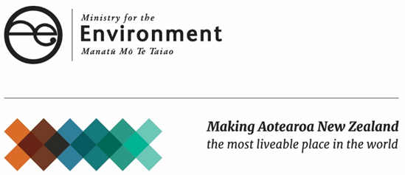

Contents
Introduction 4
Background 5
How health risks from swimming are currently measured and managed 5
The purpose of swimming maps and proposed swimming targets 6
An explanation of the proposed swimming categories 9
What constitutes ‘swimmable’ 9
Fluctuations in E. coli levels 9
The four statistical measures 9
Risk in relation to the proposed swimming categories 12
An overview of how health risk is determined from the swimming categories 12
The QMRA linking E. coli and Campylobacter 12
Risk profiles of the swimming categories 13
Other risk 15
A comparison between the proposed categories and the existing categories 16
A comparison between the proposed categories and overseas regimes 18
Limitations of international comparisons 18
European Union 18
United States of America 19
References 20

Introduction
This report provides information on the categories used in the swimming maps, proposed targets, and proposed amendments to the National Policy Statement for Freshwater Management released as part of the Government’s Clean Water package in February 2017.
This report explains what the proposed categories mean for people’s risk of getting sick when they swim, and explains how the proposed categories compare to existing categories that are used to manage water quality for swimming, both in New Zealand and overseas. It includes information on:
- the status quo, including how health risks from swimming are currently managed, and the background behind the new swimming maps and proposed targets
- the proposed categories and how the thresholds are derived
- risk profiles for the proposed categories, and what that means for people’s risk of swimming in New Zealand rivers
- comparisons between the proposed categories and the existing categories, and comparisons between the proposed categories and other countries’ systems.
This report should be read alongside the consultation document Clean water: 90% of rivers and lakes swimmable by 2040 which sets out the full range of proposals. Final decisions on the proposals will be made taking into account feedback we receive during the consultation. The proposals, including the categories, could change as a result of that feedback.

Background

How health risks from swimming are currently measured and managed

Pathogens in fresh water
Microbial pathogens are microbes such as bacteria, viruses and protozoa that can cause illness. Microbial pathogens in the water can enter the body when water is swallowed, or through the ears, nasal passages, mucous membranes or cuts in the skin. They can cause gastrointestinal illness, respiratory symptoms, or more harmful diseases like hepatitis A.
Microbial pathogens in fresh water primarily come from faecal contamination. Faecal contamination from animals can occur through runoff from farms during rainfall events, or if animals have direct access to waterways. Human faecal contamination of waterways can occur if poorly treated sewage or septic tank systems are discharged (directly or indirectly) to water, or during heavy rain when sewerage systems overflow into stormwater systems.
Campylobacter (a type of bacteria that can cause gastrointestinal illness) and noroviruses (a group of viruses that can cause gastrointestinal illness) are the pathogens most likely to cause people to become sick from swimming (McBride et al, 2002).

The use of E. coli for monitoring human health risk
It is difficult to detect pathogens in water samples obtained from freshwater sites. Methods for detecting and identifying viruses or parasites are either very difficult and/or expensive. Bacterial pathogens can be detected, but their nutritional requirements, susceptibility to environmental stresses, and sporadic presence can make the task very difficult. Because of this, the main approach for assessing the presence of pathogens is to use ‘indicator organisms’ – organisms whose presence in the water is an indication of faecal contamination and therefore the potential that other pathogens might be present.
Escherichia coli (E. coli) is a bacteria commonly found in the gut of warm blooded organisms. E. coli survives outside the body and can survive for up to four to six weeks in fresh water making it a useful indicator of faecal presence and therefore of disease-causing organisms that may be present in faecal matter. E. coli is relatively straightforward and inexpensive to measure.
The thresholds of what has been considered an acceptable level of E coli (discussed throughout this document) are based on a ‘quantitative microbial health risk assessment’ (QMRA) that assessed what the corresponding risk of Campylobacter infection would be for different concentrations of
E. coli. You can read more about the risk assessment in the chapter on risk in relation to the swimming categories.

The 2003 recreational water quality guidelines
In 2003 the Ministry of Health and Ministry for the Environment released the Microbiological water quality guidelines for marine and freshwater recreational areas. They are still used, and they use
E. coli as an indicator of the risk of Campylobacter infection.
The guidelines have two components, covering short-term and long-term considerations:
- surveillance involves using recent data to determine if an immediate problem exists that requires attention (eg, an unexpected spike in E. coli levels due to wastewater overflows)
- grading involves assessing the general conditions over time, so an overall assessment can be made about how likely the site is to be suitable for swimming in the longer term.
If surveillance data indicates a problem the guidelines advise that increased sampling should be undertaken, and public advisories (ie, warning signs at popular swimming spots) issued.
The long-term grading is based on the combination of:
- a Microbiological Assessment Category (a category based on E. coli monitoring data, with bands from A to D, with A being the best state and D the worst)
- a Sanitary Inspection Category (a category based on identifying the likely sources of faecal contamination and assessing the risk they pose).
The Microbiological Assessment Category and the Sanitary Inspection Category combine to give the site an overall Suitability for Recreation Grade ranging from ‘very good’ to ‘very poor’.
The thresholds in the surveillance requirements set a standard for what is considered ‘suitable’ or ‘not suitable’ for swimming. Action is taken in response to surveillance measurements if a set of thresholds or standards is exceeded: if concentrations exceed 550 E. coli per 100 ml, regional councils are advised to put signs up to alert the public of the immediate health risk.

The Freshwater NPS – setting objectives for water quality
In 2011, the Government introduced the National Policy Statement (NPS) for Freshwater Management. It requires councils to set freshwater objectives describing the intended state/outcomes for water bodies, as limits and methods to achieve them.
In 2014, the NPS was amended to include two compulsory values (ecosystem health and human health for recreation). A set of attributes with national bottom lines was adopted for these two values. E. coli is one of the attributes for human health for recreation. This meant councils were required to set freshwater objectives for the level of E. coli that was acceptable to the community. This objective could not be set below the ‘national bottom line’ of 1000 E. coli per 100 ml (measured as an annual median).
In February 2017, the Government proposed further changes to the NPS provisions on E. coli. In the chapter on a comparison between the proposed categories and the existing categories you can find out more about how E. coli is managed under the 2014 NPS and how the current proposals would change that.

The purpose of swimming maps and proposed swimming targets
The E. coli categories discussed in this report are used for three separate parts of the Clean Water package (swimming maps, proposed targets, and a proposed attribute table in the Freshwater NPS). In the targets and maps, E. coli applies only to rivers because E. coli is the most common reason water quality in rivers is unsuitable for swimming whereas for lakes the most common reason is toxic algae. Table 1 summarises what water bodies the E. coli categories apply to for each proposal.
Table 1: Which contaminants are used in the swimming maps, targets and attribute table
Water body type | Swimming maps | Targets | NPS attribute table
Rivers | E. coli | E. coli | E. coli
Lakes | Toxic algae | Toxic algae | E. coli and toxic algae

Background on the aspiration for swimmable rivers
The introduction of proposed new swimming categories (both as targets, and as attributes in the Freshwater NPS) is in response to public feedback that the existing national bottom line for contact recreation were not aspirational enough. The existing national bottom line required rivers to be at least suitable for wading and boating.
The use of a range of tests, including a median and a percentage of exceedances over the acceptable threshold, is intended to recognise that levels of E. coli in the water are constantly fluctuating, and therefore the risk to human health varies significantly day to day, or even within a day. By using descriptions about the percentage of time the E. coli does not exceed a minimum acceptable state, rather than just saying whether it is safe to swim, the proposed categories aim to demonstrate that risk is not binary – it is constantly changing. Rather than simply being told that a river is swimmable or not, the categories seek to give people an indication of the likely risk so they can make choices when deciding where to swim.

Purpose of the swimming targets and NPS attribute table for E. coli
The proposed swimming categories are intended to provide a more aspirational approach to managing human health risk for swimming. They are non-statutory, but set out the amount of improvement the Government is aiming for, and asking regional councils to aim for. This is expressed as a change in percentage in the length of rivers and lake edges that are swimmable by 2040, with an interim target by 2030. The proposed swimming categories are intended to provide a more aspirational approach to managing human health risk for swimming, and drive continuous improvement over time.

Purpose of the NPS attribute table for E. coli
The proposed changes to the attribute tables in the Freshwater NPS are intended to help councils give effect to the targets. They place new requirements on how councils manage the quality of lakes and rivers to provide for swimming.
More information about the swimming targets is available on the Ministry for the Environment’s website and in the consultation document Clean water: 90% of rivers and lakes swimmable by 2040.

Purpose of the swimming maps
The swimming maps on the Ministry for the Environment’s website show the current state of New Zealand’s larger rivers and lakes of a size suitable for swimming in relation to the targets, to help communities identify where to focus attention.
The maps also provide a nationwide picture about the state of rivers and lakes using the same measuring system across the country. This provides people with information about which locations have a low risk of illness, and which have a risk that is unacceptable. They use modelling to build on council data to estimate water quality for swimming not only at monitored sites, but up and down the length of river networks in rivers deep enough to swim in.
The maps provide a longer-term view of water quality, which complements the information already available on the LAWA website and individual council websites about recent monitoring results. That means people can get a general idea of the water quality for swimming over a whole river using the Ministry for the Environment’s maps, and they can visit LAWA or their council website for the most up-to-date information about health risk over the past few weeks.

An explanation of the proposed swimming categories

What constitutes ‘swimmable’
In the swimming maps, the Freshwater NPS attribute table and the accompanying targets, rivers and lakes in New Zealand are divided into five categories ranging from ‘excellent’ to ‘poor’.
Table 2: Proposed swimming categories in the Clean Water consultation document
Category | What it means for swimming
Excellent (Blue) | Safe to swim except following flood events
Good (Green) | Safe to swim except following heavy rain
Fair (Yellow) | Safe to swim in normal conditions but if in doubt, check the LAWA website
Intermittent (Orange) | Not safe to swim except if LAWA website confirms it’s ok
Poor (Red) | Not safe to swim
By using descriptions about the percentage of time the E. coli does not exceed a minimum acceptable state, rather than just saying whether it is safe to swim, the proposed categories aim to demonstrate that risk is not binary – it is constantly changing. Rather than simply being told that a river is swimmable or not, the categories seek to give people an indication of the likely risk.

Fluctuations in E. coli levels
Levels of E. coli in the water are constantly fluctuating, and therefore the risk to human health varies significantly over time.
E. coli concentrations in rivers have enormous variations from less than 100 up to more than 10,000. E. coli are generally present in rivers to some degree, but occasionally there are large spikes in the amount of E. coli. This means the infection risk can change over time with spikes in E. coli concentrations causing higher risk on occasion.
The way the swimming categories are measured (described in more detail in the section below) is designed to address a range of ways of looking at the health risk, including:
- how often E. coli levels spike over the acceptable threshold
- how high the spikes get
- what the baseline level of E. coli is when it is not spiking.

The statistical measures
There are a number of statistical measures proposed for determining which category a river would fall within. These are listed in table 3.

Table 3: The statistical measures for swimming categories
Category | Percentage of exceedances over 540  E. coli per 100 ml | Median:  E. coli per  100 ml | 95th percentile:  E. coli per  100 ml | Percentage of samples above 260  E. coli per 100 ml
What it means | How often the river exceeds the acceptable threshold for swimming | The mid-point (ie, half the time E. coli is lower than this, half the time it is higher) | E. coli only rarely goes past this point (only 5% of the time) | How often the river goes over the point where additional monitoring is needed
Excellent (Blue) | Less than 5 per cent | 130 or less | 540 or less | Less than 20 per cent
Good (Green) | 5-10 per cent | 130 or less | 1000 or less | 20-30 per cent
Fair (Yellow) | 10-20 per cent | 130 or less | 1200 or less | 20-34 per cent
Intermittent (Orange) | 20-30 per cent | More than 130 | More than 1200 | More than 34 per cent
Poor (Red) | More than 30 per cent | More than 260 | More than 1200 | More than 50 per cent

Percentage of exceedances over 540
The percentage of exceedances over 540 tells you how often the level of E. coli goes over the threshold of what is considered acceptable. This tells you how likely it is that, if you were to go swimming on any given day, E. coli levels will be low enough that your infection risk is within an acceptable range.

Median
The median E. coli level shows the mid-point in the range of E. coli that would be found in that category.
For all the categories considered swimmable (excellent, good and fair), the median is required to be less than 130 E. coli per 100 ml. This is based on a quantitative microbial risk assessment (the following chapter talks more about what that means), which determined that at 130 E. coli per 100 ml, the infection risk is less than 0.1 per cent (or less than one infection in 1000 exposures). That means rivers with median E. coli values of less than or equal to 130 E. coli per 100 ml have low risk for at least 50 per cent of the time.

95th percentile
The 95th percentile tells you the point that 95 per cent of samples are under. That means it is rare for E. coli concentrations to go over this point (only 5 per cent of the time).
The use of a 95th percentile provides an indication of the top of the range that could generally be expected, while excluding the most extreme outliers; however, it doesn’t provide a good indication of what the E. coli concentration would usually be.

Percentage of samples above 260
Two hundred and sixty E. coli per 100 ml is a threshold that was used in the 2003 recreational water quality guidelines. It is a point at which the risk of infection begins to increase but is still significantly lower than the acceptable threshold of 540. At 260 the risk is around 1 per cent, while at 540 the risk is around 5 percent (you can read more in the next chapter about the way risk is calculated). It provides councils with an indication of how much of the time they will need to carry out daily monitoring.

Risk in relation to the proposed swimming categories

An overview of how health risk is determined from the swimming categories
There is always some degree of risk that when you swim you may be infected by microbial pathogens that could make you sick, and the risk varies from day to day.
The purpose of defining an acceptable threshold of risk and various categories of ‘swimmability’, then, is to help people quantify the level of risk that exists so they can make their own judgement on what level of risk they are prepared to tolerate. It means people can make an informed decision on where and when to swim, and how much extra information to seek before doing so.
The categories in the swimming maps, targets and attribute table are based on determining:
- the baseline levels of E. coli concentration and how often they spike
- how E. coli concentrations are linked to infection risk.
The information we used to determine what E. coli concentrations are in the water, and how often they spike, is based on a mix of monitoring and modelling. The methods for developing the model are set out in more detail in the report Strategic assessment of New Zealand’s freshwaters for recreational use: a human health perspective. The methods for determining the infection risk related to different E. coli frequencies are described in more detail in the following sections.
It is important to note that all the data in this report is based on the risk of infection, and this does not mean the same thing as becoming sick. People can be infected with Campylobacter without exhibiting symptoms. It is thought that roughly half of Campylobacter infections result in illness.

The QMRA linking E. coli and Campylobacter
Quantitative microbial risk assessment (QMRA) is an approach that brings information and data together with mathematical models to assess the spread of infection and illness from microbes through environmental exposure.
As mentioned earlier in this report, the use of E. coli as an indicator (and therefore its inclusion in the 2003 recreational water quality guidelines, the Freshwater NPS, and the new swimming maps and targets) is based on a QMRA that looked at the link between E. coli concentrations and Campylobacter infections.
The QMRA took data from:
- a study that looked at the doses of Campylobacter that would be required to make a person sick
- a study that looked at the concentrations of both Campylobacter and E. coli at 22 river and 3 lake sites, to see the correlation between the two.
It used this data to develop a statistical model that took this data, and other variables (such as the ingestion rate and amount of time in the water) to come up with a predicted level of risk of Campylobacter infections for a range of different E. coli concentrations.
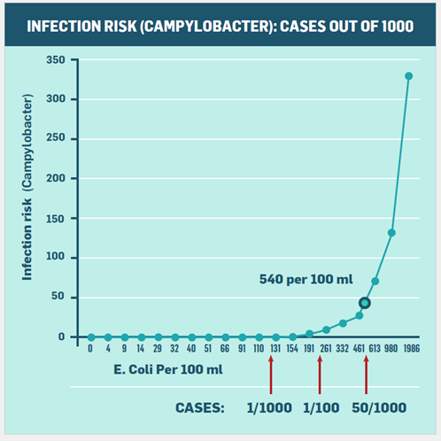
The QMRA showed that:
- waters with approximately 130 E. coli per 100 ml presented a risk of less than 1 in 1000 of infecting someone with Campylobacter. This means that at 130 the risk of infection is minimal
- waters with approximately 260 E. coli per 100 ml presented a risk of less than 10 in 1000 (or 1 per cent)
- waters with somewhere between 461 and 613 E. coli per 100 ml presented a risk of around 50 in 1000 (5 per cent, or one in 20); this was the driver for setting the maximum threshold at 540 as it is approximately the average between these two points (McBride, 2012).
We are currently procuring a review of the relevant scientific methods required to repeat the QMRA. The updated QMRA is scheduled to be performed over the 2017 to 2019 swimming seasons.

Limitations of the QMRA
As with all scientific studies, there are some uncertainties and assumptions built into the QMRA which may affect its accuracy. Some of the main ones are:
- The susceptibility of different age groups to infection: the study looked at rates of Campylobacter infection in adults. However, there is some evidence that children may be more likely to become sick from Campylobacter than adults. Some of this may simply be due to the fact that they are exposed more often (eg, swim for longer and swallow more water when they do), but there is also a possibility that children could become sick from a smaller dose. Elderly people may also be more susceptible to infection.
- Different species of Campylobacter: there are multiple strains of Campylobacter. This study assumed every strain was equally infectious, but there is evidence to suggest that some strains are more infectious than others.
- Other pathogens: this study only looked at the link between E. coli and Campylobacter. It didn’t look at how well E. coli indicated the presence of other pathogens.

Risk profiles of the swimming categories
By looking at the distribution of E. coli and the statistical tests (median, 95th percentile, and exceedances of the 540 and 260 thresholds) it’s possible to estimate a risk profile for each of the five proposed swimming categories. The better the category, the lower the risk – therefore, the better the category the less high, less often, the E. coli levels are likely to get.
Table 4 shows the risk profiles in terms of how the risk changes – it shows how much of the time the risk is minimal (less than one in 1000) and how much of the time it is over the acceptable threshold (one in 20 risk or greater). Table 5 provides more information about the risk profiles as averages across all time.
Table 4: Risk of Campylobacter infection based on swimming categories
Category | % exceedances over 540 cfu/100ml | % exceedances over 260 cfu/100ml | Median concentration (cfu/100ml) | Description of swimmability – risk of Campylobacter infection (based on E. coli indicator)
Blue / Excellent | <5% | <20% | ≤130 | For at least half the time, the estimated risk is <1 in 1000 (0.1% risk)  Less than 5% of the time, the estimated risk is ≥50 in 1000 (>5% risk)  Overall risk across all time (not taking season or weather into account) is < 1%
Green / Good | 5-10% | 20-30% | ≤130 | For at least half the time, the estimated risk is <1 in 1000 (0.1% risk)  5-10% of the time the estimated risk is ≥50 in 1000 (>5% risk)  Overall risk across all time is <2%
Yellow / Fair | 10-20% | 20-34% | ≤130 | For at least half the time, the estimated risk is <1 in 1000 (0.1% risk)  10-20% of the time the estimated risk is ≥50 in 1000  Overall risk across all time is <3%
Orange / Intermittent | 20-30% | >34% | >130 | 20-30% of the time the estimated risk is ≥50 in 1000 (>5% risk)  Overall risk across all time is >7%
Red / Poor | >30% | >50% | >260 | For more than 30% of the time the estimated risk is ≥50 in 1000 (>5% risk)  Overall risk across all time is >12%
Table 5: Average risk from each swimming category
Category | Average theoretical risk across all time (assessed by Massey University) | Average theoretical risk across all time (assessed by NIWA) | Average risk per exposure at monitored sites | Average risk during normal flows
Excellent | 0.9% | 1.0% | 0.4% | 0.3%
Good | 1.9% | 2.4% | 1.7% | 1.3%
Fair | 3.1% | 3.1% | 2.6% | 2.0%
Intermittent | More than 8.0% | More than 3.1% | More than 6.8% | More than 5.4%
Poor | More than 15.0% | More than 3.1% | More than 11.7% | More than 10.6%
The statistical methods used to assess theoretical risk can vary, and the results can differ slightly depending on the methodologies used. Table 5 shows three assessments of the average risk for each category (two are theoretical and two are based on monitored sites). The reason the theoretical risk is higher than the monitored risk is because a natural river is very unlikely to have a distribution of
E. coli exceedances at the maximum predicted level (ie, having every possible reading for every possible day at the threshold). The risk is also lower if people exercise the category advice of not swimming during high flows.

Other risk
Although microbial infection is used as a proxy to describe ‘swimmability’, infection from microbial pathogens is just one of several factors that influence risk when swimming.
Toxins are also an important safety consideration. In particular cyanobacteria (otherwise known as blue-green algae or toxic algae) has the ability to cause illness. The swimming maps on the Ministry for the Environment’s website contain flags on river sites where cyanobacteria has been observed, and councils report the presence of cyanobacteria on the LAWA website and on their own council website. Lakes on the swimming maps are graded based on toxic algae, and contain flags where high E. coli levels have been observed.
In addition, there are safety considerations such as depth, temperature, the strength of the current, clarity of the water, and the presence of hazardous objects. The Water Safety New Zealand website contains more information about staying safe while swimming.

A comparison between the proposed categories and the existing categories
The new proposed swimming categories build on both the 2003 recreational water quality guidelines and the current provisions of the Freshwater NPS. Figure 1 provides a visual comparison of the numeric thresholds in each; it shows that although the thresholds used are similar, the things that are measured at each threshold (eg, the percentage of time it can be exceeded) are different.
Figure 1: Comparison of requirements for swimmability
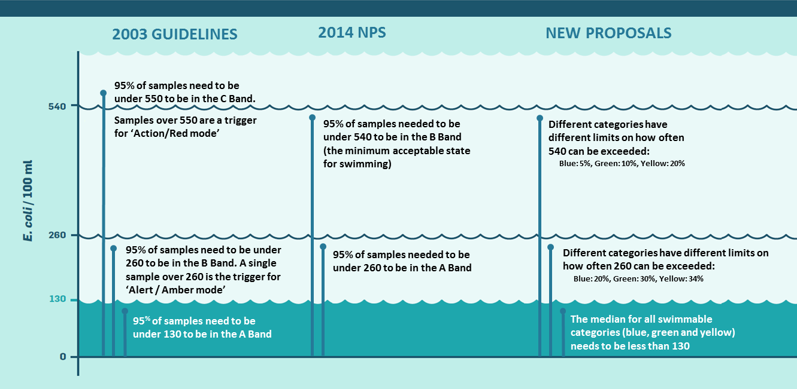
The proposals build on the 2003 recreational water quality guidelines by requiring regular monitoring and surveillance during the bathing season. The proposals:
- use 260 E. coli per 100 ml as a threshold at which to move to more rigorous monitoring and to notify the public
- use 540 E. coli per 100 ml as the threshold (the threshold in the 2003 guidelines is 550 which is close enough that the risk is approximately the same) at which water is considered unsafe for swimming
- require the public to be warned when the water exceeds acceptable levels.
The proposals build on the existing NPS provisions by:
- introducing a requirement to improve water quality in large rivers to make them suitable for swimming more often
- setting a non-statutory target setting out expectations for how much quality is expected to improve by
- using 540 E. coli as the threshold at which a river is considered no longer safe to swim, and setting categories around how often the acceptable threshold is exceeded.
Figure 2 shows a comparison of the current proposed categories and the existing NPS categories. It includes all of the bands/categories that would be considered swimmable under each regime.
Figure 2: Comparison of Campylobacter infection risk under current Freshwater NPS provisions compared to proposed Freshwater NPS provisions and targets
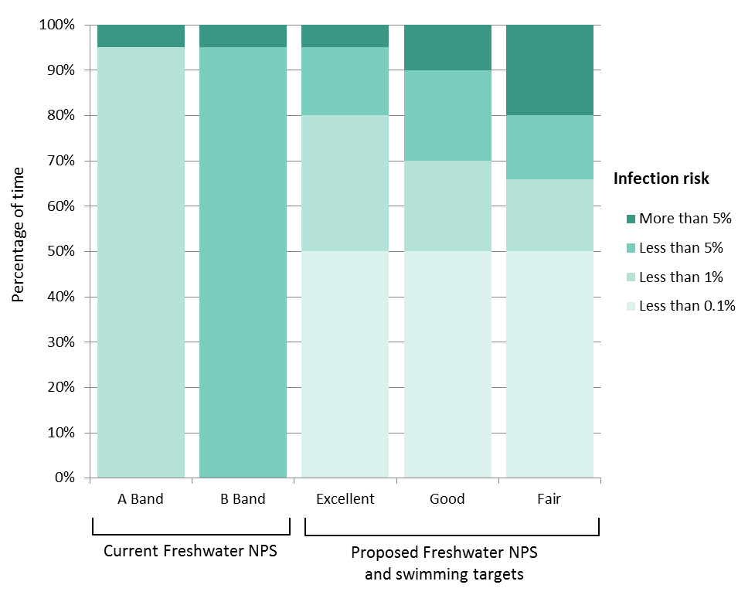
Figure 2 shows that although the new proposed categories would allow swimmable water bodies to exceed the acceptable threshold (540 E. coli per 100 ml) more often, they would also require swimmable water bodies to have a median E. coli concentration of no more than 130 per 100 ml, where the risk of infection has been predicted to be very low (at most 0.1 per cent or 1 in 1000 exposures). This means that at least 50 per cent of the time, even in rivers only graded as ‘fair’ (minimum acceptable swimming grade), there is a very low health risk to swimmers.
It means the new categories allow the water to exceed the acceptable threshold more often, but they also require the water to be very low health risk at least half of the time.
This chart describes the requirements of each category; it does not show the actual distribution of risk that is likely to exist for a river in each of those categories. For example:
- a river in the B band under the existing NPS could have a median of 130 even though it is not required to
- a river in the A band under the existing NPS may only achieve a rating of ‘intermittent’ under the new proposed categories because the median exceeds 130 E. coli per 100ml, even though it exceeds 260 less than 5 per cent of the time.

A comparison between the proposed categories and overseas regimes

Limitations of international comparisons
It is difficult to compare different E. coli categories internationally because the same E. coli concentration will have a different infection and/or illness risk in one country to another (due to the presence of different sources of E. coli contamination).
A more useful approach is to compare infection or illness risk rather than E. coli concentrations. However, different approaches to the measurement of infection and illness risk make it difficult to accurately compare across jurisdictions. For example, New Zealand uses infection risk in relation to Campylobacter, while the USA uses risk of gastro intestinal illness in general. Infection includes people who do not experience any symptoms of feeling ill, and Campylobacter is only one type of gastro intestinal infection.
Different jurisdictions also have different sampling requirements. For example the EU ratings are based on the previous four bathing seasons with at least four samples taken per season, and in the US the grade is based on approximately four samples over a 30 day sampling period. For the proposed attribute tables in the New Zealand NPS, the categories are based on 100 samples taken regularly over a maximum of 10 years.
These limitations should be noted before attempting to draw conclusions about how the New Zealand categories compare to other countries’ categories. However, for completeness the following two sections provide comparisons with the thresholds used by the European Union and the United States.

European Union
The European Union’s 2006 Bathing Water Directive has rules to safeguard human health in relation to recreation in water. It requires member states to monitor E. coli and enterococci. They classify water as excellent, good, sufficient, and poor. Table 6 summarises the thresholds for bathing waters under the EU directive.
Table 6: Comparison between proposed New Zealand swimming categories and EU categories
EU Category | Threshold | Percentile | Equivalent NZ category | Threshold | Percentile
Excellent | 500 | 95th | Excellent | 540 | 95th
Good | 1000 | 95th | Good | 1000 | 95th
 |  |  |  | 540 | 90th
Sufficient | 900 | 90th | Fair | 1200 | 95th
 |  |  |  | 540 | 80th

The categories in the EU directive are similar, but not the same as, those proposed for New Zealand:
- The requirement for the ‘excellent’ category uses the same percentile measurement, but is 500 E. coli per 100 ml in the EU and 540 E. coli per 100 ml in New Zealand. (Note: there is very little difference between these two numbers statistically).
- The ‘good’ categories require the same 95th percentile in both the EU and New Zealand.
The EU standard also allows for up to 15 per cent of samples to be discarded due to short-term pollution.

United States of America
The United States Environmental Protection Agency (USEPA) publishes Water Quality Criteria recommendations. These only have a regulatory effect if individual states choose to adopt them. The Recreational Water Quality Criteria sets out recommended E. coli concentrations to protect primary contact recreation (ie, activities like swimming that involve full immersion in water). These are shown in table 7.
Table 7: USEPA Recreational Water Quality Criteria for E. coli (summarised)
Estimated Illness Rate (NGI):  36 per 1000 primary contact recreators |  |  | Estimated Illness Rate (NGI):  32 per 1000 primary contact recreators
Geometric mean  (cfu/100 mL) | Statistical threshold value  (cfu/100 mL) | OR | Geometric mean  (cfu/100 mL) | Statistical threshold value (cfu/100 mL)
126 | 410 |  | 100 | 320
Duration and Frequency: The geometric mean should not exceed 126 or 100 in any 30-day interval. The statistical threshold value should not be exceeded more that 10% of the time in the same 30-day interval (with samples collected at least weekly).
These criteria are based on an estimated illness rate. Illness in the US means broad gastro intestinal illness (ie, whether a person presents with symptoms of being ill such as diarrhoea, vomiting, nausea and stomach ache; within 10 to 12 days after swimming).
The USEPA recommends that individual states make a risk management decision regarding illness rate to determine which set of criteria values from Table 7 to adopt into their water quality standards. There is also a choice about whether to use E. coli or enterococci in fresh water.
The USEPA grades are calculated over a 30 day period. Weekly monitoring is recommended, so the grade is generally based on the latest four measurements at a site. The grades apply to all coastal beaches and the Great Lakes, but sampling of rivers is optional.

References

McBride, G.B.; Till, D.; Ryan, T.; Ball, A. Lewis, G.; Palmer, S.; Weinstein, P. 2002. Freshwater Microbiology Research Programme. Pathogen Occurrence and Human Health Risk Assessment Analysis. Ministry for the Environment Technical Publication
Snelder T, Atalah J, Wood S. 2016. Strategic assessment of New Zealand’s freshwaters for recreational use: a human health perspective (Escherichia coli in rivers and planktonic cyanobacteria in lakes). Prepared for the Ministry for the Environment.
McBride G. 2012. Issues in setting secondary contact recreation guidelines for New Zealand freshwaters (E. Coli). Prepared for the Ministry for the Environment.

Based on analysis by Dr Jonathan Marshall of Massey University, available on github.com.
Based on analysis by Dr Graham McBride of NIWA and Jeff Solller of Soller Environmental, available on the NIWA website https://www.niwa.co.nz/
Based on analysis by the Ministry for the Environment.
This is the level of risk if people follow the category advice and avoid swimming during high flows (determined as three times normal flows) based on analysis by the Ministry for the Environment.

