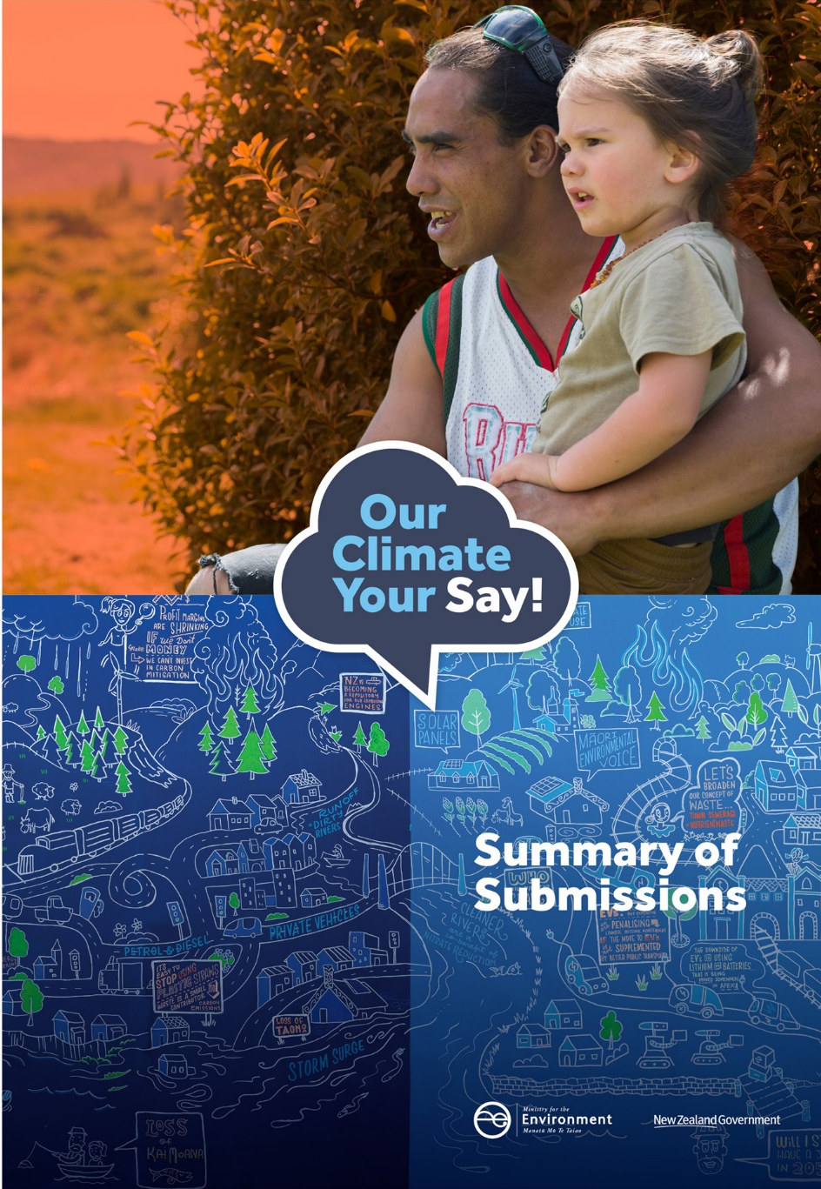

This document may be cited as: Ministry for the Environment. 2018. Zero Carbon Bill consultation: Summary of submissions. Wellington: Ministry for the Environment.

Published in October 2018 by the
Ministry for the Environment
Manatū Mō Te Taiao
PO Box 10362, Wellington 6143, New Zealand
ISBN: 978-1-98-852590-7 (online)
Publication number: ME 1386
© Crown copyright New Zealand 2018
This document is available on the Ministry for the Environment website: www.mfe.govt.nz.

Contents
Foreword 6
Introduction 8
Purpose of the Zero Carbon Bill 8
Submissions analysis and next steps 8
What we did – consultation process 10
Working with iwi/Māori 10
Consultation events 11
What we heard – responses by policy area 14
Written submissions 14
2050 target 15
Emissions budgets 22
Government response 27
Climate Change Commission 28
Adapting to the impacts of climate change 32

Tables
Table 1: Key submitter groups (long submissions) 15

Figures
Figure 1: Long submission types 14
Figure 2: What process should the Government use to set a new emissions reduction target in legislation? Long submissions’ positions by submitter group 16
Figure 3: If the Government sets a 2050 target now, which is the best target for Aotearoa New Zealand? Long submissions’ positions 17
Figure 4: If the Government sets a 2050 target now, which is the best target for Aotearoa New Zealand? Unique submissions’ positions 17
Figure 5: If the Government sets a 2050 target now, which is the best target for Aotearoa New Zealand? Short submissions’ (online form) positions 18
Figure 6: If the Government sets a 2050 target now, which is the best target for Aotearoa New Zealand? Public consultation positions 18
Figure 7: If the Government sets a 2050 target now, which is the best target for Aotearoa New Zealand? Long submissions’ positions by submitter group 19
Figure 8: 2050 target preferences by industry sector (long submissions) 19
Figure 9: How should Aotearoa New Zealand meet its targets? Long submissions’ positions by submitter group 21
Figure 10: Should the Zero Carbon Bill allow the 2050 target to be revised if circumstances change? Long submissions’ positions by submitter group 22
Figure 11: Should the Government be able to alter the last emissions budget (ie, furthest into the future)? Long submissions’ positions 23
Figure 12: Should the Government be able to alter the last emissions budget (ie, furthest into the future)? Unique submissions’ positions 24
Figure 13: Should the Government have the ability to review and adjust the second emissions budget within a specific range under exceptional circumstances? Long submissions’ positions 24
Figure 14: Should the Government have the ability to review and adjust the second emissions budget within a specific range under exceptional circumstances? Unique submissions’ positions 25
Figure 15: Should the Government have the ability to review and adjust the second emissions budget within a specific range under exceptional circumstances? Long submissions’ positions by submitter group 26
Figure 16: The Government has proposed that the Climate Change Commission advises on and monitors Aotearoa New Zealand’s progress towards its goals. Do you agree with these functions? Long submissions’ positions 28
Figure 17: The Government has proposed that the Climate Change Commission advises on and monitors Aotearoa New Zealand’s progress towards its goals. Do you agree with these functions? Short submissions’ positions 29
Figure 18: The Government has proposed that the Climate Change Commission advises on and monitors Aotearoa New Zealand’s progress towards its goals. Do you agree with these functions? Public consultation positions 29
Figure 19: What role do you think the Climate Change Commission should have in relation to the New Zealand Emissions Trading Scheme (NZ ETS)? Long submissions’ positions by submitter group 30
Figure 20: Do you think that the Zero Carbon Bill should cover adapting to climate change? Long submissions’ positions 32
Figure 21: Do you think that the Zero Carbon Bill should cover adapting to climate change? Short submissions’ positions 33
Figure 22: Do you think that the Zero Carbon Bill should cover adapting to climate change? Public consultation positions 33
Figure 23: Do you think that the Zero Carbon Bill should cover adapting to climate change? Long submissions’ positions by submitter group 34

Foreword
When we set out to talk to New Zealanders about the path to a low emissions economy, we wanted to go far and wide and cover all sectors of society. After all, we are all affected by the consequences of climate change.
What we got was more than 15,000 people and organisations having their say on the Government’s proposed Zero Carbon Bill. The 15,009 submissions we received have been publicly released along with this document which is a summary of themes that came through.
The consultation attracted many people along to public town-hall style meetings throughout the country, where the Minister for Climate Change and Ministry officials presented the policy options. We worked with iwi and other Māori groups, held workshops with agriculture and industry and events to engage young people.
Many views were expressed, from every part of society. We had submissions from businesses in New Zealand, churches, iwi, other Māori groups and organisations, community organisations and young people.
While the majority of submissions were written, people made videos, created art and even wrote poems to express how they felt about the direction we need to take.

What did people say?
Key themes of long submissions on the Zero Carbon Bill included:
- 91 per cent of respondents said they wanted a target of net zero emissions across all greenhouse gases by 2050 set in legislation now
- 96 per cent of respondents supported the establishment of a Climate Change Commission with an advisory role to Government
- 92 per cent of respondents thought the Bill should include provisions to help New Zealand adapt to the effects of climate change.
New Zealanders also want certainty about how we will respond to climate change as a country, so that business and government can invest and make effective decisions about how the transition to a low emissions economy will occur.
Many submitters also supported the concept of a ‘just transition’ that’s fair and inclusive and that governments, current and future, must support those most affected by change.
The voices of young New Zealanders, who will be living through the impacts of our decisions by 2050, were particularly strong.

What happens now?
This consultation was one part of a base of evidence that will be used to draft the Bill. The content of the submissions we received is being carefully considered by Ministers as part of putting together the proposed law and the most appropriate target. Ministers are also considering recent reports on the transition to a low emissions economy from the Parliamentary Commissioner for the Environment and the Productivity Commission, along with economic modelling, the latest science and other relevant reports.
It’s important for people to know that the conversation on the path to a low emissions economy continues. People will have a chance to put forward their views on that as part of the Select Committee process early next year after the Zero Carbon Bill is introduced in Parliament.
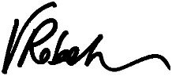
Vicky Robertson
October 2018

Introduction

Purpose of the Zero Carbon Bill
The Zero Carbon Bill (the Bill) aims to set Aotearoa New Zealand’s long-term commitment to transition us to a low emissions, climate-resilient economy. In 2015, almost every nation decided to take action together to address climate change by adopting the Paris Agreement, which commits us to increasingly ambitious targets over time. Taking a fresh look at our 2050 target will bring us further in line with the Paris Agreement.
The Bill proposes to put in place the core building blocks to give certainty to New Zealanders that there will be a long-term approach to climate change, irrespective of what government is in power. The Bill aims to set a greenhouse gas emissions reduction target into legislation and establish a new institutional framework to achieve these commitments.
Key to this new framework will be the creation of an independent Climate Change Commission (the Commission), which is proposed to support the Government in meeting its commitments to become a low emissions economy by 2050.
The Government has committed to achieving the following objectives when making decisions on the contents of the Bill:
- leadership at home and internationally
- a productive, sustainable and climate-resilient economy
- a just and inclusive society.
The Bill aims to provide clear direction for and certainty about Aotearoa New Zealand’s long-term climate change goals so that all New Zealanders, including tangata whenua, businesses, local and central government and communities can take action to protect our environment now and for future generations.
The Bill is likely to draw from the United Kingdom’s Climate Change Act 2008 to some degree; in legislating for emissions reduction targets and the roles of the government and an independent Climate Change Commission. However, the proposed Bill will need to take into consideration Aotearoa New Zealand’s unique emissions profile, as well as the characteristics, governance and collective ownership of Māori land, Māori aspirations, cultural values and rights under the Treaty of Waitangi.
The proposed Bill may also include provisions to help Aotearoa New Zealand adapt to our changing climate, as this will impact all New Zealanders.

Submissions analysis and next steps
This document summarises the feedback the Ministry for the Environment (the Ministry) received from the consultation phase on the elements proposed for inclusion in the Bill. The Ministry consulted on the Bill in June and July 2018.
The Ministry will use the submissions received during consultation as part of evidence to inform its advice on the Bill. Other evidence such as that produced by the Parliamentary Commissioner for the Environment and the Productivity Commission’s recent report on Aotearoa New Zealand’s low emissions economy will also inform the Ministry’s work on the Bill, along with science and economic data and modelling.
The draft Bill will also be subject to a Select Committee process planned for early next year, following its introduction to Parliament.

What we did – consultation process
The Ministry consulted on the Bill between 7 June and 19 July 2018. A consultation document, Our Climate Your Say: Consultation on the Zero Carbon Bill, presented the context and purpose of the Bill, and explained a set of proposals on:
- Aotearoa New Zealand’s greenhouse gas emissions reduction target to 2050
- processes to set and review emissions budgets
- the establishment of the Commission, including considerations on its expertise and its role in the New Zealand Emissions Trading Scheme (NZ ETS)
- how the Government will respond to the Commission
- whether the Bill should cover adaptation to the impacts of climate change.
The consultation document invited people to respond to 16 different questions. For the full discussion document in electronic format, go to the Ministry’s website.
To ensure as many New Zealanders as possible could take part in the climate change discussion, the Ministry also held many consultation events throughout the country in June and July 2018. These included public meetings, workshops with iwi/Māori, workshops with key stakeholders, youth engagement events and a significant audience online through our online events and social media campaign.
People had the opportunity to engage with the consultation by responding to a short online questionnaire, which focused on the 2050 target, the role of the Commission and making adaptation part of the Bill.
Thousands of people took part in and viewed an online public meeting, and the Ministry’s Facebook posts reached over 725,000 people during the consultation period. The policy team has considered all these interactions as part of the consultation process.

Working with iwi/Māori
Understanding Māori interests in climate change mitigation and adaptation are key to developing an effective Bill and a just transition.
We worked with iwi/Māori organisations before and during the consultation to ensure that iwi/Māori had the time and capability to respond to the consultations.
The Te Arawa Lakes Trust coordinated a hui in Rotorua with members of the Te Arawa Climate Group, and specific hui were held with the Federation of Māori Authorities (FOMA) and Te Rūnanga o Ngāi Tahu.
The 16 public meetings we held were open to everyone, and iwi groups were given advance notice of when they were happening in their area, where practicable. The public meeting in Manakau was co-hosted with Te Puni Kōkiri, and invitations were distributed through their local networks.
The Ministry had a focus on iwi media during the consultation to promote the consultation and public meetings. The Ministry worked with many radio stations and invited Māori TV to several events which resulted in a broadcast of many stories.

Consultation events

Public meetings
Sixteen public meetings were held in:

- Whangarei
- Auckland
- Manukau
- Hamilton
- Tauranga
- Rotorua
- Gisborne
- New Plymouth
- Hawke’s Bay
- Palmerston North
- Wellington
- Nelson
- Greymouth
- Christchurch
- Dunedin
- Invercargill.

These meetings were two hours long and were generally held in the evening so more people could attend. We provided an open forum for questions and comments after a presentation on the proposals. For the ‘local voice’ segment, we invited a representative from that region to discuss what climate change impacts were seen locally and what action was already happening in communities. These representatives were generally local councillors or representatives from councils.
Typical attendance at these meetings was between 60 and 120 people, with more attending in the main centres. For example, Wellington had approximately 220 attendees and Christchurch 160, while Auckland and Dunedin drew around 120 attendees. The Rotorua event had the fewest attendees (approximately 30 people).

Workshops
The Ministry hosted a series of day-long workshops in Auckland, Wellington and Christchurch during the consultation period. Ministry officials presented on the proposals in detail to representatives from many sectors, including energy, transport, agriculture, non-government organisations (NGOs), local government and research groups. We also had representation from iwi/Māori.
The workshops were split into sections that covered the key components of the Bill:
- 2050 targets and economic modelling
- emissions budgets
- the Commission
- adaptation.
After each section, attendees had the opportunity to ask questions about the proposals. Attendance varied from approximately 50 attending the Wellington workshop to 30 in Auckland and 23 in Christchurch.
Organisations represented at these workshops were Westpac, Sustainable Business Council, Genesis Energy, Methanex, Sir Peter Blake Trust, Tower Insurance, New Zealand Defence Force, Royal Society, Auckland District Health Board, Auckland Airport, Auckland University of Technology, Deloitte, Generation Zero, Ernst & Young, Vector, Energy Efficiency and Conservation Authority, Graymont, Air New Zealand, Sustainable Business Network, WWF, NZ Post, Meridian Energy, Trustpower, Contact Energy, Insurance Council of New Zealand, PEPANZ, Pacific Aluminium, Flick Electric, NZ Oil and Gas, AECOM, Business NZ, Local Government NZ, ASB, Gas Industry Ltd, Nova Energy, Transpower, Enviromark, Energy Management Association of New Zealand, Balance, Straterra, Dairy NZ, NZ Pork, Ravensdown, Ngāi Tahu Forestry, Akina, Christchurch City Council, Ngāi Tahu, Selwyn District Council, and Blinc Innovation.

DairyNZ workshops
The Dairy Action for Climate Change 2017–2018 (DACC) is led by DairyNZ, in partnership with Fonterra, with the support of the Ministry for Primary Industries (MPI) and the Ministry for the Environment. DACC aims to address on-farm dairy greenhouse gas emissions in the context of a profitable and sustainable dairy industry.
DACC conducted eight farmer-focused, climate change workshops around the country in June 2018 to build awareness and provide information on the mitigation options available. These workshops provided an opportunity for the Ministry to present on the 2050 greenhouse gas emissions reduction target and the Zero Carbon Act.
The objectives of these workshops were to raise awareness among dairy farmers and the wider industry of the challenge climate change poses to the dairy industry, the need to address biological emissions over the long term, the research under way and the actions that can be undertaken now.
In total, around 330 participants (mostly farm owners) attended these workshops.

Workshops hosted by others
Several organisations also hosted their own events directly related to the consultation. These included BusinessNZ, Enviro-Mark and NGOs such as Forest & Bird, WWF New Zealand and World Vision NZ.

Youth engagement events
Younger generations will be dealing with climate change and its effects throughout their lifetimes. Many organisations campaigning on climate issues, such as Generation Zero and Climate Challenge, are led by young people. The Ministry ensured this consultation had a particular focus on engaging with youth, both by taking a wide-ranging social media approach and by running four youth engagement events during the consultation period.
These events, which together covered age groups from 13 to 30 years, involved the Wellington Youth Council, Sir Peter Blake Trust (SPBT), Victoria University of Wellington Students’ Association and Climate Challenge. The SPBT and Climate Challenge events acted as workshops, where students engaged with the Government officials to discuss climate change problems, identify barriers and potential solutions, and consider options for the 2050 target.

What we heard – responses by policy area

Written submissions

Number and types of submissions
The Ministry received a total of 15,009 submissions, including:
- 12,444 long submissions
- 2161 short submissions
- 404 consultation forms.
Of the 12,444 long submissions received, just under 3000 (24 per cent) were unique (ie, submissions that did not follow a specified template). The remaining were ‘pro-forma’ submissions that individuals completed based on template submissions from Greenpeace, Generation Zero and other organisations (see figure 1).
All submissions received have been analysed and given equal weight in the analysis presented below.
Figure 1: Long submission types
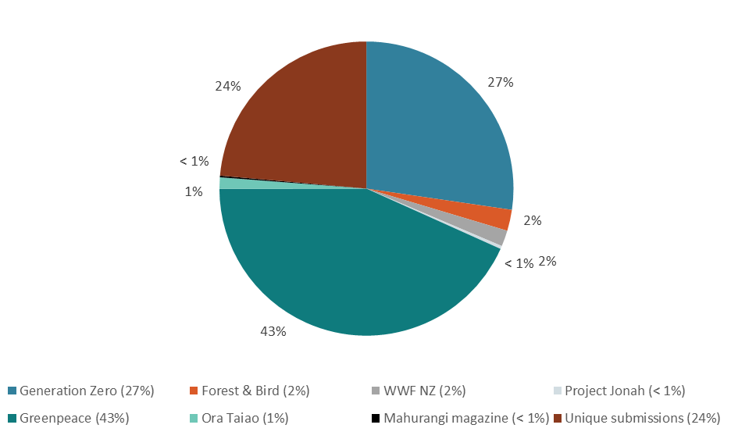
Some groups, such as the Anglican Diocese of Wellington, and the Climate Challenge Programme, prepared visual submissions to express their thoughts on the Bill. These submissions were converted into a written format and treated as long submissions in their own right.

Submitter groups
Submissions to the Bill consultation were divided into the key groups identified in table 1 (in order from the highest to the lowest number of long submissions received).
Table 1: Key submitter groups (long submissions)
Submitter group | Number of long submissions
Individual | 11,836
Business/industry | 314
Non-government organisation (NGO) | 65
School | 49
Community group | 47
Local government | 38
Unspecified/other | 28
Iwi/Māori | 26
University | 25
Research institute | 14
Government advisory body | 2
This summary includes figures with data broken down by submitter group (eg, figure 2). The data used in those figures covers all long submissions, including pro-forma submissions.
Note, almost all of the pro-forma submissions were completed by individuals.

2050 target

Q1. What process should the Government use to set a new emissions reduction target in legislation?
Respondents were invited to pick one of the two proposed processes:
- the Government sets a 2050 target in legislation now
- the Government sets a goal to reach net zero emissions by the second half of the century, and the Climate Change Commission advises on the specific target for the Government to set later.
Out of the 9282 responses to this question, 8403 submissions (91 per cent) said the Government should set a 2050 target in legislation now. Another 605 submissions (6 per cent) said the Government should set a goal to reach net zero emissions by the second half of the century and that the Commission should advise on the specific target for the Government to set later. The remaining 274 (3 per cent) were unsure or had a different opinion (eg, target should be 2040).
Looking at unique submissions only, the support for a target to be set now still remains high: out of the 2600 unique submissions that answered this question, 1727 were in favour of setting a target in legislation now (67 per cent) and 604 (23 per cent) preferred the second option. The other 269 (10 per cent) unique submissions were unsure or had a different opinion.
Figure 2 presents a breakdown of responses to this question by submitter group.

Figure 2: What process should the Government use to set a new emissions reduction target in legislation? Long submissions’ positions by submitter group
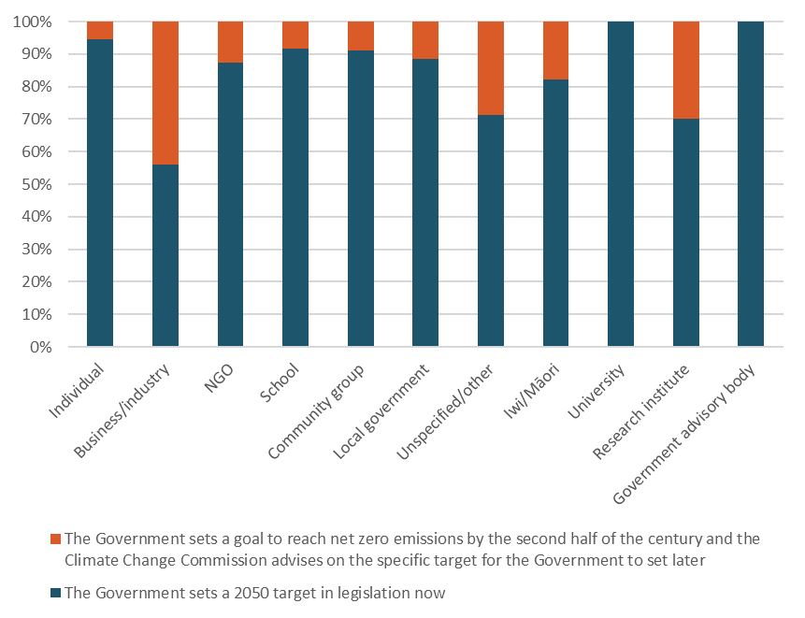

Q2. If the Government sets a 2050 target now, which is the best target for Aotearoa New Zealand?
Respondents were invited to pick one of three proposed targets:
- target 1: net zero carbon dioxide – reducing net carbon dioxide emissions to zero by 2050
- target 2: net zero long-lived gases and stabilised short-lived gases; long-lived gases to net zero by 2050, while also stabilising short-lived gases
- target 3: net zero emissions – net zero emissions across all greenhouse gases by 2050.
Of the three proposed targets, the majority of submissions were in favour of Aotearoa New Zealand setting a target of net zero emissions across all greenhouse gases.
Out of 12,154 responses to this question:
- 11,011 submissions (91 per cent) said the best target was net zero emissions across all greenhouse gases by 2050
- 587 submissions (5 per cent) said the best target was net zero long-lived gases and stabilised short-lived gases by 2050
- 282 submissions (2 per cent) said that the best target for Aotearoa New Zealand was net zero carbon dioxide by 2050
- 61 submissions (under 1 per cent) said Aotearoa New Zealand shouldn’t have a new target
- 213 submissions (2 per cent) had a different opinion or were unsure (see figure 3).
Figure 3: If the Government sets a 2050 target now, which is the best target for Aotearoa New Zealand? Long submissions’ positions
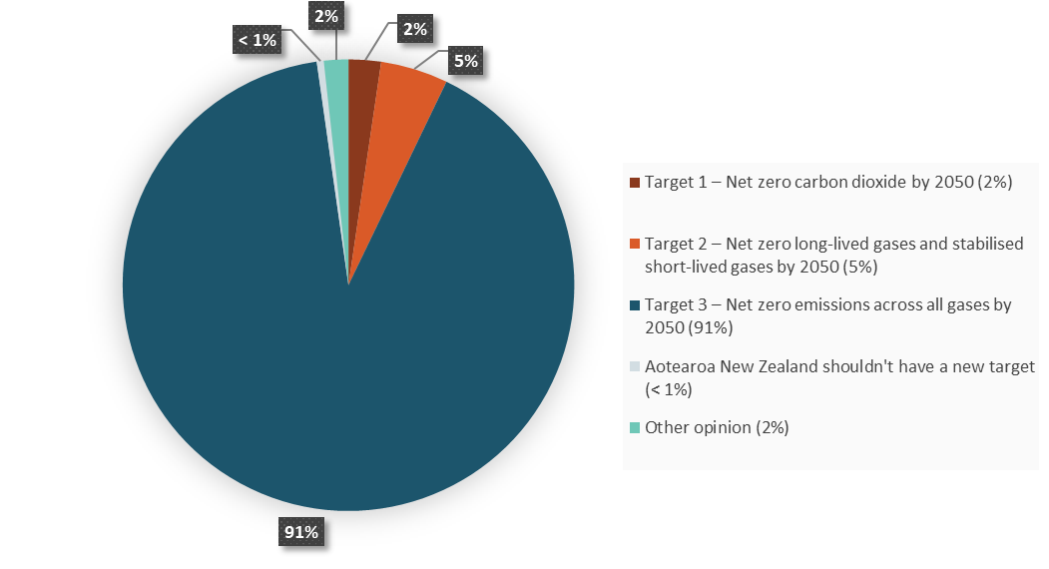
An analysis of the unique submissions (ie, excluding pro-forma submissions) shows a slightly different breakdown of preferences (with about 58 per cent support for proposed target 3, 22 per cent support for proposed target 2, 10 per cent support for proposed target 1) (see figure 4).
Figure 4: If the Government sets a 2050 target now, which is the best target for Aotearoa New Zealand? Unique submissions’ positions
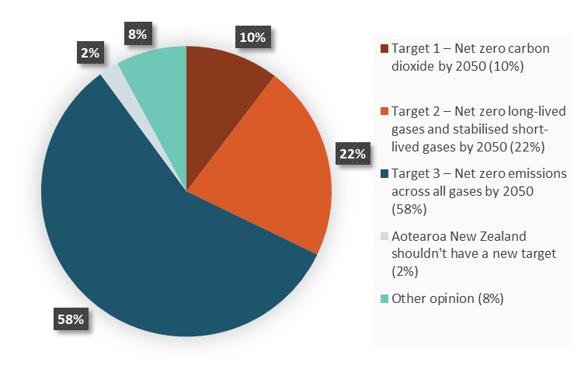
The majority of unique submissions favoured the third proposed target of net zero emissions across all greenhouse gases by 2050, followed by proposed target 2 (net zero long-lived gases and stabilised short-lived gases) and finally proposed target 1 (net zero carbon dioxide).
Responses from short submissions and public meeting submissions show a similar trend (see figures 5 and 6).
Figure 5: If the Government sets a 2050 target now, which is the best target for Aotearoa New Zealand? Short submissions’ (online form) positions
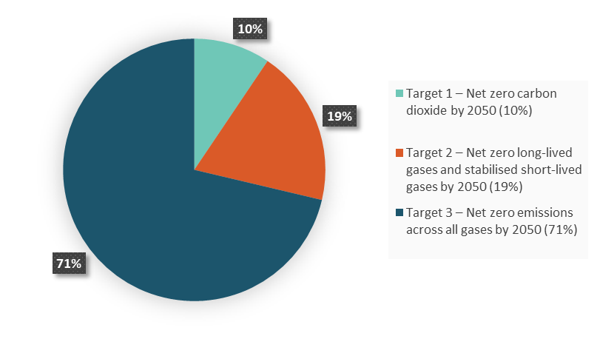
Figure 6: If the Government sets a 2050 target now, which is the best target for Aotearoa New Zealand? Public consultation positions
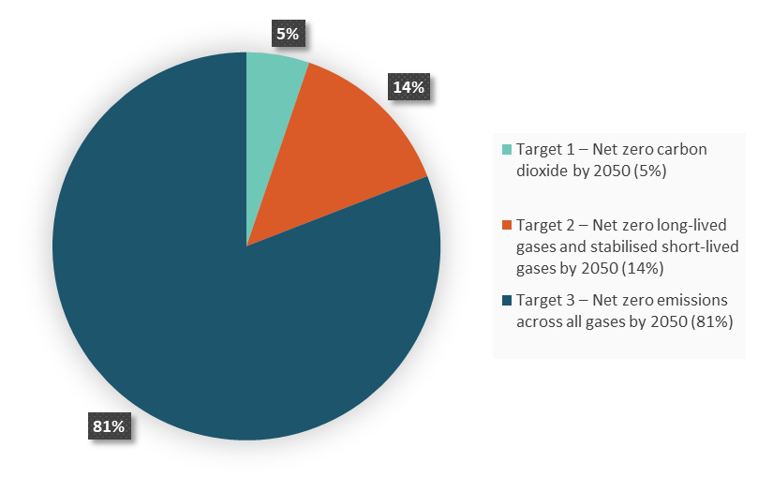
The submitter groups who were in favour of net zero emissions across all gases by 2050 included NGOs, individuals, schools, universities, research institutes and community groups.
The business/industry, local government and central government advisory body submitter groups were more divided about what target Aotearoa New Zealand should set (see figures 7 and 8).
Figure 7: If the Government sets a 2050 target now, which is the best target for Aotearoa New Zealand? Long submissions’ positions by submitter group
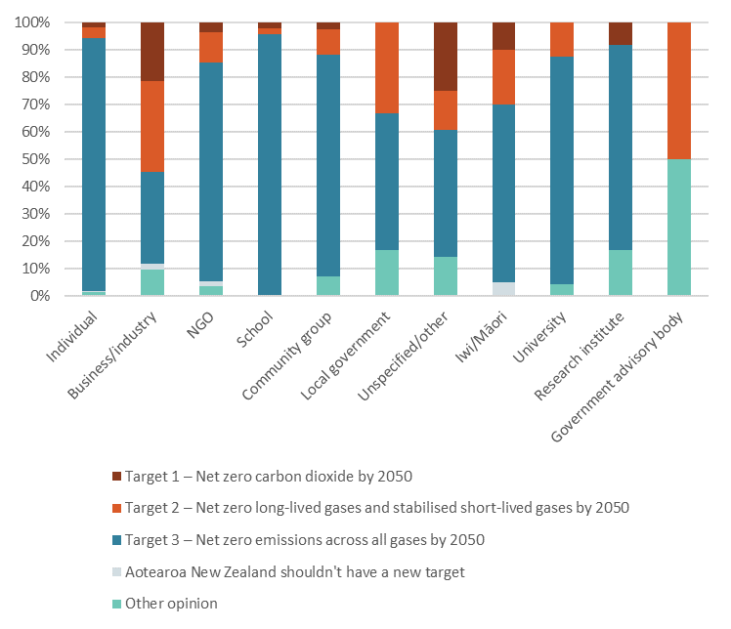
Figure 8: 2050 target preferences by industry sector (long submissions)
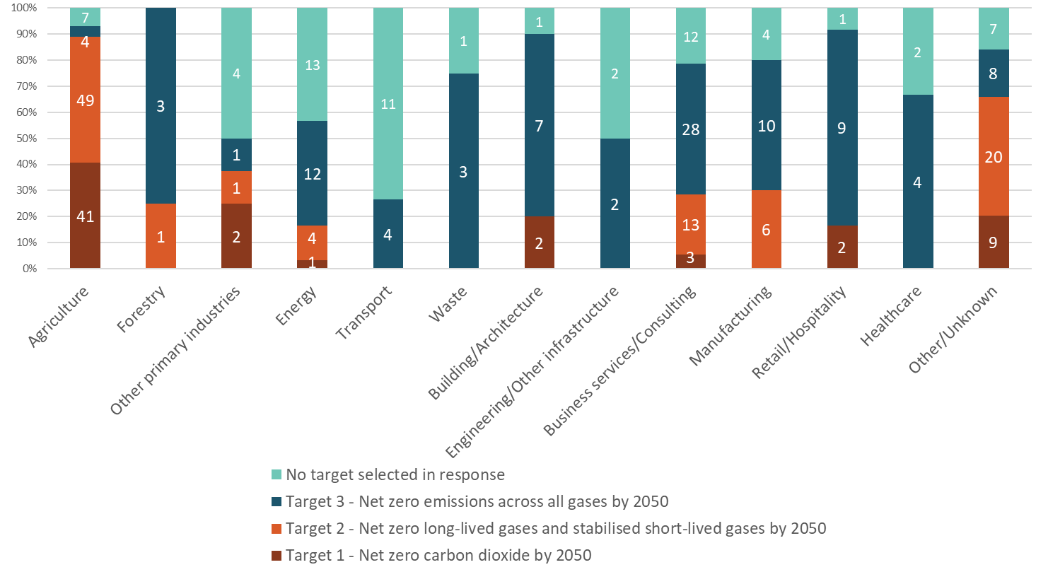
Note that the numbers in the stacked bar chart in figure 8 represent the number of submissions, not percentages.

Q3. How should Aotearoa New Zealand meet its targets?
Respondents were invited to pick one of the two proposed ways of meeting emissions targets:
- option 1: domestic emissions reductions only (including from new forest planting)
- option 2: domestic emissions reductions (including from new forest planting) and using some emissions reductions from overseas (international carbon units) that have strong environmental safeguards.
Most submissions preferred that Aotearoa New Zealand meet its emissions reduction targets through domestic actions.
Out of 11,605 responses to this question, 10,525 submissions (91 per cent) said Aotearoa New Zealand should meet its targets by domestic emissions reductions only (including from new forest planting). Another 799 submissions (7 per cent) preferred the option of using both domestic emissions reductions (including from new forest planting) and some emissions reductions from overseas (international carbon units) that have strong environmental safeguards. The remaining 281 submissions (2 per cent) had a different opinion or were unsure.
An analysis of unique submissions only showed that the majority of respondents (60 per cent, or 1495 unique submissions) still favoured the use of domestic emissions reductions only, followed by 32 per cent (796 unique submissions) in favour of using some emissions reduction from overseas as well, and 8 per cent (203 unique submissions) unsure or with a different opinion.
Figure 9 shows that while most individuals favoured domestic emissions only, local government, business/industry and research institutes were the groups most divided over this question.
Figure 9: How should Aotearoa New Zealand meet its targets? Long submissions’ positions by submitter group
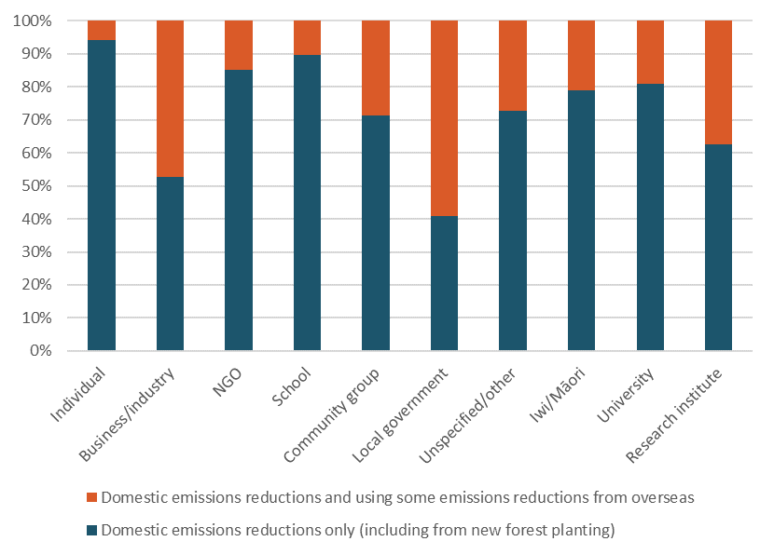

Q4. Should the Zero Carbon Bill allow the 2050 target to be revised if circumstances change?
While submissions broadly agreed Aotearoa New Zealand’s target could be revised under exceptional circumstances, they were divided on the direction of this revision. Business submissions were in favour of a more flexible target, while other submitter groups thought the target should not be allowed to be less ambitious due to the seriousness of the climate change issue.
Out of the 3472 responses to this question, 2501 submissions (72 per cent) agreed the Bill should allow the 2050 target to be revised if circumstances change. Another 851 (25 per cent) disagreed and 120 (3 per cent) had a different opinion or were unsure.
Across submitter groups (see figure 10), business/industry, government advisory bodies, research institutes and school respondents were largely in support of this proposal, while universities, community groups and iwi/Māori respondents were the most divided.
Figure 10: Should the Zero Carbon Bill allow the 2050 target to be revised if circumstances change? Long submissions’ positions by submitter group
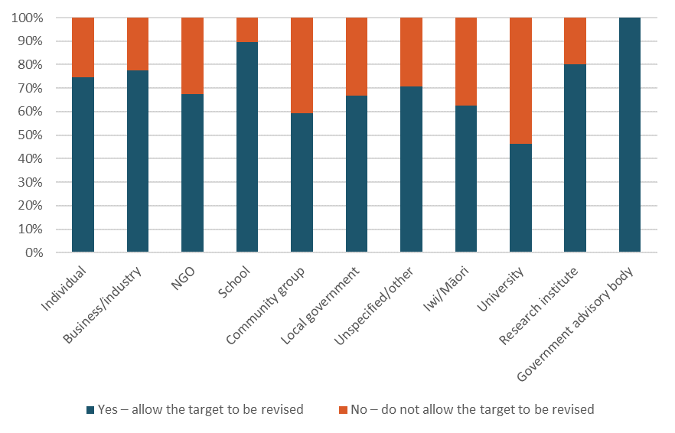

Emissions budgets

Q5. The Government proposes that three emissions budgets of five years each (ie, covering the next 15 years) be in place at any given time. Do you agree with this proposal?
In response to the proposal to have three emissions budgets of five years each in place at any given time, most submissions that agreed with the proposal, agreed with it on the basis that it should provide enough socio-economic certainty. They also felt that the emissions budgets should be set outside of Aotearoa New Zealand’s election cycle.
Out of the 8394 responses to this question, 2867 (34 per cent) agreed with the proposal to set three five-year budgets at any given time and 336 (4 per cent) disagreed. The other 5191 (62 per cent) had a different opinion or were unsure.
Looking only at the unique submissions that provided an answer to this question, the level of agreement with the proposal was much higher. In all, 1983 unique submissions (83 per cent) were in favour of the three five-year emissions budgets, 335 (14 per cent) were against and 86 (4 per cent) were unsure or held a different opinion.

Q6. Should the Government be able to alter the last emissions budget (ie, furthest into the future)?
Respondents were invited to pick one of three proposed options:
- yes, each incoming Government should have the option to review the third budget in the sequence
- yes, the third emissions budget should be able to be changed, but only when the subsequent budget is set
- no, emissions budgets should not be able to be changed.
Many submissions were concerned that allowing the second and third emissions budgets to be altered would make them susceptible to political influence and create uncertainty. For this reason, approximately half of the submissions disagreed with the proposal. The other half supported changes to the third budget.
Out of the 3369 responses to this question, 1577 (47 per cent) said emissions budgets should not be able to be changed (see figure 11). Another 858 (25 per cent) said the third emissions budget should be able to be changed but only when the subsequent budget is set, while 745 (22 per cent) said each incoming Government should have the option of reviewing the third budget in the sequence. The remaining 189 (6 per cent) had a different opinion or were unsure.
Figure 11: Should the Government be able to alter the last emissions budget (ie, furthest into the future)? Long submissions’ positions
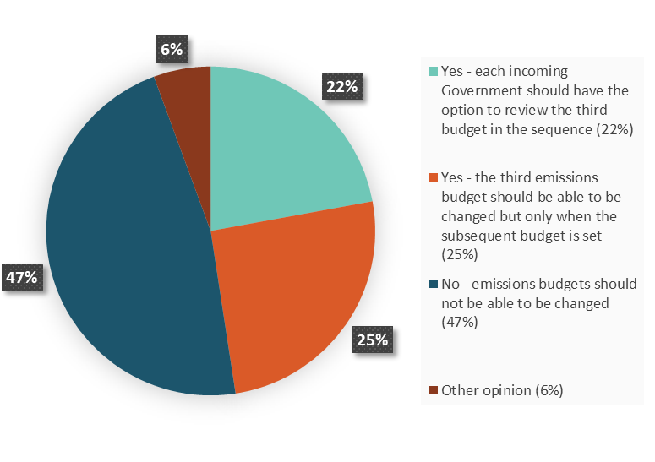
Views from unique submissions only were more evenly spread across the three options (see figure 12).

Figure 12: Should the Government be able to alter the last emissions budget (ie, furthest into the future)? Unique submissions’ positions
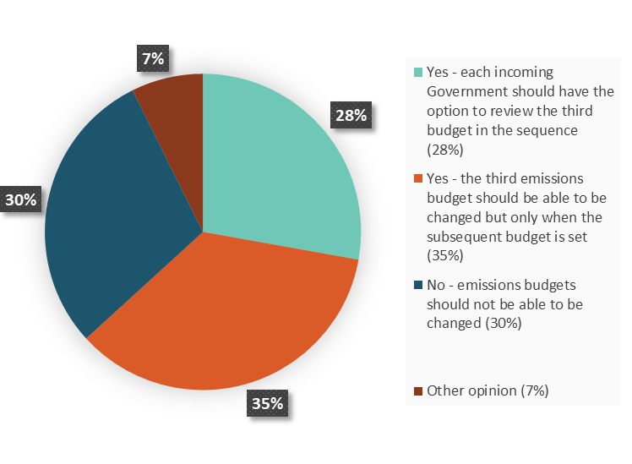

Q7. Should the Government have the ability to review and adjust the second emissions budget within a specific range under exceptional circumstances?
Out of the 3336 responses to this question, 1624 (49 per cent) disagreed with the proposal to let the Government have the ability to review and adjust the second emissions budget under exception circumstances, and 1573 (47 per cent) agreed with the proposal (see figure 13). The remaining 139 (4 per cent) had a different opinion or were unsure.
Figure 13: Should the Government have the ability to review and adjust the second emissions budget within a specific range under exceptional circumstances? Long submissions’ positions
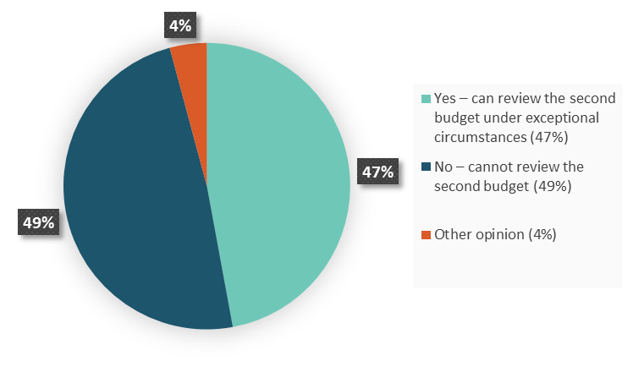
Looking at unique submissions only, over half agreed with the proposal (1411 or 61 per cent of the unique submissions that responded to this question, compared with 764 or 33 per cent against and 139 or 6 per cent unsure)(see figure 14).
Figure 14: Should the Government have the ability to review and adjust the second emissions budget within a specific range under exceptional circumstances? Unique submissions’ positions
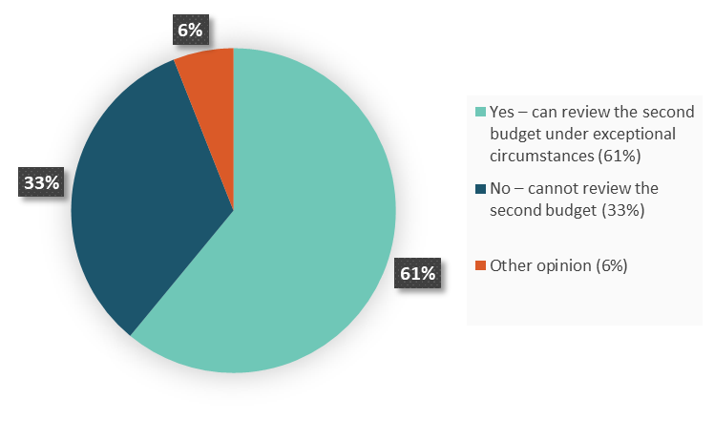
Just under half of all submissions commented that adjustment of the second budget should not be considered in any circumstances. NGOs, individuals, researchers and government advisory bodies were more strongly represented in this group. A strong theme throughout these submissions was the concern that the power to adjust the budget would open it up to political influence, with the potential to undermine the purpose of the long-term target.
Among the long submissions agreeing with this proposal, the strongest support came from the iwi/Māori, local government, business/industry and university submitter groups (see figure 15).
Figure 15: Should the Government have the ability to review and adjust the second emissions budget within a specific range under exceptional circumstances? Long submissions’ positions by submitter group
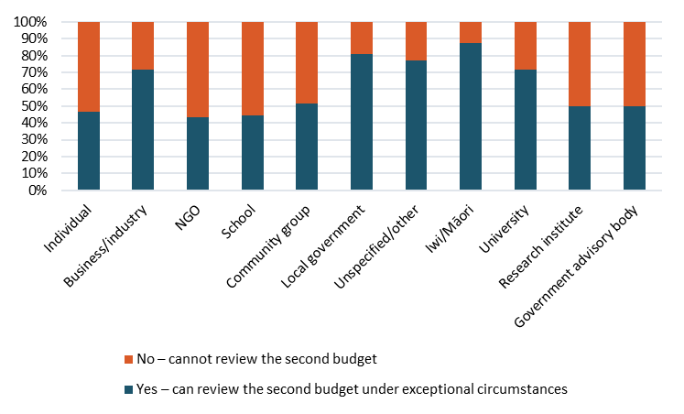

Q8. Do you agree with the considerations we propose that the Government and the Climate Change Commission take into account when advising on and setting budgets?
The proposed considerations included factors the UK Climate Change Committee takes into account when undertaking its work:
- scientific knowledge about climate change
- technology relevant to climate change
- economic circumstances and, in particular, the likely impact of the decision on the economy and the competitiveness of particular sectors of the economy
- fiscal circumstances and, in particular, the likely impact of the decision on taxation, public spending and public borrowing
- social circumstances and, in particular, the likely impact of the decision on fuel poverty
- energy policy and, in particular, the likely impact of the decision on energy supplies and the carbon and energy intensity of the economy.
Also proposed was that the Commission could consider the three government objectives for climate change policy: sustainable economy, global and local leadership and creating a just and inclusive society.
Out of the 3098 responses to this question, 2475 submissions (80 per cent) agreed with the proposed considerations that the Government and Commission should have to take into account when advising on and setting budgets. Another 319 submissions (10 per cent) disagreed with the proposed considerations and 304 (10 per cent) did not specify whether they were in favour or against.
Many submitters advised other considerations to take into account when setting budgets.

Government response

Q9. Should the Zero Carbon Bill require Governments to set out plans within a certain timeframe to achieve the emissions budgets?
Out of the 3320 responses to this question, 3037 submissions (92 per cent) agreed that the Bill should require Governments to set out plans to achieve emissions budgets. Another 227 submissions (7 per cent) disagreed with the proposal and 56 (2 per cent) did not specify whether they were in favour or against.
Three key messages consistently came through in the majority of submissions.
- Timeframes and plans were needed for transparency.
- They were needed to provide businesses with certainty and encourage informed investment decisions.
- Aotearoa New Zealand needs to learn from the United Kingdom situation, where the UK Climate Change Act did not set clear timeframes and failed to ensure detailed plans were set.
Very few submissions disagreed with the proposal. Where they did so, it was mainly for the reason that they did not believe climate change exists and thought that a Bill should not be established. Some commented they would prefer the Commission to be responsible for setting the timeframes to set out plans rather than the Government.

Q10. What are the most important issues for the Government to consider in setting plans to meet budgets? For example, who do we need to work with, what else needs to be considered?
The 2138 submissions responding to this question proposed a range of considerations.
The most common theme across all submitter groups was that it was critical to have consultation, engagement and collaboration with communities, businesses, local government, tangata whenua and also with researchers for their scientific expertise.
Māori engagement and the Government’s obligations under Te Tiriti o Waitangi were also consistently mentioned across all submitter groups, not just in iwi/Māori submissions.
Having sustainable, transparent, socially fair and cost-effective plans was seen as important by a substantial number of submissions across the different representative groups.
Two other key considerations common across many submitter groups were:
- the social impacts on vulnerable groups
- how local and central government will work together and how to strengthen the capability of local government agencies.

Climate Change Commission

Q11. The Government has proposed that the Climate Change Commission advises on and monitors New Zealand’s progress towards its goals. Do you agree with these functions?
The majority of submissions recommended the Commission should have an advisory role, on the basis that it should be politically independent and the democratically elected Government should make decisions. Many submissions, however, highlighted the importance of having mechanisms to hold the Government to account.
Out of the 11,884 responses to this question, 11,453 submissions (96 per cent) agreed with the proposed advisory and monitoring functions for the Commission (see figure 16). Another 268 submissions (2 per cent) disagreed with the proposal and 163 (1 per cent) did not specify whether they were in favour or against.
Figure 16: The Government has proposed that the Climate Change Commission advises on and monitors Aotearoa New Zealand’s progress towards its goals. Do you agree with these functions? Long submissions’ positions
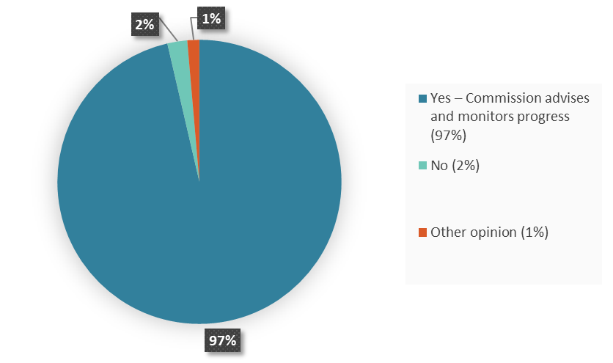
Figures 17 and 18 present the responses on this question from the short submissions and public consultations.
Figure 17: The Government has proposed that the Climate Change Commission advises on and monitors Aotearoa New Zealand’s progress towards its goals. Do you agree with these functions? Short submissions’ positions
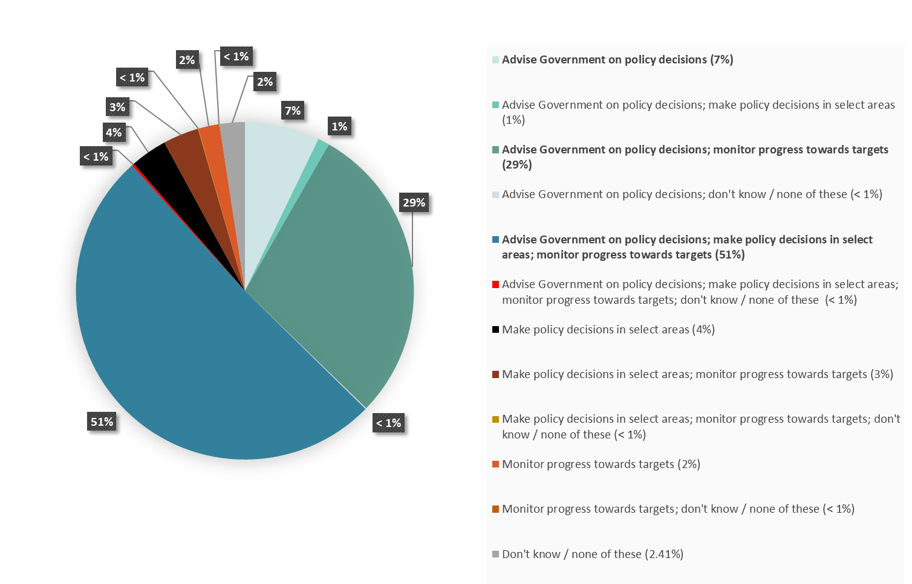
Figure 18: The Government has proposed that the Climate Change Commission advises on and monitors Aotearoa New Zealand’s progress towards its goals. Do you agree with these functions? Public consultation positions
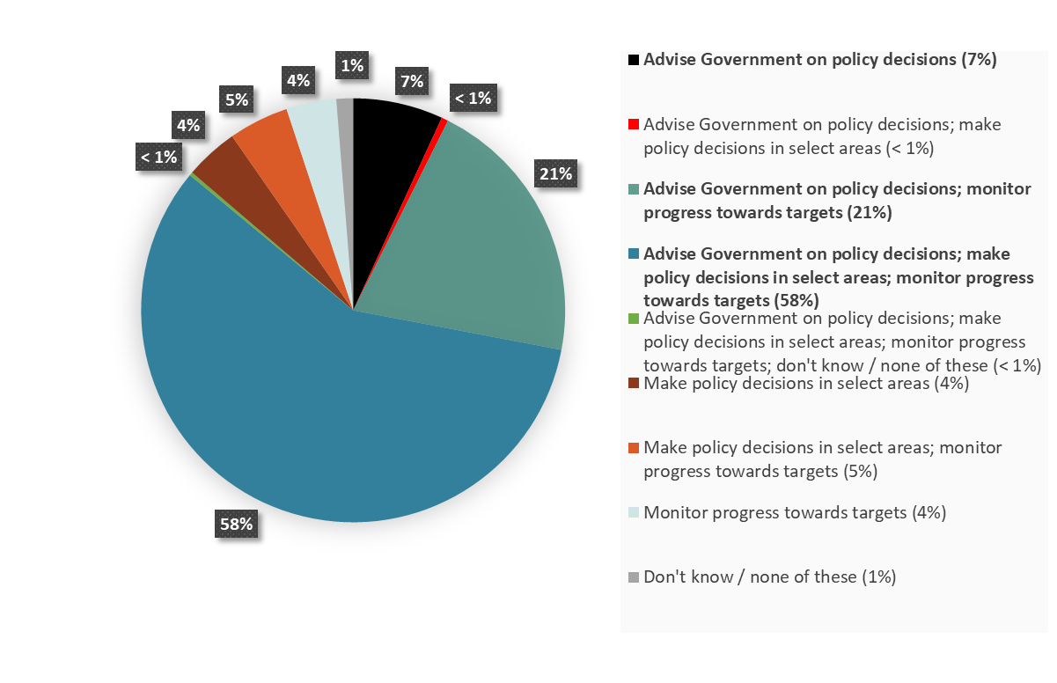

Q12. What role do you think the Climate Change Commission should have in relation to the New Zealand Emissions Trading Scheme (NZ ETS)?
Respondents were invited to pick one of two proposed roles for the Climate Change Commission:
- advising the Government on policy settings in the NZ ETS
- making decisions itself, in respect of the number of units available in the NZ ETS.
Most submissions recommended the Commission should also have an advisory role in relation to the policy settings for the NZ ETS. Some suggested this role could be extended to recommendations on the NZ ETS unit supply.
Out of the 5994 responses to this question, 5019 submissions (84 per cent) thought the Commission should advise on the NZ ETS. Another 743 submissions (12 per cent) thought the Commission should make decisions on the NZ ETS. The remaining 232 (4 per cent) did not specify whether they were in favour of or against either role.
An analysis of only unique submissions highlighted similar preferences, although with slightly different percentages (1341 or 58 per cent of the unique submissions that responded to this question were in favour of an advisory role of the Commission in relation to NZ ETS, 741 or 32 per cent in favour of a decision-making role and 225 or 10 per cent unsure).
Figure 19: What role do you think the Climate Change Commission should have in relation to the New Zealand Emissions Trading Scheme (NZ ETS)? Long submissions’ positions by submitter group
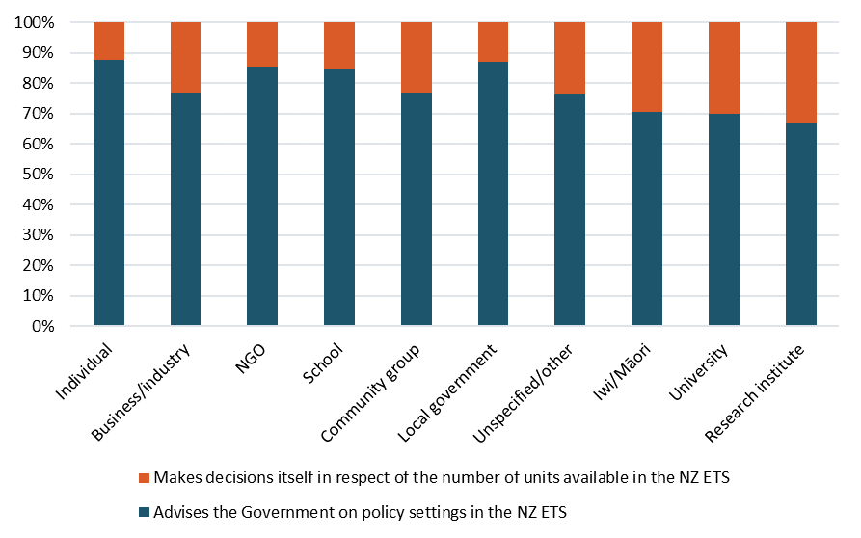
All submitter groups were in favour of an advisory role rather than a decision-making role for the Commission on the NZ ETS (see figure 19). As for question 11, the main rationale given for this preference was that the Commission should act as an independent watchdog, and policy or regulatory decisions should remain with the elected Government.

Q13. The Government has proposed that Climate Change Commissioners need to have a range of essential and desirable expertise. Do you agree with the proposed expertise?
It was proposed the Climate Change Commission should have the following essential expertise:
- climate change policy (including emissions trading)
- resource economics and impacts (including social impacts, labour markets and distribution)
- Te Tiriti o Waitangi, te reo me ona tikanga Māori and Māori interests
- climate and environmental science including mātauranga Māori
- experience with addressing adaptation challenges like planning, insurance and local government
- risk management
- engineering and/or infrastructure
- community engagement and communications.
The proposed desirable expertise included:
- business competitiveness
- knowledge of the public and private innovation and technology development system.
Out of the 3251 responses to this question, 2727 submissions (84 per cent) agreed with the proposed areas of Climate Change Commission expertise. Another 280 submissions (9 per cent) disagreed with the proposal and 240 (7 per cent) did not specify whether they were in favour or against. Four submissions stated that Aotearoa New Zealand should not have a Commission.
Many submissions agreed with the range of essential and desirable expertise proposed, while making suggestions for further expertise they felt should be included or recommending that some of the areas proposed as desirable should be considered essential expertise. The next most commented on expertise was the need for public health. Many of the other suggestions related to the particular sector a submission was from.
- Many submissions, especially in the business/industry group but also some across other groups, including local councils, commented that the Commission should have a representative with experience in markets that are exposed to international competition, and have knowledge of innovation and technology.
- Although some individuals referred to the need for business competitiveness and trade exposure expertise, others were also concerned about the potential for conflicts of interest with business sectors.
- Some submitter groups such as iwi/Māori, some NGOs and universities felt that social expertise was important (particularly in relation to equity and just transition), while others such as researchers felt that broad science knowledge was key.
- Many local government submissions believed it would be essential that the Commission include experts on adaptation, especially if adaptation were to be included in the Bill. Submissions in the business group also felt that expertise in risks and adaptation was needed.
- Māori submissions highlighted the importance of a partnership structure to effectively represent the range of Māori, hapū and iwi views. Submissions differed in the forms of the partnership they proposed; options proposed included structuring the Commission so that half of the Commissioners are Māori, or at least half have a knowledge of te ao Māori, or establishing a Māori Climate Change Advisory Group.
Some submissions suggested ways the Commission could meet the requirement for having a breadth of expertise. Examples included having a sufficiently large pool of Commissioners, subcommittees or advisory committees for particularly complex expertise areas such as adaptation; and ensuring the Commission has access to a range of information it can draw on.

Adapting to the impacts of climate change

Q14. Do you think that the Zero Carbon Bill should cover adapting to climate change?
A majority of submissions thought the Bill should include provisions to help Aotearoa New Zealand adapt to the effects of climate change, giving specific attention to those people most exposed to these risks (eg, coastal Māori communities, neighbouring Pacific Islanders). Because Māori populations, cultural assets and land (eg, urupā, or burial grounds, close to the sea) are particularly vulnerable to the effects of climate change, iwi/Māori submissions strongly emphasised their willingness to be involved throughout the process.
Out of the 6156 responses to this question, 5683 submissions (92 per cent) agreed that the Bill should cover adapting to climate change. Another 393 submissions (6 per cent) disagreed and 80 (1 per cent) did not specify whether they were in favour or against (see figure 20).
Figure 20: Do you think that the Zero Carbon Bill should cover adapting to climate change? Long submissions’ positions
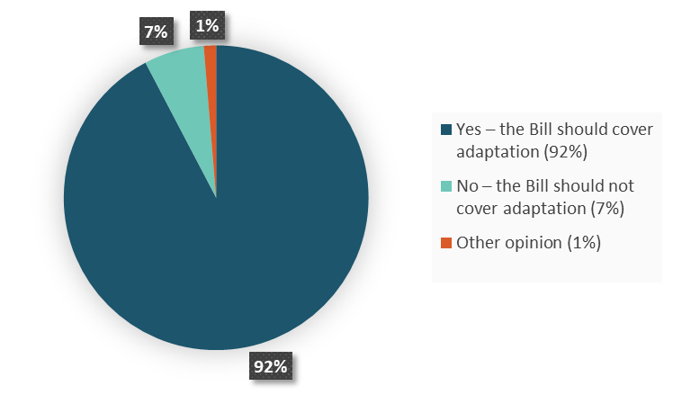
Many comments related to this question incorporated elements of the response to question 15 on the proposed new functions on adaptation. For clarity, these comments were analysed and presented with the other responses on question 15.
Figures 21 and 22 present the responses on this question on a scale from strongly agree to strongly disagree, which came from the short submissions and public consultations.
Figure 21: Do you think that the Zero Carbon Bill should cover adapting to climate change? Short submissions’ positions
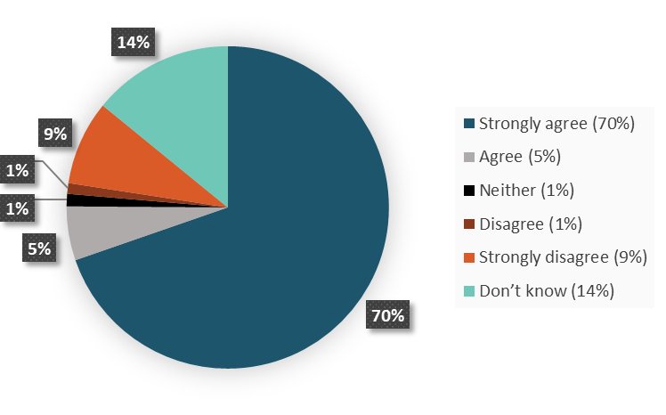
Figure 22: Do you think that the Zero Carbon Bill should cover adapting to climate change? Public consultation positions
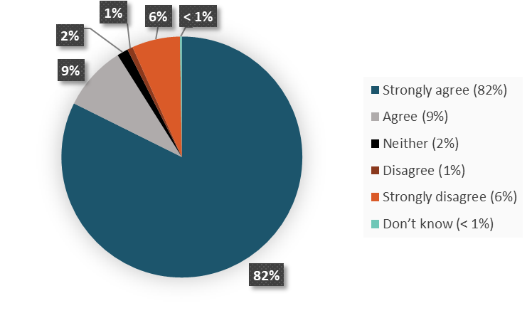
Figure 23 presents the responses to this question broken down by submitter groups.
Figure 23: Do you think that the Zero Carbon Bill should cover adapting to climate change? Long submissions’ positions by submitter group
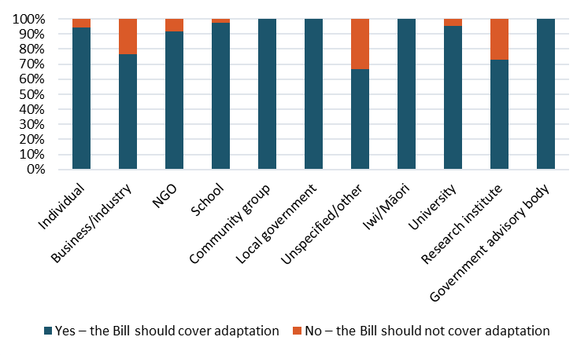

Q15. The Government has proposed a number of new functions to help us adapt to climate change. Do you agree with the proposed functions?
The proposed new functions to help us adapt to climate change included:
- a national climate change risk assessment, for which the Climate Change Commission would be responsible
- a national adaptation plan, for which the Government would be responsible
- regular review of progress towards implementing the national adaptation plan, which the Climate Change Commission would perform
- an adaptation reporting power.
Most respondents agreed with the proposed functions but due to the complexity of the topic, views diverged on who should have the responsibility for adaptation, including whether it should be the responsibility of the Government or the Commission, and if it was the responsibility of the Commission, whether it should be a separate workstream or not.
Out of the 2890 responses to this question, 2481 submissions (86 per cent) agreed with the proposed new functions to help us adapt to climate change. Another 301 submissions (10 per cent) disagreed with the proposal and 108 (4 per cent) did not specify whether they were in favour or against.

Q16. Should we explore setting up a targeted adaptation reporting power that could see some organisations share information on their exposure to climate change risks?
Most submissions agreed with the proposal to explore setting up a targeted adaptation reporting power, where some organisations could be required to provide information on their exposure to climate change risks. Many, however, would welcome further information on the roles and responsibilities, the information to be reported, the reporting framework and support for implementation.
Out of the 3089 responses to this question, 2754 submissions (89 per cent) agreed with the proposal to explore setting up a targeted adaptation reporting power. Another 256 submissions (8 per cent) disagreed with the proposal and 79 (3 per cent) did not specify whether they were in favour or against.
Many submissions, whether they agreed, disagreed or were unsure about the proposal, emphasised the need for further information and clarification before making a final decision on whether to establish an adaptation reporting power. In particular, they considered more details are needed about its roles and responsibilities, the information to be reported, the reporting framework and support for implementation.

Conclusion
The Ministry will use the submissions received during consultation as part of a range of evidence to inform its advice on the Bill, along with science and economic data and modelling.
The draft Bill will be subject to a Select Committee process planned for early next year, following its introduction to Parliament.
The full set of redacted submissions can be found on the Ministry’s website.

The Ministry for the Environment amended the foreword on 14 January 2019 to clarify these figures represent responses from long submissions.
Ministry for the Environment. 2018. Framework for Climate Change Policy and Key Upcoming Decisions. Cabinet Paper. Wellington: Cabinet Office, Department of the Prime Minister and Cabinet.
Parliamentary Commissioner for the Environment. 2018. A note on New Zealand’s methane emissions from livestock. Wellington: Parliamentary Commissioner for the Environment.
New Zealand Productivity Commission. 2018. Low-emissions economy: Final report. Wellington: New Zealand Productivity Commission.
https://www.mfe.govt.nz/publications/climate-change/our-climate-your-say-consultation-zero-carbon-bill
Submissions using the full online submission form (as in the discussion document), form submissions, emailed and posted submissions.
Three-question questionnaire on the main Zero Carbon Bill page on the Ministry’s website.
Questionnaires filled in by people at public consultation meetings. These forms have the same three questions as the short submissions.
http://www.mfe.govt.nz/have-your-say-zero-carbon

