National Planning Standards:
General provisions
Discussion paper J

Disclaimer
The opinions and options contained in this document are for consultation purposes only and do not reflect final Government policy. Please seek specific legal advice from a qualified professional person before undertaking any action based on the contents of this publication. The contents of this discussion document must not be construed as legal advice.
The Government does not accept any responsibility or liability whatsoever whether in contract, tort, equity or otherwise for any action taken as a result of reading, or reliance placed because of having read any part, or all, of the information in this discussion document, or for any error, inadequacy, deficiency, flaw in or omission from this document.

This document may be cited as: Ministry for the Environment. Ministry for the Environment. 2017. National Planning Standards: General provisions – Discussion paper J. Wellington: Ministry for the Environment.

Published in May 2017 by the
Ministry for the Environment
Manatū Mō Te Taiao
PO Box 10362, Wellington 6143, New Zealand
ISBN: 978-0-908339-98-3 (online)
Publication number: ME 1303
© Crown copyright New Zealand 2017
This document is available on the Ministry for the Environment website: www.mfe.govt.nz.

Contents
Context 5
What are the issues and opportunities? 6
What our research says 6
Options for general provisions 7
Our preferred option 9
Next steps 11
Feedback 11
Contact 11

Tables
Table 1: Options for how the planning standards should address other provisions in plans 9

Figures
Figure 1: How the National Planning Standards outcomes can be addressed through standards in this paper 5

Context
Unnecessary plan variation affects the planning system by making plans difficult to interpret and onerous to prepare. The first set of national planning standards addresses this by including minimum requirements for structure, form and core content for policy statements and plans.
This paper considers a number of structure and content-related issues for a range of general plan provisions. It particularly discusses plan provisions not considered in other papers. Figure 1 demonstrates which of the National Planning Standards outcomes can be addressed through the development of standards detailed in this discussion paper.
Figure 1: How the National Planning Standards outcomes can be addressed through standards in this paper
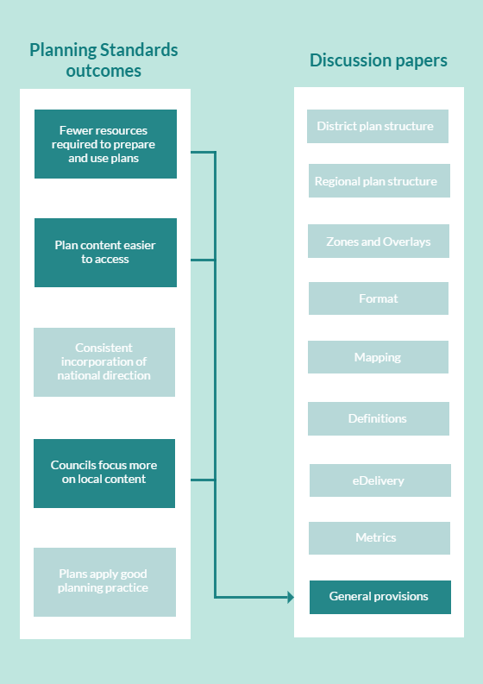

What are the issues and opportunities?
Plans contain a wide variety of provisions and other text. Most plan content is required under the Resource Management Act 1991 (RMA), some plan content is optional and other material is often included to help the user navigate the plan or provide context. These general provisions are often, but not always, located in an introduction chapter to a plan.
We have identified three main questions to be addressed during the development of the National Planning Standards as they relate to general provisions:
- whether the location in plans for general provisions should be standardised
- whether some of these provisions should have standardised content
- whether the National Planning Standards explicitly do not provide a ‘home’ for provisions that are better addressed outside of plans.

What our research says
We conducted a desktop analysis of 25 district plans and 5 regional plans to understand more about the scope, nature and location of general provisions or descriptive text included in plans. In that research, we nominally categorised a range of provisions as either administrative or general provisions. In hindsight, it has proven difficult to categorise these other plan provisions. Accordingly, this paper refers to a range of ‘general’ provisions and other types of plan text that are not discussed in detail in other discussion papers.
There were many different types of general provisions and other plan text identified in the research. The following provisions and text were the most common, having been identified in more than half of the district plans and all regional plans reviewed:
- user guidance about the RMA framework and plans
- links to other regulatory documents
- guidance on how to use the plan and the structure of the plan
- how to apply for a resource consent
- activity status information and how it is applied in plans (including notification provisions)
- outline of rules that have legal effect
- list of information to be submitted with a resource consent
- tāngata whenua values
- financial contributions
- designations
- cross-boundary provisions
- monitoring strategies.
Plan text relating to guidance of the RMA framework and links to other regulatory controls were consistently located in the introduction section of plans (ie, 23 of the 25 district plans and 4 of the 5 regional plans reviewed), but the way the information was presented varied greatly.
Most plans contained individualised text on the RMA framework. Key examples include plan text explaining the wider RMA framework and different activity statuses. Information on activity status and how to apply for a resource consent was variously located in the introduction section, within other chapters, or at the end of plans.
This results in a duplication of effort by council staff and potentially raises uncertainty for plan users due to different explanations and unnecessary differences between plans in whether and where this type of information is included.
While every plan contained a section relating to Māori and tāngata whenua values, these provisions were also located in many different parts of plans, including dedicated chapters at different locations within plans, as individual provisions within other chapters, or spread throughout multiple chapters.
Twenty-one out of 25 plans included financial contribution provisions, and 19 out of 25 included cross-boundary provisions. As with tāngata whenua value provisions, there was little consistency in where these provisions were located, with some being within other chapters or as stand-alone chapters.
The actual content and amount for certain provisions also varied between plans. Plan content on ‘how to apply for resource consent’ ranged from suggestions to contact the council and links to the council website, while other plans provided comprehensive diagrams for the consent process. Similarly, references to monitoring strategies ranged from references to other documents on a council website through to including an entire chapter on monitoring and review of the plan’s provisions.

Options for general provisions
We have identified three main areas of discussion for how general provisions are addressed in the structure of plans under the National Planning Standards.

Issue 1: Should the location for general provisions be standardised in plans?
To improve the usability of plans, the National Planning Standards will standardise the location of all main elements of plans. This includes some of the more general provisions, which our research shows currently occur in a variety of places in plans. The research shows most, but not all, of these types of provisions are set out in the introductory chapter to a plan. The planning standards could set mandatory placeholders within the structure of a plan for these provisions.
For example, all plans might be required to include reference and acknowledgement of tāngata whenua and Māori values near the beginning of the plan. Similarly, requirements relating to financial contributions, if used, might consistently be located at the end of a plan.
Issue 1: Standardised location of general provisions
Advantages | Disadvantages
General provisions are consistently located in plans, making it easy for plan users to find these provisions. | Councils lose ability to tailor location of general provisions in their plans.
More certainty for plan users that all relevant provisions have been located.
Reduces duplication of work by councils in writing and preparing the material.

Issue 2: Should better use be made of user guides, websites, other documents to simplify plans?
Related to Issue 1 is whether some text currently included in plans should not be provided for at all in the structure of plans. One way to simplify plans and make them more user friendly is to remove plan content that does not have to be there. In line with previous amendments to the RMA to streamline plans, we consider the planning standards provide an opportunity to discourage plans from containing certain information. Of particular interest is information included primarily to help a plan user navigate the plan or provide information on associated resource consent processes. User guides, sitting outside the plan on a council website, can fulfil this function. Other examples of text that does not need to be in plans are references to monitoring activities.
Issue 2: Better use of guides, websites and other documents
Advantages | Disadvantages
Declutters plans. | Plan users have to refer to a separate document to find out the meaning of RMA terms, the wider RMA system and how to apply for a resource consent.
User guides are non-statutory documents so can be amended without using the plan change process, for example, in response to legislative amendments to consent processes.
Can specify processes and requirements of each particular council.

Issue 3: Should some general provisions have standardised content?
There is potential to reduce the duplication of work by councils by standardising the content of some common plan provisions that do not change based on local circumstances or community values.
The research showed that many of these general provisions relate to the resource management plan hierarchy or other RMA processes. Because these are common to all plans, there is scope for the National Planning Standards to include standard content. Standard content for general plan text could draw on the body of guidance advice that already exists. We know that prescribing content will not be appropriate in all cases, for example how tāngata whenua values or cross-boundary issues will be managed.
Table 1 considers which general provisions may benefit from standardised content.
Issue 3: Standardised content for general provisions
Advantages | Disadvantages
Develops a common understanding and language for describing core RMA elements. | The drafting may not capture all information that a council considers is necessary.
Improves understanding of resource management plans and how they are used, thereby improving understanding of the overall RMA system. | Councils lose ability to change text that is different from what they would prefer.
Reduces duplication of work by councils in writing and preparing the material.

Our preferred option
To facilitate focused feedback on the issues we have identified, table 1 lists the common general provisions identified in our research. It also outlines initial thinking on whether the provision should remain in plans, its preferred location and whether content should be drafted for that provision. Your feedback is sought on these issues and any other general provisions you identify.
Table 1: Options for how the planning standards should address other provisions in plans
Type of plan content | Remain in plans? | If yes, preferred location in the plan  If no, where does text go? | If yes, should National Planning Standards include content as well?
User guidance about the Resource Management Act 1991 framework | No. | User guide, sitting alongside plan on council website. | Not applicable, although guidance material could be prepared if useful.
Links to other regulatory documents (eg, national policy statements, national environmental standards, regional policy statements (RPSs)) | Yes. | National, regional and strategic matters chapter (see District Plan Structure paper). | One-paragraph explanation of the national direction tool could be mandated content. Councils to provide local content for how their plan gives effect to that tool.  Councils to provide local content on links of district plan to RPS and regional plans, and any other plans prepared under other legislation.
Tāngata whenua values | Yes. | To be discussed during iwi engagement. | No.
Guidance on how to use the plan and the structure of the plan | No. | User guide, sitting alongside plan on council website. | Not applicable, although guidance material could be prepared if useful.
How to apply for a resource consent | No. | User guide, sitting alongside plan on council website. | Not applicable, although guidance material could be prepared if useful.
List of information to be submitted with a resource consent | No. | User guide, sitting alongside plan on council website. | Not applicable, although guidance material could be prepared if useful.
Activity status information and how it is applied in plans | Yes, but brief. | Introduction chapter or beginning of rules chapter. | National Planning Standards could provide optional model text.
Text relating to approach to notification provisions in plans | Yes, but brief. | Introduction chapter or beginning of rules chapter. | National Planning Standards could provide optional model text.
Rules that have legal effect | Yes, but brief. | Introduction chapter or beginning of rules chapter. | No.
Designations | Yes. | Own chapter at end of plan or as part of infrastructure chapter. | No.
Cross-boundary provisions | Yes. | General provisions chapter at end of plan. | No.
Financial contributions | No. | Resource Legislation Amendment Act 2017 removes ability for financial contributions under the RMA. | No.
Monitoring strategies | No, reference only. | General provisions chapter at end of plan would contain a reference only to a monitoring strategy.  Actual monitoring plan should sit alongside plan on a council website. | No.

Questions
J.1. What are your views on each of the issues identified?
J.2. Do you agree or disagree that some information currently included in plans is better placed outside of a plan?
J.3. Do you agree or disagree that there is an opportunity for the National Planning Standards to provide standardised content for some of these provisions?
J.4. What are your views on the examples of general provisions set out in table 1?
J.5. Is there anything missing from table 1 that you think we also need to consider?

Next steps
We are currently in a scoping phase for the National Planning Standards. The ‘Introduction to the National Planning Standards’ overview document details the process and engagement opportunities during each stage of development. The flow chart below shows each stage of the development process and the anticipated timeframes.

Feedback
We welcome your feedback on the ideas and options we have presented in this paper. Please use the questions in this paper as a guide. You do not have to answer them all and can give other constructive comments where you wish. To ensure your point of view is clearly understood, please explain your rationale and provide supporting evidence where appropriate.
We encourage you to send us feedback throughout the initial engagement period, which closes on 31 July 2017. Please send feedback to the email address below.

Contact
Email: planningstandards@mfe.govt.nz
Website: www.mfe.govt.nz
Phone: +64 4 439 7400

Relevant RMA sections: section 62: Contents of regional policy statements; section 67: Contents of regional plans; section 75: Contents of district plans.

