National Planning Standards:   
Electronic functionality and accessibility of plans and policy statements

Discussion paper H

**Disclaimer**

The opinions and options contained in this document are for consultation purposes only and do not reflect final Government policy. Please seek specific legal advice from a qualified professional person before undertaking any action based on the contents of this publication. The contents of this discussion document must not be construed as legal advice.

The Government does not accept any responsibility or liability whatsoever whether in contract, tort, equity or otherwise for any action taken as a result of reading, or reliance placed because of having read any part, or all, of the information in this discussion document, or for any error, inadequacy, deficiency, flaw in or omission from this document.

This document may be cited as: Ministry for the Environment. 2017. *National Planning Standards: Electronic functionality and accessibility of plans and policy statements   
–* *Discussion paper H*. Wellington: Ministry for the Environment.

Published in May 2017 by the  
Ministry for the Environment   
Manatū Mō Te Taiao  
PO Box 10362, Wellington 6143, New Zealand

ISBN: 978-0-908339-96-9 (online)

Publication number: ME 1301

© Crown copyright New Zealand 2017

This document is available on the Ministry for the Environment website: [www.mfe.govt.nz](http://www.mfe.govt.nz).



# Contents

Context 5

What is eDelivery, ePlan and ePlanning? 6

What is the opportunity and problem? 7

What our research tells us 11

Transitioning towards mature eDelivery systems 13

Proposals for eDelivery National Planning Standards 15

eDelivery minimum requirement within 12 months from Gazettal of the National Planning Standards 15

Mature eDelivery standard, five years after Gazettal 16

Data and information transfer standards 18

ePlanning: future considerations 20

Next steps 22

Feedback 22

Contact 22

Appendix 1: Ministry for the Environment summary of plans 23

Appendix 2: Resource sharing of GIS platforms 25

Appendix 3: List of data sources and research 26

# Figures

Figure 1: Outcomes and papers 5

Figure 2: Internet users United Kingdom, New Zealand, United States of America and Australia, 2005–15 7

Figure 3: The ePlanning progression 8

Figure 4: Plan delivery formats for district and unitary councils 11

Figure 5: Timescale of minimum and mature standards 15

Figure 6: Geographic Information System example linked to ePlan 20

Figure 7: WestMaps 25

# Context

Unnecessary plan variation impacts the planning system by making plans difficult to understand and interpret and onerous to prepare. The first set of national planning standards addresses this by setting minimum requirements for structure, form and core content for policy statements and plans. It also provides that they will specify requirements that relate to the electronic accessibility and functionality of policy statements and plans.[1]

For the purposes of this paper:

* eDelivery relates to the electronic delivery of Resource Management Act 1991 (RMA) plans online, the level of information available and the format it is presented in:
* ePlan is a subset and a form of eDelivery, it is typically used to describe an electronic plan, located on a website, fully interactive, hyperlinked embedded through the polices with ideally an embedded GIS system (or the functionality)
* ePlanning is a broader concept and refers to moving all planning functions, services and processes to an online format. For example, lodging submissions and resource consent applications online, tracking processing of consents, completing monitoring obligations online.

This paper focuses on eDelivery, due to the particular requirements of the National Planning Standards, but the broader ePlanning context is also considered. Figure 1 demonstrates which of the National Planning Standards outcomes can be addressed through the development of standards detailed in this discussion paper.

Figure 1: How National Planning Standards outcomes can be addressed through standards in this paper.

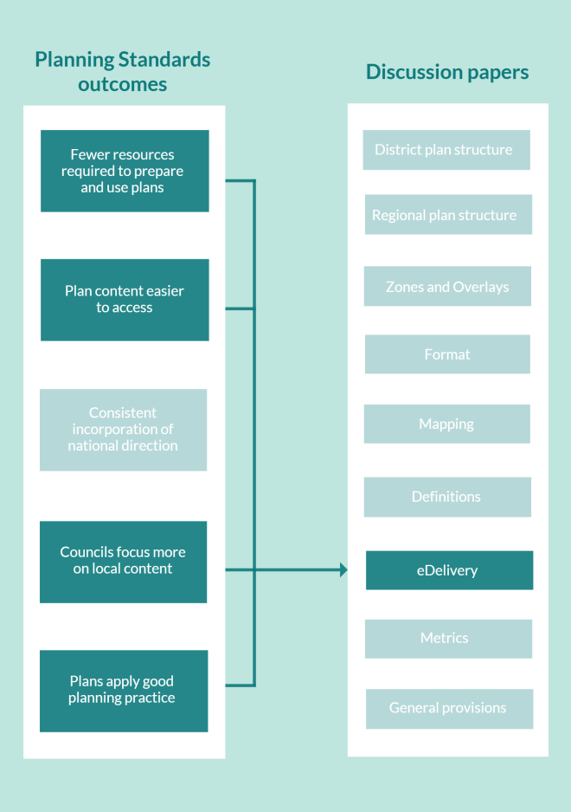

# What is eDelivery, ePlan and ePlanning?

As summarised above, electronic accessibility, more commonly referred to as electronic delivery of plans (eDelivery), refers to how RMA plans are accessed and presented online, the level of information available and the format it is presented in. ePlanning is a broader concept and refers to moving planning functions, services and processes to an online format, in addition to eDelivery of the plan itself.

While the term ePlan is used for a wide variety formats, for the context of this paper, an ePlan is not merely a paper-based plan located online because all plans in some format are already online. In the context of this paper, an ePlan refers to an electronic plan that is interactive, hyperlinked (database plan) through to the text of the policies, with ideally an embedded GIS system (or functionality) to drill through layers to highlight policies that apply to a point or area.

# What is the opportunity and problem?

Today, information and communications technology (ICT) allows plan users a smoother interaction with the planning function. This occurs through new tools, ranging from more familiar Geographic Information System (GIS) to more cutting edge virtual reality technology, e-consultation methods, online fee calculators and electronic payment routes, among other tools, with the aim of simplifying the process and improving conventional practices.

These innovations form part of rapidly changing public expectations of how goods and services are delivered in line with technological advances. Internet usage has increased dramatically in the last 10 years. As shown in figure 2, increasingly New Zealand has a comparable number of internet users to the United Kingdom and Australia (more than the United States of America), with over 70 per cent of New Zealand adults owning a smart phone.[2] As a result, there is an expectation that a wide range of government services will be delivered online to provide an *around the clock* and user friendly service to customers.

Figure 2: Internet users United Kingdom, New Zealand, United States of America   
and Australia, 2005–15[3]

The New Zealand Government’s 2015 [ICT Strategy and Action Plan](http://ict.govt.nz/assets/Uploads/Government-ICT-Strategy-and-Action-Plan-to-2017.pdf)[4] attempts to respond to this increase in public expectation regarding online public services. Increasingly, people expect to *consume* public services in the same way that private business and services are provided. While the goals in this strategy do not apply to local government planning services as yet, it provides useful guidance and a vision of what we should be working towards in the planning system. We note also the Integrated Property Services (IPS) initiative, led by Land Information New Zealand in collaboration with local government, which aims to implement the integrated provision of government-mandated location-based property services (such as planning).

For over 25 years, local government in New Zealand has been moving towards electronic delivery of public services, such as the CityNet service launched by Wellington City Council in 1991,[5] and EFTPOS electronic payments since 1985. After this very early innovation ICT within **local government, progress has slowed and councils are at different stages** along the ePlanning spectrum (see figure 3) but are moving forward. While some councils have embraced the opportunities that the internet brings to make their planning functions more user friendly, many others have not yet taken advantage of these opportunities.

Figure 3 illustrates an example of four levels of the ePlanning journey. It provides valuable context for understanding where eDelivery sits in relation to a broader ePlanning goal. Note that particular elements can be implemented or upgraded as standalone functions (eg, lodgement of resource consent applications online, even if an interactive version of the plan is not yet online).

Figure 3: The ePlanning progression[6]

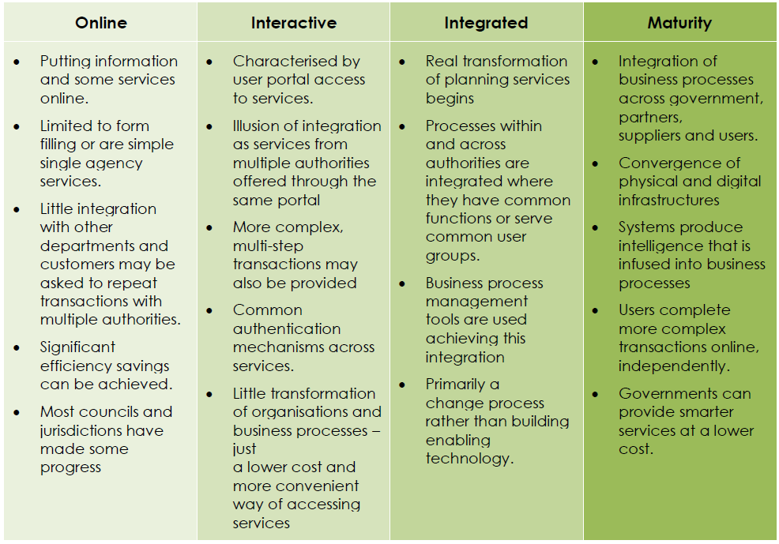

### Benefits of making paper-based plans more electronically accessible

Thinking specifically about the online accessibility of resource management plans, the key benefits of moving forward fully searchable, accessible plans online to plan users and councils include:

* improved accessibility, ease of use and 24 hours, seven days a week access to plan information
* less time spent querying the plan due to improved electronic search functionality, including property-specific searches, if the plan is linked to the GIS map query viewer
* greater transparency of planning processes as a result of improved public access to information and decision-making processes
* improved user experience via mapping standards, such as common mapping symbols, scale, colour, legend format as part of the transition to GIS maps
* a reduction in council staff time being used to answer basic plan enquiries.
* less connectivity demands because HTML web-based plans download faster than large cumbersome PDF files
* a reduction in reliance on paper-based plans and associated waste, which contributes to New Zealand’s transition towards a low carbon economy.

As other parts of the planning system are brought online alongside the delivery of plans, the benefits will increase for councils and users of the planning system. For example, greater efficiencies are possible (for councils and plan users) in the use of online submission forms and consent applications which are linked with plan provisions. In time, technological advances will provide applicants with the ability to electronically submit proposed building plans into a GIS-based application to test whether the works comply with the plan or not.

There is an increasing awareness that the digital format and resulting open data provides opportunities for economic growth, help promote business, develop cost-effective public services and create new jobs.[7] The Government raised the profile of open data by transferring responsibility from Land Information New Zealand to StatsNZ[8] to drive efficiencies in public services.

There are challenges though. Not all councils have been able to update their plans to be more electronically accessible, creating a system where some communities have a better quality of service than others when interacting with the planning system. Some factors that can inhibit councils from moving towards advanced eDelivery may be:

* size of ratepayer base
* current demand for planning services
* growth (or decline) in the district or region
* the relative importance of planning in comparison with other core council operations.

Auckland, for example, has a population of 1.5 million and grew in population size by 8.5 per cent between 2006 and 2013. Auckland Council processed 12,164 resource consents in 2014/15. It clearly has a significant demand for planning services and has pro-actively moved towards investing in an interactive plan, along with other ePlanning functionality. In contrast, Waimate District Council has a population of 7,356 and grew in size by 4.5 per cent between 2006 and 2013. With little development activity, the demand for planning-related services is comparatively low. Waimate processed 48 consents in 2014/15. Its district plan is located on its website as a PDF.

An encouraging response to these challenges has been the emergence of councils working together at the regional level to manage the costs of embracing new technology (eg, Environment Canterbury[9] and West Coast Regional Council[10]). We are interested in exploring how central government can continue to support these collaborative initiatives.

The National Planning Standards provide a unique opportunity for central government to assist councils in developing in this space and improve the online consistency of plan delivery for the benefit of all plan makers and users.

# What our research tells us

### Council website survey

In May 2016 (updated in January 2017), we surveyed[11] all district, unitary and regional council websites to gain an understanding of the usability of councils’ plans. This snapshot found the following.

* Seventy-nine per cent of district and unitary councils have their plans in some PDF format online, 18 per cent have an interactive online plan.

Figure 4: Plan delivery formats for district and unitary councils

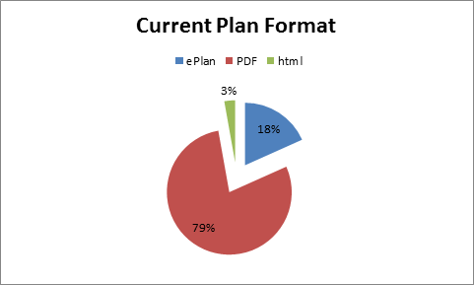

* Ninety per cent of regional councils currently use PDF (in some form) plans on their website.
* The majority of PDF plans were separated into chapters, making it difficult to search the entirety of a plan with ease; impacting on plan usability overall. Some PDFs had very low functionality, preventing simple word search queries.
* Ninety per cent of authorities have some level of interactive GIS mapping (including some hybrids with text in PDFs with links to a GIS system) on their sites, but not all of these are fully linked with the plan. Even so, the capability for property-based planning information is significant once linked with an interactive plan. The remaining 10 per cent only have *flat* PDF maps without interactivity, which provides static spatial information at a set scale.
* There is no single website that hosts or links to all councils’ planning information. However, recently some regional councils have provided a GIS platform for district councils to display their plans on a GIS viewer, for example, Environment Canterbury and West Coast Regional Council.
* The quality and ease of use of council websites and plans vary significantly. It can be difficult to locate planning information on council websites, with planning information being hosted in differently named areas of council websites. Some plans hyperlink internally to relevant provisions and definitions, while others are PDF only available in individual chapters.

### Council ePlanning workshops

The Ministry for the Environment held a series of council workshops in 2016 to explore what councils are currently doing to improve accessibility of plans, including exploring the benefits and challenges they faced. Most council representatives recognised the benefits as being improved plan usability, improved document management of the plan, and a reduction in plan administration. A number of councils have invested a significant amount of time and resources into developing and implementing an interactive plan online, and other ePlanning initiatives.

In our workshops, some council staff expressed concern that a high level of online functionality is complex, time consuming and costly to develop. Interestingly, our survey of online council plans shows there are some local councils with small populations and low development pressures have initiated interactive online plans, suggesting it is possible if funding can be prioritised. These councils typically timed the development of an interactive online plan with the review of their plan generally and had also identified the efficiencies to be gained for the long-term administration of the plan document.

In summary, councils are currently located at many points on the ePlanning spectrum. Many deliver their plan and map content in relatively basic PDF form, while others already have sophisticated mature online systems that integrate plan content with GIS mapping platforms (eg, Dunedin, Wellington and Whangarei). These differences can significantly impact plan users’ experience and the overall efficiency of the planning system.

### Plan users’ experiences

We also conducted a small survey and held a workshop with professional plan users,[12] to gauge users’ experience. We were interested in how they used plans and the particular functionality that made a plan easy or difficult to use. Key findings include the following.

* Plans can be difficult to find on some council websites.
* It is difficult, and more time consuming, to navigate plans that are available only as individual PDF chapters.
* Interactive plan systems that crosslink information efficiently within the plan are significantly easier to use. Links to relevant regional plan provisions considerably improve plan usability.[13]
* A clear structure is arguably the biggest difference between what constitutes a ‘good’ versus ‘bad’ plan. The use of numbering should be consistent and easy to reference, and clear linkages should exist between the high level strategic intent and the objectives, policies and rules.
* It can be difficult to determine the applicability and status of plan changes and variations, and it is often not clear whether plan changes have been incorporated into plans.
* The quality and scale of maps change between paper-based plans, making it difficult to use plans when operating across multiple districts.

To complement our research with council and professional plan users, we have recently commissioned research exploring the experience of lay plan users navigating both paper-based and electronic plans. These results will be available in mid-2017.

# Transitioning towards mature eDelivery systems

Based on the research to date, we have identified that the following factors need to be considered when assessing options for developing eDelivery requirements for the National Planning Standards.

* Current eDelivery and ePlanning systems cannot easily be changed overnight – systems typically evolve over time
* There are potentially many factors affecting the current varied state of eDelivery, such as available resources priorities and/or demand for planning services.
* Acknowledging that simply standardising the structure and format of plans would drastically improve the way plans look and feel online.
* A common plan structure and format will address several users’ concerns, including the poor linkages between sections and plan navigability. These improvements will have flow-on effects for the ease with which plans can be transferred into a consistent electronic format. Improved eDelivery will not inherently improve the quality of plans but can significantly improve plan users’ experience with the planning system.
* Lower cost alternatives may need to be identified to support some councils to make the desired transition. Low cost GIS options, and councils sharing platforms, are explored in appendix 2 and our Mapping Standards paper.
* Managing expectations – typically, progress occurs in stages or discrete components and is often dependent on capacity, resources and priorities. There may be a perception that any advances will deliver the best, most advanced option straight away; in practice, this may not be the case.
* Start-up cost – depending on the funding model, for some options, the benefits may not outweigh the costs. For councils that have already invested resources in developing systems, there is also a significant write-off cost for existing software infrastructure if they are required to use different software.
* Legacy system costs and integration with other software – legacy is a term that often implies the system (normally software) is out of date or in need of replacement. eDelivery as part of a wider ePlanning strategy needs to support building a system that is flexible enough to manage challenges and change, yet robust enough to support development. In addition, councils need to consider how ePlan software will connect with existing council software, such as submissions databases and consent tracking systems.
* Connectivity – some areas of New Zealand still have slow internet connectivity; however, an MfE and MBIE project with the New Zealand telecoms industry has committed that, by the end of 2017, 86 per cent of rural houses and businesses will have access to broadband peak speeds of 5Mbps[14] plus; and by 2025, 99 per cent of New Zealand will have access to 50 Mbps.[15] The increase in speed, combined with a move from fixed line connections to mobile internet, will significantly reduce, if not eliminate, potential connectivity issues. Some mature eDelivery systems may have a similar or smaller demand on user connectivity than PDF-based systems.

Questions

H.1. Are there any other key factors that are not outlined above?

H.2. What are the areas/topics of eDelivery and ePlanning that would benefit most from national planning standards?

H.3. What other functions would be beneficial if applied across New Zealand? Why?

H.4. Would the mature options with a timeframe set out provide authorities with more certainty?

H.5. What do you think of the transition costs and funding implications?

H.6. Timing alongside other (format/zoning etc) planning standards changes?

|  |
| --- |
| Although PDFs have become a very common file format, not all PDFs have the same functionality and options for users. The features that can be provided may be dependent on the quality of the source material used to form the PDF, such as correct formatting and the process it has been subjected to. When old traditional plans (including the images graphics and plan components) are converted to an electronic format, the text elements can become recorded as a static image. Text searching is not available with this type of PDF file, because it contains only image information. Although a scanned page may appear to contain text, it is actually just an image of that text and not the text itself.  Image credit: Adobe.  By utilising Optical Character Recognition (OCR) as part of the process or possibly after (depending on the software), the text can be interrogated by the user. This most commonly involves searching the PDF for a topic and interacting with the document, for example, by clicking on links to other areas of the plan. |

# Proposals for eDelivery National Planning Standards

The following section sets out a proposed transition from a minimum standard of online accessibility of plans to a mature standard. The implementation of the minimum standard will be phased in after the Gazettal of the National Planning Standards over a 12-month and 5-year period, as set out below

Opportunities for future guidance on broader ePlanning initiatives are also discussed.

Figure 5: Timescale of minimum and mature standards

Resource Legislation Amendment Act 2017 (RLAA)

+2 years of RLAA

Gazettal of standards

+12 months from Gazettal

Minimum eDelivery standard

+5 years from Gazettal

Mature eDelivery standard

## eDelivery minimum requirement within 12 months from Gazettal of the National Planning Standards

The National Planning Standards relating to eDelivery will likely set out requirements in a broad way, allowing councils to design their own solutions. The standards will include a minimum functionality, mapping standards, and elements of data and information transfer standards. Councils will be able to meet those requirements in a method that best suits them. The type of matters covered could include that:

* a user can search a plan in its entirety and see when information was last updated
* a user can clearly differentiate between proposed, operative and appealed provisions
* a user can access a plan within x number of clicks from the homepage
* plans and policy statements are hosted on a commonly named area on council websites
* links are provided between the various planning provisions (eg, hyperlinks within the plan, the use of tabulation, or bookmarking sections). This reflects an observation that many plans are not easy to navigate, and multiple sections of an individual plan and multiple planning documents are often relevant to individual applications.
* a single website (managed by the Ministry for the Environment) provides a central portal to all district and regional plans[16] (this responds to users expressing frustration that plans can be hard to locate).

### Impacts of this minimum standard on councils

While all changes will have some resource impacts on authorities, the majority of the above should be relatively low impact. This is because our research (findings presented in appendix 1) shows that 97 per cent of the 78 district and regional councils already have a basic search function as part of their plan.

Although functionality, such as the date the plan was last updated, can be provided in a PDF, not all features, such as full searchability and user interrogation, can be easily achieved. PDFs, even with live links and additional functions, are still a relatively static entity. As such, the long-term goal would be to move beyond PDF. The 3 per cent of plans that do not currently meet the basic PDF search functionality can achieve this standard relatively easily by reformatting the plan text. For councils that currently have separate PDFs for plan chapters or subject areas, searching and interrogation of the plan can also be improved by complementing those chapter PDFs with a version of the plan in one PDF, allowing the plan to be searched in its entirety. For this PDF, the correct formatting of images within the plan can reduce the overall file size. Further information about types of PDF, functions that are required, and a brief overview of their creation methods are set out above.

Clear labelling of the status of provisions, clear labelling and reducing the number of website clicks through to the plan are more matters of online management best practice and are likely to need to be addressed with or without planning standards.

Questions

H.7. Do you agree a staged approach that sets broad requirements and progresses over time is the best approach? Why/why not?

H.8. Does the refresh of a council website, to allow more user-direct access, have unforeseen impacts on core business?

H.9. Councils appear to be moving independently and more quickly to ePlans than initially expected. Is a minimum standard relating to improving the quality of PDFs ambitious enough?

## Mature eDelivery standard, five years after Gazettal

The mature standard builds on the minimum standards set out above and sets a vision for how plans will be delivered online. This includes requirements for councils to provide interactive GIS presentation of plans (eg, as used by Hurunui, Dunedin, Auckland, Matamata–Piako and others).

In addition to the minimum standard, councils will need to provide for what is often described as an ePlan[17] by:

* having an interactive online delivery of plans as an ePlan (sometimes referred to as a database plan) with the text component of the plan presented in HTML[18] form allowing full linkages
* embedding interactive GIS systems providing online delivery of visual aspects of plans (zone layers and so on).

Some benefits are that it:

* would result in greater gains to the functionality of plans and accessibility of planning information in the short and medium term
* sets a higher bar for eDelivery requirements and better reflects the rapid pace at which ePlanning services are improving, but does so within a staged transition period
* acts as an impetus for councils, whose current eDelivery services are lagging behind, to improve.

### Impacts of this standard

The Ministry for the Environment 2017 research (the data of which are set out in appendix 1[19]) identified *around* 40 per cent[20] of councils will already meet most of these requirements of this standard. Currently, close to 25 per cent of councils have a *full* ePlan with a GIS system (or functionality of one), and we are aware of several others who are currently developing an ePlan to launch within the next 12 months. In addition to the time period and the more basic low-cost or free GIS platforms, there are open source options for elements such as the move from Word to XML.[21]

The mature standard will impact smaller, less-resourced councils. It will impose costs on those councils least able to afford it and who have less demand for planning services. Such investments should be also be viewed in the wider frame of the benefits the improved system can bring. While the upfront costs associated with the current ePlan software providers are not excessive, compared with many other IT software projects, there are staff resourcing implications for councils making the transition to a database ePlan.[22] Similarly, the costs associated with interactive GIS mapping that links to the ePlan may be excessive for some councils.

### Options to manage costs of this transition

We know that some councils may struggle to prioritise funding for an ePlan, and they have sought to recognise this by proposing a staged implementation of technology. There is a need to quickly improve the user friendliness of some online PDF plans.

The minimum option seeks to respond to concerns from some councils that they may not be resourced to manage a transition to a more fully interactive method for delivering their plans online. The staged transition identifies minimum standards that must be met within 12 months (after Gazettal), and that can be met with a simple upgrade of PDF technology and some additional time invested by staff to improve plan functionality using hyperlinks. It also provides a clear vision for where we expect councils to move towards in the coming five years (after Gazettal), such as the move beyond PDFs. This is identified as a vision for improving the accessibility of plans – a vision that is still seven years away, taking account of the two-year development period of the National Planning Standards. We are keen to explore how we can work with councils that struggle to make this transition as part of any normal plan review process.

Almost all councils have GIS, if only for internal works (LIM reports, for example), but not all have a public facing viewer that allows users to readily access planning information. A barrier to the adoption of GIS for local government has often been the cost of, and licences for these systems, but there are many open source (virtually free) options that can be used by councils. Councils are collaborating together at the regional scale to manage the cost burden of providing quality GIS mapping systems, such as WestMaps, a platform-sharing partnership between West Coast Regional Council and Buller District Council set out in appendix 2.

Questions

H.10. How can we work collaboratively with you and other agencies to manage this transition period?

H.11. If the move to ePlan was changed to the (earlier) minimum standard, are there other wider ePlanning measures that should be set out that would improve the delivery and functionality of plans?

H.12. Are there any other key factors that are not outlined above?

## Data and information transfer standards

Data and information transfer standards are a wider New Zealand Government goal and a modernisation conversation. Data standards present a significant opportunity for the National Planning Standards and could reduce the burden associated with monitoring (eg, National Monitoring System data would be consistently recorded). Data standards encompass standards on what data councils collect and how they present it (eg, maps data, resource consent data). The standards will allow easier transfer of information and enable third-party access to display relevant planning information to the public at an increasingly user-centric scale, that is, property-based enquiries.

The benefits of setting in place and implementing data transfer standards are that they will:

* address most of the key concerns raised by plan users and councils of what is currently lacking or needs improvement for the eDelivery of plans
* provide flexibility for councils to meet requirements and standards in a manner that is cost effective and reflects their existing systems
* raise the standard of plans across the country for future advancements to follow
* improve the consistency of the look and feel of plans online, and improve access to and usability of planning information.

The disadvantages of this option are that:

* councils that already have more advanced eDelivery/ePlanning systems may already meet many of these requirements; we could been seen as setting the bar too low
* it does not address the multiple other components of online planning (eg, applications, submissions and enquiries).

We consider the focus of the first set of requirements should be on raising the existing standard of eDelivery. These requirements will be largely aimed at councils with less sophisticated systems. This will enable the Ministry for the Environment to set a foundation that can be built on over time in response to advancing technology and increased demand for ePlanning functionality. Importantly, this option will not undermine existing council systems where more advanced ePlanning systems have already been adopted.

Question

H.13. Data transfer standards may need to form part of the National Planning Standards in the future. Do you have any views on the need for data transfer standards and how these should work in practice?

# ePlanning: future considerations

ePlanning systems can provide different levels and quality of tools but can include:

* plan-making processes (eg, online consultation options, streaming panel hearings)
* preparation and lodgement of consent applications and determining appeals
* lodgement of submissions to plan changes or consent applications
* property information (eg, LIM reports)
* GIS property-based mapping is a system designed to capture, store, manipulate, analyse, manage, and present spatial or geographic data (see figure 6)
* spatial planning tools (eg, visualisations of property-specific requirements, such as height and set-back rules) to virtual/augmented reality is mock ups of completed schemes
* tracking systems (historic and real time) for planning processes, such as plan making and applications
* public and internal records of consents systems (that are linked back to GIS)
* eAdministrative functions – online application forms, web-based fee calculations and so on.

Figure 6: Geographic Information System example linked to ePlan

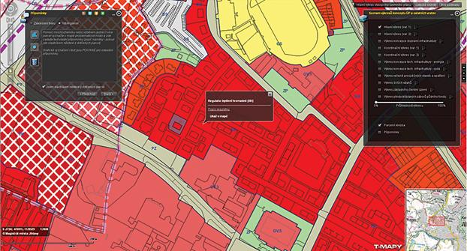

While the National Planning Standards have a particular focus on the electronical accessibility of plans, MfE remains broadly interested in the issues and opportunities associated with advancing an ePlanning system that involves all planning functions moving online. Early areas of focus are likely to be:

* online consent applications (submission and tracking)
* online submissions on plans changes
* online forms and fee payment for all services.

In addition to the benefits gained by moving plans online, the benefits of a fully functioning ePlanning system would significantly improve the plan users’ experience with the planning system.

Given the significant steps some councils have already taken in this area, the Ministry is curious about what its role could be to support the broader uptake of ePlanning functionality by councils.

The concept of a centrally developed common ePlanning system has been raised on multiple occasions, including in submissions made on *Improving our resource management system: A discussion document*.[23]

A central ePlanning system refers to a centrally developed portal that hosts planning information for all councils. At a minimum, users would visit a single platform to utilise spatial tools to identify information on planning controls, complete the entire (or most of the) application process and pay for all services online.

The benefits of such systems are that it would:

* provide the greatest improvement to plan usability, functionality and accessibility
* provide the greatest capacity for improved and increased integration of planning services between territorial and regional councils
* provide economies of scale, with such services being provided by central government.

This option is likely to be desirable to councils that have not embarked on any aspect of the ePlanning journey. However, it will impact most significantly on those councils that have innovated early by investing in developing their ePlanning capability. Requiring councils to move to a new central planning system may result in a cost to write off existing systems and move to a new central planning system. For example, in Australia, the New South Wales and the Victorian governments have invested millions of state government funding to set up and maintain planning portals.[24] The UK Government has similarly done the same. The UK planning portal contains links to all planning authorities, allowing the ability to apply for and appeal online and includes plain English interactive guides[25] to help the public understand planning. These models are easier in part, because the UK national Government and, to a point, Australian states have a more standardised system than New Zealand.

As part of any future discussions about the long-term evolution of the planning system in New Zealand, it is inevitable attention will turn not only *how to* deliver the system but also to make it a more effective via a greater use of technology. We expect to keep working with local government to explore what future systems could look like in that context.

# Next steps

We are currently in a scoping phase for the National Planning Standards. The [‘Introduction to the National Planning Standards’](http://www.mfe.govt.nz/publications/rma/introduction-national-planning-standards) overview document details the process and engagement opportunities during each stage of development. The flow chart below shows each stage of the development process and the anticipated timeframes.

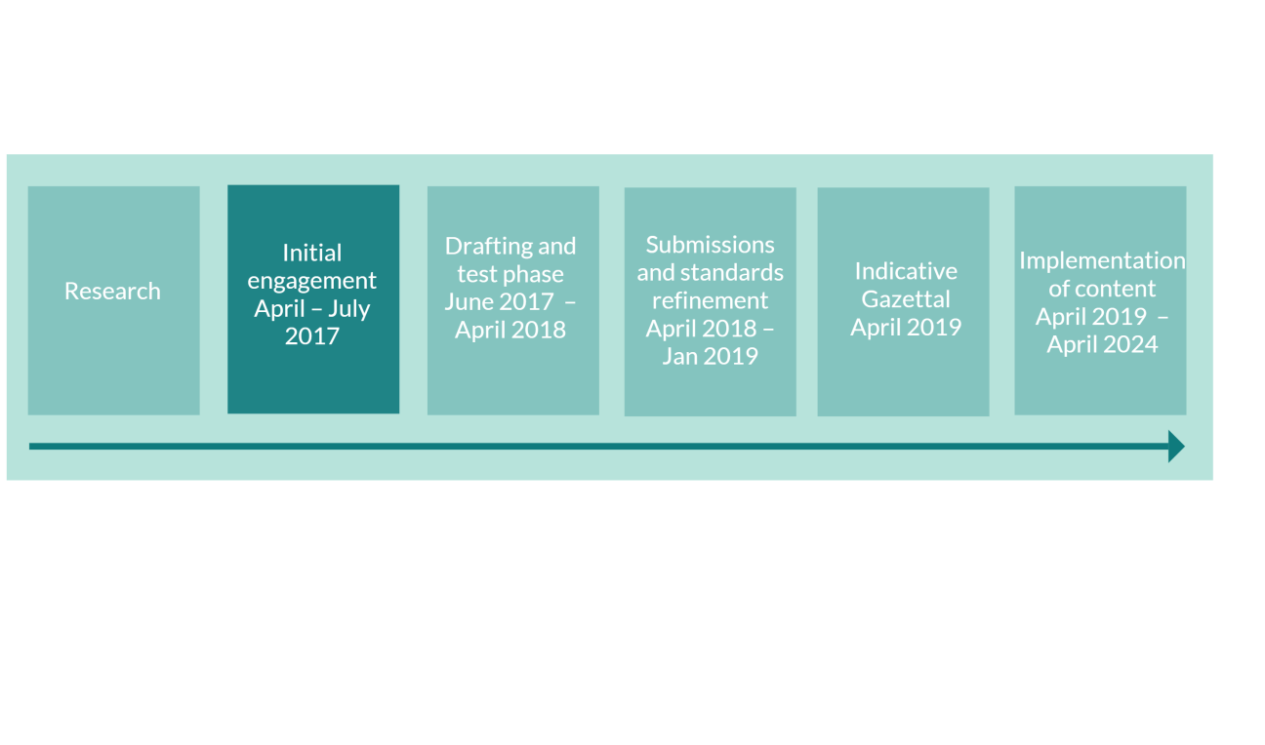

## Feedback

We now welcome your feedback on the ideas and options we have presented in this paper. Please use the questions in this paper as a guide. You do not have to answer them all and can give other constructive comments where you wish. To ensure your point of view is clearly understood, please explain your rationale and provide supporting evidence where appropriate.

We encourage you to send us feedback through the initial engagement period, which closes on 31 July 2017. Please send feedback to the email address below.

## Contact

Email: [planningstandards@mfe.govt.nz](mailto:planningstandards@mfe.govt.nz)

Website: [www.mfe.govt.nz](http://www.mfe.govt.nz)

Phone: +64 4 439 7400

# Appendix 1: Ministry for the Environment summary of plans

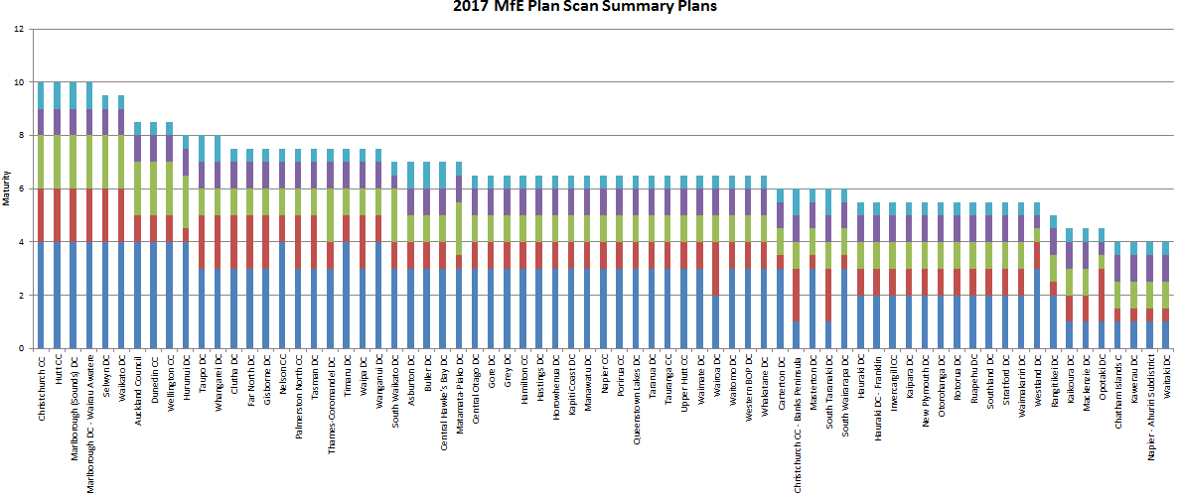

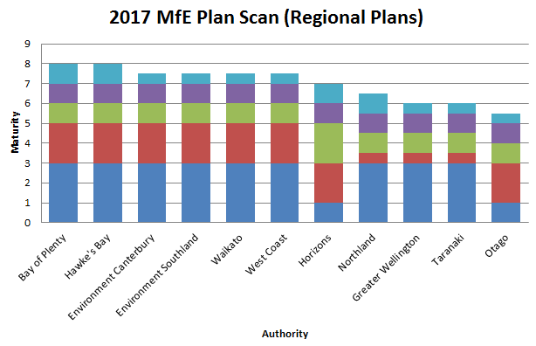

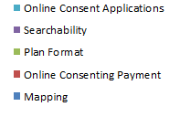

|  |  |  |  |  |  |  |
| --- | --- | --- | --- | --- | --- | --- |
| Value | Feature |  |  |  |  |  |
| Mapping |  |  |  |  |  |  |
| 1 | PDF |  |  |  |  |  |
| 2 | DP maps PDF, has GIS capability for other features | | | | |  |
| 3 | DP maps PDF, has GIS with DP layers | | | |  |  |
| 4 | DP maps are GIS | |  |  |  |  |
| Online consenting payment | | |  |  |  |  |
| 0.5 | No |  |  |  |  |  |
| 1 | Yes, but limited (rates, fines etc) | | | |  |  |
| 2 | Yes. |  |  |  |  |  |
| Plan format | |  |  |  |  |  |
| 0.5 | PDF |  |  |  |  |  |
| 1 | HTML |  |  |  |  |  |
| 2 | E-Plan |  |  |  |  |  |
| Ability to search plan for key words | | | |  |  |  |
| 0.5 | No |  |  |  |  |  |
| 1 | Yes |  |  |  |  |  |
| Online consent application | | |  |  |  |  |
| 0.5 | No |  |  |  |  |  |
| 1 | Yes |  |  |  |  |  |

# Appendix 2: Resource sharing of GIS platforms

Figure 7 shows an example of councils resource sharing to produce GIS maps for the community to use. WestMaps[26] is a partnership between West Coast Regional Council and Buller District Council.

Figure 7: WestMaps

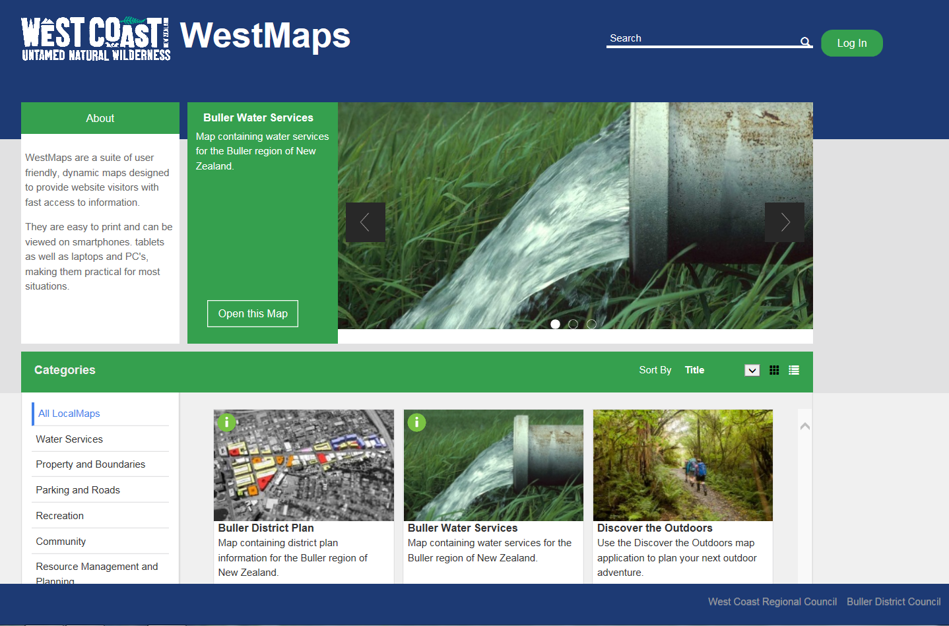

# Appendix 3: List of data sources and research

For this paper, some of the data and insight has been obtained from the following research.

**External**

* Datacom (2013) *An appraisal of the electronic delivery of land use planning systems and plans*

**Internal**

* Statistics New Zealand (2014) *Design principles for maps using New Zealand’s statistical data*
* Ministry for the Environment (2015) *ePlanning prioritisation* (internal working document)
* Ministry for the Environment (2016) *ePlanning workshop*
* Ministry for the Environment (May 2016) *ePlanning users survey*
* Ministry for the Environment (2016) *Australian planning system presentation*
* Ministry for the Environment (2016, updated 2017) *PlanScan of the e-levels of authorities* (for example, PDF versus Geographic Information System)

1. Section 58c(4f) of New Zealand Resource Legislation Amendment Act 2017 <http://www.legislation.govt.nz/act/public/2017/0015/latest/DLM6669205.html?search=ts_act%40bill%40regulation%40deemedreg_Resource+legislation__25_a&p=1>
2. Research New Zealand. 2015. *A Report on a Survey of New Zealanders’ Smartphones and other Mobile Communication Devices 2015*. Wellington: Research New Zealand. Retrieved from [www.researchnz.com/ pdf/special%20reports/research%20new%20zealand%20special%20report%20-%20use%20of%20 smartphones.pdf](http://www.researchnz.com/pdf/special%20reports/research%20new%20zealand%20special%20report%20-%20use%20of%20%20smartphones.pdf%20) (April 2017).
3. World Bank, *World Development Indicators* <http://data.worldbank.org/indicator/IT.NET.USER.P2> 3 January 2016
4. See [www.ict.govt.nz/strategy-and-action-plan/strategy/](https://www.ict.govt.nz/strategy-and-action-plan/strategy/).
5. Wellington City Council was only the second local authority outside the United States of America to offer such a service. Wellington City Council. 2013. *Thematic Heritage Study of Wellington*. Wellington: Wellington City Council. Retrieved from [http://wellington.govt.nz/~/media/services/community-and-culture/heritage/files/thematic-heritage-study.pdf?la=en](http://wellington.govt.nz/~/media/services/community-and-culture/heritage/files/thematic-heritage-study.pdf?la=en%20) (April 2017).
6. Source for illustration, PlanDev Business Solutions. 2011. *The Future of ePlanning in Australia National ePlanning Vision*, page 21. Retrieved from [http://daf.asn.au/wp-content/uploads/2015/08/National-ePlanning-Vision-2011.pdf](http://daf.asn.au/wp-content/uploads/2015/08/National-ePlanning-Vision-2011.pdf%20) (April 2017).
7. Organisation for Economic Co-operation and Development (OECD). 2015. *2015 OECD Survey on Open Government Co-ordination and Citizen Participation in the Policy Cycle*. Paris: OECD. Organisation for Economic Co-operation and Development (OECD). 2016. *Open Government: The Global Context and the Way Forward*. Paris: OECD.
8. New Zealand Government. 2017. *Stats NZ takes lead on open data*. Retrieved from [www.beehive.govt.nz/release/stats-nz-takes-lead-open-data](https://www.beehive.govt.nz/release/stats-nz-takes-lead-open-data) (April 2017).
9. Environment Canterbury. 2017. *Plans, strategies and bylaws*. Retrieved from <https://ecan.govt.nz/your-region/plans-strategies-and-bylaws/> (April 2017).
10. West Coast Maps. Retrieved from <http://gis.westcoast.govt.nz/westmaps> (April 2017).
11. Presented in appendix 1, Plan Scan – levels of ePlanning in plans provisions.
12. For example, utilities providers, planning consultants, resource management lawyers and other government agencies.
13. Overlapping plan provisions are discussed in the Regional Planning discussion paper D.
14. Ministry of Business, Innovation and Employment. 2017. *Phase One Broadband Initiatives*. Retrieved from [www.mbie.govt.nz/info-services/sectors-industries/technology-communications/communications/ broadband-mobile-initiatives/phase-one-broadband-initiatives](http://www.mbie.govt.nz/info-services/sectors-industries/technology-communications/communications/broadband-mobile-initiatives/phase-one-broadband-initiatives) (April 2017).
15. Ministry of Business, Innovation and Employment. 2016. *Rural Broadband Initiative 2 (RBI2) and Mobile Black Spot Fund policy settings*. Retrieved from [www.mbie.govt.nz/info-services/sectors-industries/%20technology-communications/fast-broadband/new-initiatives/rbi2-mbsf-policy-settings?searchterm=RBI2](http://www.mbie.govt.nz/info-services/sectors-industries/%20technology-communications/fast-broadband/new-initiatives/rbi2-mbsf-policy-settings?searchterm=RBI2) (April 2017).
16. This portal website page will fulfil the requirements of the Resource Legislation Amendment Act 2017 to ensure that all plans are accessible from a single, searchable website (section 58J).
17. For the purposes of this paper, ‘ePlan’ is defined at the beginning of the paper.
18. HTML is a mark-up language that is used to design web pages to display data, with a focus on how the data looks.
19. Plan Scan data from internal 2017 Ministry for the Environment research is set out in appendices 1 and 2.
20. This is an approximate percentage because some functionality of a true ePlan is mimicked by advanced PDF functions.
21. XML is a language whose primary purpose is to transport and store data.
22. Some estimates suggest approximately one full-time equivalent for 12 months.
23. Ministry for the Environment. 2013. *Improving our resource management system: A discussion document*. Wellington: Ministry for the Environment. Retrieved from [www.mfe.govt.nz/sites/default/files/ improving-our-resource-management-system-discussion-document.pdf](http://www.mfe.govt.nz/sites/default/files/improving-our-resource-management-system-discussion-document.pdf) (April 2017).
24. New South Wales Government, Planning and Environment. No date. *NSW Planning Portal*. Retrieved from [www.planningportal.nsw.gov.au/](https://www.planningportal.nsw.gov.au/) (April 2017).
25. Needham, K. 2016. NSW interactive guides. *Sydney Morning Herald* 11 June. Retrieved from [www.smh.com.au/nsw/nsw-government-announces-planning-portal-interactive-website-for-home-renovation-20160611-gph1fl.html](http://www.smh.com.au/nsw/nsw-government-announces-planning-portal-interactive-website-for-home-renovation-20160611-gph1fl.html) (April 2017).
26. See <http://gis.westcoast.govt.nz/westmaps> for further information.