National Planning Standards:
Formatting Plans and Policy Statements
Discussion paper E

Disclaimer
The opinions and options contained in this document are for consultation purposes only and do not reflect final Government policy. Please seek specific legal advice from a qualified professional person before undertaking any action based on the contents of this publication. The contents of this discussion document must not be construed as legal advice.
The Government does not accept any responsibility or liability whatsoever whether in contract, tort, equity or otherwise for any action taken as a result of reading, or reliance placed because of having read any part, or all, of the information in this discussion document, or for any error, inadequacy, deficiency, flaw in or omission from this document.

This document may be cited as: Ministry for the Environment. 2017. National Planning Standards: Formatting plans and policy statements – Discussion paper E. Wellington: Ministry for the Environment.

Published in May 2017 by the
Ministry for the Environment
Manatū Mō Te Taiao
PO Box 10362, Wellington 6143, New Zealand
ISBN: 978-0-908339-93-8 (online)
Publication number: ME 1298
© Crown copyright New Zealand 2017
This document is available on the Ministry for the Environment website: www.mfe.govt.nz.

Contents
Context 5
What is format and what is the opportunity here? 6
What our research tells us 6
Components of good formatting 7
Next steps 20
Feedback 20
Contact 20

Tables
Table 1: Table-based format for presenting objectives and policies 8
Table 2: Text-based format for presenting objectives and policies 9

Figures
Figure 1: How the National Planning Standards outcomes can be addressed through standards in this paper 5
Figure 1: Activity status above the description of the activity 11
Figure 2: Text–table hybrid for presenting objectives and policies 12
Figure 3: Table-based format for presenting objectives and policies 13
Figure 4: Ashburton District Plan, Figure 4-3: Recession plane application to adjacent driveways 17
Figure 5: Queenstown Lakes Proposed District Plan, Section 8.2 18

Context
Unnecessary plan variation affects the planning system by making plans difficult to interpret and onerous to prepare. The first set of national planning standards addresses this by including minimum requirements for the structure, form and core content of policy statements and plans.
This paper sets out the Ministry’s ideas for how the National Planning Standards could provide a more consistent approach to plans and national policy statements, focussing specifically on the formatting aspects of form. In doing so, this paper addresses two key objectives of the planning standards: namely, to improve the consistency and user friendliness of plans.
The paper is designed to prompt discussion and seek feedback on the approaches the Ministry for the Environment could take as part of the Planning Standards. Accordingly, matters discussed here include possible formats for rules, objectives and policies, design elements (eg, legibility, contents pages, numbering systems, headings) and ePlanning. Figure 1 below demonstrates which of the Planning Standards outcomes can be addressed through the development of standards detailed in this discussion paper.
Figure 1: How the National Planning Standards outcomes can be addressed through standards in this paper
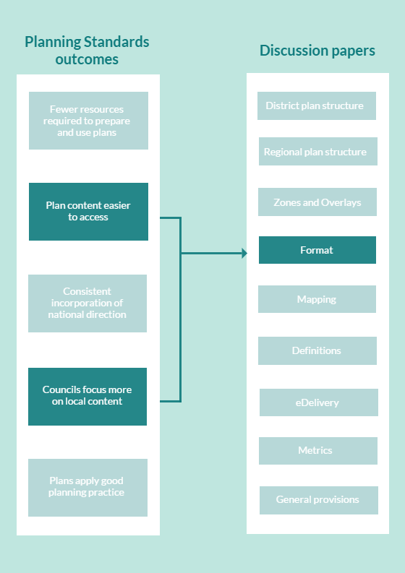

What is format and what is the opportunity here?
Plans and policy statements are mandatory parts of New Zealand’s resource management system. In the absence of specific national direction on plan structure and format, however, there is now significant variation throughout the country. Formatting, such as the design of objectives, policies and rules, contents pages, font style, numbering systems and illustrations, can be different from plan to plan. There are also diverse rule formats, which can take the form of tables, columns, flow charts and a range of text-based formats.
For users who work across different plans, diverse formats add complexity, time and cost due to the need to locate, interpret and apply relevant rules, objectives and policies. The use of consistent formatting could address these problems by helping plan users to more readily identify the similarities and differences across plans.
Formatting also influences how coherent planning documents are and how they plug into the wider planning framework.
This paper discusses potential formatting requirements that could be introduced under the National Planning Standards, including rule format, plan design and font.

What our research tells us

Plans should be well written and accessible
Best practice advice from the Quality Planning website advocates structuring plans around user expectations and conventions. It notes that many publications follow a particular organisational style and format that people subconsciously absorb and expect to see in other documents (for example, a table of contents and an introduction at the start, appendices and an index at the back).
A presentation at the Resource Management Law Association conference in 2002 focused on the way that plans are worded. It contemplated the need for every plan to be readable and accessible, with a well-organised structure and logical connections between its constituent parts.
Different approaches to drafting provisions, particularly issues, objectives and policies, affect the usability of plans. Our research indicated that plans that are succinct and drafted in plain English are the easiest to interpret and follow.

Rules should be clear and easily understood
Our research on the structure and format of regional plans made the following recommendations on the format of regional plan rules:
- the activity status of each rule should be located within the heading of the rule (or in the rule row, when using a table format)
- activity status summary tables should be used at the start of each chapter
- matters of control and discretion should be located with the rule rather than in a separate section.
These findings are also applicable to district and unitary plans.

Contents pages should be user friendly
Contents pages are most advantageous for the user when they are limited to 1–2 pages at the beginning of a plan and supplemented by miniature contents pages at the start of each chapter. Our research also highlighted the advantages of interactive contents pages in a web-based environment, particularly in terms of improved navigability.

Numbering systems and cross referencing can improve navigability
Numbering systems and cross referencing have also been identified as two formatting issues that varied significantly. The easiest plans to navigate were those that followed the numbering system advocated by best practice guidance (eg, the partially operative Hamilton City District Plan). The use and style of cross references were also highly variable, with some plans including very little cross referencing, while others included extensive cross references both within the text and rules tables (eg, the proposed Kāpiti Coast District Plan).

Components of good formatting
Good formatting should increase the clarity, usability and accessibility of plans for resource management professionals and members of the public.
This paper outlines our thinking on how standardising the format of plans and policy statements could achieve this. In some instances, a number of options are presented and our preference indicated. In others, basic principles are set out and questions asked. In each case, we are looking for your feedback.
The following discussion is based on five key areas.
- The format and layout of objectives, policies and rules influence and affect the readability of a plan. Achieving a common layout for these plan elements will standardise the look and feel of plans.
- Navigational tools that affect usability and legibility include tables of contents, the use of headings and subheadings and the numbering system. A number of principles are outlined in relation to each of these aspects of plan format.
- Elements of user-friendly design, such as legibility, use of colour, page layout and illustrations are also discussed. These elements contribute to the look and feel of a plan and can be used to improve accessibility and readability.
- Increasingly, plans are required to work in an ePlanning environment and be delivered online, as well as seeking to achieve a standard of plain English that improves overall understanding of plan content.

Objectives, policies and rules

Well-formatted objectives and policies: Two options
A consistent layout of objectives and policies will create plans that have a common look and feel, improving usability. Two options for the layout of objectives and policies are considered below. Both options assume that the objectives and policies for a given topic are set out in the same chapter. This reflects the preferred option in the district and regional planning structure papers, which signal a preference for a plan structure where there is a clear line of sight between objectives, policies and methods.

Option 1: Table-based format
Presenting objectives and policies in a table ensures that policies are clearly linked to the specific objective they are designed to achieve. Within a given chapter, this may mean that policies (which contribute to several different objectives) are repeated several times under each of those different objectives. The need to provide a clear line of sight between the objectives and policies may override the issue of policies being repeated.
In practice, this format will result in objective and policies sections that resemble Table 1. Please note that the text below simply acts as a placeholder.
Table 1: Table-based format for presenting objectives and policies
Objective 4.2 | Policies
Various forms of residential density and different dwelling types provide sectors of the community with dwelling choices and high levels of amenity. | Policy (a)  A mix of residential densities shall be encouraged to provide for a variety of dwelling options.
Policy (b)
Residential subdivision and development should efficiently place dwellings on a site to minimise unused space and maximise on-site amenity and usable open space.

Option 2: Text-based format
The alternative model would allow local authorities to present objectives and policies in a text format. In this option, an objective would be set out in free-flowing text, followed by each of the supporting policies.
Table 2 shows what this option could look like in practice. Again, please note that the text does not reflect suggested content and simply acts as a placeholder.
Table 2: Text-based format for presenting objectives and policies
4.2 Residential objectives and policies
Objective 4.2(a)
Various forms of residential density and different dwelling types provide sectors of the community with dwelling choices and high levels of amenity.
Policies
4.2(a)(i) A mix of residential densities shall be encouraged to provide for a variety of dwelling options.
4.2(a)(ii) Residential subdivision and development should efficiently place dwellings on a site to minimise unused space and maximise on-site amenity and usable open space.

Does the Ministry for the Environment have a preferred option?
We currently prefer a table-based format, because it aids accessibility and creates a stronger link between objectives and policies. However, the preferred option may be strongly influenced by other factors, including the research currently being conducted with lay users of plans.
This paper does not address layout for policy explanations and where these should be located within these formats. We consider this to be closely connected to the approach used by councils for drafting their objectives and policies. We have heard some practitioners say that well-drafted policies should not need policy explanations. We have also heard that policy explanations can provide valuable context to a policy.
The Environment Court is taking an active interest in how plan provisions are drafted. Any guidance on policy drafting, and therefore the need for policy explanations, may benefit and inform future work on the National Planning Standards.
Questions
E.1. Which option do you consider to more clearly link the objectives and policies? Why?
E.2. Are there alternative formats that you would recommend?

Clear rule formats that include four key elements
Plan rules have been formatted in a variety of ways in district and regional plans across the country and can include tables, columns, flow charts and different text-based formats.
Any format should include the following main elements:
- A rule summary table that provides the key rule information at a glance, grouped by general classes of activities (residential, commercial, industrial, rural and so on) that has:
- a rule number (unique identifier within the plan)
- activity name (using the broad activity category principle)
- activity status (P, C, RD, D, NC, Pro)
- short descriptors of standards that must be met for that particular activity status, for example: ‘zone standards’ or ‘goods sold on site’, with a reference (unique identifier) to the text (or separate table) description of the standard
- the activity status (P, C, RD, D, NC, Pro) if the standard(s) are not met.
- Full details on the standards relevant to general zone activities or specific activities: text, tables, diagrams, other content.
- Full details on the controlled and restricted discretionary matters and assessment criteria (if relevant) that apply to controlled and restricted discretionary activities.
- Non-statutory advice notes should be limited where possible.
There are two options for the placement of standards. Standards can be included within the body of the rule or separated from the main rule (ie, in a different chapter). Standards are often common to a number of rules and activities and their inclusion within each rule creates duplication and long rules. Separating standards from the rules does, however, mean that another part of the plan needs to be referred to determine activity status. Our preference is for the standards to be located in a separate section within the chapter or to form a separate chapter.
The following options combine each of these elements. Each option includes a model showing the layout of the various elements, followed by an example of how this may work in practice. Please note that the text used in these examples acts as a placeholder only and does not represent content being proposed by the standards.

Option 1: Activity status above the description of the activity
The strengths of this model include a clear indication of the activity status and a summary of the relevant standards within the format (see figure 1). The vertical layout makes it easy to locate and read the necessary information.
The disadvantage of this format is that the inclusion of the standards within the rule framework can make individual rules, and the rules section as a whole, quite lengthy.
Figure 1: Activity status above the description of the activity
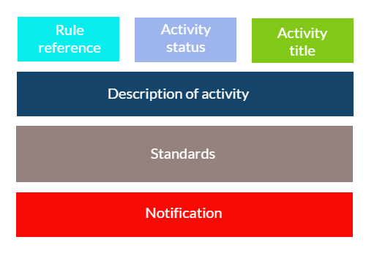
Rule 5 | Status: Permitted discretionary | Activity title: Residential activities
5.1 Activity description
5.1(a) Permitted activities
Residential activities are Permitted Activities, provided they comply with the standards specified in section 5.6.1 (Activities).

5.1(b) Discretionary activities
Residential activities that would be Permitted Activities but that do not meet one or more of the standards outlined in section 5.6.1 (Activities) are Discretionary Activities. Discretion is limited to the effects generated by the standards not met:
- fixed plant noise (Standard XX)
- vehicle parking (Standard XX)
- site access (Standard XX)

subject to compliance with the following condition:
- noise emission levels under standard XX (fixed plant noise) shall not be exceeded by more than 5 decibels. This condition does not apply to temporary activity noise.
5.2 Activity standards
These standards apply to all activities in the residential area:
- noise (Standard XX)
- fixed plant noise (Standard XX)
- vehicle parking (Standard XX)
- site access (Standard XX)
- work from home activities (Standard XX)
- use, storage and handling of hazardous substances (Standard XX)
- signage (Standard XX)
- waste management (Standard XX)
- other (Standard XX).

5.3 Notification
In respect of rule 5.1(b), applications will not be publicly notified (unless special circumstances exist) or limited notified, except that, in relation to xxxx (vehicle parking) and xxxx (site access), the New Zealand Transport Agency must be notified where it is considered to be an affected party to an application.

Option 2: Text–table hybrid
This format enables each individual feature (ie, activity title, rule reference and activity status) to be easily identified (see figure 2). The separation of the standards into a different section results in very precise rule tables.
The disadvantage of this option is that the user would need to scroll down the page to see a summary of the relevant standards and refer to a different section to see whether a proposed activity meets the standards.
Figure 2: Text–table hybrid for presenting objectives and policies
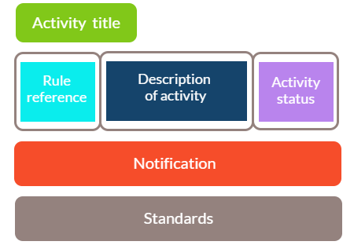
Residential activities
Rule 5 | 5.1 Activity description  5.1(a) Permitted activities  Residential activities are Permitted Activities provided they comply with the standards specified in section 5.6.1 (Activities). |  | Permitted
 | 5.1(b) Discretionary activities  Residential activities that would be Permitted Activities but that do not meet one or more of the standards outlined in section 5.6.1 (Activities) are Discretionary Activities. Discretion is limited to the effects generated by the standards not met:  i) fixed plant noise (standard 5.6.1.2)  ii) vehicle parking (standard 5.6.1.3)  iii) site access (standard 5.6.1.4)  subject to compliance with the following condition:  iv) noise emission levels under standard 5.6.1.2 (fixed plant noise) shall not be exceeded by more than 5 decibels. This condition does not apply to temporary activity noise. |  | Discretionary
5.2 Notification
In respect of rule 5.1(b), applications will not be publicly notified (unless special circumstances exist) or limited notified, except that, in relation to xxxx (vehicle parking) and xxxx (site access), the New Zealand Transport Agency must be notified where it is considered to be an affected party to an application.
5.3 Activity standards
These standards apply to all activities in the residential area:
a) noise (Standard XX)
b) fixed plant noise (Standard XX)
c) vehicle parking (Standard XX)
d) site access (Standard XX)
e) work from home activities (Standard XX)
f) use, storage and handling of hazardous substances (Standard XX)
g) signage (Standard XX)
h) waste management (Standard XX)
i) other (Standard XX).

Option 3: Table
A third option is the entirely table-based format as shown in figure 3. This model sets each element out in its own column, enabling to be easily identified and read. In contrast to options 1 and 2 above, this requires the reader to read the rule from left to right.
However, this option has the potential to create long columns, some of which may be sparsely populated (ie, activity status), while others will contain a significant amount of text (ie, standards and assessment criteria). As a result, this may not represent the best use of space or be the most readable or user friendly of the options.
Figure 3: Table-based format for presenting objectives and policies
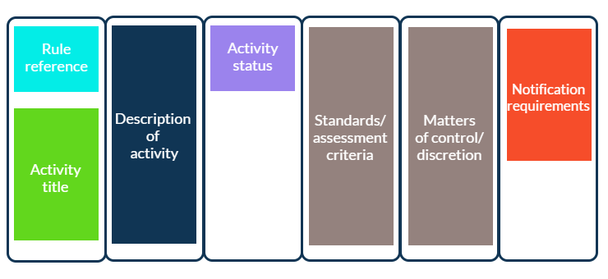

Rule 5
Residential activities | 5.1 Activity description |  | 5.2 Activity standards | 5.3 Notification
 | 5.1(a) Permitted activities  Residential activities are Permitted Activities provided they comply with the standards specified in section 5.6.1 (Activities)  5.1(b) Discretionary activities  Residential activities which would be Permitted Activities but which do not meet one or more of the standards outlined in section 5.6.1 (Activities) are Discretionary Activities. Discretion is limited to the effects generated by the standards not met:  - fixed plant noise (standard 5.6.1.2)  - vehicle parking (standard 5.6.1.3)  - site access (standard 5.6.1.4)  subject to compliance with the following condition:  - noise emission levels under standard 5.6.1.2 (fixed plant noise) shall not be exceeded by more than 5 decibels. This condition does not apply to temporary activity noise. | Permitted  Discretionary | These standards apply to all activities in the Residential Area:  - noise(Standard XX)  - fixed plant noise (Standard XX)  - vehicle parking (Standard XX)  - site access (Standard XX)  - work from home activities (Standard XX)  - use, storage and handling of hazardous substances (Standard XX)  - signage (Standard XX)  - waste management (Standard XX)  - other (Standard XX). | In respect of rule 5.1(b), applications will not be publicly notified (unless special circumstances exist) or limited notified, except that, in relation to xxxx (vehicle parking) and xxxx (site access), the New Zealand Transport Agency must be notified where it is considered to be an affected party to an application.

Does the Ministry for the Environment have a preferred option?
The Ministry prefers the text–table hybrid represented by Option 2 for the following reasons:
- This format presents each element clearly, allowing the user to quickly understand the purpose and scope of the rule and ascertain its applicability to their proposed activity.
- The activity description provides an in-depth understanding of the rule’s intent.
- The format highlights the activity status.
- Everything is in the one place (including an indication of the relevant performance standards), which enhances the plan’s readability, flow and user friendliness.
Questions
E.3. Where do you think performance standards should be located? Why?
E.4. Do you agree with the Ministry’s preference for the text–table hybrid (Option 2)? What do you perceive to be its advantages and disadvantages?
E.5. Are there any other elements that you consider essential to any rule format?

Navigational tools

Concise and interactive tables of contents
Tables of contents can greatly improve the navigation of a plan or an individual plan chapter. Our research found that a concise contents page (ie, 1–2 pages) at the beginning of a plan was invaluable. A specified format for a table of contents is likely to be part of a planning standard. ePlans and online versions of plans and policy statements should include links that take the user to the relevant sections or chapters of the plan.
Question
E.6. Do you agree with the principles outlined above? How do you think contents pages can best serve plan users?

Consistent numbering systems
A numbering system that is consistent across plans and policy statements, and provides each provision with a unique reference number or code is important. Any system should easily distinguish between elements of the plan - for example, issues, objectives, policies and rules.
Best practice indicates that the length of sequential numbers and/or letters should be minimised, with a maximum of four ‘rungs’ (eg, Rule 11.2(a)(ii) rather than Rule 11.2.7.4.3(a)). The numbering system should also be logical and align with the structure of the various plan sections and improve a plan’s ease of reference and accessibility. The use of an alpha-numeric numbering system may also help with memorability and increase usability.
Numbering systems also need to be resilient to plan changes, additions and deletions.
Question
E.7. Do you agree with the principles outlined above? Why or why not?

Clear and simple headings and subheadings
The formatting and style of headings and subheadings is another element that could be standardised across all plans and policy statements. Each heading and subheading should be clear and identifiable, delineating sections and subsections in a simple and obvious way.
Question
E.8. How can headings be used to guide and help plan users?

User-friendly design
Across the country, no two plans are alike. The design of plans includes elements such as font, illustrations, colour and page layout (for paper-based plans), each of which will determine what a plan looks like.
Standardising design elements will provide a sense of familiarity across different plans and enable users to identify the section they need quickly and easily. However, we also acknowledge that councils may wish their plans to look as if they are ‘their own’. The National Planning Standards will provide a number of opportunities for this, for example, through the cover design, headers and footers in paper-based versions and front pages for websites.

Legible text
Font affects the look and legibility of district, regional and unitary plans and the National Planning Standards could therefore prescribe the font and size. Any font selected should be readable, widely available and compatible with the use of macrons. The use of bold, underlining, italics and font size in certain situations – for example, to more clearly indicate headings, subheadings and key provisions also affects legibility and could be standardised.
The choice of font should also be informed by looking at the fonts commonly used in plans, together with their e-reader functionality and feedback received from plan users.
Plans also need to be accessible to users who are visually impaired. Accessible formats provide alternative versions of print-based sources to meet the needs of individual plan users, including file formats that are capable of enlargement. PDF formats, for example, are compatible with text-to-speech programmes and can be magnified without affecting the resolution or quality of the image. Audio files could also be linked to individual plan sections.
We consider that there are two ways to ensure that these standards are met.

Option 1: Prescribe font size and style
The first option is to prescribe font size and style. This is the approach taken by the Victorian Government in Australia, where the state planning template not only prescribes fonts and text size, but also things such as spacing. While this approach results in uniform plans, it also affects corporate branding and the individual identity of local authorities.

Option 2: Set standards for the font size and style to be used
This option would stop short of prescribing font style but, instead, allow local authorities to select their own fonts provided they comply with certain standards. These could include (but not be limited to) the following requirements:
- font should be compatible with eReaders and ePlan formats
- font should be widely available
- font should be easy to read and cater for people with impaired vision and cognitive disabilities.
This option would enable local authorities to express a degree of individuality and maintain their corporate branding, while also ensuring the readability of plans. By the same token, however, it would result in slight variations in the look and feel of plans across the country.
Questions
E.9. Which option do you prefer?
E.10. Do you think the National Planning Standards should prescribe font style? Why?

Explanatory illustrations
The use of illustrations can improve the accessibility of plans by providing an alternative (and sometimes simpler) means of communicating a concept. Diagrams are already common in district plans to help users understand ideas, such as height in relation to boundary requirements (also known as recession planes and sunlight access planes) (see figure 4).
Figure 4: Ashburton District Plan, Figure 4-3: Recession plane application to adjacent driveways
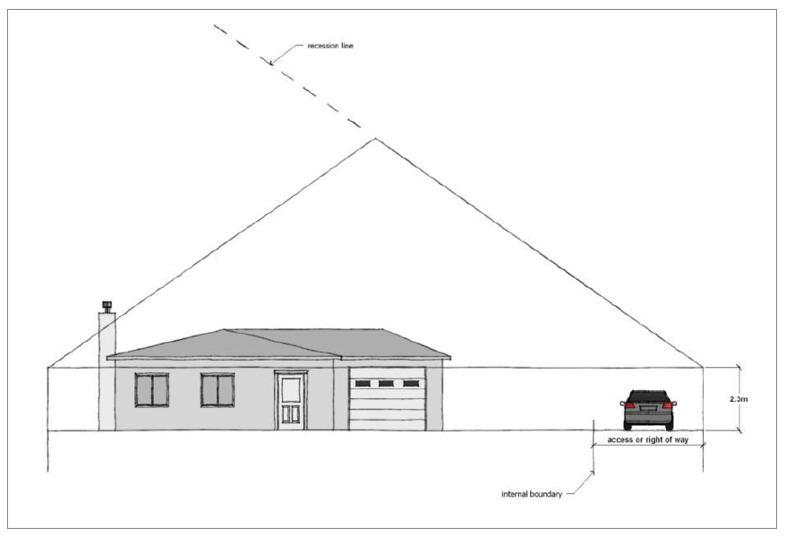
Source: Ashburton District Council
Question
E.11. Can you think of any examples where illustrations and/or diagrams could enhance the usability of plans and policy statements?

Strategic use of colour
Some plans use colour to define sections and highlight elements. The Queenstown Lakes District Plan, for example, uses colour to highlight the number and name of the section and, together with the use of bold font, clearly distinguish between the objectives and underlying policies (see figure 5). The use of a colour banner to the right of the page also creates clear divisions within each section and/or chapter to enhance its readability and usability. In other plans, such as the proposed Thames–Coromandel District Plan (Decisions Version), colour is used sparingly and primarily delineates the different sections within the tables used throughout the plan (ie, activity tables).
While there are distinct advantages, it is worth noting that colour may increase the costs associated with paper-based copies and producing hard copies from electronic versions of plans. A colour plan printed in black and white may also result in decreased legibility.
Given the movement towards ePlanning, the use of colour seems likely, but the choices will need to be deliberate. The colours chosen will need to be printable in grayscale without adversely affecting the plan’s readability and should comply with the New Zealand Government Web Standards.
Figure 5: Queenstown Lakes Proposed District Plan, Section 8.2
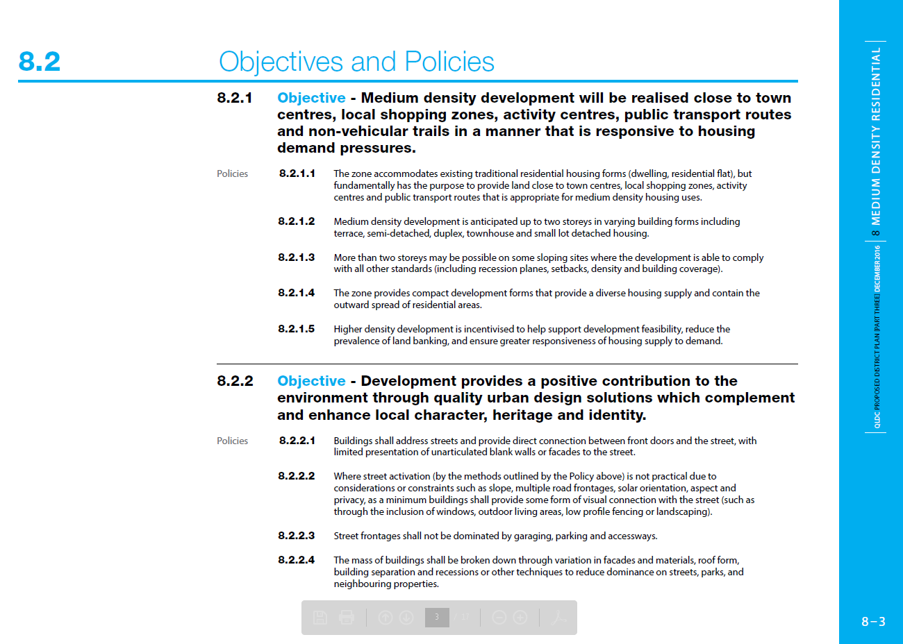
Source: Queenstown Lakes District Council
Note: This image was taken from one of the PDF files available on the Council’s website. These elements would ideally be carried across to the ePlan.
Question
E.12. Are you aware of any examples of plans and/or policy statements that have used colour in an innovative way? How has this helped plan users?

Effective page layout
In developing this paper, a survey of 23 district plans was undertaken. Of these, only the Queenstown Lakes District Plan had a landscape page layout. A portrait layout is considered more efficient as it allows greater ease of use (particularly in terms of their use in ring binders) and allows more text to fit on a page.

Does the Ministry for the Environment have a preferred option for these elements?
Some work is still needed to identify what would be optimal in terms of font, page layout, illustrations and colour. Some of these design choices may be affected by decisions on other aspects of the planning standards and input from graphic design professionals or be required to conform to government standards. At this stage, the Ministry does not have any preferred options, but is interested in your thoughts on these aspects of plan format.

Formats that work in an ePlanning environment
One of the key drivers towards ePlanning is usability. Searchability, cross referencing and the provision of a ‘one-stop shop’ that provides easy access to information and stronger links between sections all contribute to usability. The goal is to make it easier for all plan users to interact with and understand plans and the wider planning system.
The formatting of plans and regional policy statements needs to be appropriate for an eDelivery environment, whether this takes the form of PDFs or ePlans. Any revisions to ePlans will need to be checked regularly to ensure they have not resulted in formatting anomalies, such as hyperlinks that no longer work or that take the reader to the wrong page. Errors may also result from incorrectly formatted word processed text being converted to HTML (web formatting). In developing ePlans, the user’s ability to capture and communicate the relevant sections should be considered.
Please see the paper on the eDelivery of plans and policy statements for further information and an opportunity to comment.
Questions
E.13. What do you consider to be the key formatting elements in an ePlan context?
E.14. How could the National Planning Standards use formatting to enhance the usability of plans and policy statements?

Plain English
Provisions should be succinct and precise, using the principles of ‘plain English’ and ideally aiming for the standards represented by New Zealand’s WriteMark and Plain English Awards. This would require plans and policy statements to be drafted in clear and unambiguous language that is both technically and legally robust. In addition, the ordinary and natural meaning of words should be used (and used consistently) to ensure that the documents are accessible and provide certainty for users.
Question
E.15. How easily could the plain English principles be applied in the context of plans and policy statements?

Next steps
We are currently in a scoping phase for the National Planning Standards. The ‘Introduction to the National Planning Standards’ overview document details the process and engagement opportunities during each stage of development. The flow chart below shows each stage of the development process and the anticipated timeframes.

Feedback
We welcome your feedback on the ideas and options presented in this paper. Please use the questions in this paper as a guide. You do not have to answer them all and can give other constructive comments where you wish. To ensure your point of view is clearly understood, please explain your rationale and provide supporting evidence where appropriate.
We encourage you to send us feedback throughout the initial engagement period, which closes on 31 July 2017. Please send feedback to the email address below.

Contact
Email: planningstandards@mfe.govt.nz
Website: www.mfe.govt.nz
Phone: +64 4 439 7400

See www.qualityplanning.org.nz/index.php/plan-steps/structuring-plans/plan-structure-overarching-principles.
4Sight Consulting. 2015. Urban Zones Research. Prepared for the Ministry for the Environment by 4Sight Consulting. Wellington: Ministry for the Environment.
The Hamilton City and Ashburton district plans were considered to be good examples.
Beca Ltd. 2016. Ministry for the Environment – Review of Structure and Format of Regional Plans and Interaction with District Plans. Prepared for the Ministry for the Environment by Beca Ltd. Wellington: Ministry for the Environment; Beca Ltd. 2017. Ministry for the Environment – Regional Rules Structure and Format. Prepared for the Ministry for the Environment by Beca Ltd. Wellington: Ministry for the Environment.
Beca Ltd. 2016. Ministry for the Environment – Review of Structure and Format of Regional Plans and Interaction with District Plans. Prepared for the Ministry for the Environment by Beca Ltd. Wellington: Ministry for the Environment.
The placement of objectives and policies in relation to each other is explored more fully in the papers on district plan structure and regional planning structure.
Beca Ltd. 2017. Ministry for the Environment – Regional Rules Structure and Format. Prepared for the Ministry for the Environment by Beca Ltd. Wellington: Ministry for the Environment, p 8.
Beca Ltd. 2017. Ministry for the Environment – Regional Rules Structure and Format. Prepared for the Ministry for the Environment by Beca Ltd. Wellington: Ministry for the Environment, p 13.
Beca Ltd. 2017. Ministry for the Environment – Regional Rules Structure and Format. Prepared for the Ministry for the Environment by Beca Ltd. Wellington: Ministry for the Environment, p 13.
See https://webtoolkit.govt.nz/guidance/design-and-development/document-accessibility-guide-microsoft-word/.
See www.qldc.govt.nz/assets/Uploads/Planning/District-Plan/PDP-Chapters/Chapter-8-Medium-Density-Residential.pdf.
See https://webtoolkit.govt.nz/standards.
For example, linking sometimes disparate functions (ie, consenting, monitoring, plan enquiries, submissions) into single tools.
The WriteMark is a quality mark awarded to documents that are written to communications whose ‘wording, structure, and design are so clear that the intended readers can easily find what they need, understand what they find, and use that information’. The New Plymouth District Council currently holds a WriteMark for its guide ‘How to apply for resource consent’, demonstrating that this is an achievable goal for national planning standards in New Zealand. Please see the following link for further information: www.writemark.co.nz/about-the-writemark.
See www.plainenglishawards.org.nz.

