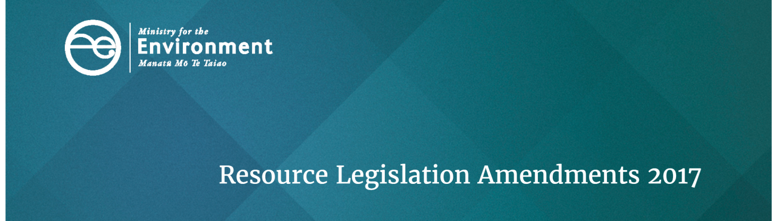
Checklist for councils: New mandatory actions from the 2017 Resource Legislation Amendments
The Resource Legislation Amendment Bill became law on 18 April 2017. This table lists the new actions that councils must take to implement the changes. It does not include:
- new optional processes for councils
- mandatory requirements that may arise through new regulations, national policy statements, or national environmental standards that may be issued under the RMA

Topic | RMA section(s) |  | Task | Fact sheet number  (for more info)
Apply from day after 19 April 2017
Natural hazards | s6 | Recognise and provide for management of significant risks from natural hazards. |  | 2
Animal drinking water | s14 | Treat ‘natural’ and ‘non-natural’ persons (including companies and trusts) the same as private individuals when managing animal drinking water. |  | 2
Procedural principles | s18A | Incorporate new principles for efficiency, clarity and collaboration in council RMA procedures. |  | 2
Development capacity | s30-31 | Establish, implement and review objectives, policies and methods to ensure sufficient development capacity to meet long-term demands of the region/district/city (also see NPS Urban Development Capacity). |  | 2
Hazardous Substances | s30 and s31 | Be aware that regional and territorial authorities no longer have the explicit function to control certain matters related to hazardous substances. |  | 2
Section 32 reports | s32 | Include iwi authority advice and the response to this in section 32 evaluation reports. |  | 3
Plan hearing panel | s34A | Consult iwi about including a commissioner with tikanga Maori and local iwi/hapu perspective to a plan hearing panel, and appoint if appropriate. |  | 3
Monitoring RMA processes | s35 | Monitor efficiency and effectiveness of council processes, powers, functions, duties. |  | 2
Mana whakahono a rohe/iwi participation arrangement | s35A, s58K-T, cl 1A, 1B and 26A of Schedule 1 | Respond to requests by iwi authorities for a mana whakahono a rohe/iwi participation arrangement, and prepare it within 18 months (unless otherwise agreed) – see new section 58P Keep records about these arrangements. |  | 3
Combined plans | s80 | Apply RMA Part 5 requirements when preparing a combined plan. |  | 4
Written notice to requiring authorities about district plan reviews | Schedule 1 cl 4 | State which planning process the council intends to use (SPP, CPP or Part 1 Schedule 1) in written notices to requiring authorities (and other information if the council intends to use the collaborative planning process). |  | 4, 5 and 6
Iwi input to draft plans | Schedule 1 cl 4A | Seek and have particular regard to iwi advice on draft policy statements and plans. |  | 3
Land acquisition | Public Works Act  s 72 – 72E | Adjust compensation payments for taking private land under the Public Works Act. |  | 16
Apply from 18 October 2017
Public notices | s2AB | Publish public notices on an internet site, with a summary in one or more newspapers.  Ensure the notice and the short summary are worded in clear and concise manner. |  | 13
Subdivision | s11 | Check implications of subdivision being permitted unless it is restricted by a rule in a NES or a plan. |  | 2
 | s6, 106, and 220 | Ensure subdivision consent processes incorporate new requirements related to natural hazards. |  | 10
Fast-track consents | s87AAC and 87AAD | Apply new consent process for fast-track consent applications. |  | 8
Boundary activities | s87AAB – 87BA | Establish a system to record, charge and issue notices for permitted ‘boundary activities’. |  | 8
Consent Exemptions | s87BB | Establish a system to record, charge and issue resource consent waivers for marginal/temporary non-compliance. |  | 8
Consent notification | s95 – 95E | Apply new step by step process to determine public or limited notification of resource consent applications. |  | 9
Consent decisions | s104 | Have regard to measures proposed by an applicant to offset or compensate for adverse effects |  | 10
 | s108AA | Ensure resource consent conditions comply with new section 108AA. |  | 10
Consent appeals | s120 | Ensure that any advice is consistent with the new limits on Environment Court appeal rights. |  | 14
Electronic address | s352 | If a person has specified an electronic address for service, and has not requested an alternative, ensure the electronic address is used as an address for service. |  | 13
Objections to consents | s357AB, 357C, and 357CA | Incorporate independent commissioner changes to the objection process for consents. |  | 14
Plan-making extensions | Schedule 1 clause s10A | If required, apply to the Minister for any extension to the 2-year timeframe for plan-making. |  | 4
Apply within one year of first national planning standards publication (which will be 18 April 2019)
National planning standards | s58H | Amend planning documents to give effect to the directions provided by the national planning standards that do not require using the Schedule 1 process, unless the standard itself provides a different timeframe. |  | 1
Online plans | s58J | Ensure all planning documents (and changes/variations) are freely available for use on a single website
Apply by 18 April 2022
Financial contributions | Schedule 12 cl 18 | Amend plans to remove financial contribution provisions. |  | 4
Apply within five years of first national planning standards publication
National planning standards | s58I | Amend planning documents to give effect to the national planning standards that require using the Schedule 1 process, unless the standard itself provides a different timeframe. |  | 1

Find out more
Contact the Ministry for the Environment by emailing info@mfe.govt.nz or visit www.mfe.govt.nz/rma.
If you are a council staff member you can subscribe to the Resource Legislation Amendments forum on the Society of Local Government Managers ‘LG Connect’ service.

Disclaimer
The information in this publication is, according to the Ministry for the Environment’s best efforts, accurate at the time of publication. The information provided does not alter the laws of New Zealand and other official guidelines or requirements. Users should take specific advice from qualified professional people before undertaking any action as a result of information obtained from this publication.
The Ministry for the Environment does not accept any responsibility or liability whether in contract, tort, equity or otherwise for any action taken as a result of reading, or reliance placed on the Ministry for the Environment because of having read any part, or all, of the information in this publication or for any error, or inadequacy, deficiency, flaw in or omission from the information provided in this publication.

Published in April 2017 by the
Ministry for the Environment
Publication number: INFO 785
