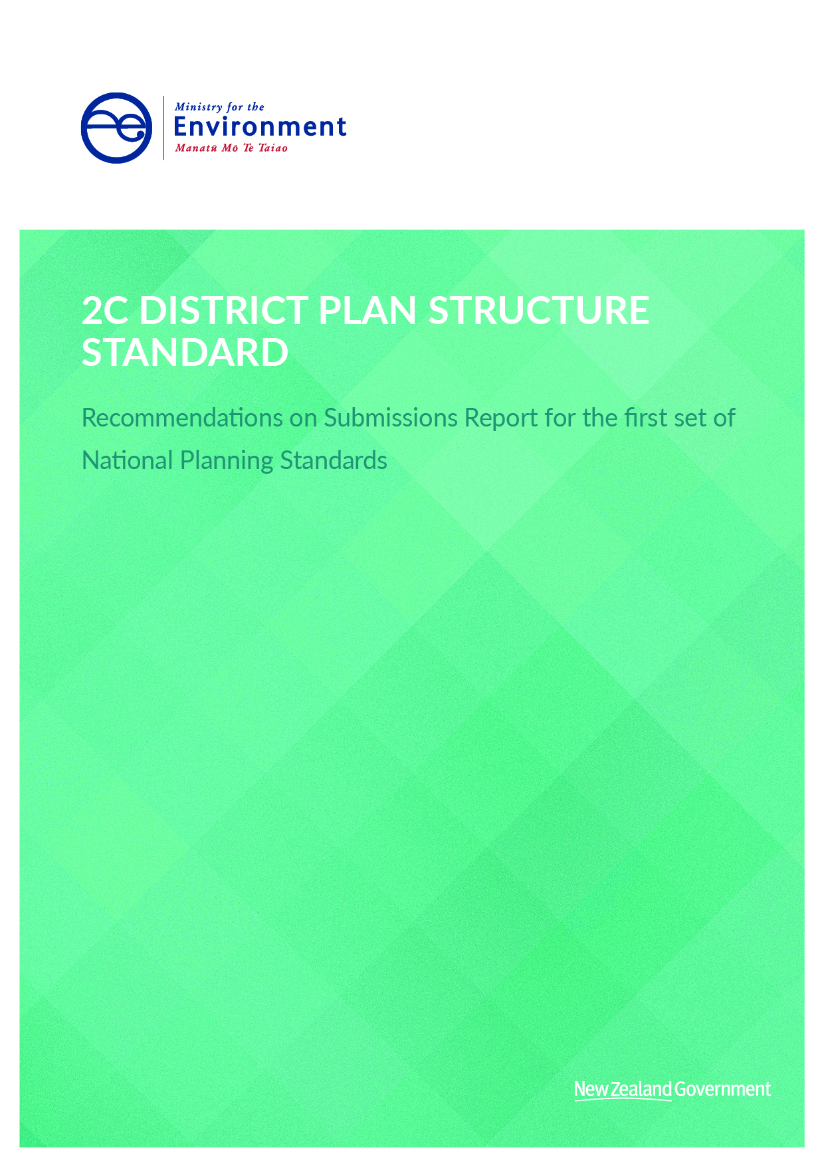

This document may be cited as: Ministry for the Environment. 2019. 2C District Plan Structure Standard - Recommendations on Submissions Report for the first set of National Planning Standards. Wellington: Ministry for the Environment.

Published in April 2019 by the
Ministry for the Environment
Manatū Mō Te Taiao
PO Box 10362, Wellington 6143, New Zealand
ISBN: 978-1-98-857902-3 (online)
Publication number: ME 1398
© Crown copyright New Zealand 2019
This document is available on the Ministry for the Environment website: www.mfe.govt.nz.

Contents
Context to this document 4
1 District plan structure 5
1.1 Background 5
1.2 Scope of this report and general approach to analysis of submissions 5
2 High-level architecture of District Plan Structure Standard 6
2.1 Submissions 6
3 Specific queries on topic order and where certain matters go 10
3.1 Submissions, analysis and recommendations 10
3.2 Grouping and order of topics 10
3.3 Coastal-related provisions 11
3.4 Referenced documents 11
4 Recommendations 12

Context to this document
This document forms part of the suite of recommendations on submissions reports prepared for the National Planning Standards. It should be read in conjunction with the Overall Introduction and is likely to reference the other recommendations on submissions reports listed below. The recommendations on submissions reports are organised as follows:
- Overall introduction
- Explanation of all of the recommendations on submissions reports
- High-level submissions analysis
Detailed recommendation reports
- Regional Policy Statement Structure Standard report
- Regional Plan Structure Standard report
- District Plan Structure Standard
- Combined Plan Structure Standard
- Chapter Standards report including
- Introduction and General Provisions Standard
- National Direction
- Tangata Whenua Standard
- Strategic Direction Standard
- District-wide Matters Standard
- Designations Standard
- Schedules, Appendices and Maps Standard
- Format Standard including
- Chapter Form Standard
- Status of Rules and Other Text and Numbering Form Standard
- Zone Framework Standard
- Spatial Layers Standards including
- Regional Spatial Layers Standard
- District Spatial Layers Standard
- Definitions Standard
- Noise and Vibration Metrics Standard
- Electronic Accessibility and Functionality Standard including
- Baseline electronic accessibility
- Online interactive plans
- Mapping Standard
- Implementation of the Standards

District plan structure

Background
The District Plan Structure Standard forms part of the package of National Planning Standards. The draft District Plan Standard prescribed the name and order of the main parts, chapters and sections of district plans. The standard clarified that councils can still add locally derived sections, if required. That is, the plan structure sought to standardise district plans at three main levels, but it provided flexibility for councils to have other sections as needed. The standards also set out what subject material plans must or can contain, including national direction and designations.

Scope of this report and general approach to analysis of submissions
This report assesses submissions on the overall draft District Plan Structure Standard, that is, the high level architecture of the standard and how the different components relate to each other. More detailed submissions on individual directions and chapters are addressed in the report 2E Chapter Standards. These two reports should be read in conjunction, to receive a full picture of the recommendations affecting district plans.
This report summarises submissions and sets out our analysis on a theme basis. The main themes identified for this report are:
- high-level architecture of the District Plan Structure Standard
- specific queries on topic order and where certain matters go.

High-level architecture of District Plan Structure Standard

Submissions

Broad support
There was broad support from councils and other plan users for the approach taken in the District Plan Structure Standard.
Manawatu District Council supported the purpose of having a structure standard for district plans that allows for a prescribed name, order of main parts, chapters and sections. The Council considered this would allow district plan users to pick up any plan and know generally where information is contained. Similarly, Clutha, Buller and Waipa district councils stated their support for a standardised structure, and Taupo District Council stated it seemed to make logical sense. Queenstown Lakes District Council and the Joint Southland Councils Technical Submission were generally supportive of the proposed structure.
Tauranga City Council also generally supported the draft order of plan chapters, noting its current operative plan has a reasonable level of consistency with the District Plan Structure Standard.
Wellington City Council considered that the chapters included:
…are appropriate and the Council does not consider that additional chapters are necessary. WCC [Wellington City Council] considers that the ability for councils to add additional chapters, if deemed necessary, is appropriate. The proposed District Plan structure is logical and user friendly and will enable plan users to easily navigate to the relevant sections of the plan.
A number of business groups that use plans regularly also considered that the plan structure would have significant benefits for them in navigating plans more easily. For example, Vodafone New Zealand Limited considered the draft standards would:
…provide the opportunity for those of us that have to use every regional and district plan document in New Zealand to know and understand the layout and how the plan is going to work in relation to other chapters or National Environmental Standards.
Vodafone supports the proposals in each of the standards. These views were also shared by Fonterra Limited, MidCentral Public Health Services, Spark, 2degrees, New Zealand Motor Caravan Association and Woolworths.
Harrison Grierson Ltd supports in principle the intention of standardising the structure of district plans throughout New Zealand, to improve their ease of use. Harrison Grierson laid out in its submission some of the pros and cons of different styles of different district plan types. Overall, it concluded that a combination plan approach (topic and zone based) is best. This is the approach taken in the draft standards.
Heritage New Zealand Pouhere Taonga supports the structure and considers that ePlans will make the order of chapters less relevant, but standardising the numbering of the sections will help people find what they are looking for, and prescribing the order of the chapters will help users still reliant on hard copy versions.

Submissions raising concerns with workability and complexity
Some submitters were, however, concerned about the workability of the structure. They questioned whether the various components were clear and whether the standard would result in more complex plans as a result of trying to achieve standardisation.
Western Bay of Plenty District Council supported the general order of topics but considered the chapter and section layout to be messy, confusing and did not consider it usable.
The chapters (over and above the use of sections) appear to be unnecessary and their use is inconsistent … The chapters don’t add any further value and they just make the relationship between chapters and sections confusing.
Western Bay of Plenty District Council requested that the use of parts is retained and either chapters or sections are used (but not both).
Similarly, Selwyn District Council was also generally supportive of a standardised district plan structure across the country, but they also highlighted concerns about aspects of the structure. The draft standards feature parts, chapters and sections, and this council considered they would result in an additional layer of complexity in district plans that does not necessarily result in added value. For example:
1) The top level headings like ‘Community Values’ and ‘General District Wide Matters’ should be removed from the plan structure; and
2) ‘Signs’, Historic Heritage’ and ‘Coastal Environment’ should become their own chapters, as opposed to sections under the proposed Chapters (General District Wide Matters, Community Values and Natural Environment).
Selwyn District Council requested the removal of the additional layer of complexity that results from having chapters with subsections. Alternatively, they suggest that, if the ‘top level’ headings are to remain, the requirement for all chapters AND sections to have objectives, policies and rules (if any) should be removed, because they believe these could lead to objectives and policies being repeated in plans.
Dunedin City Council noted that the structure does not align well with their second generation proposed plan, and they considers that a significant rework would be required in some places. The Council was also unclear how the three levels (parts, chapters and sections) would work together and what is best addressed here or later at the level of objectives, policies and rules. The Council considers that the approach:
[in] the Dunedin 2GP [second generation proposed plan] of using a strategic direction section to overview the key issues for the district and the methods used to achieve them including the criteria used to determine zones and to schedule item is a critical aspect of the usability of the DCC [Dunedin City Council] 2GP that had broad support through submission on the 2GP and should be enabled by the Standard.
Dunedin City Council also noted that:
Plan users should be able to quickly (ideally on one page) see all the rules that relate to their activity. It is submitted that this is best done through integrated activity status tables as in the Dunedin 2GP.
Christchurch City Council generally supports the proposed plan structure and considers that the proposed standard that groups district-wide and area-specific standards is helpful and logical. However, they requested several amendments to the structure. One of the overall comments was that schedules, precincts and development areas should be located with their zone or topic chapters, instead of sitting in separate plan sections with unrelated content. The Council considers that this is appropriate because they are:
…really just a refinement/modification of the underlying zone and it is much clearer and more efficient for the Plan user to view those modifications in that zone, as they are likely to start in the underlying zone chapter.
The New Zealand Planning Institute expressed concern about the rigidity of the proposed district plan structure. They consider that there “is a need to ensure that the national planning standard does not unintentionally compartmentalise the management of natural and physical resources in planning documents”. They noted there is often a link between provisions in different chapters, and the current structure has the potential to perpetuate issues of conflict between provisions. Overall, the New Zealand Planning Institute considers that:
The national planning standard also needs sufficient flexibility to acknowledge that matters relating to certain topics may appear in multiple chapters in plans. This may not be precluded by the draft standard, but it’s not clearly endorsed either.
Rotorua Lakes District Council noted the complexity they will have to deal with in integrating the effects-based Lakes A zone provisions to meet the structure and limited number of zones. Rotorua Lakes District Council considers that “the national planning standards are likely to drive a reduction in the uniqueness of provisions for this special environment”.

Submission analysis and recommendations
We acknowledge the support provided for the draft District Plan Structure Standard by many submitters. But, in light of concerns raised by some submitters, we have considered the issues raised to see how we can address these concerns while maintaining the broad approach agreed to by other submitters.
We accept the submissions of Selwyn and Western Bay of Plenty district councils that there are issues with the level of chapters and sections in some parts of the structure. We agree that chapters were used inconsistently in the draft and that some would have no content (or, if they did, it would be repetitive), just sections below them.
Therefore, we recommend changing chapters that would have no contents into headings. The headings are effectively subheadings within a part and serve a purpose of grouping like chapters. A consequential change of this is to elevate what were previously sections to become chapters. This change also means that ‘signs’, ‘historic heritage’ and ‘coastal environment’ are now chapters under headings in the district plan structure as opposed to subsections, as requested by Selwyn District Council.
We believe this change will make the standard easier to use, create more scope for councils to create sections that suit their plans and reduce the need for subsections. We note that the revised standard removes the ‘section’ column from the table in the District Plan Structure Standard, but this does not mean councils are not able to use sections. It reflects that the standard now only standardises the plan format at two main levels (ie, parts and chapters). Councils are free to organise their plan content at the section or subsection level, as they see fit.
We do not agree with the New Zealand Planning Institute regarding the need for more flexibility about where provisions are placed. The aim of the planning standards is for provisions to be placed consistently across the country where possible. However, we do recommend adding more requirements about cross-referencing between chapters and provisions. This is to make it clear (to plan users) where provisions are if these provisions were previously commonly located in more than one place.
With regard to Dunedin City Council’s submission, we acknowledge there is a significant difference between the Dunedin second generation proposed plan and the standards as notified. The standards were drafted to reflect the most common approaches to plan structure that are considered to work well, in order to reduce the implementation impacts on councils as much as possible. We accept that Dunedin City Council has developed a unique second generation proposed plan that it considers serves it’s community well. We do, however, consider that all of the provisions within the Dunedin proposed plan can be accommodated within the district plan structure.
In the case of Dunedin City Council’s submission regarding plan users being able to quickly see all rules related to their activity, we consider that this is possible through ePlan functionality.
Regarding the submission from Christchurch City Council that schedules, precincts and development areas should be located with their zone or topic chapters, we have considered this in the relevant chapter standard report. We note here, though, that we agree with the views expressed by this submitter and others and are recommending changes to allow councils to have the option to locate precincts, development areas, schedules and appendices within the relevant zone rules or district-wide matters, rather than grouping them together.

Specific queries on topic order and where certain matters go

Submissions, analysis and recommendations
Submitters also raised a number of specific queries about where certain plan matters should go in the structure, because it was not clearly or explicitly stated, or they questioned the approach for specific chapters or sections. These are addressed in turn below.

Grouping and order of topics
Porirua and Upper Hutt city councils supported the grouping of topics (eg, ‘natural environment values’ and ‘community values’) but consider it would be more logical to have the values chapters located together rather than separated by the ‘environmental risk’ chapter. They consider that the ‘environmental risk’ chapter should be located either before the ‘natural environment values’ chapter or after the ‘community values’ chapter. Similarly, the Resource Management Law Association and New Zealand Law Society noted there does not seem to be a pattern to the manner in which the district-wide matters listed have been ordered. They both note that alphabetical order would seem suitable and easy to implement or, alternatively, related chapters (eg, ‘national environmental values’ and ‘community values’) could be linked.
We agree with Porirua and Hutt city councils that it would be more logical to have the values chapters located together, rather than separated by the ‘environmental risk’ chapter. We have moved the ‘environmental risk’ chapter (recommended elsewhere to be renamed ‘hazards and risks’) to be after the ‘community values’ (now ‘historic and cultural values’) chapter.
In respect of the views expressed by the Resource Management Law Association and New Zealand Law Society, we also agree that using alphabetical ordering will be appropriate in several other places, such as the chapters under some headings. But this is not logical for all components of the plan structure (eg, Part 1 or where we have grouped zones differently). Therefore, we recommend using alphabetical ordering wherever logical within the District Plan Structure Standard.
CivilPlan Consultants Limited noted that the standards were drafted so that chapters contain a mix of provisions that apply to all areas and provisions that apply to specific areas (overlays). It considers it would be preferable to have provisions:
…related to a specific overlay, such as Outstanding Natural Landscapes or Historic Heritage Extents be located separately to provisions that apply to all areas, such as those for earthworks or signs. This will also allow for a clearer interpretation when overlay provisions ‘replace’ zone provisions or district/region wide provisions.
CivilPlan Consultants considers that this approach is consistent with the Auckland Unitary Plan.
We consider that this is a valid approach, however, we have decided to use a structure that is more similar to most district plans. We consider that the clear interpretation of provisions, when there are overlays and zone provisions, can be achieved by the relevant council explaining how this works in the ‘how the plan works’ section.

Coastal-related provisions
A common theme for submitters across all plan structures was that it was unclear where coastal provisions should go. Auckland Council stated that it is very unclear what goes in the coastal environment chapter for matters that overlap with other chapters. For example, it is not clear if esplanade reserves and strips are in the ‘coastal environment’ or ‘subdivision’, or whether coastal setbacks are in the ‘coastal environment’ or zones. Auckland Council considered that the standards should include clear direction regarding whether other applicable sections should be cross-referenced or whether they need to be duplicated. Rotorua Lakes District Council was unclear where esplanade reserve provisions should be located.
We agree that the standards should give clearer direction for the location of coastal environment provisions. To achieve this we have made some key changes to the structure. Firstly, we recommend moving the coastal environment chapter to be a chapter under the General District-Wide Matters heading. This is because the issues covered by the coastal environment chapter are wider than just the natural environment. The NZCPS covers a wider range of issues than natural environment values (eg, coastal hazards, infrastructure and reclamation).
Secondly, we accept the concern raised by Auckland Council and consider there are issues that could legitimately lie within two different chapters. We think flexibility should be maintained through enabling cross-referencing for any coastal environment provisions that a council considers sit better within another topic chapter. Coastal environment may not be the best basis for addressing all issues, for example biodiversity needs to take into account ecological functioning and a consistent approach to management of natural hazards both within and outside the coastal environment is desirable.
Conversely, we also agree that the standards should give direction for the location of coastal hazard provisions and we recommend doing this by adding a direction in the Coastal Chapter that states that coastal hazards provisions must be located there. This is to ensure that councils are consistent with the NZCPS and to achieve integration in the area of coastal hazards.
We agree with Rotorua Lakes District Council that it is unclear as to where esplanade reserve provisions should be located. To address this issue we recommend adding a chapter to the structure called “Public Access”. This gives a location for these reserves and any other relevant issues.

Referenced documents
Whangarei District Council stated that no consideration has been given to referenced documents in the structure. The ability to add an additional section for reference documents should be included.
We agree this could be clearer, because reference documents are a common feature of plans. It is expected that councils will continue to reference documents, so this will be made clear in the guidance material. We consider reference documents to be similar to appendices or schedules. However, with the move to ePlans, we consider that a link to the document should be sufficient as opposed to including the whole document.

Recommendations
We recommend amending the District Plan Structure Standard and its related chapter standards as follows:
- using alphabetical ordering wherever logical within the District Plan Structure Standard
- move the ‘environmental risk’ chapter (recommended elsewhere to be renamed ‘hazards and risks’) to be after the ‘community values’ (now ‘historic and cultural values’)
- move the Coastal environment chapter to be placed under the General District-Wide Matters Heading
- adding a direction in the Coastal Chapter that states that Coastal Hazards provisions must be located there
- adding directions regarding cross referencing between chapters where necessary
- adding a chapter called “Public Access”.
We recommend including guidance material that states that we consider reference documents to be similar to appendices or schedules.
More detailed changes relating to the content of district plans can also be found in the 2E Chapter Standards recommendation report.

