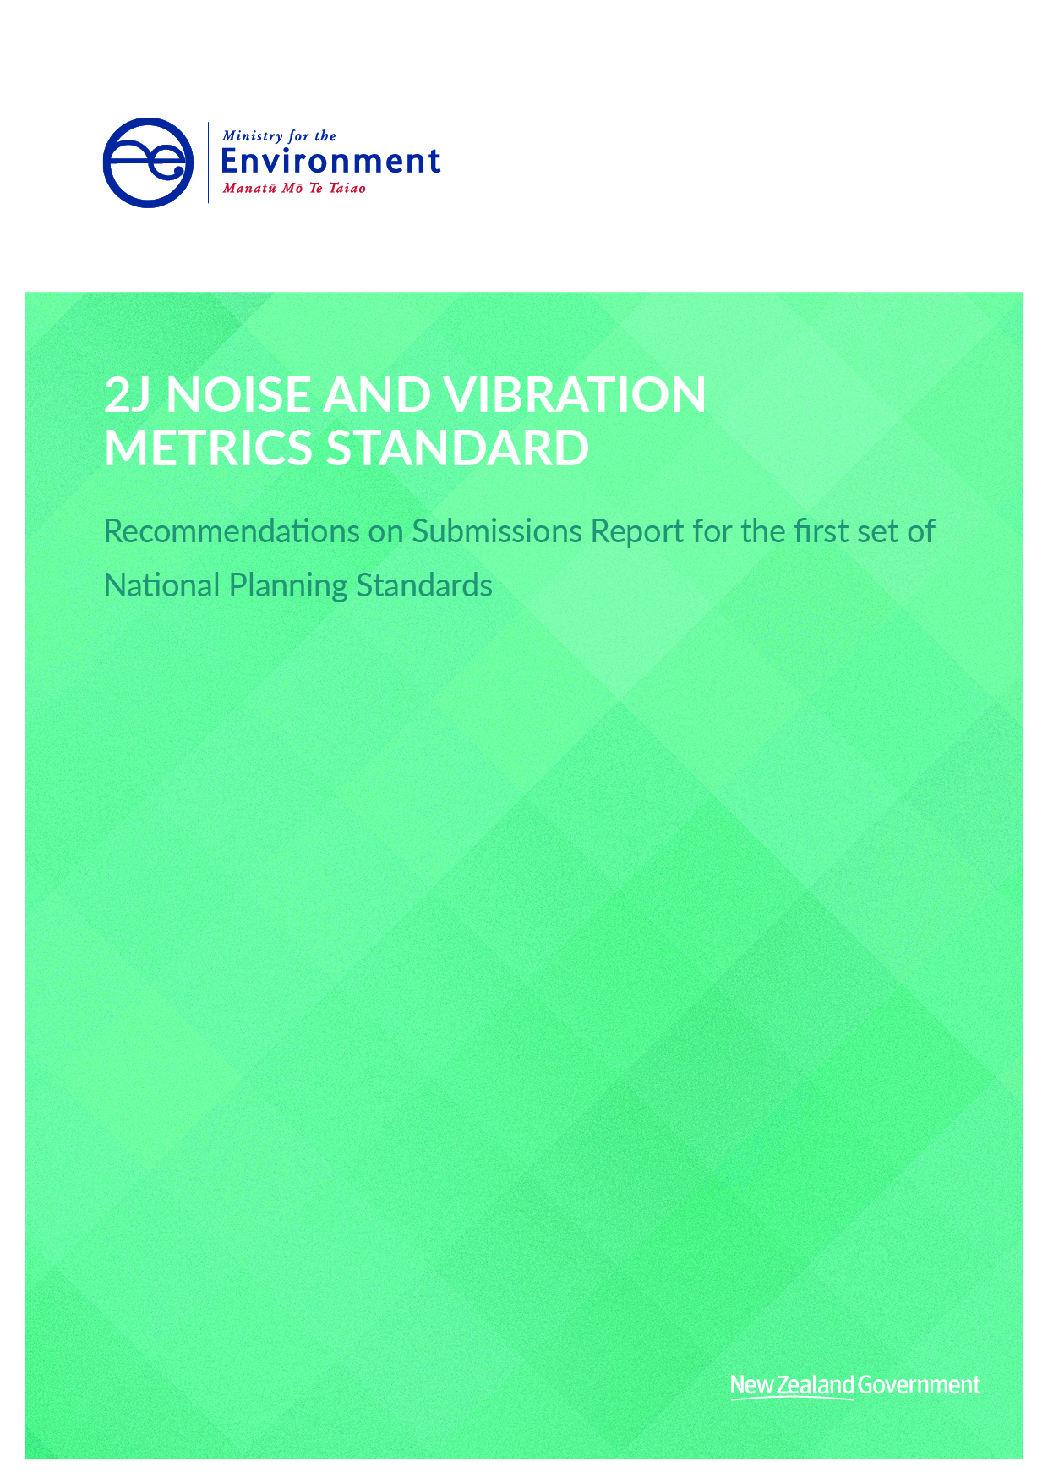

This document may be cited as: Ministry for the Environment. 2019. 2J Noise and Vibration Metrics Standard 2019 – Recommendations on Submissions Report for the first set of National Planning Standards. Wellington: Ministry for the Environment.

Published in April 2019 by the
Ministry for the Environment
Manatū Mō Te Taiao
PO Box 10362, Wellington 6143, New Zealand
ISBN: 978-1-98-857909-2 (online)
Publication number: ME 1405
© Crown copyright New Zealand 2019
This document is available on the Ministry for the Environment website: www.mfe.govt.nz.

Contents
Context to this document 4
1 Changes to the Draft Noise and Vibration Metrics Standard 5
1.1 Introduction 5
1.2 Background 5
1.3 Submissions 6
1.4 Analysis 7
1.5 Guidance 10
1.6 Recommendation(s) 10

Context to this document
This document forms part of the suite of recommendations on submissions reports prepared for the National Planning Standards. It should be read in conjunction with the Overall Introduction and is likely to reference other recommendations on submissions reports listed below. The recommendations on submissions reports are organised as follows:
- Overall introduction
- Explanation of all of the recommendations on submissions reports
- High-level submissions analysis
Detailed recommendation reports
- Regional Policy Statement Structure Standard report
- Regional Plan Structure Standard report
- District Plan Structure Standard
- Combined Plan Structure Standard
- Chapter Standards report including
- Introduction and General Provisions Standard
- National Direction
- Tāngata Whenua Standard
- Strategic Direction Standard
- District-wide Matters Standard
- Designations Standard
- Schedules, Appendices and Maps Standard
- Format Standard including
- Chapter Form Standard
- Status of Rules and Other Text and Numbering Form Standard
- Zone Framework Standard
- Spatial Layers Standards including
- Regional Spatial Layers Standard
- District Spatial Layers Standard
- Definitions Standard
- Noise and Vibration Metrics Standard
- Electronic Accessibility and Functionality Standard including
- Baseline electronic accessibility
- Online interactive plans
- Mapping Standard
- Implementation of the Standards

Changes to the Draft Noise and Vibration Metrics Standard

Introduction
This section covers the changes proposed for the Noise and Vibration Metrics Standard.
The Noise and Vibration Metrics Standard provides a consistent methodology for the management of vibration effects and requires rules that manage noise emissions to reflect the latest version of relevant acoustical New Zealand Standards (NZSs).
The following issues are covered in more detail in this section:
- changes to acoustical New Zealand Standards used
- clarification of the scope of the acoustical New Zealand Standards and planning standards
- clarification where acoustical New Zealand standards conflict with each-other
- additions to detail of planning standards and interaction with other planning standards.

Background
Metrics are standards of measurement for a variety of aspects ranging from simple matters (eg, length or area) to more complicated matters (eg, noise and radio frequency). In regard to district and regional plans, metrics are typically part of a rule and are accompanied by thresholds that indicate if a use or development is permitted or requires a particular level of consent.
Noise metrics are included frequently in council plans but are inconsistently used, formatted and described. Noise metrics in some plans are outdated or have been superseded and do not reflect the latest acoustical NZSs. This is largely due to the need for technical noise experts to review plan content, and the requirement for councils to use a formal Resource Management Act 1991 (RMA) plan change process to update the metrics.
The Ministry for the Environment released a discussion paper on potential metrics in May 2017. The paper identified the following four metric themes for potential inclusion in the first set of planning standards: earthworks; noise; light spill; and building bulk and location. Feedback on this paper was received in the practitioner workshops in June and July 2017 and in submissions on the discussion paper. It was considered that, given the variation in the noise metrics, standardising them would be beneficial. The Acoustical Society of New Zealand (ASNZ) was also willing to help develop noise metrics and provided the necessary technical input to this topic area.
Under the RMA, managing the effects of noise is a function of territorial authorities. A number of acoustical NZSs deal with how noise should be measured and assessed. Some of these standards have been amended over time to reflect changes in what is considered best practice. The differences between versions can result in different measurement of the real-world environmental effects experienced. The acoustical NZSs are often used or referred to in district plans, resource consent conditions and designation conditions. Standardising the noise metric makes it much easier for councils to update noise measurement methods over time.

Submissions
Of the 55 submitters on this proposal, 54 were largely in support, with suggested changes to clarify the scope of the standards and the standards that would be best to use. Support was particularly strong for the proposed approach of using the standards for methodology but leaving councils to set local limits. Only one council expressed significant concern about the proposal.

Support
Those in support of the proposal included industry, councils, environmental groups and iwi. Most of the support was based on the view that having a single set of standards simplified the approach. Reasons for supporting standardised acoustical NZSs included eliminating debate, increasing efficiency, decreasing cost and increasing consistency and certainty for resource consent applicants. As Harrison Grierson explained, “removing variation would allow acoustic engineers to focus on the issue rather than to explain how a plan might differ from a NZ Standard”.
Submitters saw the benefit of having planning standards that would encourage councils to keep up to date. They also emphasised that it was important to have adequate planning standards because of the health effects of noise. For example, MidCentral Public Health Service noted that:
… it is important that the National Planning Standards keep up-to-date with changes to the technical standards for managing noise, and that Territorial Authorities are required to update their plans when a new noise standard is adopted. Noise has adverse effects on health, the understanding of noise and monitoring for noise is likely to continue to change over time. It is not appropriate for plans to continue to rely on old standards when more appropriate newer technical standards become available.

Opposition
One submitter expressed significant concerns about the standard use of acoustical NZSs. Queenstown Lakes District Council (QLDC) questioned the appropriateness of using acoustical NZSs as a basis for noise matters, explaining that “QLDC had to deal with Environment Court appeals when it simply sought to update to the latest NZS for noise matters”. A number of submitters also questioned why NZS 6807:1994 Noise Management and Land Use Planning for Helicopter Landing Areas was not included.

Suggestions for improvement
Most submitters who wanted changes to the Noise and Vibration Metrics Standard suggested clarifying the scope of where the acoustical NZSs apply or adjusting the planning standards being used to avoid situations where acoustical NZSs are applied inappropriately. Around 10 submissions were received from individual submitters who were concerned about the application of NZS 6801:2008 and NZS 6802:2008 to impulsive sounds. Forest & Bird wanted clarity on the application of standards to underwater sound and Christchurch Airport wanted clarity on whether standards would apply to existing airports or just new ones. The New Zealand Defence Force (NZDF) and the New Zealand Transport Agency (NZTA) questioned the appropriateness of using the German standard DIN 4150-3 to manage construction vibration, because it does not include amenity effects or effects on people. Similarly, Hauraki District Council was concerned that it only considers the effects of vibration on structures of buildings. The NZ Airports Association suggested clarifying that the acoustical NZSs apply in the coastal marine area.
Other submitters supported the standard use of acoustical NZSs but requested local exemptions or exemptions for specific circumstances. The Joint Southland Councils’ technical submission stated, “The Councils are amenable to this idea in principle provided that there is still the ability for exceptions to the standard allowed to provide recognition for unique localised environments.” Hauraki District Council provided the example of having “specialised standards to ensure that the vibration effects of mining on amenity are … addressed, due to the Martha Mine opencast and underground operations in Waihi” and explained that in its view “it is important that we can continue to use these standards”. Wellington City Council submitted, “we are concerned about the potential implications of this in the context of the Wellington International Airport and suggest that there be some flexibility provided to recognise particular local situations”.
A number of submissions also recommended improvements to wording to avoid conflicting or unintended meanings of directions and ensure that the standards are consistent with the Noise and Light section in the General District Wide Matters chapter. Mercury NZ Limited and KiwiRail raised “a concern with the terminology used in Clause 3 and 4 of the Standard … that the various standards (including NZS 6806) use metrics other than rating level and lmax from NZS 6802, and you cannot comply with both parts 3 and 4”. They explained that “to fix this part 4 should probably list out the units for each different source in the referenced standards”. Along with other submitters, KiwiRail also pointed out incorrect use of the word ‘limits’ instead of ‘metrics’ in direction 5, which is outside of the scope of the Noise and Vibration Metrics Standard. Mercury NZ Limited also addressed a concern that:
while Directions 24 and 32 of the District Wide Matters (S-DSM) Standard do require any noise related metrics to be consistent with the Noise and Vibration Metrics (CM-2) Standard, those Directions do not require the measurement methods to be consistent with the New Zealand Standard.

Analysis

Scope of Noise and Vibration Metrics Standard
Submitters were concerned about the effect that the Noise and Vibration Metrics Standard might have on the content of their noise sections. For example, Wellington City Council explained that “specifying the application of the New Zealand Standard 6805:1992 Airport noise management and land use planning in the Planning Standards could result in re-litigation of the noise issues associated with the Wellington Airport”. The NZ Airports Association had a similar concern in relation to noise-related land-use planning. Similarly, Wellington City Council was concerned about the effect that the standardising noise measurement and assessment might have on existing situations, such as Wellington International Airport, and asked for clarification that standards would only apply “where new airports are proposed”. As discussion in section 1.3, two submitters asked for the ability to make local exemptions because of these concerns.
The Noise and Vibration Metrics Standard is applied only in relation to noise measurement and assessment methods, not to noise limits. The intention of this limited scope of applicability is that it will not affect plan outcomes, content or rules. A number of submitters supported this scope. As Harrison Grierson explained, it leaves “the maximum and minimum thresholds to Council’s to reflect local situations, following consultation with the local community”. Christchurch City Council submitted that decisions about boundaries such as air noise boundaries and outer control boundaries should be “a decision for local authority decision makers in the context of their communities”. It is recommended that the scope of the standards is maintained because of the limited application to noise measurement and assessment and the support received for this limited application. In order to provide further clarity over which parts of the NZSs apply, we also recommend changing the wording to clarify that symbols are included and that plans must only be consistent with the mandatory parts of NZSs.
We did consider specifying the parts of the NZSs that apply. However, the ‘plan rule’ must be consistent with the standards, and plan rules most often do not include details of the standards themselves. The ASNZ also advised that the standards are best understood as a whole, and that measurement methods and symbols are included throughout. Further explanation of relevant parts of the NZSs can also be provided in guidance.
Another recommendation is not to provide an ability to make local exemptions, because the Noise and Vibration Metrics Standard does not apply to plan outcomes, content or rules.

Applicability of Noise and Vibration Metrics Standard
Submitters requested clarification of how the Noise and Vibration Metrics Standard applies in relation to water. Forest & Bird submitted that “the Acoustic NZ Standards do not provide an appropriate terminology or methodology for measuring underwater sound as the basis for setting limits and considering effects in RMA plans” because they do not necessarily include vibration, which is “important when considering effects of activities in the marine environment”. Forest & Bird suggested that the “terminology for underwater noise and vibration should refer to ISO/FDIS 18405:2017(E) Underwater acoustics — Terminology”. It is recommended that the purpose statement should be modified to specify that the standards are not intended to apply to underwater noise, as it is not their intended purpose to standardise underwater noise measurement and assessment.
A similar concern was raised in relation to the coastal marine area (CMA). The NZ Airports Association proposed that “the Standard should be amended to clarify that it applies to the coastal marine area, as well as land-based measurement” because “a number of airports operations involve noise emissions over the coastal marine area, and it should be made clear in the Standard that the same measurement methods apply”. The ASNZ advised that the NZS can be applied to the above-water noise generation in the CMA and that, from a practical perspective, there is no need to restrict the use of the NZS to the coastal area, as sources further out at sea would be unlikely to have an effect on land-based receivers. It is recommended that it is noted in guidance that the Noise and Vibration Metrics Standard applies to the CMA.
Around 10 submissions related to concerns about the application of the NZS to impulse noise. The submitters requested that the acoustic standard ISO 17201-1 should be used to measure short, impulsive noises such as gunfire and blasting, using the dB Lpeak measurement included in this standard, rather than the dB Leaq measurement used for continuous, steady sound in NZS 6802:2008 Acoustics – Environmental Noise. As Elise Purdie explained, “Gunfire is not a continuous sound. It is short sharp blast. Therefore an average weighted metric such as dBLeq or L-max is inappropriate” because “the extremely loud noise [of] the gunfire seldom violates the levels as an average weighted metric factors in the silence between shots”. The submitters were concerned that the application of NZS 6802:2008 had enabled the development of a gunfire range in a previously quiet valley. OBD Consultants Ltd provided the information that “in the New Zealand context in Brooks v Western Bay of Plenty District Council, the Environment Court expressly recognised (based on expert evidence) that general amenity noise standards in New Zealand Standard 6802:2008 were not applicable to impulsive noise”. The NZAS advised that measurement of gunfire noise is anticipated in some situations under clause 8.6 of NZS6801:2008 but that the assessment of gunfire is outside the scope of NZS6802:2008. It is recommended that direction 4 clarifies the applicability of NZS 6802:2008.

Proposed noise standards to be used in the Noise and Vibration Metrics Standard
As discussed in section 1.3, the NZDF, Hauraki District Council and NZTA questioned the appropriateness of using the German standard DIN 4150-3 to manage construction vibration, because it does not include amenity effects, effects on people or the effects of vibration on the structure of buildings. The NZDF was particularly concerned because its “activities can result in vibration felt by people typically from airborne sound from explosions, artillery and detonations” and “this ‘blast over-pressure’ can be perceived as vibration and is felt by people rather than resulting in a structural vibration effect”. The NZDF suggested using the most recent version of the German standard, DIN 4150-3. The NZTA suggested that “an international ISO standard is preferable as New Zealand experts (through MBIE/Standards New Zealand) can provide input to and vote on ISO standards”. The ASNZ advised that it would be possible to include ISO4866:2010 for survey methodology. It is recommended that this standard is adopted because of the opportunity it provides for New Zealand input.
The Horticultural Society of New Zealand (HortNZ), the NZDF, the Resource Management Law Association, the Joint Southland Councils and the Environmental Noise Analysis and Advice Service requested clarification of why NZS 6807:1994 Noise Management and Land Use Planning for Helicopter Landing Areas was not included in the table of NZSs. The NZDF asked for the standard to be included because it “does apply to a number of NZDF sites which experience regular helicopter movements and is currently referenced in many district plans”. HortNZ requested that it was included because it “makes differentiation for intermittent use which is important for frost fighting in orchards”. The ASNZ had originally advised that the standard should be excluded because, since it was developed 25 years ago, helicopter use in tourist attractions has become much more prominent. The standard was not included because of this. The ASNZ later clarified that the limits set in the standard were too low and averaging would mean that excessive amounts of activity could be carried out at undesirable times. It is recommended that the standard is included, with a specification that limits and averaging do not apply. Inclusion in the planning standards does not require councils to use the standard. They will still only use it if it is included in the plan, unless a schedule 1 process is carried out to include it.

Clarifications to the Noise and Vibration Metrics Standard
As discussed in section 1.3, submissions suggested changes to the wording of the Noise and Vibration Metrics Standards to provide clarification or avoid conflicting instructions. These submissions were made particularly in relation to a conflict between directions 3 and 4, the use of the word ‘limits’ instead of ‘metrics’ in direction 5 and consistency with the District Wide Matters standard. As reflected in the planning standards, a number of wording changes have been made to the Noise and Vibration Metrics Standard in response to these submissions.

Guidance
Guidance may elaborate on technical details on the acoustical NZSs and how they are intended to operate. Guidance is likely to be used to clarify what measurement units and methods are involved with each of the acoustical NZSs. This will help councils to understand how the Noise and Vibration standard may affect rules. This may involve copies of the parts of the NZS that the Noise and Vibration standard is referring to and text that councils could use to refer to the NZS when writing their plans. It is also likely to clarify what ‘measurement methods’ refers to.
The scope of application of the Noise and Vibration standards is also likely to be clarified in guidance. As discussed above, submissions raised questions about the scope of the standards and where they apply. Guidance will be able to emphasise the intention that the Noise and Vibration standard does not affect plan rules and only generally applies to measurement, rather than to noise levels or assessment. Guidance can also further explain which standards are intended to apply to which types of noises. For example, submitter Anthony O’Brian requested that “the ISO standards are referenced for guidance on the correct way to measure gunfire”.
Guidance is also likely to explain how the standards will be chosen and updated when new acoustical NZSs are made. The Resource Management Law Association asked for guidance on these matters, submitting that it would be useful to have “a guidance note to indicate the method for determining the most appropriate international standards, and clarifying that ‘latest version’ of such standards means the most up-to-date version currently available in English”. Similarly, guidance can clarify how the Ministry for the Environment will update standards and how a schedule one process will not be required. Guidance like this was requested by the Joint Southland Councils, which submitted that “clear guidance is needed on the process applicable for updating references to external standards when updated versions are released”. This would help clarify for councils how, and how frequently, they will need to update acoustical NZSs and the Noise and Vibration Metrics Standard.

Recommendation(s)
- Maintain application of standards to noise assessment and measurement only and clarify this in the mandatory directions and by including symbols in the table direction.
- Do not provide for local exemptions to be made to the Noise and Vibration Metrics Standard.
- Specify in the purpose statement that the standards do not apply to underwater noise.
- Note in guidance that the Noise and Vibration Metrics Standard applies to the coastal marine area.
- Clarify the applicability of NZS 6802:2008 in the Noise and Vibration Metrics Standard direction 4 by adding the text “provided that the emission of noise in question is within the scope of New Zealand Standard 6802:2008”.
- Replace the use of DIN-4150-3 with ISO4866:2010.
- Include NZS 6807:1994 Noise Management and Land Use Planning for Helicopter Landing Areas.
- Provide guidance on the parts of the NZSs that are intended to apply, the scope of applicability of the NZSs and how the process of updating standards following review of them.

